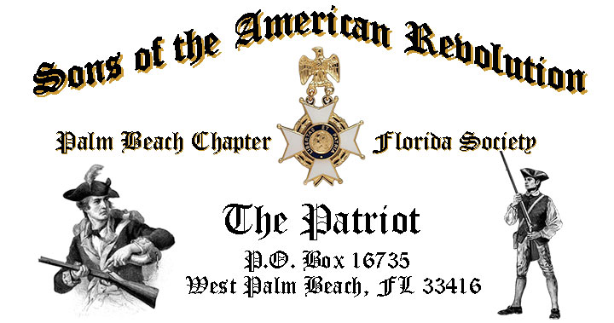

***Volume 23 April 2017 Number 04***

***Join us for the annual “Thin Blue Line* *Recognition Ceremony”***, ***to Honor our local Law Enforcement professionals*** and enjoy a special demonstration by the ***Palm Beach Sheriffs K-9*** ***Unit***, *Tuesday* **April 18, 12:00 Noon Sharp** @ the Embassy Suites 1601 Belvedere Road, WPB! "***RSVP Today*** for this popular event!

***April Meeting Highlights:***

* ***Thin Blue Line* *Recognition Ceremony, Guest Speakers & K-9 Demo!***
* ***Buffet******Lunch***, Desserts & Beverages, **$28** per person **Check/Cash** at the door!
* ***Reservations*** **required,** **RSVP**, Don Lanman **(561)-315-5073!**
* **Family, Friends & Guests** are always ***Welcome***!

**Newsletter Content:**

* **President’s** Message
* **2017** Chapter Meeting Dates &Topics
* **Officers** & Board Members
* ***President’s*** *Brigade* Financial Supporters
* **Committees**, Chairmen & Members
* **National**/State Society News & Events
* **Feature Articles:**  ***Paul Revere - Truth-Fiction-Fact!***
* **Chapter** **March** Meeting Pictures
* **Compatriot** Sponsored Promotions

**President’s Message:**

***Fellow Compatriots & Friends…Don’t Miss the annual Thin Blue Line* *Recognition Ceremony*** honoring our local law enforcement professionals, and featuring a special police dog demonstration by the ***Palm Beach County Sheriff’s Office K-9 Unit!***

[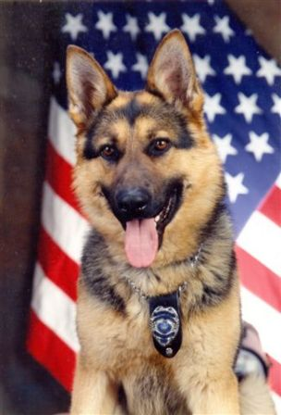](https://www.google.com/url?sa=i&rct=j&q=&esrc=s&source=images&cd=&cad=rja&uact=8&ved=0ahUKEwjsnJ-Vl5DTAhUBMSYKHQrYBX4QjRwIBw&url=http%3A%2F%2Fwww.plymouthtownship.org%2Fpolice%2Fdivisions%2FK9.cfm&psig=AFQjCNFHDlcajnhuo6xIIuw0HlIrRYPUuA&ust=1491580090690200) [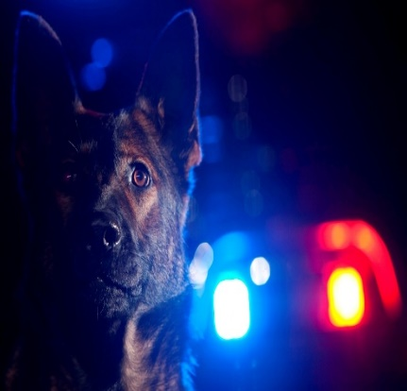](https://www.google.com/url?sa=i&rct=j&q=&esrc=s&source=images&cd=&cad=rja&uact=8&ved=0ahUKEwiwr9bcmpDTAhUE0iYKHYQbB40QjRwIBw&url=https%3A%2F%2Fwww.gofundme.com%2Fshenandoah-police-k9-2uqnwgxf&psig=AFQjCNFHDlcajnhuo6xIIuw0HlIrRYPUuA&ust=1491580090690200)[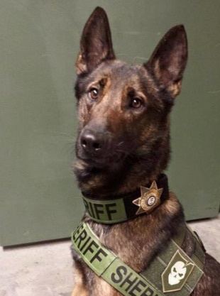](https://www.google.com/url?sa=i&rct=j&q=&esrc=s&source=images&cd=&cad=rja&uact=8&ved=0ahUKEwjTiJaKmJDTAhXFJiYKHcoeB1EQjRwIBw&url=http%3A%2F%2Fsafetybeforebulldogs.blogspot.com%2F2015%2F10%2Flist-of-pit-bull-attacks-on-police-k9.html&psig=AFQjCNFHDlcajnhuo6xIIuw0HlIrRYPUuA&ust=1491580090690200) [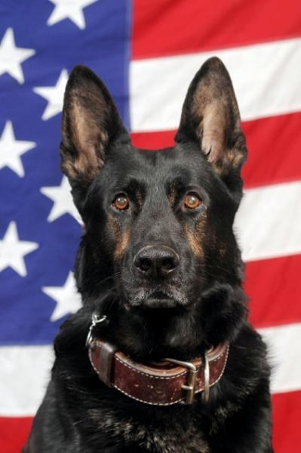](https://www.google.com/url?sa=i&rct=j&q=&esrc=s&source=images&cd=&cad=rja&uact=8&ved=0ahUKEwj-g527mJDTAhUERiYKHdn0BD0QjRwIBw&url=http%3A%2F%2Fbethelpark.net%2Fpolice_k9.cfm&psig=AFQjCNFHDlcajnhuo6xIIuw0HlIrRYPUuA&ust=1491580090690200)

The March meeting was very exceptional including a special presentation by international author James Gabler with a compelling review of dinners at the white house with Thomas Jefferson.

We honored Compatriot and Past President Ed Buckley with a ***Certificate of Appreciation*** and ***Chapter 80th Anniversary Commemorative Coin*** for his historic support of the Chapter and in recognition of receiving the prestigious ***SAR Patriot Medal*** by the State society.

Compatriot Buckley has supported the SAR for over 20 years, served as *Chapter President 2006-2007*, is member of the *FLSSAR Veterans Battalion* and is a *WW-2 Veteran*.

Buckley’s *Patriot Medal* will be presented at the May 19-20 Board of Management Meeting in Orlando. All Compatriots are encouraged to attend the presentation in honor of the *“Chapter’s Own”* Compatriot Edward Buckley IV.

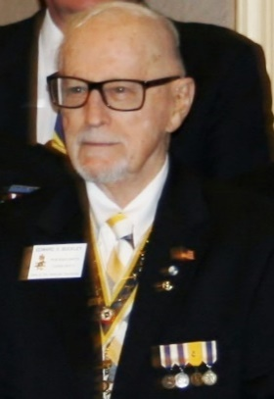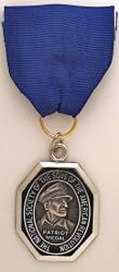

The Chapter is a historic supporter of our Nation’s Veterans. Over 20% of our members are veterans and we encourage all Compatriots who served in the military to provide us with a copy of their DD-214 to be recognized with an *SAR Military Service Medal*.

In support of our Veterans, four Chapter Compatriots volunteered and were selected to serve as Veteran Guardians for WW-2 and Korean War veterans on the April 8, 2017 ***Southeast Veterans*** ***Honor Flight*** to Washington DC.

Compatriots *Lanman, Tidwell, Curry,* and *Van Otteren* will serve as escorts for these war veterans to visit historic monuments and tributes to our fallen veterans in the Nation’s Capital.

All Compatriots are encouraged to join fellow members and the ***Chapter Women’s Auxiliary***to greet the ***Honor Flight*** on its return at the *West Palm Beach International Airport* on April 8 at 7:30 pm.

The Chapter provided a heartfelt remembrance for Compatriots ***Henry Michael “Mike” Burkhardt*** and ***Donald Eugene Moore*** at the March meeting. The Chapter will also submit the names of our departed Compatriots to both State and National Societies to be inscribed on the *SAR Rolls of Remembrance* and *Respect*.

A custom ***Palm Beach Chapter Commemorative Challenge Coin*** is now available in recognition and honor of the Chapter’s 80th year. Cast in historic *Blue* and *Gold*, the striking bronze coin commemorates the founding of the Palm Beach Chapter in ***1938***.

The coin lists the four major revolutionary war battles waged in *Florida* with an illustration of a Minuteman guarding *Florida* and the state moto of ***“In God We Trust”*** inscribed on side one. Represented on the reverse side of this impressive coin is the iconic NSSAR Logo.

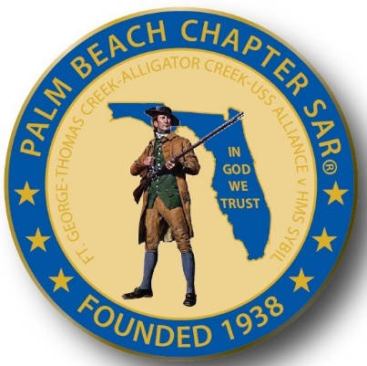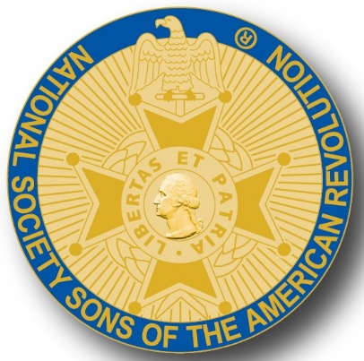

The custom Palm Beach Commemorative anniversary coins are designed for special guests, patriotic occasions, and are available for purchase at $10 each.

A major Chapter goal is membership development and mentoring of new members.

With the natural turnover of members, we need all Compatriots to help grow our membership with civic-minded individuals interested in supporting our constitution, honoring our patriot ancestors and good fellowship.

So please, get involved and help grow our membership by enrolling your Sons and Grandsons, inviting friends and neighbors to join and encouraging wives, daughters, and granddaughters to join the *DAR* and *Chapter Women’s Auxiliary*.

**Committee members** are needed to support our many youth and civic programs including Flag Certificates, Liberty Tree Program, Medals/Awards, Veterans Programs, Newsletter, Publicity, High School/Youth Programs, Boy Scouts, JROTC, Rumbaugh Historical Oration and Knight Essay Contests, Police-Firefighters-EMS Service Awards, Chapter Events, Americanism-Patriot Bios, Audit, Membership Development, Officer Nomination, Speakers Bureau, Website Support, Fundraising/Endowment Programs.

Another Chapter goal is to expand relationships and joint event activity with all of the local *DAR Chapters*. We welcome our Patriot Daughters to all Chapter meetings and events, and sincerely appreciate their new member referrals and related support.

Compatriots we need **“Gift Baskets”** for our meeting raffles to raise funds to support our many *Youth* programs. All donors are acknowledged at meetings, included in the newsletter, and are recognized in the Chapter’s *Presidents Brigade*.

Please help us avoid losing money on the chapter luncheons by attending and bringing guests!

The hotel requires a minimum number of guests to cover the room, food, and services, so when attendance is low or there are no shows, the Chapter must pay the difference.

Fellow Compatriots, I look forward to seeing you at our next meeting! Please, join me in honoring our nations Veterans, Patriot Ancestors, and especially our Dear Departed Compatriots.

**God Bless You** and **God Bless the *United States of America*.**

**-D. Lanman**

**2017 Chapter Meeting Dates/Topics:**

**Visit** the Palm Beach Chapter web site @ [www.sarpbchapter.org](http://www.sarpbchapter.org) for a meeting calendar, special events, articles, pictures, and general information.

* **Apr. 18 Law Enforcement** Awards & Special Guest Speaker
* **May 16 Firefighters/EMT** Awards & Special Guest Speaker
* **Oct. 17, Special** Guest Speakers
* **Nov. 21,** **2018** **Officer Nominations**, Special Guest Speaker
* **Dec. 9,** **Kings Academy Holiday Musical**

**2017 Officers & Board:**

**President** **Donald Lanman**

**Vice President** **Benjamin Tidwell III**

**Secretary** **Gary Green**

**Treasurer** **Peter Johnston**

**Registrar** **Robert Boggs**

**Chaplain** **Father Sanford Sears**

**Sgt. @ Arms Brian Davey**

**Historian** **Samuel “Buddy” Miller**

**Officer @ Large** **Bill Johnson**

**Patriot Newsletter Editor** **Donald Lanman**

**Support Youth & Scholarship Programs- Donate to the President’s Brigade:**

The Chapter has approved $1,000 Scholarship to the Palm Beach Atlantic University again this year.

We want to increase the scholarship to $4,000 and respectfully ask Compatriots to consider helping the Chapter grow the amount and support students of character.

The Chapter honors and expresses its sincere appreciation to the Compatriots of the ***President’s Brigade*** who support the scholarship and youth programs.

The dedicated members of the ***President’s Brigade*** donate “extra dollars” in support of the Chapter’s many youth programs, scholarships, civic activities, award certificates, police/firefighter/EMT medals, veterans’ projects, and related community civic programs.

**Honored Presidents Brigade Members:**

**-Bronze Level: $25-$99**

***M. Anderson, B. Boggs, J. Brown , R. Cass, D. Coldwell, B. Davey, J. Dorsey, W. Davis, F. Devitt J. Harper, J. Kane, J. Mayne, S. McWhorter, C. Odell, G. Parkinson, W. Told***

**-Silver Level: $100-$199**

***J. Curry, R. Culpepper, T. Friend, G. Green, F. Green, A. Griswold, B. Johnson***

**-Gold Level: $200-$499**

***R. Brinckerhoff, R. Banta , E. Buckley, K. Christie, S. Hitt, D. Lanman, W. Meakin, B. Tidwell, R. Utley, J. Wynns***

**-Platinum Level: $500+**

**Committees, Chairs & Members:**

**Fellow Compatriots**…..The Chapter expresses its sincere appreciation to those members who volunteer to serve on our committees and projects. As you can see a few Compatriots are serving on multiple committees and could use support!

**Please** volunteer today to help with any of the chapter committees listed below. It does not take much time and is a major help with our many civic initiatives. **Call** or email Don Lanman or Ben Tidwell **Today** to lend a hand with any of the following committees.

* **JROTC -Tidwell**
* **Law Enforcement-Fire Safety -Green, Tidwell**
* **Veterans Affairs -Wenman, Lanman**
* **Newsletter/Publicity -Lanman**
* **Boy Scouts -Tidwell**
* **Knight Essay/Rumbaugh Oration -Boggs**
* **American History Teacher -Boggs**
* **DAR Liaison -Lanman, Tidwell**
* **Speakers Bureau -Lanman, Tidwell**
* **Audit -Coldwell, Tidwell, Lanman**
* **2017 Officer Nomination -Lanman, Tidwell, Boggs**
* **Flag Certificates -Clouse, Miller, Tidwell**
* **Membership -Green, Boggs, Tidwell**
* **Liberty Tree -Lanman**
* **Patriot Bios -Miller**
* **Web Site-Facebook -Open**
* **80th Anniversary -All Chapter Officers**

**Get Your Custom Bronze Chapter Commemorative Challenge Coin!**

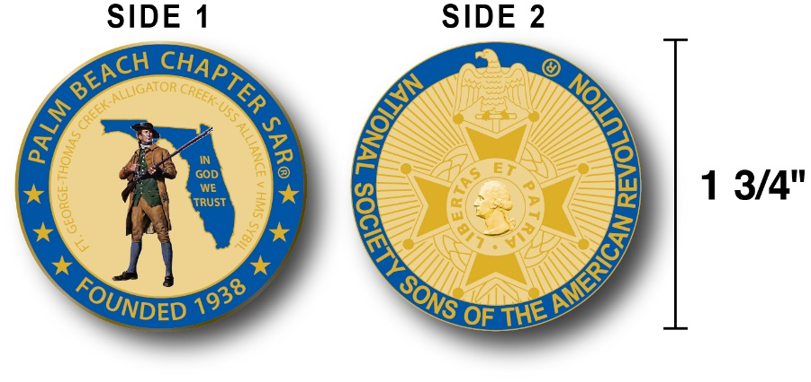

The Chapter has designed a custom bronze *Commemorative Challenge Coin* honoring the founding of the Palm Beach Chapter in 1938 and its 80 years of historic, patriotic, and civic service in Palm Beach County and Florida State.

The custom bronze coin is highlighted in the George Washington colors of military Blue on a Gold background.

Side-1 is personalized to our Chapter including the founding date, a Minuteman standing guard over Florida, the Florida State motto ***"In God We Trust”.***

The coin also includes a notation listing the four major Revolutionary War battles waged in Florida including the battle of *Ft. George-Pensacola, Thomas Creek Massacre, Alligator Creek battle,* and the *Last Naval Battle* of the Revolutionary War and Patriot victory, *USS Alliance v HMS Sybil.*

Side-2 displays our national NSSAR logo.  Very impressive indeed!

The custom bronze ***Commemorative Challenge Coin*** is designed to celebrate our founding in **1938**, create a distinctive and impressive image for our Chapter and be used as a token of appreciation for honored guests, speakers, and as special awards.

Compatriots may purchase these unique Chapter challenge coins for just $10.

**Classy SAR Lapel Pins $10:**

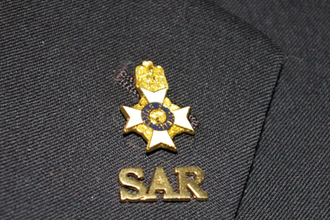

Make a fashion statement with a gold ***SAR*** pin for your suit lapel or shirt. The SAR Lapel Pin is part of a national branding program to help promote the S.A.R. and stimulate new membership! The **classy** lapel pin is a recognizable symbol of the SAR for the public, gives you immediate recognition as a member, and may spark conversation about SAR that leads to a new member.

The gold lapel pin and SAR member rosette create a very professional image that will improve overall SAR name recognition. The Chapter has a supply of pins for Compatriots for just $10. **Get yours today**!

**Chapter, State & National News:**

**-CHAPTER:** Four ChapterCompatriot volunteers (Lanman, Tidwell, Curry, Van Otteren) will participate in the April 8 ***Veterans Honor Flight***.

**-STATE/NATIONAL:** *Battle of Thomas Creek* event in Jacksonville on 5-13, Board of Management meeting Orlando 5-19-22 & SAR Congress 7-6.

**- FSSDAR HONOR FLIGHT Guardian Program:** The Palm Beach Chapter is supporting the *Florida State Society of the Daughters of the American Revolution* and *Honor Flights Southeast Florida* Honor Flight event on **April 8, 2017** from Palm Beach Airport to Washington DC.

Chapter Compatriots completed an application, submitted $400 for travel expenses and were trained to escort WW-2 & Korean War Veterans on their visit to war memorials in DC!

**Information** on the April 8 welcome home event contact Gladys Van Otteren, *FSSDAR* State Chairman Honor Flight program (561)-324-2937 or email Gladys @ [HMFchapterDAR@gmail.com](mailto:HMFchapterDAR@gmail.com).

**Feature Article**

***Paul Revere….Truth-Fiction-Fact***

***By Samuel A. (Buddy) Miller, Palm Beach Chapter Past President & Historian***

[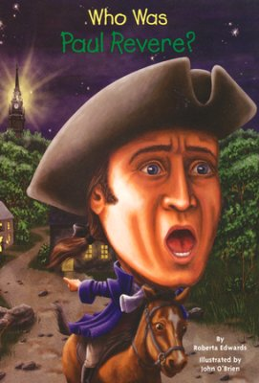](https://www.google.com/url?sa=i&rct=j&q=&esrc=s&source=images&cd=&cad=rja&uact=8&ved=0ahUKEwjpiYqek47TAhVI2yYKHe6QDdkQjRwIBw&url=https://www.christianbook.com/who-was-paul-revere/roberta-edwards/9780448457154/pd/457154&psig=AFQjCNFk55gOq9DR9_LP1MgqwYBFKxv_vA&ust=1491510293059987)

***“Listen my children and you shall hear***

***Of the midnight ride of Paul Revere.***

***On the eighteenth of April, in Seventy-five,***

***Hardly a man is now alive who remembers that famous day and year.”***

Almost everybody recognizes the opening stanza of “Paul Revere’s Ride,” the stirring poem written by Henry Wadsworth Longfellow in 1861. The poem was so popular that generations of schoolchildren were required to memorize the lines.

Nevertheless, during Revere’s life his role in the events of that evening were not looked upon by him or his contemporaries as being particular noteworthy. It would take Longfellow’s poem written more than 40 years after Revere’s death to bring him such fame and glory.

Writers and poets frequently use what is commonly known as “literary license” when creating their written works. Longfellow was no exception, taking many liberties with the events of the evening in penning “Paul Revere’s Ride.” His greatest shortcoming was giving sole credit to Paul Revere for the achievement of alerting the countryside of the British plans to march to Lexington and Concord.

In reality, there were at least three riders and unquestionably many others who alerted colonist throughout the countryside after the initial warning.

Paul Revere was born in late December 1734 in Boston, the son of a French Huguenot father who had entered Massachusetts Bay around 1716.

His father, Apollos Rivoire, came to Boston from Germany at the age of thirteen and there was apprenticed to a silversmith. Securing his own shop, he was able to marry Deborah Hichborn, a member of a long-standing merchant family.

About this time, he anglicized his name to Paul Revere. Young Paul, one of twelve children, worked in his father’s trade and when his father died in 1754, he continued the silver trade while his mother managed the business.

[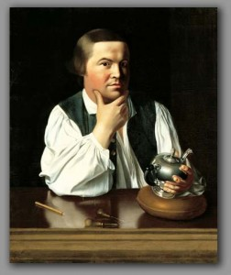](https://www.google.com/url?sa=i&rct=j&q=&esrc=s&source=images&cd=&cad=rja&uact=8&ved=0ahUKEwjTqsLdk47TAhVLSiYKHUknCekQjRwIBw&url=https://danfitzpatrickcomedy.com/2014/07/&psig=AFQjCNFk55gOq9DR9_LP1MgqwYBFKxv_vA&ust=1491510293059987)

He served briefly as a second lieutenant in an artillery regiment during the French and Indian War. Upon leaving the army, Revere returned to Boston and assumed control of the silver shop in his name.

One of the skills that distinguished him from other silversmiths was that he was not only an expert smith but also a skilled engraver and one of the few craftsmen who could complete a piece of silver, even to the engraved decoration. The quality of his work made Revere’s services much in demand.

In August 1757, Paul married Sarah Orne who bore him eight children, six of whom survived. He became involved with a number of Bostonians who were agitating over British policies in Massachusetts and ultimately joined the Sons of Liberty, a secret citizens group organized in the various colonies to protect against British policies, especially taxation.

Revere began to fashion engravings that were anti-British, the most famous of which portrayed the Boston Massacre. The engraving, a masterpiece of propaganda, had the desired effect on those who saw its reprint in newspapers throughout the colonies. The engraving heightened the growing fear of increased numbers of British soldiers in the colonies and therefore increased fear of British government’s meddling in colonial affairs.

Revere’s wife Sarah died in 1773 and in October of that year, he married Rachel Walker with whom he would have five more surviving children.

After the Boston Tea Party in December 1773, Revere began work as a messenger for the Boston Committee of Public Safety, often delivering messages to New York and Philadelphia about the political unrest in the city. His messages also took him into the Massachusetts countryside and northward to New Hampshire. By April 1775, Revere was one of the most experienced riders for the Committee.

On the night of April 18, 1775, Boston was rife with rumors concerning the motives of the British redcoats, marshalling throughout the city. Informants warned of an impending march on Lexington to arrest John Hancock and Samuel Adams, two of the most outspoken members of the Sons of Liberty.

From there the redcoats would march to Concord where the colonists had a large store of ammunition. The British relied on cover of darkness and the element of surprise to accomplish this task, one it was believed that would lessen the colonists’ chances for rebellion.

Revere and William Dawes, a leather worker who was also a member of the Sons of Liberty, were instructed to ride first to Lexington, warn Adams and Hancock and then to Concord so that the military supplies might be removed. Revere was to cross the Charles River, then take a horse from Charles Town and ride to Lexington. Dawes was sent on the longer route via the Boston Neck and then on to Lexington.

The signal from the steeple of the Old North Church, “one if by land, two if by sea,” was not really to inform Revere of the British movement. He was already aware of their plans. The purpose was to get the message through to Charles Town in case both Revere and Dawes were captured.

Revere arrived in Lexington around midnight. Dawes arrived about a half hour later. After discussing the events with Hancock and Adams, the two riders set out for Concord, a distance of about eight miles.

They were joined by Samuel Prescott, a doctor from Concord who was returning there after a visit to a lady friend in Lexington. Halfway to Concord the three riders were detained by British troops.

[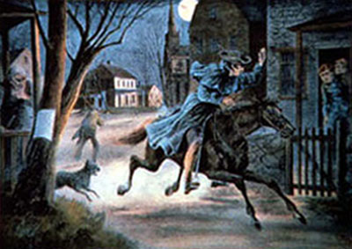](https://www.google.com/url?sa=i&rct=j&q=&esrc=s&source=images&cd=&cad=rja&uact=8&ved=0ahUKEwiWpsmPlI7TAhVB4yYKHdSfAnYQjRwIBw&url=http://www.forbes.com/sites/erikkain/2011/06/04/the-sad-defense-of-sarah-palins-botched-history/&psig=AFQjCNFk55gOq9DR9_LP1MgqwYBFKxv_vA&ust=1491510293059987)

In a deposition given by Revere to the Provincial Congress after the Battle of Lexington, he had the following to say of their capture.

*“In an instant I saw four of them, who rode up to me with their pistols in their hands, said ‘G-d d-n you stop. If you go an inch further you are a dead man.’ Immediately Mr. Prescot came up. We attempted to get through them, but they kept before us, and swore if we did not turn into that pasture, they would blow our brains out…….They forced us in. When we had got in, Mr. Prescot said ‘Put on!’ He took to the left, I to the right towards a wood at the bottom of the pasture intending, when I gained that, to jump my Horse and run off afoot. Just as I reached it, out started six officers, seized my bridle, put their pistols to my breast, ordered me to dismount, which I did.”*

Revere was caught. Somehow, in the confusion both Dawes and Prescott managed to escape. Soon after he broke away, Dawes fell off his horse and was unable to continue. Dr. Prescott broke free in the pasture, jumped a fence, and escaped into the woods. He aroused minutemen along the way and arrived in Concord bringing the first news of the British approach.

After questioning Revere, the British led him back to Lexington, refusing to allow him to hold the reins of his horse. In Lexington, the horse left for Revere had the bridle and saddle cut before the British freed him. In the end, it wasn’t important who succeeded in warning the countryside of the British intentions, only that someone did.

Revere served for several years as an officer in the Massachusetts militia.

His military career was somewhat undistinguished and it ended with unsuccessful campaigns against the British in Newport, Rhode Island and the Penobscot Indians.

At the close of the war, Revere resumed his trade of silversmith, which he carried on in connection with a general hardware business. In 1792, he opened a bell and cannon foundry, in the North of Boston.

He was one of the earliest bell casters in America, producing over 900, many that are still being used in churches and courthouses throughout New England. In 1801 Revere became a pioneer in the production of copper plating opening North America’s first copper mill. Copper from his company was used to cover the original wooden dome of the Massachusetts State House in 1802. His company re-coppered the bottom of the frigate Constitution in 1803 just before it went into battle against pirates in Tripoli.

His copper and brass works eventually grew, through sales and corporate merger into a large national corporation, Revere Copper and Brass, Inc. After a life of accomplishments, Paul Revere died on May 10, 1818 at the age of 83.

He is buried along with other Bostonian patriots in the Old Granary Burying Ground.

Longfellow’s poem surely made Paul Revere one of the best known and admired patriots even if he didn’t quite accomplish all for which the poet gave him credit. Nevertheless, Revere was a true patriot as dedicated to the cause of freedom as any of his compatriots.

**Is Your Membership Active? If Not…Reinstate Today!**

**If you forgot to send in your 2017 SAR membership dues, you may reinstate NOW…**

**But Don’t wait….Mail** your $75 annual membership fee to ***SAR PB Chapter, PO Box 16735 West Palm Beach, FL 33416-6735*** along with any changes to your personal contact information.

***Remember*….Your** membership dues and additional donations fund the many Chapter civic activities including **Scholarships**, ***Boy Scout & JROTC medals, Rumbaugh & Knight Essay Youth contests, Police-Firefighter-EMT awards, Flag Certificates, Americanism, & Community programs.***

***-Chapter March Meeting Pictures-***

**President Lanman with Past Presidents & Patriot Medal Recipients**

**Ed Buckley & Jim Blackburn**

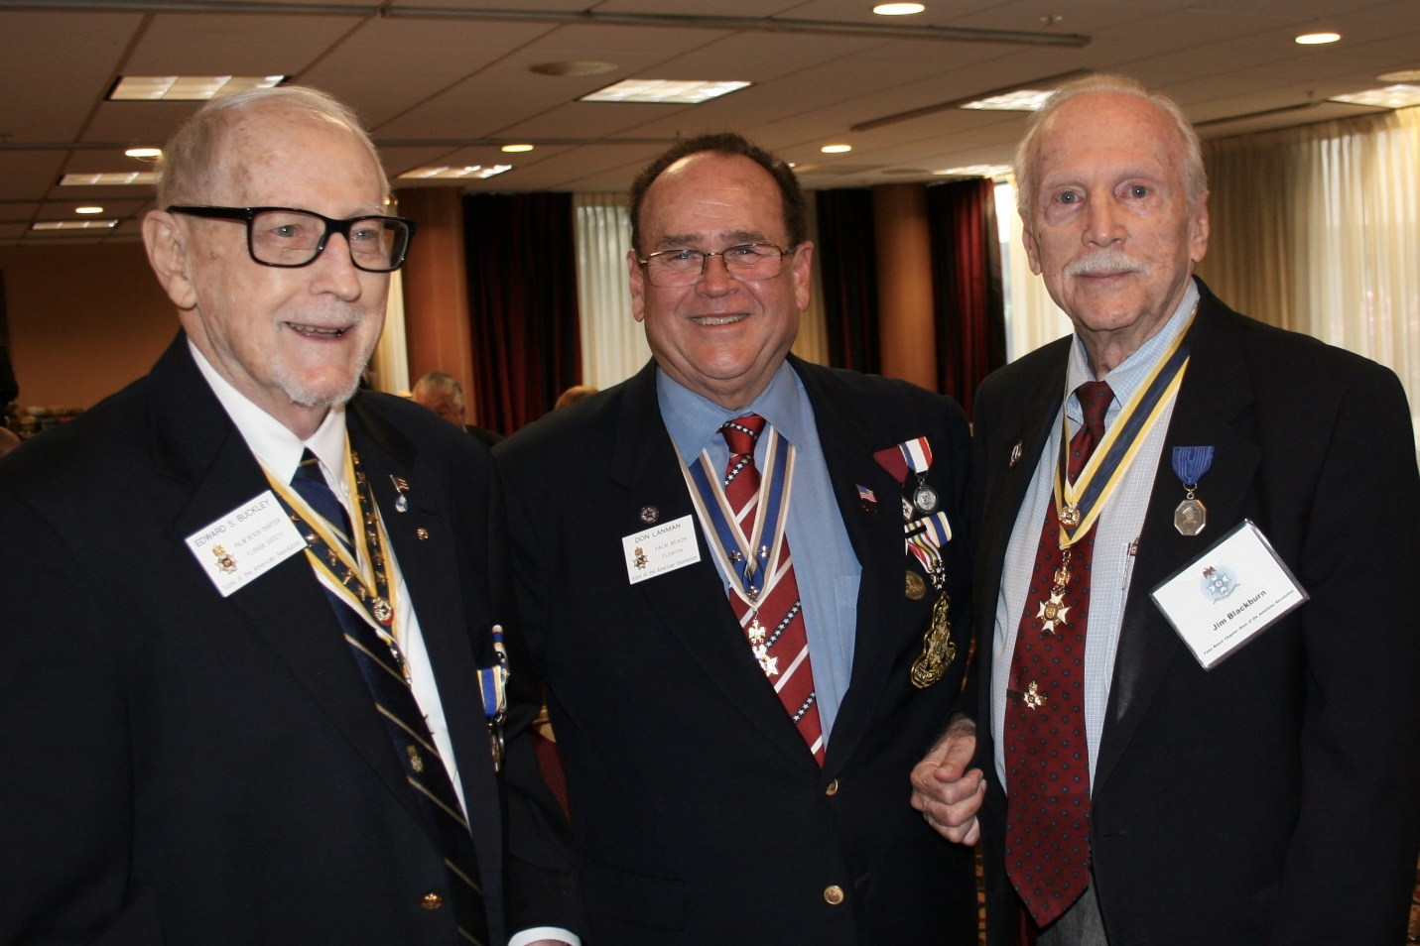

***President Lanman Honors Past President Ed Buckly with custom***

***Chapter Commemorative Challenge Coin as Wife Joan looks on***

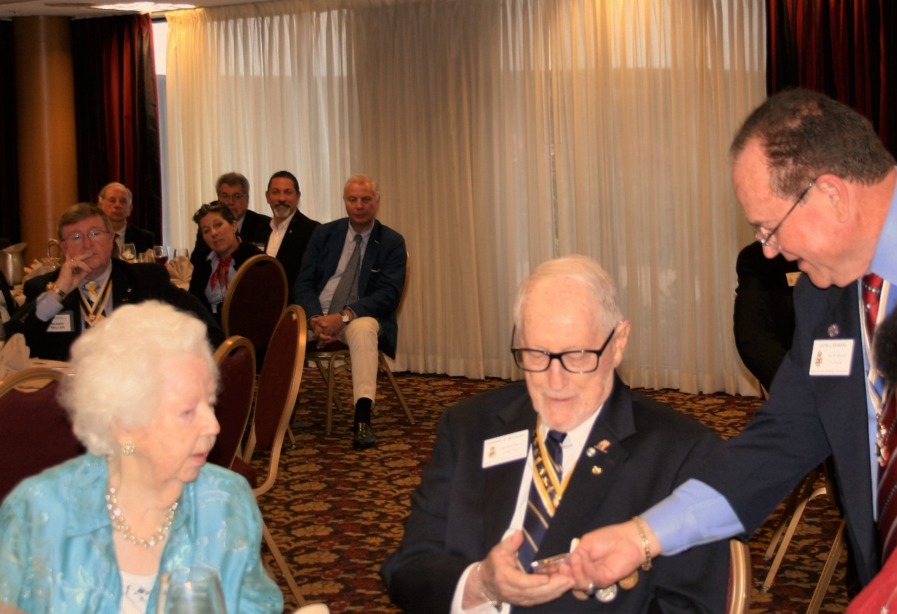

**Lanman presents speaker Jim Garber with Certificate of Appreciation**

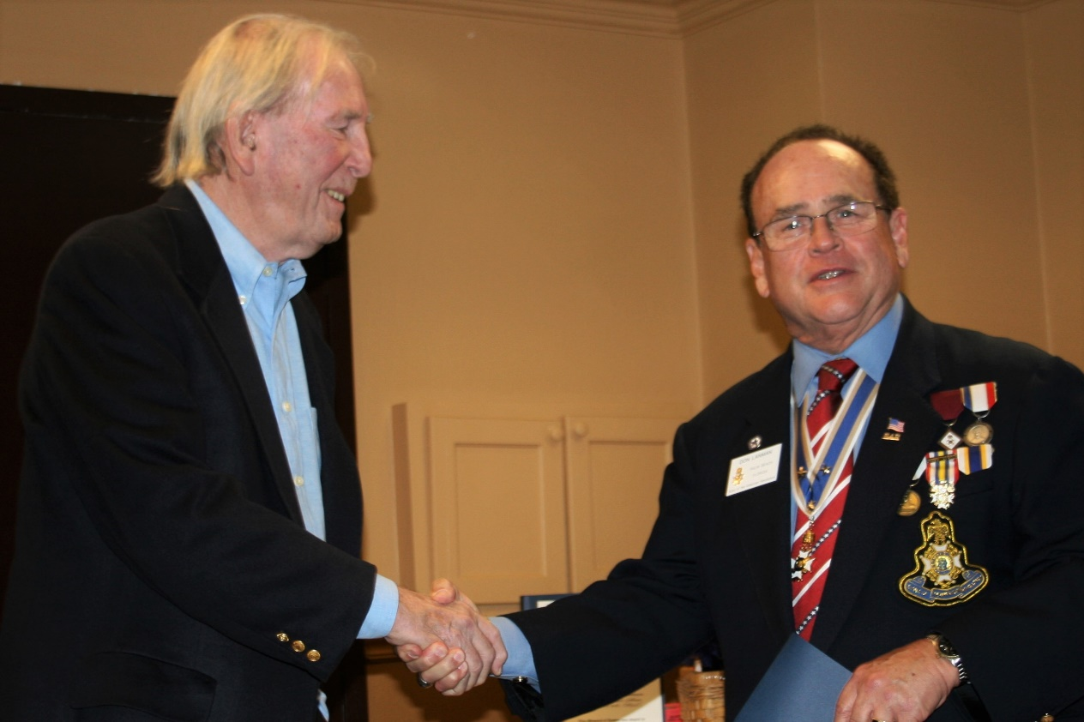

**President Lanman presents Memorial Certificate**

**to Mrs. Burkhardt in honor of dear departed**

**Compatriot Henry Michael Burkhardt**

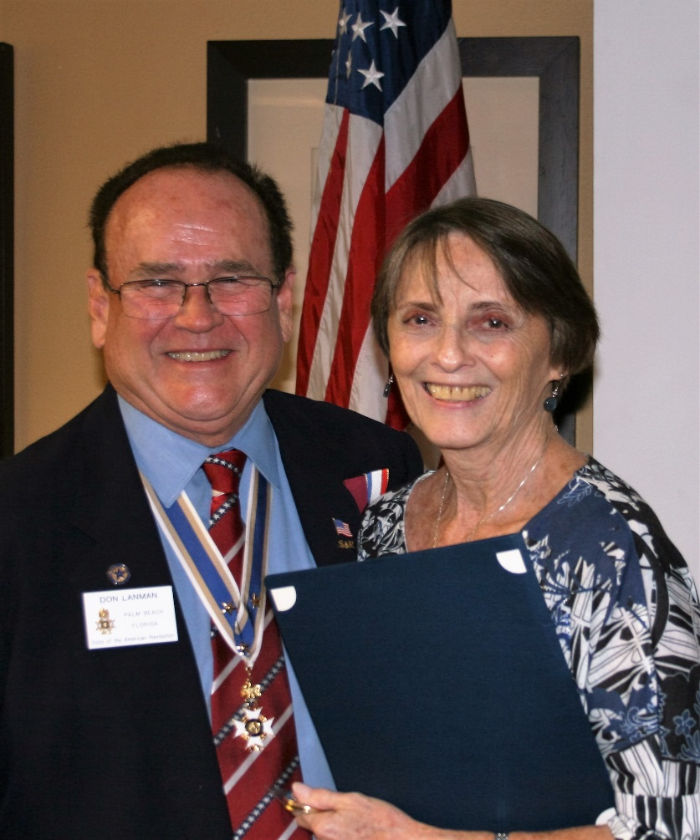

**Sgt. @ Arms Davey presents Raffle Basket to**

**Winner Mrs. Burkhardt as Son Vince looks on**

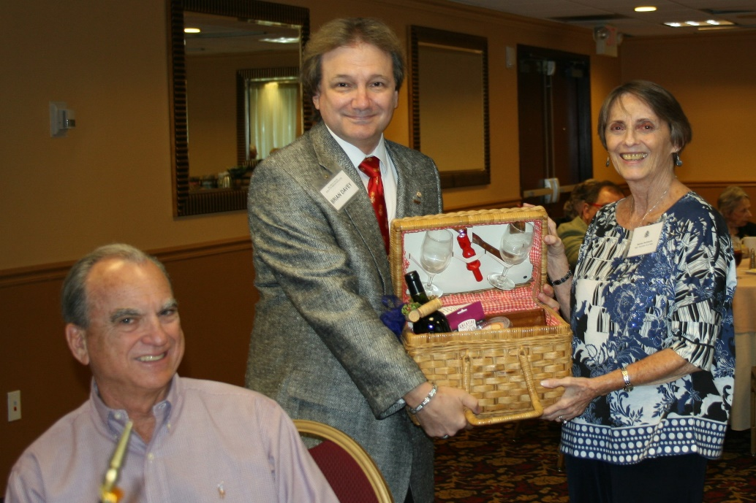

**Custom Palm Beach Chapter 80th Anniversary Commemorative Challenge Coin**

**Available for $10 Each**

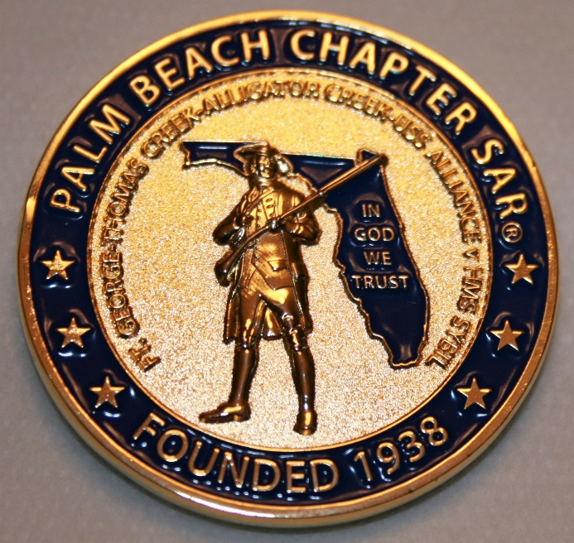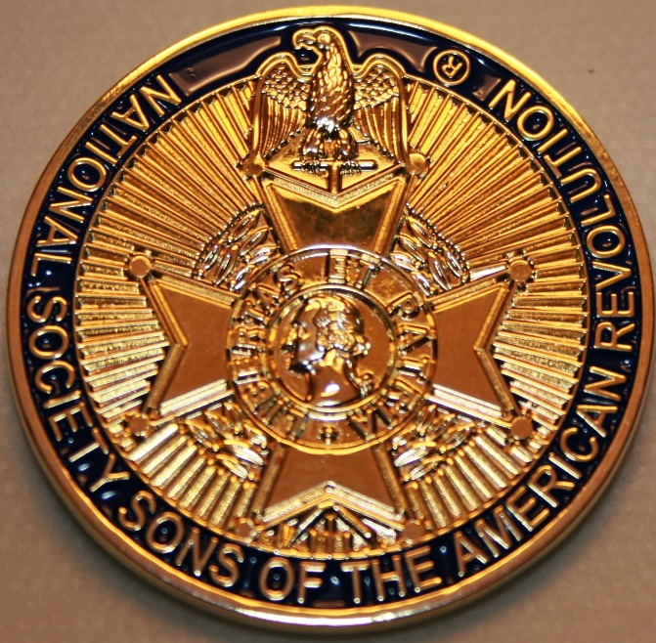

**-Compatriot Sponsored Promotions-**

**Compatriot sponsored newsletter Ads are important to the Chapter as they represent additional funds in support of Chapter projects including *Scholarships, Boy Scout & JROTC medals, Rumbaugh & Knight Essay Youth contests, Police-Firefighter-EMT medals, Americanism & community civic programs!***

**Help** your Chapter, sponsor an Ad for **8** issuesat a modest cost: **Business Card $50, Half Page $100, Full Page $250. Your AD donation will also qualify you for a listing in the *Presidents Brigade*. Call Don Lanman 561-315-5073 for information.**

***SPECIAL SPONSORED ADS ON FOLLOWING PAGES…***

***-COMPATRIOT ROBERT BRINCKERHOFF***

***-GARCILASO DE LA VEGA, CHAPTER DAUGHTERS OF THE AMERICAN REVOLUTION***

***-COMPATRIOT ALEXANDER DREYFOOS***

***-Morgan Stanley-***

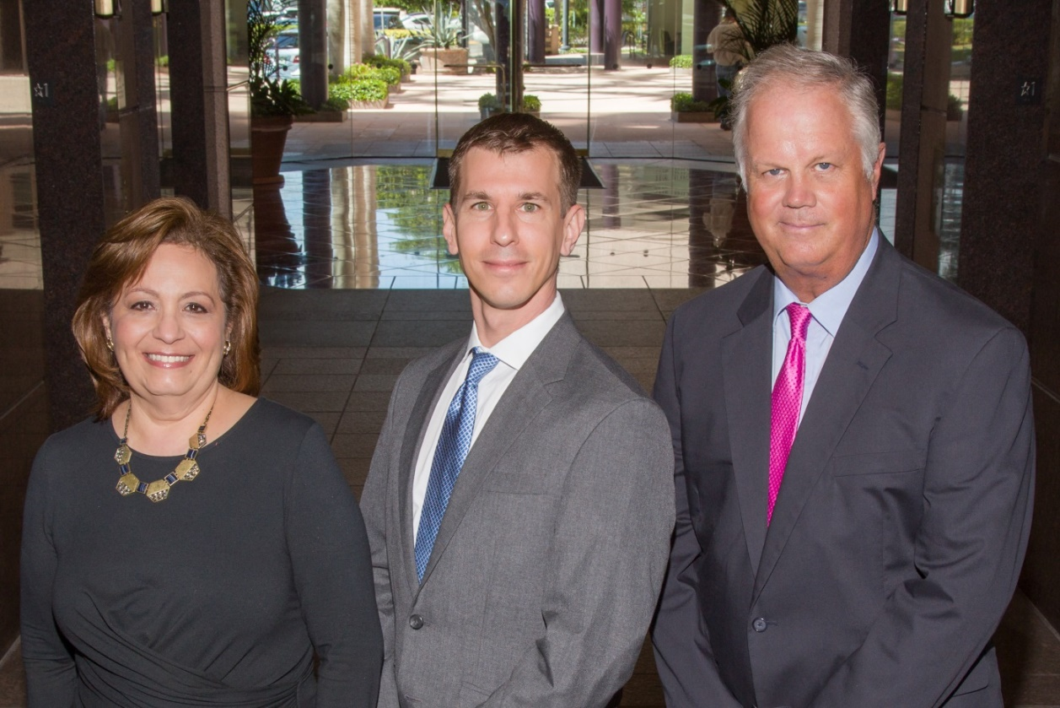  
**Amani Gaballa, Senior Registered Associate; Robert Scarborough, Financial Advisor; Robert Brinckerhoff, First Vice President, Financial Advisor**

***Robert W. Brinckerhoff  
Senior Vice President, Financial Advisor  
777 S. Flagler Dr. Suite 700, East Tower  
West Palm Beach, FL 33401  
(561) 650-7514  
Robert.Brinckerhoff@MorganStanley.com***

***Bob has been a financial advisor since March 1976. He focuses on investment strategies, retirement planning, liquidity solutions for individuals, commercial real estate, and small business owners.***

***Bob is a graduate of the University of Vermont. His clients are geographically diverse and he frequently travels from the east coast to the west to meet with clients. He is active with nonprofit organizations that support the blind and visually impaired. Bob is also an active enthusiast in Ferraris.***

*The investments listed may not be suitable for all investors. Morgan Stanley Smith Barney LLC recommends that investors independently evaluate particular investments and encourages investors to seek the advice of a financial advisor. The appropriateness of a particular investment will depend upon an investor’s individual circumstances and objectives. Morgan Stanley Smith Barney LLC is a registered Broker/Dealer, Member SIPC, and not a bank.*

*Where appropriate, Morgan Stanley Smith Barney LLC has entered into arrangements with banks and other third parties to assist in offering certain banking related products and services. Investment, insurance and annuity products offered through Morgan Stanley Smith Barney LLC are: NOT FDIC INSURED, MAY LOSE VALUE, NOT BANK GUARANTEED, NOT A BANK DEPOSIT, NOT INSURED BY ANY FEDERAL GOVERNMENT AGENCY. Copy write 2015 Morgan Stanley Smith Barney LLC, Member SIPC CRC1355648 11/15.*

*TWO GREAT BOOKS-ONE GREAT MAN*

***-Alexander W. Dreyfoos-***

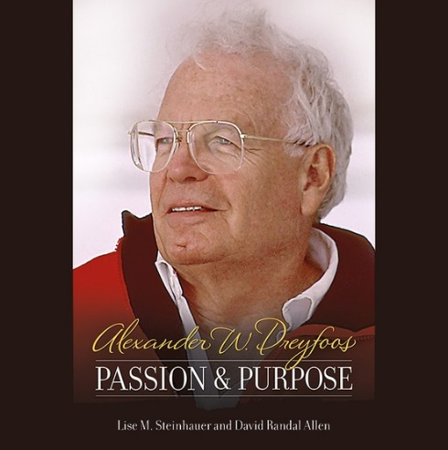

***-A PHOTOGRAPHIC ODYSSEY- -PASSION & PURPOSE-***

***Compatriot Alexander W Dreyfoos, Jr.*** an honored member of the *Palm Beach Chapter Sons of the American Revolution*, noted American entrepreneur, and philanthropist has published two remarkable books that should be on every bookshelf. **Book sales** **proceeds** **donated to local West Palm Beach charities!**

* ***Passion & Purpose*** chronicles a remarkable lifetime of passion with photography, his business, inventions and philanthropic ventures, as well as his adventures above and below the water. **$29.95.**
* ***A Photographic Odyssey*** is a remarkable collection of hundreds of stunning pictures from 100,000 photos taken by Alex around the world and bound in an elegant 15” by 10” glossy photographic book. You will travel with Alex around the world, above and below the water, to forests, jungles, glaciers, and deserts in the exotic locals of Papua New Guinea, Bhutan, Nepal, China, Japan, and Tibet. The subjects are very divergent contrasting palaces and temples with the vulnerability of people, animals, and exotic scenery. **$60.00.**
* **Support your Chapter & local charities! Get both books, *Passion & Purpose & A Photographic Odyssey,* just $71.96 @ kravis.org/books or Call 561-651-4329.**

***-Alexander W. Dreyfoos-***

*Graduating from MIT and Harvard Business School, Alex founded Photo Electronics Corporation (PCS), specializing in photography and video production. Over the decades, Alex earned 10 US patents and invented the Video Color Negative Analyzer for motion pictures earning him an Academy Award for technical achievement.Many inventions, developed by PCS, are on permanent display at the Smithsonian Institution. Locally Alex also owned television station WPEC TV-12, the CBS affiliate in West Palm Beach. Alex’s many philanthropic achievements include founding the Palm Beach County Cultural Council, the Raymond F. Kravis Center for the Performing Arts and gifting a million dollars to the Dreyfoos School of the Arts. Alex also donated a million dollars each to the Palm Beach County biomedical research campus of the Scripps Research Institute and the local Max Planck Florida Foundation for Neuroscience in Jupiter, Florida.*

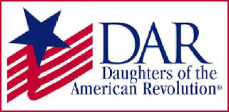

*Garcilaso de la Vega Chapter, NSDAR*

*Lake Worth, Florida*

*Sheila Zile-Pecoraro, Regent*

*Judy Mahaffey,* Registrar

Phone; 561-876-9520-Email; [Smileson@AOL.com](mailto:Smileson@AOL.com)

Chapter Email: [GarcilasodelaVegaDAR@gmail.com](mailto:GarcilasodelaVegaDAR@gmail.com)

Visit us on ***Facebook*** @ <https://www.facebook.com/LWDAR>