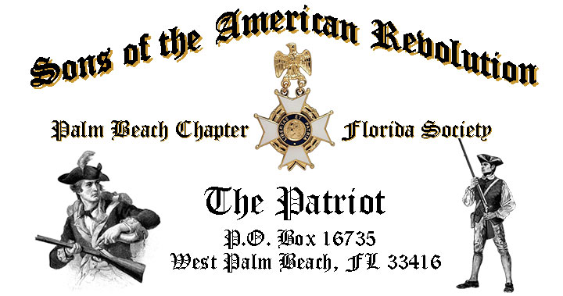

***Volume 24 April 2018 Number 04***

***Join us for the Annual “Thin Blue Line* *Recognition & Awards Ceremony”***, ***in Honor of our local Law Enforcement Professionals,*** Tuesday **April 17** @ **12 Noon** @ the *Embassy Suites Hotel* 1601 Belvedere Road, WPB! ***RSVP Today for this moving Ceremony!***

***April 17 Meeting Event Highlights…***

* ***“Thin Blue Line* *Recognition & Awards Ceremony”***, ***Honoring Our Local Law Enforcement Professionals***
* ***4-Course Buffet Lunch, 2-Special Desserts & Beverages***
* ***$28 per person Check/Cash at the Door***
* ***Reservations*** **Required,** **RSVP**, **Ben Tidwell** **(561)-704-9918!**
* **Family, Friends & Guests** **are always** ***Welcome***!

***Newsletter Content:***

* **President’s** **Message**
* **2018 Officers & Board Members**
* **2018 Chapter Meeting Dates &Topics**
* ***President’s Brigade* Financial Supporters**
* **Committees, Chairmen & Members**
* **National/State/Chapter, News & Events**
* **Feature Articles: *Inspiration for America- One People, One Nation, One God***
  + - * ***Battle of Thomas Creek-Jacksonville Florida***
* **Pictures-Meetings** **& Even**ts
* **Compatriot Sponsored Promotions**

***President’s Message:***

***Fellow Compatriots & Friends…***

As your President, I am overwhelmed with the support of our team of officers this year. Not one *Compatriot* has said no, when asked to step up and be counted. It makes this job and any job so much more rewarding with the support of a great staff. However, there’s still work to be done, so if you are interested in working with our staff as a Committee Chair or on a committee please contact me.

The April meeting will feature a ***Cadet Color Guard*** from ***Lake Worth High School Air Force JROTC*** to kick off our annual ***“Thin Blue Line Recognition & Awards Ceremony”*** in *Honor* of our *Local Law Enforcement Professionals*.

We’ll share stories of *dedication, heroism* and *community* service, and recognize Officers from several local cities in *Palm Beach County* with the prestigious ***SAR Law Enforcement Commendation Medal***.

[](https://www.google.com/url?sa=i&rct=j&q=&esrc=s&source=images&cd=&cad=rja&uact=8&ved=2ahUKEwi7gJnN757aAhXC51MKHTcyACgQjRx6BAgAEAU&url=https://delmarvasupportslawenforcement.blogspot.com/2016/07/its-that-time-of-year-again-thank.html&psig=AOvVaw1dIME00bzJCTifYPT_6CF7&ust=1522870758572518) 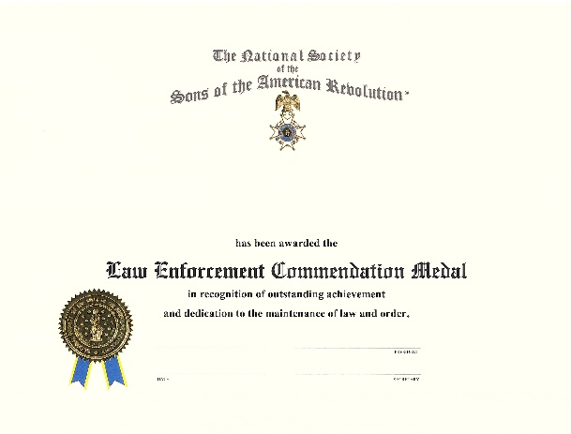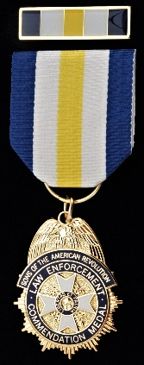

Our March guest speaker, *Former Chapter President, Don Lanman,* took us on a revealing journey on the history, impact, value and immense importance of the ***400+*** ***Lineage Societies*** to our Nation including the ***SAR, DAR, Society of the Cincinnati,*** and ***Illegitimate Sons/Daughters of the Kings of Britain.***

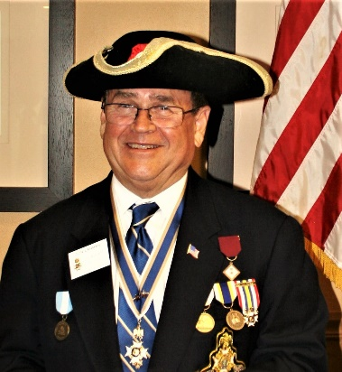 [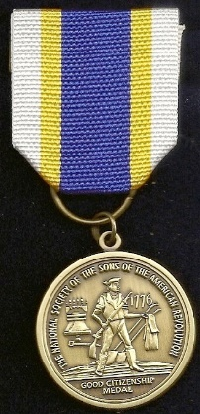](https://www.google.com/url?sa=i&rct=j&q=&esrc=s&source=images&cd=&cad=rja&uact=8&ved=2ahUKEwill4bA9Z7aAhWN7FMKHR1AAAwQjRx6BAgAEAU&url=http://www.thewelloflivingwater.com/Patriot/index.php?id%3Dbio.&psig=AOvVaw0JOtlzWTx0x2QP6pSBpuPf&ust=1522872807458024)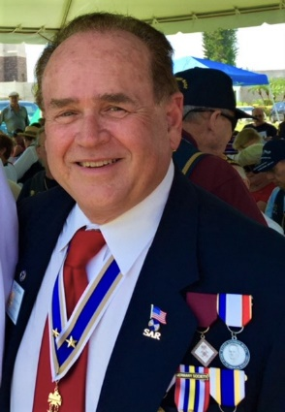

*President Tidwell* presented the prestigious ***SAR Chapter’s Bronze*** and ***State Societies Silver ‘Good Citizenship’ Medals*** to *Former Chapter President****, Don Lanman***in recognition of a long history of civic, community and national service on over ten community, civic and philanthropic boards over the past 8 years including the ***Palm Beach State College Foundation***, ***Florida Veterans Foundation***, ***Red Cross*** and national ***Aneurysm Outreach Association***.

High School Honor student ***Evan Alexander Sanchez*** delivered his informative and interesting essay on the 1780 ***Battle of Springfield***, NJ that won him the Chapter’s ***2018 George & Stella Knight Essay*** contest. *Evan* earned the Knight Essay Medal along with an education donation from the Chapter. *Evan* will go to represent our Chapter at the SAR State and perhaps the National essay contests.

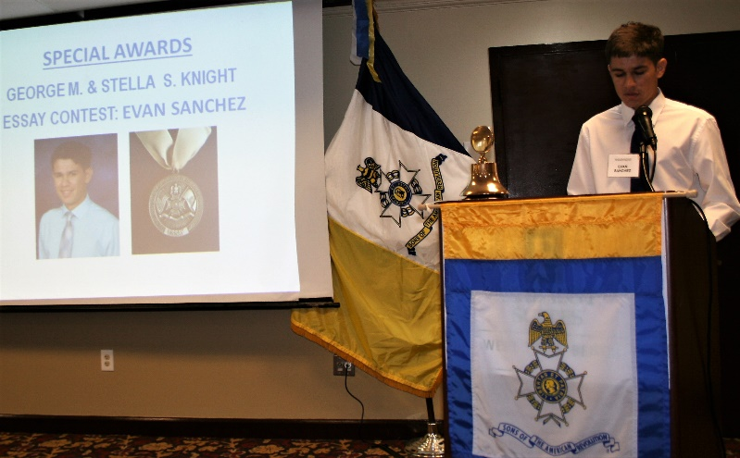

Compatriots are encouraged to recommend essay candidates for both the Knight Essay and Rumbaugh Oration contests, assist on the essay committee and provide donations for the essay medals and cash awards.

Compatriots ***Peter Miller*** and ***Richard Linn*** were presented with the ***SAR Military Service Medal*** and welcomed into the***State SAR* *Veterans Battalion*** and the ***Chapter’s Own*** **“*Band of Brothers***.

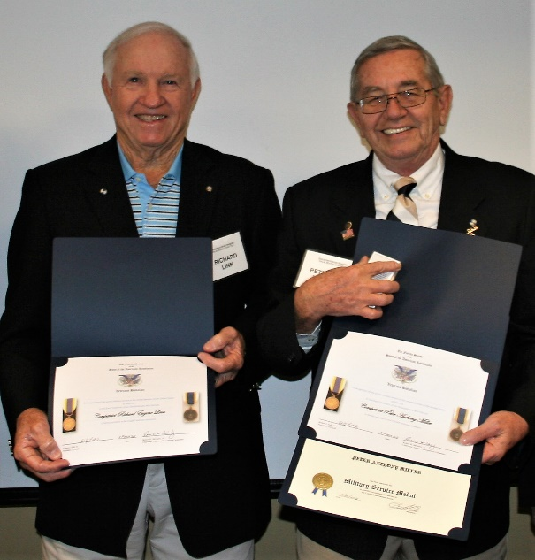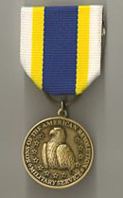

All *Compatriot Veterans* are encouraged to be recognized with the ***SAR Military Service or War Service Medals*.** Provide us a copy of your ***DD-214*** and join the 15% of our members who have served our Nation honorably from *WW II to Iraq*.

*Compatriots* *Tidwell*, *Lanman* and *Barber* represented the Chapter at several events and patriotic functions in *March* including the *Last Naval Battle* ceremony, *DAR State Conference*, *JROTC* Medal presentations, *Vietnam Veterans Day* and greetings to *DAR Chapter* meetings.

Compatriots are encouraged to attend meetings, events and patriotic functions. April events include the annual *Thomas Creek Battle* ceremony (Jacksonville 4/7), *Missing in America Veterans* ceremony (WPB 4/14), Chapter meeting (4/17).



***Ask what You can do for your Chapter***….***Volunteer Today…Will You?*** We need some help on committees supporting our youth and civic programs including ***Historical Oration, Knight Essay, Historical Poster*** and ***Brochure*** contests***, American History Teacher of the Year, Boy Scouts, JROTC, Police-Firefighter-EMS* recognition**and ***Veterans*** supportprograms*.*

***Grow Chapter Membership***! The Chapter goal for 2018 is 200 members and you can help by recruiting sons, relatives and friends interested in patriotism, good fellowship and honoring our patriot ancestors.

***Start Today***, by enrolling your *Sons* and *Grandsons* and encourage wives, daughters, and granddaughters to join the *Daughters of the American Revolution, Children of the Revolution* and the *Chapter Women’s Auxiliary*.

***Thank you DAR!*** Our beloved ***DAR Patriot Daughters*** are always welcome at all Chapter meetings and events, and we sincerely appreciate their tireless efforts with new SAR member referrals and related support. Compatriots are asked to actively support our local *DAR* Chapters by attending their fundraising and patriotic events and meetings.

***Chapter Financials***, Compatriots, please help your chapter from losing money on our meeting luncheons by **attending** each meeting and **bringing** family members and guests.

**Remember** the Hotel requires a minimum number of guests to cover the food, room, and services fees, so when attendance is below 40 or if there are no shows, your **Chapter must pay the difference**.

*Compatriots*, I look forward to seeing you at the *April 17* meeting! Please, join me remembering our Patriot Ancestors, departed Compatriots and especially our nation’s Veterans. ***God Bless You*** and ***God Bless the United States of America.***

***Yours In Patriotism*** **– *Benjamin F. Tidwell III***

*** Hear Ye-Hear Ye…..Chapter Editorial***

***~LIBERTAS ET PATRIA~***

***~LIBERTY & COUNTRY~***

***Fellow Compatriots, Friends & Veteran Supporters,***

|  |
| --- |
|  |

You are cordially invited to join me and fellow *Chapter Patriots* for the *Missing in America Call to Honor* to lay at rest the unclaimed remains of 25 of our nation's forgotten Veterans with full Military Honors.

The 25 Veterans being interred served in the *US Army, Marine Corps., Navy* and *Air Force, serving in World War II, Korea,* and *Vietnam*. Several Veterans being interred laid unclaimed since 1988.

The MIA event is scheduled for *Saturday April 14, 2018* @ 11AM @ the South Florida National Cemetery. **No** *RSVP* needed.Call me if you have questions.

***~MISSING IN AMERICA PROJECT – FLORIDA CALL TO HONOR~***

***~MISSION STATEMENT***~

***The mission of the Missing in America Project (MIAP) is to locate, identify and inter the unclaimed cremated remains of American Veterans through the joint efforts of private, state and federal organizations, and to provide honor, respect and dignity to those who have served this country by securing a final resting place for these forgotten heroes.***

Compatriots…stand up, join in and participate in *Chapter* activities including *DAR* programs and patriotic events like *SAR ceremonies*, *MIA*, *Memorial Day, Honor Flights, Flag Day, July 4th, Veterans Day* and others.

Encourage and support our Chapter leadership with their responsibilities, but don’t wait to be asked…just ask what -You can do to help. ***God Bless You*** and ***God Bless the United States of America.***

***~In Heartfelt Comradeship & Patriotism******- D. Lanman, Editor***

***2018 Chapter Meeting Dates/Topics:***

**Visit** the Palm Beach Chapter web site @ [www.sarpbchapter.org](http://www.sarpbchapter.org) for a meeting calendar, special events, articles, pictures, and general information.

* **April 17, 2018**, ***Law Enforcement Awards Ceremony***
* **May 15,2018, *Firefighters/EMT Awards Ceremony***
* **Oct. 16, 2018**, ***Special Guest Speaker***
* **Nov. 20, 2018**, ***Special Guest Speaker***
* **Dec. 8, 2018**, ***80th Anniversary &*** ***Christmas-Holiday Event***

***2018 Officers & Board:***

* ***President******Benjamin Franklin Tidwell III***
* ***Vice President******Robert Boggs***
* ***Secretary******Gary Green***
* ***Treasurer******Peter Johnston***
* ***Registrar******Robert Boggs***
* ***Chaplain******Father Sanford Sears***
* ***Sgt. @ Arms Peter Miller***
* ***Historian******Samuel “Buddy” Miller***
* ***Officer @ Large******Sonny Barber***
* ***Patriot Newsletter Editor******Donald Lanman***

***Join the President’s Brigade…***

***Support Scholarship & Youth Programs:***

The Chapter has authorized ***$1,000***Scholarship to the ***Palm Beach Atlantic University*** again for ***2018***. This university educates our youth on the values of God and Country and help develop character for the leaders of tomorrow.

Help us increase the scholarship grant amount this year to ***$4,000****! W*e respectfully ask all Compatriots to consider donating a few dollars to the ***Presidents Brigade*** to grow the scholarship fund in support of these students of character.

The Chapter honors and expresses its sincere appreciation to the Compatriots of the ***President’s Brigade*** who support the scholarship and youth programs.

The dedicated members of the ***President’s Brigade*** donate “extra dollars” in support of the Chapter’s many youth programs, scholarships, civic activities, award certificates, police/firefighter/EMT medals, veterans’ projects, and related community civic programs.

***Honored Presidents Brigade Members*:**

* **Bronze Level: $25-$99:**

***M. Anderson, J. Blackburn, B. Boggs, J. Chataing, A. Cass, C. Coldwell, D. Coldwell, M. Curry, S. Curry, J. Damron, J. Dorsey, W. Davis, F. Devitt, J. Harper, J. Kane, L. Lassitter, P. Miller, S. Miller, J. Mayne, G. Parkinson, H. Oyer, J. Porter, S. Sears, A. Shea, W. Told, J. Wearn, L Watkins***

* **Silver Level: $100-$199:**

***J. Curry, R. Culpepper, T. Friend, G. Green, F. Green, A. Griswold, W. Johnson, D. Shepherd, S. McWhorter***

* **Gold Level: $200-$499:**

***R. Brinckerhoff, S. Barber, R. Banta , E. Buckley, J. Curry, S. Hitt, W. Meakin, J. Wynns***

* **Platinum Level: $500+**

1. ***Dreyfoos, B. Tidwell, D. Lanman, K. Christie***

***Committees, Chairs & Members:***

***Fellow Compatriots…..***The Chapter expresses its sincere appreciation to those members who volunteer to serve on our committees and projects. As you can see a few Compatriots are serving on multiple committees and could use some extra support! **Please** select a committee of interest for ***2018*** to help on any of the chapter committees listed. It doesn’t take much time and is a major help with our many civic and youth initiatives. **Call Ben Tidwell (561-704-9918) or Bob Boggs (561-241-3128)**-**Today** to lend a hand on any of these committees.

* ***2019 Officer Nominations -All Chapter Members***
* ***80th Anniversary -Lanman, Tidwell, Officers***
* ***JROTC & Boy Scouts -Barber, Tidwell***
* ***Law Enforcement-Fire Safety -Parkinson, Green***
* ***Veterans Affairs -Lanman, Curry***
* ***Newsletter/Publicity -Lanman***
* ***Knight Essay/Rumbaugh Oration -Boggs***
* ***American History Teacher -Boggs***
* ***Medals/Awards -Lanman, Tidwell***
* ***DAR Liaison -Lanman, Tidwell***
* ***Speakers Bureau -Lanman, Tidwell***
* ***Audit -Coldwell, Lanman***
* ***Flag Certificates -Miller, Johnston***
* ***Membership Development -Green, Boggs, Tidwell***
* ***Liberty Tree -Chapter Officers***
* ***Patriot Bios -Miller***
* ***Web Site-Facebook/Social Media -Anderson***

**Palm Beach Chapter 80th Year Commemorative Coin $10!**

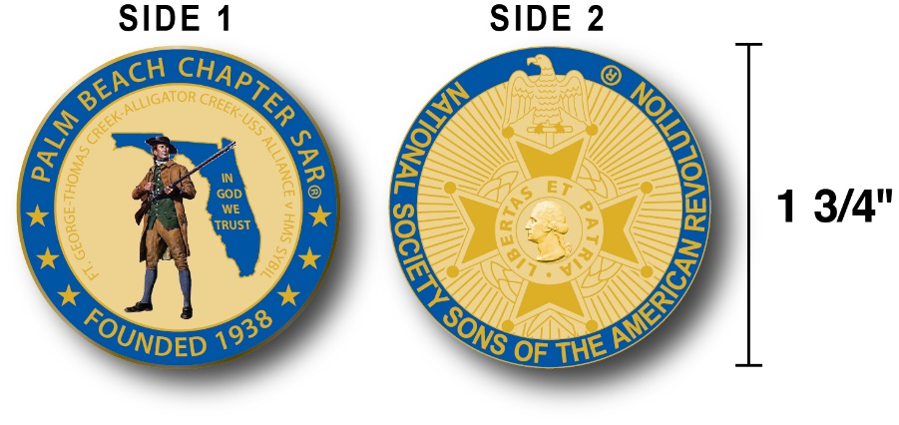

The Chapter created a custom bronze *Commemorative Anniversary Coin* honoring the founding of the ***Palm Beach Chapter* in *1938*** and celebrating its 80 years of historic, patriotic, and civic service in Palm Beach County and Florida.

The beautiful collector’s coin is highlighted in ***George Washington*** ***military blue*** on a stunning ***Gold*** background. Side-one is personalized for our Chapter with the founding date, *Patriot* *Minuteman* guarding *Florida* with the *Florida State* motto ***"In God We Trust”.***

The collector’s coin includes an inscription listing the four major Revolutionary War battles waged in *Florida* including the battles of:

***Ft. George-Pensacola, Thomas Creek Massacre, Alligator Creek Battle,*** and the ***Last Naval Battle* of the Revolutionary War** between the ***USS Alliance*** & ***HMS Sybil.***

Side-two displays the national ***NSSAR*** ***Cross of Malta***.  Very impressive indeed!

The custom bronze ***Commemorative Anniversary Coin*** is designed to celebrate our founding in **1938**, create a distinctive and impressive image for our Chapter and be used as a token of appreciation for honored guests, speakers, and as special awards.

***Purchase this unique Commemorative collector coin for just $10.***

***Classy SAR Lapel Pins $10:***

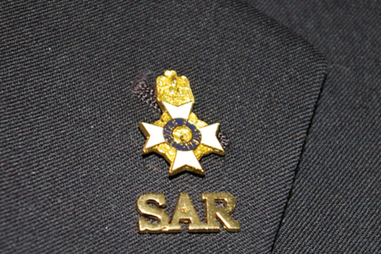

Display a ***Gold*** ***SAR*** pin on your suit lapel or shirt with the ***SAR Rosette***. The SAR Lapel Pin is part of a national branding program to help promote the S.A.R. and stimulate new membership!

The striking lapel pin is a recognizable public symbol of the SAR, provides you recognition as a member of this great society, and will spark conversations about SAR that leads to a new member.

The gold lapel pin and SAR Rosette create a professional image that will improve overall SAR name recognition. The Chapter has a supply of pins for Compatriots for just $10. ***Show Chapter Spirit….*Get your Gold SAR Pin today**!

***SAR Chapter, State & National Events:***

**-*CHAPTER/STATE*:**

***Join Chapter members presenting an Honor Wreaths at the SAR Thomas Creek Battle, Jacksonville, FL, 4/7. MIA Event 4/14, State Board of Management conference 5/18-19. See Ben Tidwell/Don Lanman for details.***

***DON’T MISS THE 2018 SAR NATIONAL CONGRESS***

***The 128th SAR Congress is scheduled for July 12-19 in Houston, Texas. Hotel registration is open now at a special SAR price of $159.00 per night King or 2-Queens.***

***Reservations can be made by calling the Westin Memorial City Hotel @ 1-800-937-8461 or online @*** [***www.starwoodmeeting.com/book/nssar2018***](http://www.starwoodmeeting.com/book/nssar2018)***. Questions contact Paul Callanan @*** [***LTCMRSC@aol.com***](mailto:LTCMRSC@aol.com) ***or 906-273-2424.***

***Feature Articles:***

***“Inspiration for America”***

***One Nation, One People, One God!***

***Compiled & Edited by Palm Beach Chapter SAR Former President Don Lanman***

***George Washington:***  
   
**“O eternal and everlasting God, I presume to present myself this morning before thy Divine majesty…**

**Beseeching thee to accept of my humble and hearty thanks, that it hath pleased thy great goodness to keep and preserve me the night past from all the dangers poor mortals are subject to, and has given me sweet and pleasant sleep, whereby I find my body refreshed and comforted for performing the duties of this day, in which I beseech thee to defend me from all perils of body and soul....**

**Increase my faith in the sweet promises of the gospel; give me repentance from dead works; pardon my wanderings, and direct my thoughts unto thyself, the God of my salvation…**

**Teach me how to live in thy fear, labor in thy service, and ever to run in the ways of thy commandments; make me always watchful over my heart, that neither the terrors of conscience, the loathing of holy duties, the love of sin, nor an unwillingness to depart this life, may cast me into a spiritual slumber, but daily frame me more and more into the likeness of thy son Jesus Christ, that living in thy fear, and dying in thy favor, I may in thy appointed time attain the resurrection of the just unto eternal life bless my family, friends, and kindred. Amen”**

***Thomas Jefferson:***

**“Almighty God, Who has given us this good land for our heritage; We humbly beseech Thee that we may always prove ourselves a people mindful of Thy favor and glad to do Thy will.**

**Bless our land with honorable ministry, sound learning, and pure manners. Save us from violence, discord, and confusion, from pride and arrogance, and from every evil way.**

**Defend our liberties, and fashion into one united people, the multitude brought hither out of many kindreds and tongues.**

**Endow with Thy spirit of wisdom those whom in Thy name we entrust the authority of government, that there may be justice and peace at home, and that through obedience to Thy law, we may show forth Thy praise among the nations of the earth.**

**In time of prosperity fill our hearts with thankfulness, and in the day of trouble, suffer not our trust in Thee to fail; all of which we ask through Jesus Christ our Lord. Amen.”**

***Franklin D. Roosevelt:***

**“Almighty God: Our sons, pride of our nation, this day have set upon a mighty endeavor, a struggle to preserve our Republic, our religion and our civilization, and to set free a suffering humanity.**

**Lead them straight and true; give strength to their arms, stoutness to their hearts, steadfastness in their faith.**

**They will need Thy blessings. Their road will be long and hard. For the enemy is strong. He may hurl back our forces. Success may not come with rushing speed, but we shall return again and again; and we know by Thy grace, and by the righteousness of our cause, our sons will triumph...**

**Embrace these, Father, and receive them, Thy heroic servants, into Thy kingdom.**

**And for us at home--fathers, mothers, children, wives, sisters, and brothers of brave men overseas, whose thoughts and prayers are ever with them--help us, Almighty God, to rededicate ourselves in renewed faith in Thee in this hour of great sacrifice.**

**Give us strength, too--strength in our daily tasks, to redouble the contributions we make in the physical and the material support of our armed forces.**

**With Thy blessing, we shall prevail over the unholy forces of our enemy. Help us to conquer the apostles of greed and racial arrogances.**

**Lead us to the saving of our country, and with our sister nations into a world unity that will spell a sure peace--a peace invulnerable to the schemings of unworthy men.**

**And a peace that will let all men live in freedom, reaping the just rewards of their honest toil. Amen”**

***Abraham Lincoln:***

**“Dear Lord, Fondly do we hope, fervently do we pray, that this mighty scourge of war may speedily pass away.**

**Yet if God wills that it continues... until every drop of blood drawn with the lash shall be paid another drawn with the sword... so still it must be said that the judgments of the Lord are true and righteous altogether.**

**With malice toward none, with charity for all, with firmness in the right as God gives us to see the right, let us finish the work we are in, to bind up the nation's wounds, to care for him who shall have borne the battle, and for his widow and for his orphans, to do all which may achieve and cherish a just and a lasting peace among ourselves and with all nations. Amen.”**

***Ronald Reagan:***  
  
**“To preserve our blessed land we must look to God... It is time to realize that we need God more than He needs us...**

**We also have His promise that we could take to heart with regard to our country, that "If my people, which are called by my name shall humble themselves, and pray and seek my face, and turn from their wicked ways; then I will hear from heaven and will forgive their sin, and will heal their land.**

**Let us, young and old, join together, as did the First Continental Congress, in the first step, in humble heartfelt prayer.**

**Let us do so for the love of God and His great goodness, in search of His guidance and the grace of repentance, in seeking His blessings,**

**His peace, and the resting of His kind and holy hands on ourselves, our nation, our friends in the defense of freedom, and all mankind, now and always.**

**The time has come to turn to God and reassert our trust in Him for the healing of America...**

**Our country is in need of and ready for a spiritual renewal. Today, we utter no prayer more fervently than the ancient prayer for peace on Earth.**

**If I had a prayer for you today, among those that have all been uttered, it is that one we're so familiar with:**

**"The Lord bless you and keep you; the Lord make His face to shine upon you and be gracious unto you; the Lord lift up His countenance upon you and give you peace...."**

**And God bless you all. Amen.”**

***Bill Clinton:***  
 **“May Those generations whose faces we cannot yet see, whose names we may never know, say of us here that we led our beloved land into a new century with the American Dream alive for all her children;**

**With the American promise of a more perfect union a reality for all her people; with America's bright flame of freedom spreading throughout all the world.**

**From the height of this place and the summit of this century, let us go forth.**

**May God strengthen our hands for the good work ahead--and always, always, bless our America. Amen.”**

***G.W. Bush:***

“**We come before God to pray for the missing and the dead, and for those who love them... On this national day of prayer and remembrance, we ask Almighty God to watch over our nation, and grant us patience and resolve in all that is to come.**

**We pray that He will comfort and console those who now walk in sorrow. We thank Him for each life we now must mourn, and the promise of a life to come.**

**As we have been assured, neither death nor life, nor angels nor principalities nor powers, nor things present nor things to come, nor height nor depth, can separate us from God's love.**

**May He bless the souls of the departed. May He comfort our own. And may He always guide our country. Amen.”**

***SAR Prayer:***

**Our Father in Heaven, we thank Thee for Thy abiding presence in the life of our Country.**

**We thank Thee for all of those yesterdays of our human race whose lessons and fulfillments have become a heritage to us.**

**Continue, we pray, Thy blessings upon this Nation that all who are part of it may learn true nobility of manhood and womanhood.**

**Grant us growth in understanding and increasing devotion to righteousness. In Thy name we pray. Amen.”**

***“Thomas Creek Massacre”***

***Revolutionary War’s Southernmost Battle-May 1777***

**Compiled & written by Former Chapter President Don Lanman**

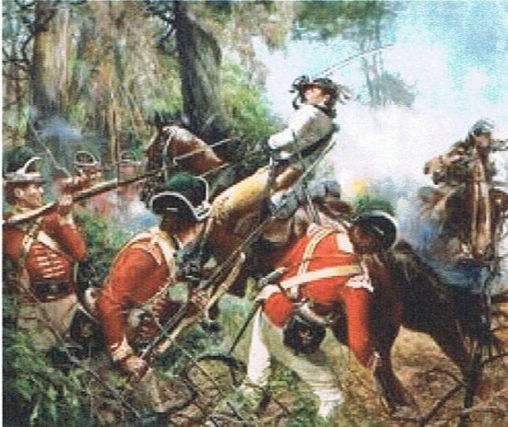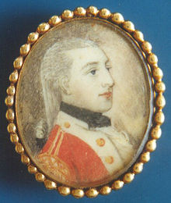

***Lt. Colonel Samuel Elbert*** ***Ambush at Thomas Creek Florida***

**When the American War of Independence began residents of the new British colonies of *Northern Florida* did not seek separation from England as did the 13 colonies.  As a result Florida remained comparatively free of serious fighting throughout the Revolutionary War.**

**However, on May 17th, 1777, Americans initiated a land and sea invasion of East Florida in retaliation for loyalists’ incursions into Georgia and with a goal of capturing *British* held St. Augustine, its fort, port and supplies.**

**The American expedition was composed of 300 Continental Army regulars from the *1st and 2nd Georgia Regiments* commanded by *Lt. Colonel Samuel Elbert* and supported by 100 Georgia militia cavalry led by *Colonel James Baker*.**

**The British East Florida St. Augustine garrison under the command *Brigadier General Augustine Prevost* included battle hardened British Regulars, loyalist rangers, militia cavalry, and local "Creek" Indian allies.**

**The British received advance knowledge of the pending invasion and on May 17th, the land element of the Colonial army was attached by British Regulars commanded by *Major J. M. Prevost* supported by loyalist rangers and Indians commanded by Colonel Thomas Brown.**

**Known as the *"Battle of Thomas Creek",* or the "Thomas Creek Massacre", the battle took place at *Thomas Creek* near the *Nassau River*.  The successful British ambush surprised and routed the Continentals who were outnumbered due to the sea flotilla failing to reach its rendezvous point.**

**After suffering heavy casualties, the American forces, discouraged by the ambush and failure of the flotilla to provide needed troops and supplies, retreated from *Florida*.  In 1778 another Colonial expedition against the East Florida garrison also failed to capture St. Augustine at the *"Battle of Alligator Bridge".***

**While the battles were minor engagements in the scope of the Revolutionary War, the failed attempts to capture St. Augustine prompted the British to send forces from New York, supported by the St. Augustine garrison in December 1778 to capture Savannah and reestablish royal authority in Georgia.**

**Officers and members of the *National, State* and *Palm Beach Chapters* of SAR and DAR attend the annual anniversary of the southernmost battle of the Revolutionary War with dedications at the *“SAR Florida Historical Marker”* at the battle site on the *Seaton Creek Historic Preserve* near Jacksonville, Florida.**

***Note: The Thomas Creek Battle site is located on the Seaton Creek Historic Preserve Park near Jacksonville, Florida. Traveling south on I-95 take Exit 366 heading west 2.5 miles on Pecan Park Road 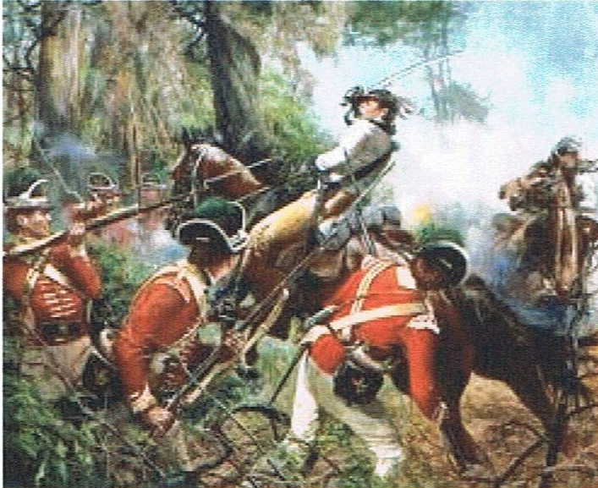to 2145 Arnold Road, Jacksonville, FL (3 miles north of the Jacksonville airport). GPS N30.521109; W81.670325.***

***Keep Your SAR Membership Active!***

**Don’t lose your SAR Membership….Reinstate your membership today by mailing** **your $75** annual membership dues today to ***SAR PB Chapter, PO Box 16735 West Palm Beach, FL 33416-6735! Include*** any changes to your personal contact information.

***Remember*….Your** **membership dues plus any additional donations fund the many Chapter’s youth and civic activities including**:

**Scholarships**, ***Boy Scout & JROTC medals, Rumbaugh & Knight Essay Youth contests, Police-Firefighter-EMT awards, Flag Certificates, Americanism, American History Teacher, Civic & Community programs.***

***~March Meeting & Event Pictures~***

***President Tidwell & VP Boggs present the SAR Chapter’s***

***Bronze & SAR State’s Silver ‘Good Citizenship’ Medals***

***to Former Chapter President Don Lanman***

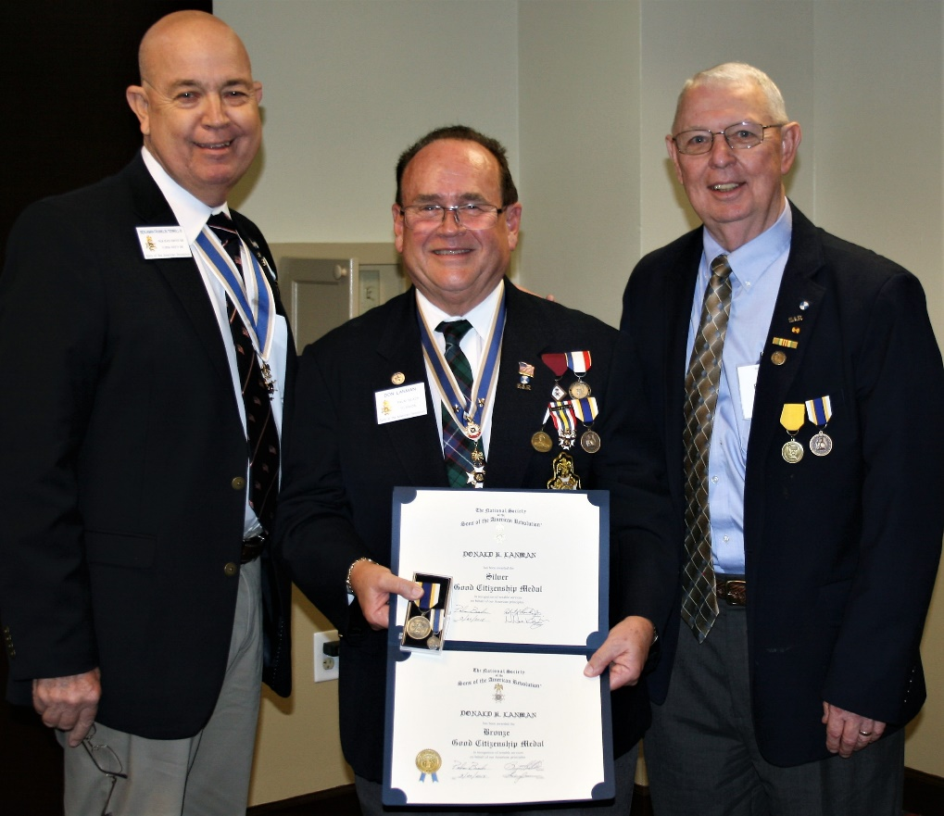

***President Tidwell presents essay contest winner Evan Alexander Sanchez***

***with the Knight Essay Medal, Certificate & Education Donation***

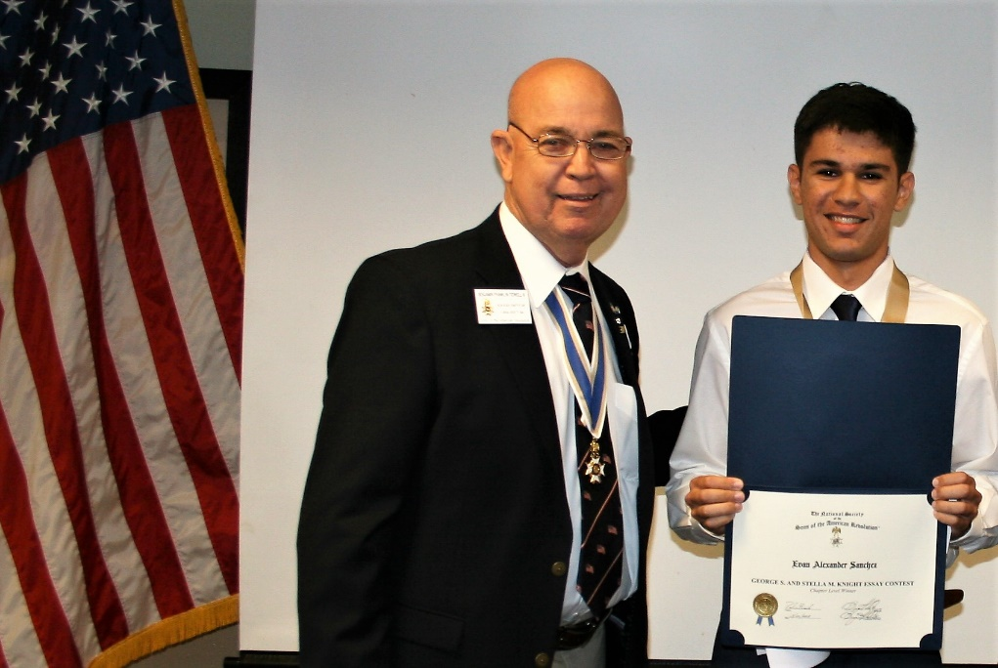

***President Tidwell & Vice President/Registrar Boggs present SAR***

***Military Service Medals & Certificates to Compatriots R. Linn & P. Miller***

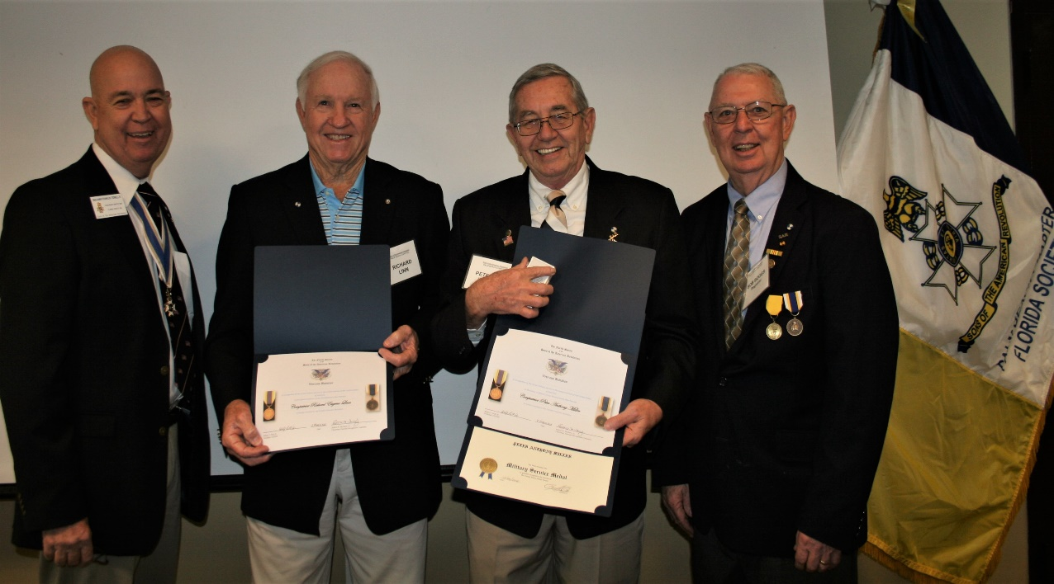

***JROTC Committee Member Compatriot Sonny Barber presents***

***the SAR JROTC Service Medal to Olympic Heights High School***

***JROTC US Marine Cadet LT Alexis Durrance***

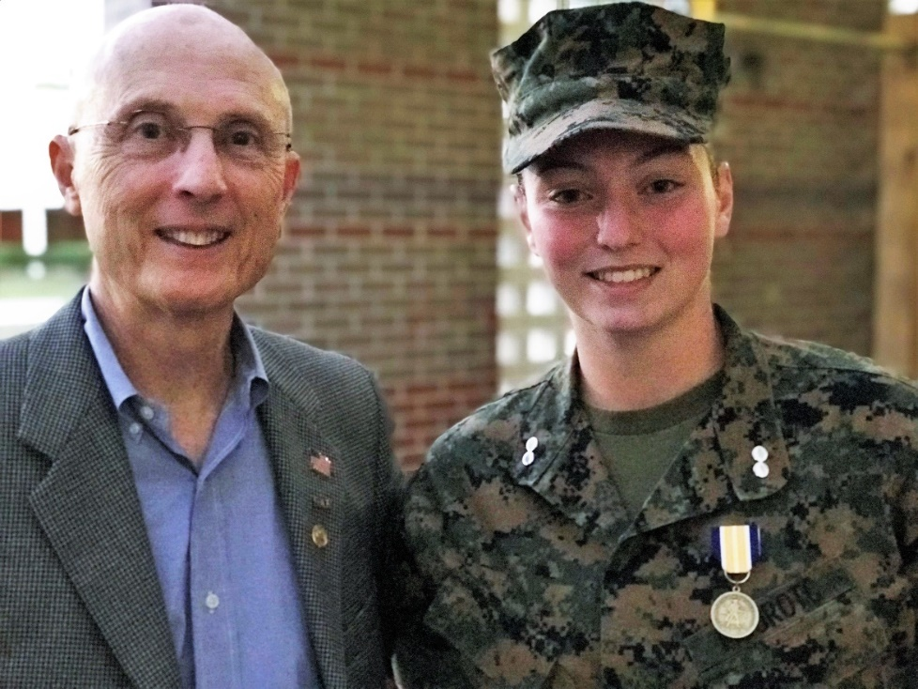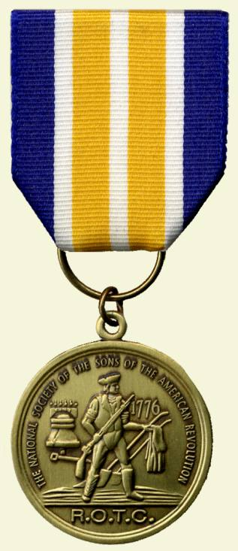

***Former Chapter Presidents Lanman & Stewart joins DAR Daughter***

***& Veteran Gillian Boice recruiting SAR members @ DAR State Conference***

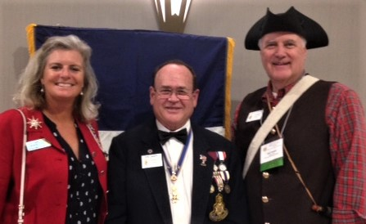

***President Tidwell presents Chapter Honor Wreath & receives***

***event Flag Streamer @ the Last RW Naval Battle Ceremony***

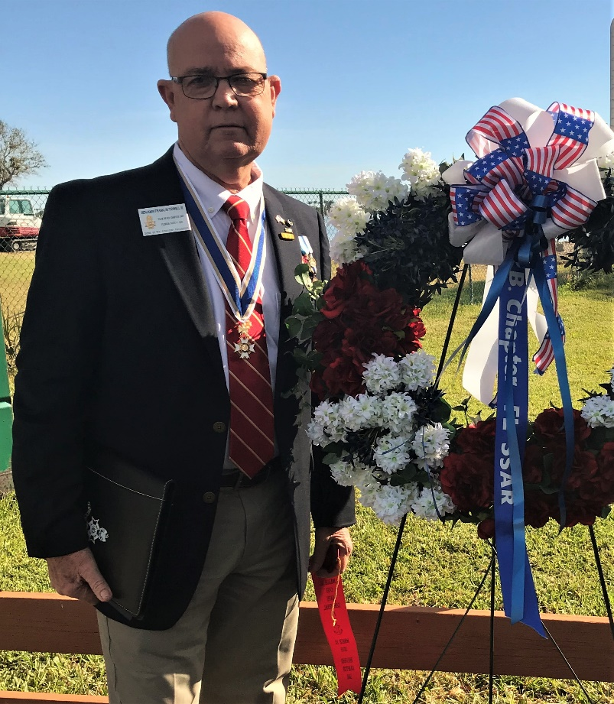

***Compatriots Bill Told & Past President-Patriot Medal Winner***

***Jim Blackburn actively support Palm Beach Chapter projects & programs***

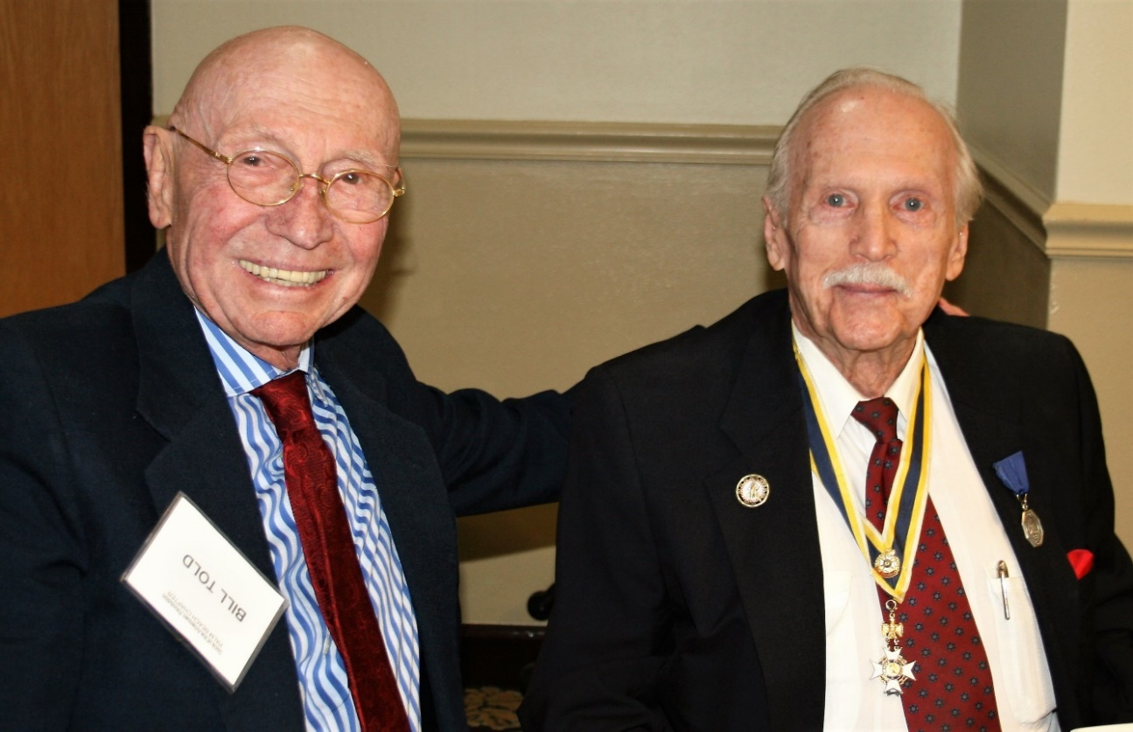

***Sgt. @ Arms Peter Miller delivers raffle basket***

***to basket winner DAR Daughter Kiki Schiller***

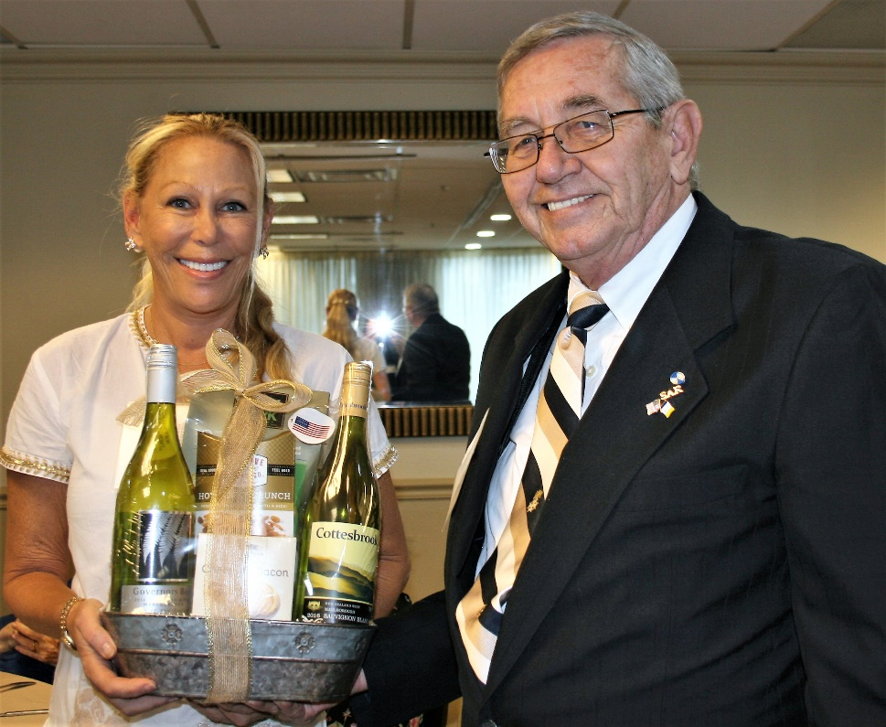

***~80th Anniversary Collectors Commemorative Coin $10.00~***

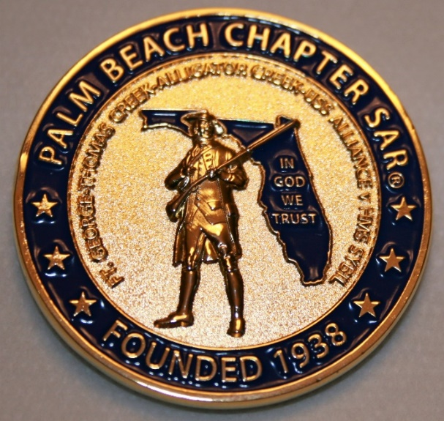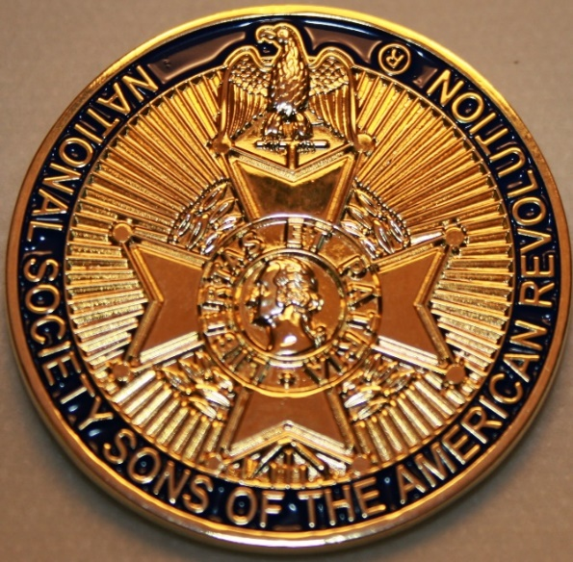

***~Compatriot Sponsored Promotions~***

**Compatriot sponsored newsletter Ads are important to the Chapter as they represent additional funds in support of Chapter projects including;**

***Scholarships, Boy Scout & JROTC medals, Rumbaugh & Knight Essay Youth contests, Police-Firefighter-EMT medals, Americanism & community civic programs!*** Support your Chapter…sponsor an Ad for **8** issuesat a modest cost:

**Business Card $50, Half Page $100, Full Page $250.**

**Your AD donation will also qualify you for the *Presidents Brigade*. Call Don Lanman 561-315-5073 for information.**

***SPECIAL SUPPORT ADS ON FOLLOWING PAGES…***

***~COMPATRIOT ROBERT BRINCKERHOFF***

***~FINANCIAL SERVICES PROFESSIONAL***

***~COMPATRIOT ALEXANDER DREYFOOS***

***~AUTHOR/PHOTOGRPHER/PATRIOT***

***~COMPATRIOT SONNY BARBER***

***~HISTORIAN/AUTHOR/PATRIOT***

***~GARCILASO DE LA VEGA, DAR CHAPTER***

***~DAUGHTERS OF THE AMERICAN REVOLUTION***

***-Morgan Stanley-***

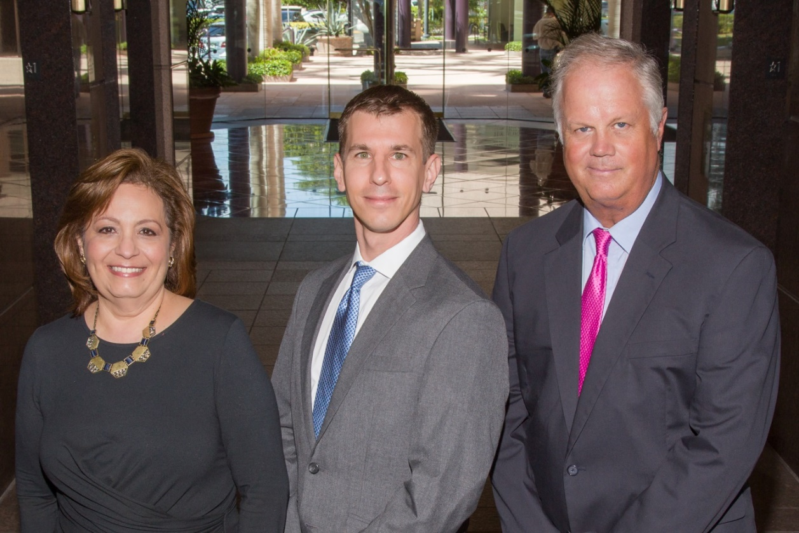  
***Amani Gaballa, Senior Registered Associate; Robert Scarborough, Financial Advisor; Robert Brinckerhoff, First Vice President, Financial Advisor***

***Robert W. Brinckerhoff  
Senior Vice President, Financial Advisor  
777 S. Flagler Dr. Suite 700, East Tower  
West Palm Beach, FL 33401  
(561) 650-7514  
Robert.Brinckerhoff@MorganStanley.com***

***Bob has been a financial advisor since March 1976. He focuses on investment strategies, retirement planning, liquidity solutions for individuals, commercial real estate, and small business owners.***

***Bob is a graduate of the University of Vermont. His clients are geographically diverse and he frequently travels from the east coast to the west to meet with clients. He is active with nonprofit organizations that support the blind and visually impaired. Bob is also an active enthusiast in Ferraris.***

*The investments listed may not be suitable for all investors. Morgan Stanley Smith Barney LLC recommends that investors independently evaluate particular investments and encourages investors to seek the advice of a financial advisor. The appropriateness of a particular investment will depend upon an investor’s individual circumstances and objectives. Morgan Stanley Smith Barney LLC is a registered Broker/Dealer, Member SIPC, and not a bank.*

*Where appropriate, Morgan Stanley Smith Barney LLC has entered into arrangements with banks and other third parties to assist in offering certain banking related products and services. Investment, insurance and annuity products offered through Morgan Stanley Smith Barney LLC are: NOT FDIC INSURED, MAY LOSE VALUE, NOT BANK GUARANTEED, NOT A BANK DEPOSIT, NOT INSURED BY ANY FEDERAL GOVERNMENT AGENCY. Copy write 2015 Morgan Stanley Smith Barney LLC, Member SIPC CRC1355648 11/15.*

*TWO GREAT BOOKS-ONE GREAT MAN*

***-Alexander W. Dreyfoos-***



***-A PHOTOGRAPHIC ODYSSEY- -PASSION & PURPOSE-***

***Compatriot Alexander W Dreyfoos, Jr.*** an honored member of the *Palm Beach Chapter Sons of the American Revolution*, noted American entrepreneur, and philanthropist has published two remarkable books that should be on every bookshelf. **Book sales** **proceeds** **donated to local West Palm Beach charities!**

* ***Passion & Purpose*** chronicles a remarkable lifetime of passion with photography, his business, inventions and philanthropic ventures, as well as his adventures above and below the water. **$29.95.**
* ***A Photographic Odyssey*** is a remarkable collection of hundreds of stunning pictures from 100,000 photos taken by Alex around the world and bound in an elegant 15” by 10” glossy photographic book. You will travel with Alex around the world, above and below the water, to forests, jungles, glaciers, and deserts in the exotic locals of Papua New Guinea, Bhutan, Nepal, China, Japan, and Tibet. The subjects are very divergent contrasting palaces and temples with the vulnerability of people, animals, and exotic scenery. **$60.00.**
* **Support your Chapter & local charities! Get both books, *Passion & Purpose & A Photographic Odyssey,* just $71.96 @ kravis.org/books or Call 561-651-4329.**

***-Alexander W. Dreyfoos-***

*Graduating from MIT and Harvard Business School, Alex founded Photo Electronics Corporation (PCS), specializing in photography and video production. Over the decades, Alex earned 10 US patents and invented the Video Color Negative Analyzer for motion pictures earning him an Academy Award for technical achievement.Many inventions, developed by PCS, are on permanent display at the Smithsonian Institution. Locally Alex also owned television station WPEC TV-12, the CBS affiliate in West Palm Beach. Alex’s many philanthropic achievements include founding the Palm Beach County Cultural Council, the Raymond F. Kravis Center for the Performing Arts and gifting a million dollars to the Dreyfoos School of the Arts. Alex also donated a million dollars each to the Palm Beach County biomedical research campus of the Scripps Research Institute and the local Max Planck Florida Foundation for Neuroscience in Jupiter, Florida.*

***HISTORICAL MYSTERY SERIES FROM THEREVOLUTIONARY WAR ACROSS TIME***



***Follow Kay Telfair across time beginning with Crossed & Found followed by Gold Hush & Stone-Walled….***

***Kay is a normal young teen—normal if that means being unusually curious and having an uncanny knack for putting herself in dangerous situations, which stresses her parents and often tests the relationship with best friend Anna.***

***The series follows Kay across two intrigue-filled summers on adventures involving events in American history. Join Kay’s journey of adventure steeped in American History through three books that excite all ages. At*** [***amazon.com***](http://amazon.com)***, Barnes & Noble or Chapter meetings. (See book summaries following page)***

***SAR Palm Beach Chapter Compatriot/Author Sonny Barber developed an interest in American history at an early age, reading and collecting newspapers, magazines and other materials on historic U.S. and world events. He’s coupled that interest with his fiction writing to create a modern-day “mystery history” Series perfect for Preteens to Adults.***

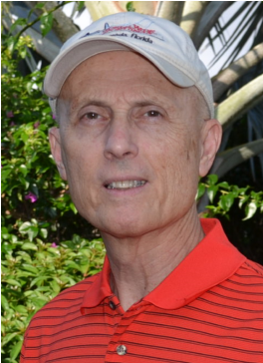

***~Crossed & Found~***



**Thirteen-year-old Kay Telfair believes her life is over when she moves with her family a thousand miles to their new home near the Delaware River in New Jersey. But her life takes an unexpected turn when she meets Anna and discovers a two-centuries-old letter--a letter that could change American history. Before she unravels the letter's mystery, Kay stumbles headlong into an adventure--confronting fears she'd never experienced, stretching the limits of her friendship with Anna, and forcing a test of Kay's physical strength that could save her own life.**

***~Gold Hush~***



**“I’m avoiding any activity that involves excitement…I’ve learned my lesson.” After an adventure-filled June, all Kay Telfair wants is a quiet vacation in Maine with her family and best friend Anna—no drama, no stress. But the thirteen-year-old’s hopes for a tranquil August stay in the village of Prospect Harbor soon fade when the girls compete for the attention of a young boy and Kay makes a startling discovery—a discovery that sends the three teens on a dangerous quest. Ignoring advice—and menacing threats from others—they continue their pursuit, drawing them deeper into a perilous mystery, deeper than Kay ever could have imagined.**

***~Stonewalled~***

[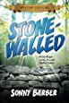](https://www.amazon.com/Stonewalled-Mystery-History-Book-Three/dp/1519351291/ref=pd_bxgy_14_img_3?_encoding=UTF8&psc=1&refRID=75QVZ72QHQ8A2W2F3RK1)

**Kay stared at the gray line of stone walls. “They won’t be too upset to see these knocked down...” A mystery that threatens the relationship with best friend Anna, a battle with Mother Nature at her worst, and the discovery of a tragic secret—not exactly what fourteen-year-old Kay Telfair was looking for in a summer getaway. But that’s what confronts the young teen while helping the owners of Windcrest Farm find a way to stop destruction of nearby farmland and its three-hundred-year-old stone walls. Vacationing with her family and Anna at Windcrest in the quiet, coastal village of Little Compton, Rhode Island, the young teen soon discovers her goal will not be easy. Kay’s prospects for helping preserve the valuable land and stone walls look much better after a surprise visit by a boy from her past. With his help, she pours all her energy and passion into the quest, searching for answers in New England’s Native American and colonial history and learning some important lessons about perseverance and friendship.**

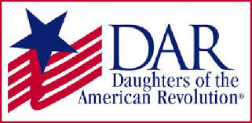

*Garcilaso de la Vega Chapter, NSDAR*

*Lake Worth, Florida*

*Alisha Darcy, Regent*

*Karen Christie, Registrar*

Phone; 561-236-2460-Email; [IMC4U4@AOL.com](mailto:IMC4U4@AOL.com)

Chapter Email: [GarcilasodelaVegaDAR@gmail.com](mailto:GarcilasodelaVegaDAR@gmail.com)

Visit us on ***Facebook*** @ <https://www.facebook.com/LWDAR>