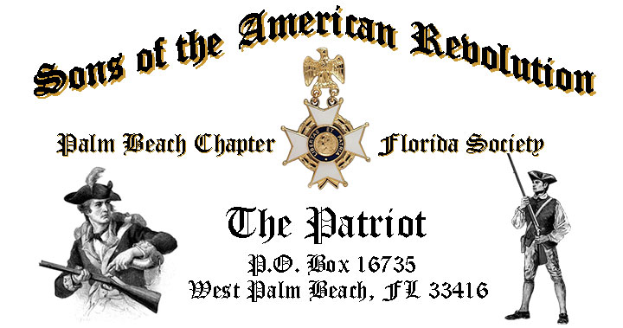

***Volume 22 December 2016 Number 08***

***Kick off the Season with the family @ the Chapter’s Annual Holiday Musical*** *featuring the award winning* ***Kings Academy Conservatory of the Arts Choir…*Saturday**, **December 10**, 12:00 Noon sharp @ the Embassy Suites Hotel 1601 Belvedere Road, West Palm Beach!

***December Meeting Highlights:***

* ***Kings Academy Musical Choir!***
* ***Chapter’s American History Teacher Award Winner Ms. Lauren Goepfert!***
* **Buffet** Lunch, Desserts & Beverages @ **$28** per person **check/cash** at the door!
* **Reservations** required **RSVP** Don Lanman (561)-315-5073!
* **Family, Friends & Guests** are always welcome!

**Newsletter Content:**

* ***2017 SAR* Membership Fees are Due-Don’t lose your SAR Membership!**
* **President’s** Message
* **2016/17** Chapter Meeting Dates &Topics
* **Officers** & Board Members
* ***President’s*** *Brigade* Financial Supporters
* **Committees**, Chairmen & Members
* **National**/State Society News & Events
* **Feature Article:** ***Patriot General Nicholas Herkimer! Battle of Oriskany Hero!***
* **Chapter** Activities Pictures
* **Compatriot** Sponsored Promotions

**President’s Message:**

***Fellow Compatriots, Don’t miss our annual Holiday Tradition!*** Bring the whole Family, Friends and neighbors to kick off the Holiday Season in style to the wonderful choir music of the award winning…***Kings Academy Choir!***

***-Palm Beach Chapter Annual Holiday Musical-***

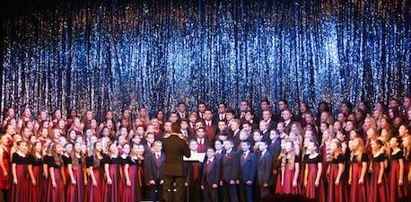

***The Kings Academy Conservatory of the Arts-Choir***

The Chapter honored Veterans Month at the November meeting with special guests; First Sergeant *Antonio Correa* JROTC instructor for the Forest Hill Community High School, school Color Guard and Staff Sergeant *Carl Arfa*, WW2 Battle of the Bulge Veteran and Liberator of concentration camps!

Please join your fellow Compatriots with a warm welcome home, and *“Thank You for Your Service”* to all our Veterans, and especially remember those heroes who made the ultimate sacrifice at the “Alter of Freedom” never to return home.

Compatriots, the *FLSSAR* “Veterans Battalion” honors all Chapter Veterans for their military service. I invite all Chapter veterans to provide a copy of their DD-214 to receive the SAR “Service Medal” and Veterans Battalion certificate.

Chapter Veterans are also encouraged to apply for the ***Florida State Governors Military Service Award!*** All Florida residents who served honorably in the Armed Services is eligible to receive the medal personally from the Governor. Apply at [www.floridavets.org/gvsa](http://www.floridavets.org/gvsa).

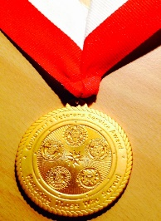

The Chapter welcomed 4 new Compatriots **Dennis Krieger, Jim Brown, Sonny Barber and Anthony Shea** inducted at the November meeting…Welcome!

With these inductions our membership has grown to 170 with another 20+ applications in process! However, we need your help to continue growing our membership with like-minded individuals interested in good fellowship, honoring our patriot ancestors.

Help us grow our membership by Paying your 2017 Dues, enrolling Sons and Grandsons in SAR, invite friends and neighbors to join and encourage wives, daughters, and granddaughters to join the *DAR* and *SAR Women’s Auxiliary*.

* **Spread the word about SAR civic activities!**
* **Serve as Officers & on Committees!**
* **Attend Chapter lunches & bring guests!**
* **Recruit new members!**

**The 2017** **Officer candidates** nominated at the November meeting and to be voted on at the December meeting, include for ***President; Don Lanman, Vice President; Ben Tidwell, Secretary; Gary Green, Registrar; Bob Boggs, Treasurer; Peter Johnston, Historian Buddy Miller; Sergeant at Arms Brian Davey; Chaplain Father Sanford Sears*** and ***Officer at Large; Bill Johnson.***

**Committee members** are needed to support its many youth and civic programs including: Flag Certificates, Liberty Tree Program, Medals/Awards, Veterans Programs, Newsletter, Publicity, High School/Youth Programs; Boy Scouts, JROTC, Rumbaugh Historical Oration and Knight Essay Contests, Police-Firefighters-EMS Service Awards, Chapter Events, Americanism-Patriot Bios, Audit, Membership Development , Officer Nomination, Speakers Bureau, Website Support, Fundraising/Endowment Programs.

Compatriots, **please** help on committees of most interest to you to make your Chapter both interesting and successful!

The Chapter awarded a $2,000 scholarship to Palm Beach Atlantic University at the November meeting including a $1,000 gift from Compatriot Alex Dreyfoos! Thank you Alex and all Compatriots who donate to the President’s Brigade!

The 2016 *Dr. Tom & Betty Lawrence American History Techer Award* goes to Ms. Lauren Goepfert, the World and American history teacher at the Bak Middle School of Palm Beach.

Ms. Goepfert is an active member of the *Palm Beach DAR Chapter*, serves on the Americanism and Citizenship committees for the DAR, and coaches boys/girls soccer and track/field programs at Bak. She will go on to represent our Chapter in the SAR state competition.

The Chapter offers **“Gift Basket Raffles”** at chapter meetings to raise funds to support our *Youth Programs*. We need donations of raffle items or gift baskets with a suggested retail value of $60. Donations are acknowledged at the meeting, included in the newsletter, and donors recognized in support of the Chapter’s *Presidents Brigade*.

The December raffle basket includes a special hand-made ***Patriotic Quilt*** by ***Diane Wenman*** *Treasurer* of the *Henry Morrison Flagler DAR Chapter*, plus a holiday basket that includes; wine, glasses, cord screw and all the items needed for a great Holiday! ***Thank you so much Diane!***

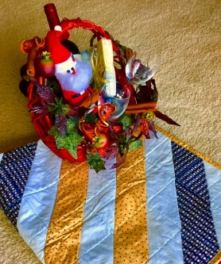

The Chapter continues to expand its relationships and joint event activity with all of the local DAR Chapters, and we are pleased to welcome our Patriot Sisters to all of our meetings and events.

DAR representatives from Palm Beach chapters including *Palm Beach, Garcilaso de la Vega, Henry Morrison Flagler, Lighthouse Point, Seminole* and *Spirit of Liberty,* continue to refer SAR prospects to our Chapter. We sincerely appreciate these referrals and the ongoing DAR support of our programs. Thank our Patriot Sisters whenever you see them.

Special speaker for the January meeting will be Ms. Maureen McGowan-Singer, a nationally recognized expert on the topic of Heraldry & Coat of Arms history! She is the National Chairman for Heraldry~Coats of Arms for the Colonial Dames XVII Century and Co-author of an acclaimed handbook on Heraldry.

Ms. Singer is also a member of the DAR, Past National Chairman of the Colonial Dames America, President *Palm Beach Colonial Dames XVII Century*, President of Chapter XIX - Florida Everglades and founding General Registrar for the *Society of Descendants of Lady Godiva*." A sought after speaker, Ms. Singer has conducted over 50 Heraldry & Coat of Arms History workshops and presentations across the U.S.!

Compatriots, we need your help to avoid losing money on the chapter luncheons. The hotel requires a minimum number of guests to cover the room, food, and services, so when attendance is low, the Chapter must pay the difference. **Please**, come to the meetings, bring friends and be sure to cancel reservations or pay the $28 lunch fee if your plans change! Many Thanks.

**IMPORTANT—Don’t lose your SAR membership, mail your $75.00 2017 Dues immediately to:*SAR PB Chapter, PO Box 16735 West Palm Beach, FL 33416-6735*** including any changes to your personal contact information.

Fellow Compatriots, I look forward to seeing you at the December 10 meeting! In closing please, join me in honoring our Veterans, patriot ancestors and especially remembering our departed Compatriots. **God Bless the *United States of America*.**

**-D. Lanman**

**2016/2017 Chapter Meeting Dates/Topics:**

**Visit** the Palm Beach Chapter web site @ [www.sarpbchapter.org](http://www.sarpbchapter.org) for a meeting calendar, special events, articles, pictures, and general information.

* **Dec. 10** Officers Vote,Holiday Event: **Kings Academy Holiday Musical**
* **Jan. 17** 2017 Officer Inductions, **Service Awards & Guest Speaker**
* **Feb. 21** Washington’s Birthday, **Thomas Jefferson to Speak**
* **Mar. 21** Boy Scout/JROTC Awards & Special Guest Speaker
* **Apr. 18** Law Enforcement Awards & Special Guest Speaker
* **May 16** Firefighters/EMT Awards & Special Guest Speaker

**2016 Officers & Board:**

**President**; Donald Lanman

**Vice President;** Benjamin Tidwell III

**Secretary**; Gary Green

**Treasurer**; Peter Johnston

**Registrar**; Robert Boggs

**Chaplain**; Father Sanford Sears

**Sgt. @ Arms**: Byrd Wenman

**Historian**; Samuel “Buddy” Miller

**Patriot Newsletter Editor**; Donald Lanman

**Support Youth Programs-Donate to the President’s Brigade:**

The Chapter honors and expresses its sincere appreciation to the Compatriots of the ***President’s Brigade***! The dedicated members of the ***President’s Brigade*** donate “extra dollars” in support of the Chapter’s many youth programs, scholarships, civic activities, award certificates, police/firefighter/EMT medals, veterans’ projects, and related community civic programs.

**Presidents Brigade Members:**

**-Bronze Level: $50-$99**

**-Silver Level: $100-$199**

G. Green

J. Harper

J. Curry

A. Griswold

T. Friend

H. Wynns

R. Culpepper

D. Coldwell

**-Gold Level: $200-$499**

R. Brinckerhoff

R. Banta

W. Meakin

R. Beck

E. Buckley

D. Lanman

B. Tidwell

S. Hitt

**-Platinum Level: $500+**

1. Dreyfoos

**Committees, Chairs & Members:**

Fellow Compatriots…..The Chapter expresses its sincere appreciation to those members who have volunteered to help with the many committees and projects. **Please** volunteer to help with any of the chapter committees. It does not take much time and is a major help with our many civic initiatives. **Call** or email Don Lanman or Ben Tidwell **Today** to lend a hand on any of the following committees.

* **JROTC** -Tidwell, Chasteen
* **Law Enforcement-Fire Safety** -Davis, Tidwell, Green
* **Veterans Affairs** -Wenman, Lanman
* **Newsletter/Publicity** -Lanman
* **Boy Scouts** -Tidwell
* **Knight Essay/Rumbaugh** **Oration** -Boggs
* **American History Scholarship** -Boggs
* **DAR Liaison** -Lanman, Tidwell
* **Speakers Bureau** -Lanman, Tidwell
* **Audit** -Coldwell, Tidwell, Lanman
* **2017 Officer Nomination** -Lanman, Tidwell, Boggs
* **Flag Certificates** -Clouse, Lanman, Tidwell
* **Membership** -Green, Boggs
* **Liberty Tree** -Open
* **Patriot Bios** -Open

**SAR Lapel Pin:**

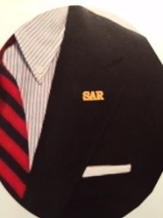

Make a fashion statement with a new ***SAR*** pin for your lapel or shirt. The new society Lapel Pin is part of an S.A.R. Branding program to help promote the S.A.R. and stimulate new membership!

The **classy** new lapel pin is a recognizable symbol of the SAR for the public, gives you immediate recognition as a member, and may spark conversation about SAR that leads to a new member. The new pin worn with the SAR rosette creates a very professional image that will improve overall SAR name recognition. The Chapter has a supply of pins for Compatriots at the monthly meetings for just $10. **Get yours today**!

**National & State Society News:**

**-Chapter Events:** Compatriots participated in a November Regional Meeting on Strategic Planning.

**-State Society:** Board of Management meeting will be held in February.

**- “HONOR FLIGHT” Guardian Program:** The Palm Beach Chapter is supporting the *Florida State Society of the Daughters of the American Revolution* and *Honor Flights Southeast Florida* with an Honor Flight event on **April 8, 2017** from Palm Beach Airport to Washington DC.

Interested Chapter Compatriots must complete an application and submit $400 for travel expenses to join Florida DAR members and WW 2 & Korean War Vets on their visit to war memorials in DC!

For **information** and an application contact Gladys Van Otteren, FSSDAR State Chairman Honor Flight program (561)-324-2937 or [HMFchapterDAR@gmail.com](mailto:HMFchapterDAR@gmail.com).

**Feature Article:**

***General Nicholas Herkimer…***

***Hero of the Battle of Oriskany!\****

**Compiled By Don Lanman, President SAR Palm Beach Chapter**

On August 6, 1777, 800 militiamen from Tryon, County, New York, commanded by Patriot General Nicholas Herkimer were ambushed as they attempt to relieve Fort Stanwix (now Rome, New York), which was occupied by the British. General Herkimer was mortally wounded during the ensuing fight and died 10 days after the battle.

Nicholas Herkimer grew up in a Palatinate German community in the Mohawk River Valley of New York and gained military experience as a militia captain during the Seven Years’ War.

He led the *Tryon County Committee of Safety* beginning in 1775 and later served as colonel of the Tryon county militia. After independence was declared, he was promoted to brigadier general in the New York state militia.

When Herkimer learned that the British had taken Fort Stanwix in July 1777, he ordered the largely immigrant German county militia to gather at Fort Dayton (now Herkimer, New York), to begin the 40-mile westward march to the besieged Stanwix.

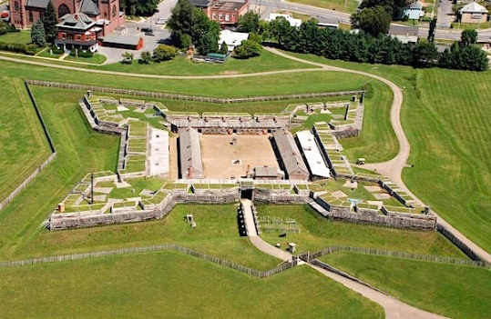

**Fort Stanwix Today**

On August 6, the Patriots still marching to relieve Fort Stanwix, were ambushed by a mixed party of British regulars and Mohawk Indians in what became known as the Battle of Oriskany.

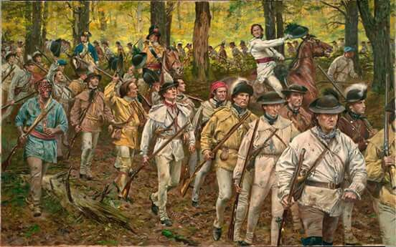 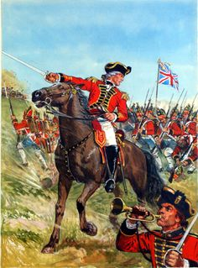

General Herkimer, though wounded during the battle propped himself against a tree, lit a pipe and commanded his men to avoid a panicked retreat. Herkimer’s leadership and heroism is depicted in a famous painting by F.C. Yohn.

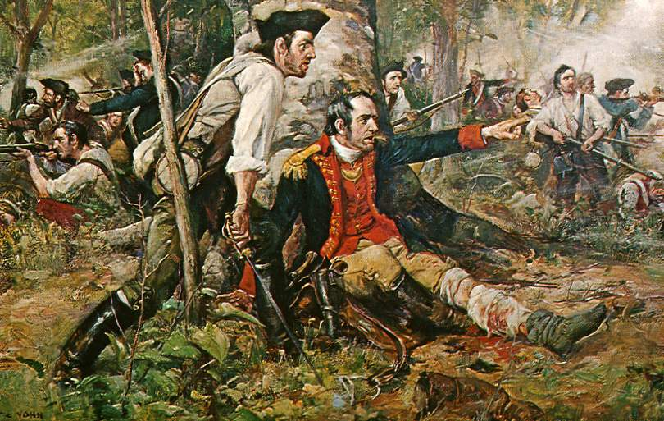

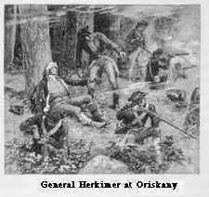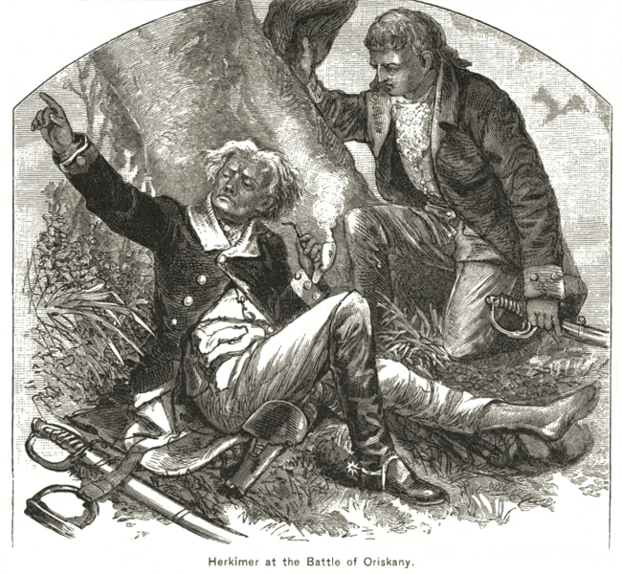

When the militia departed the field, they transported Herkimer to his home, where he endured the amputation of his leg, only to die of complications from the operation on August 16, 1777, at age 49. His home in what is now Danube, New York, is a state historic park and the town of Herkimer and Herkimer County, New York, are named in his memory.

The enemy coming from Oswego might have taken Fort Stanwix, later named Fort Schuyler, had General Herkimer not engaged them at Oriskany. Herkimer’s fortitude during the battle, despite a mortal wound, kept up the fight until the British, Indians, and Tories fled.

January, 1777, British General John Burgoyne suggested a plan to divide and conquer the American colonies; a plan which would bring him into the state of New York.

The proposal is basically valid, though quite complex in timing and coordination. His proposal is approved by the Crown, and in May, 1777, his ship arrives in Montreal.  With a strong force of seasoned troops, Burgoyne began a march south from Canada to capture Fort Ticonderoga and lead a drive on to Albany.

If successful, any significant American military presence in the colony of New York would have been decimated, and New England, considered the hotbed of the Revolution, would be sealed off from the rest of the revolt.  In Albany he would come under the command of General William Howe, then based in New York City.   
  
Burgoyne's plan also called for a second column composed of British regulars, Hessians, Loyalists and Indians to march down the Mohawk River from their base at Oswego on Lake Ontario.

This secondary force would capture the rich farmland of the Mohawk Valley in New York and link up with Burgoyne in Albany.  Strategically, the Mohawk Valley and Oriskany NY was considered the "Breadbasket of the Revolution", and a main supplier of food for George Washington's army, thus critical to the war effort.  
  
To command the western wing of his invading army, Burgoyne chooses Lieutenant Colonel Barry St. Leger who had gained a reputation during the French and Indian War as a solid leader in frontier fighting.

On June 2, 1777, St. Leger took command of his soldiers, including Sir John Johnson.  They were joined by 100 Tory rangers under the leadership of Colonel John Butler.  Around June 21, St. Leger's command began its movement down the St. Lawrence River to Lake Ontario.

Upon reaching Fort Oswego, St. Leger's troops were met by about 1000 warriors of the Six Nation Confederacy, who were to join the British on its eastward march against the colonists.  On August 3, 1777 St. Leger and nearly 2000 fighting men reached Fort Stanwix in what is now Rome, NY.   
  
At three o’clock in the afternoon, Sunday, August 3, 1777, Barry St. Leger formally invaded Fort Stanwix, sending Captain Gilbert Tice to visit the garrison’s commandant, Peter Gansevoort.

On the same day, 40 miles away at Fort Dayton, another soldier was also answering his country’s call.  It is here that Brigadier General Nicholas Herkimer mustered 800 men of the patriot Tryon County Militia to march to the relief of their compatriots at Fort Stanwix.   
  
On the morning of August 4 the rebel militia sets out on their mission.  Most of the men are farmers, and most are descended from the original Palatine settlers of the Mohawk Valley.  They spend their first night at Staring Creek.

The second night finds the men of Tryon County encamped near the Oneida Indian Bear Clan village of Oriska.  Earlier in the day, General Herkimer had sent three scouts to Peter Gansevoort at Fort Stanwix with a proposal for disrupting the enemy siege.  His plans in proper order, the Brigadier slumbers.  However, others in the camp are not so restful.  
  
On the fateful morning of August 6, Herkimer calls a conference of his officers to discuss his plan.  When the sound of three cannons booming in succession are heard from Fort Stanwix, the militia are eager to advance westward.  At around the same time, Fort Stanwix commandant, Peter Gansevoort, will launch a major sortie from the fort.

Squeezed between the two forces, the enemy siege would be severely disrupted.  Some junior officers and members of the political Tryon County Committee of Safety with the column are impatient.  They insist upon an immediate advance.

Finally the conspirators within the militia ranks go too far when they accuse Herkimer of cowardice and disloyalty.  In a rage and despite his better judgement, Herkimer strides to his white horse, gives the order to march, and the column is on its way westward from the Oriska village toward Fort Stanwix.

A group of sixty warriors of the Oneida Indian Nation led by their war chief Han Yerry Doxtader join the militia.  The presence of the Oneida braves fighting alongside the patriots gives America its first ally in war.  It also marks the end of the three-century "great peace" of the Iroquois Confederacy.

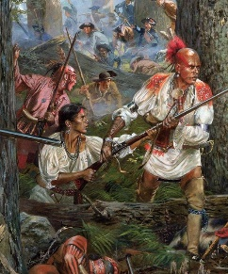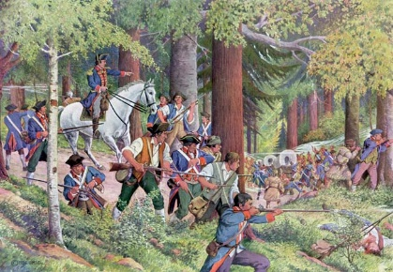

Moments after issuing his command, General Herkimer regrets it.  He knows the Military Road they have to march is long and dangerous with many areas that are perfect for ambush.  As captain of militia he had helped to build it 19 years before.

The militia of Tryon County are indeed at risk, just two miles west of Oriska 700 Crown regulars, loyalists and Indian allies lie concealed in the heavy woods, waiting in ambush.

Positioned in a fishhook pattern, the bulk of the Iroquois warriors and Tory rangers are on the high ground, south of the King’s Highway.  A detachment of the King’s Royal Regiment of New York blocks the road to Fort Stanwix.

The Mohawk leader, Joseph Brant, has selected this place wisely. His plan is to attack the militia as they enter an upcoming ravine, and the patriots will be trapped in the marshy low ground.

The Tryon County Militia and Oneida allies march into the trap unaware, led by General Herkimer and Colonel Ebenezer Cox.  The advance guard is the first to be attacked while they were resting by a stream.

Exhilarated by this swift victory, the Mohawk and Seneca head down the Military Road directly into the path of the militia, and another bloody battle ensues. Ebenezer Cox is killed, along with other militia and Indians causing the militia to panic.  Viewing this confusion, Joseph Brant now strikes from his position on the eastern heights, leading to a bloody slaughter.

In *“Burgoyne’s Orderly Book”,* British General John Burgoyne wrote a poem for the Patriots, letting them know his intentions to use his Iroquois Indian allies to show no mercy:

***“I will let loose the dogs of hell,  
Ten thousand Indians, who shall yell  
And foam and tear, and grin and roar,  
And drench their moccasins in gore:  
To these I’ll give full scope and play  
From Ticonderog to Florida!”***

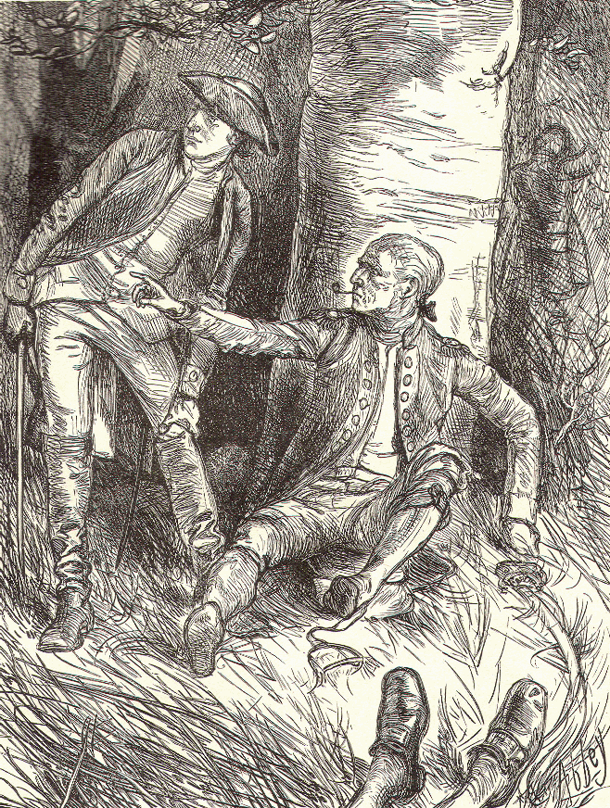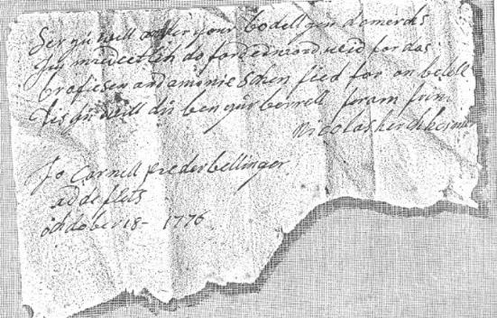

The battle lost, General Herkimer died several days later from a botched amputation of his wounded leg. At the Herkimer House Museum, his old Bible is displayed, open to Psalm 38 which he read just before his death.

***Psalm 38:***

*1 O Lord, rebuke me not in your anger nor discipline me in your wrath!  
2: For your arrows have sunk into me and your hand has come down on me.*

*3: There is no soundness in my flesh because of your indignation; there is no health in my bones because of my sin.  
4: For my iniquities have gone over my head; like a heavy burden, they are too heavy for me.*

*5: My wounds stink and fester because of my foolishness.  
6: I am utterly bowed down and prostrate; all the day I go about mourning.  
7: For my sides are filled with burning and there is no soundness in my flesh.  
8: I am feeble and crushed; I groan because of the tumult of my heart.*

*9: O Lord, all my longing is before you; my sighing is not hidden from you.  
10: My heart throbs; my strength fails me and the light of my eyes—it also has gone from me.  
11: My friends and companions stand aloof from my plague, and my nearest kin stand far off.*

*12: Those who seek my life lay their snares; those who seek my hurt speak of ruin and meditate treachery all day long.*

*13: But I am like a deaf man; I do not hear, like a mute man who does not open his mouth.  
14 I have become like a man who does not hear, and in whose mouth are no rebukes.*

*15 But for you, O Lord, do I wait; it is you, O Lord my God, who will answer.  
16 For I said, “Only let them not rejoice over me who boast against me when my foot slips!”*

*17: For I am ready to fall and my pain is ever before me.  
18: I confess my iniquity; I am sorry for my sin.  
19: But my foes are vigorous, they are mighty and many are those who hate me wrongfully.  
20: Those who render me evil for good accuse me because I follow after good.*

*21: Do not forsake me, O Lord! O my God, be not far from me!  
22: Make haste to help me O Lord, my salvation.*

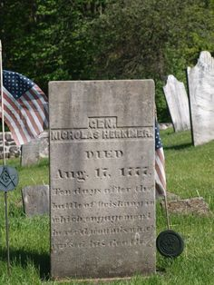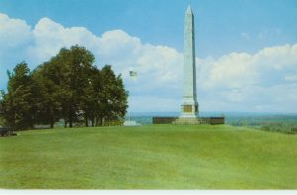

**\*Sources include Paul Boehlert “The Battle of Oriskany & General Nicholas Herkiimer” & online resources.**

***Herkimer House Museum***

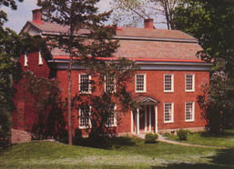 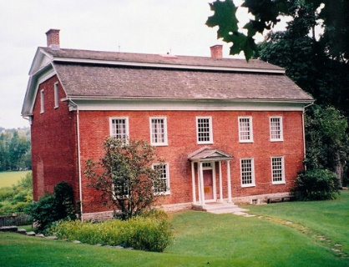 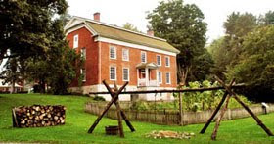

Johan Jost Herchhcimer *was one of a number of refugees from the German Palatinate who, in 1725, settled at German Flatts south of the present village of Herkimer. He was an industrious farmer who also engaged in trade and transport on the Mohawk River, and held important contracts to provision the military garrison at Oswego.*

*As a major Mohawk Valley landowner, he acquired over 5,000 acres of land south of the Mohawk, which included the strategic "carrying place" or portage around Little Falls. It was here, about 1752, that his eldest son Nicholas established a farmstead.*  
Nicholas Herkimer *pursued his own interests in farming and trade, which were particularly profitable during the French and Indian Wars.*

*About 1764 he was able to replace his earlier dwelling with a fashionable English Georgian style mansion, now known as Herkimer Home. This residence on the frontier was unusually grand and as remarkable then as it is today, a unique example of colonial Mohawk Valley architecture.*

*Regarded a hero and a martyr to the cause of American freedom, his home became a shrine to chroniclers of the American Revolution.* Herkimer had no children*so his home passed to his brother George, whose son John sold it out of the family in 1814.*

*The house changed hands six times after and, in considerable disrepair, it was acquired by the State of New York in 1913.* Preservation was begun *in 1914, and in the 1960s a major restoration was completed, although elements of architectural alterations made in the nineteenth century remain.*Important period furnishings*include a number of pieces of local Mohawk Valley or Herkimer family significance.*

*The unspoiled landscape, including the Herkimer family burying ground, is remarkably unchanged from that of the eighteenth century. A nineteenth-century barn has been remodeled as a visitor center, which houses interpretive exhibits and audio-visual programs. View the latest, up to date information for summer activities at:*[www.HerkimerHomeAcademy.org](http://www.herkimerhomeacademy.org/). *Research library and collectable information is also available at*[www.HerkimerHomeAcademy.org](http://www.herkimerhomeacademy.org/)

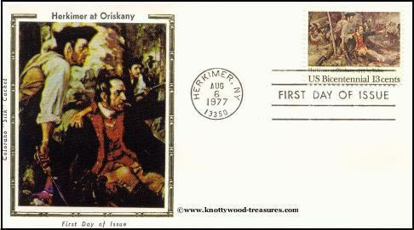

**Keep You Membership Active! 2017 Membership Fees are Due Now!**

**Don’t lose your SAR membership…**mail in the 2017 SAR membership dues today as we must send them to State and National SAR.

**Mail** your $75 annual membership fee to ***SAR PB Chapter, PO Box 16735 West Palm Beach, FL 33416-6735*** ASAP along with any changes to your personal contact information.

**Remember….Your** membership dues and additional donations fund the many Chapter civic activities including **Scholarships**, ***Boy Scout & JROTC medals, Rumbaugh & Knight Essay Youth contests, Police-Firefighter-EMT awards, Flag Certificates, Americanism, & Community programs.***

**Chapter Activities Pictures**

**President Lanman inducts new Compatriots: Krieger, Barber, Brown, Shea**

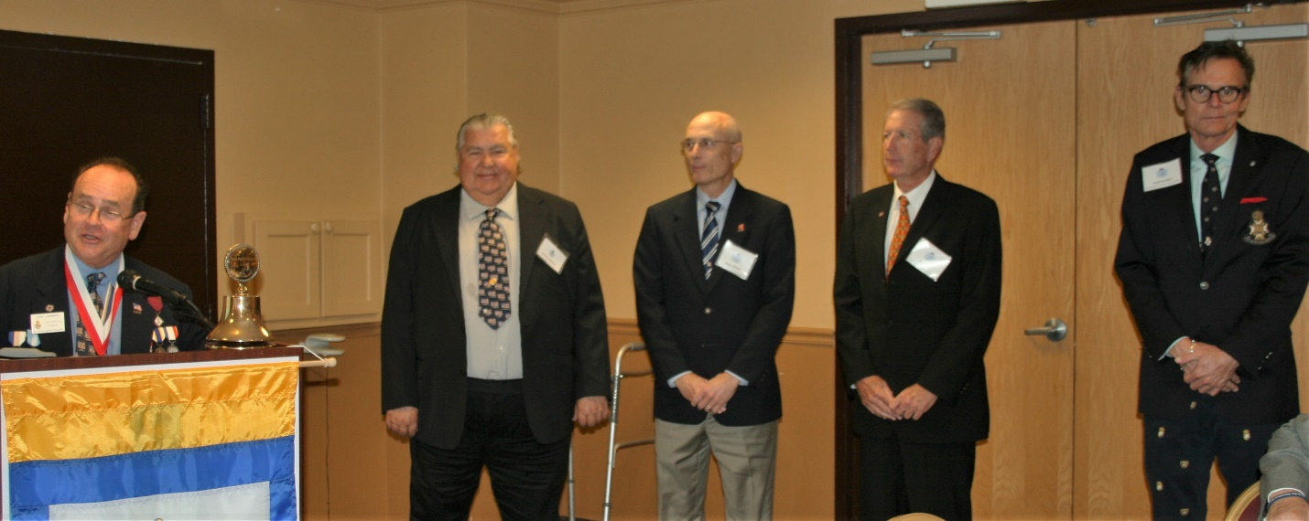

**Army 1st Sergeant Correa & Forest Hill HS Color Guard**

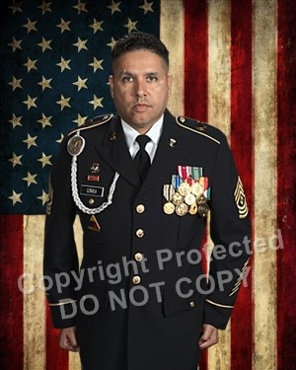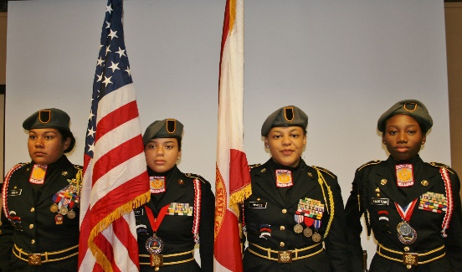

**President Lanman presents Scholarship Check to Palm**

**Beach Atlantic U. VP Vicki Pugh with Compatriot Dreyfoos**

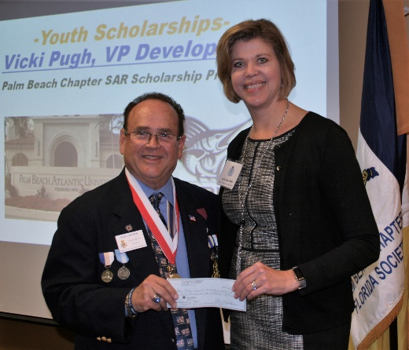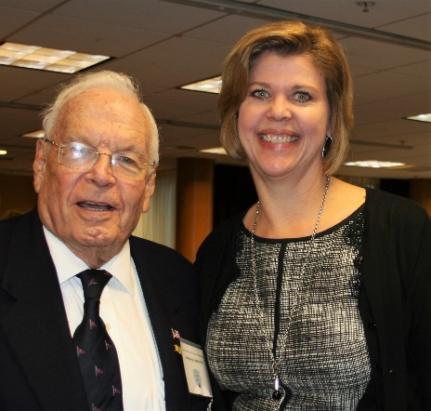

**President Lanman, VP Tidwell Honor WW2 Vet Carl Arfa**

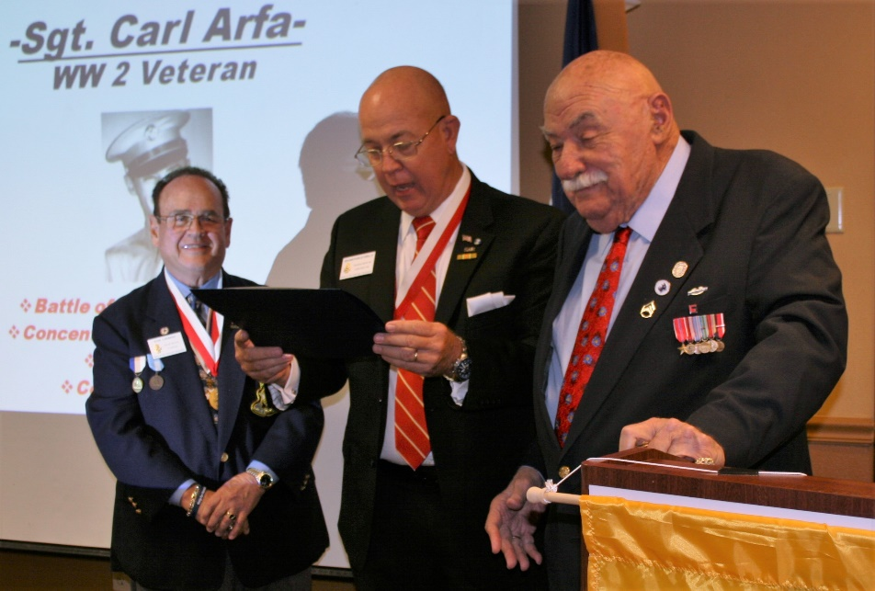

**Forest Hill Community HS JROTC Color Guard**

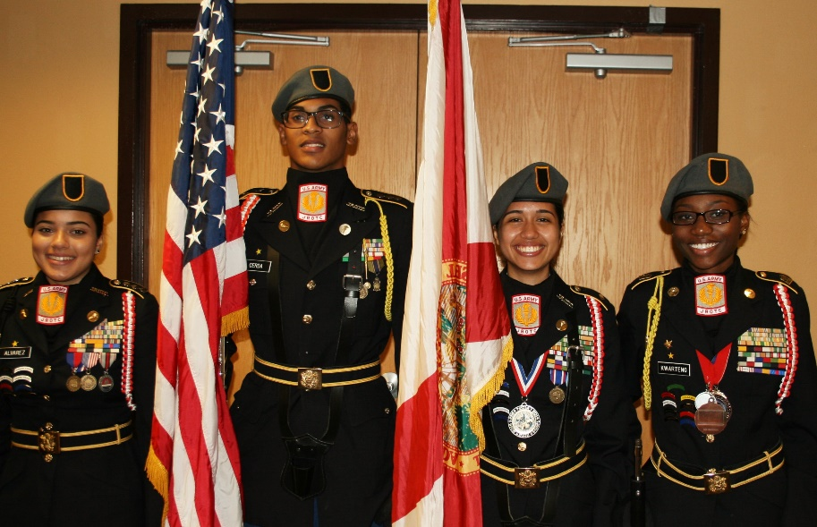

**Compatriot Tidwell Honors JROTC Color Guard**

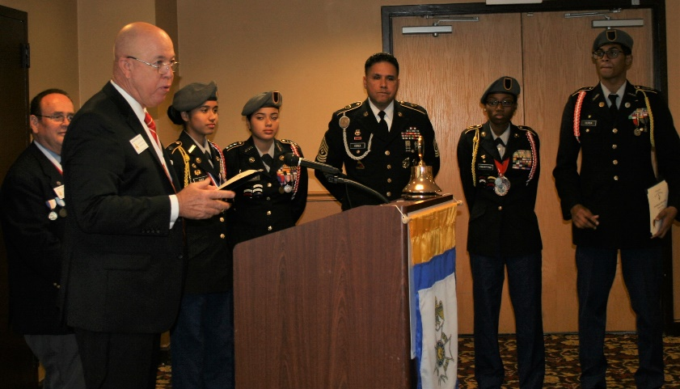

**Compatriot Sponsored Promotions:**

The Compatriot sponsored Ads are important to the Chapter as they represent additional funds to support all Chapter projects including: ***Boy Scout & JROTC medals, Rumbaugh & Knight Essay Youth contests, Police-Firefighter-EMT awards, Americanism & community programs!***

**Please** consider helping your Chapter with an Ad at the modest cost for **8** issues **@ Business Card $50, Half Page $100, Full Page $200.**

**Your AD donation will also qualify you for the *Presidents Brigade* listing. Call Don Lanman 561-315-5073 for information.**

***SPECIAL SPONSORED ADS ON FOLLOWING PAGES…***

***-COMPATRIOT ALEXANDER DREYFOOS***

***-COMPATRIOT ROBERT BRINCKERHOFF***

***-DAR GARCILASO DE LA VEGA, CHAPTER DAUGHTERS OF THE AMERICAN REVOLUTION***

*TWO GREAT BOOKS-ONE GREAT MAN*

***-Alexander W. Dreyfoos-***

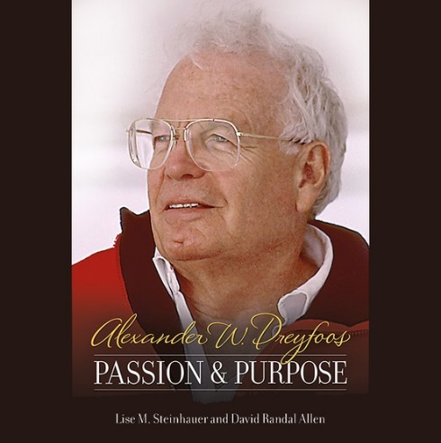

***-A PHOTOGRAPHIC ODYSSEY- -PASSION & PURPOSE-***

***Compatriot Alexander W Dreyfoos, Jr.*** an honored member of the *Palm Beach Chapter Sons of the American Revolution*, noted American entrepreneur, and philanthropist has published two remarkable books that should be on every bookshelf. **Book sales** **proceeds** **donated to local West Palm Beach charities!**

* ***Passion & Purpose*** chronicles a remarkable lifetime of passion with photography, his business, inventions and philanthropic ventures, as well as his adventures above and below the water. **$29.95.**
* ***A Photographic Odyssey*** is a remarkable collection of hundreds of stunning pictures from 100,000 photos taken by Alex around the world and bound in an elegant 15” by 10” glossy photographic book. You will travel with Alex around the world, above and below the water, to forests, jungles, glaciers, and deserts in the exotic locals of Papua New Guinea, Bhutan, Nepal, China, Japan, and Tibet. The subjects are very divergent contrasting palaces and temples with the vulnerability of people, animals, and exotic scenery. **$60.00.**
* **Support your Chapter & local charities! Get both books, *Passion & Purpose & A Photographic Odyssey,* just $71.96 @ kravis.org/books or Call 561-651-4329.**

***-Alexander W. Dreyfoos-***

*Graduating from MIT and Harvard Business School, Alex founded Photo Electronics Corporation (PCS), specializing in photography and video production. Over the decades, Alex earned 10 US patents and invented the Video Color Negative Analyzer for motion pictures earning him an Academy Award for technical achievement.Many inventions, developed by PCS, are on permanent display at the Smithsonian Institution. Locally Alex also owned television station WPEC TV-12, the CBS affiliate in West Palm Beach. Alex’s many philanthropic achievements include founding the Palm Beach County Cultural Council, the Raymond F. Kravis Center for the Performing Arts and gifting a million dollars to the Dreyfoos School of the Arts. Alex also donated a million dollars each to the Palm Beach County biomedical research campus of the Scripps Research Institute and the local Max Planck Florida Foundation for Neuroscience in Jupiter, Florida.*

-Morgan Stanley-

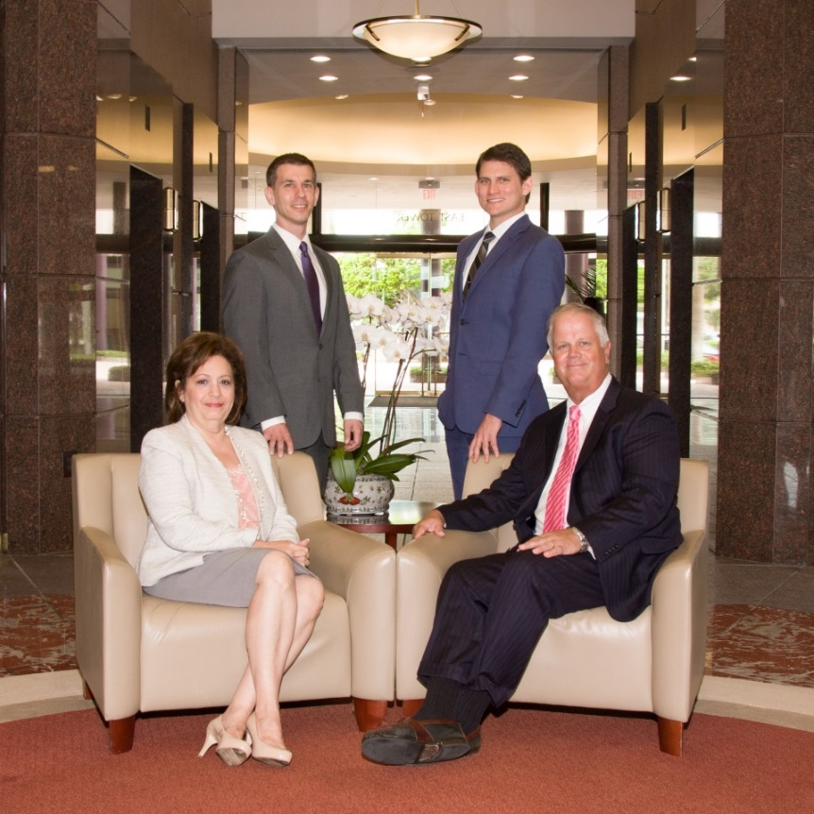  
***Robert Scarborough, Financial Advisor; Amani Gaballa, Senior Registered Associate;***

***Logan Gordon, Financial Advisor; Robert Brinckerhoff, Senior Vice President, Financial Advisor***

***Robert W. Brinckerhoff, Senior Vice President, Financial Advisor  
777 S. Flagler Dr. Suite 700, East Tower  
West Palm Beach, FL 33401, (561) 650-7514***[***Robert.Brinckerhoff@MorganStanley.com***](mailto:Robert.Brinckerhoff@MorganStanley.com)

***Bob has been a financial advisor since March 1976. He focuses on investment strategies, retirement planning, liquidity solutions for individuals, commercial real estate, and small business owners.***

***Bob is a graduate of the University of Vermont. His clients are geographically diverse and he frequently travels from the east coast to the west to meet with clients. He is active with nonprofit organizations that support the blind and visually impaired. Bob is also an active enthusiast in Ferraris.***

*The investments listed may not be suitable for all investors. Morgan Stanley Smith Barney LLC recommends that investors independently evaluate particular investments and encourages investors to seek the advice of a financial advisor. The appropriateness of a particular investment will depend upon an investor’s individual circumstances and objectives. Morgan Stanley Smith Barney LLC is a registered Broker/Dealer, Member SIPC, and not a bank.*

*Where appropriate, Morgan Stanley Smith Barney LLC has entered into arrangements with banks and other third parties to assist in offering certain banking related products and services. Investment, insurance and annuity products offered through Morgan Stanley Smith Barney LLC are: NOT FDIC INSURED, MAY LOSE VALUE, NOT BANK GUARANTEED, NOT A BANK DEPOSIT, NOT INSURED BY ANY FEDERAL GOVERNMENT AGENCY. Copy write 2015 Morgan Stanley Smith Barney LLC, Member SIPC CRC1355648 11/15.*

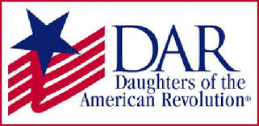

*Garcilaso de la Vega Chapter, NSDAR*

*Lake Worth, Florida*

*Sheila Zile-Pecoraro, Regent*

*Judy Mahaffey,* Registrar

Phone; 561-876-9520-Email; [Smileson@AOL.com](mailto:Smileson@AOL.com)

Chapter Email: [GarcilasodelaVegaDAR@gmail.com](mailto:GarcilasodelaVegaDAR@gmail.com)

Visit us on ***Facebook*** @ <https://www.facebook.com/LWDAR>