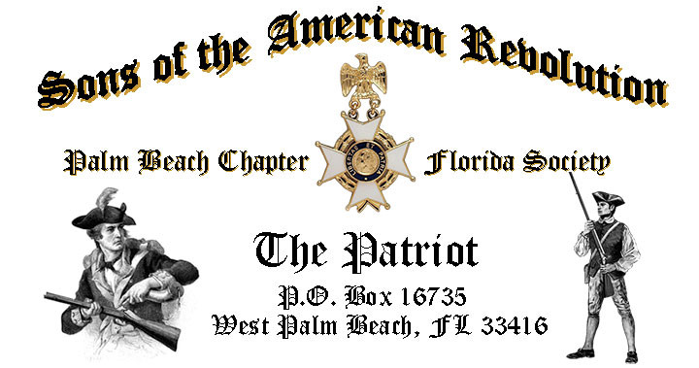
Volume 23 December 2017 Number 09

RSVP early for our Special Holiday-Christmas event featuring the music of award winning “Dimension 20 Choir “, Saturday December 9, 12:00 Noon @ the Embassy Suites 1601 Belvedere Road, WPB! RSVP Today for this popular event.

December 9, Holiday-Christmas Event Highlights:

- “Dimension 20”~Forest Hill Community High School Award Winning Choir!
- Holiday Buffet Lunch, Desserts & Beverages, $28 per person Check/Cash!
- Reservations required, RSVP, Don Lanman (561)-315-5073!
- Family, Friends & Guests are always Welcome!

Newsletter Content:
- President’s Message
- 2018 Chapter Meeting Dates &Topics
- Officers & Board Members
- President’s Brigade Financial Supporters
- Committees, Chairmen & Members
- National/State Society News & Events
- Feature Articles:
  - Lydia Darragh ~ Revolution’s First Female Spy!
  - A Mount Vernon Christmas!
- Chapter Meeting & Event Pictures
- Compatriot Sponsored Promotions
President’s Message:

Fellow Compatriots & Friends…

Get into the Spirit of the Season with Holiday Music, Food and Fellowship! Bring the whole family to our annual Holiday-Christmas event featuring the vocal music of the award winning Choir, Dimension 20”!

“Dimension 20” is the most advanced choral group in the Forest Hill Community High School senior music department and is renowned for its high standards of excellence, dedication, quality and commitment from its members.

Formed in 1973 to provide a more concentrated experience for the serious and strongly committed choral and music students, its name was derived from a multi-dimensional approach to performance and style of musicianship, versatility, and variety.

“Dimension 20” became known with its award winning composition entitled “In the beginning God” - God is Love - Love is Dimension 20 and has been the groups theme song since, and continues to bond the choral group as a family.

Now in its 44th year, “Dimension 20” appears numerous times a year both locally and regionally for community, professional, and fraternal organizations.

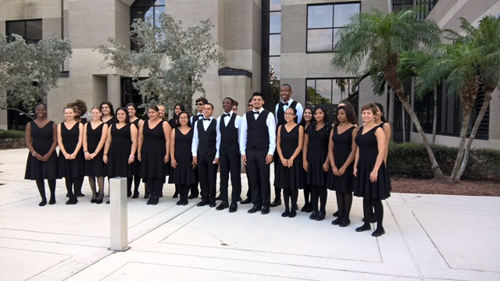

The November meeting featured Florida historian/author Steve Carr who took us back to Prohibition-Era Palm Beach to follow the exploits of John Ashley and Laura Upthegrove, the “King & Queen of the Everglades”!

The meeting also welcomed FLSSAR State President Robert Folk, and featured a special presentation of our National Anthem and God Bless America by aspiring vocalist, pianist, and Children of the American Revolution Page, Ms. Emma Robbins.

In recognition and honor of Veterans Month, November meeting attendees received a special “American Veteran Flag” lapel pin donated by Compatriot Thom Irwin. Thank you Thom!

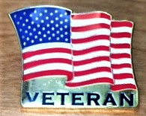

The Palm Beach Chapter is a historic supporter of our Nation’s Veterans, with over 15% of its members serving from WW II to Iraq.

All Compatriot veterans are encouraged to provide their DD-214 to be recognized with the SAR Military Service Medal and welcomed into both the FLSSAR Veterans Battalion and the Chapter’s Own “Band of Brothers.”

The Chapter welcomed new Compatriots Dr. Ronald Giddens, Peter Miller, Richard Linn and Robin Martin at a special induction ceremony during the November meeting.

The 2018 Chapter Officers were voted in by the membership including: Ben Tidwell, President, Bob Boggs, VP, Gary Green, Secretary, Bob Boggs, Registrar, Peter Johnston, Treasurer, Father Sanford Sears, Chaplain, Buddy Miller, Historian, Peter Miller, Sgt.@ Arms and Sonny Barber, Officer @ Large.

Your 2018 Officers will be formally inducted, by Chapter President Lanman, at the January 16 meeting, Congratulations Gentlemen!

Compatriots….your 2018 Membership Dues are due NOW! Compatriots need to send in their 2018 Membership Dues of $75 plus additional donations immediately to maintain membership in the SAR. It’s also a good time to update your contact information.

A primary Chapter goal for the continued success of our Chapter is membership development and the mentoring of new members. We are currently at 185 members with 41 prospects in the pipeline.

However, with the natural turnover of members, we need all Compatriots to help grow membership by recruiting civic-minded individuals interested in honoring our patriot ancestors and enjoying good fellowship.

Take action today to enroll Sons and Grandsons, invite friends to join and encourage wives, daughters, and granddaughters to join the DAR and Chapter Women’s Auxiliary.

Another important mission is expanding our relationships with all of the Palm Beach DAR Chapters. We welcome our DAR Patriot Daughters to all Chapter meetings and events, and sincerely appreciate their new member referrals and ongoing support. Thank you DAR!


Our Chapter desperately needs Compatriots for the 2018 committees to support our many civic programs including Rumbaugh Historical Oration/Knight Essay Contests, Teacher of the Year, social media, website support, Veterans programs, Publicity, Boy Scouts, JROTC, Police-Firefighters-EMS Service Awards, and Fundraising/Endowment Programs. Volunteer Today!

Compatriots, please remember that our hotel requires a minimum number of guests to cover the room, food, and services fees, so when attendance is low or there are no shows, the Chapter must pay the difference. Please help us avoid losing money on the chapter luncheons by attending each meeting and bringing guests!

Fellow Compatriots, December marks the end of my service as your President. It has been my rare privilege and high honor to lead the Chapter over the past two years. Thank you!

In concert with my fellow officers we have grown the membership from 153 to 189 representing a 24% increase, distributed dozens of civic medals for Police, Firefighter/EMT, JROTC, presented scholarships, were honored with 2 Patriot Medals recipients and set meeting standards for other Chapters to follow.

Thank you for your support and encouragement over the past two years, and count on me to continue my full support of our Chapter as a Former President, Board member, Committee Chairman and state officer.

I look forward to seeing you at our December 9 meeting! Please, join me in honoring our nation’s Veterans, Patriot Ancestors, and especially our Dear Departed Compatriots. God Bless You and God Bless the United States of America. In Heartfelt Patriotism - D. Lanman

2017/18 Chapter Meeting Dates/Topics:

Visit the Palm Beach Chapter web site @ www.sarpbchapter.org for a meeting calendar, special events, articles, pictures, and general information.

- Dec. 9, Dimension 20 Choir Christmas & Holiday Musical
- Jan. 16, 2018 Officer Inductions, Historian/Author, Dr. Wesley Borucki
- Feb. 20, 2018, Special Guest Thomas Jefferson
- March 20, 2018, Special Guest Speaker
- April 17, 2018, Law Enforcement Awards Ceremony
- May 15,2018, Firefighters/EMT Awards Ceremony

2017 Officers & Board:

President Donald Lanman
Vice President Benjamin Tidwell III
Secretary Gary Green
Treasurer Peter Johnston
Registrar Robert Boggs
Chaplain Father Sanford Sears
Sgt. @ Arms Brian Davey
Historian Samuel “Buddy” Miller
Officer @ Large Bill Johnson
Patriot Newsletter Editor Donald Lanman

2018 Officers & Board:

President Benjamin Tidwell III
Vice President Robert Boggs
Secretary Gary Green
Treasurer Peter Johnston
Registrar Robert Boggs
Chaplain Father Sanford Sears
Sgt. @ Arms Peter Miller
Historian Samuel “Buddy” Miller
Officer @ Large Sonny Barber
Patriot Newsletter Editor Donald Lanman

Support Scholarship & Youth Programs- Join the President’s Brigade:

The Chapter has awarded $1,000 Scholarship to the Palm Beach Atlantic University again this year.

We want to increase the scholarship to $4,000 and respectfully ask Compatriots to consider helping the Chapter grow the amount and support these students of character.

The Chapter honors and expresses its sincere appreciation to the Compatriots of the President’s Brigade who support the scholarship and youth programs.

The dedicated members of the President’s Brigade donate “extra dollars” in support of the Chapter’s many youth programs, scholarships, civic activities, award certificates, police/firefighter/EMT medals, veterans’ projects, and related community civic programs.

Join the Honored Presidents Brigade Today….

Honored Presidents Brigade Members:

-Bronze Level: $25-$99

M. Anderson, B. Boggs, J. Brown , R. Cass, D. Coldwell, B. Davey, J. Dorsey, W. Davis, F. Devitt J. Harper, J. Kane, J. Mayne, S. McWhorter, C. Odell, G. Parkinson, W. Told

-Silver Level: $100-$199

J. Curry, R. Culpepper, T. Friend, G. Green, F. Green, A. Griswold, B. Johnson, B. Told

-Gold Level: $200-$499

R. Brinckerhoff, R. Banta , E. Buckley, K. Christie, S. Hitt, D. Lanman, W. Meakin, B. Tidwell, R. Utley, J. Wynns

-Platinum Level: $500+

A. Dreyfoos

Committees, Chairs & Members:

Fellow Compatriots…..The Chapter expresses its sincere appreciation to those members who volunteer to serve on our committees and projects. As you can see a few Compatriots are serving on multiple committees and could use support!

Please select a committee of interest for 2018 to help on any of the chapter committees listed. It does not take much time and is a major help with our many civic and youth initiatives. Thank You! Call or email Don Lanman or Ben Tidwell Today to lend a hand with any of the following committees.
- 2019 Officer Nominations -All Chapter Members
- 80th Anniversary -All Chapter Officers
- JROTC & Boy Scouts -Tidwell
- Law Enforcement-Fire Safety -Green, Tidwell
- Veterans Affairs -Lanman, Curry
- Newsletter/Publicity -Lanman
- Knight Essay/Rumbaugh Oration -Boggs
- American History Teacher -Boggs
- DAR Liaison -Lanman, Tidwell
- Speakers Bureau -Lanman, Tidwell
- Audit -Coldwell, Tidwell, Lanman
- Flag Certificates -Clouse, Miller, Johnston
- Membership -Green, Boggs, Tidwell
- Liberty Tree -Chapter Officers
- Patriot Bios -Miller
- Web Site-Facebook/Social Media -Open

Palm Beach Chapter 80th Year Commemorative Challenge Coin $10!

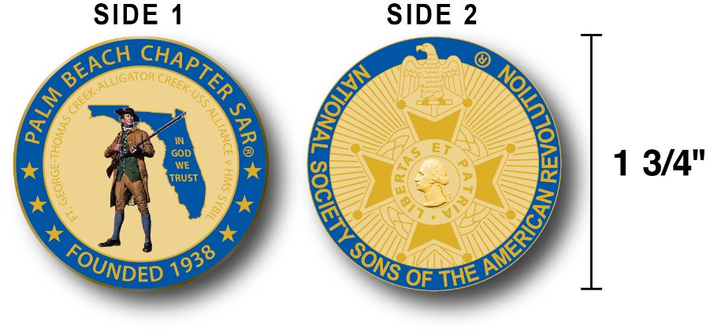

The Chapter has produced a custom bronze Commemorative Anniversary Coin honoring the founding of the Palm Beach Chapter in 1938 and celebrating its 80 years of historic, patriotic, and civic service in Palm Beach County and Florida.

The beautiful bronze coin is highlighted in George Washington military blue on a stunning gold background. Side-one is personalized to our Chapter with the founding date, a Minuteman standing guard over Florida, and the Florida State motto of "In God We Trust”.

The coin also includes a notation listing the four major Revolutionary War battles waged in Florida including the battles of: Ft. George-Pensacola, Thomas Creek Massacre, Alligator Creek, and the Last Naval Battle of the Revolutionary War between the USS Alliance & HMS Sybil.

Side-two displays the national NSSAR logo. Very impressive indeed!

The custom bronze Commemorative Anniversary Coin is designed to celebrate our founding in 1938, create a distinctive and impressive image for our Chapter and be used as a token of appreciation for honored guests, speakers, and as special awards.

Compatriots may purchase these unique collector coins for just $10 each.

Classy SAR Lapel Pins $10:
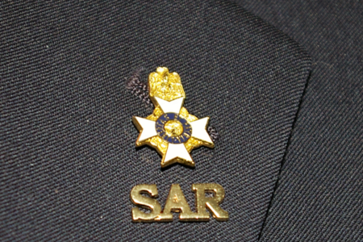

Display a Gold SAR pin on your suit lapel or shirt with the SAR Rosette. The SAR Lapel Pin is part of a national branding program to help promote the S.A.R. and stimulate new membership!

The striking lapel pin is a recognizable public symbol of the SAR, provides you recognition as a member of this great society, and will spark conversations about SAR that leads to a new member.
The gold lapel pin and SAR Rosette create a professional image that will improve overall SAR name recognition. The Chapter has a supply of pins for Compatriots for just $10. Show your Spirit….Get your Gold SAR Pin today!
SAR Chapter, State & National Events:

-STATE/NATIONAL:

DON’T MISS THE 2108 SAR NATIONAL CONGRESS

The 128th SAR Congress is scheduled for July 12-19 in Houston, Texas. Hotel registration is open now at a special SAR price of $159.00 per night King or 2-Queens.

Reservations can be made by calling the Westin Memorial City Hotel @ 1-800-937-8461 or online @ www.starwoodmeeting.com/book/nssar2018. Questions contact Paul Callanan @ LTCMRSC@aol.com or 906-273-2424.

Feature Articles:

Revolution’s First Female Spy...
Lydia Darragh Saves Washington's Army!

~Compiled/Edited by Don Lanman, Palm Beach SAR Chapter President

On September 26, 1777, British troops occupied Philadelphia. General William Howe located his headquarters across the street from the Darraghs, in a house formerly belonging to John Cadwalader.

Lydia Darragh had been regularly providing her Patriot son Charles with information regarding the enemy's plans, gathered by eavesdropping in her home and around town. She would often write this information in simple code on pieces of scrap paper, which she hid in large buttons that she and the messengers wore.

On September 27, 1777, Major John Andre, aide to General Howe, requested use of the Darraghs home for Howe's staff. Lydia told them that they had already sent away their two youngest children to live with relatives in another city, and they had nowhere else to go and would like to stay in their home.

She continued her protest going straight to Howe's residence at the Cadwalader House across the street from her home. Prior to her meeting Howe, however, a British officer introduced himself as Captain William Barrington of the 7th Regiment of Foot Royal Fusiliers. She was immediately taken aback by his Irish brogue and his name Barrington, which was her maiden name.

Captain Barrington told her that he was from Dublin and in the course of the conversation, she discovered that he was, in fact, her second cousin. She explained to him the situation and he promised to take up her case with General Howe immediately.
They both walked into Cadwalader House and were taken in to see General Howe who agreed to let her stay in her home but that both he and his staff needed to use the large parlor in her house for staff meetings. The Darraghs' were also permitted to remain in their home because as Quakers they were believed to be unsupportive of war, and therefore posed no apparent risk to the British Army.

On the evening of December 2, 1777, while eavesdropping from an adjoining room, Lydia overheard the British commanders planning a surprise attack on Washington’s army at Whitemarsh on December 4. Taking careful notes on the British attack she concealed the plans by sewing them into her coat to pass them onto American troops stationed outside the city.

Using a cover story that she needed to buy flour from a nearby mill just outside the British line in Frankford, Lydia passed the information onto American Lieutenant Colonel Thomas Craig the following day. Colonel Craig relayed the intelligence directly to General Washington, who had time to prepare his troops and defenses for the attack.

The British marched towards Whitemarsh on December 4, and were surprised to find General Washington and the Continental Army well prepared and waiting for them. After three inconclusive days of skirmishing, General Howe's generals and engineers once again studied the American positions, looking for any advantage they could exploit, but to the astonishment of both the British and the Americans, Howe decided to withdraw and return to Philadelphia.

Despite being successful in two major skirmishes over the previous days, his maneuvering had not gotten as far around the American flank as he had hoped and his troops' provisions were running low.

Howe had concluded that Washington's defenses were just too strong to warrant the risk of a general assault, so at 2 pm, the British began their general strategic withdrawal, leaving their heavy gear and lighting numerous campfires in a tactic similar to one used by Washington three days prior to conceal their movements.

An American reconnaissance party, led by Captain McLane, discovered that Howe's army was marching back down Old York Road into Philadelphia and communicated this intelligence back to Washington.

Washington immediately ordered his troops to harass the enemy's rear, in particular Grey's column, which was hindered by the weight of the artillery being transported. A contingent of Hessians attacked them with their fieldpieces forcing Morgan's troops to retreat. The British arrived in Philadelphia later that day.

To this day some members of the American Central Intelligence Agency maintain that Lydia Darragh, was one of the first female spies in American history.

In her honor, The National Society of the Sons of the American Revolution created the Lydia Darragh Medal. The Lydia Darragh Medal may be awarded by the incumbent President General, Vice President General, State Society President or Chapter President to a woman who has provided significant service to him during his term of office. The medal recognizes the assistance of women who work behind the scenes supporting SAR programs.
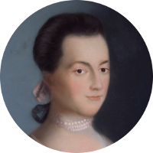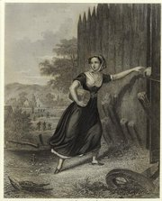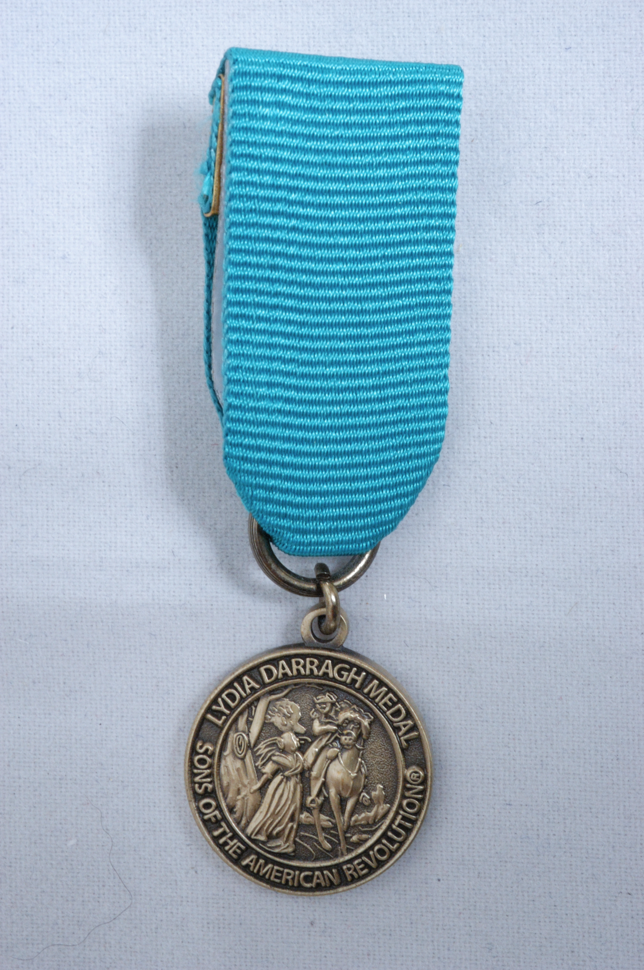

A Mount Vernon Christmas…
By Samuel “Buddy” Miller Palm Beach Chapter Historian & Former President

This is America’s first and greatest Christmas story, yet one known only to a few. It is deeply moving and uniquely American. It reveals much of the man and the fledgling nation.

What transpired between late November and Christmas Eve 1783 could not have happened anywhere but America. It shaped our republic in ways being felt today and cemented Washington as the greatest man of his era. In an age filled with hollow hyperbole, this account of the 1783 Mount Vernon Christmas is an authentic feel-good classic to share with the entire family.

During the war years prior to 1783, the Washingtons had not had the luxury of a joyous Christmas celebrated with family and friends. On Christmas Day 1776, Washington was desperate.

That year had been the darkest in American history. He had just endured a succession of military disasters; the morale of his remaining army, starving and freezing, was low; hundreds deserted during the night; he was down to 2,400 troops.

At least one-third of the men had no shoes and they were forced to wrap their feet in burlap during the all night march, leaving a trail of blood in the snow. Faced with impossible odds the American Revolution seemed to be down to one last desperate throw of the dice.
Although Washington’s attack on Trenton that Christmas in 1776 was one of the most successful surprise attacks in history, it only bought his army more time. Still to come was the desperate winter of 1777-78 at Valley Forge. Indeed every winter and Christmas until 1783 was to be the same story of hunger, cold, and privation.

In late November 1783, Washington received word that the peace treaty ending the war had been signed. Only then could he resign his commission and return home to Mount Vernon.

As soon as Washington learned of the treaty, he wanted very much to return to Mount Vernon for Christmas. Except for a few days enroute to Yorktown, he had been away for about eight years.

However, he had less than six weeks with many duties to preform and many miles to travel. This is the story of his incredible 38-day Christmas journey.
Just before learning of the peace treaty, Washington dealt with a rebellion while quartered in Newburgh, New York.

Washington called a meeting, gave a short speech, and then reached for a letter from congress in his pocket to read aloud.

He gazed upon it and fumbled with it without speaking. He then took a pair of reading glasses from his pocket which none had seen him wear. He said, “Gentlemen, you will permit me to put on my spectacles, for I have not only grown gray but almost blind in the service of my country.” This moved everyone to tears as they realized the sacrifices Washington had made. The rebellion died instantly.

On November 17, Washington issued his “Farewell Orders.” He lauded his troops for their extreme hardship and urged them never to forget the extraordinary events to which they bore witness. He closed by announcing his retirement from service stating, “The curtain of separation will soon be drawn…. And closed forever” meaning for all future offices. Instead of using such an opportunity to promote himself, he appeared above all human ambition. When his remarks reached King George III, he called Washington” the greatest man of his age”.

Washington arriving in New York from Newburgh via West Point on November 21 believed it necessary to reoccupy New York but had to wait for the British to evacuate. While there he made sure Tories who had secretly assisted the American cause were shielded from retribution.

He also protected the British withdrawal to prevent untoward actions. Everywhere Washington was greeted as a hero with cheering and enthusiastic crowds. Nearly every home had a drawing or lithograph of him displayed in the window. Receptions and dinners were held nightly in his honor.
On December 4, Washington hosted a farewell reception for his officers at Fraunces Tavern. He realized the inadequacy of any formal address and did not trust his emotions to read one.

When all the glasses were filled, Washington offered a toast, “With a heart filled with love and gratitude, I now take my leave of you. I most devoutly wish your later days may be as prosperous and happy as your former ones have been glorious and honorable.”

Following the toast, blinded by tears and voice faltering, Washington continued, “I cannot come to each of you but shall be obliged if each of you will come and take my hand.’ Each officer came forward suffused with tears and unable to utter an intelligible word.

From December 5 through the 18^{th,} Washington’s journey took him to Philadelphia where he spent several days and then onward, via Wilmington toward Annapolis, where Congress was sitting. At every stop and all along his route (throughout his entire journey) citizens gathered to pay tribute. Always courteous, the general accepted every hand and returned every greeting.

America never before and never again will experience such an emotional outpouring for one man. Every citizen understood he had conducted them through a long and bloody war that achieved glory and independence for their country. All knew viscerally there never again would be such a moment or such a man.

Washington arrived in Annapolis, then the Capitol and seat of Congress, on December 19. From December 20 through the 22nd he feted endlessly at lavish dinners and balls always preceded with 13 toasts followed by 13 cannon shots.

On December 23, there was a special session of Congress to honor Washington and to accept his resignation. Attendance overflowed the facility. He closed his address by stating, “I retire from the great theatre of action, and….here offer my commission and take leave of all the employments of public life.”

Then he withdrew from his coat pocket the parchment given to him in 1775 that was his appointment as Commander-in-Chief and ceremoniously returned it. Some consider it the most significant address ever delivered in civil society.

Immediately after returning his commission, Washington set out for Mount Vernon, still hoping to arrive in time for Christmas. It was so late on the 23rd and the days so short that he only got as far as Blandenburgh, Maryland before retiring for the night.

The next morning, Christmas Eve, he rode to the Potomac River, crossed with a ferry to Alexandria, and rode the final miles. It already was dark when he approached Mount Vernon. About a mile away, he could see its many green shuttered windows, now ablaze with Christmas candles.
What a glad Christmas it was for all in that pleasant home on the banks of the Potomac. It was a Christmas to be specially remembered by the retired soldier. It was a day long hoped for by him when engaged in the mighty labors of his official station. Rest, rest he often sighed for, and now the elements seemed to sympathize in his great desire.

An intensely severe winter closed almost every avenue to Mount Vernon, and even neighborly communication was almost impossible. Washington now had plenty of time to rest.

To Lafayette he wrote on the first of February 1784,”on the eve of Christmas I entered these doors an older man by nine years, than when I left. Since that period, we have been fast locked up in frost and snow, and excluded in a manner from all kinds of intercourse.”

I have not only retired from all public employments,” he added, “but I am retiring within myself, and shall be able to view the solitary walks, and tread the paths of private life with heartfelt satisfaction.

Envious of none, I am determined to be pleased with all; and this, my dear friend being the order of my march, I will move gently down the stream of life, until I sleep with my fathers.” Little did Washington know how soon his leadership would be needed to guide the new nation safely forward.

2018 Dues are due…Now….Keep Your Membership Active!

Don’t lose your SAR Membership….Mail your $75 annual membership fee as soon as you receive your notices to SAR PB Chapter, PO Box 16735 West Palm Beach, FL 33416-6735!

Include any changes to your personal contact information.

Remember….Your membership dues plus additional donations fund the many Chapter civic activities including:

Scholarships, Boy Scout & JROTC medals, Rumbaugh & Knight Essay Youth contests, Police-Firefighter-EMT awards, Flag Certificates, Americanism, American History Teacher, Civic & Community programs.

-Meeting & Event Pictures-

Award Winning ~ Dimension 20 Choral Group, Forest Hill Community HS
December 9 Holiday Musical

President Lanman presents National Anthem guest vocalist
CRA Page Emma Robbins with Certificate of Appreciation
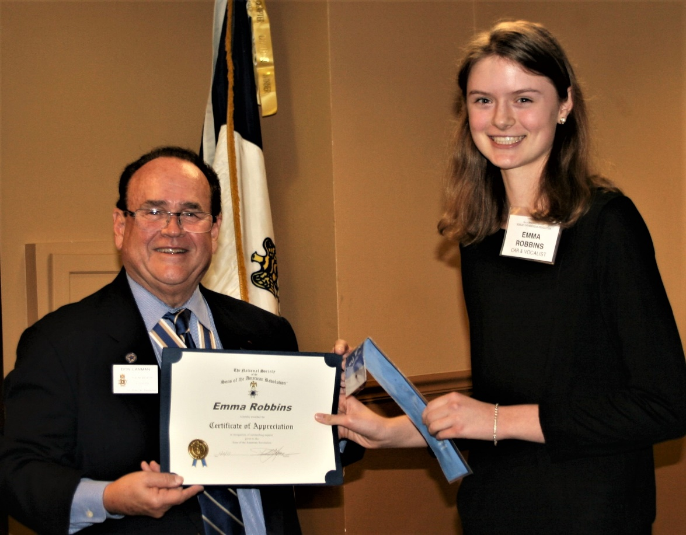

FLSSAR State President Robert Folk delivers Greetings
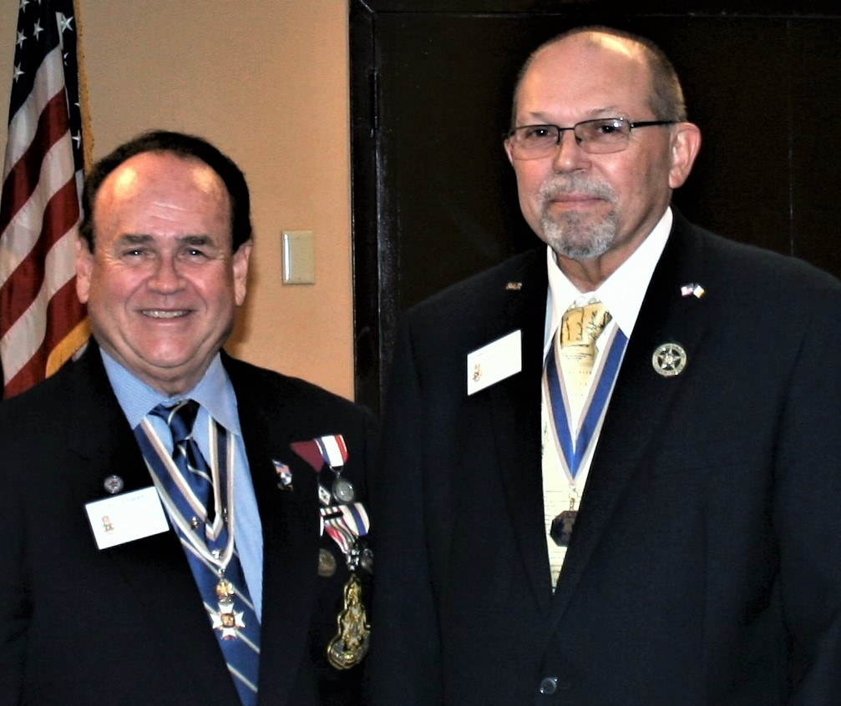

President Lanman Welcomes Compatriots Dr. Ron Giddens,
Peter Miller, Richard Linn & Robin Martin into Chapter
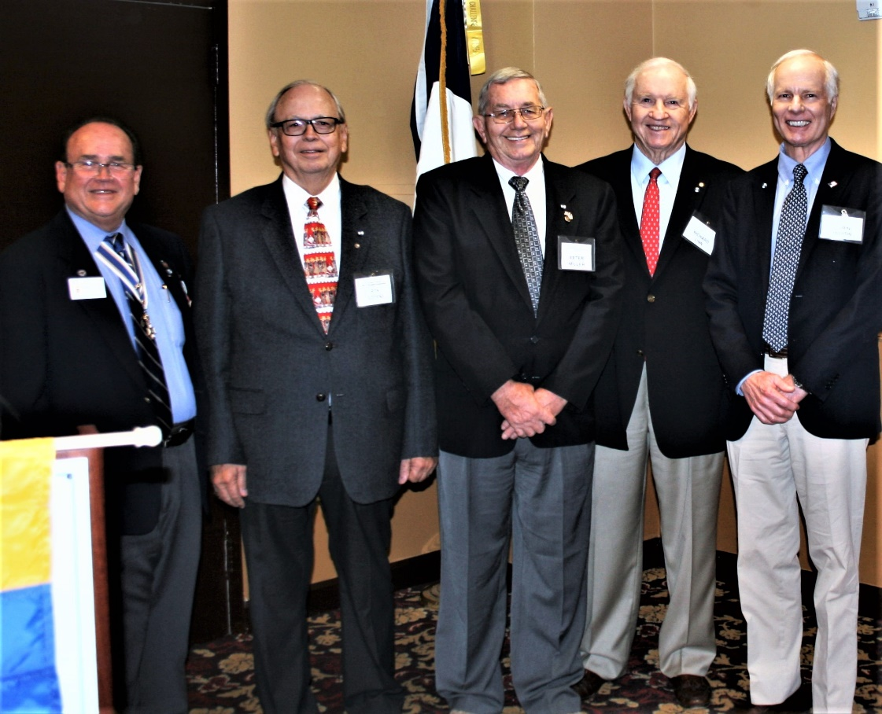
DAR Daughters & Honored Chapter Supporters Sally Hitt & Fran Green
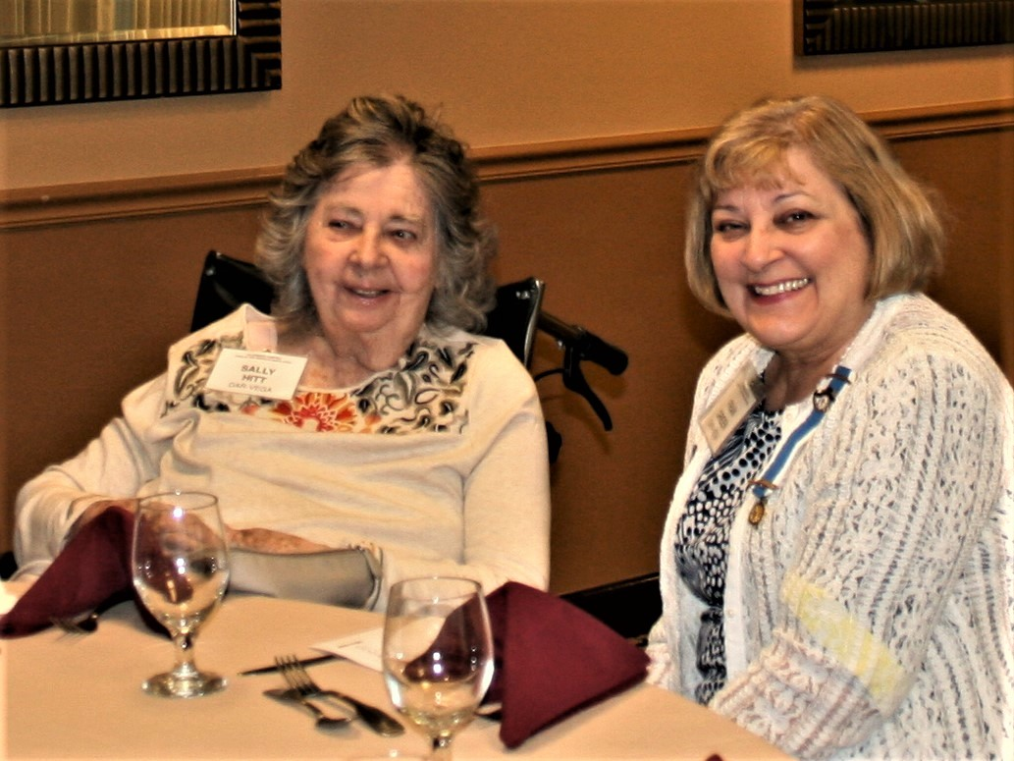

~80th Anniversary Bronze Commemorative Collector Coin $10.00~
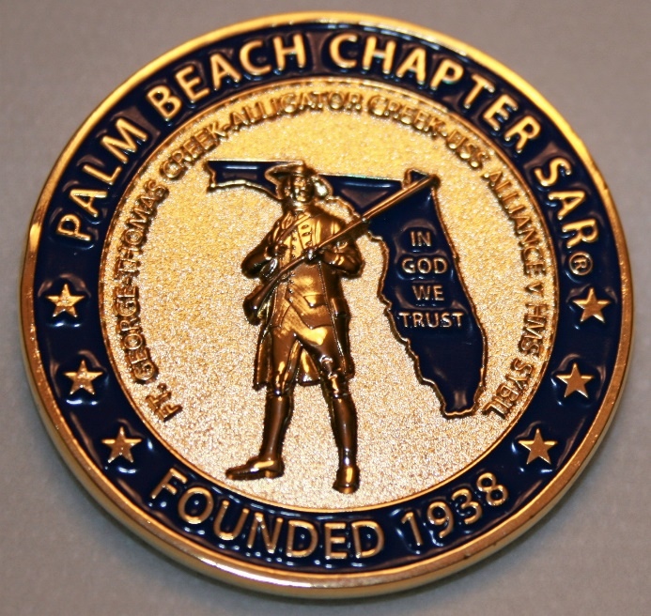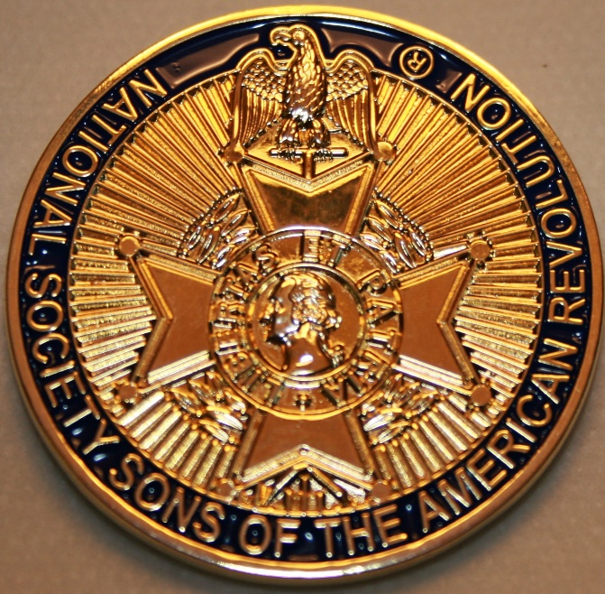

~Compatriot Sponsored Promotions~

Compatriot sponsored newsletter Ads are important to the Chapter as they represent additional funds in support of Chapter projects including Scholarships, Boy Scout & JROTC medals, Rumbaugh & Knight Essay Youth contests, Police-Firefighter-EMT medals, Americanism & community civic programs!

Help your Chapter, sponsor an Ad for 8 issues at a modest cost: Business Card $50, Half Page $100, Full Page $250. Your AD donation will also qualify you for a listing in the Presidents Brigade. Call Don Lanman 561-315-5073 for information.

SPECIAL SPONSORED ADS ON FOLLOWING PAGES…

~COMPATRIOT ROBERT BRINCKERHOFF

~COMPATRIOT ALEXANDER DREYFOOS
AUTHOR/PHOTOGRPHER

~COMPATRIOT SONNY BARBER,
HISTORIAN/AUTHOR

~GARCILASO DE LA VEGA, CHAPTER
DAUGHTERS OF THE AMERICAN REVOLUTION

-Morgan Stanley-
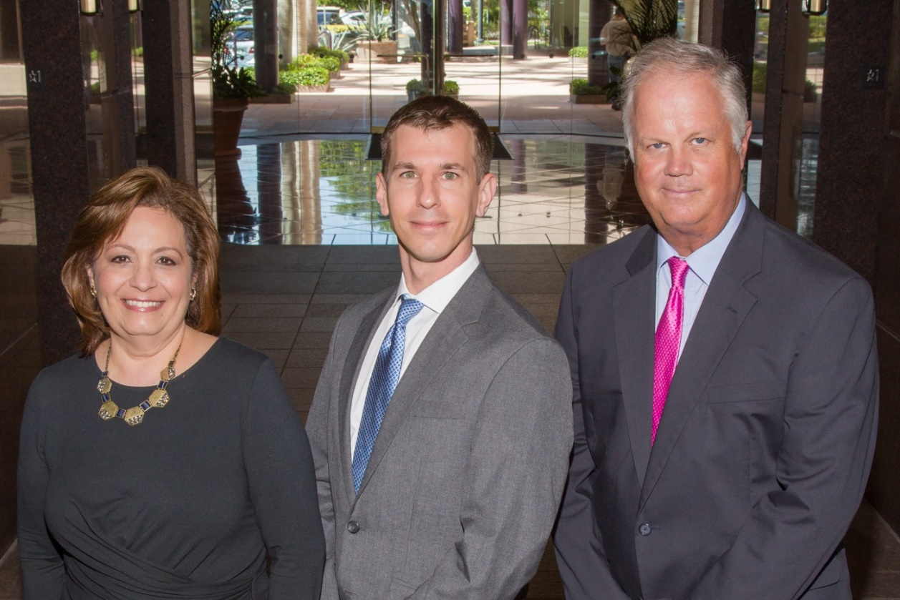
Amani Gaballa, Senior Registered Associate; Robert Scarborough, Financial Advisor; Robert Brinckerhoff, First Vice President, Financial Advisor
Robert W. Brinckerhoff
Senior Vice President, Financial Advisor
777 S. Flagler Dr. Suite 700, East Tower
West Palm Beach, FL 33401
(561) 650-7514
Robert.Brinckerhoff@MorganStanley.com

Bob has been a financial advisor since March 1976. He focuses on investment strategies, retirement planning, liquidity solutions for individuals, commercial real estate, and small business owners.

Bob is a graduate of the University of Vermont. His clients are geographically diverse and he frequently travels from the east coast to the west to meet with clients. He is active with nonprofit organizations that support the blind and visually impaired. Bob is also an active enthusiast in Ferraris.

The investments listed may not be suitable for all investors. Morgan Stanley Smith Barney LLC recommends that investors independently evaluate particular investments and encourages investors to seek the advice of a financial advisor. The appropriateness of a particular investment will depend upon an investor’s individual circumstances and objectives. Morgan Stanley Smith Barney LLC is a registered Broker/Dealer, Member SIPC, and not a bank.

Where appropriate, Morgan Stanley Smith Barney LLC has entered into arrangements with banks and other third parties to assist in offering certain banking related products and services. Investment, insurance and annuity products offered through Morgan Stanley Smith Barney LLC are: NOT FDIC INSURED, MAY LOSE VALUE, NOT BANK GUARANTEED, NOT A BANK DEPOSIT, NOT INSURED BY ANY FEDERAL GOVERNMENT AGENCY. Copy write 2015 Morgan Stanley Smith Barney LLC, Member SIPC CRC1355648 11/15.
TWO GREAT BOOKS-ONE GREAT MAN
-Alexander W. Dreyfoos-

-A PHOTOGRAPHIC ODYSSEY- -PASSION & PURPOSE-
Compatriot Alexander W Dreyfoos, Jr. an honored member of the Palm Beach Chapter Sons of the American Revolution, noted American entrepreneur, and philanthropist has published two remarkable books that should be on every bookshelf. Book sales proceeds donated to local West Palm Beach charities!

- Passion & Purpose chronicles a remarkable lifetime of passion with photography, his business, inventions and philanthropic ventures, as well as his adventures above and below the water. $29.95.
- A Photographic Odyssey is a remarkable collection of hundreds of stunning pictures from 100,000 photos taken by Alex around the world and bound in an elegant 15” by 10” glossy photographic book. You will travel with Alex around the world, above and below the water, to forests, jungles, glaciers, and deserts in the exotic locals of Papua New Guinea, Bhutan, Nepal, China, Japan, and Tibet. The subjects are very divergent contrasting palaces and temples with the vulnerability of people, animals, and exotic scenery. $60.00.
- Support your Chapter & local charities! Get both books, Passion & Purpose & A Photographic Odyssey, just $71.96 @ kravis.org/books or Call 561-651-4329.
-Alexander W. Dreyfoos-

Graduating from MIT and Harvard Business School, Alex founded Photo Electronics Corporation (PCS), specializing in photography and video production. Over the decades, Alex earned 10 US patents and invented the Video Color Negative Analyzer for motion pictures earning him an Academy Award for technical achievement. Many inventions, developed by PCS, are on permanent display at the Smithsonian Institution. Locally Alex also owned television station WPEC TV-12, the CBS affiliate in West Palm Beach. Alex’s many philanthropic achievements include founding the Palm Beach County Cultural Council, the Raymond F. Kravis Center for the Performing Arts and gifting a million dollars to the Dreyfoos School of the Arts. Alex also donated a million dollars each to the Palm Beach County biomedical research campus of the Scripps Research Institute and the local Max Planck Florida Foundation for Neuroscience in Jupiter, Florida.

HISTORICAL MYSTERY SERIES FROM THEREVOLUTIONARY WAR ACROSS TIME
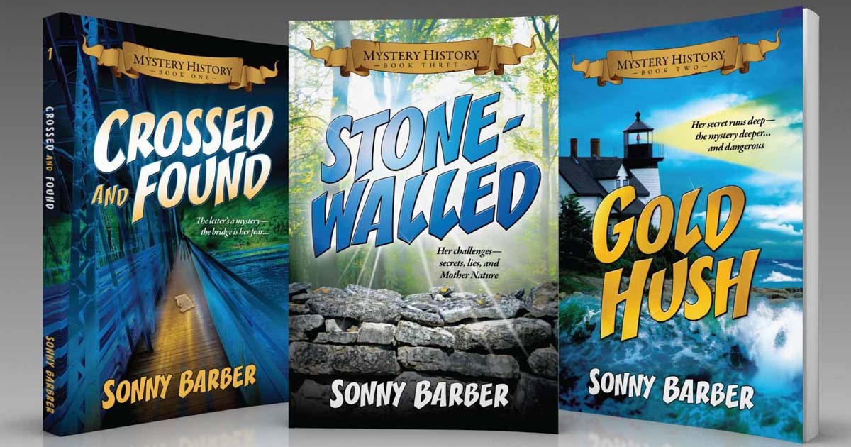

Follow Kay Telfair across time beginning with Crossed & Found followed by Gold Hush & Stone-Walled….

Kay is a normal young teen—normal if that means being unusually curious and having an uncanny knack for putting herself in dangerous situations, which stresses her parents and often tests the relationship with best friend Anna.

The series follows Kay across two intrigue-filled summers on adventures involving events in American history. Join Kay’s journey of adventure steeped in American History through three books that excite all ages. At amazon.com, Barnes & Noble or Chapter meetings. (See book summaries following page)

SAR Palm Beach Chapter Compatriot/Author Sonny Barber developed an interest in American history at an early age, reading and collecting newspapers, magazines and other materials on historic U.S. and world events. He’s coupled that interest with his fiction writing to create a modern-day “mystery history” Series perfect for Preteens to Adults.
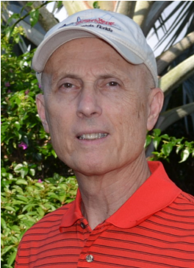

~Crossed & Found~
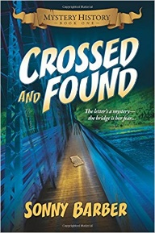
Thirteen-year-old Kay Telfair believes her life is over when she moves with her family a thousand miles to their new home near the Delaware River in New Jersey. But her life takes an unexpected turn when she meets Anna and discovers a two-centuries-old letter--a letter that could change American history. Before she unravels the letter's mystery, Kay stumbles headlong into an adventure--confronting fears she'd never experienced, stretching the limits of her friendship with Anna, and forcing a test of Kay's physical strength that could save her own life.
~Gold Hush~
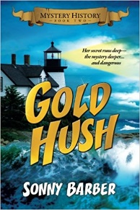
“I’m avoiding any activity that involves excitement…I’ve learned my lesson.” After an adventure-filled June, all Kay Telfair wants is a quiet vacation in Maine with her family and best friend Anna—no drama, no stress. But the thirteen-year-old’s hopes for a tranquil August stay in the village of Prospect Harbor soon fade when the girls compete for the attention of a young boy and Kay makes a startling discovery—a discovery that sends the three teens on a dangerous quest. Ignoring advice—and menacing threats from others—they continue their pursuit, drawing them deeper into a perilous mystery, deeper than Kay ever could have imagined.

~Stonewalled~
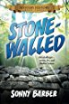
Kay stared at the gray line of stone walls. “They won’t be too upset to see these knocked down...” A mystery that threatens the relationship with best friend Anna, a battle with Mother Nature at her worst, and the discovery of a tragic secret—not exactly what fourteen-year-old Kay Telfair was looking for in a summer getaway. But that’s what confronts the young teen while helping the owners of Windcrest Farm find a way to stop destruction of nearby farmland and its three-hundred-year-old stone walls. Vacationing with her family and Anna at Windcrest in the quiet, coastal village of Little Compton, Rhode Island, the young teen soon discovers her goal will not be easy. Kay’s prospects for helping preserve the valuable land and stone walls look much better after a surprise visit by a boy from her past. With his help, she pours all her energy and passion into the quest, searching for answers in New England’s Native American and colonial history and learning some important lessons about perseverance and friendship.
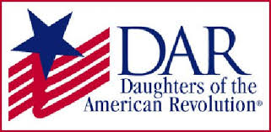
Garcilaso de la Vega Chapter, NSDAR
Lake Worth, Florida

Alisha Darcy, Regent
Karen Christie, Registrar
Phone; 561-236-2460-Email; IMC4U4@AOL.com
Chapter Email: GarcilasodelaVegaDAR@gmail.com
Visit us on Facebook @ https://www.facebook.com/LWDAR

