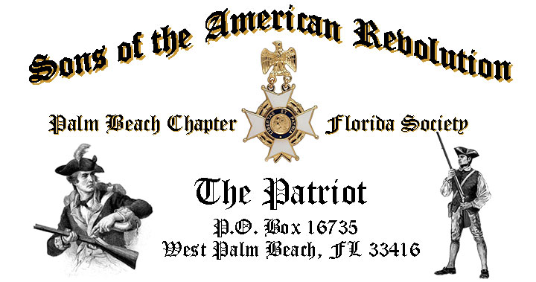

***Volume 24 December 2018 Number 09***

***You are cordially invited to join us at the Chapter Transfer of Leadership, 2019 Officer Installations, Awards & Recognition****,* ***Tuesday,*** **January 15** @ **12 Noon** @ the *Embassy Suites Hotel* 1601 Belvedere Road, WPB! ***RSVP Now for this event!***

***January 15 Meeting Highlights…***

* ***“Transfer of Power, 2019 Officer Installations, Awards & Recognition****,*
* ***4-Course Buffet Lunch, 2-Special Desserts & Beverages***
* ***$28 per person Check/Cash at the Door***
* **Family, Friends & Guests Always** ***Welcome***
* ***Reservations*** **Required,** **RSVP**, **Ben Tidwell** **(561)-704-9918**

***Newsletter Content:***

* **President’s** **Message**
* **2019 Officers & Board Members**
* **2019 Chapter Meeting Dates &Topics**
* ***President’s Brigade* Financial Supporters**
* **Committees, Chairmen & Members**
* **National/State/Chapter, News & Events**
* **Feature Article:** 
  + ***America’s Hidden Patriots-Heroines of the Revolution***
* **Pictures-Meetings** **& Events**

***President’s Message:***

***Fellow Compatriots, DAR Daughters & Friends…***

November is *Veterans’ Month*, and especially *Veterans Day* is the time honored opportunity to say *“Thank You”* to our nation’s veterans and serving members of our beloved military world-wide.

Our November meeting was highlighted by a moving presentation by *Compatriot*, *Navy* *Veteran and Author*, *Sonny Barber*! Sonny delivered a heartfelt window into the tragedy and meaning of the WW One on its 100th Anniversary.

You’ll also want to read *Compatriot* and *Army Veteran Lanman’s* reveling article “***America’s Hidden Patriots”***honoring the unsung “***Heroines of the Revolution”***.

I am excited to share with you that the ***80th Anniversary***celebration held Saturday December 8 at the historic *Everglades Club* was a resounding event hosting 140 guests*,* a 3-course plated lunch and our ***Annual Christmas Holiday Musical*** featuring the award winning ***Dimension 20 Choir***. The January Newsletter will feature all the exciting details along with the event pictures.

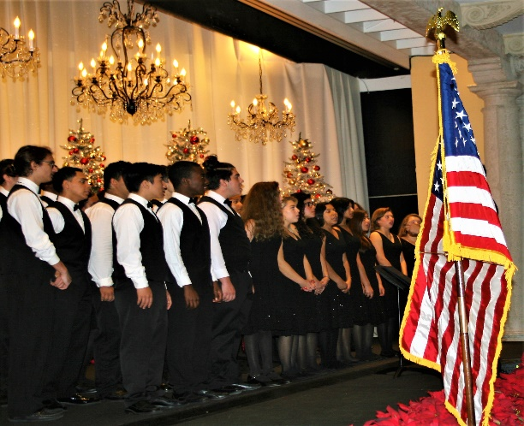

January represents the last month that I will serve as the Chapter President. While 2018 has gone by quickly, and as I turn over the responsibility to the new Officers I reflect with pride on our many chapter accomplishments.

I thank the officers and compatriots for their 100% support during the year as we maintained our leadership as the largest chapter in the State, the induction of over 10 new compatriots, the 80th Anniversary celebration, and participating in numerous patriotic activities including *Memorial Day, Flag Day, Constitution Week, Veteran Honor Flights, Missing in America Veteran Burial* Ceremonies, *Forgotten Soldiers Day*, *Veterans Day*, *Last Naval Battle*, DAR events, and Genealogical Society membership recruiting events.

Please join us on January 15 to participate in the very special Chapter Transfer of Leadership to the ***2019 Officer Installation, Awards & Recognition*** event***.***

Your 2019 Officers will be formally inducted by me at the January meeting and will include ***President******Robert Boggs****,* ***Vice President******Thomas Hayes****,* ***Secretary******Gary Green****,* ***Treasurer******Peter Johnston****,* ***Registrar******Robert Boggs****,* ***Chaplain******Father Sanford Sears****,* ***Historian******Samuel “Buddy” Miller, Sgt. @ Arms Peter Miller****,* ***Officer @ Large******Greg Parkinson***. Congratulations Gentlemen!

As I conclude my term as Chapter President I am humbled by the wonderful support that I received from my fellow officers, former presidents and all Compatriots who made my job so enjoyable. I can never thank you enough.

As a former president, I intend to continue my active and full support of the chapter’s vision, mission and goals by serving as chairman of the Endowment Trust Fund, JROTC and related Youth programs along with my state level committee commitments.

The Chapter bid a sad farewell to Honorary Compatriot General Albin F. Irzyk 1917-2018. A true American Hero, General Irzyk was a WW2 Veteran of the Battle of the Bulge, commanded the 14th Armored Cavalry Regiment along the “Iron Curtain” in Europe and the Headquarters Area Command in Saigon, Vietnam during the TET Offensive of 1968.

[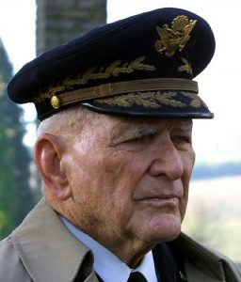](https://www.google.com/url?sa=i&rct=j&q=&esrc=s&source=images&cd=&cad=rja&uact=8&ved=2ahUKEwjRoOnP67jdAhUwq1kKHUfGDtgQjRx6BAgBEAU&url=https://jimsudmeier.com/albin-irzyk/&psig=AOvVaw1btwrtt360gqClBm4r6Zby&ust=1536957549009075)

***Compatriots….your 2018 Membership Dues are past due NOW!*** To keep your membership active, Compatriots need to send in their **2018 Membership Dues of $75** plus additional donations immediately to maintain membership in the SAR before 12/31.

A primary Chapter goal for the continued success of our Chapter is membership development and the mentoring of new members. We are currently at 185 members with 41 prospects in the pipeline.

However, with the natural turnover of members, we need all Compatriots to help grow membership by recruiting civic-minded individuals interested in honoring our patriot ancestors and enjoying good fellowship.

*Compatriot Veterans* are encouraged to join the Veterans Battalion by providing the Chapter with a copy of their ***DD-214*** and be recognized with the ***SAR Military Service*** or ***War Service Medal*** and join the 15% of Chapter Vets who’ve served honorably from ***WW II*** to***Iraq***.



***Don’t wait to be asked***, we need help on committees supporting our youth and civic programs including ***Historical Oration, Knight Essay, Poster*** and ***Brochure*** contests***, American History Teacher of the Year, Boy Scouts, Police-Firefighter* recognition*, Flag & Liberty Tree,*** and ***Veterans*** services*.*

***Help Grow Chapter Membership*** by enrolling your ***Sons*** and ***Grandsons*** and encourage wives, daughters, and granddaughters to join the *Daughters of the American Revolution, Children of the Revolution* and the *Chapter Women’s Auxiliary*.

Our beloved ***DAR Patriot Daughters*** support our Chapter meetings and events, and we sincerely appreciate their tireless efforts to help us by referring new SAR prospects.

All Compatriots are encouraged to support local *DAR* Chapters by attending their meetings, fundraising and patriotic events.

***Compatriots***, I look forward to seeing you at the ***January 15th***meeting! Please, join me in remembering our *Patriot Ancestors, Departed Compatriots* and especially our nation’s Veterans.

***God Bless You*** & ***God Bless the United States of America.***

***Yours in Patriotism*** **– *Benjamin Franklin Tidwell III, President 2018***

*** Hear Ye-Hear Ye…..Chapter Editorial***

***~LIBERTAS ET PATRIA~***

***~LIBERTY & COUNTRY~***

|  |
| --- |
|  |

*The Palm Beach Chapter* was founded and chartered by then ***President General Messmore Kendall*** on ***March 16, 1938*** in the iconic ***Writing Room*** of the historic ***Palm Beach Everglades Club***.

The *Charter’s 19* founding members included many of America’s leading political, civic and business leaders of the time including *Compatriots* *Messmore Kendall, Charles F. Coe, Clifford V. Brokaw, Phil H. Sawyer, Blane Webb, J. Field Wardlaw, David B. Crandall, Harold A. Braman, Roscoe T. Anthony, Loring W. White, Ellingsworth Warner, W. Marvin Clifton, Homer E. Sawyer, F. Reeves Rutledge, James A. Dew, Ira L. Nesmith, W. Murry Hammer* and *Richard P. Robbins.*

In honor of our ***80th Anniversary****,* the Chapter designed a custom gold ***Chapter Commemorative* *Coin*** honoring the *Palm Beach Chapter* and its 80 years of patriotic, philanthropic, and civic service in Palm Beach County, Florida. These coins may be purchased for just $10 each.

A year-long celebration that began in January concluded with a very special ***80th Anniversary*** 3-course plated luncheon at the iconic/historic ***Palm Beach Everglades Club*** on *Palm Beach Island*, on Saturday *December 8.*

Attended by a record ***140*** guests, the event included a ***Toast to Washington***, 3-course plated lunch, ***80th Souvenir Program***, ***Anniversary Coin*** and the ***Chapter’s Holiday Musical*** featuring the award winning ***Dimension 20 Choir***.

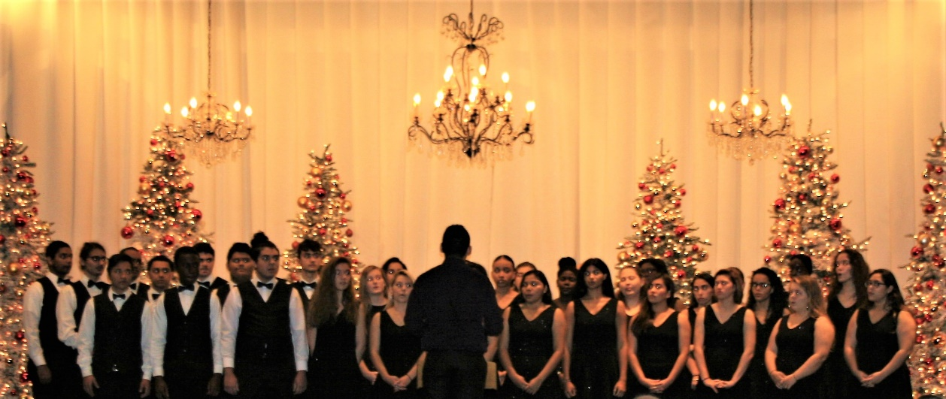

***~In Heartfelt Comradeship & Patriotism******- D. Lanman, Editor***

***2019 Chapter Meeting Dates/Topics:***

**Visit** the Palm Beach Chapter web site @ [www.sarpbchapter.org](http://www.sarpbchapter.org) for a meeting calendar, special events, articles, pictures, and general information.

* **Dec. 8, 2018**, ***80th Anniversary-Christmas-Holiday Musical***
* **Jan. 15. 2019, Officer Installations, Recognition & Awards**
* **Feb. 19, Special Guest Speaker, *Thomas Jefferson***
* **Mar. 19, Special Guest Speaker**
* **April, 16, Police & Law Enforcement Recognition**
* **May, 21, Firefighter & First Responder Recognition**
* **Oct. 15, Special Guest Speaker**
* **Nov. 19, Special Guest Speaker**
* **Dec. 7, 2019, *Christmas-Holiday Musical***

***2019 Officers & Board:***

* ***President******Robert Boggs***
* ***Vice President******Thomas Hayes***
* ***Secretary******Gary Green***
* ***Treasurer******Peter Johnston***
* ***Registrar******Robert Boggs***
* ***Chaplain******Father Sanford Sears***
* ***Sgt. @ Arms Peter Miller***
* ***Historian******Samuel “Buddy” Miller***
* ***Officer @ Large******Greg Parkinson***
* ***Patriot Newsletter Editor******Donald Lanman***

***Join the President’s Brigade to Support Youth Programs!***

The Chapter authorized ***$1,000***Scholarship to the ***Palm Beach Atlantic University*** again for ***2019***. This university educates our youth on the values of God and Country and helps develop character for the leaders of tomorrow.

The Chapter honors and expresses its sincere appreciation to the *Compatriots* of the ***President’s Brigade*** who support our scholarship and youth programs.

The dedicated members of the ***President’s Brigade*** donate ***“Extra Dollars”*** in support of the Chapter’s many youth programs, scholarships, civic activities, award certificates, police/firefighter/EMT medals, veterans’ projects, and related community civic programs.

***Please Help*** increase the scholarship amount this year to ***$4,000*** *by* donating a few dollars to the ***Presidents Brigade*** in support of these students of character.

***Honored Presidents Brigade Members*:**

* **Bronze Level: $25-$99:**

***M. Anderson, J. Blackburn, B. Boggs, J. Chataing, A. Cass, C. Coldwell, M. Curry, S. Curry, J. Dorsey, W. Davis, F. Devitt, J. Harper, J. Kane, L. Lassitter, P. Miller, S. Miller, J. Mayne, G. Parkinson, H. Oyer, J. Porter, S. Sears, A. Shea, W. Told, J. Wearn, L Watkins***

* **Silver Level: $100-$199:**

***J. Curry, D. Coldwell, R. Culpepper, T. Friend, G. Green, F. Green, A. Griswold, W. Johnson, W. Meakin, S. McWhorter***

* **Gold Level: $200-$499:**

***R. Brinckerhoff, S. Barber, R. Banta , E. Buckley, J. Curry, S. Hitt, W. Meakin, J. Wynns***

* **Platinum Level: $500+**

1. ***Dreyfoos, B. Tidwell, D. Lanman, K. Christie, J. Damron-Fritz***

***Committees, Chairs & Members:***

***Fellow Compatriots…..***The Chapter expresses its sincere appreciation to those members who volunteer to serve on our committees and projects. As you can see a few Compatriots are serving on multiple committees and could use some extra support! **Just** choose a committee of interest for ***2019***.

It doesn’t take much time and is a major help with our many civic and youth initiatives. **Call Bob Boggs (561-241-3128)** **Today** and lend a hand on the following committees…

* ***2020 Officer Nominations -Chapter Members***
* ***80th Anniversary -Lanman, Tidwell, Officers***
* ***JROTC & Boy Scouts -Barber, Tidwell***
* ***Law Enforcement-Fire Safety -Parkinson, Green***
* ***Veterans Affairs -Lanman, Curry***
* ***Newsletter/Publicity -Lanman***
* ***Knight Essay/Rumbaugh Oration -Boggs***
* ***American History Teacher -Boggs***
* ***Medals/Awards -Lanman, Tidwell***
* ***DAR-CAR Liaison -Tidwell, Lanman***
* ***Speakers Bureau -Lanman, Tidwell***
* ***Audit -Coldwell, Tidwell***
* ***Flag Certificates -Miller, Johnston***
* ***Membership Development -Green, Boggs, Tidwell***
* ***Liberty Tree -Chapter Officers***
* ***Patriot Bios -Miller***
* ***Web Site-Facebook/Social Media -Anderson, Lanman***

**Palm Beach Chapter 80th Year Commemorative Coin $10!**

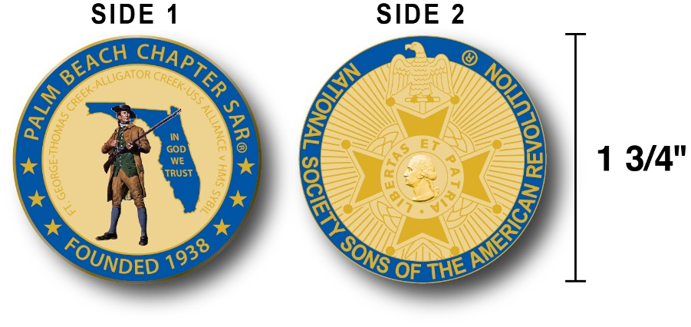

The Chapter created a custom bronze *Commemorative Anniversary Coin* honoring the founding of the ***Palm Beach Chapter in 1938*** and celebrating its 80 years of historic, patriotic, and civic service in Palm Beach County and Florida.

The beautiful collector’s coin is highlighted in ***George Washington*** ***military blue*** on a stunning ***Gold*** background. *Side-one* is personalized for our Chapter with our founding date and a ***Patriot* *Minuteman*** guarding *Florida* over the *State* motto ***"In God We Trust”.***

The collector’s coin includes an inscription listing the four major Revolutionary War battles waged in ***Florida*** including the battles of ***Ft. George-Pensacola, Thomas Creek Massacre, Alligator Creek Battle,*** and the ***Last Naval Battle* of the Revolutionary War** between the mighty ***USS Alliance*** vs. the ***HMS Sybil.***

Side-two displays the national ***SAR*** ***Cross of Malta***.  Very impressive indeed!

The custom bronze ***Commemorative Anniversary Coin*** is designed to celebrate our founding in **1938**, create a distinctive and impressive image for our Chapter and be used as a token of appreciation for honored guests, speakers, and as special awards.

***Classy SAR Lapel Pins $10:***

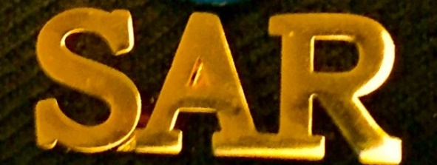

Display a ***Gold*** ***SAR*** pin on your suit lapel or shirt with the ***SAR Rosette***. The SAR Lapel Pin is part of a national branding program to help promote the S.A.R. and stimulate new membership!

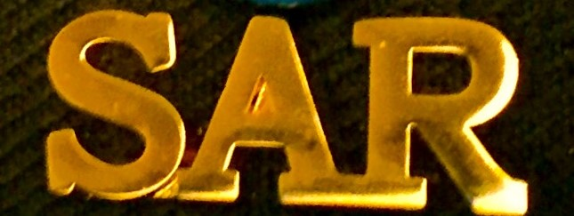

The striking lapel pin is a recognizable public symbol of the SAR, provides you recognition as a member of this great society, and will spark conversations about SAR that leads to a new member.

The ***SAR Gold*** lapel pin along with the ***SAR Rosette*** create a professional image that will improve overall SAR name recognition. The Chapter has a supply of pins for Compatriots for just $10.

***Show Chapter Spirit….***

**Get your 80th Anniversary Coin & Gold SAR Pin today**!

***SAR Chapter, State & National Events:***

**-*CHAPTER/STATE*:**

***Join Chapter Members at SAR events. See Bob Boggs/Don Lanman for details.***

***~Feature Articles~***

***America’s Hidden Patriots***

***Heroines of the Revolution!***

***Compiled-Edited-Written by Don Lanman, Palm Beach Chapter SAR President 2017-2018***

***30 Revolutionary War Heroines played a vital role in winning the Revolution, serving as soldiers, nursing injured soldiers, spying on the enemy, providing supplies to patriots and raising morale…***

***Deborah Sampson***

[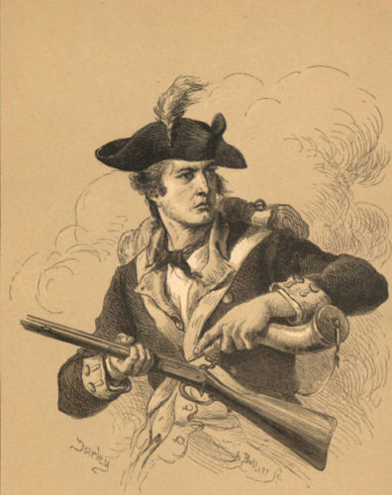](https://www.google.com/url?sa=i&rct=j&q=&esrc=s&source=images&cd=&cad=rja&uact=8&ved=2ahUKEwi6wfiW4obfAhVBJt8KHeOdBesQjRx6BAgBEAU&url=https://ohiohistoryhost.org/ohiomemory/archives/3520&psig=AOvVaw3tR0wfL1l17d8ykoq-2ViH&ust=1544033204615583)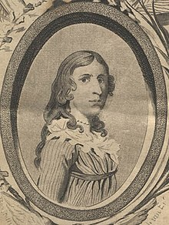 **[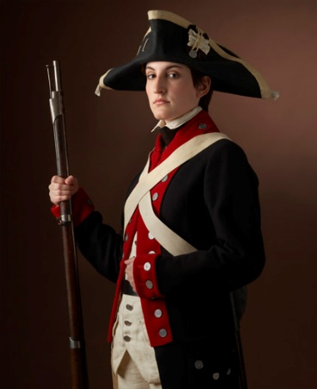](https://www.google.com/url?sa=i&rct=j&q=&esrc=s&source=images&cd=&cad=rja&uact=8&ved=2ahUKEwjMofWpzs7ZAhWGUlAKHRn4CyoQjRx6BAgAEAY&url=http://cooper11.wikis.birmingham.k12.mi.us/Tess-Deborah%2BSampson&psig=AOvVaw0zSREiv4HuBN3jLYaGSfoD&ust=1520112926591833)**

***Deborah Sampson Gannett*, was a Massachusetts woman who disguised herself as a man in order to serve in the *Continental Army* during the American Revolutionary War.**

**She is one of a small number of women with a documented record of military combat experience in that war. *Age 21 Deborah Sampson joined the Continental Army in the famed 4th Massachusetts Regiment disguised as a man, Robert Shurtliff.***

***Severely wounded* by a sword slash across the forehead and two musket balls lodged in her thigh *at the battle of Tarrytown in 1782 Deborah successfully hid her secret by treating her own wounds.* Subsequently taken ill with fever, she was discovered, and honorably discharged for her gallant service. She later received a pension and continued to actively advocate for women's rights.**

***Lydia Barrington Darragh***

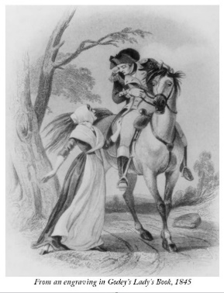[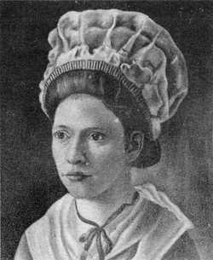](https://www.google.com/url?sa=i&rct=j&q=&esrc=s&source=imgres&cd=&cad=rja&uact=8&ved=2ahUKEwjanpKUhLHeAhXOslkKHS7yD-cQjRx6BAgBEAU&url=https://www.findagrave.com/memorial/28814348/lydia-darragh&psig=AOvVaw11KdN2vyQPU8fiz9-hIjGE&ust=1541087414027632)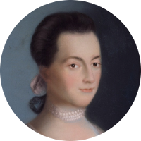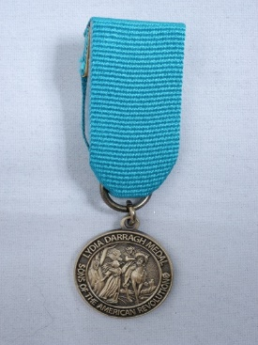

***Lydia Darragh*, an American woman patriot crossed, British lines during the British occupation of Philadelphia, PA during the American Revolutionary War, delivering information to the *Continental Army* that warned them of a pending *British* attack.**

**Though she opposed war, this gentle Quaker was an ardent patriot who risked her life to warn *Washington* of secret British plans to make a surprise attack on the** [***Continental Army***](https://en.wikipedia.org/wiki/Continental_army) **camped at** [***Whitemarsh***](https://en.wikipedia.org/wiki/Battle_of_White_Marsh)***,* PA allowing the Patriots to prevail.**

**Despite her patriotism both Lydia and her husband Charles lost their membership in the *Society of Friends-Quakers* for taking an active role in war. She is honored by the *CIA* as the first American female spy and by the *National Society Sons of the American Revolution in the form of its prestigious “Lydia Darragh Medal”*.**

**Mary Ludwig Hays McCauley, “Molly Pitcher”**

[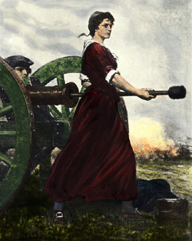](https://www.google.com/url?sa=i&rct=j&q=&esrc=s&source=imgres&cd=&cad=rja&uact=8&ved=2ahUKEwjHgsKg-7DeAhUtwVkKHWwgCAcQjRx6BAgBEAU&url=https://www.findagrave.com/memorial/820/molly-pitcher&psig=AOvVaw0-H3Tkqlwibwd8Ab_rpTsZ&ust=1541085031340600)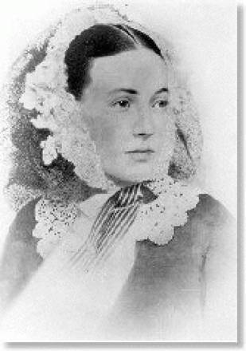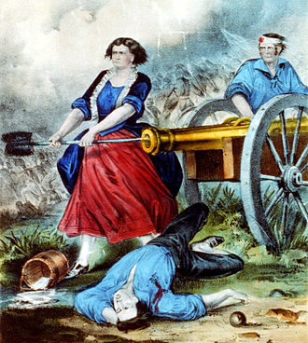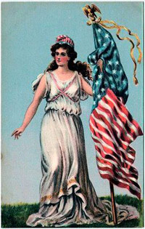

**Better known as *Molly Pitcher*, she was the legendary Patriot Heroine who contributed to the American victory at *Monmouth Battle* by firing her wounded husband’s cannon.**

**Earning her nickname “Molly”, she carried pitchers of water to soldiers on the battlefield, but following her husband’s collapse from injuries she continued to fire his cannon delivering blistering fire on *British* troops. Honored in 1822 for her bravery, the spring she used as her water supply on the Monmouth battlefield is now marked as the *“Molly Pitcher Spring”.***

***Sybil Ludington***

[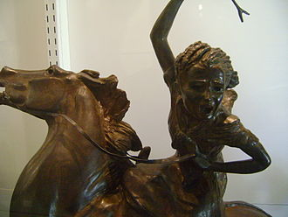](https://en.wikipedia.org/wiki/File:File-Sybil_Ludington_statue_close_up,_Offner_museum.JPG)[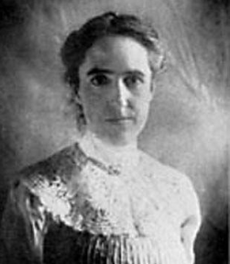](https://www.google.com/url?sa=i&rct=j&q=&esrc=s&source=imgres&cd=&cad=rja&uact=8&ved=2ahUKEwjnkenAgbHeAhVMrlkKHUyfAXUQjRx6BAgBEAU&url=https://alaforveterans.wordpress.com/2017/03/31/the-struggle-to-serve-sybil-ludington-rides-to-gather-the-troops/&psig=AOvVaw1WbU_CKGtM2KeBcMI5Xgeo&ust=1541086698211634)[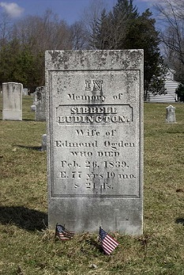](https://en.wikipedia.org/wiki/File:Sybil_Ludington_grave.jpg) 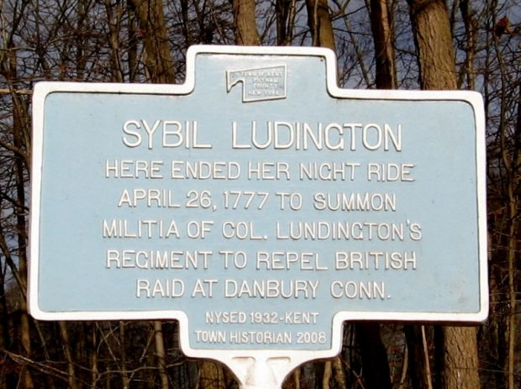

**Sybil Ludington is celebrated as a heroine of the American Revolutionary War. On April 26, 1777, Sybil Ludington rode her horse, *Star*, 40 miles through the night in** [**Putnam County, New York**](https://en.wikipedia.org/wiki/Putnam_County,_New_York) **to warn 400** [**militiamen**](https://en.wikipedia.org/wiki/Militiamen)**, under the command of her father, that *British* troops were planning to attack the Continental Army at the supply depot at** [**Danbury, Connecticut**](https://en.wikipedia.org/wiki/Danbury,_Connecticut)**.**

**Ludington's ride started at 9 p.m. and ended around dawn, and on her way to alert her father's troops, she also warned the people of Danbury and surrounding community of the British approach.**

**That afternoon, after *Sybil* had warned residents of Danbury, the British troops burned down three buildings and destroyed multiple houses, but failed to find or kill many patriots due to Sybil’s timely warning.**

**Prior to her famous ride, Sybil saved her father from capture. When a royalist named Ichabod Prosser along with 50 royalists, tried to capture her father, Sybil lit candles around the house and organized her siblings to march in front of the windows in military fashion, creating the impression of many troops guarding the house causing the royalists to flee.**

**Unlike accounts about the rides of** [**Paul Revere**](https://en.wikipedia.org/wiki/Paul_Revere) **and** [**William Dawes**](https://en.wikipedia.org/wiki/William_Dawes) **before the outbreak of the Revolution, little was told of Sybil Ludington's ride or heroism since the only record of the events was written by her great grandson.**

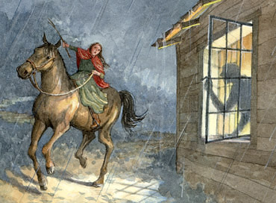

**Emily Geiger**

[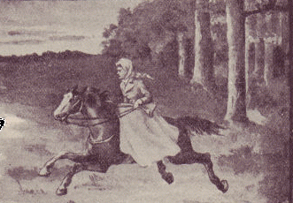](https://www.google.com/url?sa=i&rct=j&q=&esrc=s&source=images&cd=&cad=rja&uact=8&ved=2ahUKEwiSuLe8qbHeAhWD1lkKHVAmAXAQjRx6BAgBEAU&url=https://blog.ultimateflags.com/2017/11/30/teenage-heroine-emily-geiger/&psig=AOvVaw3qV5RNPyHLPB6tOvyytZgi&ust=1541097398771316)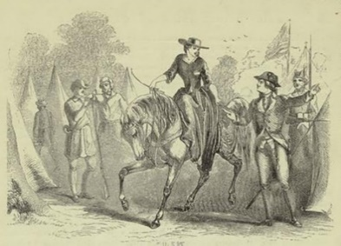[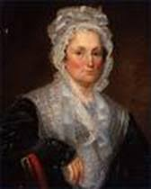](https://www.google.com/url?sa=i&rct=j&q=&esrc=s&source=images&cd=&ved=2ahUKEwiMza-33tbeAhWSrFkKHQf8A_kQjRx6BAgBEAU&url=https://www.thinglink.com/scene/615264017002266624&psig=AOvVaw28WNW9UeFLtTS4iLM0jadb&ust=1542382696322300)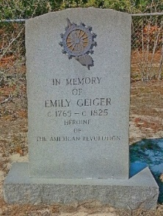

[**A true American Revolutionary War**](https://en.wikipedia.org/wiki/American_Revolutionary_War) **heroine this young girl volunteered to deliver a vital military message form General Greene to General Sumter through territory patrolled by the *British*.**

**Emily was provided with the letter but also committed the message to memory in case of capture. Traveling on horseback, she traveled under the disguise of being on her way to visit relatives.**

**On the second day, *British* scouts intercepted her coming from the direction of Greene's army and not being able to lie without blushing, Emily was arrested under suspicion of being a spy.**

**However, following a search by a loyalist matron nothing could be found since, having memorized the message, Emily had eaten the letter. With no evidence, *Emily* was released and proceeded to verbally deliver the message to General Sumter. Her successful mission led to a significant patriot victory.**

**Mammy Kate**

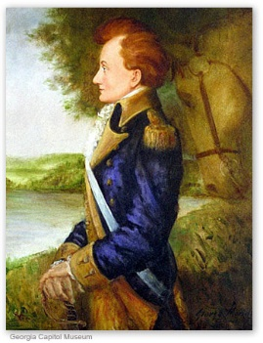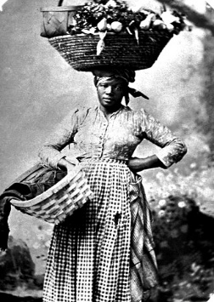[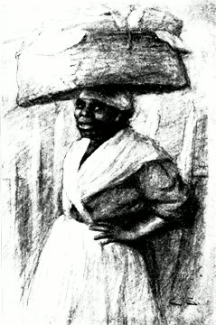](https://www.google.com/url?sa=i&rct=j&q=&esrc=s&source=imgres&cd=&cad=rja&uact=8&ved=2ahUKEwj7wLfjmrHeAhUhzlkKHY4hAS8QjRx6BAgBEAU&url=https://mamafrancisca.blogspot.com/?view%3Dsnapshot&psig=AOvVaw1p7WkTJ7bxL_OZlleP0oaq&ust=1541093474222109)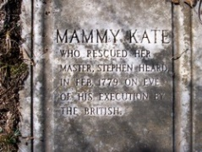

**An** [**enslaved**](https://en.wikipedia.org/wiki/Slavery_in_the_United_States) **woman, Mammy Kate, was owned by** [**Stephen Heard**](https://en.wikipedia.org/wiki/Stephen_Heard)**, Revolutionary War** [**Lieutenant Colonel**](https://en.wikipedia.org/wiki/Lieutenant_Colonel) **of the Georgia Militia, friend of** [**George Washington**](https://en.wikipedia.org/wiki/George_Washington)**, hero of the** [**Battle of Kettle Creek**](https://en.wikipedia.org/wiki/Battle_of_Kettle_Creek)**, and the future Governor of** [**Georgia**](https://en.wikipedia.org/wiki/Georgia_(U.S._state))**.**

**Heard suffered greatly at the hands of the** [***Loyalists***](https://en.wikipedia.org/wiki/Loyalist_(American_Revolution)) **who burned his house and forced his wife and daughter into a snowstorm where they died of exposure. Heard was subsequently captured by the *British* at the *Battle of Kettle Creek*, and taken to prison where he was** [**sentenced to death**](https://en.wikipedia.org/wiki/Capital_punishment)**.**

***Manny Kate* followed Heard to the prison one morning presenting herself with a large covered basket on her head. Telling the** [**sentry**](https://en.wiktionary.org/wiki/sentry) **that she was there to pick up *Colonel Heard's* soiled linen, she was admitted to his cell. Kate concealed Heard, a very small man, in the basket and calmly walked past the guard carrying Heard balanced in the basket on her head.**

***Manny Kate* carried Heard to where she had hidden two horses for their escape. Heard offered to set her free, but she responded by telling him that while he could set her free, but she was never going to set him free.**

**Heard did give Kate her** [**freedom**](https://en.wikipedia.org/wiki/Freedman) **plus a deed to a small tract of land and a four-roomed house, but she continued to live and work for the Heard family while raising her own family.**

**Nanyehi, “Nancy Ward”**

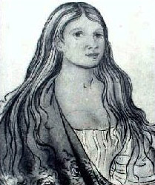 [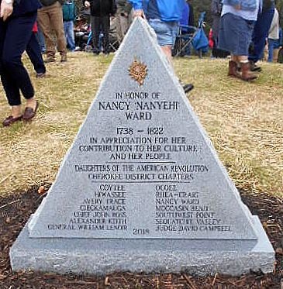](https://www.google.com/url?sa=i&rct=j&q=&esrc=s&source=images&cd=&cad=rja&uact=8&ved=2ahUKEwijk97j5NbeAhXGzlkKHcx4Cn8QjRx6BAgBEAU&url=https://www.pinterest.com/pin/288441551128228323/&psig=AOvVaw0HlX1iwe72cj00QgiKEhK1&ust=1542384645734832)[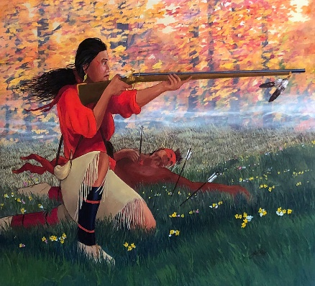](https://www.google.com/url?sa=i&rct=j&q=&esrc=s&source=images&cd=&cad=rja&uact=8&ved=2ahUKEwihq6b-5tbeAhUIk1kKHZDaCpgQjRx6BAgBEAU&url=https://fineartamerica.com/featured/nanyehi-at-taliwa-john-guthrie.html&psig=AOvVaw0HlX1iwe72cj00QgiKEhK1&ust=1542384645734832) [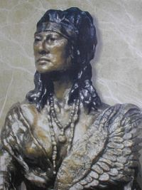](https://www.google.com/url?sa=i&rct=j&q=&esrc=s&source=images&cd=&cad=rja&uact=8&ved=2ahUKEwjd8Oq_6NbeAhWFjVkKHYRwD_oQjRx6BAgBEAU&url=https://www.pinterest.com/pin/43487952635289789/&psig=AOvVaw0HlX1iwe72cj00QgiKEhK1&ust=1542384645734832)

**In July 1776, Cherokee Nanyehi (Nan-Ye-Hi) also known as Nancy Ward, was a beloved leader of the *Cherokee* who advocated for a peaceful coexistence with settlers and warned a group of patriot settlers on the Virginia border of imminent attacks by British and their Cherokees loyalists.**

**Trying to prevent wholesale retaliations against all Cherokees, Nanyehi continued to warn the Americans of British and Cherokee Loyalists’ attacks, while providing provisions and cattle to the starving Patriot militia.**

**A year later, Nanyehi negotiated a peace treaty between the Cherokees and the Americans allowing *Washington* to move large numbers of his patriot army to reinforce the *Colonial Army* fighting *British General Cornwallis* at Yorktown.**

**Martha Custis Washington**

[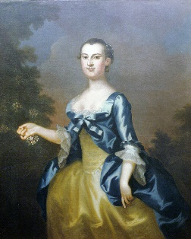](https://www.google.com/url?sa=i&rct=j&q=&esrc=s&source=images&cd=&cad=rja&uact=8&ved=2ahUKEwi80NCh6tbeAhVpxFkKHYUOAQ0QjRx6BAgBEAU&url=https://www.mountvernon.org/george-washington/martha-washington/biography/&psig=AOvVaw0gqBNxZGsKhed2cYW6XHbB&ust=1542386136546311)[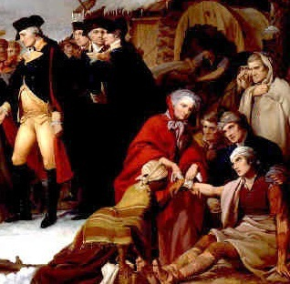](https://www.google.com/url?sa=i&rct=j&q=&esrc=s&source=images&cd=&cad=rja&uact=8&ved=2ahUKEwixu7zY6tbeAhXRq1kKHWLfBXsQjRx6BAgBEAU&url=http://www.firstladies.org/biographies/firstladies.aspx?biography%3D1&psig=AOvVaw0gqBNxZGsKhed2cYW6XHbB&ust=1542386136546311)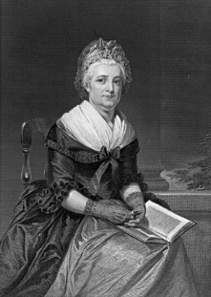[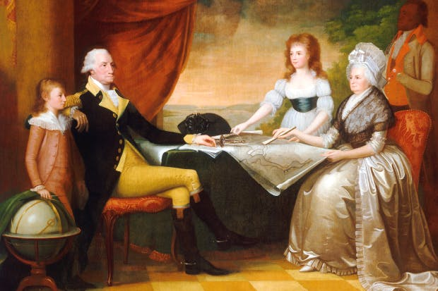](https://www.google.com/url?sa=i&rct=j&q=&esrc=s&source=images&cd=&cad=rja&uact=8&ved=2ahUKEwiGyvWC69beAhVInlkKHd8CCocQjRx6BAgBEAU&url=https://www.spectator.co.uk/2015/12/george-and-martha-washington-were-an-odd-first-first-couple/&psig=AOvVaw0gqBNxZGsKhed2cYW6XHbB&ust=1542386136546311)

***Martha Washington* took her familiar role as her husband's hostess at camp. Wife of the commander in chief, she accompanied or traveled to her husband whenever possible helping to support and cheer the troops and the general.**

**Throughout the grim winter at Valley Forge she not only encouraged the troops but socialized with the soldiers, their wives and the senior officers at Valley Forge.**

**Years later an aide to** [***Baron von Steuben***](https://en.wikipedia.org/wiki/Baron_von_Steuben)**, recalled that the ladies and officers at camp would meet at each other's quarters to discuss how to encourage the troops, improve morale and support the war effort.**

**During her lifetime she was often referred to as *"Lady Washington”* and although the title was not coined until after her death, Martha served as the first “**[**First Lady” of the United States**](https://en.wikipedia.org/wiki/First_Lady_of_the_United_States)**.**

**Abigail Smith Adams**

[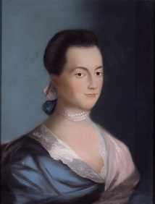](https://en.wikipedia.org/wiki/File:Abigail_Adams.jpg)[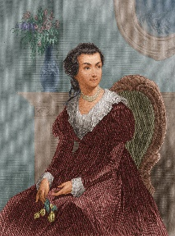](https://www.google.com/url?sa=i&rct=j&q=&esrc=s&source=images&cd=&cad=rja&uact=8&ved=2ahUKEwjMxvH48NbeAhUFrlkKHYDLDZ0QjRx6BAgBEAU&url=https://www.biography.com/people/groups/abigail-and-john-adams&psig=AOvVaw2wh1QObbD3k9eE75NPb-FL&ust=1542387778366024)[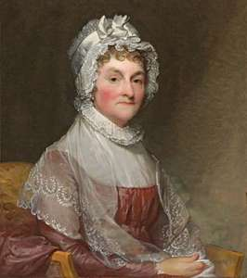](https://www.google.com/url?sa=i&rct=j&q=&esrc=s&source=images&cd=&cad=rja&uact=8&ved=2ahUKEwjsrIew8NbeAhWouVkKHUg9DFwQjRx6BAgBEAU&url=https://www.britannica.com/biography/Abigail-Adams&psig=AOvVaw2wh1QObbD3k9eE75NPb-FL&ust=1542387778366024)[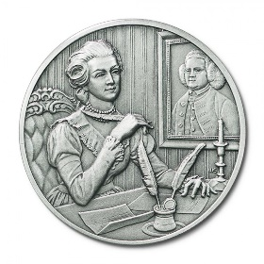](https://www.google.com/url?sa=i&rct=j&q=&esrc=s&source=images&cd=&cad=rja&uact=8&ved=2ahUKEwiwxrnI8NbeAhWHwFkKHdChB5kQjRx6BAgBEAU&url=https://www.blackmountaincoins.com/dar-great-women-of-the-american-revolution-abigail-smith-adams-pewter-medallion.html&psig=AOvVaw2wh1QObbD3k9eE75NPb-FL&ust=1542387778366024)

**Abigail was wife and closest advisor of** [**John Adams**](https://en.wikipedia.org/wiki/John_Adams)**, as well as the mother of** [***John Quincy Adams***](https://en.wikipedia.org/wiki/John_Quincy_Adams)**. Abigail was a gifted writer and editor. She also had a great influence in writing correspondence for Adams eloquently urging others to continue supporting and fighting for American independence.**

**She is sometimes considered to be the first** [**Second Lady**](https://en.wikipedia.org/wiki/Second_Lady_of_the_United_States) **and second** [**First Lady of the United States**](https://en.wikipedia.org/wiki/First_Lady_of_the_United_States)**, although these titles were not used at the time.**

**Adams's life is one of the most documented of the First Ladies: she is remembered for the many letters she wrote to her husband while he stayed in** [**Philadelphia**](https://en.wikipedia.org/wiki/Philadelphia)**, during the** [**Continental Congress**](https://en.wikipedia.org/wiki/Continental_Congress)**.**

**John frequently sought Abigail’s advice of on many matters, and their letters are filled with intellectual discussions on government and politics. Her letters also serve as eyewitness accounts of the** [**American Revolutionary War.**](https://en.wikipedia.org/wiki/American_Revolutionary_War)

**Sarah "Sally" Franklin Bache**

[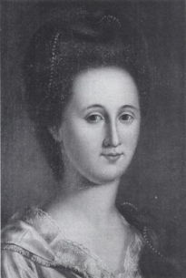](https://www.google.com/url?sa=i&rct=j&q=&esrc=s&source=images&cd=&cad=rja&uact=8&ved=2ahUKEwjByM2u89beAhUhzlkKHRRVA-cQjRx6BAgBEAU&url=https://www.revolvy.com/page/Sarah-Franklin-Bache&psig=AOvVaw3ESQq2D5J7i4kPlKOMJNIu&ust=1542388421482138)[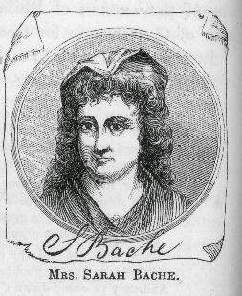](https://www.google.com/url?sa=i&rct=j&q=&esrc=s&source=images&cd=&cad=rja&uact=8&ved=2ahUKEwjL7aj88tbeAhVx0FkKHVu2B7EQjRx6BAgBEAU&url=http://kidlitwhm.blogspot.com/2015/03/women-heroes-of-american-revolution.html&psig=AOvVaw3ESQq2D5J7i4kPlKOMJNIu&ust=1542388421482138)[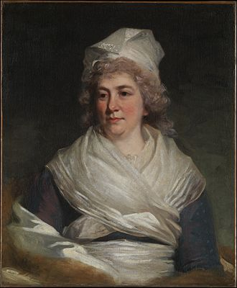](https://en.wikipedia.org/wiki/File:Sarah_Franklin_Bache1793.jpg) [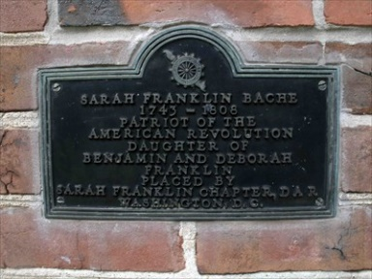](https://www.google.com/url?sa=i&rct=j&q=&esrc=s&source=images&cd=&cad=rja&uact=8&ved=2ahUKEwjHz-zY9dbeAhUGvVkKHZVZC-cQjRx6BAgBEAU&url=http://www.waymarking.com/waymarks/WMCZP2_Sarah_Franklin_Bache_Philadelphia_PA&psig=AOvVaw3ESQq2D5J7i4kPlKOMJNIu&ust=1542388421482138)[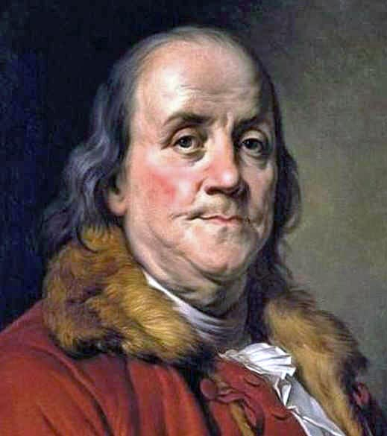](https://www.google.com/url?sa=i&rct=j&q=&esrc=s&source=images&cd=&cad=rja&uact=8&ved=2ahUKEwjiwsHw8tbeAhWDq1kKHaG7BQIQjRx6BAgBEAU&url=https://www.findagrave.com/memorial/9282003/sarah-bache&psig=AOvVaw3ESQq2D5J7i4kPlKOMJNIu&ust=1542388421482138)

***Sarah Bache* was the daughter of**[***Benjamin Franklin***](https://en.wikipedia.org/wiki/Benjamin_Franklin) **and** [**Deborah Read**](https://en.wikipedia.org/wiki/Deborah_Read)**. She was a leader in relief work during the** [**American Revolutionary War**](https://en.wikipedia.org/wiki/American_Revolutionary_War) **involved in the Ladies Association of** [**Philadelphia**](https://en.wikipedia.org/wiki/Philadelphia) **providing material support, and raising money for the** [**Continental Army**](https://en.wikipedia.org/wiki/Continental_Army)**.**

**In 1780, under Sarah’s leadership, the group made over 2,200 shirts for the soldiers in the *Continental Army* at the army's winter quarters at** [**Valley Forge**](https://en.wikipedia.org/wiki/Valley_Forge)**. She also frequently served as her father's political hostess, as her mother had done before her death in 1774.**

**Margaret Cochran Corbin**

[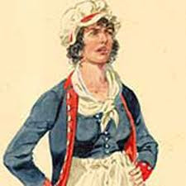](https://www.google.com/url?sa=i&rct=j&q=&esrc=s&source=imgres&cd=&cad=rja&uact=8&ved=2ahUKEwiCq9nA_LDeAhXBrFkKHUbAB4MQjRx6BAgBEAU&url=http://www.accountableinaction.org/weekly-spotlight-american-hero-margaret-corbin/&psig=AOvVaw1u0ViAKzjqbTX3ffvOfhG_&ust=1541085355763020)[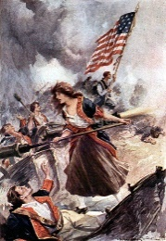](https://www.google.com/url?sa=i&rct=j&q=&esrc=s&source=images&cd=&cad=rja&uact=8&ved=2ahUKEwjtnp-2-tbeAhXGtlkKHaksAwYQjRx6BAgBEAU&url=http://www.eonimages.com/media/c789d9bc-3c54-11e0-a682-77c86b5f5b65-mary-ludwig-hays-aka-molly-pitcher-at-battle-of-monmouth&psig=AOvVaw3vvEH-Fj8I2kDxJvDOighk&ust=1542389339514329)[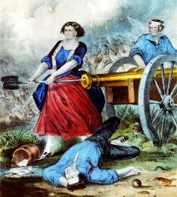](https://www.google.com/url?sa=i&rct=j&q=&esrc=s&source=images&cd=&cad=rja&uact=8&ved=2ahUKEwirqpaL-9beAhXxqlkKHRYCA98QjRx6BAgBEAU&url=https://strangeremains.com/2018/07/04/where-is-the-grave-of-revolutionary-war-hero-captain-margaret-corbin/&psig=AOvVaw3vvEH-Fj8I2kDxJvDOighk&ust=1542389339514329)[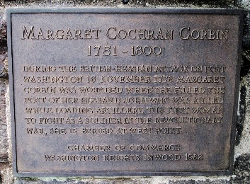](https://www.google.com/url?sa=i&rct=j&q=&esrc=s&source=images&cd=&cad=rja&uact=8&ved=2ahUKEwizw7ze-tbeAhXD1VkKHVs5AdcQjRx6BAgBEAU&url=https://www.wearethemighty.com/articles/meet-the-badass-revolutionary-war-heroine-who-mowed-down-redcoats-with-a-cannon&psig=AOvVaw3vvEH-Fj8I2kDxJvDOighk&ust=1542389339514329)

**On November 16, 1776, Margaret’s husband, John Corbin, was one of some 600 American soldiers defending** [***Fort Washington***](https://en.wikipedia.org/wiki/Fort_Washington_(New_York)) **in northern** [**Manhattan**](https://en.wikipedia.org/wiki/Manhattan) **from 4,000 attacking** [**Hessian troops**](https://en.wikipedia.org/wiki/Hessian_(soldiers)) **under *British* command. Margaret, too nervous to let her husband go into battle alone, decided she wanted to go with him. Because Margaret was a nurse, she was allowed to accompany her husband to serve as a nurse for injured soldiers.**

***John Corbin* served on the crew of two cannons deployed against the British when he fell in action. *Margaret immediately* took his place and continued to fire the cannon until she too was seriously wounded.**

**It is said that *Margaret* was standing next to her husband when he fell during battle. Because she had watched her husband fire the cannon she was able to take his position, clean, aim and fire the cannon with great ease and speed delivering lethal fire on the *British*.**

***Margaret’s* grace under fire impressed the other soldiers and was the beginning of her military career.*Margaret* later became the first woman in U.S. History to receive a pension from Congress for military service, and because she could no longer serve due to injury and was enlisted into the *American Corps of Invalids*.**

**Prudence Cummings "Pru" Wright**

[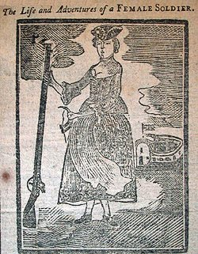](https://www.google.com/url?sa=i&rct=j&q=&esrc=s&source=imgres&cd=&cad=rja&uact=8&ved=2ahUKEwjb-vC7_tbeAhWMuVkKHcWJBckQjRx6BAgBEAU&url=https://sites.psu.edu/slavoffpassion/2017/04/03/prudence-cummings-wright/&psig=AOvVaw1UsQ28SICjDbbk-kIrCrKH&ust=1542391564435597) [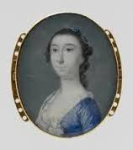](https://www.google.com/url?sa=i&rct=j&q=&esrc=s&source=imgres&cd=&cad=rja&uact=8&ved=2ahUKEwjng4-n_tbeAhVBlVkKHc7bCjYQjRx6BAgBEAU&url=https://revolutionaryrochambeau.com/tag/prudence-cummings-wright/&psig=AOvVaw3v5mQdIcsmfuVnDFDZMWPp&ust=1542391520853309)[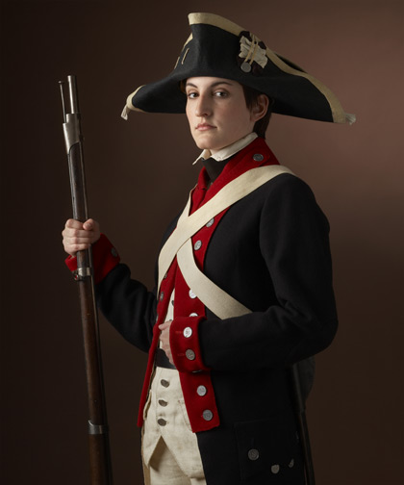](https://www.google.com/url?sa=i&rct=j&q=&esrc=s&source=images&cd=&cad=rja&uact=8&ved=2ahUKEwjMofWpzs7ZAhWGUlAKHRn4CyoQjRx6BAgAEAY&url=http://cooper11.wikis.birmingham.k12.mi.us/Tess-Deborah%2BSampson&psig=AOvVaw0zSREiv4HuBN3jLYaGSfoD&ust=1520112926591833)[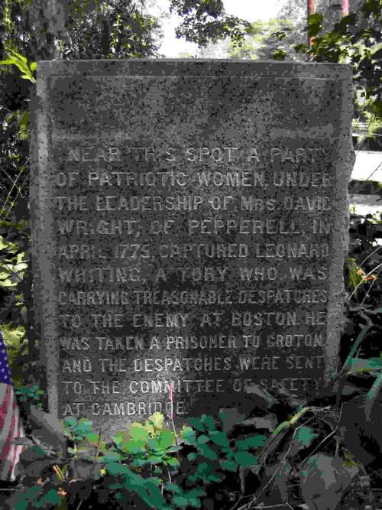](https://www.google.com/url?sa=i&rct=j&q=&esrc=s&source=images&cd=&cad=rja&uact=8&ved=2ahUKEwjJj8SuhNfeAhUPjVkKHaoMCWAQjRx6BAgBEAU&url=http://www.massdar.org/PrudenceWrightChapter.html&psig=AOvVaw0xwiUp22LDHly3zm452h0v&ust=1542391602713663)

**Prudence Cummings "Pru" Wright was a** [**militia**](https://en.wikipedia.org/wiki/Militia) **commander during the** [**Revolutionary War**](https://en.wikipedia.org/wiki/American_Revolutionary_War)**. Born in** [**Hollis, New Hampshire**](https://en.wikipedia.org/wiki/Hollis,_New_Hampshire)**, she was the daughter of Prudence and Samuel Cummings. She had two brothers. Her father was the town clerk.**

**While, she was a patriot, much of her family was loyal to the *British* crown. In 1761, she married *David Wright*, a private in the American militia.**

**Wright was elected by the townsfolk to command a women's militia known as the “**[***Mrs. David Wright's Guard***](https://en.wikipedia.org/wiki/Mrs_David_Wright%27s_Guard)***”*, based in** [**Pepperell, Massachusetts**](https://en.wikipedia.org/wiki/Pepperell,_Massachusetts)**.**

**The group consisted of about 30 or 40 local *Patriot Women* whose husbands were members of the regular militia ordered to march towards Boston following the battles of *Lexington* and *Concord*. The *Wright’s Guard* members dressed in their husbands' clothes and carried "anything that would serve as a potential weapon", including** [**pitchforks**](https://en.wikipedia.org/wiki/Pitchfork)**.**

***Pru Wright* appointed *Sarah Hartwell* *Shattuck* of Groton as her lieutenantand began organizing patrols of the town and the surrounding area.**

**On one patrol in April 1777, the *Wright’s Guard* members arrested** [**loyalist**](https://en.wikipedia.org/wiki/Loyalist) **spies *Captain Leonard Whiting* and two of Wright's own brothers at Jewett's Bridge over the Nashua River.**

**Although the *Wright’s Guard* women were not to be paid for militia service, in 1777 the town convened a committee to compensate *Mrs. David Wright's Guard* (referred to as Leonard Whiting's Guard) for their actions. Leonard Whiting was a British Army officer and a friend of the two arrested spies.**

**On March 19, 1777, Prudence Wright's guard was paid 7 pounds, 17 shillings, and sixpence by the Town of Pepperell's Committee of Estimation. The Town Meeting Minutes referred to *Pru’s* guard as “Leonard Whiting's Guard” because women were not allowed to be overtly paid for services performed during the Revolution.**

**Nancy Morgan Hart**

[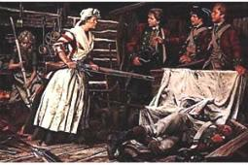](https://www.google.com/url?sa=i&rct=j&q=&esrc=s&source=images&cd=&cad=rja&uact=8&ved=2ahUKEwjupdC1iLHeAhWLxVkKHUPwDKEQjRx6BAgBEAU&url=http://www.womenhistoryblog.com/2010/11/nancy-morgan-hart.html&psig=AOvVaw034uA5EUimIMYSBAbbG07x&ust=1541088516327673)[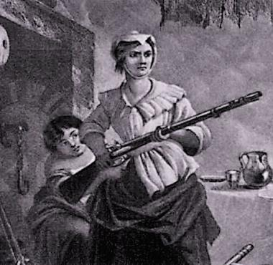](https://www.google.com/url?sa=i&rct=j&q=&esrc=s&source=images&cd=&cad=rja&uact=8&ved=2ahUKEwiegoLR64bfAhVyUd8KHf9hATQQjRx6BAgBEAU&url=https://www.battlefields.org/learn/biographies/nancy-hart&psig=AOvVaw02UWKoqG2i1_K0JJUO-LZV&ust=1544035765034396)[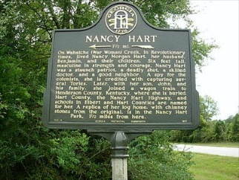](https://www.google.com/url?sa=i&rct=j&q=&esrc=s&source=images&cd=&cad=rja&uact=8&ved=2ahUKEwiujs35iLHeAhWEwVkKHQb-BGsQjRx6BAgBEAU&url=http://www.waymarking.com/waymarks/WM7J97&psig=AOvVaw034uA5EUimIMYSBAbbG07x&ust=1541088516327673)

***Nancy Hart* was a rebel heroine of the American Revolutionary War noted for her exploits against** [**Loyalists**](https://en.wikipedia.org/wiki/Tory#American_Revolution) **in the northeast Georgia backcountry. She is characterized as a tough, resourceful frontier woman who repeatedly outsmarted Tory soldiers, and killed some outright.**

**During the** [**Revolution**](https://en.wikipedia.org/wiki/American_Revolutionary_War)**, a group of six** [**Loyalists**](https://en.wikipedia.org/wiki/Tory#American_Revolution) **soldiers came by the Hart house looking for food and** [**patriot**](https://en.wikipedia.org/wiki/Patriot_(American_Revolution))**s they were pursuing. The** [**Loyalists**](https://en.wikipedia.org/wiki/Tory#American_Revolution) **demanded that Hart cook them one of her** [**turkeys**](https://en.wikipedia.org/wiki/Turkey_(bird)) **and she agreed. As they entered the cabin, they placed their rifles by the door before sitting at her table to eat.**

**While they were drinking and eating, *Nancy* pushed their rifles outside through a hole in the wall of the cabin. After the soldiers had been drinking a sufficient time, she grabbed one of the remaining rifles and ordered the men to stay still. One** [**Loyalists**](https://en.wikipedia.org/wiki/Tory#American_Revolution) **ignored her threat, so *Nancy* shot and killed him.**

**Another** [**Loyalists**](https://en.wikipedia.org/wiki/Tory#American_Revolution) **made a move toward the weapons, and *Nancy* killed him too. She held the remaining soldiers’ captive until her husband arrived. Her husband wanted to shoot the soldiers outright, but Nancy demanded that they be hanged, which was accomplished from a nearby tree.**

**Hannah White Arnett**

[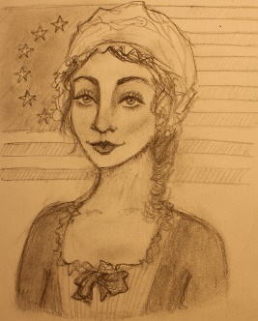](https://www.google.com/url?sa=i&rct=j&q=&esrc=s&source=imgres&cd=&cad=rja&uact=8&ved=2ahUKEwimm4ibtLHeAhWOrVkKHdWOBe8QjRx6BAgBEAU&url=http://girlwithalessonplan.tumblr.com/post/90755787571/coolchicksfromhistory-hannah-white-arnett&psig=AOvVaw2sxyH6ghkjCe5EJsP6ekj3&ust=1541100321078020)[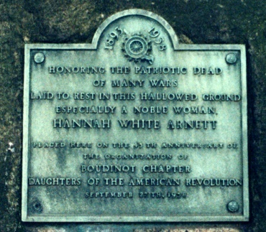](https://www.google.com/url?sa=i&rct=j&q=&esrc=s&source=images&cd=&cad=rja&uact=8&ved=2ahUKEwjOnJiS7IbfAhWBg-AKHeqUDiMQjRx6BAgBEAU&url=http://www.njwomenshistory.org/discover/biographies/hannah-white-arnett/&psig=AOvVaw1vlx65yfxaatJpBIBHlSQq&ust=1544035903783306)[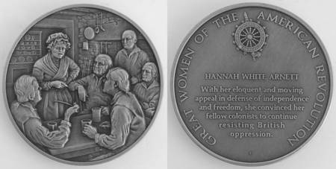](https://www.google.com/url?sa=i&rct=j&q=&esrc=s&source=images&cd=&cad=rja&uact=8&ved=2ahUKEwjnxbHE7IbfAhUoWN8KHeL6ANgQjRx6BAgBEAU&url=https://www.replacements.com/webquote/co_frmbicmedgrw.htm&psig=AOvVaw1vlx65yfxaatJpBIBHlSQq&ust=1544035903783306)

***Hannah Arnett* was an American woman who is known for preventing a group of men in Elizabethtown,** [**Province of New Jersey**](https://en.wikipedia.org/wiki/Province_of_New_Jersey) **from proclaiming their loyalty to** [***Great Britain***](https://en.wikipedia.org/wiki/Great_Britain) **in exchange for "protection of life and property."**

**While meeting in her house, *Hannah* heard the men talking about this offer, she called them cowards and traitors. Although her husband Isaac tried to get her out of the room, she continued to harangue the men and stated that she would leave her husband if he did not continue to support the** [***American Revolution***](https://en.wikipedia.org/wiki/American_Revolution)**.**

**The men eventually refused the British offer, and based on Hannah’s eloquent, moving and relentless appeal in defense of independence and freedom, she convinced her fellow colonists to continue resisting *British* oppression.**

**Mary Clap Wooster**

[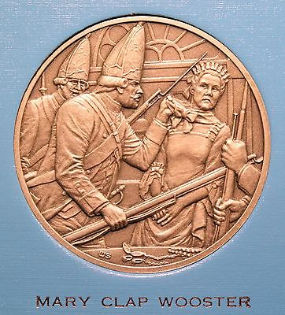](https://www.google.com/url?sa=i&rct=j&q=&esrc=s&source=images&cd=&cad=rja&uact=8&ved=2ahUKEwin5dXu67PeAhUEvFkKHeWjBbQQjRx6BAgBEAU&url=https://picclick.com/Great-Women-of-the-American-Revolution-DAR-401501790996.html&psig=AOvVaw2xCO3UUoUilh5drbo8T2VI&ust=1541183969395322)[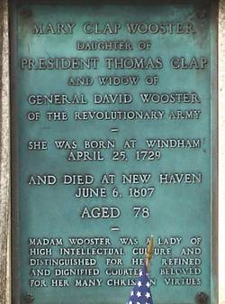](https://www.google.com/url?sa=i&rct=j&q=&esrc=s&source=images&cd=&cad=rja&uact=8&ved=2ahUKEwjTxJuG7LPeAhWDrVkKHXEbChcQjRx6BAgBEAU&url=https://www.findagrave.com/memorial/10495634/mary-wooster&psig=AOvVaw2xCO3UUoUilh5drbo8T2VI&ust=1541183969395322) [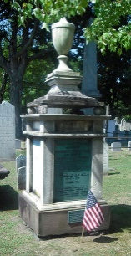](https://www.google.com/url?sa=i&rct=j&q=&esrc=s&source=images&cd=&cad=rja&uact=8&ved=2ahUKEwjhr5fy7IbfAhVhc98KHcVtCoQQjRx6BAgBEAU&url=http://www.maryclapwoosterdar.org/ChapterHistory.html&psig=AOvVaw3a_2zQc5UoCu6oFLzmgchI&ust=1544036083160777)

**Mary was the wife of *Major General David Wooster* and the daughter of *Thomas Clap, President of Yale College* from 1740 to 1766. She was a woman of rare qualities and entered with great ardor into the cause of independence, sustaining her husband with her brave and patriotic spirit throughout his military career**

**During the raid on New Haven in 1779, she was a target of *British* hostility. Nevertheless, she refused to leave her home and gallantly faced the enemy troops and refusing to provide any support.**

***Mercy Otis Warren***

[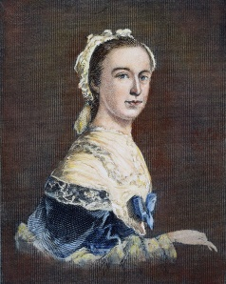](https://www.google.com/url?sa=i&rct=j&q=&esrc=s&source=imgres&cd=&cad=rja&uact=8&ved=2ahUKEwiixKjEqLHeAhViplkKHW7IAfQQjRx6BAgBEAU&url=https://library.concordiashanghai.org/c.php?g%3D576381%26p%3D3976536&psig=AOvVaw3zZj7eJkH1IPcpTkTPU4Fw&ust=1541097175531216) [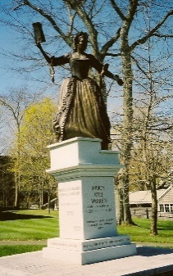](https://www.google.com/url?sa=i&rct=j&q=&esrc=s&source=images&cd=&cad=rja&uact=8&ved=2ahUKEwie3Mmc74bfAhXvhOAKHQgWBSIQjRx6BAgBEAU&url=http://mercywarren.weebly.com/legacy.html&psig=AOvVaw3GTS9tGxqOeyS6YDBa2fty&ust=1544036629868194) [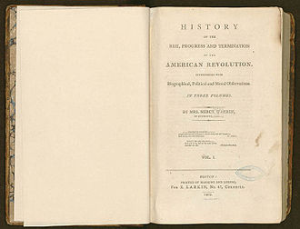](https://en.wikipedia.org/wiki/File:History_of_the_Rise,_Progress_and_Termination_of_the_American_Revolution_(1805).jpg)[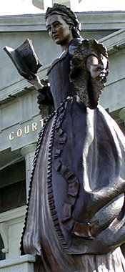](https://www.google.com/url?sa=i&rct=j&q=&esrc=s&source=images&cd=&cad=rja&uact=8&ved=2ahUKEwjF2LzE74bfAhVSMt8KHSyEDvMQjRx6BAgBEAU&url=http://www.capecodtoday.com/article/2007/04/18/929-Nominees-Sought-Mercy-Otis-Woman-Year-Award&psig=AOvVaw3GTS9tGxqOeyS6YDBa2fty&ust=1544036629868194)

***Mercy Otis Warren* was remarkable women of powerful intellect, her patriotic writings inspired revolutionary leaders. She was one of the most influential women of the war as a political writer and propagandist of the** [**American Revolution**](https://en.wikipedia.org/wiki/American_Revolution)**.**

**During the years before the American Revolution, *Warren* published poems and plays that attacked *Royal* authority in Massachusetts and urged colonists to resist British infringements on colonial rights and liberties. She was married to** [***James Warren***](https://en.wikipedia.org/wiki/James_Warren_(politician))**, who was likewise heavily active in the independence movement.**

**During the debate over the** [**United States Constitution**](https://en.wikipedia.org/wiki/United_States_Constitution) **in 1788, *Warren* issued a pamphlet, *Observations on the new Constitution, and on the Federal and State Conventions* written under the pseudonym "A Columbian Patriot," that opposed ratification of the document and advocated the inclusion of a** [***Bill of Rights***](https://en.wikipedia.org/wiki/United_States_Bill_of_Rights)**.**

***Observations* was long thought to be the work of other writers, most notably** [**Elbridge Gerry**](https://en.wikipedia.org/wiki/Elbridge_Gerry)**. It was not until her descendant,** [**Charles Warren**](https://en.wikipedia.org/wiki/Charles_Warren_(U.S._author))**, found a reference to it in a 1787 letter to British historian,** [**Catharine Macaulay**](https://en.wikipedia.org/wiki/Catharine_Macaulay)**, that *Warren* was finally accredited its authorship.**

**In 1790, *Mercy Otis Warren* published a collection of poems and plays under her own name, a highly unusual occurrence for a woman at the time.**

**In 1805, *Mercy Otis Warren* published one of the earliest histories of the American Revolution, a three-volume** [***History of the Rise, Progress, and Termination of the American Revolution***](https://en.wikipedia.org/wiki/History_of_the_Rise,_Progress,_and_Termination_of_the_American_Revolution)**, the first history of the *American Revolution* authored by a woman.**

**Elizabeth Maxwell Steele**

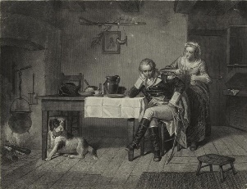

**Sacrificing her life savings, *Elizabeth* gave the generous sum to General Nathanael Greene supporting the revolution and bolstering the Southern Campaign.**

**The encounter occurred at breakfast when a weary and disheartened** [**General Greene**](https://en.wikipedia.org/wiki/Nathanael_Greene) **entered Steele’s NC tavern following a disastrous battle. It was clear that Greene was in need of aid, so she gave him breakfast to help bolster his spirits.**

**Once Steele learned of the current situation, she went into the backroom and returned with two small bags of silver and gold, and giving it to General Greene in support of the patriots cause with the words "Take this, General, you need them and I can do without them."**

**Esther De Berdt Reed**

[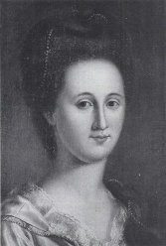](https://en.wikipedia.org/wiki/File:Esther_de_Berdt_Reed_by_Charles_Peale.png) [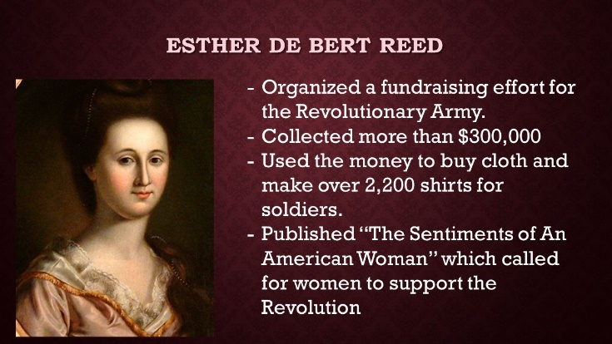](https://www.google.com/url?sa=i&rct=j&q=&esrc=s&source=images&cd=&cad=rja&uact=8&ved=2ahUKEwjct6TD-obfAhWLVN8KHYeIAo4QjRx6BAgBEAU&url=https://slideplayer.com/slide/9944137/&psig=AOvVaw3Pie1-l-PNTJ0aQVpjfJ34&ust=1544039584700959)[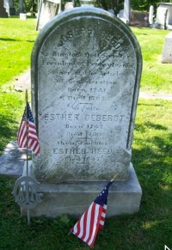](https://www.google.com/url?sa=i&rct=j&q=&esrc=s&source=images&cd=&cad=rja&uact=8&ved=2ahUKEwij9KOG-obfAhWmVN8KHbI_AoQQjRx6BAgBEAU&url=http://inthewordsofwomen.com/?cat%3D279&psig=AOvVaw3Pie1-l-PNTJ0aQVpjfJ34&ust=1544039584700959)

***Esther Reed* was active in the** [**American Revolutionary War**](https://en.wikipedia.org/wiki/American_Revolutionary_War) **as a civic leader for soldiers' relief, who formed and led the *Ladies Association of Philadelphia* to provide aid for** [**Washington**](https://en.wikipedia.org/wiki/George_Washington)**'s troops during the war. Though she was English by birth, Esther was exceptionally devoted to the revolutionary cause. During the Revolutionary War, the Ladies Association of Philadelphia under Reed’s leadership raised thousands of dollars in support of the war.**

**At the suggestion of *General Washington*, the group then used the funds to purchase** [**linen**](https://en.wikipedia.org/wiki/Linen) **and sew clothing for American troops. DeBerdt had wanted to give the men gold or silver coins, something above and beyond what they would normally receive, but *Washington* feared the money would be used for liquor.**

**Esther also had each volunteer seamstress, whether married or unmarried, sew her name into the clothing she made. Over 2,200 shirts were created from the funds and the labor of these women for the soldiers. Esther also published *“The Sentiments of an American Woman”* calling for all women to support the Revolution. For de Berdt's efforts in support of the American cause, she was formally recognized as a** [***Daughter of Liberty***](https://en.wikipedia.org/wiki/Daughters_of_Liberty)**.**

**Mary Aldis Draper**

[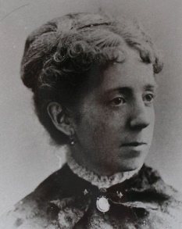](https://www.google.com/url?sa=i&rct=j&q=&esrc=s&source=imgres&cd=&cad=rja&uact=8&ved=2ahUKEwiIo7n4i7HeAhVSmVkKHb5rCsgQjRx6BAgBEAU&url=https://alchetron.com/Mary-Draper&psig=AOvVaw018jiUgsaUfc90qE3G4ZW-&ust=1541089502716262) [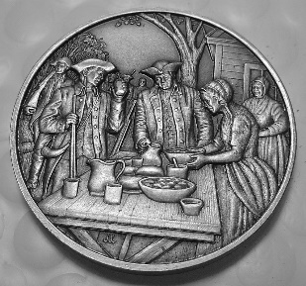](https://www.google.com/url?sa=i&rct=j&q=&esrc=s&source=images&cd=&cad=rja&uact=8&ved=2ahUKEwiPxNjM-4bfAhXLhOAKHXjzASsQjRx6BAgBEAU&url=https://www.ebay.com/itm/Daughters-of-the-American-Revolution-MARY-ALDIS-DRAPER-Pewter-DAR-Medal-/362145084325&psig=AOvVaw2gCtFe96lJU4GRIw2czpB6&ust=1544040056552244)

***Mary Draper* prepared food, made uniforms and molded bullets from pewter heirlooms for patriot soldiers on their way into battle greatly aiding the cause of freedom.**

**Her husband and son serving in the Continental Army, *Mary* and her six children showed their patriotism for the revolution by using all resources possible to provide aid, reduce hunger and generally support the soldiers by providing food and servicing the wounded. Mary also housed the homeless displaced as a result of war.**

**Mary’s daughter Kate and their maid helped her make cloth into coats for the *Colonial* soldiers, sheets and blankets were made into shirts and flannel in her clothes was turned into men's clothing. Mary’s view on war was that she wanted to serve the war effort in order to gain freedom. She died at the age of 91.**

**Elizabeth Cairnes Poe**

***Elizabeth Cairnes Poe*, a relative of Edgar Allen Poe, organized, worked and supervised patriot women and girls of Baltimore making hundreds of uniforms for *Lafayette’s* troops in support of the Southern Campaign.**

**Mary Videau**

**After being held as a rebel spy aboard a British prison ship in Charleston harbor, she planned and executed a daring escape with several other patriots.**

**Faith Robinson Trumbull**

**A prominent woman of colonial Connecticut, she aided suffering patriot troops with generous contributions and inspired other women to join the war effort.**

**Catharine Van Rensselaer Schuyler**

**To prevent the harvest from falling into enemy hands, she burned her extensive wheat fields. Her example was an inspiration to other patriots.**

**Catharine Littlefield**

**Wife of a great patriot general, she opened her home as a hospital to treat victims of smallpox. Her spirit inspired others during the war’s darkest days.**

**Mary Worrell Knight**

**She made her way many times through the British lines with food, clothing and medicine to relieve the suffering of patriot troops at Valley Forge.**

**Hannah Hunter Hendee**

**When her son and eight other children were captured by hostile Indians led by the British, she demanded their release, risking her life to rescue them.**

**Nancy Hanson**

**While the enemy occupied her town, she helped her patriot brothers-in-arms escape. Her daring action under fire saved their lives.**

**Susannah Smith Elliott**

**She made the handsome military banners for the Second South Carolina Regiment that were carried proudly throughout the war of independence.**

**Hannah Ogden Caldwell**

**A martyr to American liberty, she was killed in her home by British soldiers. Her tragic death aroused patriotic fervor among the colonists.**

**Meliscent Barrett**

**Although she was only 15, she supervised a group of women and young girls who made all the cartridges used by patriots at the battle of Concord.**

***~November Meeting & Event Pictures~***

***Officer @ Large Sonny Barber delivers heartfelt presentation***

***in Honor of the 100th Anniversary of WW 1***

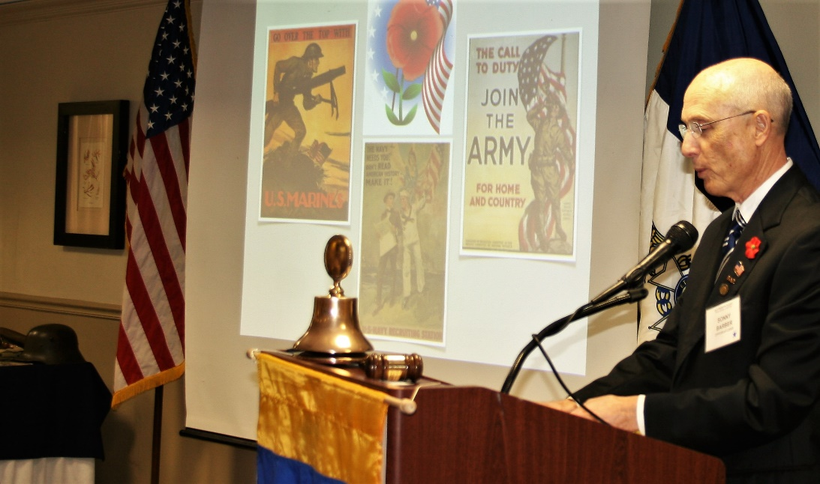

***President Tidwell presents Certificate of Appreciation***

***to Officer @ Large Sonny Barber for his WW1 Presentation***

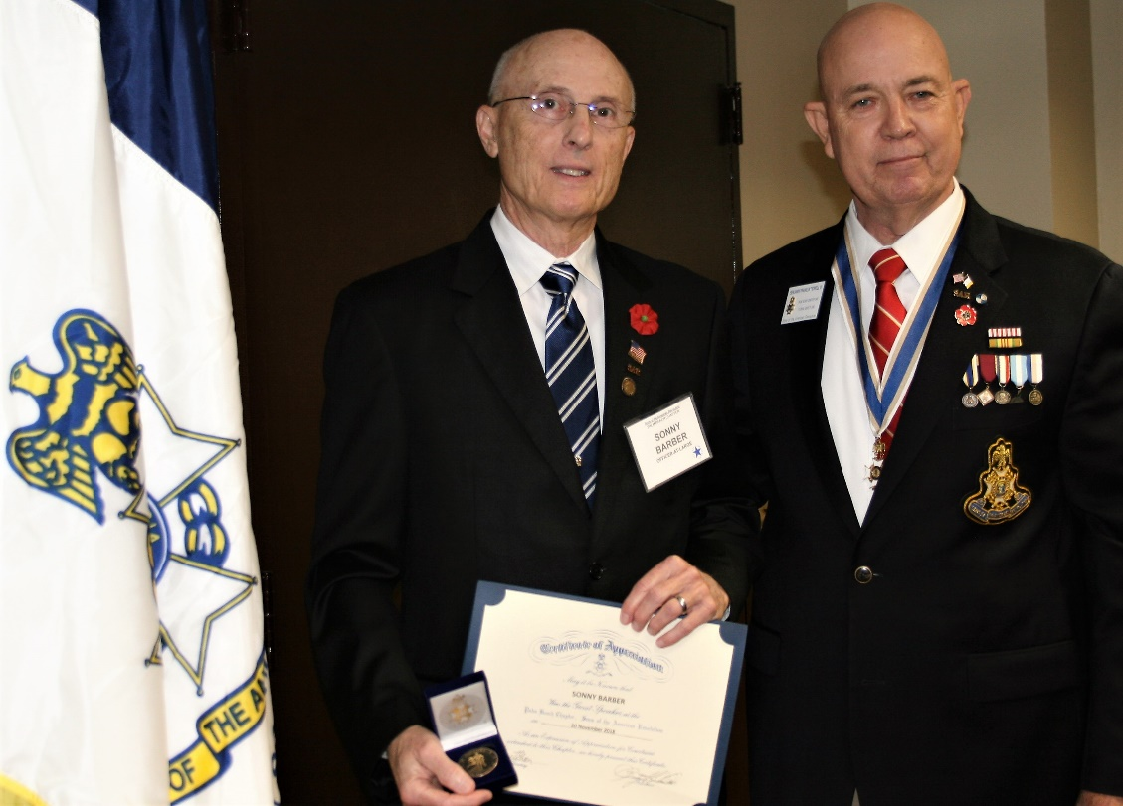

***Compatriot & Veteran Lanman Delivers message Honoring All Veterans***

***~Bunker Hill, New Orleans, Gettysburg, Europe, Korea, Vietnam, Middle East~***

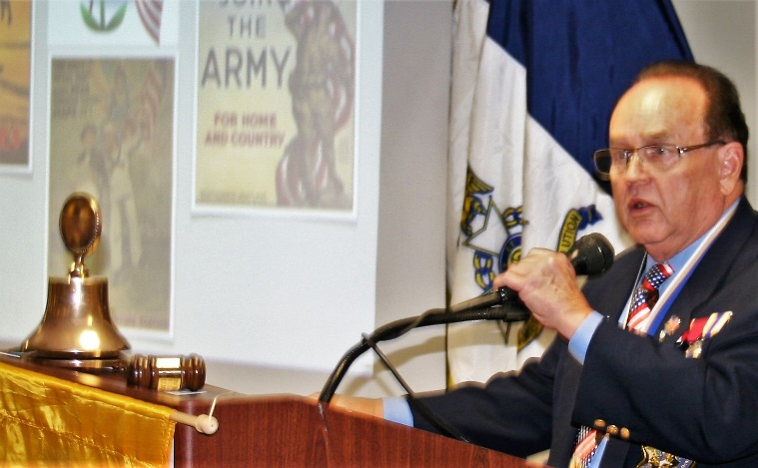 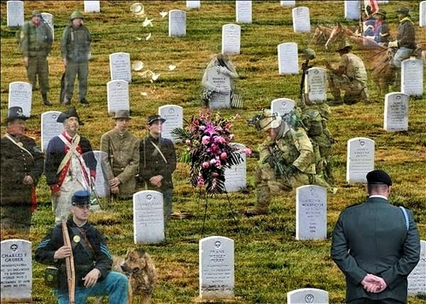

***President Tidwell delivers heartfelt eulogy in honor of***

***Honorary Compatriot & General Albin F. Irzyk 1917-2018***

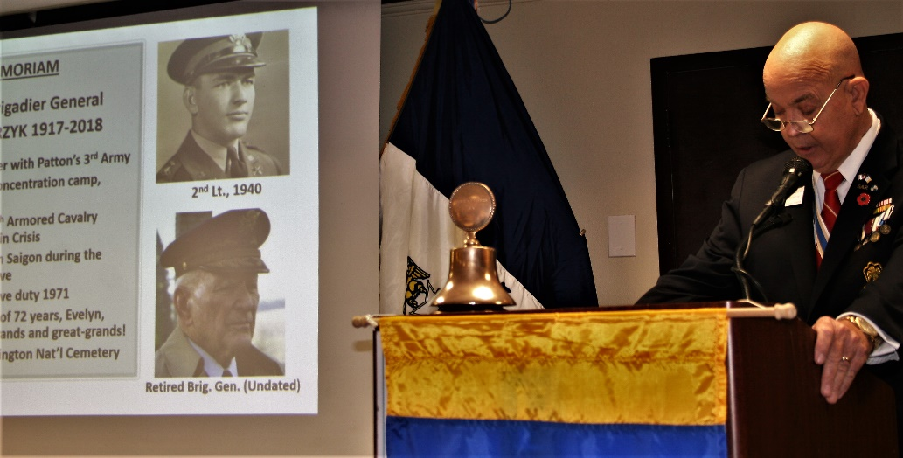

***Honoring Veterans Month President Tidwell presented guests***

***a “Red Poppy” Lapel Pin representing WW 1 Flanders Field***

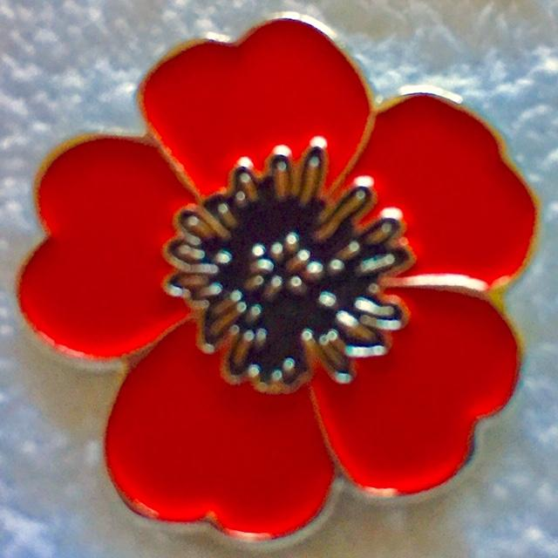

***FMR Presidents Lanman & Parkinson provided a unique display of***

***rare military artifacts in Honor of the WW 1 100th Anniversary***

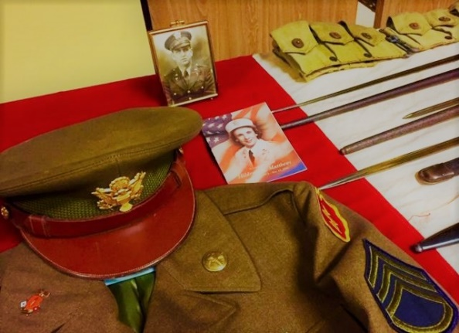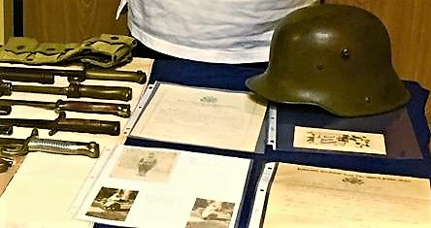

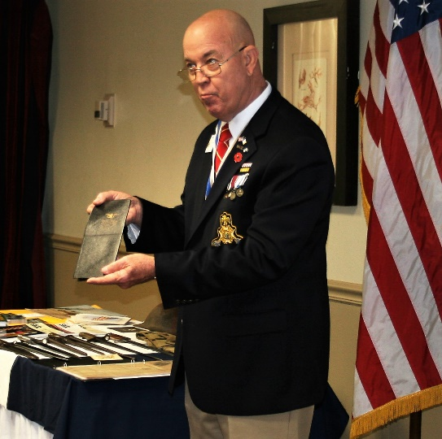 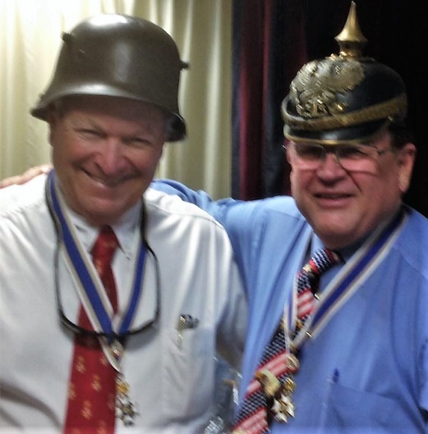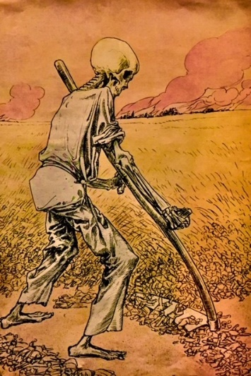

***Honored DAR Daughters continue supporting the Palm Beach Chapter***

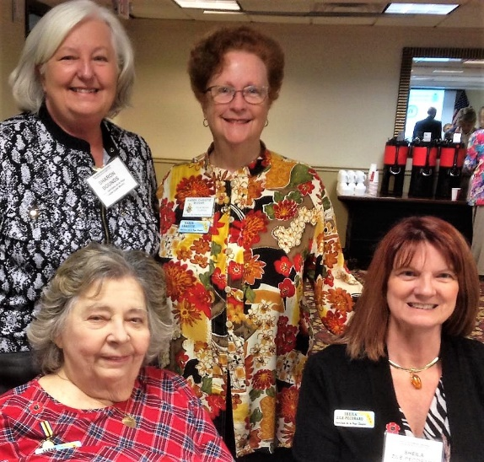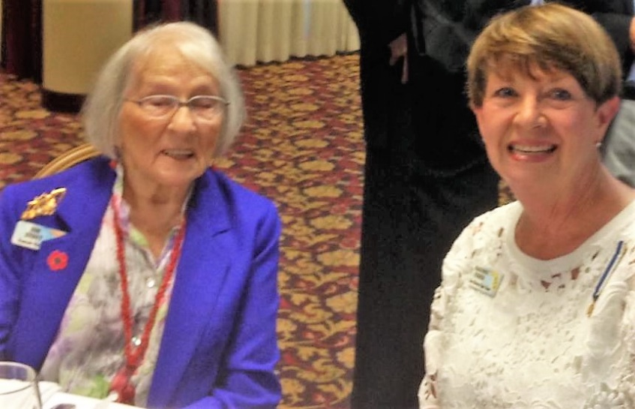

***Compatriots, DAR Daughters & Guests Celebrate Veterans Month Together***

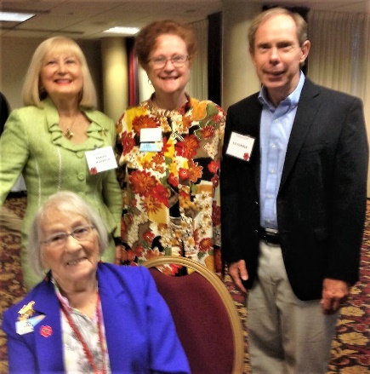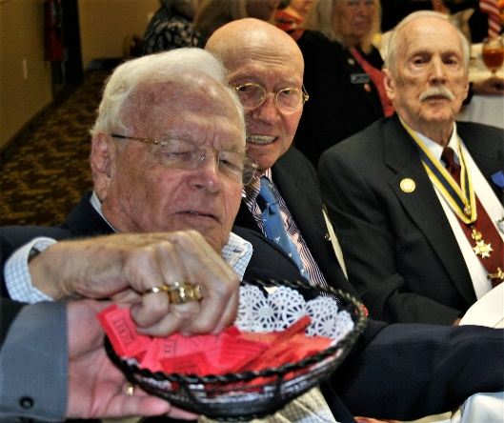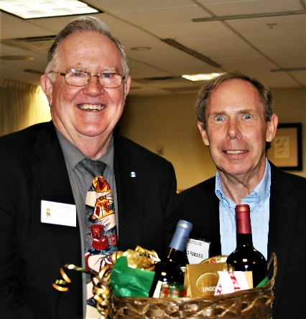

***Military & Veterans--Thank You for Your Service!***

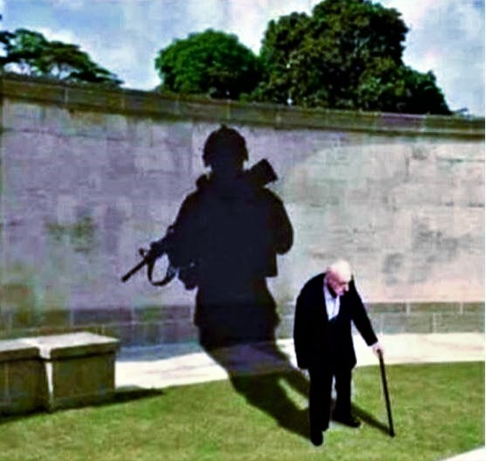

***~80th Anniversary Collectors Commemorative Coin $10.00~***

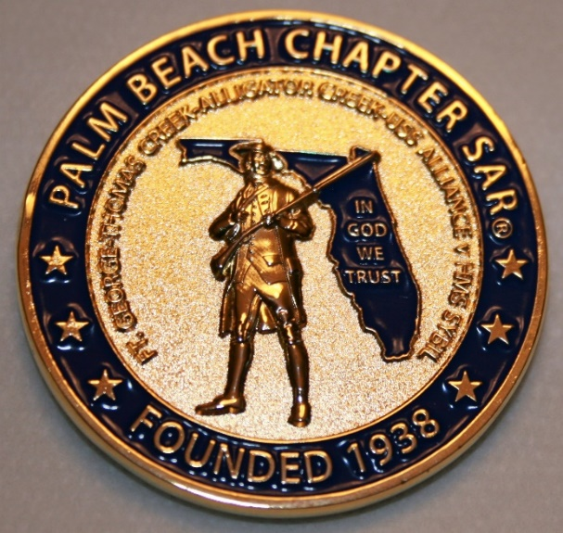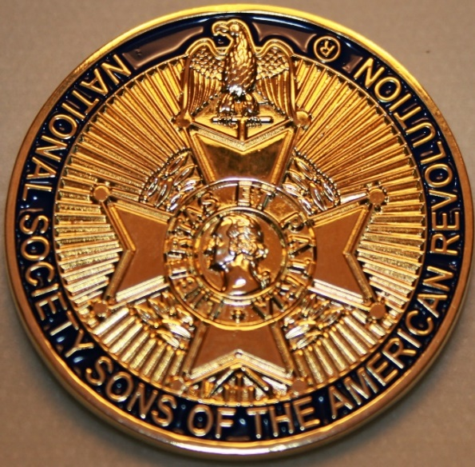

***~Compatriot Sponsored Promotions~***

**Compatriot sponsored newsletter Ads are important to the Chapter as they represent additional funds in support of Chapter projects including; *Scholarships, Boy Scout & JROTC medals, Rumbaugh & Knight Essay Youth contests, Police-Firefighter-EMT medals, Americanism & community civic programs!*** Support your Chapter…sponsor an Ad for **8** issuesat a modest cost:

**Business Card $50, Half Page $100, Full Page $250.**

**Your AD donation will also qualify you for the *Presidents Brigade*. Call Don Lanman 561-315-5073 for information.**

***CHAPTER SUPPORT ADS…***

***~COMPATRIOT ALEXANDER DREYFOOS***

***~AUTHOR/PHOTOGRPHER/VETERAN/PATRIOT***

***~COMPATRIOT SONNY BARBER***

***~HISTORIAN/AUTHOR/VETERAN/PATRIOT***

***~GARCILASO DE LA VEGA, DAR CHAPTER***

***~DAUGHTERS OF THE AMERICAN REVOLUTION***

***~JAMESTOWN SOCIETY***

***~International Lineage Society***

*~TWO GREAT BOOKS-ONE GREAT MAN~*

***-Alexander W. Dreyfoos-***



***-A PHOTOGRAPHIC ODYSSEY- -PASSION & PURPOSE-***

***Compatriot Alexander W Dreyfoos, Jr.*** an honored member of the *Palm Beach Chapter Sons of the American Revolution*, noted American entrepreneur, and philanthropist has published two remarkable books that should be on every bookshelf. **Book sales** **proceeds** **donated to local West Palm Beach charities!**

* ***Passion & Purpose*** chronicles a remarkable lifetime of passion with photography, his business, inventions and philanthropic ventures, as well as his adventures above and below the water. **$29.95.**
* ***A Photographic Odyssey*** is a remarkable collection of hundreds of stunning pictures from 100,000 photos taken by Alex around the world and bound in an elegant 15” by 10” glossy photographic book. You will travel with Alex around the world, above and below the water, to forests, jungles, glaciers, and deserts in the exotic locals of Papua New Guinea, Bhutan, Nepal, China, Japan, and Tibet. The subjects are very divergent contrasting palaces and temples with the vulnerability of people, animals, and exotic scenery. **$60.00.**
* **Support your Chapter & local charities! Get both books, *Passion & Purpose & A Photographic Odyssey,* just $71.96 @ kravis.org/books or Call 561-651-4329.**

***-Alexander W. Dreyfoos-***

***Graduating from MIT and Harvard Business School, Alex founded Photo Electronics Corporation (PCS), specializing in photography and video production. Over the decades, Alex earned 10 US patents and invented the Video Color Negative Analyzer for motion pictures earning him an Academy Award for technical achievement.Many inventions, developed by PCS, are on permanent display at the Smithsonian Institution. Locally Alex also owned television station WPEC TV-12, the CBS affiliate in West Palm Beach. Alex’s many philanthropic achievements include founding the Palm Beach County Cultural Council, the Raymond F. Kravis Center for the Performing Arts and gifting a million dollars to the Dreyfoos School of the Arts. Alex also donated a million dollars each to the Palm Beach County biomedical research campus of the Scripps Research Institute and the local Max Planck Florida Foundation for Neuroscience in Jupiter, Florida.***

***HISTORICAL MYSTERY SERIES FROM THE REVOLUTIONARY WAR~ACROSS TIME***



***Follow Kay Telfair across time beginning with Crossed & Found followed by Gold Hush & Stone-Walled….***

***Kay is a normal young teen—normal if that means being unusually curious and having an uncanny knack for putting herself in dangerous situations, which stresses her parents and often tests the relationship with best friend Anna.***

***The series follows Kay across two intrigue-filled summers on adventures involving events in American history. Join Kay’s journey of adventure steeped in American History through three books that excite all ages. At*** [***amazon.com***](http://amazon.com)***, Barnes & Noble or Chapter meetings. (See book summaries following page)***

***SAR Palm Beach Chapter Compatriot/Author Sonny Barber developed an interest in American history at an early age, reading and collecting newspapers, magazines and other materials on historic U.S. and world events. He’s coupled that interest with his fiction writing to create a modern-day “mystery history” Series perfect for Preteens to Adults.***

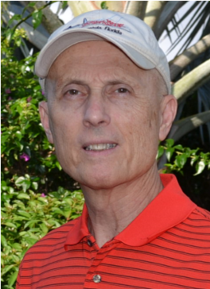

***~Crossed & Found~***



**Thirteen-year-old Kay Telfair believes her life is over when she moves with her family a thousand miles to their new home near the Delaware River in New Jersey. But her life takes an unexpected turn when she meets Anna and discovers a two-centuries-old letter--a letter that could change American history. Before she unravels the letter's mystery, Kay stumbles headlong into an adventure confronting fears she'd never experienced, stretching the limits of her friendship with Anna, and forcing a test of Kay's physical strength that could save her life.**

***~Gold Hush~***

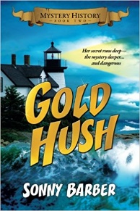

**“I’m avoiding any activity that involves excitement…I’ve learned my lesson.” After an adventure-filled June, all Kay Telfair wants is a quiet vacation in Maine with her family and best friend Anna—no drama, no stress. But the thirteen-year-old’s hopes for a tranquil August stay in the village of Prospect Harbor soon fade when the girls compete for the attention of a young boy and Kay makes a startling discovery—a discovery that sends the three teens on a dangerous quest. Ignoring advice—and menacing threats from others—they continue their pursuit, drawing them deeper into a perilous mystery, deeper than Kay ever could have imagined.**

***~Stonewalled~***

[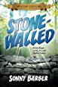](https://www.amazon.com/Stonewalled-Mystery-History-Book-Three/dp/1519351291/ref=pd_bxgy_14_img_3?_encoding=UTF8&psc=1&refRID=75QVZ72QHQ8A2W2F3RK1)

**Kay stared at the gray line of stone walls. “They won’t be too upset to see these knocked down...” A mystery that threatens the relationship with best friend Anna, a battle with Mother Nature at her worst, and the discovery of a tragic secret—not exactly what fourteen-year-old Kay Telfair was looking for in a summer getaway. But that’s what confronts the young teen while helping the owners of Windcrest Farm find a way to stop destruction of nearby farmland and its three-hundred-year-old stone walls. Vacationing with her family and Anna at Windcrest in the quiet, coastal village of Little Compton, Rhode Island, the young teen soon discovers her goal will not be easy. Kay’s prospects for helping preserve the valuable land and stone walls look much better after a surprise visit by a boy from her past. With his help, she pours all her energy and passion into the quest, searching for answers in New England’s Native American and colonial history and learning some important lessons about perseverance and friendship.**



*~Garcilaso De La Vega Chapter, NSDAR~*

***Lake Worth, Florida***

*~Michelle Robertson, Regent~*

*~Karen Christie, Registrar~*

Phone; 561-236-2460-Email; [IMC4U4@AOL.com](mailto:IMC4U4@AOL.com)

Chapter Email: [GarcilasodelaVegaDAR@gmail.com](mailto:GarcilasodelaVegaDAR@gmail.com)

Visit us on ***Facebook*** @ <https://www.facebook.com/LWDAR>

***JAMESTOWN SOCIETY***

