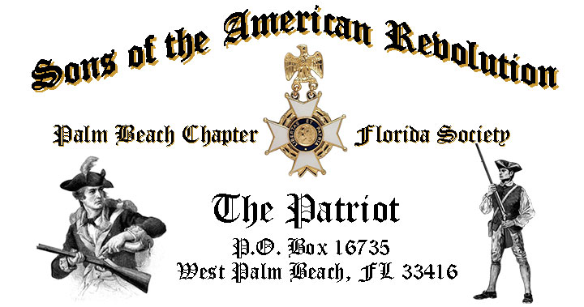

***Volume 23 February 2017 Number 02***

***Happy 286th Birthday President Washington!***  Celebrate the Presidents 286th Birthday with special guest ***President Thomas Jefferson, Tuesday*** **February 21, 12:00 Noon** @ the Embassy Suites Hotel 1601 Belvedere Road, WPB! RSVP now for this popular event!

***February Meeting Highlights:***

* **President Thomas Jefferson portrayed by Re-Enactor John Stewart**
* ***Special Visit by NSSAR President General J. Michael Tomme Sr.***
* **Buffet** Lunch, Desserts & Beverages @ **$28** per person **check/cash** at the door!
* **Reservations** **required** **RSVP** Don Lanman (561)-315-5073!
* **Family, Friends & Guests** are always welcome!

**Newsletter Content:**

* **President’s** Message
* **2017** Chapter Meeting Dates &Topics
* **Officers** & Board Members
* ***President’s*** *Brigade* Financial Supporters
* **Committees**, Chairmen & Members
* **National**/State Society News & Events
* **Feature Articles:**  ***By George! It’s Washington’s Birthday!***
  + ***A Senate Tradition. Reading Washington’s Farewell Address!***
* **Chapter** Activities Pictures
* **Compatriot** Sponsored Promotions

**President’s Message:**

***Fellow Compatriots & Friends…Don’t Miss President Thomas Jefferson…***

Join us for a very special Chapter event featuring ***Thomas Jefferson*** re-enactor *John Stewart* and a personal visit by ***National SAR President General, Michael Tomme****, South Atlantic VP General Lawrence Fehrenbaker MD,* and *Florida Society President Ray Wess*!

Compatriot John Stewart, the acclaimed Thomas Jefferson re-enactor, is honoring us with an encore’ presentation. **RSVP early for this popular event**!

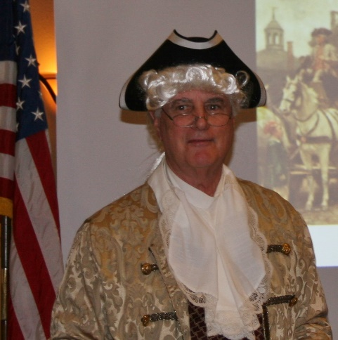

John has been interested in the life of *Thomas Jefferson* since he was a student at the University of Virginia and has lectured on Jefferson's life and influence in American History to schools, civic groups, and business audiences for over 30 years.

He portrays *Jefferson* in both the costume, language, and the speaking style of the 1700s, so you’re sure to be entertained by John’s convincing portrayal of our *3rd* *President* while benefiting from his extensive knowledge of *Jefferson's* personal life, especially his complex and sometimes-adversarial relationship with his Excellency, *George Washington*.

An exciting part of the presentation takes the form of an audience Q & A, structured like a modern day Press Conference! So don’t be afraid to ask any question of our 3rd President!

John’s long SAR career includes serving as the Chapter President for both the *Palm Beach* and *St. Petersburg* Chapters! John also serves as the SAR State Society Chairman for the youth *Knight Essay Contest* further demonstrating his dedication to historic preservation, teaching the important lessons and solid example set by our *Patriot Ancestors*!

The January meeting was most exceptional including the installation of the 2017 Chapter officers by Southeast Regional Vice President Lee Popham.

The 2017 Officersinstalled included ***President Don Lanman, Vice President Ben Tidwell, Secretary Gary Green, Registrar Bob Boggs, Treasurer Peter Johnston, Historian Buddy Miller Sergeant at Arms Brian Davey Chaplain Father Sanford Sears*** and ***Officer at Large Bill Johnson.***

We recognized the chapter officers, compatriots and DAR supporters who contributed so much to make 2016 one of the most productive in our 79 year history.

Recognized patriots included; **Ben Tidwell**-Distinguished Service Medal, **Gary Green** and **Peter Johnston**-Roger Sherman Bronze Medal, **Buddy Miller, Bob Boggs, Father Sears** and **Byrd Wenman**, SAR Certificates of Appreciation along with the formal induction of Compatriot **Thomas Van Otteren**.

**DAR** patriots recognized included **Karen Christie**-SAR Martha Washington Medal, **Fran Green** and **Sally Hitt**-SAR Medal of Appreciation, **Gladys Van Otteren** and **Karen DesHotels** SAR Certificates of Appreciation.

The Chapter reported a very successful year growing the membership by 20 new Compatriots, awarding 11 JROTC medals along with 12 Police/Firefighter/EMT medals plus sponsoring chapter and state winners for Rumbaugh and Knight Essay, *Talia Fradkin* and American History Teacher of the Year *Lauren Goepfert*.

Chapter Compatriots participated in over 12 SAR and local civic events and provided two scholarships to PBAU students. Several chapter compatriots received State society medals including a Patriot Medal, two Silver Roger Sherman Medals, plus a DAR Excellence in Citizenship award.

A major goal for 2017 is membership development. With the natural turnover of members, we need your help to continue growing our membership with like-minded individuals interested in good fellowship, honoring our patriot ancestors.

Get involved, help grow our membership by enrolling your Sons and Grandsons in SAR, inviting friends and neighbors to join and encouraging wives, daughters, and granddaughters to join the *DAR* and *SAR Women’s Auxiliary*.

**Committee members** are also needed to support our many youth and civic programs including Flag Certificates, Liberty Tree Program, Medals/Awards, Veterans Programs, Newsletter, Publicity, High School/Youth Programs, Boy Scouts, JROTC, Rumbaugh Historical Oration and Knight Essay Contests, Police-Firefighters-EMS Service Awards, Chapter Events, Americanism-Patriot Bios, Audit, Membership Development, Officer Nomination, Speakers Bureau, Website Support, Fundraising/Endowment Programs.

This year’s ***Dr. Tom & Betty Lawrence American History Techer Award*** went to Ms. Lauren Goepfert, the World & American history teacher at the Bak Middle School of Palm Beach. She represented our Chapter in the SAR state competition and won that contest earning the right to represent our chapter and state at the National competition in May.

Compatriots, the Chapter offers **“Gift Basket Raffles”** at all meetings to raise funds to support our many *Youth and Civic* programs. We are seeking donations of raffle items or gift baskets with a suggested retail value of $50. Donors are acknowledged at meetings, included in the newsletter, and donors are recognized in the Chapter’s *Presidents Brigade*.

In 2017, the Chapter plans to expand its relationships and joint event activity with all of the local *DAR Chapters*, and we are always honored to welcome our Patriot Sisters to all meetings and events, and sincerely appreciate their SAR member referrals and support.

Compatriots, we need your help to avoid losing money on the chapter luncheons by attending and bringing guests! The hotel requires a minimum number of guests to cover the room, food, and services, so when attendance is low or reservations cancelled, the Chapter must pay the difference.

Fellow Compatriots, I look forward to seeing you our next meeting! Please, join me in honoring our nations Veterans, Patriot Ancestors, and especially our Dear Departed Compatriots. **God Bless the *United States of America*.**

**-D. Lanman**

**2017 Chapter Meeting Dates/Topics:**

**Visit** the Palm Beach Chapter web site @ [www.sarpbchapter.org](http://www.sarpbchapter.org) for a meeting calendar, special events, articles, pictures, and general information.

* **Feb. 21 Washington’s Birthday**,Guest Speaker, **Thomas Jefferson**
* **Mar. 21 Boy Scout/JROTC** Awards & Speaker, **Jim Gabler-Historian**
* **Apr. 18 Law Enforcement** Awards & Special Guest Speaker
* **May 16 Firefighters/EMT** Awards & Special Guest Speaker
* **Oct. 17, Special** Guest Speaker
* **Nov. 21,** **2018** Officer Nominations, Special Guest Speaker
* **Dec. 9,** **Kings Academy Holiday Musical**

**2017 Officers & Board:**

**President** **Donald Lanman**

**Vice President** **Benjamin Tidwell III**

**Secretary** **Gary Green**

**Treasurer** **Peter Johnston**

**Registrar** **Robert Boggs**

**Chaplain** **Father Sanford Sears**

**Sgt. @ Arms Brian Davey**

**Historian** **Samuel “Buddy” Miller**

**Officer @ Large** **Bill Johnson**

**Patriot Newsletter Editor** **Donald Lanman**

**Donate to the President’s Brigade- Support Youth Programs:**

The Chapter honors and expresses its sincere appreciation to the Compatriots of the ***President’s Brigade***!

The dedicated members of the ***President’s Brigade*** donate “extra dollars” in support of the Chapter’s many youth programs, scholarships, civic activities, award certificates, police/firefighter/EMT medals, veterans’ projects, and related community civic programs.

**Honored Presidents Brigade Members:**

**-Bronze Level: $25-$99**

***M. Anderson, B. Boggs, J. Brown , R. Cass , J. Curry, D. Coldwell, B. Davey, J. Dorsey, W. Davis, F. Devitt J. Harper, J. Kane, J. Mayne, S. McWhorter, C. Odell, G. Parkinson, W. Told***

**-Silver Level: $100-$199**

***R. Culpepper, T. Friend, G. Green, F. Green, A. Griswold, B. Johnson***

**-Gold Level: $200-$499**

***R. Brinckerhoff, R. Banta , E. Buckley, K. Christie, S. Hitt, D. Lanman, W. Meakin, B. Tidwell, R. Utley, J. Wynns***

**-Platinum Level: $500+**

**Committees, Chairs & Members:**

**Fellow Compatriots**…..The Chapter expresses its sincere appreciation to those members who volunteer to serve on our committees and projects. As you can see a few Compatriots are serving on multiple committees and could use support!

**Please** volunteer today to help with any of the chapter committees listed below. It does not take much time and is a major help with our many civic initiatives.

**Call** or email Don Lanman or Ben Tidwell **Today** to lend a hand with any of the following committees.

* **JROTC -Tidwell**
* **Law Enforcement-Fire Safety -Green, Tidwell**
* **Veterans Affairs -Wenman, Lanman**
* **Newsletter/Publicity -Lanman**
* **Boy Scouts -Tidwell**
* **Knight Essay/Rumbaugh Oration -Boggs**
* **American History Teacher -Boggs**
* **DAR Liaison -Lanman, Tidwell**
* **Speakers Bureau -Lanman, Tidwell**
* **Audit -Coldwell, Tidwell, Lanman**
* **2017 Officer Nomination -Lanman, Tidwell, Boggs**
* **Flag Certificates -Clouse, Miller, Tidwell**
* **Membership -Green, Boggs, Tidwell**
* **Liberty Tree -Lanman**
* **Patriot Bios -Miller**
* **Web Site-Facebook -Open**
* **80th Anniversary -Chapter Officers**

**Custom Chapter Challenge Coin:**

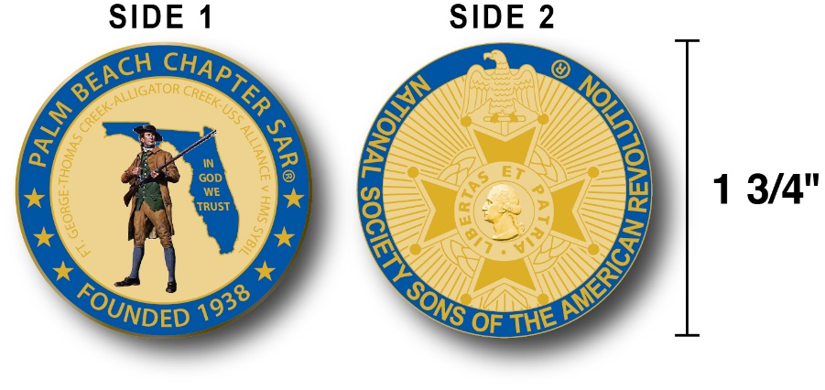

The Chapter has designed a custom bronze *Challenge Coin* honoring the founding of the Palm Beach Chapter in 1938 and its 79 years of patriotic and civic service in Palm Beach County.

The bronze coin is highlighted in a George Washington military Blue with a Gold background. Side one is personalized to our chapter including the founding date, a Minuteman standing guard over Florida, the Florida State motto ***"In God We Trust"*** and notation of the four major Revolutionary War battles waged in Florida.  Side two displays the National NSSAR logo.  Very impressive indeed!

The custom bronze chapter challenge coin is designed to celebrate our founding in 1938, create a distinctive and impressive image and used as a token of appreciation for honored guests, guest speakers and special awards.  Compatriots may also purchase these unique challenge coins for just $10. **Get yours at the next meeting.**

**National, State & Chapter News:**

**-Chapter Events:** Compatriots participated with CAR in Veterans Hospital Support Programs.

**-State Society:** Board of Management meeting will be held *February 4th.*

**- “HONOR FLIGHT” Guardian Program:** The Palm Beach Chapter is supporting the *Florida State Society of the Daughters of the American Revolution* and *Honor Flights Southeast Florida* with an Honor Flight event on **April 8, 2017** from Palm Beach Airport to Washington DC.

Interested Compatriots must complete an application and if accepted submit $400 for travel expenses to join Florida DAR members and WW 2 & Korean War Vets on their visit to war memorials in DC!

**Information** and an application contact Gladys Van Otteren, FSSDAR State Chairman Honor Flight program (561)-324-2937 or [HMFchapterDAR@gmail.com](mailto:HMFchapterDAR@gmail.com).

**Feature Articles:**

***By George! It’s Washington's Birthday!***

**Compiled & Edited By Don Lanman**

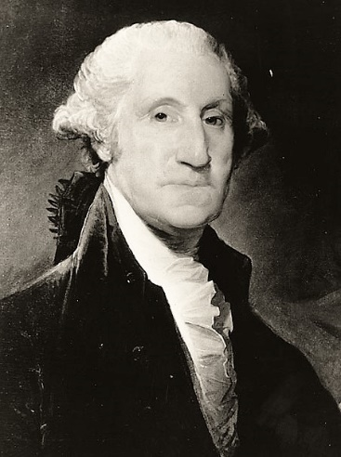

George Washington was born in Virginia on February 11, 1731, according to the then-used Julian calendar. In 1752, however, Britain and all its colonies adopted the Gregorian calendar, which moved Washington's Birthday a year and 11 days to February 22, 1732.

Americans celebrated Washington's Birthday long before Congress declared it a federal holiday. The centennial of his birth prompted festivities nationally and Congress established a Joint Committee to arrange for the occasion.

At the recommendation of the Committee, chaired by Henry Clay of the Senate and Philemon Thomas of the House, Congress adjourned on February 22, 1832 out of respect for Washington's memory and in commemoration of his birth.

Prompted by a memorial from the mayor and other citizens of Philadelphia, the House and Senate commemorated the 130th Anniversary of Washington's birth by reading aloud his Farewell Address.

In a special joint session held in the House Chamber, the House and Senate, along with several cabinet officials, Justices of the Supreme Court and high-ranking officers of the Army and Navy, gathered to listen to the Secretary of State read the address aloud. Eventually, the reading of George Washington's Farewell Address became an annual event for the Senate, a tradition that is still observed to this day.

Washington's Birthday, however, did not become a legal holiday until January 31, 1879 when Congress added February 22nd to the list of holidays to be observed by federal employees in the District of Columbia.

The act did not stipulate that employees were to be paid for the holiday - in fact, some government employees in the District of Columbia were paid while others were not. In 1885, Congress resolved this discrepancy with legislation that required federal employees to be paid for all federal holidays and made federal holidays applicable to *all* federal government employees, including those employed outside the Washington DC area.

Washington's Birthday was celebrated on February 22nd until well into the 20th Century. However, in 1968 Congress passed the Monday Holiday Law to "provide uniform annual observances of certain legal public holidays on Mondays." By creating more 3-day weekends, Congress hoped to "bring substantial benefits to both the spiritual and economic life of the Nation."

One of the provisions of this act changed the observance of Washington's Birthday from February 22nd to the third Monday in February. Ironically, this guaranteed that the holiday would never be celebrated on Washington's actual birthday, as the third Monday in February cannot fall any later than February 21.

Therefore, George Washington's Birthday is celebrated as a federal holiday on the third Monday in February. It is one of eleven permanent holidays established by Congress.

Moreover, federal holidays apply only to the federal government and the District of Columbia; Congress has never declared a national holiday binding in all states and each state decides its own legal holidays.

Contrary to popular belief, neither Congress nor the President has ever stipulated that the name of the holiday observed as Washington's Birthday be changed to "President's Day”.

***A Senate Tradition…***

***Annual Reading of Washington's Farewell Address***

**Compiled/Edited by Don Lanman from the National Archives & Historical resources**

No Senate tradition has been more steadfastly maintained than the annual reading of President George Washington’s 1796 Farewell Address.

In His Excellency's letter to “Friends and Citizens,” Washington warned that the forces of geographical sectionalism, political factionalism, and interference by foreign powers in the nation's domestic affairs threatened the stability of the Republic.  He urged Americans to subordinate sectional jealousies to common national interests.

The Senate tradition began on February 22, 1862, as a morale-boosting gesture during the darkest days of the Civil War.  Citizens of Philadelphia had petitioned Congress to commemorate the forthcoming 130th anniversary of Washington's birth by reading the Address at a joint meeting of both houses.

Tennessee Senator Andrew Johnson introduced the petition in the Senate.  "In view of the perilous condition of the country," he said, "I think the time has arrived when we should recur back to the days, the times, and the doings of Washington and the patriots of the Revolution, who founded the government under which we live."

Two by two, members of the Senate proceeded to the House Chamber for a joint session.  As they moved through Statuary Hall, they passed a display of recently captured Confederate battle flags.   President Abraham Lincoln, whose son Willie had died two days earlier, did not attend.

But members of his cabinet, the Supreme Court, and high-ranking military officers in full uniform packed the chamber to hear Secretary of the Senate John W. Forney read the Address.

Early in 1888—the centennial year of the Constitution’s ratification—the Senate recalled the ceremony of 1862 and had its presiding officer read the Address on February 22.  Within a few years, the Senate made the practice an annual event.

Every year since 1896, the Senate has observed Washington's Birthday by selecting one of its members, alternating parties, to read the 7,641-word statement in legislative session.  Delivery generally takes about 45 minutes.

In 1985, Florida Senator Paula Hawkins tore through the text in a record-setting 39 minutes, while in 1962, West Virginia Senator Jennings Randolph, savoring each word, consumed 68 minutes.

At the conclusion of each reading, the appointed senator inscribes his or her name and brief remarks in a black, leather-bound book maintained by the Secretary of the Senate. Early entries in the notebook were typically brief explanations of the practice, accompanied by signature and date. Often, several entries appeared on a single page.

In more recent years, the entries have grown more elaborate and have included personal stories or comments on contemporary politics and policy.

In 1956, Minnesota Senator Hubert Humphrey wrote that every American should study this memorable message. “It gives one a renewed sense of pride in our republic,” he wrote. “It arouses the wholesome and creative emotions of patriotism and love of country.”

The book's first entry bears the signature of Ohio Republican Joseph Foraker and is dated February 22, 1900.

**Is Your Membership Active???**

**If you forgot to send in your 2017 SAR membership dues…**justmail your 2017 SAR membership dues of $75 today and we will reinstate you in March.

**But Don’t wait….Mail** your $75 annual membership fee to ***SAR PB Chapter, PO Box 16735 West Palm Beach, FL 33416-6735*** ASAP along with any changes to your personal contact information.

**Remember….Your** membership dues and additional donations fund the many Chapter civic activities including **Scholarships**, ***Boy Scout & JROTC medals, Rumbaugh & Knight Essay Youth contests, Police-Firefighter-EMT awards, Flag Certificates, Americanism, & Community programs.***

***-Chapter January Meeting Pictures-***

**SE VP Popham inducts 2017 Chapter officers, President Lanman, VP Tidwell, Treasurer Johnston, Secretary Green, Registrar Boggs, Chaplain Sears, Historian Miller, Sgt @ Arms Davey, Officer @ Large Johnson.**

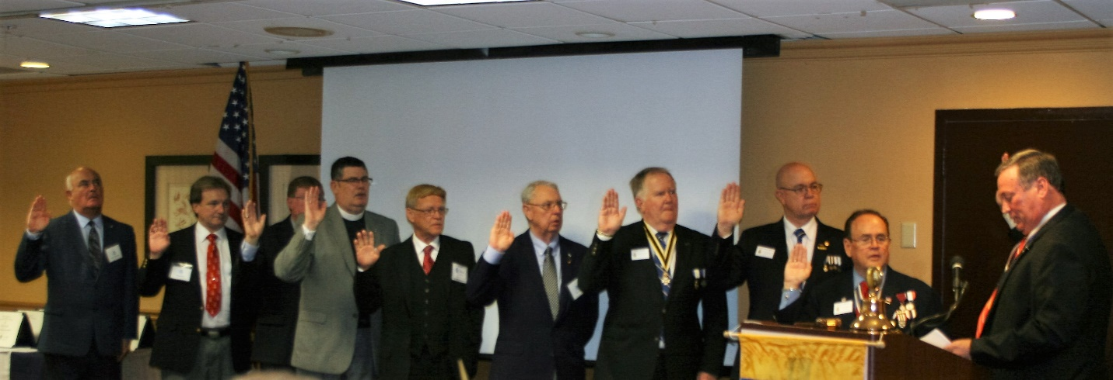

**Lanman inducts Compatriot Thomas Van Otteren with Mother Gladys Van Otteren**

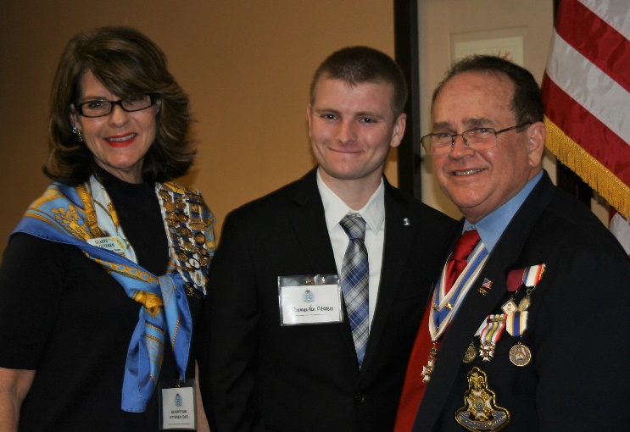

***President Lanman Honors Speaker Maureen Singer***

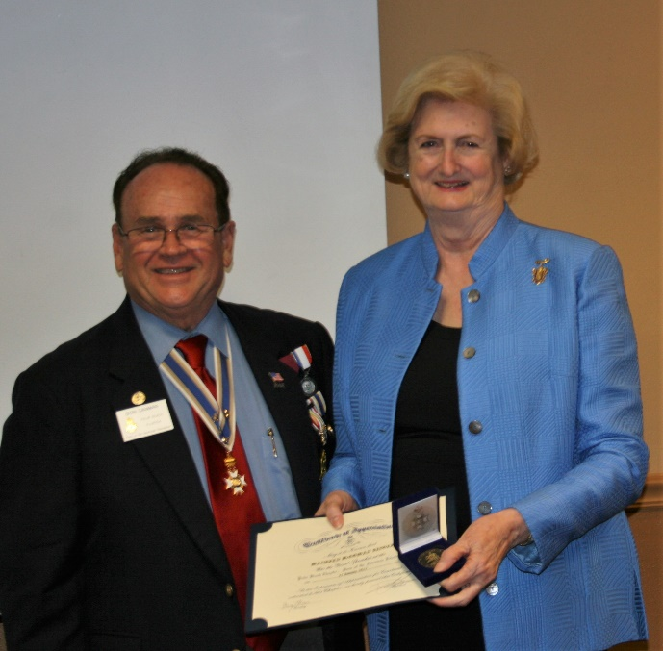

***Lanman Awards Tidwell, Green & Johnston with Prestigious Service Medals***

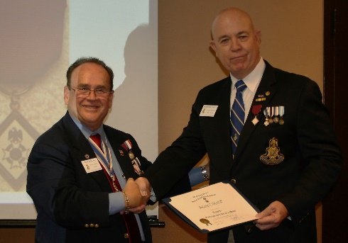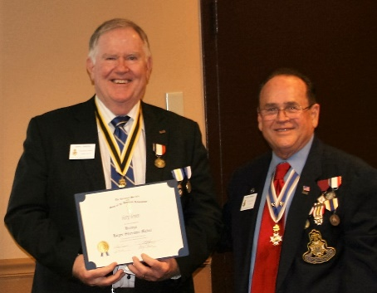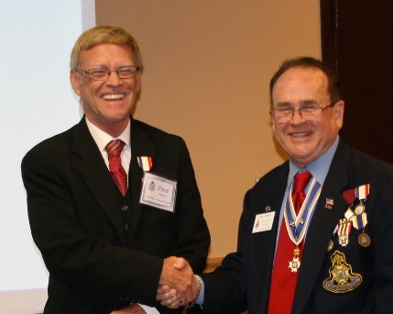

***Lanman Honors Chapter Officers Sears, Boggs, Miller & Wenman***

***with SAR Certificates of Appreciation***

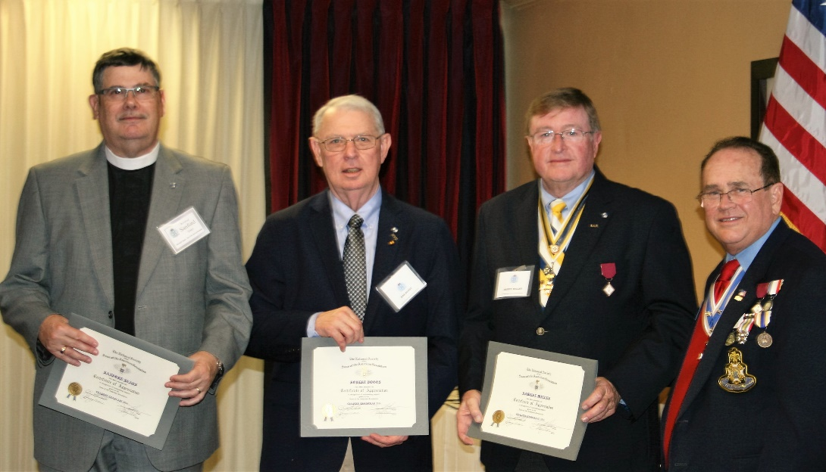

**DAR Patriot Karen Christie Honored with**

**SAR Martha Washington Medal**

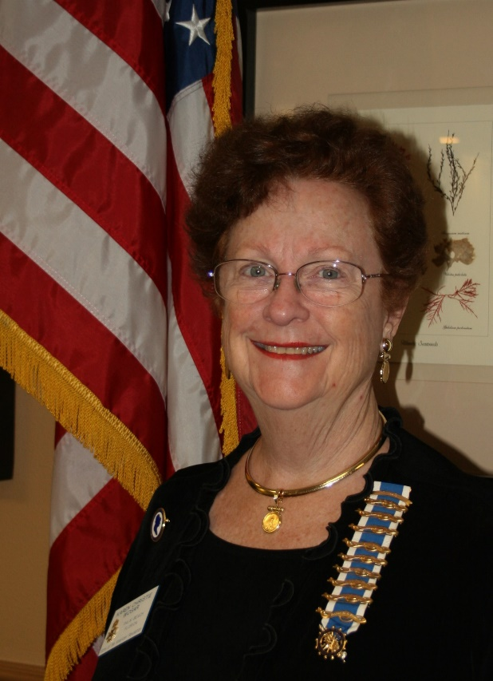

**DAR Patriots Fran Green &**

**Sally Hitt Honored with SAR Medals of Appreciation**

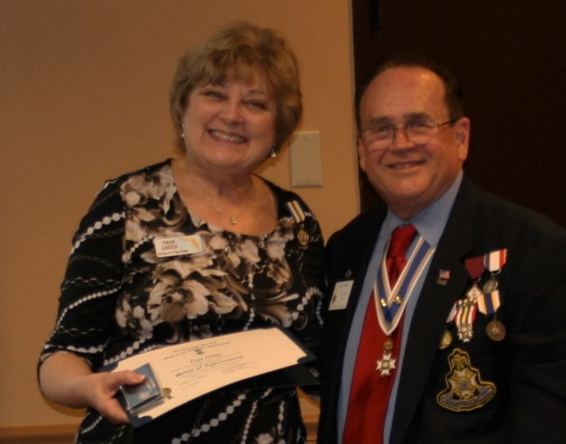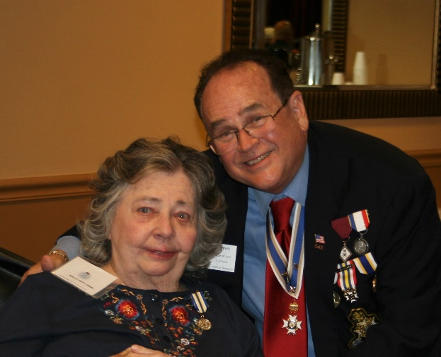

**DAR Patriots Gladys Van Otteren & Diane Tidwell**

**Honored with SAR Certificates of Appreciation**

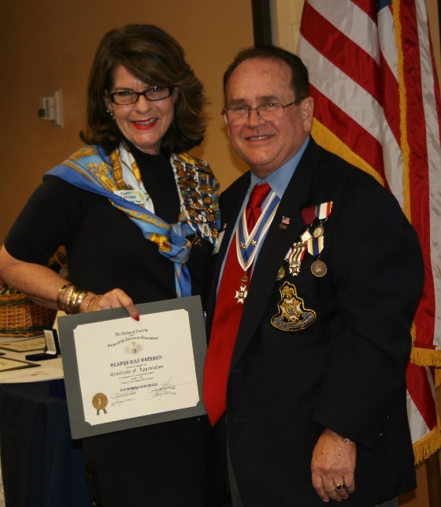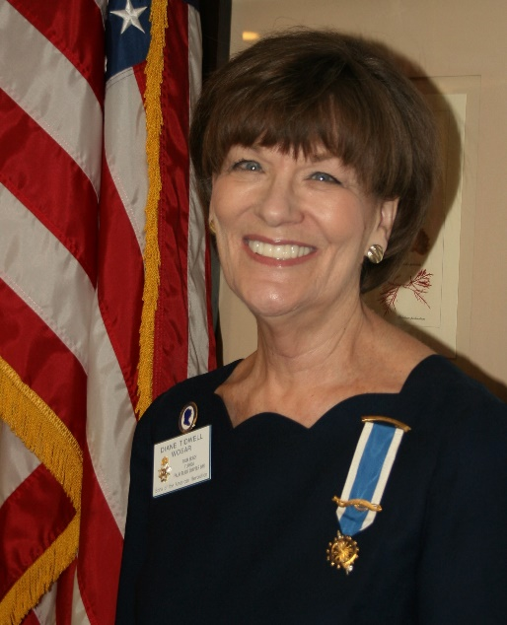

**Lanman Honors SAR SE Regional VP Lee Popham**

**with George Washington Challenge Coin**

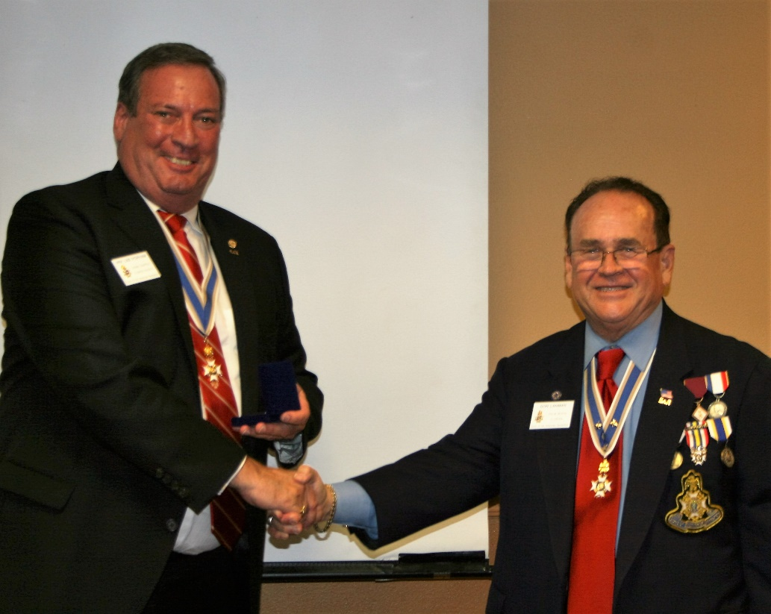

**Compatriot Sponsored Promotions:**

Compatriot sponsored Ads are important to the Chapter as they represent additional funds in support of Chapter projects including ***Boy Scout & JROTC medals, Rumbaugh & Knight Essay Youth contests, Police-Firefighter-EMT awards, Americanism & community civic programs!***

**Please** consider helping your Chapter with an Ad at the modest cost for **8** issues **@ Business Card $50, Half Page $100, Full Page $250.**

**Your AD donation will also qualify you for a listing in the *Presidents Brigade*. Call Don Lanman 561-315-5073 for information.**

***SPECIAL SPONSORED ADS ON FOLLOWING PAGES…***

***-COMPATRIOT ROBERT BRINCKERHOFF***

***-GARCILASO DE LA VEGA, CHAPTER DAUGHTERS OF THE AMERICAN REVOLUTION***

***-COMPATRIOT ALEXANDER DREYFOOS***

***-Morgan Stanley-***

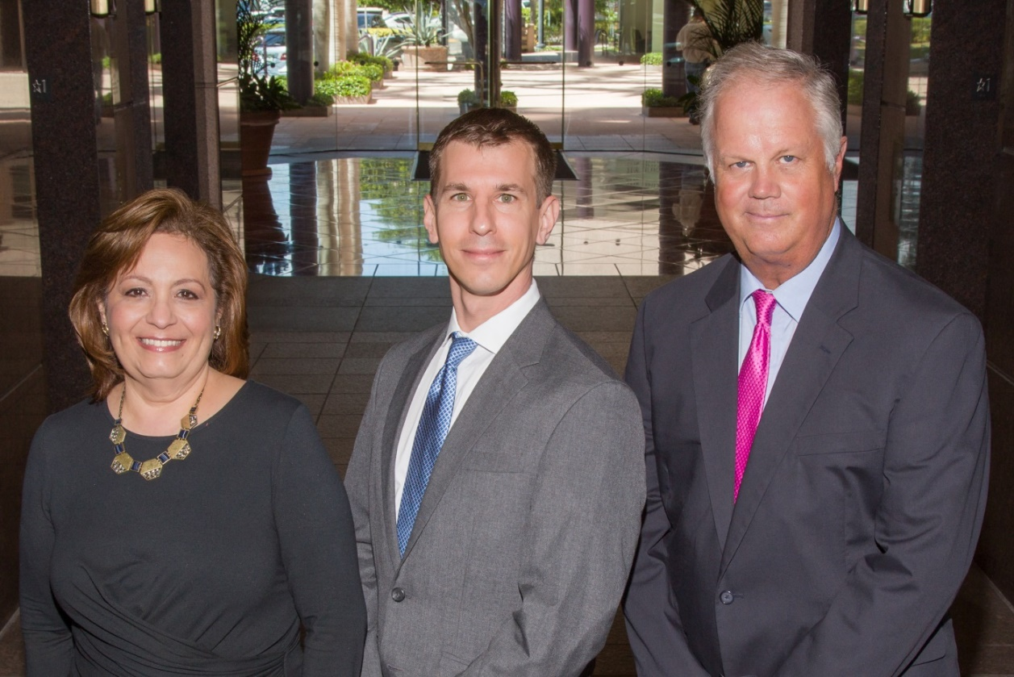  
**Amani Gaballa, Senior Registered Associate; Robert Scarborough, Financial Advisor; Robert Brinckerhoff, First Vice President, Financial Advisor**

***Robert W. Brinckerhoff  
Senior Vice President, Financial Advisor  
777 S. Flagler Dr. Suite 700, East Tower  
West Palm Beach, FL 33401  
(561) 650-7514  
Robert.Brinckerhoff@MorganStanley.com***

***Bob has been a financial advisor since March 1976. He focuses on investment strategies, retirement planning, liquidity solutions for individuals, commercial real estate, and small business owners.***

***Bob is a graduate of the University of Vermont. His clients are geographically diverse and he frequently travels from the east coast to the west to meet with clients. He is active with nonprofit organizations that support the blind and visually impaired. Bob is also an active enthusiast in Ferraris.***

*The investments listed may not be suitable for all investors. Morgan Stanley Smith Barney LLC recommends that investors independently evaluate particular investments and encourages investors to seek the advice of a financial advisor. The appropriateness of a particular investment will depend upon an investor’s individual circumstances and objectives. Morgan Stanley Smith Barney LLC is a registered Broker/Dealer, Member SIPC, and not a bank.*

*Where appropriate, Morgan Stanley Smith Barney LLC has entered into arrangements with banks and other third parties to assist in offering certain banking related products and services. Investment, insurance and annuity products offered through Morgan Stanley Smith Barney LLC are: NOT FDIC INSURED, MAY LOSE VALUE, NOT BANK GUARANTEED, NOT A BANK DEPOSIT, NOT INSURED BY ANY FEDERAL GOVERNMENT AGENCY. Copy write 2015 Morgan Stanley Smith Barney LLC, Member SIPC CRC1355648 11/15.*

*TWO GREAT BOOKS-ONE GREAT MAN*

***-Alexander W. Dreyfoos-***



***-A PHOTOGRAPHIC ODYSSEY- -PASSION & PURPOSE-***

***Compatriot Alexander W Dreyfoos, Jr.*** an honored member of the *Palm Beach Chapter Sons of the American Revolution*, noted American entrepreneur, and philanthropist has published two remarkable books that should be on every bookshelf. **Book sales** **proceeds** **donated to local West Palm Beach charities!**

* ***Passion & Purpose*** chronicles a remarkable lifetime of passion with photography, his business, inventions and philanthropic ventures, as well as his adventures above and below the water. **$29.95.**
* ***A Photographic Odyssey*** is a remarkable collection of hundreds of stunning pictures from 100,000 photos taken by Alex around the world and bound in an elegant 15” by 10” glossy photographic book. You will travel with Alex around the world, above and below the water, to forests, jungles, glaciers, and deserts in the exotic locals of Papua New Guinea, Bhutan, Nepal, China, Japan, and Tibet. The subjects are very divergent contrasting palaces and temples with the vulnerability of people, animals, and exotic scenery. **$60.00.**
* **Support your Chapter & local charities! Get both books, *Passion & Purpose & A Photographic Odyssey,* just $71.96 @ kravis.org/books or Call 561-651-4329.**

***-Alexander W. Dreyfoos-***

*Graduating from MIT and Harvard Business School, Alex founded Photo Electronics Corporation (PCS), specializing in photography and video production. Over the decades, Alex earned 10 US patents and invented the Video Color Negative Analyzer for motion pictures earning him an Academy Award for technical achievement.Many inventions, developed by PCS, are on permanent display at the Smithsonian Institution. Locally Alex also owned television station WPEC TV-12, the CBS affiliate in West Palm Beach. Alex’s many philanthropic achievements include founding the Palm Beach County Cultural Council, the Raymond F. Kravis Center for the Performing Arts and gifting a million dollars to the Dreyfoos School of the Arts. Alex also donated a million dollars each to the Palm Beach County biomedical research campus of the Scripps Research Institute and the local Max Planck Florida Foundation for Neuroscience in Jupiter, Florida.*

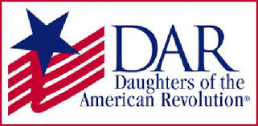

*Garcilaso de la Vega Chapter, NSDAR*

*Lake Worth, Florida*

*Sheila Zile-Pecoraro, Regent*

*Judy Mahaffey,* Registrar

Phone; 561-876-9520-Email; [Smileson@AOL.com](mailto:Smileson@AOL.com)

Chapter Email: [GarcilasodelaVegaDAR@gmail.com](mailto:GarcilasodelaVegaDAR@gmail.com)

Visit us on ***Facebook*** @ <https://www.facebook.com/LWDAR>