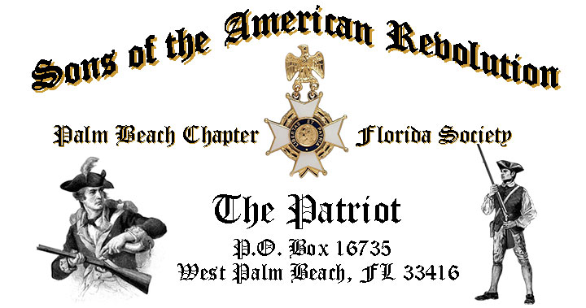

***Volume 24 February 2018 Number 02***

***Happy 287th Birthday-President Washington!***  Join us and celebrate the ***Presidents 287th*** Birthday with special guest ***President Thomas Jefferson,*** Tuesday **February 20** @ **12 Noon** @ the *Embassy Suites Hotel* 1601 Belvedere Road, WPB! ***RSVP now for this Popular event!***

***February 20 Meeting Event Highlights…***

* ***President Thomas Jefferson* portrayed by Re-Enactor John Stewart**
* **Memorial Service for Compatriot Edward O. “Ned” Payne III**
* ***4-Course Buffet Lunch, Desserts & Beverages, $28 per person Check/Cash!***
* ***Reservations*** **Required,** **RSVP**, **Ben Tidwell** **(561)-704-9918!**
* **Family, Friends & Guests** are always ***Welcome***!

***Newsletter Content:***

* **President’s** Message
* **2018 Officers** & Board Members
* **2018** **Chapter** Meeting Dates &Topics
* ***President’s******Brigade*** Financial Supporters
* **Committees**, Chairmen & Members
* **National**/**State/Chapter**, News & Events
* **Feature Articles: *Revolutionary War’s 15 Little Known Facts!***
  + ***By George! It’s Washington’s Birthday!***
* **Chapter** **Meetings** **& Event** Pictures
* **Compatriot** **Sponsored** Advertisements

***President’s Message:***

***Fellow Compatriots & Friends…***

*Greetings, fellow compatriots! This is our Chapter’s 80th year of service to the Palm Beaches and surrounding community. To kick off this special year, our very own John Stewart will transform himself into Thomas Jefferson and speak about the* ***Barbary Pirates*** *at our Tuesday, Feb. 20th luncheon.* ***RSVP******Now as space is limited! Regards-- B. F. Tidwell***

Back by popular demand, this special Chapter meeting features the popular ***Thomas Jefferson*** re-enactor *John Stewart*. Fellow Compatriot and former Chapter President John Stewart, an acclaimed *Thomas Jefferson* re-enactor, is honoring us with another encore’ presentation.

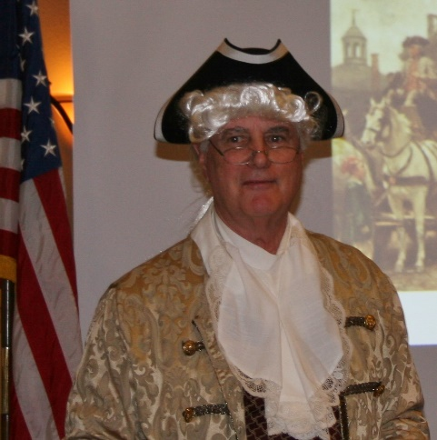

John has been interested in the life of *Thomas Jefferson* since he was a student at the *University of Virginia* and has lectured on Jefferson's life and influence in American History to schools, youth and civic groups, and to business audiences for 30+ years.

*President Jefferson* is portrayed in the dress, language, and the speaking style of the 1700s, so we’re sure to be entertained by John’s convincing portrayal of our *3rd* *President* while benefiting from his extensive knowledge of *Jefferson's* personal life, especially his leadership against the infamous *Barbary Pirates*.

A special highlight of the presentation takes the form of an audience ***Q & A***, structured much like a modern day Presidential Press Conference! So don’t be afraid to ask any question of our 3rd President!

John’s long SAR career includes serving as the Chapter President for both the *Palm Beach* and *St. Petersburg* chapters! He also serves as the SAR State Society Chairman for the youth *Knight Essay Contest* further demonstrating his dedication to historic preservation, teaching the important lessons and solid example set by our *Patriot Ancestors*!

The January meeting was most exceptional including the installation of the 2018 Chapter officers by 2-term Chapter President Donald Lanman.

2016 & 2017 Chapter President Lanman installed the ***2018 Chapter Officers*** including: *Ben Tidwell,* ***President****, Bob Boggs,* ***Vice President****, Gary Green,* ***Secretary****, Bob Boggs,* ***Registrar****, Peter Johnston,* ***Treasurer****, Father Sanford Sears,* ***Chaplain****, Buddy Miller,* ***Historian****, Peter Miller,* ***Sgt. @ Arms*** *and Sonny Barber,* ***Officer @ Large***.

President Lanman also recognized the outstanding SAR service of Chapter Compatriots; **Ben Tidwell**-*Chapter* *Presidents Eagle Award*, **Gary Green,** *Distinguished Service Medal*, **Buddy Miller** and **Father Sanford Sears,** *Roger Sherman Bronze Medals*. **DAR** patriots recognized for service to our chapter included *Chapter First Lady* **Karen Christie**-*SAR Lydia Darragh Medal*, and *2018 Chapter First Lady* **Diane Tidwell,** *SAR Medal of Appreciation*.

The Chapter will conduct a special ***SAR Memorial Service*** for ***Compatriot Edward O. (Ned) Payne III***, 77 called home November 7, 2017.

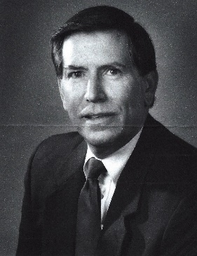

Born July 15, 1940, Ned was a native of Shelter Island and Greenport, NY.  He served honorably in the United States Navy aboard the *USS Boston* and at Guantanamo Bay where he was awarded the *Navy Good Conduct Medal*.

Ned’s business career spanned 25 years with the *IBM Corporation* in Westchester County, NY, where he also served a part-time Deputy Sheriff with the *Putnam County Sheriff’s Department*.  Moving to Jupiter, FL, Ned served as the Executive administrator to the Chief Operations officer of the *PGA of America Association* for ten years.

Ned was an active member of the *National Society of the Sons of the American Revolution* as a member of the *Palm Beach Chapter*, President of the *Westchester, NY Chapter* and *Vice President of the New York State Chapter*. He also served in the *Fraternal Order of Police*.

Ned is survived by his loving wife *Mary*, daughter, *Carrie*, son-in-law, *Steve Fleischmann*, and three grandchildren, *Alexis, Connor* and *Abigail*. Family members will attend the Memorial Service.



***Help Your Chapter*** by serving on a committee supporting our youth and civic programs including *Rumbaugh Historical Oration, Knight Essay, Historical Poster* and *Brochure contests, History Teacher of the Year, Veterans programs, Boy Scouts, JROTC* and *Police-Firefighter-EMS Service* recognitionprograms*.*

***Grow Chapter Membership***! An important mission for the continued success of our Chapter is membership development and the mentoring of new members. With the natural turnover of members, we need all Compatriots to help us grow membership by recruiting men interested in patriotism, good fellowship and honoring our patriot ancestors.

***Take action today***, by enrolling your Sons and Grandsons, inviting friends to join and encouraging wives, daughters, and granddaughters to join the *Daughters of the American Revolution* and the *Palm Beach* *Chapter Women’s Auxiliary*.

Join us in expanding our great relationships with all of the local *Palm Beach* *DAR Chapters*. We welcome all of our ***DAR Patriot Daughters*** to Chapter meetings and events, and sincerely appreciate their efforts with new member referrals and related support. ***Thank you DAR!***

Compatriots, the Palm Beach Chapter is a long term supporter of our Nation’s Veterans, with direct support of Veterans programs. 15% of our members are veterans serving from *WW II to Iraq*. All Compatriot veterans are encouraged to provide us with their *DD-214*, and be recognized with the ***SAR Military Service Medal*** and welcomed into both the***State SAR* *Veterans Battalion*** and the ***Chapter’s Own*** **“*Band of Brothers.”***

***Chapter Financials Alert***, Compatriots, please help your chapter avoid losing money on our meeting luncheons by attending each meeting and bringing family members and guests. **Remember** the Hotel requires a minimum number of guests to cover the food, room, and services fees, so when attendance is below 40 or there are no shows, the Chapter must pay the difference.

*Compatriots*, I look forward to seeing you at the *February 20* meeting! Please, join me in honoring our nation’s Veterans, Patriot Ancestors, and especially our Departed Compatriots. ***God Bless You*** and ***God Bless the United States of America.***

***In Patriotism*** **– Benjamin F. Tidwell III**

*** Hear Ye-Hear Ye…..Chapter Editorial***

***Fellow Compatriots***, January marked the official end of my service as your President. It has been my distinct privilege and high honor to lead our Chapter over the past two years.

In partnership with my fellow officers and your support, we grew the Chapter membership by 24% from 153 to 186, distributed dozens of SAR civil service medals to *Police, Firefighter/EMT, JROTC*, awarded student scholarships, and were honored with two *Patriot Medal* recipients while setting meeting content standards for other chapters to follow.

I’ve passed the gavel of authority to *President* *Benjamin Franklin Tidwell III* and enjoined upon him the duty of wielding it with dignity, impartiality and courtesy, never forgetting that, though we are temporarily the Chief among our brethren, we have only emerged for a brief time from the ranks and to those ranks we all return.

As I return to the ranks, I encourage all *Compatriots* to remember that the *Palm Beach SAR Chapter* is blessed with qualified and exceptional members. I have every confidence that President Tidwell and our 2018 team of officers will lead the Palm Beach Chapter to new levels of success.

Please congratulate, encourage and support your Chapter leadership in their new responsibilities. **God Bless You** and **God Bless the *United States of America*.**

***In Heartfelt Comradeship & Patriotism******- D. Lanman***

***2018 Chapter Meeting Dates/Topics:***

**Visit** the Palm Beach Chapter web site @ [www.sarpbchapter.org](http://www.sarpbchapter.org) for a meeting calendar, special events, articles, pictures, and general information.

* **Feb. 20, 2018**, ***Special Guest Speaker President Thomas Jefferson***
* **March 20, 2018**, **Speaker- *Past Chapter President Donald Lanman***
* **April 17, 2018**, ***Law Enforcement Awards Ceremony***
* **May 15,2018, *Firefighters/EMT Awards Ceremony***
* **Oct. 16, 2018**, ***Special Guest Speaker***
* **Nov. 20, 2018**, ***Special Guest Speaker***
* **Dec. 8, 2018**, ***80th Anniversary &*** ***Christmas-Holiday Special***

***2018 Officers & Board:***

* ***President******Benjamin Franklin Tidwell III***
* ***Vice President******Robert Boggs***
* ***Secretary******Gary Green***
* ***Treasurer******Peter Johnston***
* ***Registrar******Robert Boggs***
* ***Chaplain******Father Sanford Sears***
* ***Sgt. @ Arms Peter Miller***
* ***Historian******Samuel “Buddy” Miller***
* ***Officer @ Large******Sonny Barber***
* ***Patriot Newsletter Editor******Donald Lanman***

***Join the President’s Brigade to…***

***Support Scholarship & Youth Programs:***

The Chapter has authorized ***$1,000***Scholarship to the ***Palm Beach Atlantic University*** again for ***2018***.

To help us increase the scholarship grant amount to ***$4,000,*** *w*e respectfully ask all Compatriots to consider helping the Chapter grow the scholarship amount to support these students of character.

The Chapter honors and expresses its sincere appreciation to the Compatriots of the ***President’s Brigade*** who support the scholarship and youth programs.

The dedicated members of the ***President’s Brigade*** donate “extra dollars” in support of the Chapter’s many youth programs, scholarships, civic activities, award certificates, police/firefighter/EMT medals, veterans’ projects, and related community civic programs.

***Honored Presidents Brigade Members*:**

* **Bronze Level: $25-$99:**

***M. Anderson, J. Blackburn, B. Boggs, J. Chataing, A. Cass, C. Coldwell, D. Coldwell, M. Curry, S. Curry, J. Damron, J. Dorsey, W. Davis, F. Devitt, J. Harper, J. Kane, L. Lassitter, P. Miller, S. Miller, J. Mayne, G. Parkinson, H. Oyer, J. Porter, S. Sears, A. Shea, W. Told, J. Wearn, L Watkins***

* **Silver Level: $100-$199:**

***J. Curry, R. Culpepper, T. Friend, G. Green, F. Green, A. Griswold, W. Johnson, D, Shepherd, S. McWhorter***

* **Gold Level: $200-$499:**

***R. Brinckerhoff, S. Barber, R. Banta , E. Buckley, J. Curry, K. Christie, S. Hitt, D. Lanman, W. Meakin, B. Tidwell, J. Wynns***

* **Platinum Level: $500+**

1. ***Dreyfoos***

***Committee Chairs & Members:***



**Fellow Compatriots**…..The Chapter expresses its sincere appreciation to those members who volunteer to serve on our committees and projects. As you can see a few Compatriots are serving on multiple committees and could use some extra support!

**Please** select a committee of interest for ***2018*** to help on any of the chapter committees listed. It does not take much time and is a major help with our many civic and youth initiatives. **Call** Ben Tidwell (561-704-9918) or Bob Boggs (561-241-3128) **Today** to lend a hand on any of these important committees.

* ***2019 Officer Nominations -All Chapter Members***
* ***80th Anniversary -Chapter Officers***
* ***JROTC & Boy Scouts -Barber, Tidwell***
* ***Law Enforcement-Fire Safety -Parkinson, Green***
* ***Veterans Affairs -Lanman, Curry***
* ***Newsletter/Publicity -Lanman***
* ***Knight Essay/Rumbaugh Oration -Boggs***
* ***American History Teacher -Boggs***
* ***Medals/Awards -Lanman, Tidwell***
* ***DAR Liaison -Lanman, Tidwell***
* ***Speakers Bureau -Lanman, Tidwell***
* ***Audit -Coldwell, Lanman***
* ***Flag Certificates -Clouse, Miller, Johnston***
* ***Membership Development -Green, Boggs, Tidwell***
* ***Liberty Tree -Chapter Officers***
* ***Patriot Bios -Miller***
* ***Web Site-Facebook/Social Media -Open***

**Palm Beach Chapter 80th Year Commemorative Challenge Coin $10!**

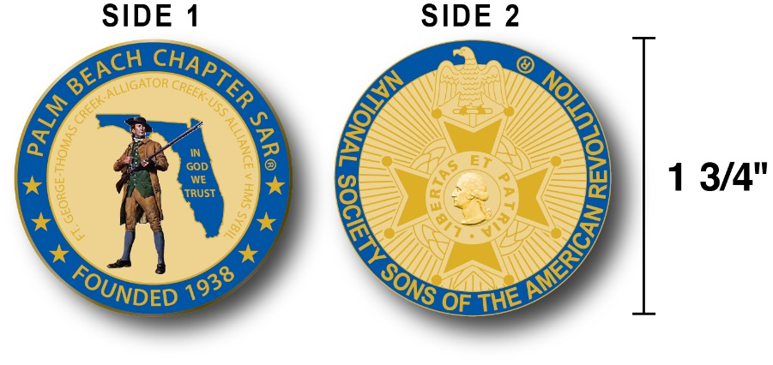

The Chapter created a custom bronze *Commemorative Anniversary Coin* honoring the founding of the *Palm Beach Chapter* in *1938* and celebrating its 80 years of historic, patriotic, and civic service in Palm Beach County and Florida.

The beautiful collector’s coin is highlighted in ***George Washington*** ***military blue*** on a stunning ***gold*** background. Side-one is personalized for our Chapter with the founding date, a Minuteman standing guard over *Florida*, and the *Florida State* motto of ***"In God We Trust”.***

The collector’s coin includes an inscription listing the four major Revolutionary War battles waged in *Florida* including the battles of: ***Ft. George-Pensacola, Thomas Creek Massacre, Alligator Creek,*** and the ***Last Naval Battle* of the Revolutionary War** between the ***USS Alliance*** & ***HMS Sybil.*** Side-two displays the national ***NSSAR*** ***Cross of Malta***.  Very impressive indeed!

The custom bronze ***Commemorative Anniversary Coin*** is designed to celebrate our founding in **1938**, create a distinctive and impressive image for our Chapter and be used as a token of appreciation for honored guests, speakers, and as special awards.

***Purchase these unique Commemorative collector coins for just $10.***

***Classy SAR Lapel Pins $10:***

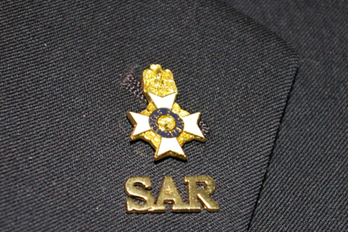

Display a ***Gold*** ***SAR*** pin on your suit lapel or shirt with the ***SAR Rosette***. The SAR Lapel Pin is part of a national branding program to help promote the S.A.R. and stimulate new membership!

The striking lapel pin is a recognizable public symbol of the SAR, provides you recognition as a member of this great society, and will spark conversations about SAR that leads to a new member.

The gold lapel pin and SAR Rosette create a professional image that will improve overall SAR name recognition. The Chapter has a supply of pins for Compatriots for just $10. ***Show Spirit….*Get your Gold SAR Pin today**!

***SAR Chapter, State & National Events:***

**-*STATE/NATIONAL*:**

***Join Chapter members presenting an Honor Wreath at the SAR Last Naval Battle Ceremony at Merritt Island Florida at 10 am March 10, 2018, and enjoy the SAR parade, wreath laying presentations and BBQ lunch. See Ben Tidwell for details.***

***DON’T MISS THE 2108 SAR NATIONAL CONGRESS***

***The 128th SAR Congress is scheduled for July 12-19 in Houston, Texas. Hotel registration is open now at a special SAR price of $159.00 per night King or 2-Queens.***

***Reservations can be made by calling the Westin Memorial City Hotel @ 1-800-937-8461 or online @*** [***www.starwoodmeeting.com/book/nssar2018***](http://www.starwoodmeeting.com/book/nssar2018)***. Questions contact Paul Callanan @*** [***LTCMRSC@aol.com***](mailto:LTCMRSC@aol.com) ***or 906-273-2424.***

***Feature Articles:***

***Revolutionary War’s 15 Little Known Facts….***

***~Compiled/Edited by Don Lanman, Palm Beach SAR Chapter 2016 & 2017 President***

***While most Americans think they know all about the Revolution simply because they are Americans, there are many little known facts about the American Revolutionary War, as noted by historians like Thomas Fleming and George Neumann, including:***

1. ***The Americans of 1776 had the highest standard of living and the lowest taxes in the western world!***   
   **Farmers, lawyers and business owners in the Colonies were thriving, with some plantation owners and merchants making the equivalent of $500,000 a year. The British wanted a slice of the cash flow and tried to tax the Colonists who resisted violently, convinced that their prosperity and their liberty were at stake.**

1. ***There were two Boston tea parties!***   
   **Everyone knows how 50 or 60 "Sons of Liberty," disguised as Mohawks, protested the 3 cents per pound British tax on tea by dumping chests of the popular drink into Boston Harbor on December 16, 1773. Fewer know that the improper Bostonians repeated the performance on March 7, 1774. The two tea parties cost the British around $3 million in modern money.**
2. ***Benjamin Franklin wrote the first Declaration of Independence!***   
   **In 1775, Franklin, disgusted with the arrogance of the British and appalled by the bloodshed at Lexington and Concord, wrote a Declaration of Independence. Thomas Jefferson was enthusiastic. But, he noted, many other delegates to the Continental Congress were "revolted at it."**

**It would take another year of bitter conflict to persuade the Congress to vote for the Declaration of Independence written by Jefferson -- with many astute editorial suggestions by Franklin.**

1. ***John Adams defended Boston Massacre-British Soldiers!***   
   **British Captain Thomas Preston led some British Soldiers to aid another British Soldier who was having things thrown at him and was also hit several times with a board. After their arrival, the people continued to pelt the soldiers and finally shots were fired and the infamous "Boston Massacre" was over.**

**Captain Thomas Preston and eight soldiers were charged with murder. Future President John Adams took up the defense of the soldiers. He, along with Joshua Quincy, was able to get all but two acquitted by a local jury. Those two were found guilty of manslaughter, but claimed benefit of clergy. This means that they were allowed to make penance instead of being executed. To insure that they never could use benefit of clergy again they were both branded on the thumbs.**

1. ***History's first submarine attack was in New York Harbor-1776!***   
   **Connecticut inventor David Bushnell called his submarine invention the *Turtle* because it resembled two large tortoise shells of equal size joined together.**

**The watertight hull was made of 6-inch-thick oak timbers coated with tar. On September 6, 1776, the Turtle targeted the *HMS Eagle*, flagship of the British fleet. The submarine was supposed to secure a cask of gunpowder to the hull of the Eagle and sneak away before it exploded. Unfortunately, the Turtle got entangled with the Eagle's rudder bar, lost ballast and surfaced before the gunpowder could be planted.**

1. ***Benedict Arnold was the Best General in the Continental Army!***   
   **"Without Benedict Arnold in the first three years of the war," says the historian George Neumann, "we would probably have lost the Revolution." In 1775, the future traitor came close to conquering Canada. In 1776, he built a fleet and fought a bigger British fleet to a standstill on Lake Champlain. At Saratoga in 1777, his brilliant battlefield leadership forced the British army to surrender. The victory persuaded the French to join the war on the American side. Ironically, Arnold switched sides in 1780 partly because he disapproved of the French alliance and disagreements with General Washington.**
2. ***By 1779, 1 in 7 Americans in Washington's army was black****!*  
   **At first General Washington was hesitant about enlisting blacks. But when he heard they had fought well at Bunker Hill, he changed his mind. The all-black *First Rhode Island Regiment* composed of 33 freedmen and 92 slaves who were promised freedom if they served until the end of the war and distinguished itself in the *Battle of Newport.* Later, they were all but wiped out in a British attack.**
3. ***There were women in the Continental Army who saw combat!***   
   **Probably the best known is *Mary Ludwig Hays*, nicknamed *"Molly Pitcher."* She replaced her wounded husband at his cannon during the *Battle of Monmouth* in 1778. Another wife of an artilleryman, *Margaret Corbin*, was badly wounded serving in her husband's gun crew at *the Battle of Harlem Heights* in 1776. Lidia Darragh was renowned for her remarkable ability to spy for Washington. Thousands of other women served in Washington's army as cooks and nurses.**
4. ***Washington was the best spymaster in American History!***   
   **Washington ran dozens of espionage rings in British-held New York and Philadelphia effectively using both men and women as spies, and the man who supposedly could not tell a lie was a genius at disinformation. He constantly befuddled the British by leaking, through double agents, inflated reports on the strength and location of his army.**
5. ***By 1779, there were more Americans fighting with the British than with Washington!***   
   **There were 21 regiments (estimated to total 6,500 to 8,000 men) of loyalists in the British army. Washington reported a field army of 3,468. About a third of Americans opposed the Revolution.   
     
   At Yorktown, the Frenchman outnumbered Americans almost three to one! Washington had 11,000 men engaged in the battle, while the French had at least 29,000 soldiers and sailors. The 37 French ships-of-the-line played a crucial role in trapping the 8,700 strong British army and winning the engagement.**
6. ***King George almost abdicated when the British lost the war!***   
   **Following the British defeat at Yorktown, King George III vowed to keep fighting. When parliament demurred, the King wrote a letter of abdication -- then withdrew it. He tried to console himself with the thought that Washington would become a dictator and make the Americans long for royal rule. When he was told that Washington planned to resign his commission, the monarch gasped*: "If he does that, sir, he will be the greatest man in the world."***
7. ***Sweet*** ***Revenge!***

**While it was common practice for Patriots to tar and feather Loyalists, the *Daughters of Liberty* had a less painful alternative: They used molasses and flowers instead.**

1. ***Independence!***

**The word “*independence*” never appears in the *Declaration of Independence* rather, the famous document is titled “*The unanimous Declaration of the thirteen united States of America*.”**

1. ***Females Soldiers*** ***at the Front!***

**In 1782, 21-year-old *Deborah Sampson* dressed as a man, called herself *Robert Shurtlieff Sampson* (after a deceased brother) enlisting in the *Fourth Massachusetts Regiment of the Continental Army*. She served for over a year, until a doctor discovered her secret while treating her for an unhealed injury. She was discharged with honor**.

1. ***Washington’s*** ***Teeth were a Lie***!

**The general’s dentures weren’t made of wood, as legend has it, but rather of hippopotamus ivory and cows’ teeth, held in place by metal springs.**

***By George! It’s Washington's Birthday!***

***~Compiled/Edited by Don Lanman, Palm Beach SAR Chapter 2016 & 2017 President***

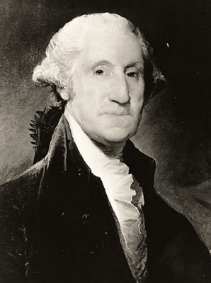

*George Washington* was born in Virginia on February 11, 1731, according to the then-used Julian calendar. In 1752, however, Britain and all its colonies adopted the Gregorian calendar, which moved Washington's Birthday a year and 11 days to February 22, 1732.

Americans celebrated Washington's Birthday long before Congress declared it a federal holiday. The centennial of his birth prompted festivities nationally and Congress established a Joint Committee to arrange for the occasion.

At the recommendation of the Committee, chaired by Henry Clay of the Senate and Philemon Thomas of the House, Congress adjourned on February 22, 1832 out of respect for Washington's memory and in commemoration of his birth.

Prompted by a memorial from the mayor and other citizens of Philadelphia, the House and Senate commemorated the 130th Anniversary of Washington's birth by reading aloud his Farewell Address.

In a special joint session held in the House Chamber, the House and Senate, along with several cabinet officials, Justices of the Supreme Court and high-ranking officers of the Army and Navy, gathered to listen to the Secretary of State read the address aloud. Eventually, the reading of George Washington's Farewell Address became an annual event for the Senate, a tradition that is still observed to this day.

Washington's Birthday, however, did not become a legal holiday until January 31, 1879 when Congress added February 22nd to the list of holidays to be observed by federal employees in the District of Columbia.

The act did not stipulate that employees were to be paid for the holiday - in fact, some government employees in the District of Columbia were paid while others were not. In 1885, Congress resolved this discrepancy with legislation that required federal employees to be paid for all federal holidays and made federal holidays applicable to *all* federal government employees, including those employed outside the Washington DC area.

Washington's Birthday was celebrated on February 22nd until well into the 20th Century. However, in 1968 Congress passed the Monday Holiday Law to "provide uniform annual observances of certain legal public holidays on Mondays." By creating more 3-day weekends, Congress hoped to "bring substantial benefits to both the spiritual and economic life of the Nation."

One of the provisions of this act changed the observance of Washington's Birthday from February 22nd to the third Monday in February. Ironically, this guaranteed that the holiday would never be celebrated on Washington's actual birthday, as the third Monday in February cannot fall any later than February 21.

Therefore, George Washington's Birthday is celebrated as a federal holiday on the third Monday in February. It is one of eleven permanent holidays established by Congress.

Moreover, federal holidays apply only to the federal government and the District of Columbia; Congress has never declared a national holiday binding in all states and each state decides its own legal holidays.

Contrary to popular belief, neither Congress nor the President has ever stipulated that the name of the holiday observed as Washington's Birthday be changed to "President's Day”.

###

***Keep Your Membership Active! Mail Your 2018 Dues Today!***

**Don’t lose your SAR Membership….Reinstate your membership today and mail** **your $75** annual membership dues today to ***SAR PB Chapter, PO Box 16735 West Palm Beach, FL 33416-6735! Include*** any changes to your personal contact information.

***Remember*….Your** **membership dues plus additional donations fund the many Chapter’s youth and civic activities including**:

**Scholarships**, ***Boy Scout & JROTC medals, Rumbaugh & Knight Essay Youth contests, Police-Firefighter-EMT awards, Flag Certificates, Americanism, American History Teacher, Civic & Community programs.***

***-Meeting & Event Pictures-***

***2018 Officers Installed by President Lanman: President B. Tidwell, Secretary G. Green, Treasurer P. Johnston, Chaplain Sears, Historian B. Miller, Sgt.@ Arms P. Miller, S. Barber, Officer@ Large, B. Boggs Vice President/Registrar (not pictured)***

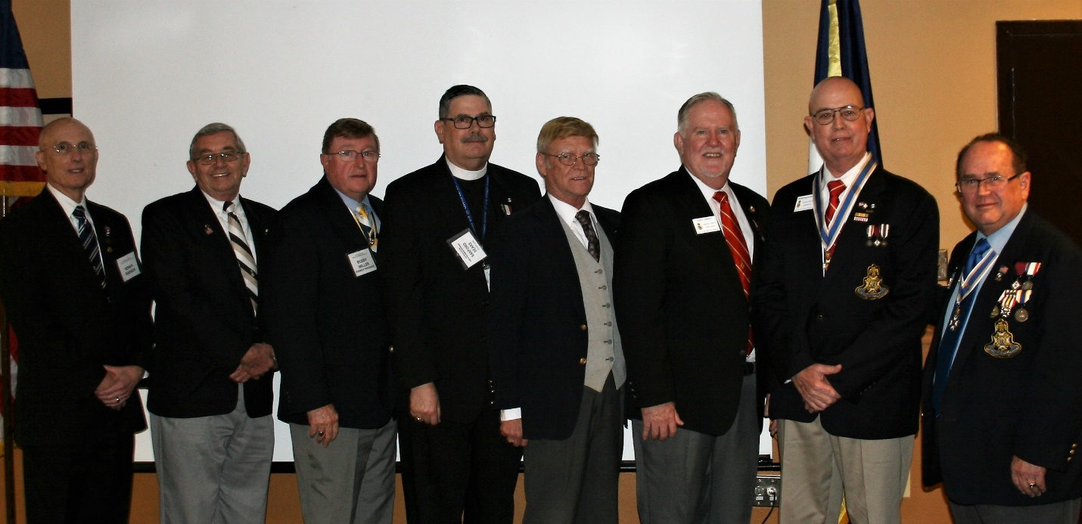

***President Lanman recognizes Palm Beach Atlantic University speaker Dr. Wes Borucki, Chapter scholarship student Mr. Davies, Mr. Morse & Dr. Lloyd***

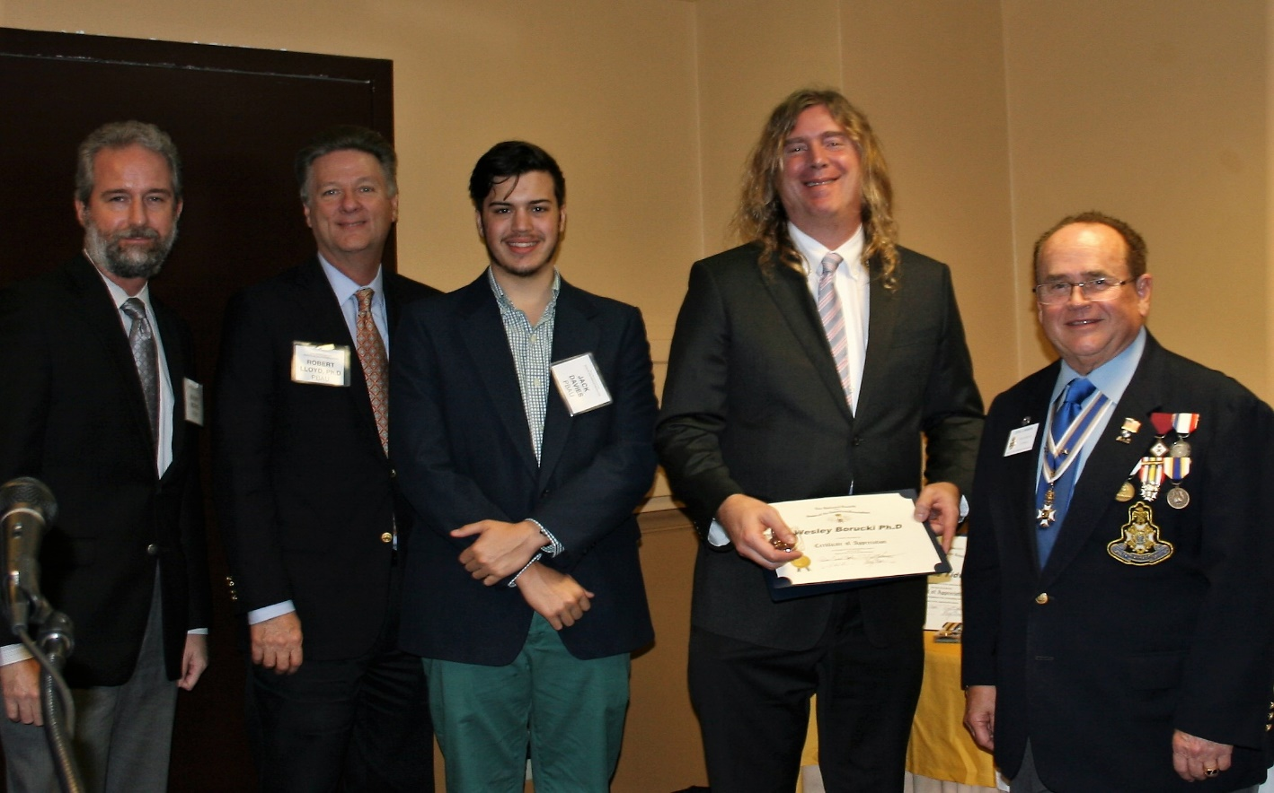

***President Lanman awards 2018 President Ben Tidwell with the***

***Chapter’s “Eagle” Award for Outstanding Service***

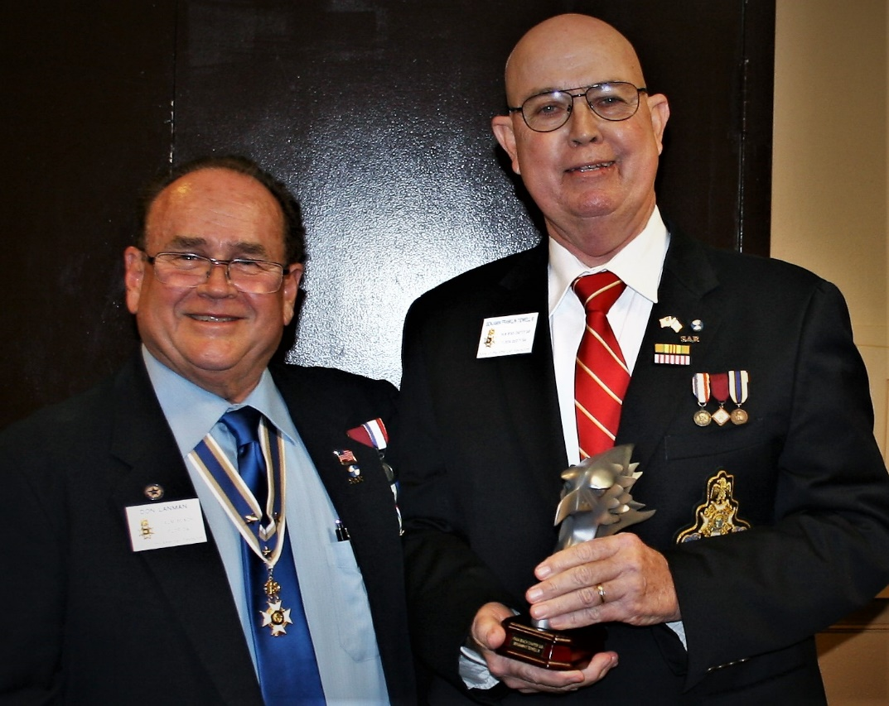

***President Lanman awards Chapter Distinguished Service Medal***

***to Secretary/Past President Gary Green for outstanding service***

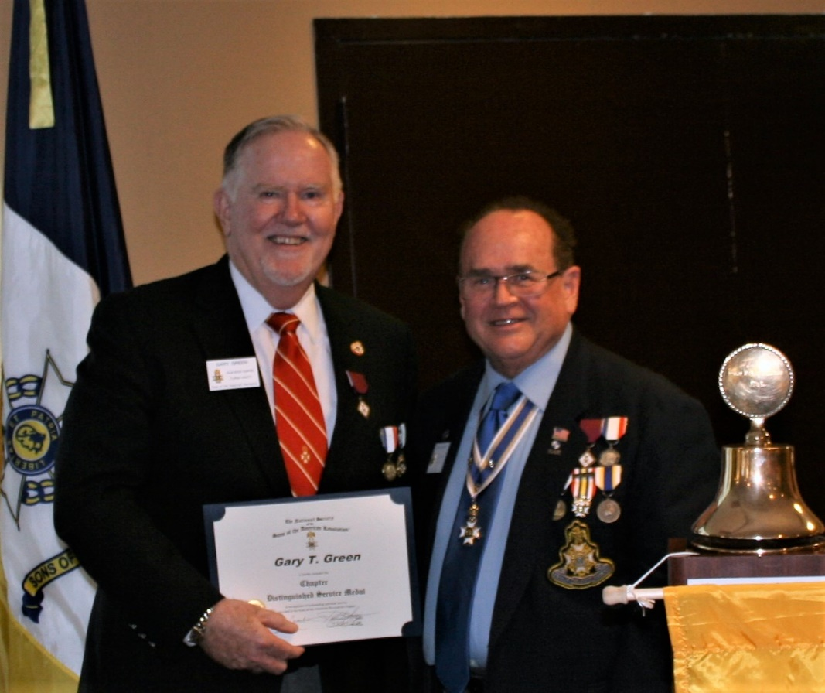

***President Lanman presents the Bronze Roger Sherman Medal to Chapter***

***Historian Buddy Miller & Chaplain Father Sanford Sears for outstanding service***

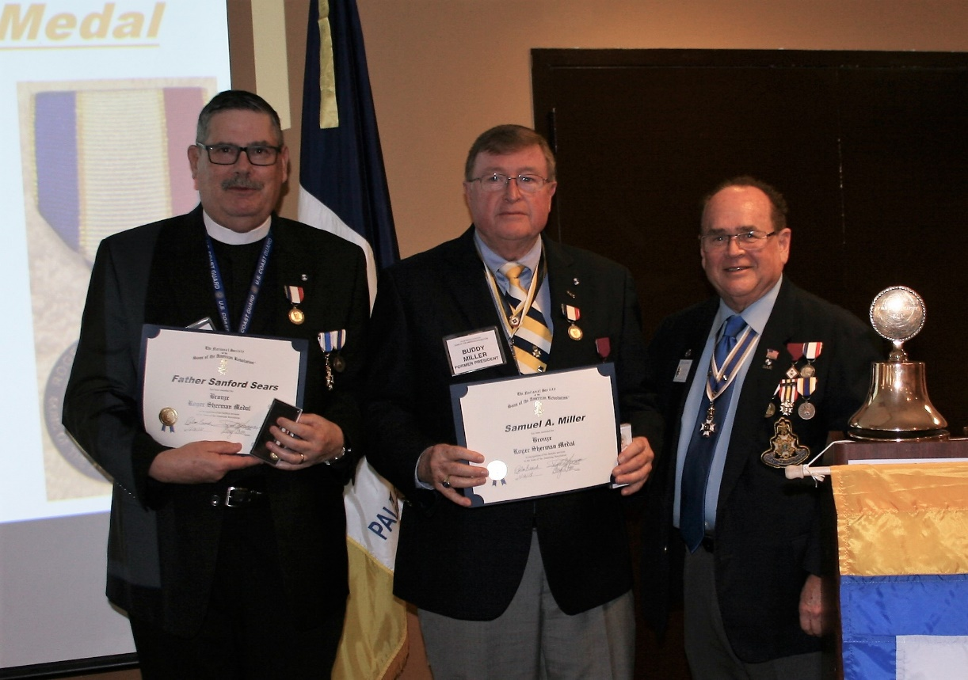

***President Lanman awards SAR “Lydia Darragh” Medal to***

***First Lady Karen Christie for outstanding service to the Chapter***

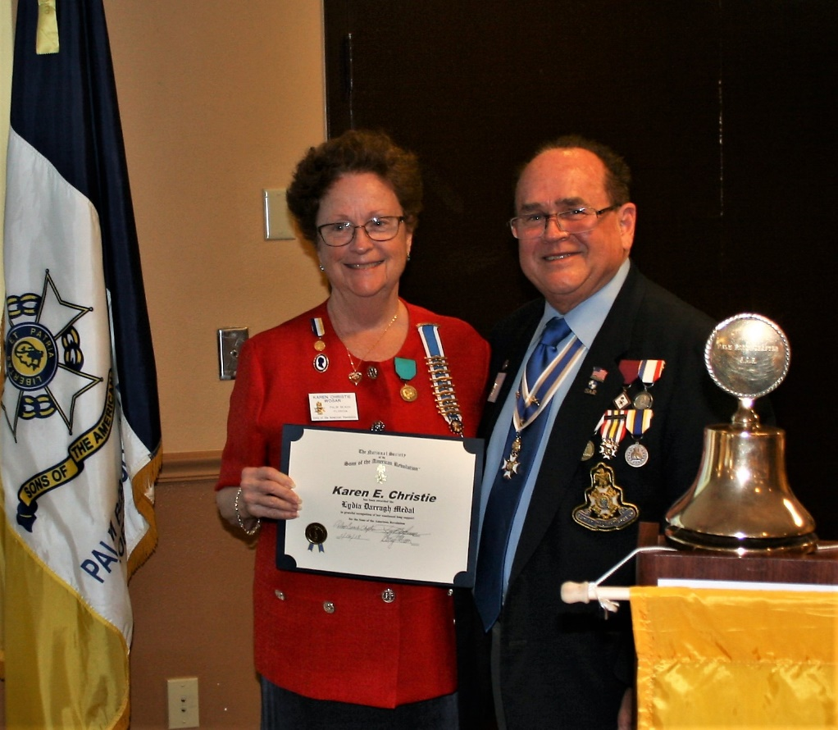

***President Lanman awards SAR Medal of Appreciation to 2018***

***First Lady Diane Tidwell for outstanding service to the Chapter***

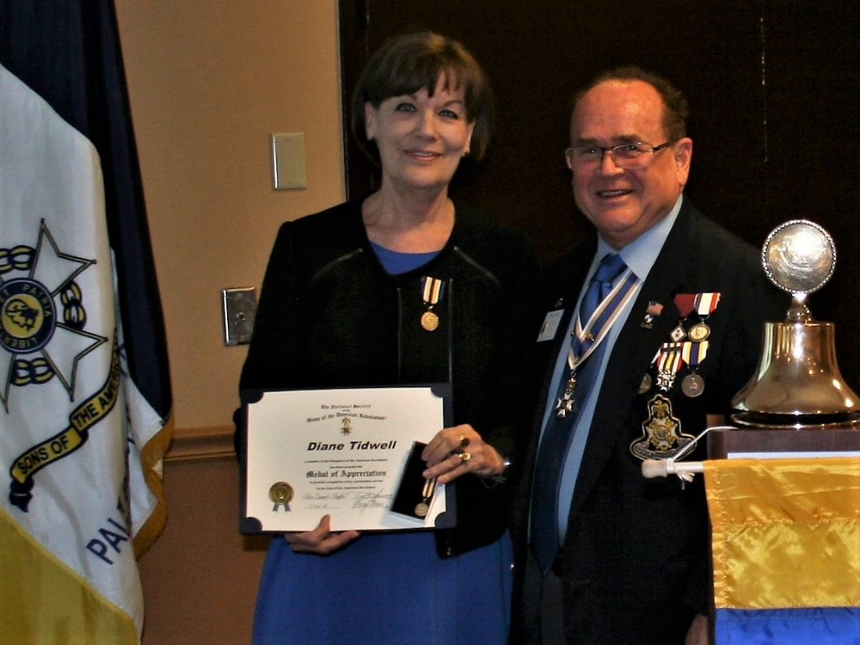

***President Lanman bestows SAR “Wounded Warrior” Medallion to***

***Past State/Chapter President Wess for selfless military service to our Nation***

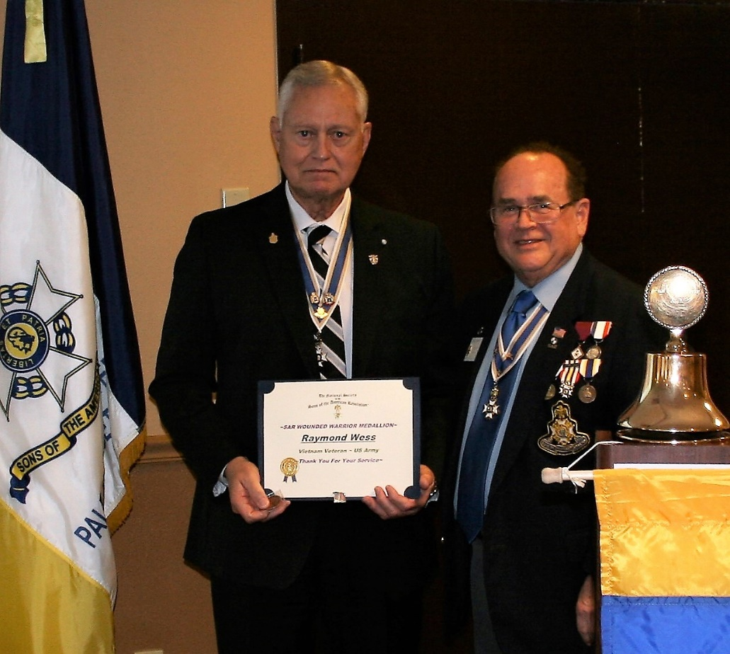

***2018 Chapter President Tidwell presents President Lanman***

***Recognition for selfless service to the Palm Beach Chapter***

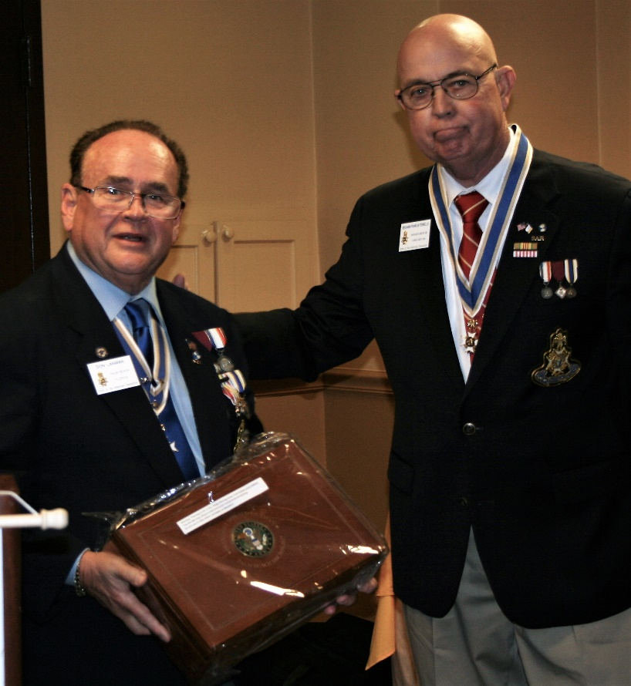

***Chapter First Lady Karen Christie presents***

***Flowers to 2018 Chapter First Lady Diane Tidwell***

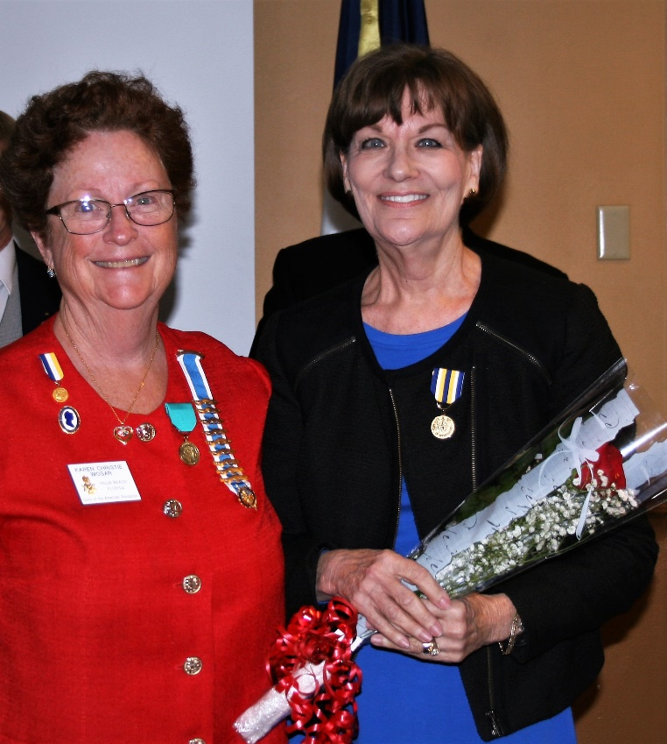

***HMF DAR Past Regent Brenda Fritz wins Valentine’s Day Raffle Basket***

***Pictured Secretary Gary Green & Sgt. @ Arms Peter Miller***

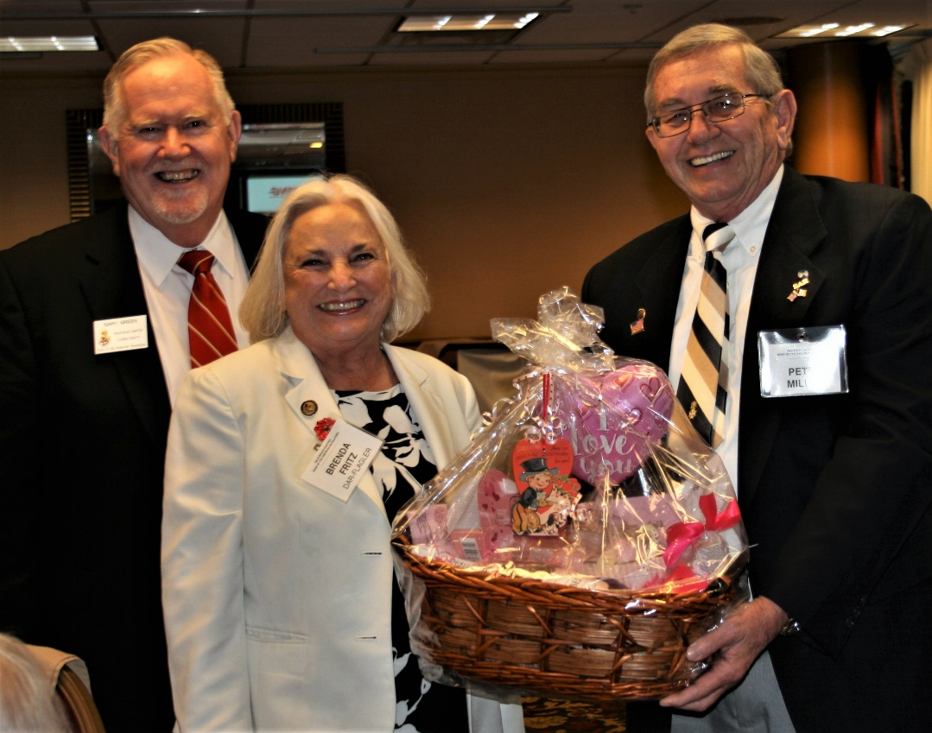

***GdlV DAR Daughter Sally Hitt Congratulates 2018 President Tidwell***

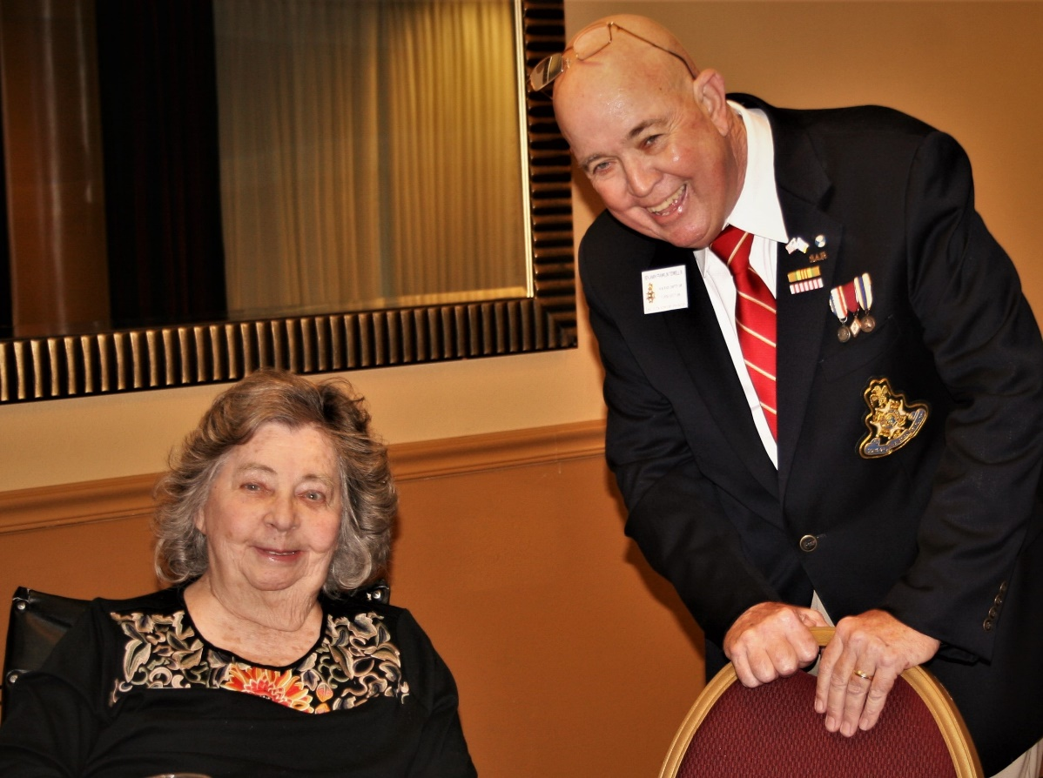

***Compatriot Chase Davis shows great Team Spirit sporting an SAR Tattoo***

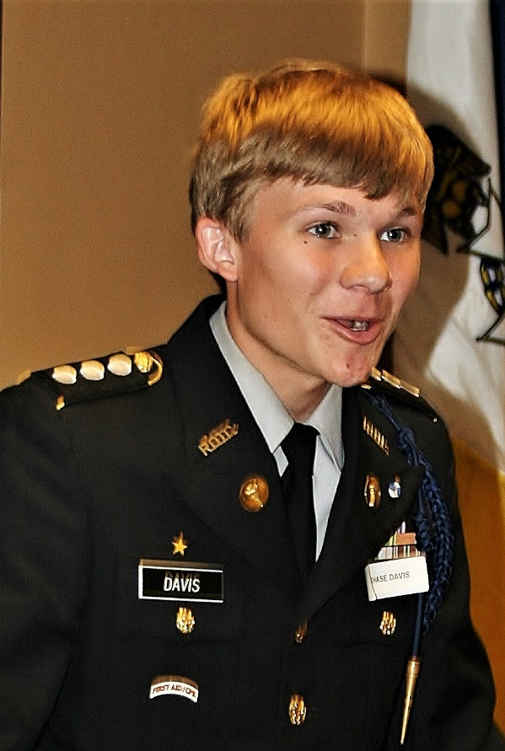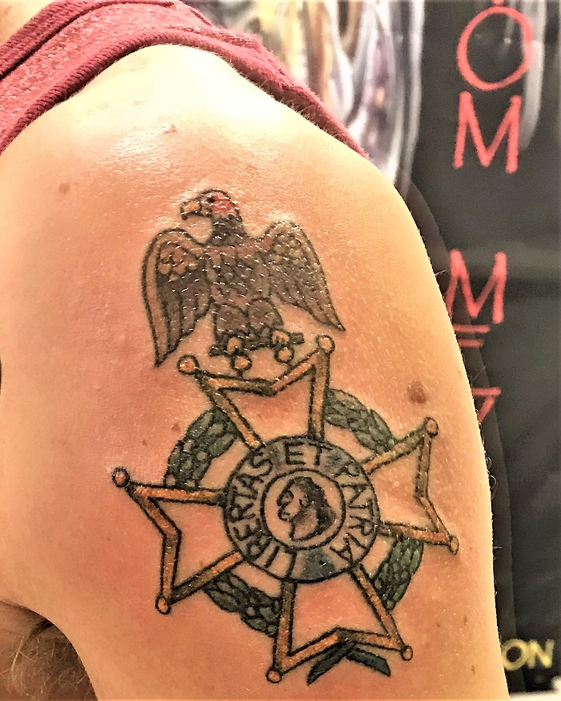

***~80th Anniversary Collectors Commemorative Collector Coin $10.00~***

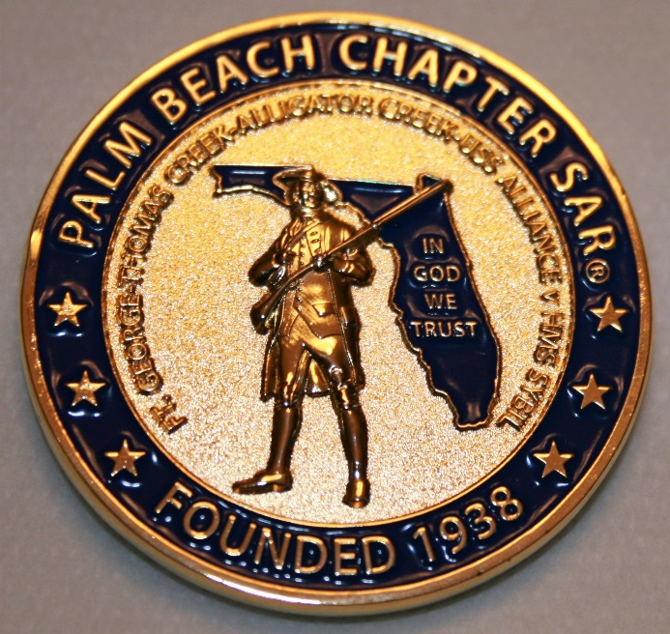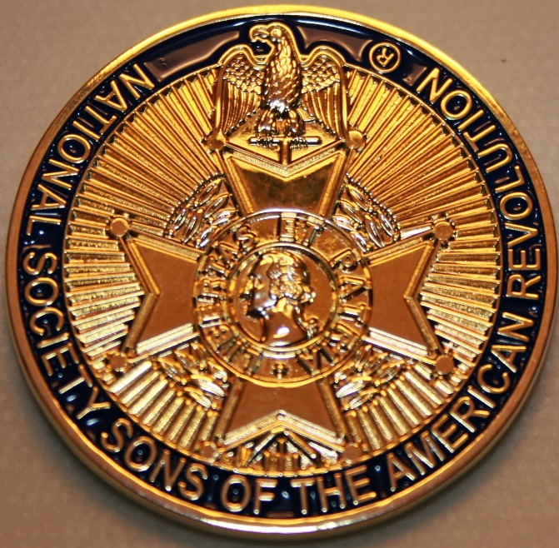

***~Compatriot Sponsored Promotions~***

**Compatriot sponsored newsletter Ads are important to the Chapter as they represent additional funds in support of Chapter projects including *Scholarships, Boy Scout & JROTC medals, Rumbaugh & Knight Essay Youth contests, Police-Firefighter-EMT medals, Americanism & community civic programs!***

**Help** your Chapter, sponsor an Ad for **8** issuesat a modest cost: **Business Card $50, Half Page $100, Full Page $250. Your AD donation will also qualify you for the *Presidents Brigade*. Call Don Lanman 561-315-5073 for information.**

***SPECIAL SPONSORED ADS ON FOLLOWING PAGES…***

***~COMPATRIOT ROBERT BRINCKERHOFF***

***~FINANCIAL SERVICES PROFESSIONAL***

***~COMPATRIOT ALEXANDER DREYFOOS***

***AUTHOR/PHOTOGRPHER***

***~COMPATRIOT SONNY BARBER***

***HISTORIAN/AUTHOR***

***~GARCILASO DE LA VEGA, CHAPTER***

***DAUGHTERS OF THE AMERICAN REVOLUTION***

***-Morgan Stanley-***

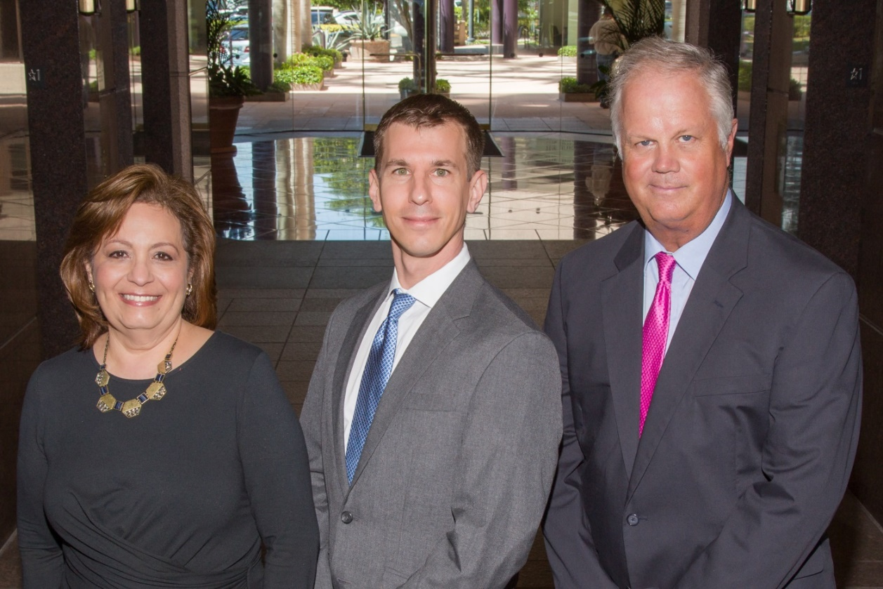  
***Amani Gaballa, Senior Registered Associate; Robert Scarborough, Financial Advisor; Robert Brinckerhoff, First Vice President, Financial Advisor***

***Robert W. Brinckerhoff  
Senior Vice President, Financial Advisor  
777 S. Flagler Dr. Suite 700, East Tower  
West Palm Beach, FL 33401  
(561) 650-7514  
Robert.Brinckerhoff@MorganStanley.com***

***Bob has been a financial advisor since March 1976. He focuses on investment strategies, retirement planning, liquidity solutions for individuals, commercial real estate, and small business owners.***

***Bob is a graduate of the University of Vermont. His clients are geographically diverse and he frequently travels from the east coast to the west to meet with clients. He is active with nonprofit organizations that support the blind and visually impaired. Bob is also an active enthusiast in Ferraris.***

*The investments listed may not be suitable for all investors. Morgan Stanley Smith Barney LLC recommends that investors independently evaluate particular investments and encourages investors to seek the advice of a financial advisor. The appropriateness of a particular investment will depend upon an investor’s individual circumstances and objectives. Morgan Stanley Smith Barney LLC is a registered Broker/Dealer, Member SIPC, and not a bank.*

*Where appropriate, Morgan Stanley Smith Barney LLC has entered into arrangements with banks and other third parties to assist in offering certain banking related products and services. Investment, insurance and annuity products offered through Morgan Stanley Smith Barney LLC are: NOT FDIC INSURED, MAY LOSE VALUE, NOT BANK GUARANTEED, NOT A BANK DEPOSIT, NOT INSURED BY ANY FEDERAL GOVERNMENT AGENCY. Copy write 2015 Morgan Stanley Smith Barney LLC, Member SIPC CRC1355648 11/15.*

*TWO GREAT BOOKS-ONE GREAT MAN*

***-Alexander W. Dreyfoos-***



***-A PHOTOGRAPHIC ODYSSEY- -PASSION & PURPOSE-***

***Compatriot Alexander W Dreyfoos, Jr.*** an honored member of the *Palm Beach Chapter Sons of the American Revolution*, noted American entrepreneur, and philanthropist has published two remarkable books that should be on every bookshelf. **Book sales** **proceeds** **donated to local West Palm Beach charities!**

* ***Passion & Purpose*** chronicles a remarkable lifetime of passion with photography, his business, inventions and philanthropic ventures, as well as his adventures above and below the water. **$29.95.**
* ***A Photographic Odyssey*** is a remarkable collection of hundreds of stunning pictures from 100,000 photos taken by Alex around the world and bound in an elegant 15” by 10” glossy photographic book. You will travel with Alex around the world, above and below the water, to forests, jungles, glaciers, and deserts in the exotic locals of Papua New Guinea, Bhutan, Nepal, China, Japan, and Tibet. The subjects are very divergent contrasting palaces and temples with the vulnerability of people, animals, and exotic scenery. **$60.00.**
* **Support your Chapter & local charities! Get both books, *Passion & Purpose & A Photographic Odyssey,* just $71.96 @ kravis.org/books or Call 561-651-4329.**

***-Alexander W. Dreyfoos-***

*Graduating from MIT and Harvard Business School, Alex founded Photo Electronics Corporation (PCS), specializing in photography and video production. Over the decades, Alex earned 10 US patents and invented the Video Color Negative Analyzer for motion pictures earning him an Academy Award for technical achievement.Many inventions, developed by PCS, are on permanent display at the Smithsonian Institution. Locally Alex also owned television station WPEC TV-12, the CBS affiliate in West Palm Beach. Alex’s many philanthropic achievements include founding the Palm Beach County Cultural Council, the Raymond F. Kravis Center for the Performing Arts and gifting a million dollars to the Dreyfoos School of the Arts. Alex also donated a million dollars each to the Palm Beach County biomedical research campus of the Scripps Research Institute and the local Max Planck Florida Foundation for Neuroscience in Jupiter, Florida.*

***HISTORICAL MYSTERY SERIES FROM THEREVOLUTIONARY WAR ACROSS TIME***



***Follow Kay Telfair across time beginning with Crossed & Found followed by Gold Hush & Stone-Walled….***

***Kay is a normal young teen—normal if that means being unusually curious and having an uncanny knack for putting herself in dangerous situations, which stresses her parents and often tests the relationship with best friend Anna.***

***The series follows Kay across two intrigue-filled summers on adventures involving events in American history. Join Kay’s journey of adventure steeped in American History through three books that excite all ages. At*** [***amazon.com***](http://amazon.com)***, Barnes & Noble or Chapter meetings. (See book summaries following page)***

***SAR Palm Beach Chapter Compatriot/Author Sonny Barber developed an interest in American history at an early age, reading and collecting newspapers, magazines and other materials on historic U.S. and world events. He’s coupled that interest with his fiction writing to create a modern-day “mystery history” Series perfect for Preteens to Adults.***

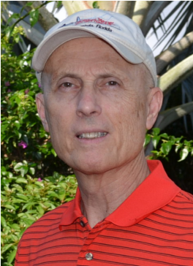

***~Crossed & Found~***

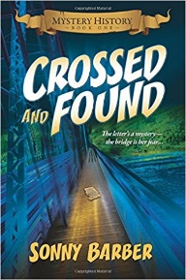

**Thirteen-year-old Kay Telfair believes her life is over when she moves with her family a thousand miles to their new home near the Delaware River in New Jersey. But her life takes an unexpected turn when she meets Anna and discovers a two-centuries-old letter--a letter that could change American history. Before she unravels the letter's mystery, Kay stumbles headlong into an adventure--confronting fears she'd never experienced, stretching the limits of her friendship with Anna, and forcing a test of Kay's physical strength that could save her own life.**

***~Gold Hush~***

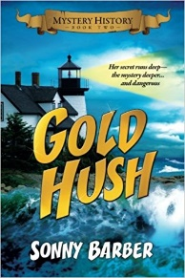

**“I’m avoiding any activity that involves excitement…I’ve learned my lesson.” After an adventure-filled June, all Kay Telfair wants is a quiet vacation in Maine with her family and best friend Anna—no drama, no stress. But the thirteen-year-old’s hopes for a tranquil August stay in the village of Prospect Harbor soon fade when the girls compete for the attention of a young boy and Kay makes a startling discovery—a discovery that sends the three teens on a dangerous quest. Ignoring advice—and menacing threats from others—they continue their pursuit, drawing them deeper into a perilous mystery, deeper than Kay ever could have imagined.**

***~Stonewalled~***

[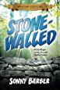](https://www.amazon.com/Stonewalled-Mystery-History-Book-Three/dp/1519351291/ref=pd_bxgy_14_img_3?_encoding=UTF8&psc=1&refRID=75QVZ72QHQ8A2W2F3RK1)

**Kay stared at the gray line of stone walls. “They won’t be too upset to see these knocked down...” A mystery that threatens the relationship with best friend Anna, a battle with Mother Nature at her worst, and the discovery of a tragic secret—not exactly what fourteen-year-old Kay Telfair was looking for in a summer getaway. But that’s what confronts the young teen while helping the owners of Windcrest Farm find a way to stop destruction of nearby farmland and its three-hundred-year-old stone walls. Vacationing with her family and Anna at Windcrest in the quiet, coastal village of Little Compton, Rhode Island, the young teen soon discovers her goal will not be easy. Kay’s prospects for helping preserve the valuable land and stone walls look much better after a surprise visit by a boy from her past. With his help, she pours all her energy and passion into the quest, searching for answers in New England’s Native American and colonial history and learning some important lessons about perseverance and friendship.**

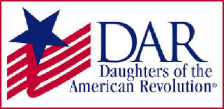

*Garcilaso de la Vega Chapter, NSDAR*

*Lake Worth, Florida*

*Alisha Darcy, Regent*

*Karen Christie, Registrar*

Phone; 561-236-2460-Email; [IMC4U4@AOL.com](mailto:IMC4U4@AOL.com)

Chapter Email: [GarcilasodelaVegaDAR@gmail.com](mailto:GarcilasodelaVegaDAR@gmail.com)

Visit us on ***Facebook*** @ <https://www.facebook.com/LWDAR>