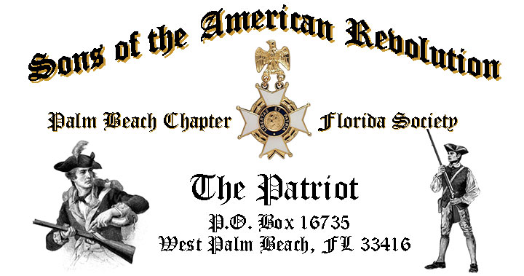

***Volume 23 January 2017 Number 01***

***Happy New Year!*** We’re kicking off 2017 with a terrific meeting featuring a remarkable guest speaker on ***Heraldry & Coats of Arms of Revolutionary War*** ***Patriots, Tuesday*** **January 17, 12:00 Noon** @ the Embassy Suites Hotel 1601 Belvedere Road, West Palm Beach!

***January Meeting Highlights:***

* **Revolutionary War Patriots Coats of Arms & Heraldry!**
* ***2017 Officer Installation, Recognition & Awards***
* **Buffet** Lunch, Desserts & Beverages @ **$28** per person **check/cash** at the door!
* **Reservations** **required** **RSVP** Don Lanman (561)-315-5073!
* **Family, Friends & Guests** are always welcome!

**Newsletter Content:**

* **President’s** Message
* **2017** Chapter Meeting Dates &Topics
* **Officers** & Board Members
* ***President’s*** *Brigade* Financial Supporters
* **Committees**, Chairmen & Members
* **National**/State Society News & Events
* **Feature Articles:** ***Grand Union Flag…The First US Flag!***
  + ***Two Countries from One…The Tory Act of 1776!***
* **Chapter** Activities Pictures
* **Compatriot** Sponsored Promotions

**President’s Message:**

***Fellow Compatriots & Friends,*** Please bring family members, friends and neighbors to our first Chapter event/meeting of the New Year!

Our special guest speaker is renowned author Ms. Maureen McGowan-Singer, a recognized expert on Heraldry & Coat of Arms history! She will review this interesting subject with some examples of the Revolutionary Patriots and Chapter members with actual Coats of Arms.

Maureen is the National Chairman for Heraldry~Coats of Arms for the Colonial Dames XVII Century and Co-author of an acclaimed handbook on Heraldry.

She is a member of the DAR, Past National Chairman of the Colonial Dames America, President Palm Beach Colonial Dames XVII Century, President of Chapter XIX - Florida Everglades and founding General Registrar for the Society of Descendants of Lady Godiva."

A sought after speaker, Ms. Singer has conducted over 50 Heraldry & Coat of Arms History workshops and presentations across the U.S. so don’t miss this event!

The January meeting will also include the installation of your 2017 officers by Regional Vice President Lee Popham.

2017 Officersinclude ***President; Don Lanman, Vice President; Ben Tidwell, Secretary; Gary Green, Registrar; Bob Boggs, Treasurer; Peter Johnston, Historian Buddy Miller; Sergeant at Arms Brian Davey; Chaplain Father Sanford Sears*** and ***Officer at Large; Bill Johnson.***

We will also recognize the chapter officers, members and DAR supporters who contributed so much to make 2016 one of the most productive in our 79 year history.

In addition to the many civic and SAR events supported, Law Enforcement/Firefighters/EMS medals awarded, scholarships and youth programs supported, our membership grew this year to 181 members with another 15 applications in process!

However, with the natural turnover of members for any number of reasons, we still need your help to continue growing our membership with like-minded individuals interested in good fellowship, honoring our patriot ancestors.

You can help grow our membership by enrolling your Sons and Grandsons in SAR, inviting friends and neighbors to join and encouraging wives, daughters, and granddaughters to join the *DAR* and *SAR Women’s Auxiliary*.

**Committee members** are needed to support our youth and civic programs including: Flag Certificates, Liberty Tree Program, Medals/Awards, Veterans Programs, Newsletter, Publicity, High School/Youth Programs; Boy Scouts, JROTC, Rumbaugh Historical Oration and Knight Essay Contests, Police-Firefighters-EMS Service Awards, Chapter Events, Americanism-Patriot Bios, Audit, Membership Development , Officer Nomination, Speakers Bureau, Website Support, Fundraising/Endowment Programs.

The Chapter awarded a $2,000 scholarship to Palm Beach Atlantic University at the November meeting and the two students who earned the scholarships will be at the January meeting to say Thank You!

Also, the ***Dr. Tom & Betty Lawrence American History Techer Award*** went to Ms. Lauren Goepfert, the World and American history teacher at the Bak Middle School of Palm Beach. She went on to represent our Chapter in the SAR state competition where she won that contest too. She will now represent both our chapter and state at the National competition in May.

The Chapter offers **“Gift Basket Raffles”** at chapter meetings to raise funds to support our *Youth Programs*. We seek donations of raffle items or gift baskets with a suggested retail value of $50. All donations are acknowledged at the meeting, included in the newsletter, and donors recognized in support of the Chapter’s *Presidents Brigade*.

The Chapter plans to expand its relationships and joint event activity with all of the local *DAR Chapters* in 2017, and we are always honored to welcome our Patriot Sisters to all of our meetings and events.

*DAR* representatives from Palm Beach chapters including *Palm Beach, Garcilaso de la Vega, Henry Morrison Flagler, Lighthouse Point, Seminole* and *Spirit of Liberty,* continue to refer SAR prospects to our Chapter. We sincerely appreciate these referrals and the ongoing DAR support of our programs.

Compatriots, we need your help to avoid losing money on the chapter luncheons. The hotel requires a minimum number of guests to cover the room, food, and services, so when attendance is low, the Chapter must pay the difference.

**Please** attend our meetings, always bring a friend and be sure to cancel reservations or pay the $28 lunch fee if your plans change! Many Thanks.

Fellow Compatriots, I look forward to seeing you at the January 17 meeting! In closing please, join me in honoring our nations Veterans, patriot ancestors and especially remembering our dear departed Compatriots. **God Bless the *United States of America*.**

**-D. Lanman**

**2017 Chapter Meeting Dates/Topics:**

**Visit** the Palm Beach Chapter web site @ [www.sarpbchapter.org](http://www.sarpbchapter.org) for a meeting calendar, special events, articles, pictures, and general information.

* **Jan. 17** **2017** **Ms. Maureen McGowan-Singer** & Officer Inductions
* **Feb. 21 Washington’s Birthday**,Guest Speaker, **Thomas Jefferson**
* **Mar. 21 Boy Scout/JROTC** Awards & Special Guest Speaker
* **Apr. 18 Law Enforcement** Awards & Special Guest Speaker
* **May 16 Firefighters/EMT** Awards & Special Guest Speaker
* **Oct. 17, Special** Guest Speaker
* **Nov. 21,** **2018** Officer Nominations, Special Guest Speaker
* **Dec. 9,** **Kings Academy Holiday Musical**

**2017 Officers & Board:**

**President**; Donald Lanman

**Vice President;** Benjamin Tidwell III

**Secretary**; Gary Green

**Treasurer**; Peter Johnston

**Registrar**; Robert Boggs

**Chaplain**; Father Sanford Sears

**Sgt. @ Arms**: Brian Davey

**Historian**; Samuel “Buddy” Miller

**Officer @ Large**: Bill Johnson

**Patriot Newsletter Editor**; Donald Lanman

**Support Youth Programs-Donate to the President’s Brigade:**

The Chapter honors and expresses its sincere appreciation to the Compatriots of the ***President’s Brigade***!

The dedicated members of the ***President’s Brigade*** donate “extra dollars” in support of the Chapter’s many youth programs, scholarships, civic activities, award certificates, police/firefighter/EMT medals, veterans’ projects, and related community civic programs.

**Presidents Brigade Members:**

**-Bronze Level: $25-$99**

***B. Boggs, J. Harper, J. Kane, S. McWhorter, J. Dorsey, F. Devitt***

***J. Curry, J. Brown, D. Coldwell, W. Davis, M. Anderson, G. Parkinson***

***C. Odell, R. Cass, W. Told, J. Mayne, B. Davey***

**Presidents Brigade Members:**

**-Silver Level: $100-$199**

***B. Johnson, G. Green, A. Griswold, T. Friend, R. Culpepper***

**-Gold Level: $200-$499**

***H. Wynns, R. Utley, R. Banta , W. Meakin, E. Buckley, D. Lanman***

***B. Tidwell, S. Hitt***

**-Platinum Level: $500+**

**Committees, Chairs & Members:**

**Fellow Compatriots**…..The Chapter expresses its sincere appreciation to those members who volunteer to serve on our committees and projects.

**Please** volunteer to help with any of the chapter committees listed below. It does not take much time and is a major help with our many civic initiatives.

**Call** or email Don Lanman or Ben Tidwell **Today** to lend a hand with any of the following committees.

* **JROTC** -Tidwell
* **Law Enforcement-Fire Safety** -Tidwell, Green
* **Veterans Affairs** -Wenman, Lanman
* **Newsletter/Publicity** -Lanman
* **Boy Scouts** -Tidwell
* **Knight Essay/Rumbaugh** **Oration** -Boggs
* **American History Teacher**  -Boggs
* **DAR Liaison** -Lanman, Tidwell
* **Speakers Bureau** -Lanman, Tidwell
* **Audit** -Coldwell, Tidwell, Lanman
* **2017 Officer Nomination** -Lanman, Tidwell, Boggs
* **Flag Certificates** -Clouse, Miller, Lanman, Tidwell
* **Membership** -Green, Boggs, Tidwell
* **Liberty Tree** -Lanman
* **Patriot Bios** -Miller
* **Web Site-Facebook** -Open

**Custom Chapter Challenge Coin:**

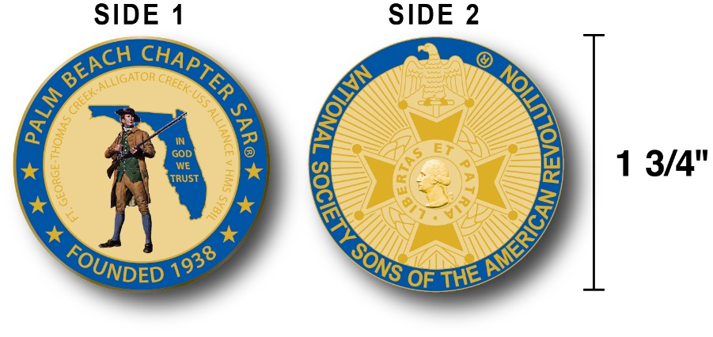

The Chapter has designed a custom Challenge Coin honoring the founding of the Palm Beach Chapter and its 79 years of patriotic and civic service in Palm Beach County.

The custom bronze coin is highlighted with a military blue and gold background with side one is personalized to our chapter including the date of our founding, a minute man standing guard over a map of Florida, the state motto "In God We Trust" and a listing of the 4 major RW battles waged in Florida.  Side 2 displays the National NSSAR logo for the SAR.  Very impressive indeed.

The custom chapter challenge coin is designed to celebrate our founding in 1938, create a distinctive and impressive image and will be used as a token of appreciation for honored guests, guest speakers and special awards.  These bronze challenge coins may also be purchased by Chapter Compatriots at just $10 each.

**National & State Society News:**

**-Chapter Events:** Compatriots participated in December Veterans Holiday Programs.

**-State Society:** Board of Management meeting will be held February 4th.

**- “HONOR FLIGHT” Guardian Program:** The Palm Beach Chapter is supporting the *Florida State Society of the Daughters of the American Revolution* and *Honor Flights Southeast Florida* with an Honor Flight event on **April 8, 2017** from Palm Beach Airport to Washington DC.

Interested Chapter Compatriots must complete an application and submit $400 for travel expenses to join Florida DAR members and WW 2 & Korean War Vets on their visit to war memorials in DC!

For **information** and an application contact Gladys Van Otteren, FSSDAR State Chairman Honor Flight program (561)-324-2937 or [HMFchapterDAR@gmail.com](mailto:HMFchapterDAR@gmail.com).

**Feature Article:**

***Grand Union Flag!!***

***First Flag of the United States of America!***

**Compiled By Don Lanman, President SAR Palm Beach Chapter**

[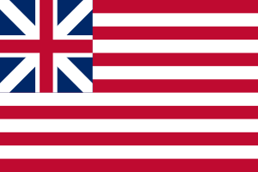](https://www.google.com/url?sa=i&rct=j&q=&esrc=s&source=images&cd=&cad=rja&uact=8&ved=0ahUKEwjQq7i31LPRAhUEKyYKHfDzA1QQjRwIBw&url=https://en.wikipedia.org/wiki/Grand_Union_Flag&psig=AFQjCNEHQiT141Yuwu5eCTAZ5mPgGyI5mw&ust=1484003081232171)[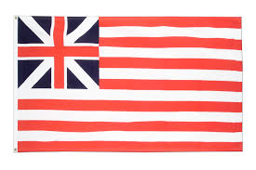](https://www.google.com/url?sa=i&rct=j&q=&esrc=s&source=images&cd=&cad=rja&uact=8&ved=0ahUKEwiW3qv3j6TRAhWETSYKHRYvCfsQjRwIBw&url=https://www.flaggenplatz.ch/grand-union-1775-flagge-2093.html&psig=AFQjCNHlMjyZAUl5WJ4n852ntVjRI7xSUg&ust=1483467022118566)

[](https://www.google.com/url?sa=i&rct=j&q=&esrc=s&source=images&cd=&cad=rja&uact=8&ved=0ahUKEwiW3qv3j6TRAhWETSYKHRYvCfsQjRwIBw&url=https://www.flaggenplatz.ch/grand-union-1775-flagge-2093.html&psig=AFQjCNHlMjyZAUl5WJ4n852ntVjRI7xSUg&ust=1483467022118566)

[](https://www.google.com/url?sa=i&rct=j&q=&esrc=s&source=images&cd=&cad=rja&uact=8&ved=0ahUKEwiW3qv3j6TRAhWETSYKHRYvCfsQjRwIBw&url=https://www.flaggenplatz.ch/grand-union-1775-flagge-2093.html&psig=AFQjCNHlMjyZAUl5WJ4n852ntVjRI7xSUg&ust=1483467022118566)

The *"****Grand Union Flag****"* was adopted in January 1776, also known as the *"****Continental Colors****",* the *"****Congress Flag****",* the **"Cambridge Flag",** and the *"****First Navy Ensign****",* and is considered by historians to be the first national flag of the United States of America.

The flag consisted of 13 alternating red and white stripes, like the current US flag, but with the upper inner corner displaying the British Union Flag of the time.

By the end of 1775, during the first year of the American Revolutionary War the Second Continental Congress operated as the de facto war government authorizing the creation of an Army, Navy and a Marine Corps.

A new flag was required to represent the Congress and fledgling nation, initially the United Colonies, with a banner distinct from the British Red ensign flown from civilian and merchant vessels, the White Ensign of the King's Royal Navy and the British Union flags carried by the King's army land troops.

The American colonist's "Continental Colour" was first hoisted on the colonial warship *Alfred*, in the harbor on the western shore of the Delaware River at Philadelphia on December 3, 1775, by newly-appointed Lieutenant John Paul Jones of the formative Continental Navy.

The event had been documented in letters to Congress along with eyewitness accounts.

The flag was used by the American Continental Army forces as both a naval ensign and garrison flag throughout 1776 and early 1777.  It is not known for certain when or by whom the design of the Continental Colors was created, but the flag could easily be produced by sewing white stripes onto the British Red Ensigns.

Known as the *"Alfred"* flag, it has been credited to *Margaret Manny* and it was widely believed to be the flag that was raised by George Washington's Army on New Year's Day, 1776, at *Prospect Hill* in *Charleston* near his headquarters at Cambridge, Massachusetts, which was then surrounding and laying siege to the British forces then occupying Boston.

However, the flag was interpreted by British military observers in the city, under commanding General Thomas Gage, as a sign of surrender. Some scholars dispute this traditional account and assert that the flag raised at Prospect Hill was probably a British union flag.

The name ***"Grand Union"*** is contemporary to reconstruction-era historians and was first applied to the Continental Colors by George Henry Preble, in his 1872 *History of the American Flag*.

The design of the flag itself is strikingly similar to the flag of the British East India Company (BEIC). Indeed, certain BEIC designs in use since 1707, when the canton was changed from the flag of England to that of the Kingdom of Great Britain were nearly identical, but the number of stripes varied from 9 to 15. The fact that the BEIC flags was well known by the American colonists has been the basis of a theory of the origin of the first national flag's design.

The Flag Act of 1777 by the Continental Congress authorized a new official national flag of a design similar to that of the Colors, with thirteen stars representing the thirteen States on a field of blue replacing the British Union Flag in the canton. The resolution describes only "a new constellation" for the arrangement of the white stars in the blue canton so a number of designs were later interpreted and made with a circle of equal stars, another circle with one star in the center, and various designs of even or alternate horizontal rows of stars, even the "Bennington Flag" from Bennington, Vermont which had the number "76" surmounted by an arch of 13 stars, later also becoming known in 1976 as the "Bicentennial Flag".

 The symbolism of a union of equal parts was retained in the new American flag, as described in the Flag Resolution of June 14, 1777 and later celebrated in American culture and history as **"Flag Day**".

***January 1776 Congress Publishes the Tory Act!***

***Revolution Created Two Countries from One…..***

***Compiled By Don Lanman, President SAR Palm Beach Chapter***

The Continental Congress publishes the ***“Tory Act”*** resolution on January 2, 1776, which describes how colonies should handle those Americans who remain loyal to the British and King George.

The act called on colonial committees to indoctrinate those “honest and well-meaning, but uninformed people” by enlightening them as to the “origin, nature and extent of the present controversy.”

The Congress remained “fully persuaded that the more our right to the enjoyment of our ancient liberties and privileges is examined, the more just and necessary our present opposition to ministerial tyranny will appear.”

However, those “unworthy Americans,” who had “taken part with our oppressors” with the aim of gathering “ignominious rewards,” were left to the relevant bodies, some ominously named “councils of safety,” to decide their fate.

Congress merely offered its “opinion” that dedicated Tories “ought to be disarmed, and the more dangerous among them either kept in safe custody, or bound with sufficient sureties to their good behavior.”

The lengths Congress and lesser colonial bodies would go to in order to repress Loyalists took a darker tone later in the act.

Listing examples of the “execrable barbarity with which this unhappy war has been conducted on the part of our enemies,” Congress vowed to act “whenever retaliation may be necessary” although it might prove a “disagreeable task.”

In the face of such hostility, some Loyalists chose not to remain in the American colonies. During the war, between 60,000 and 70,000 free persons and 20,000 slaves abandoned the rebellious 13 colonies for other destinations within the British Empire.

The Revolution effectively created two countries: Patriots formed the new United States, while fleeing Loyalists populated Canada.

**Keep You Membership Active! 2017!**

**If you failed to send in your SAR membership dues…**mail in the 2017 SAR membership dues today and we can reinstate you in March.

**Don’t wait….Mail** your $75 annual membership fee to ***SAR PB Chapter, PO Box 16735 West Palm Beach, FL 33416-6735*** ASAP along with any changes to your personal contact information.

**Remember….Your** membership dues and additional donations fund the many Chapter civic activities including **Scholarships**, ***Boy Scout & JROTC medals, Rumbaugh & Knight Essay Youth contests, Police-Firefighter-EMT awards, Flag Certificates, Americanism, & Community programs.***

***-Chapter Activities Pictures-***

**President Lanman presents Sgt @ Arms Byrd Wenman an**

**Appreciation Certificate for wife Diane Wenman’s Patriotic**

**Quilt donation for the December Raffle.**

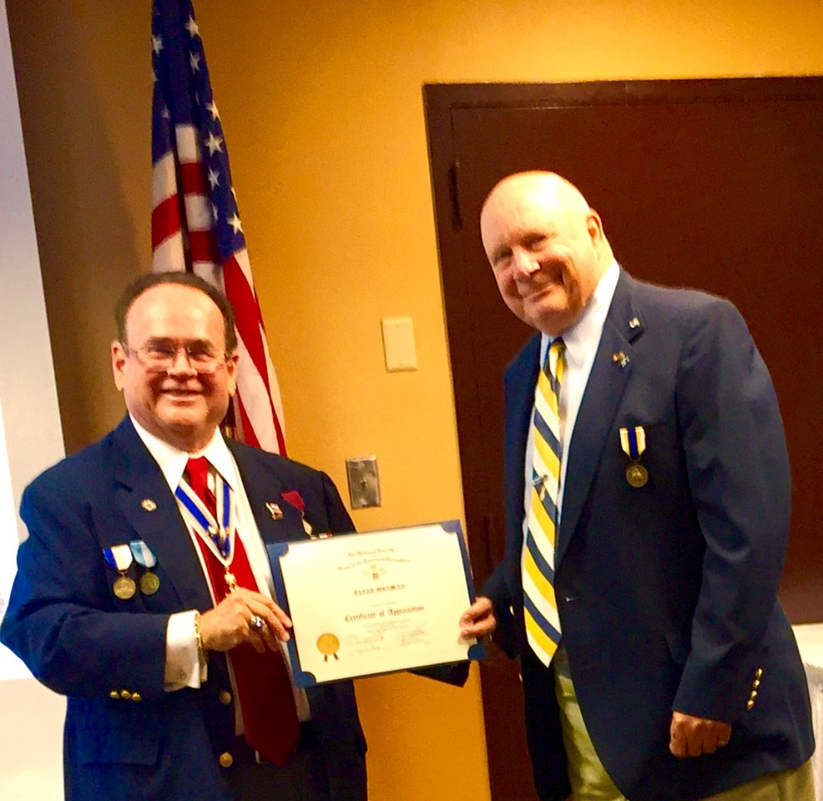

**Judy Mahaffey Registrar DAR Chapter**

**Garcilaso de la Vega Registrar wins Raffle**

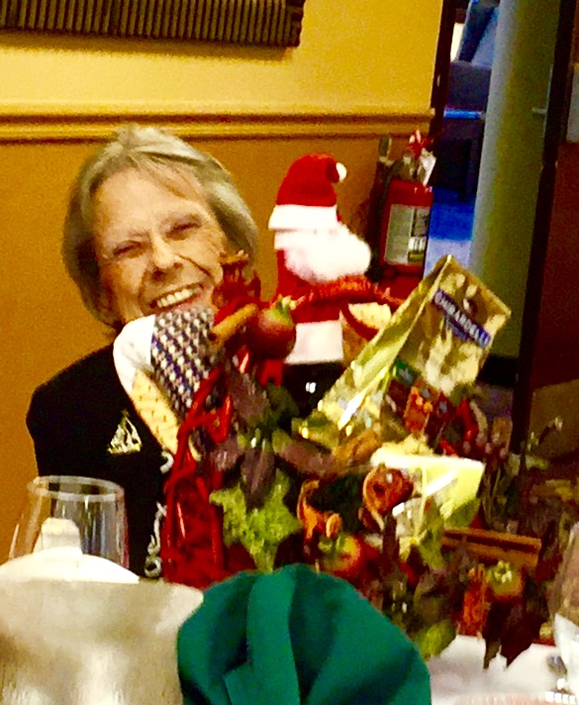

**Kings Academy Holiday Musical Choir**

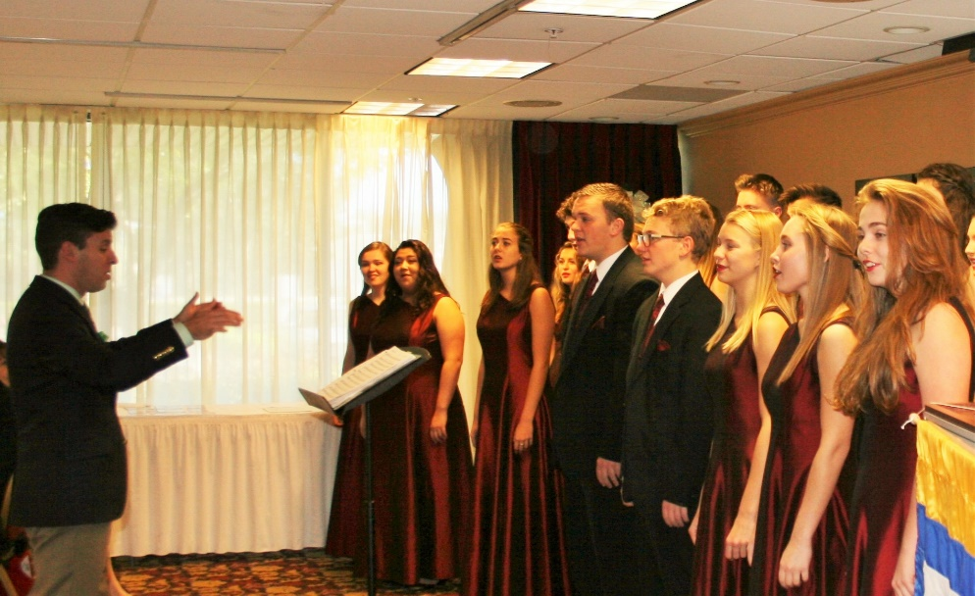

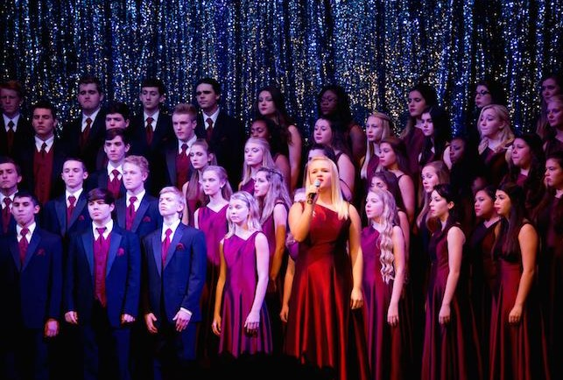

**Compatriot Sponsored Promotions:**

The Compatriot sponsored Ads are important to the Chapter as they represent additional funds to support all Chapter projects including: ***Boy Scout & JROTC medals, Rumbaugh & Knight Essay Youth contests, Police-Firefighter-EMT awards, Americanism & community programs!***

**Please** consider helping your Chapter with an Ad at the modest cost for **8** issues **@ Business Card $50, Half Page $100, Full Page $200.**

**Your AD donation will also qualify you for the *Presidents Brigade* listing. Call Don Lanman 561-315-5073 for information.**

***SPECIAL SPONSORED ADS ON FOLLOWING PAGES…***

***-COMPATRIOT ALEXANDER DREYFOOS***

***-COMPATRIOT ROBERT BRINCKERHOFF***

***-DAR GARCILASO DE LA VEGA, CHAPTER DAUGHTERS OF THE AMERICAN REVOLUTION***

*TWO GREAT BOOKS-ONE GREAT MAN*

***-Alexander W. Dreyfoos-***

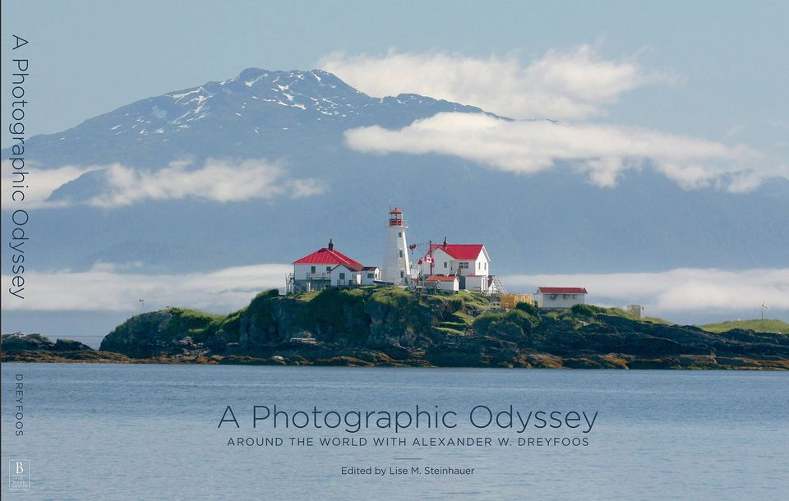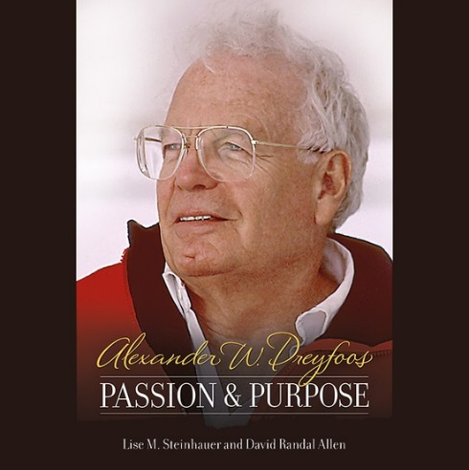

***-A PHOTOGRAPHIC ODYSSEY- -PASSION & PURPOSE-***

***Compatriot Alexander W Dreyfoos, Jr.*** an honored member of the *Palm Beach Chapter Sons of the American Revolution*, noted American entrepreneur, and philanthropist has published two remarkable books that should be on every bookshelf. **Book sales** **proceeds** **donated to local West Palm Beach charities!**

* ***Passion & Purpose*** chronicles a remarkable lifetime of passion with photography, his business, inventions and philanthropic ventures, as well as his adventures above and below the water. **$29.95.**
* ***A Photographic Odyssey*** is a remarkable collection of hundreds of stunning pictures from 100,000 photos taken by Alex around the world and bound in an elegant 15” by 10” glossy photographic book. You will travel with Alex around the world, above and below the water, to forests, jungles, glaciers, and deserts in the exotic locals of Papua New Guinea, Bhutan, Nepal, China, Japan, and Tibet. The subjects are very divergent contrasting palaces and temples with the vulnerability of people, animals, and exotic scenery. **$60.00.**
* **Support your Chapter & local charities! Get both books, *Passion & Purpose & A Photographic Odyssey,* just $71.96 @ kravis.org/books or Call 561-651-4329.**

***-Alexander W. Dreyfoos-***

*Graduating from MIT and Harvard Business School, Alex founded Photo Electronics Corporation (PCS), specializing in photography and video production. Over the decades, Alex earned 10 US patents and invented the Video Color Negative Analyzer for motion pictures earning him an Academy Award for technical achievement.Many inventions, developed by PCS, are on permanent display at the Smithsonian Institution. Locally Alex also owned television station WPEC TV-12, the CBS affiliate in West Palm Beach. Alex’s many philanthropic achievements include founding the Palm Beach County Cultural Council, the Raymond F. Kravis Center for the Performing Arts and gifting a million dollars to the Dreyfoos School of the Arts. Alex also donated a million dollars each to the Palm Beach County biomedical research campus of the Scripps Research Institute and the local Max Planck Florida Foundation for Neuroscience in Jupiter, Florida.*

-Morgan Stanley-

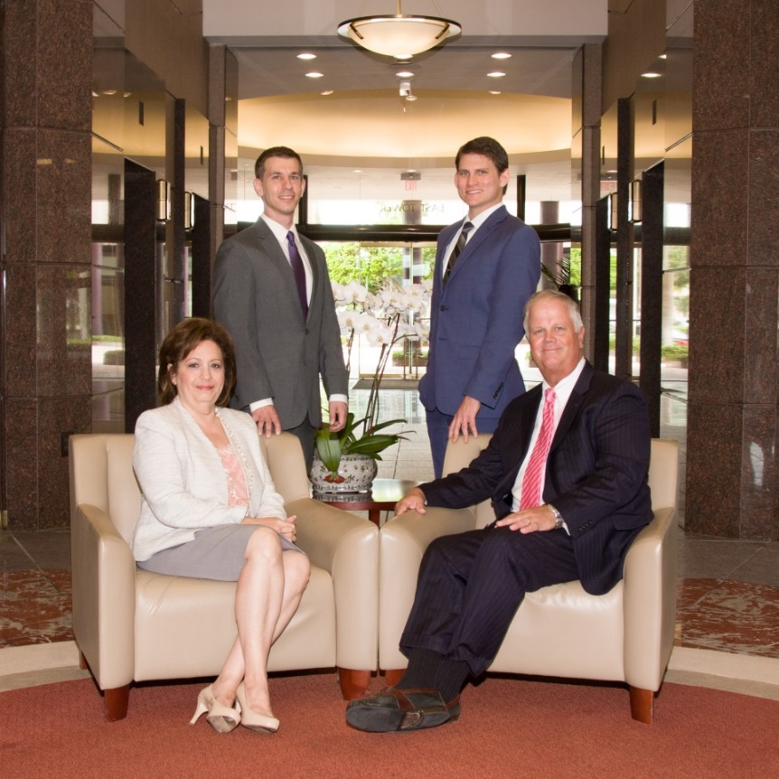  
***Robert Scarborough, Financial Advisor; Amani Gaballa, Senior Registered Associate;***

***Logan Gordon, Financial Advisor; Robert Brinckerhoff, Senior Vice President, Financial Advisor***

***Robert W. Brinckerhoff, Senior Vice President, Financial Advisor  
777 S. Flagler Dr. Suite 700, East Tower  
West Palm Beach, FL 33401, (561) 650-7514***[***Robert.Brinckerhoff@MorganStanley.com***](mailto:Robert.Brinckerhoff@MorganStanley.com)

***Bob has been a financial advisor since March 1976. He focuses on investment strategies, retirement planning, liquidity solutions for individuals, commercial real estate, and small business owners.***

***Bob is a graduate of the University of Vermont. His clients are geographically diverse and he frequently travels from the east coast to the west to meet with clients. He is active with nonprofit organizations that support the blind and visually impaired. Bob is also an active enthusiast in Ferraris.***

*The investments listed may not be suitable for all investors. Morgan Stanley Smith Barney LLC recommends that investors independently evaluate particular investments and encourages investors to seek the advice of a financial advisor. The appropriateness of a particular investment will depend upon an investor’s individual circumstances and objectives. Morgan Stanley Smith Barney LLC is a registered Broker/Dealer, Member SIPC, and not a bank.*

*Where appropriate, Morgan Stanley Smith Barney LLC has entered into arrangements with banks and other third parties to assist in offering certain banking related products and services. Investment, insurance and annuity products offered through Morgan Stanley Smith Barney LLC are: NOT FDIC INSURED, MAY LOSE VALUE, NOT BANK GUARANTEED, NOT A BANK DEPOSIT, NOT INSURED BY ANY FEDERAL GOVERNMENT AGENCY. Copy write 2015 Morgan Stanley Smith Barney LLC, Member SIPC CRC1355648 11/15.*

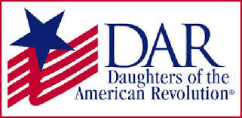

*Garcilaso de la Vega Chapter, NSDAR*

*Lake Worth, Florida*

*Sheila Zile-Pecoraro, Regent*

*Judy Mahaffey,* Registrar

Phone; 561-876-9520-Email; [Smileson@AOL.com](mailto:Smileson@AOL.com)

Chapter Email: [GarcilasodelaVegaDAR@gmail.com](mailto:GarcilasodelaVegaDAR@gmail.com)

Visit us on ***Facebook*** @ <https://www.facebook.com/LWDAR>