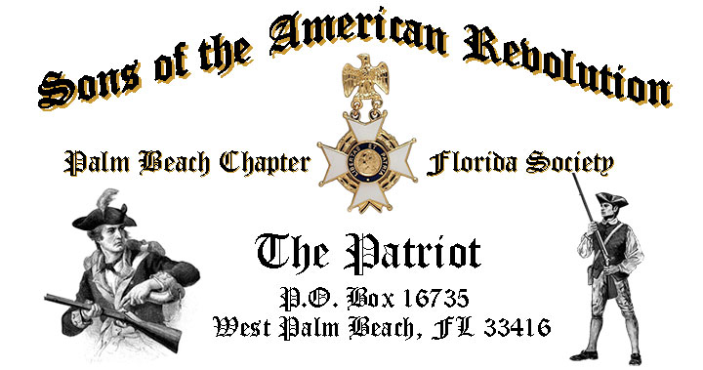

***Volume 24 January 2018 Number 01***

***RSVP early for a Special presentation featuring author/historian Dr. Wes Borucki American History Professor-Palm Beach Atlantic University***, **Tuesday January 16, 12:00 Noon** @ Embassy Suites 1601 Belvedere Rd, WPB! ***RSVP* Today**!

***January 16 Meeting Event Highlights:***

* ***Dr. Borucki American History Professor Palm Beach Atlantic University!***
* ***4-Course Buffet Lunch, Desserts & Beverages, $28 per person Check/Cash!***
* ***Reservations*** **Required,** **RSVP**, **Ben Tidwell** **(561)-704-9918!**
* **Family, Friends & Guests** are always ***Welcome***!

***Newsletter Content:***

* **President’s** Message
* **2018 Officers** & Board Members
* **2018** **Chapter** Meeting Dates &Topics
* ***President’s******Brigade*** Financial Supporters
* **Committees**, Chairmen & Members
* **National**/**State/Chapter**, News & Events
* **Feature Articles:** 
  + ***Honoring Those Who Sacrificed @ the Alter of Freedom!***
  + ***Origins & Evolution of the United States Flag!***
* **Chapter** **Meeting**s & Event Pictures
* **Compatriot** **Sponsored** Promotions

***President’s Message:***

***Fellow Compatriots & Friends…***

As we, together, begin the New Year, it is with pride and humility that I assume the office of President of the Palm Beach Chapter Sons of the American Revolution.

My goal this year is to perpetuate the ideals that our founders had, as true selfless servants. We will strive to model the core beliefs that our organization and our country were founded upon including, especially, honoring those who serve us in our community and teaching the next generation that freedom comes at such a great price. Thank you, in advance, for all the help and support—from both SAR and DAR—in achieving this goal.

We will launch the new-year with an enlightening presentation by Author/Historian*, Dr. Wes Borucki* *on "The Importance of Providence to the Revolutionary Generation: God's Will and Revolutionary Thought."*

*Wes Borucki*, Ph.D., is an esteemed professor of *American History at Palm Beach Atlantic University* specializing in southern American history. He has published *“First Men, America’s Presidents*” series: *“Ronald Reagan: Heroic Dreamer”*, and “*George H.W. Bush: In Defense of Principle*”.

The December meeting included our traditional ***Christmas & Holiday*** celebration featuring ***“Dimension 20***” the renowned choral group from the *Forest Hill Community High School* senior music department. Now in its 44th year, “***Dimension 20”*** appears numerous times a year both locally and regionally for community, professional, and fraternal organizations.

Chapter President Lanman will install the ***2018 Chapter Officers*** at the January meeting including: *Ben Tidwell,* ***President****, Bob Boggs,* ***Vice President****, Gary Green,* ***Secretary****, Bob Boggs,* ***Registrar****, Peter Johnston,* ***Treasurer****, Father Sanford Sears,* ***Chaplain****, Buddy Miller,* ***Historian****, Peter Miller,* ***Sgt.@ Arms*** *and Sonny Barber,* ***Officer @ Large***.



Your Chapter is seeking Compatriots to commit just a couple of hours a week by serving on one of our committees in support our civic and community programs including the *Rumbaugh Historical Oration/Knight Essay Youth Contests, Teacher of the Year, social media/website support, Veterans programs, Publicity, Boy Scouts, JROTC, Police-Firefighter-EMS Service Awards, and Endowment Programs*. ***Please Help-Volunteer Today!***

A primary goal for the continued success of our Chapter is membership development and the mentoring of new members. With the natural turnover of members, we need all Compatriots to help us grow membership by recruiting men interested in honoring our patriot ancestors and enjoying good fellowship.

Take action today, enroll your Sons and Grandsons, invite friends to join and encourage wives, daughters, and granddaughters to join the *DAR* and *Chapter Women’s Auxiliary*.

Another important mission is expanding our great relationships with all of the Palm Beach *DAR Chapters*. We welcome our ***DAR Patriot Daughters*** to all Chapter meetings and events, and sincerely appreciate their new member referrals and ongoing support. ***Thank you DAR!***

The Palm Beach Chapter is a historic supporter of our Nation’s Veterans, with over 15% of our members serving from *WW II to Iraq*. All Compatriot veterans are encouraged to provide their *DD-214* to be recognized with the ***SAR Military Service Medal*** and welcomed into both the***FLSSAR* *Veterans Battalion*** and the ***Chapter’s Own*** **“*Band of Brothers.”***

***Compatriots***, please remember that the hotel requires a minimum number of guests to cover the food, room, and services fees, so when attendance is low or there are no shows, the Chapter must pay the difference. Help us avoid losing money on the luncheons by attending each meeting and bringing guests!

Compatriots, I look forward to seeing you at the January 16 meeting! Please, join me in honoring our nation’s Veterans, Patriot Ancestors, and especially our Departed Compatriots. **God Bless You** and **God Bless the *United States of America*. *In Patriotism*** **– Ben Tidwell**

***President Lanman - Farewell Message:***

***Fellow Compatriots***, December marked the end of my service as your President. It has been my rare privilege and high honor to lead our Chapter over the past two years.

In partnership with my fellow officers we grew the Chapter membership by 24% from 153 to 186, distributed dozens of SAR civil service medals for *Police, Firefighter/EMT, JROTC*, presented youth scholarships, and were honored with two *Patriot Medals* recipients while setting meeting content standards for other Chapters to follow.

Now, as I present *Benjamin Tidwell III* with the gavel of authority, I enjoin upon him the duty of wielding it with dignity, impartiality and courtesy, never forgetting that, though we are temporarily the chief among our brethren, we have only emerged for a brief time from the ranks and to those ranks we all soon return.

As I return to the ranks, I encourage all Compatriots to remember that the *Palm Beach SAR Chapter* are blessed with a large number of qualified and exceptional leaders. Please encourage and support these leaders in their new responsibilities. I have every confidence President Tidwell and the 2018 team of officers will lead our Chapter to new levels of success.

*Fellow Compatriots*, thank you for your support and encouragement over the past two years, and count on me to continue my full support of our Chapter as a Former President, Board Member, Committee Chairman and State Officer.

I look forward to seeing you at the *January 16* meeting as I install the 2018 officers! Please, join me in honoring these officers, our nation’s Veterans, Patriot Ancestors, and especially our dear Departed Compatriots.

**God Bless You** and **God Bless the *United States of America*.**

***In Heartfelt Comradeship & Patriotism******- D. Lanman***

***2018 Chapter Meeting Dates/Topics:***

**Visit** the Palm Beach Chapter web site @ [www.sarpbchapter.org](http://www.sarpbchapter.org) for a meeting calendar, special events, articles, pictures, and general information.

* **Jan. 16, 2018** **Officer Inductions**, ***Historian/Author, Dr. Wes Borucki***
* **Feb. 20, 2018**, ***Special Guest Speaker President Thomas Jefferson***
* **March 20, 2018**, **Special Guest** Speaker
* **April 17, 2018**, ***Law Enforcement Awards Ceremony***
* **May 15,2018, *Firefighters/EMT Awards Ceremony***
* **Oct. 16, 2018**, ***Special Guest Speaker***
* **Nov. 20, 2018**, ***Special Guest Speaker***
* **Dec. 8, 2018**, ***Christmas-Holiday Special***

***2018 Officers & Board:***

* **President** **Benjamin Tidwell III**
* **Vice President** **Robert Boggs**
* **Secretary** **Gary Green**
* **Treasurer** **Peter Johnston**
* **Registrar** **Robert Boggs**
* **Chaplain** **Father Sanford Sears**
* **Sgt. @ Arms Peter Miller**
* **Historian** **Samuel “Buddy” Miller**
* **Officer @ Large** **Sonny Barber**
* **Patriot Newsletter Editor** **Donald Lanman**

**Join the President’s Brigade….**

**Support Scholarship & Youth Programs:**

The Chapter has authorized ***$1,000***Scholarship to the *Palm Beach Atlantic University* again for 2018.

We want to increase the scholarship to ***$4,000*** and respectfully ask all Compatriots to consider helping the Chapter grow the amount to support these students of character.

The Chapter honors and expresses its sincere appreciation to the Compatriots of the ***President’s Brigade*** who support the scholarship and youth programs.

The dedicated members of the ***President’s Brigade*** donate “extra dollars” in support of the Chapter’s many youth programs, scholarships, civic activities, award certificates, police/firefighter/EMT medals, veterans’ projects, and related community civic programs.

***Honored Presidents Brigade Members*:**

* **Bronze Level: $25-$99:**

***M. Anderson, J. Blackburn, B. Boggs, J. Chataing, A. Cass, C. Coldwell, D. Coldwell, M. Curry, S. Curry, J. Damron, J. Dorsey, W. Davis, F. Devitt, J. Harper, J. Kane, L. Lassitter, P. Miller, S. Miller, J. Mayne, G. Parkinson, H. Oyer, J. Porter, S. Sears, A. Shea, W. Told, J. Wearn, L Watkins***

* **Silver Level: $100-$199:**

***J. Curry, R. Culpepper, T. Friend, G. Green, F. Green, A. Griswold, W. Johnson, D, Shepherd, S. McWhorter***

* **Gold Level: $200-$499:**

***R. Brinckerhoff, S. Barber, R. Banta , E. Buckley, J. Curry, K. Christie, S. Hitt, D. Lanman, W. Meakin, B. Tidwell, J. Wynns***

* **Platinum Level: $500+**

1. ***Dreyfoos***

***Committees, Chairs & Members:***

**Fellow Compatriots**…..The Chapter expresses its sincere appreciation to those members who volunteer to serve on our committees and projects. As you can see a few Compatriots are serving on multiple committees and could use support!

**Please** select a committee of interest for ***2018*** to help on any of the chapter committees listed. It does not take much time and is a major help with our many civic and youth initiatives. Thank You! **Call** or email Ben Tidwell or Bob Boggs **Today** to lend a hand with any of the following committees.

* **2019 Officer Nominations -All Chapter Members**
* **80th Anniversary -All Chapter Officers**
* **JROTC & Boy Scouts -Tidwell**
* **Law Enforcement-Fire Safety -Green, Tidwell**
* **Veterans Affairs -Lanman, Curry**
* **Newsletter/Publicity -Lanman**
* **Knight Essay/Rumbaugh Oration -Boggs**
* **American History Teacher -Boggs**
* **DAR Liaison -Lanman, Tidwell**
* **Speakers Bureau -Lanman, Tidwell**
* **Audit -Coldwell, Tidwell, Lanman**
* **Flag Certificates -Clouse, Miller, Johnston**
* **Membership -Green, Boggs, Tidwell**
* **Liberty Tree -Chapter Officers**
* **Patriot Bios -Miller**
* **Web Site-Facebook/Social Media -Open**

**Palm Beach Chapter 80th Year Commemorative Challenge Coin $10!**

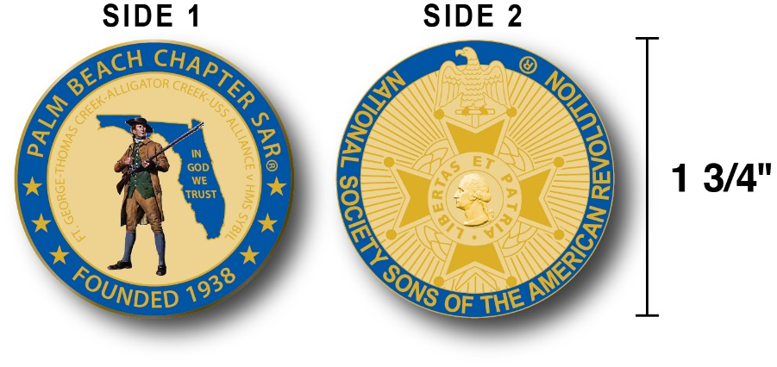

The Chapter has produced a custom bronze *Commemorative Anniversary Coin* honoring the founding of the *Palm Beach Chapter* in 1938 and celebrating its 80 years of historic, patriotic, and civic service in Palm Beach County and Florida.

The beautiful bronze coin is highlighted in ***George Washington*** military blue on a stunning gold background. Side-one is personalized to our Chapter with the founding date, a Minuteman standing guard over Florida, and the Florida State motto of ***"In God We Trust”.***

The coin also includes a notation listing the four major Revolutionary War battles waged in Florida including the battles of: ***Ft. George-Pensacola, Thomas Creek Massacre, Alligator Creek,*** and the ***Last Naval Battle* of the Revolutionary War** between the ***USS Alliance*** & ***HMS Sybil.*** Side-two displays the national *NSSAR* logo.  Very impressive indeed!

The custom bronze ***Commemorative Anniversary Coin*** is designed to celebrate our founding in **1938**, create a distinctive and impressive image for our Chapter and be used as a token of appreciation for honored guests, speakers, and as special awards.

***Compatriots may purchase these unique collector coins for just $10.***

***Classy SAR Lapel Pins $10:***

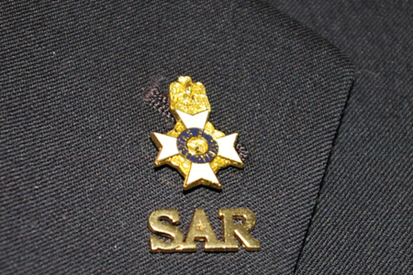

Display a ***Gold*** ***SAR*** pin on your suit lapel or shirt with the ***SAR Rosette***. The SAR Lapel Pin is part of a national branding program to help promote the S.A.R. and stimulate new membership!

The striking lapel pin is a recognizable public symbol of the SAR, provides you recognition as a member of this great society, and will spark conversations about SAR that leads to a new member.

The gold lapel pin and SAR Rosette create a professional image that will improve overall SAR name recognition. The Chapter has a supply of pins for Compatriots for just $10.

***Show your Spirit….*Get your Gold SAR Pin today**!

***SAR Chapter, State & National Events:***

**-*STATE/NATIONAL*:**

***DON’T MISS THE 2108 SAR NATIONAL CONGRESS***

***The 128th SAR Congress is scheduled for July 12-19 in Houston, Texas. Hotel registration is open now at a special SAR price of $159.00 per night King or 2-Queens.***

***Reservations can be made by calling the Westin Memorial City Hotel @ 1-800-937-8461 or online @*** [***www.starwoodmeeting.com/book/nssar2018***](http://www.starwoodmeeting.com/book/nssar2018)***. Questions contact Paul Callanan @*** [***LTCMRSC@aol.com***](mailto:LTCMRSC@aol.com) ***or 906-273-2424.***

***Feature Articles:***

***Respecting Our Flag & Honoring Those Who Sacrificed at the Alter of Freedom!***

**Compiled, Edited & Written By Don Lanman, President P.B. Chapter SAR-2016 & 2017**

Citizens who, in the name of the free speech rights afforded by the first amendment, choose to disrespect the *American Flag* and our *National Anthem* out of a perceived wrong or injustice are to be pitied for their ignorance.

Our Constitution and Bill of Rights affords everyone the right to speak their mind and protest grievances as they choose, but their choice of venues brings into sharp focus both their ignorance of the meaning of the American Flag and our National Anthem.

As Patriots, I believe that it is our responsibility to educate our fellow citizens on the virtues and values of our founding fathers as embodied in the Constitution and Bill of Rights, and reaffirmed over the past 240 years by the sacrifices of so many at the Alter of Freedom.

We should endeavor to lead these citizens down the path of education, awareness and self-enlightenment on both the history and values of our Republic.

Part of that education is the meaning and history of the flag of the United States of America and the national anthem that symbolizes and reaffirms that we are a democratic republic with freedoms guaranteed for all citizens.

The American flag was born on June 14, 1777, in Philadelphia where the Continental Congress adopted the stars and stripes as the national flag. The thirteen stripes alternating red and white, with a union of thirteen white stars in a field of blue, represented a new constellation, a new nation dedicated to the personal and religious liberty of all mankind.

The fifty stars that now adorn our flag, one for each of the fifty sovereign states, signifies the greatest constitutional republic the world has ever known. Its colors symbolize the patriotic ideals and spiritual qualities of the citizens of America.

Its red stripes proclaim the fearless courage and integrity of American men and boys and the self-sacrifice and devotion of American mothers and daughters in defense of our virtues and values. The white stripes stand for liberty and equality for all and the blue reminds us of heaven, loyalty, and faith and represent these eternal principles: liberty, justice, and humanity.

The American flag embodies the promise of uniquely American freedom: freedom of speech, religion, assembly, the press, and the sanctity of the home. It typifies the indomitable spirit of determination brought to our land by all our forefathers - the Pilgrims, Puritans, settlers at Jamestown and Plymouth, and the many great leaders who have shaped our unique republic.

***Follow the evolution of the honored United States of America Flag…..***

***Old Glory…..***

* *I am as old as my nation.*
* *I am a living symbol of my nation's law: the Constitution and the Bill of Rights.*
* *I voice Lincoln's philosophy: "A government of the people, by the people, for the people."*
* *I stand in support of the nation's schools, the seedbed of good citizenship and patriotism.*
* *I am displayed in every schoolroom and schoolyard throughout my nation.*
* *Daily thousands of our children pledge their allegiance to me and my country.*
* *My own Public Law 829, "The Flag Code", defines my correct use and display.*
* *I have my own special day, Flag Day June 14, to honor my birth.*
* *I am the sacred emblem of our country symbolizing the birthright and heritage of liberty for all Americans purchased with blood and treasure of our forefathers.*
* *I am the deed of freedom for Americans to enjoy and hold in trust for posterity.*
* *I pray Americans to keep this sacred trust inviolate for if nullified we risk becoming slaves to despots.*
* *Commit to the virtues: "One nation under God, indivisible, with liberty and justice for all."*
* *Salute as you see me silhouetted against the peaceful skies, remember that I am the flag of your country, standing for the "land of the free and the home of the brave"!*
* *I shall ever be known as "Old Glory," the flag of the United States of America!*
* *God grant that we spend eternity in the shadow of Old Glory!*
* *Maintaining vigilance for all enemies domestic and foreign is the price of freedom so guard me well, lest our freedoms perish.*

## Evolution of the United States Flag

No one knows with absolute certainty who designed the first stars and stripes or who made it. Congressman [Francis Hopkinson](http://www.usflag.org/history/francishopkinson.html) seems most likely to have designed it, and a few historians believe that [Betsy Ross](http://www.usflag.org/history/aboutbetsyross.html), a Philadelphia seamstress, made the first one. Until the Executive Order of June 24, 1912, neither the order of the stars nor the proportions of the flag was prescribed. Consequently, flags dating before this period sometimes show unusual arrangements of the stars and odd proportions, these features being left to the discretion of the flag maker. In general, however, straight rows of stars and proportions similar to those later adopted officially were used. The principal acts affecting the flag of the United States are the following:

* **On June 14, 1777**, in order to establish an official flag for the new nation, the Continental Congress passed the first Flag Act resolving that the flag of the United States be made of thirteen stripes, alternate red and white; that the union be thirteen stars, white in a blue field, representing a new Constellation."
* **Act of January 13, 1794** - provided for 15 stripes and 15 stars after May 1795.
* Act of April 4, 1818 - provided for 13 stripes and one star for each state, to be added to the flag on the 4th of July following the admission of each new state.
* **Executive** Order of President Taft dated June 24, 1912 - established proportions of the flag and provided for arrangement of the stars in six horizontal rows of eight each, a single point of each star to be upward.
* **Executive** Order of President Eisenhower dated January 3, 1959 - provided for the arrangement of the stars in seven rows of seven stars each, staggered horizontally and vertically.
* **Executive** Order of President Eisenhower dated August 21, 1959 - provided for the arrangement of the stars in nine rows of stars staggered horizon tally and eleven rows of stars staggered vertically.

## The Grand Union Flag

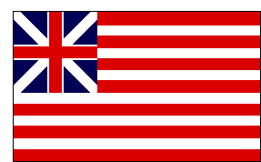

**The Grand Union 1775**: Also known as the Continental flag, it is the first true U.S. Flag. It combined the British King's Colours and the thirteen stripes signifying Colonial unity. George Washington liked this design so well that he chose it to be flown to celebrate the formation of the Continental Army on New Year’s Day, 1776. On that day the Grand Union Flag was proudly raised on Prospect Hill in Somerville, near his headquarters at Cambridge, Massachusetts.

**The Gadsden Flag**

|  |
| --- |
|  |

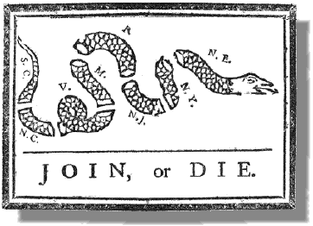

 The rattlesnake was the favorite animal emblem of the Americans even before the Revolution. In 1751 Benjamin Franklin's *Pennsylvania Gazette* carried a bitter article protesting the British practice of sending convicts to America. The author suggested that the colonists return the favor by shipping "a cargo of rattlesnakes, which could be distributed in St. James Park, Spring Garden, and other places of pleasure, and particularly in the noblemen's gardens." Three years later the same paper printed the picture of a snake as a commentary on the Albany Congress. To remind the delegates of the danger of disunity, the serpent was shown cut to pieces. Each segment is marked with the name of a colony, and the motto "Join or Die" below. Other newspapers took up the snake theme.

By 1774 the segments of the snake had grown together, and the motto had been changed to read: "United Now Alive and Free Firm on this Basis Liberty Shall Stand and Thus Supported Ever Bless Our Land Till Time Becomes Eternity"

Other authors felt the rattlesnake was a good example of America's virtues. They argued that it is unique to America; individually its rattles produce no sound, but united they can be heard by all; and while it does not attack unless provoked, it is deadly to step upon one.

**The Gadsden Flag**: The American Revolutionary period was a time of intense but controlled individualism - when self-directing responsible individuals again and again decided for themselves what they should do, and did it- without needing anyone else to give them an assignment or supervise them in carrying it out.

Such a person was the patriot Colonel Christopher Gadsden of South Carolina. He had seen and liked a bright yellow banner with a hissing, coiled rattlesnake rising up in the center, and beneath the serpent the same words that appeared on the Striped Rattlesnake Flag - Don't Tread On Me.

Colonel Gadsden made a copy of this flag and submitted the design to the Provincial Congress in South Carolina. Commodore Esek Hopkins, commander of the new Continental fleet, carried a similar flag in February, 1776, when his ships put to sea for the first time.

Hopkins captured large stores of British cannon and military supplies in the Bahamas. His cruise marked the salt-water baptism of the American Navy, and it saw the first landing of the Corps of Marines, on whose drums the Gadsden symbol was painted.

## The Bennington Flag

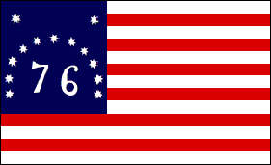

**The Bennington Flag**: Used in the Battle of Bennington, August 16, 1777, by Vermont militia. This flag is the first to lead American armed forces on land. The original is preserved in the museum at Bennington, Vermont.

## The Serapis Flag

|  |
| --- |
|  |

**The Serapes Flag**: Designed with 13 stripes alternating red, white and blue. This flag was raised by Captain John Paul Jones on the British frigate *Serapis* during the most famous Revolutionary naval battle.

He was born John Paul in Scotland in 1747 and went to sea when he was only twelve years old. By the time he arrived in Philadelphia in 1775 as an experienced sea captain, he had changed his name to John Paul Jones.

After conducting sea raids on the coast of Britain, he took command in 1779 of a rebuilt French merchant ship, renamed the *U.S.S.Bonhomme Richard* to honor Benjamin Franklin. On September 23, 1779, Jones engaged the British frigate *Serapis* in the North Sea, daringly sailing in close, lashing his vessel to the British ship, and fighting the battle at point-blank range.

During the fight two of his cannon burst, and the British captain asked Jones if he was ready to surrender. Replied Jones: "**Sir, I have not yet begun to fight**." The American crew finally boarded the *Serapis* after the British had struck her colors, and from the deck of the *Serapis* they watched the *U.S.S. Bonhomme Richard* sink into the North Sea.

## The Betsy Ross Flag

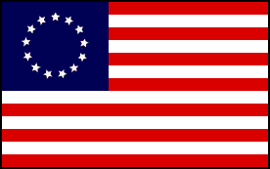

Since there was no official flag during the first year of the United States, there were a great number of homespun flag designs. This flag is without question the most well-known of those. There are many reasons why this flag is confused with the first official U.S. flag.

## Washington's Flag 1775

|  |
| --- |
|  |

**Washington's Flag 1775**: This was the personal flag of the Commander-In-Chief during the Revolutionary War. A reproduction of this flag flies today at Washington's Headquarters, Valley Forge.

## The First Official United States Flag; 13-Stars

|  |
| --- |
|  |

**The First Official United States Flag**: This 13-Star Flag became the Official United States Flag on June14th, 1777 and is the result of the congressional action that took place on that date. Much evidence exists pointing to Congressman [Francis Hopkinson](http://www.usflag.org/history/francishopkinson.html) as the person responsible for its design. The only President to serve under this flag was [George Washington (1789-1797)](http://www.whitehouse.gov/history/presidents/gw1.html). This Flag was to last for a period of 18 years.

Each star *and* stripe represented a Colony of which there were thirteen, united nearly one year earlier by the Declaration of Independence. The thirteen Colonies are listed below with the date that each ratified the Constitution and became a State.

* **(1st)** [**Delaware**](http://www.state.de.us/) **December 7th, 1787**
* **(2nd)** [**Pennsylvania**](http://www.state.pa.us/) **December 12th,1787**
* **(3rd)** [**New Jersey**](http://www.state.nj.us/) **December18th, 1787**
* **(4th)** [**Georgia**](http://www.state.ga.us/) **January 2nd, 1788**
* **(5th)** [**Connecticut**](http://www.state.ct.us/) **January 9th, 1788**
* **(6th)** [**Massachusetts**](http://www.state.ma.us/) **February 6th, 1788**
* **(7th)** [**Maryland**](http://www.mec.state.md.us/) **April 28th, 1788**
* **(8th)** [**South Carolina**](http://www.myscgov.com/SCSGPortal/static/home_tem4.html) **May 23rd, 1788**
* **(9th)** [**New Hampshire**](http://www.state.nh.us/) **June 21st, 1788**
* **(10th)** [**Virginia**](http://www.state.va.us/) **June 25th, 1788**
* **(11th)** [**New York**](http://www.state.ny.us/) **July 25th, 1788**
* **(12th)** [**North Carolina**](http://www.ncgov.com/) **November 21st, 1789**
* **(13th)** [**Rhode Island**](http://www.state.ri.us/) **May 29th, 1790**

## The Star Spangled Banner 15-Star Flag

|  |
| --- |
|  |

**The Star Spangled Banner**: This Flag became the Official United States Flag on May 1st, 1795. Two stars were added for the admission of [Vermont](http://vermont.gov/) (the 14th State on March 4th, 1791) and [Kentucky](http://www.state.ky.us/) (the 15th State on June 1st, 1792, and was to last for 23 years.

The five Presidents who served under this flag were; [George Washington (1789-1797)](http://www.whitehouse.gov/history/presidents/gw1.html), [John Adams (1797-1801)](http://www.whitehouse.gov/history/presidents/ja2.html), [Thomas Jefferson (1801-1809)](http://www.whitehouse.gov/history/presidents/tj3.html), [James Madison (1809-1817)](http://www.whitehouse.gov/history/presidents/jm4.html), and [James Monroe (1817-1825)](http://www.whitehouse.gov/history/presidents/jm5.html).

**The 15-star,** **15-stripe** flag was authorized by the Flag Act of January 13, 1794, adding 2 stripes and 2 Stars. The regulation went into effect on May 1, 1795. This flag was the only U.S. Flag to have more than 13 stripes.

It was immortalized by [Francis Scott Key](http://www.usflag.org/history/francisscottkey.html) during the bombardment of Fort McHenry, Sept 13, 1814. The image above is representative of the actual flag that flew over Fort McHenry on that day and which is now preserved in the Smithsonian Museum. You can notice the "tilt" in some of the stars just as in the [original Star Spangled Banner](http://www.usflag.org/history/francisscottkey.html#Pickersgill).

**The unique journey of the original Star Spangled Banner Flag...**

**-1814**

The battle occurred, and the flag won its glory. Armistead was promoted to Lt. Colonel by Madison. Armistead died in service on April 25, 1818. He acquired the flag sometime before that date, but at this point it is unknown how.

**-1818**

Armistead died and "legend" says that the flag was used in his funeral. However, in all of the newspaper accounts of Armistead's funeral, there is no mention of the flag being displayed at it. At his death the flag passed to his widow, Louisa Armistead.

**-1824**

The flag was used in a reception for General Lafayette.

**-1861**

Louisa Armistead died on October 3, 1861, and in her will left the flag to her daughter, Georgiana Armistead Appleton. The flag was sent to England for safe keeping during the Civil War, according to one of the Armistead family members, who made this statement in a newspaper interview in the 1880's. But Georgiana said, in a letter to Admiral George Preble, that the flag was in her possession during the rebellion.

**-1873**

The flag was displayed in the Charleston Naval Yards. Canvas backing was sewn on the flag and one of the first photographs was taken of it.

**-1876**

The flag was loaned to the Navy Department for the Centennial Celebration.

**-1879**

Georgiana Armistead Appleton died in 1879 and left the flag to her son Eben Appleton.

**-1907**

Eben Appleton loaned the flag to the Smithsonian.

**-1912**

Eben Appleton converts the loan of the flag to a gift to the Smithsonian.

**-1914**

Amelia Fowler was commissioned to remove the canvas backing sewn on the flag when it was photographed in 1873 and replace it with the present linen backing.

## The 1818 20-Star Flag

|  |
| --- |
|  |

**The 1818 Flag**: Realizing that the addition of a new star and new stripe for each new State was impractical, Congress passed the Flag Act of 1818 which returned the flag design to 13 stripes and specified 20 stars for the 20 states.

This Flag became the Official United States Flag on April 13th, 1818. Five stars were added for the admission of [Tennessee](http://www.state.tn.us/) (the 16th State on June 1st, 1796), [Ohio](http://www.state.oh.us/) (the 17th State on March 1st, 1803), [Louisiana](http://www.state.la.us/) (the 18th State on April 30th, 1812), [Indiana](http://www.state.in.us/) (the 19th State on December 11th, 1816), and [Mississippi](http://www.state.ms.us/) (the 20th State on December 10, 1817), and was to last for just one year. The only President to serve under this flag was [James Monroe (1817-1825)](http://www.whitehouse.gov/history/presidents/jm5.html).

**THE ORIGINAL “OLD GLORY”**

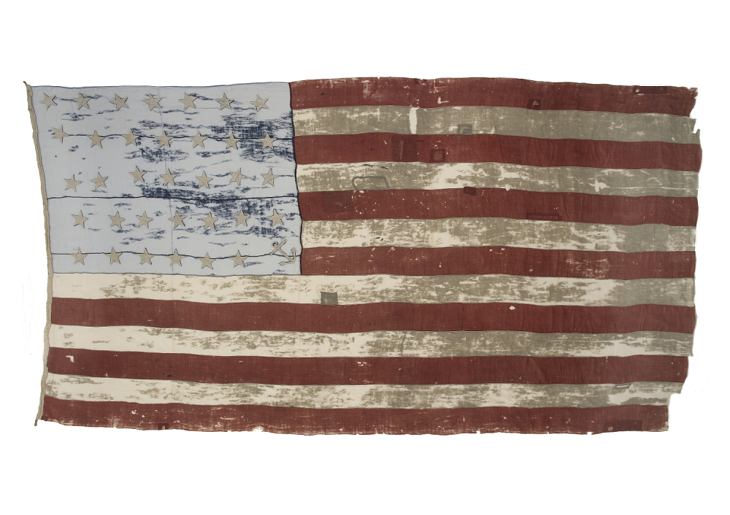

Old Glory! This famous name was coined by Captain William Driver, a shipmaster of Salem, Massachusetts, in 1831.

As he was leaving on one of his many voyages aboard the brig CHARLES DOGGETT - and this one would climax with the rescue of the mutineers of the BOUNTY - some friends presented him with a beautiful flag of twenty four stars.

***As the banner opened to the ocean breeze for the first time, he exclaimed "Old Glory!"***

He retired to Nashville in 1837, taking his treasured flag from his sea days with him. By the time the Civil War erupted, most everyone in and around Nashville recognized Captain Driver's "Old Glory." When Tennessee seceded from the Union, Rebels were determined to destroy his flag, but repeated searches revealed no trace of the hated banner.

Then on February 25th, 1862, Union forces captured Nashville and raised the American flag over the capital. It was a rather small ensign and immediately folks began asking Captain Driver if "Old Glory" still existed.

Happy to have soldiers with him this time, Captain Driver went home and began ripping at the seams of his bedcover. As the stitches holding the quilt-top to the batting unraveled, the onlookers peered inside and saw the 24-starred original "Old Glory"!

Captain Driver gently gathered up the flag and returned with the soldiers to the capitol. Though he was sixty years old, the Captain climbed up to the tower to replace the smaller banner with his beloved flag.

The Sixth Ohio Regiment cheered and saluted - and later adopted the nickname "Old Glory" as their own, telling and re-telling the story of Captain Driver's devotion to the flag we honor yet today. Captain Driver's grave is located in the old Nashville City Cemetery, and is one of three (3) places authorized by act of Congress where the Flag of the United States may be flown 24 hours a day.

A caption above a faded black and white picture in the book, The Stars and the Stripes, states that “‘Old Glory' may no longer be opened to be photographed, and no color photograph is available." Visible in the photo in the lower right corner of the canton is an appliqued anchor, Captain Driver's very personal note.

"Old Glory" is the most illustrious of a number of flags - both Northern and Confederate - reputed to have been similarly hidden, then later revealed as times changed.

The flag was given to his granddaughter or niece and she later donated it to the Smithsonian.

## The 50-Star Flag

|  |
| --- |
|  |

**50-Star Flag**: Executive Order of President Eisenhower dated August 21, 1959 - provided for the arrangement of the stars in nine rows of stars staggered horizon tally and eleven rows of stars staggered vertically. This is the current flag of the United States. [Hawaii](http://www.state.hi.us/) was admitted as the 50th state on August 21st, 1959.

The 27th flag of the United States became the official flag on July 4th, 1960. 12 presidents have served under this flag; Dwight D. Eisenhower [John F. Kennedy](http://www.whitehouse.gov/history/presidents/jk35.html), Lyndon B. Johnson, Richard M. Nixon, Gerald R. Ford, Jimmy Carter, Ronald W. Reagan, George Bush, William J. Clinton, George W. Bush, Barack H. Obama, Donald J. Trump.

**2018 Dues PAST due….Keep Your Membership Active!**

**Don’t lose your SAR Membership….You can reinstate your membership by Mailing** **your $75** annual membership fee as soon as you receive your notices to ***SAR PB Chapter, PO Box 16735 West Palm Beach, FL 33416-6735! Include*** any changes to your personal contact information.

***Remember*….Your** **membership dues plus additional donations fund the many Chapter civic activities including**:

**Scholarships**, ***Boy Scout & JROTC medals, Rumbaugh & Knight Essay Youth contests, Police-Firefighter-EMT awards, Flag Certificates, Americanism, American History Teacher, Civic & Community programs.***

***-Meeting & Event Pictures-***

***Chapter December 9 Holiday Musical Event***

***Dimension 20 Choral Group, Forest Hill Community HS***

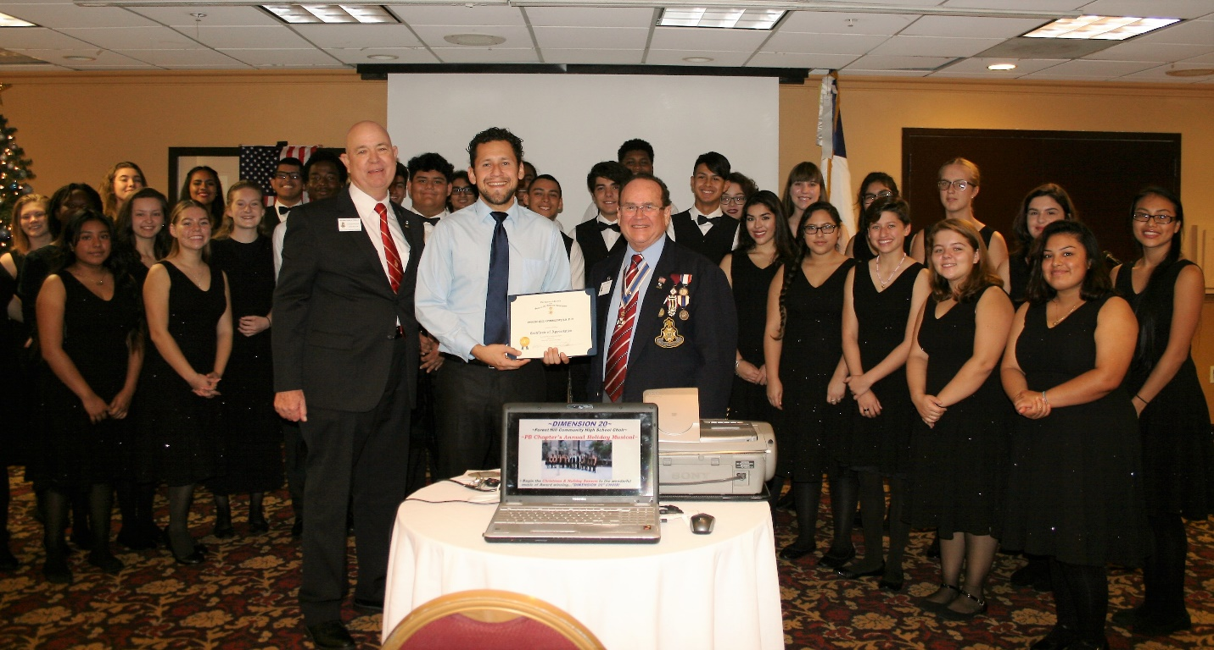

***Compatriots Curry, Barber & HMF DAR Vice Regent***

***Brenda Fritz donate to the Youth Program Auction***

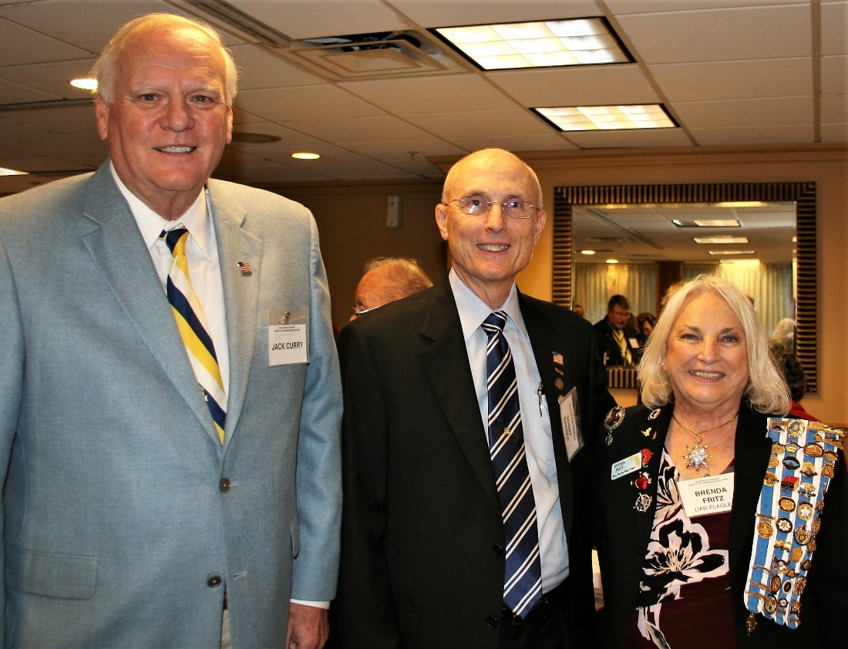

***SAR & DAR Coldwell Family Enjoy the Concert***

***Winning the Holiday Basket Drawing***

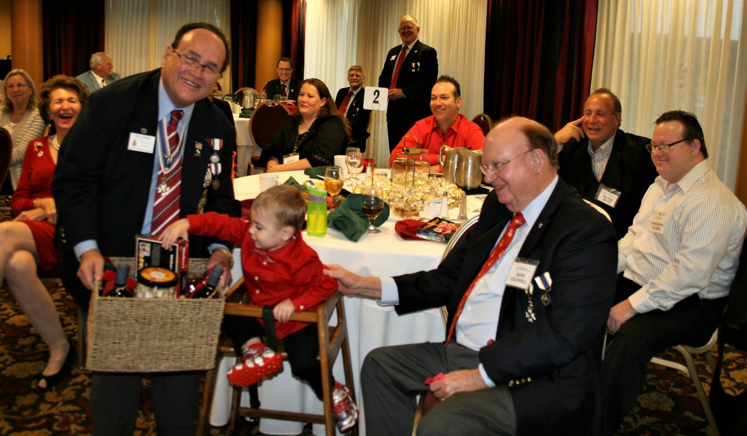

***Compatriot Carter Coldwell (age 3 triplets) joins sisters @ Holiday Event***



***Compatriots, David, Carter & Christopher enjoy Holiday Event***

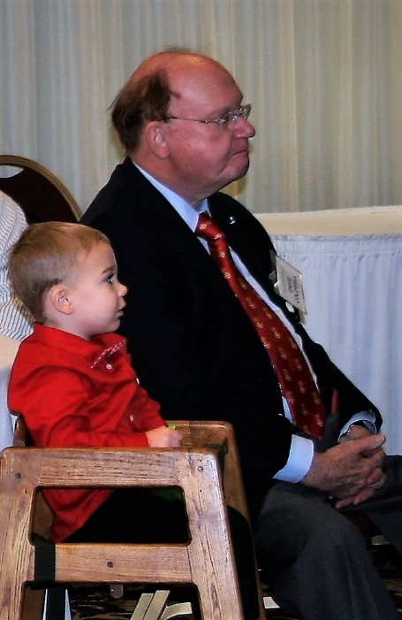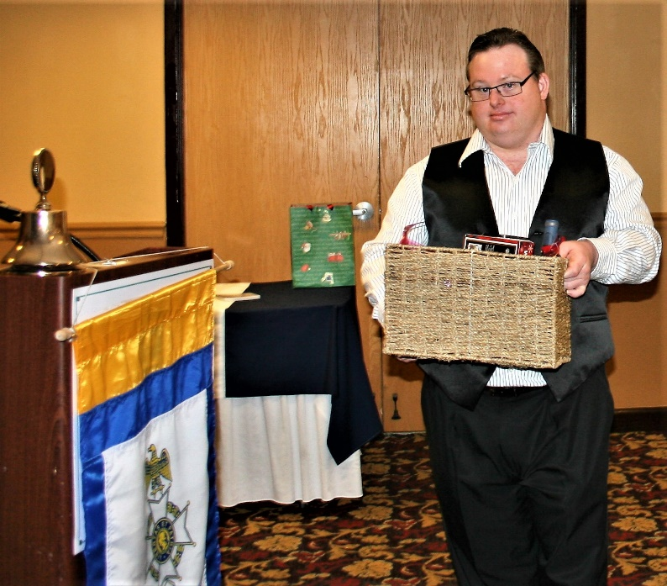

***~80th Anniversary Bronze Commemorative Collector Coin $10.00~***

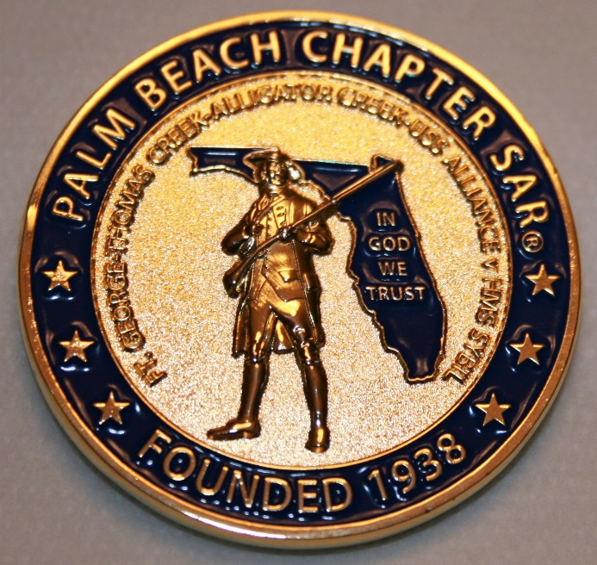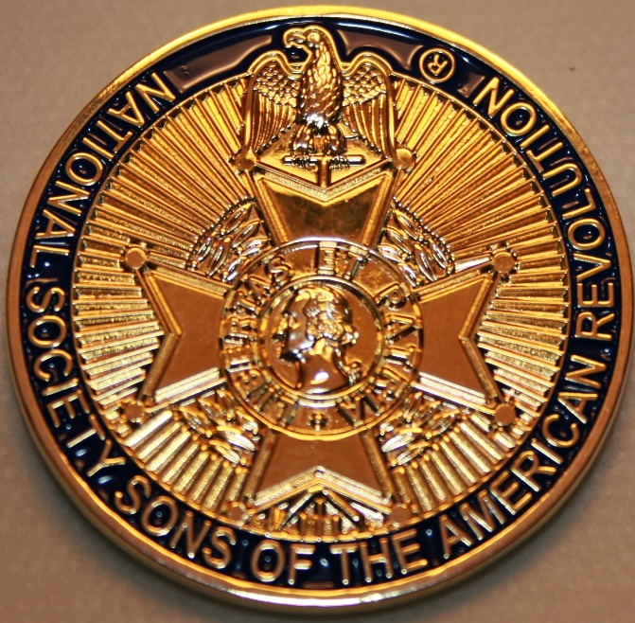

***~Compatriot Sponsored Promotions~***

**Compatriot sponsored newsletter Ads are important to the Chapter as they represent additional funds in support of Chapter projects including *Scholarships, Boy Scout & JROTC medals, Rumbaugh & Knight Essay Youth contests, Police-Firefighter-EMT medals, Americanism & community civic programs!***

**Help** your Chapter, sponsor an Ad for **8** issuesat a modest cost: **Business Card $50, Half Page $100, Full Page $250. Your AD donation will also qualify you for a listing in the *Presidents Brigade*. Call Don Lanman 561-315-5073 for information.**

***SPECIAL SPONSORED ADS ON FOLLOWING PAGES…***

***~COMPATRIOT ROBERT BRINCKERHOFF***

***~COMPATRIOT ALEXANDER DREYFOOS***

***AUTHOR/PHOTOGRPHER***

***~COMPATRIOT SONNY BARBER,***

***HISTORIAN/AUTHOR***

***~GARCILASO DE LA VEGA, CHAPTER***

***DAUGHTERS OF THE AMERICAN REVOLUTION***

***-Morgan Stanley-***

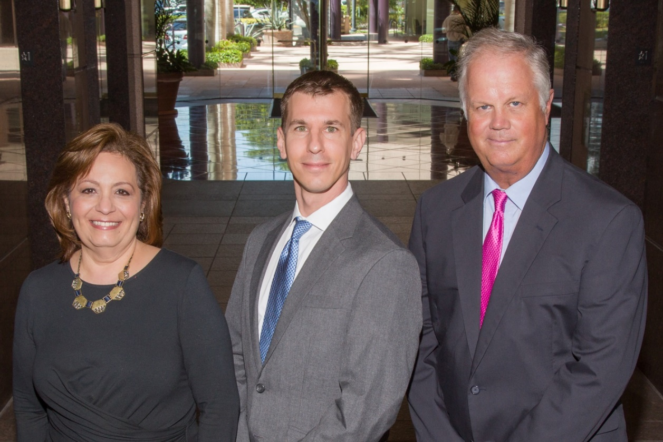  
***Amani Gaballa, Senior Registered Associate; Robert Scarborough, Financial Advisor; Robert Brinckerhoff, First Vice President, Financial Advisor***

***Robert W. Brinckerhoff  
Senior Vice President, Financial Advisor  
777 S. Flagler Dr. Suite 700, East Tower  
West Palm Beach, FL 33401  
(561) 650-7514  
Robert.Brinckerhoff@MorganStanley.com***

***Bob has been a financial advisor since March 1976. He focuses on investment strategies, retirement planning, liquidity solutions for individuals, commercial real estate, and small business owners.***

***Bob is a graduate of the University of Vermont. His clients are geographically diverse and he frequently travels from the east coast to the west to meet with clients. He is active with nonprofit organizations that support the blind and visually impaired. Bob is also an active enthusiast in Ferraris.***

*The investments listed may not be suitable for all investors. Morgan Stanley Smith Barney LLC recommends that investors independently evaluate particular investments and encourages investors to seek the advice of a financial advisor. The appropriateness of a particular investment will depend upon an investor’s individual circumstances and objectives. Morgan Stanley Smith Barney LLC is a registered Broker/Dealer, Member SIPC, and not a bank.*

*Where appropriate, Morgan Stanley Smith Barney LLC has entered into arrangements with banks and other third parties to assist in offering certain banking related products and services. Investment, insurance and annuity products offered through Morgan Stanley Smith Barney LLC are: NOT FDIC INSURED, MAY LOSE VALUE, NOT BANK GUARANTEED, NOT A BANK DEPOSIT, NOT INSURED BY ANY FEDERAL GOVERNMENT AGENCY. Copy write 2015 Morgan Stanley Smith Barney LLC, Member SIPC CRC1355648 11/15.*

*TWO GREAT BOOKS-ONE GREAT MAN*

***-Alexander W. Dreyfoos-***



***-A PHOTOGRAPHIC ODYSSEY- -PASSION & PURPOSE-***

***Compatriot Alexander W Dreyfoos, Jr.*** an honored member of the *Palm Beach Chapter Sons of the American Revolution*, noted American entrepreneur, and philanthropist has published two remarkable books that should be on every bookshelf. **Book sales** **proceeds** **donated to local West Palm Beach charities!**

* ***Passion & Purpose*** chronicles a remarkable lifetime of passion with photography, his business, inventions and philanthropic ventures, as well as his adventures above and below the water. **$29.95.**
* ***A Photographic Odyssey*** is a remarkable collection of hundreds of stunning pictures from 100,000 photos taken by Alex around the world and bound in an elegant 15” by 10” glossy photographic book. You will travel with Alex around the world, above and below the water, to forests, jungles, glaciers, and deserts in the exotic locals of Papua New Guinea, Bhutan, Nepal, China, Japan, and Tibet. The subjects are very divergent contrasting palaces and temples with the vulnerability of people, animals, and exotic scenery. **$60.00.**
* **Support your Chapter & local charities! Get both books, *Passion & Purpose & A Photographic Odyssey,* just $71.96 @ kravis.org/books or Call 561-651-4329.**

***-Alexander W. Dreyfoos-***

*Graduating from MIT and Harvard Business School, Alex founded Photo Electronics Corporation (PCS), specializing in photography and video production. Over the decades, Alex earned 10 US patents and invented the Video Color Negative Analyzer for motion pictures earning him an Academy Award for technical achievement.Many inventions, developed by PCS, are on permanent display at the Smithsonian Institution. Locally Alex also owned television station WPEC TV-12, the CBS affiliate in West Palm Beach. Alex’s many philanthropic achievements include founding the Palm Beach County Cultural Council, the Raymond F. Kravis Center for the Performing Arts and gifting a million dollars to the Dreyfoos School of the Arts. Alex also donated a million dollars each to the Palm Beach County biomedical research campus of the Scripps Research Institute and the local Max Planck Florida Foundation for Neuroscience in Jupiter, Florida.*

***HISTORICAL MYSTERY SERIES FROM THEREVOLUTIONARY WAR ACROSS TIME***



***Follow Kay Telfair across time beginning with Crossed & Found followed by Gold Hush & Stone-Walled….***

***Kay is a normal young teen—normal if that means being unusually curious and having an uncanny knack for putting herself in dangerous situations, which stresses her parents and often tests the relationship with best friend Anna.***

***The series follows Kay across two intrigue-filled summers on adventures involving events in American history. Join Kay’s journey of adventure steeped in American History through three books that excite all ages. At*** [***amazon.com***](http://amazon.com)***, Barnes & Noble or Chapter meetings. (See book summaries following page)***

***SAR Palm Beach Chapter Compatriot/Author Sonny Barber developed an interest in American history at an early age, reading and collecting newspapers, magazines and other materials on historic U.S. and world events. He’s coupled that interest with his fiction writing to create a modern-day “mystery history” Series perfect for Preteens to Adults.***

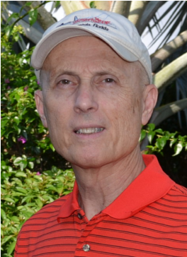

***~Crossed & Found~***



**Thirteen-year-old Kay Telfair believes her life is over when she moves with her family a thousand miles to their new home near the Delaware River in New Jersey. But her life takes an unexpected turn when she meets Anna and discovers a two-centuries-old letter--a letter that could change American history. Before she unravels the letter's mystery, Kay stumbles headlong into an adventure--confronting fears she'd never experienced, stretching the limits of her friendship with Anna, and forcing a test of Kay's physical strength that could save her own life.**

***~Gold Hush~***



**“I’m avoiding any activity that involves excitement…I’ve learned my lesson.” After an adventure-filled June, all Kay Telfair wants is a quiet vacation in Maine with her family and best friend Anna—no drama, no stress. But the thirteen-year-old’s hopes for a tranquil August stay in the village of Prospect Harbor soon fade when the girls compete for the attention of a young boy and Kay makes a startling discovery—a discovery that sends the three teens on a dangerous quest. Ignoring advice—and menacing threats from others—they continue their pursuit, drawing them deeper into a perilous mystery, deeper than Kay ever could have imagined.**

***~Stonewalled~***

[](https://www.amazon.com/Stonewalled-Mystery-History-Book-Three/dp/1519351291/ref=pd_bxgy_14_img_3?_encoding=UTF8&psc=1&refRID=75QVZ72QHQ8A2W2F3RK1)

**Kay stared at the gray line of stone walls. “They won’t be too upset to see these knocked down...” A mystery that threatens the relationship with best friend Anna, a battle with Mother Nature at her worst, and the discovery of a tragic secret—not exactly what fourteen-year-old Kay Telfair was looking for in a summer getaway. But that’s what confronts the young teen while helping the owners of Windcrest Farm find a way to stop destruction of nearby farmland and its three-hundred-year-old stone walls. Vacationing with her family and Anna at Windcrest in the quiet, coastal village of Little Compton, Rhode Island, the young teen soon discovers her goal will not be easy. Kay’s prospects for helping preserve the valuable land and stone walls look much better after a surprise visit by a boy from her past. With his help, she pours all her energy and passion into the quest, searching for answers in New England’s Native American and colonial history and learning some important lessons about perseverance and friendship.**

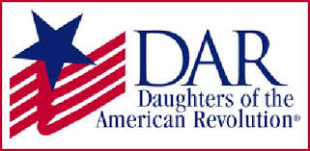

*Garcilaso de la Vega Chapter, NSDAR*

*Lake Worth, Florida*

*Alisha Darcy, Regent*

*Karen Christie, Registrar*

Phone; 561-236-2460-Email; [IMC4U4@AOL.com](mailto:IMC4U4@AOL.com)

Chapter Email: [GarcilasodelaVegaDAR@gmail.com](mailto:GarcilasodelaVegaDAR@gmail.com)

Visit us on ***Facebook*** @ <https://www.facebook.com/LWDAR>