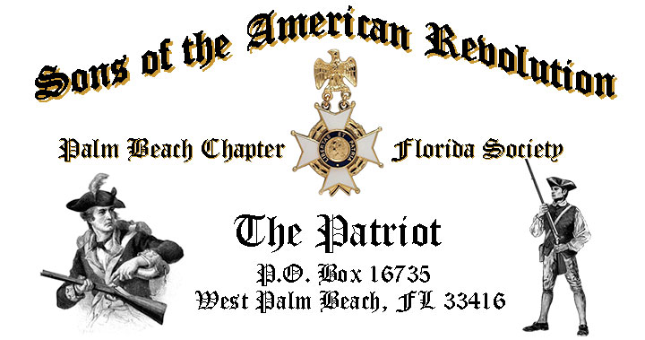

***Volume 23 March 2017 Number 03***

***Join Us for “Thomas Jefferson @ the White House: Dinner, Wine & Conversation”*** with International Author/Speaker ***James Gabler***, *Tuesday* **March 21, 12:00 Noon** @ the Embassy Suites Hotel 1601 Belvedere Road, WPB! "***RSVP Today*** for this special event!

***March Meeting Highlights:***

* ***Dining with Thomas Jefferson*, International Author/Speaker *James Gabler!***
* ***Buffet******Lunch***, Desserts & Beverages, **$28** per person **Check/Cash** at the door!
* ***Reservations*** **required,** **RSVP**, Don Lanman **(561)-315-5073**!
* **Family, Friends & Guests** are always Welcome!

**Newsletter Content:**

* **President’s** Message
* **Departed** Compatriots
* **2017** Chapter Meeting Dates &Topics
* **Officers** & Board Members
* ***President’s*** *Brigade* Financial Supporters
* **Committees**, Chairmen & Members
* **National**/State Society News & Events
* **Feature Articles:**  ***Siege of Boston 1775-1776!***
  + ***Florida-Last Naval Battle of the Revolutionary War!***
* **Chapter** February Meeting Pictures
* **Compatriot** Sponsored Promotions

**President’s Message:**

***Fellow Compatriots & Friends…Don’t Miss Dinner, Wine & Conversation with Thomas Jefferson…***

Join us for a very special Chapter event featuring guest speaker International Author, James Gabler presenting ***Dinner, Wine & Conversation with Thomas Jefferson***!

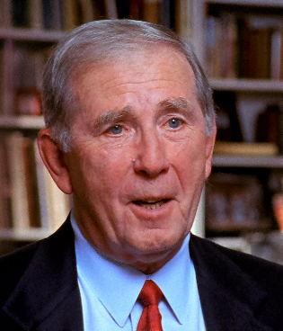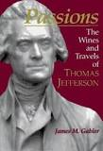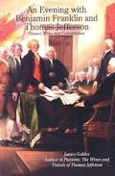

Through a combination of original research, imaginative writing, and beautiful illustrations, James Gabler has captured an intimate portrait of *Thomas Jefferson* at leisure, enjoying two of his passions--wine and travel.

Jim’s many books include; “*Passions, The Wines & Travels of Thomas Jefferson, An Evening with Thomas Jefferson & Benjamin Franklin, Wine into Words, How to be a Wine Expert and The Secret Formula”.*

The February meeting was very exceptional including an encore event featuring *Thomas Jefferson* re-enactor *John Stewart*, and a personal visit by *National SAR President General, Michael Tomme, First Lady Cilla* and *Florida Society President Ray Wess*!

To the haunting *skirl* of Bag Pipe sounds, delivered by members of the ***United States Coast Guard Pipe Band***, Presidents Tomme and Wess, and First Ladies Cilla and Nomi were welcomed by 60+ members of the *Palm Beach Chapter*.

The Chapter presented *President General Tomme* with an honor plaque in recognition of his vision and leadership, honored *State President Wess* with the ***Palm Beach Chapter 80th Anniversary Challenge Coin,*** and made a donation to *First Lady Cilla’s* “*Shoes for School”* charity project.

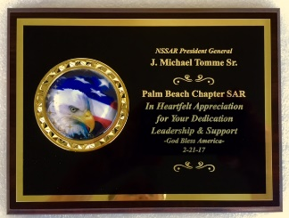

State President Wess announced that Chapter Past President ***Edward Swift Buckley IV*** has been awarded the prestigious ***SAR Patriot Medal*** in recognition of his 20+ years of selfless service to the SAR.

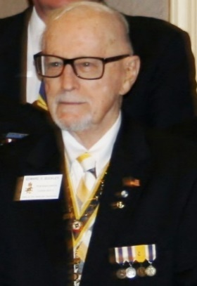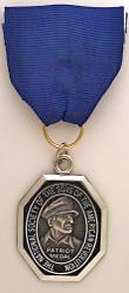

Compatriot Buckley has supported the SAR for over 20 years, served as *Chapter President 2006-2007*, is member of the *FLSSAR Veterans Battalion* and is a *WW-2 Veteran*.

Buckley’s *Patriot Medal* will be presented at the May 19-20 Board of Management Meeting in Orlando. All Compatriots are encouraged to attend the presentation in honor of the *“Chapter’s Own”* Compatriot Buckley.

I am pleased to announce that four Chapter Compatriots volunteered and were selected to serve as Veteran Guardians on the April 8, 2017 ***Veterans*** ***Honor Flight*** to Washington DC.

Compatriots *Lanman, Tidwell, Curry* and *Van Otteren* will serve as guardians to WW-2 and Korean war veterans to visit several historic monuments and tributes to our fallen veterans in the Nation’s Capital.

Members of *Chapter Women’s Auxiliary* andChapter *Compatriots* will greet the *Honor Flight* on its return at the *West Palm Beach International Airport* on April 8.

A custom ***Palm Beach Chapter Challenge Coin*** was unveiled at the *February* meeting in preparation for and honor of the 80th year of our founding.

Cast in historic *Blue* and *Gold* colors, the striking bronze coin commemorates the founding of the Palm Beach Chapter in ***1938***, notes the four major revolutionary war battles waged in *Florida* and illustrates a Minuteman over *Florida* and the state moto ***“In God We Trust”*** inscribed on side one, with the NSSAR Logo represented on the reverse side.

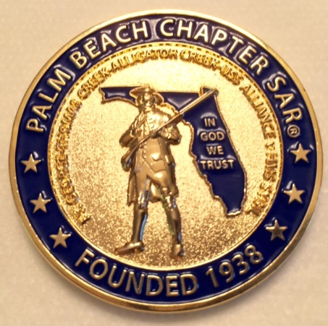

The bronze Palm Beach Challenge anniversary coins will be presented to special guests, used at events and are available to Chapter Compatriots at $10 each.

It is my sad duty to report the passing of two Chapter Compatriots, Henry Michael “Mike” Burkhardt, age 70, following a brief illness, and Donald Eugene Moore, age 94, following a hospital stay.

Chaplain *Father Sears* will deliver a eulogy for both Compatriots at the March meeting, and the Chapter will submit our departed Compatriots names to the State and National Societies where they will be inscribed into the SAR Rolls of Remembrance and Respect.

A major 2017 Chapter goal is both membership development and the mentoring of new members. With the natural turnover of members, we need all Compatriots to help grow our membership with like-minded individuals interested in good fellowship, honoring our patriot ancestors.

So please, get involved and help grow our membership by enrolling your Sons and Grandsons, inviting friends and neighbors to join and encouraging wives, daughters, and granddaughters to join the *DAR* and *SAR Women’s Auxiliary*.

**Committee members** are also needed to support our many youth and civic programs including Flag Certificates, Liberty Tree Program, Medals/Awards, Veterans Programs, Newsletter, Publicity, High School/Youth Programs, Boy Scouts, JROTC, Rumbaugh Historical Oration and Knight Essay Contests, Police-Firefighters-EMS Service Awards, Chapter Events, Americanism-Patriot Bios, Audit, Membership Development, Officer Nomination, Speakers Bureau, Website Support, Fundraising/Endowment Programs.

We need Chapter members to donate **“Gift Baskets”** for meetings to raise funds to support our many *Youth and Civic* programs.

We appreciate donations of raffle items and/or gift baskets with a retail value of $50. All donors are acknowledged at meetings, included in the newsletter, and are recognized in the Chapter’s *Presidents Brigade*.

Another 2017 Chapter goal is to expand its relationships and joint event activity with all of the local *DAR Chapters*, and we welcome our Patriot Sisters to all SAR meetings and events, and sincerely appreciate their SAR new member referrals and related support.

Compatriots, please help us avoid losing money on the chapter luncheons by attending and bringing guests! The hotel requires a minimum number of guests to cover the room, food, and services, so when attendance is low or there are no shows, the Chapter must pay the difference. We appreciate your support.

Fellow Compatriots, I look forward to seeing you at our next meeting! Please, join me in honoring our nations Veterans, Patriot Ancestors, and especially our Dear Departed Compatriots. **God Bless You and God Bless the *United States of America*.**

**-D. Lanman**

**2017 Chapter Meeting Dates/Topics:**

**Visit** the Palm Beach Chapter web site @ [www.sarpbchapter.org](http://www.sarpbchapter.org) for a meeting calendar, special events, articles, pictures, and general information.

* **Mar. 21 Boy Scout/JROTC** Awards & Speaker, **Jim Gabler-Historian**
* **Apr. 18 Law Enforcement** Awards & Special Guest Speaker
* **May 16 Firefighters/EMT** Awards & Special Guest Speaker
* **Oct. 17, Special** Guest Speaker
* **Nov. 21,** **2018** Officer Nominations, Special Guest Speaker
* **Dec. 9,** **Kings Academy Holiday Musical**

**2017 Officers & Board:**

**President** **Donald Lanman**

**Vice President** **Benjamin Tidwell III**

**Secretary** **Gary Green**

**Treasurer** **Peter Johnston**

**Registrar** **Robert Boggs**

**Chaplain** **Father Sanford Sears**

**Sgt. @ Arms Brian Davey**

**Historian** **Samuel “Buddy” Miller**

**Officer @ Large** **Bill Johnson**

**Patriot Newsletter Editor** **Donald Lanman**

**Support Youth Programs- Donate to the President’s Brigade:**

The Chapter honors and expresses its sincere appreciation to the Compatriots of the ***President’s Brigade***!

The dedicated members of the ***President’s Brigade*** donate “extra dollars” in support of the Chapter’s many youth programs, scholarships, civic activities, award certificates, police/firefighter/EMT medals, veterans’ projects, and related community civic programs.

**Honored Presidents Brigade Members:**

**-Bronze Level: $25-$99**

***M. Anderson, B. Boggs, J. Brown , R. Cass, D. Coldwell, B. Davey, J. Dorsey, W. Davis, F. Devitt J. Harper, J. Kane, J. Mayne, S. McWhorter, C. Odell, G. Parkinson, W. Told***

**-Silver Level: $100-$199**

***J. Curry, R. Culpepper, T. Friend, G. Green, F. Green, A. Griswold, B. Johnson***

**-Gold Level: $200-$499**

***R. Brinckerhoff, R. Banta , E. Buckley, K. Christie, S. Hitt, D. Lanman, W. Meakin, B. Tidwell, R. Utley, J. Wynns***

**-Platinum Level: $500+**

**Committees, Chairs & Members:**

**Fellow Compatriots**…..The Chapter expresses its sincere appreciation to those members who volunteer to serve on our committees and projects. As you can see a few Compatriots are serving on multiple committees and could use support!

**Please** volunteer today to help with any of the chapter committees listed below. It does not take much time and is a major help with our many civic initiatives. **Call** or email Don Lanman or Ben Tidwell **Today** to lend a hand with any of the following committees.

* **JROTC -Tidwell**
* **Law Enforcement-Fire Safety -Green, Tidwell**
* **Veterans Affairs -Wenman, Lanman**
* **Newsletter/Publicity -Lanman**
* **Boy Scouts -Tidwell**
* **Knight Essay/Rumbaugh Oration -Boggs**
* **American History Teacher -Boggs**
* **DAR Liaison -Lanman, Tidwell**
* **Speakers Bureau -Lanman, Tidwell**
* **Audit -Coldwell, Tidwell, Lanman**
* **2017 Officer Nomination -Lanman, Tidwell, Boggs**
* **Flag Certificates -Clouse, Miller, Tidwell**
* **Membership -Green, Boggs, Tidwell**
* **Liberty Tree -Lanman**
* **Patriot Bios -Miller**
* **Web Site-Facebook -Open**
* **80th Anniversary -All Chapter Officers**

**Get Your Custom Bronze Chapter Challenge Coin!**

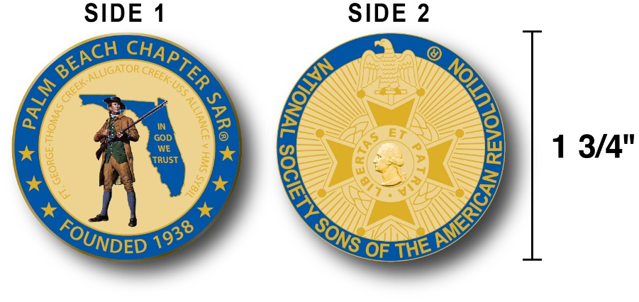

The Chapter has designed a custom bronze *Challenge Coin* honoring the founding of the Palm Beach Chapter in 1938 and its 80 years of historic, patriotic, and civic service in Palm Beach County and Florida State.

The custom bronze coin is highlighted in the George Washington colors of military Blue with a Gold background.

Side-1 is personalized to our Chapter including the founding date, a Minuteman standing guard over Florida, the Florida State motto ***"In God We Trust”,*** and notation of the four major Revolutionary War battles waged in Florida.  Side-2 displays our national NSSAR logo.  Very impressive indeed!

The custom bronze Chapter Challenge Coin is designed to celebrate our founding in **1938**, create a distinctive and impressive image and be used as a token of appreciation for honored guests, speakers, and as special awards.

Compatriots may purchase these unique Chapter challenge coins for just $10.

**Classy SAR Lapel Pins $10:**

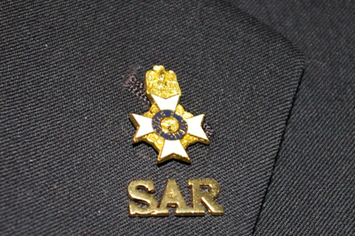

Make a fashion statement with a gold ***SAR*** pin for your lapel or shirt. The new society Lapel Pin is part of an S.A.R. Branding program to help promote the S.A.R. and stimulate new membership! The **classy** lapel pin is a recognizable symbol of the SAR for the public, gives you immediate recognition as a member, and may spark conversation about SAR that leads to a new member.

The gold lapel pin and SAR rosette creates a very professional image that will improve overall SAR name recognition. The Chapter has a supply of pins for Compatriots for just $10. **Get yours today**!

**Chapter, State & National News:**

**-CHAPTER:** Four ChapterCompatriots (Lanman, Tidwell, Curry, Van Otteren) volunteered for the April 8 Veterans Honor Flight.

**-STATE/NATIONAL:** Last Naval Battle event 4-11 @ Merritt Island, Board of Management meeting *5-19-20* in Orlando*, Pensacola Battle* event 5-6*, Battle of Thomas Creek* event 5-13.

**- FSSDAR HONOR FLIGHT Guardian Program:** The Palm Beach Chapter is supporting the *Florida State Society of the Daughters of the American Revolution* and *Honor Flights Southeast Florida* with an Honor Flight event on **April 8, 2017** from Palm Beach Airport to Washington DC.

Interested Compatriots must complete an application and if accepted submit $400 for travel expenses to join other members and WW-2 & Korean War Veterans on their visit to war memorials in DC!

**Information** & applications contact Gladys Van Otteren, *FSSDAR* State Chairman Honor Flight program (561)-324-2937 or email Gladys @ [HMFchapterDAR@gmail.com](mailto:HMFchapterDAR@gmail.com).

**Guest Speaker:**

***Thomas Jefferson in the White House:***

***Dinner, Wine & Conversation!***

**Compiled & Edited By Don Lanman**

Through a combination of original research, imaginative writing, and beautiful illustrations our March speaker is international bestselling author, James Gabler has captured an intimate portrait of Thomas Jefferson at leisure, enjoying two of his passions--wine and travel.

Jefferson was the most knowledgeable wine connoisseur of his age, and his favorite wines remain favorites of wine lovers today. He also loved to travel "to see what I have not yet seen."

Gabler will allow us to travel with Jefferson to the vineyards of Burgundy, Côte Rotie, Hermitage, Bordeaux, Provence, over the Alps into Italy, along the French and Italian Rivieras, through Lanquedoc on the Canal-du-Midi, down the Rhine with tastings at famous German vineyards. We will visit the great Roman antiquities of Gaul: Glanum, Pont du Gard, Masion Carrée, Théatre at Orange, Amphithéatres in Nîmes and Arles.

We will eavesdrop on dinner conversations at his Paris residence on the Champs-Elysées, the White House and Monticello where the finest wines were served. We will join him in Paris, London, Amsterdam, Frankfurt, Heidelberg, Strasbourg, New York, Philadelphia, and Washington.

Compatriots will accompany John Adams and Jefferson into the English countryside to see the great landscape gardens, and bear witness to the unfolding of the French Revolution through Jefferson's eyes.

We will sail Lakes George and Champlain and visit the battlegrounds at Saratoga, Fort Ticonderoga, and Bennington with Jefferson and James Madison. Wine was a lifelong passion; Jefferson called it "a necessary of life”.

Jefferson’s wine interests, however, went far beyond just drinking it. He was interested in its viticulture, making notes on German and Italian grape growing and examining "the details relative to the most celebrated wines of France."

He planted vineyards at Monticello and experimented with grape growing in his Paris garden with vine cuttings from such famous vineyards as Montrachet, Chambertin, Clos de Vougeot, Hochheim, and Rudesheim.

He encouraged Philip Mazzei and John Adlum and others in their vineyard efforts and accurately predicted that America would, some day, make wines as good as those of France. He was a wine advisor to Presidents Washington, Madison, and Monroe.

Throughout his life Jefferson was an advocate of the virtues of wine, arguing, "No nation is drunken where wine is cheap, and none sober where the dearness of wine substitutes ardent spirits as the common beverage."

His wine advice to merchants and friends opened channels for the importation of wine into the United States from France, Italy, Germany, Spain, and Portugal. To encourage the importation of wine, he effectively lobbied Congress for a reduction in taxes while serving as Secretary of State, President and later in retirement.

At a White House dinner in 1962, President Kennedy told a group of Nobel Prize winners that "this is the most extraordinary collection of talent, of human knowledge that has ever gathered together in the White House with the possible exception of when Thomas Jefferson dined alone."

But as you will learn, Jefferson, while President, rarely dined alone. Dinner conversations spanned the range of human knowledge with an emphasis on his passions-- architecture, music, wine, food, books, literature, gardening, and his years in France.

Author James Gabler spent seven years researching and writing Jefferson's interests in wine and travel and has uncovered facts never before been revealed.  He followed Jefferson's footsteps across Europe and the United States that has allowed him to update what Jefferson saw and drank. Gabler’s book is a definitive account of the wines and travels of one of the most extraordinary men in history.

**Feature Articles:**

***The Siege of Boston! April 19, 1775 – March 17, 1776***

***First Major Battle of the Revolutionary War!***

***Compiled & Edited by Don Lanman, President Palm Beach Chapter SAR***

The historic siege of Boston began April 19, 1775 following the seminal Battles of Lexington and Concord, when the militia from surrounding Massachusetts communities surrounded the British and blocked land access to Boston.

In a key strategic move, the New England militiamen prevented the resupply, by land, to the British Army garrisoned in what was then the peninsular city of Boston. Both sides, however, had to deal with serious resource supply and personnel issues over the course of the deadly siege.

In June 1775, the British army seized Bunker and Breed's Hills, but their casualties were heavy and their gains insufficient to break the Continental Army's hold on land access to Boston. Military actions during the remainder of the siege were limited to occasional raids, minor skirmishes, and sniper fire.

The Continental Congress formed the Continental Army from the militia, with George Washington as its Commander in Chief, and in November 1775, Washington ordered the 25-year-old bookseller-turned-soldier, Colonel of Artillery *Henry Knox*, to transport to Boston the 56 cannons captured at Fort Ticonderoga by *LT. Colonel Benedict Arnold*, along with *Ethan Allen* and his *Green Mountain Boys*.

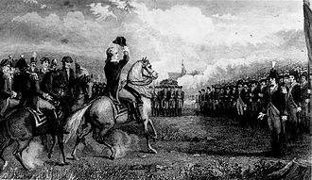

***Washington takes Command***

In a technically complex and demanding winter operation, Colonel Knox moved the 56 cannons to the Boston area by January 1776. In March 1776, the Patriot artillery fortified Dorchester Heights overlooking Boston and its harbor, thereby threatening the British supply lifeline. In advance of the Continental Army’s occupation of Dorchester Heights, General Washington ordered existing American artillery forces to begin bombarding Boston from their positions at Lechmere Point, northwest of the city center.

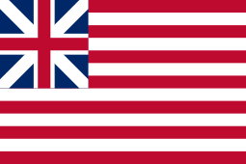

***American Grand Union Flag***

***Flown by Washington @ Boston***

After two straight days of bombardment, American Brigadier General John Thomas slipped an additional 2,000 troops and the captured cannons into position south of Boston on the high ground at Dorchester Heights.   By March 5, 1776, the Continental Army had artillery troops in position around Boston, including the elevated position at Dorchester Heights, overlooking the city.

With the threat of the additional artillery and the British resupply and reinforcement activities limited to sea access, the British General William Howe realized Boston was indefensible and decided, on March 7, 1776, to abandon the city.

Following the eleven-month siege, on March 17, 1776, the eight-year Red Coat occupation of Boston ended when British troops evacuated the city and sailed to the safety of Halifax, Nova Scotia. (Celebrated in Nova Scotia as Evacuation Day).

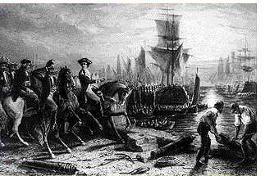

***British Evacuation of Boston***

**Feature Articles:**

***Florida-Last Naval Battle of the Revolutionary War***

**By Don Lanman**

The last naval battle of the *American Revolutionary War* took place in 233 years ago off the coast of present day Cape Canaveral, on Florida March 10, 1783.

The sea battle was joined when a British squadron of three war ships sighted two Continental Navy ships, the *Alliance* a 36-gun frigate commanded by Captain John Barry (later Commodore & Father of the American Navy), and the *Duc De Lauzun* a 20-gun war sloop commanded by Captain John Green.

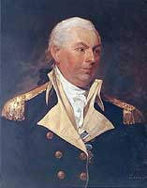

***Father of the US Navy, Capt. John Barry***

The British HMS *Alarm*, a 32-two gun frigate, commanded by Captain Charles Cotton, the HMS *Sybil*, a 28-eight gun frigate, under Captain James Vashon, and the HMS *Tobago*, an 18-gun sloop of war, commanded by Captain George Martin took chase to engage the two American ships.

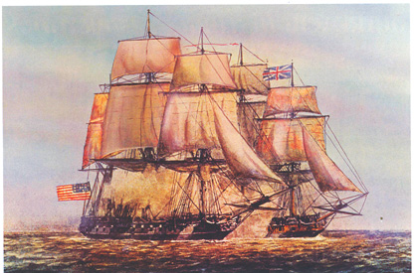

***USS Alliance v. HMS Sybil***

Sailing northward along the coast of Florida, the mighty *Alliance*, and the *Duc De Lauzun*, were determined to evade the British ships to save 72,000 Spanish silver coins they were shipping, from Cuba to Philadelphia, to support the American war effort.

With the chase on, the slower *Duc De Lauzun* lagged behind causing Captain Barry to order Captain Green to jettison his cannons. Then a fourth ship appeared on the horizon that caused the British to adjust their strategy by dispatching one of their ships to investigate this possible enemy ship.

The faster British war ship HMS *Sybil*, a 28-gun frigate, commanded by Captain James Vashon, continued to chase the *Alliance* and the *Duc De Lauzun*. Closing on the slower *Duc De Lauzun*, the HMS *Sybil* fired first, exchanging numerous shots with the Continental vessel.

Commanding the mighty *Alliance*, Captain Barry believed the change in the British strategy as a signal that the fourth ship was indeed friendly and, in a daring sea maneuver, reversed his course to directly engage the *Sybil* and allow the slower *Duc De Lauzun* time to escape. While under constant cannon fire, the *Alliance* waited until the HMS *Sybil* closed before unleashing the fury of his superior 36 cannons.

As the HMS *Sybil* came alongside the *Alliance*, Captain Barry fired a full broadside on the enemy vessel. The close-in sea fighting lasted less than an hour when the HMS *Sybil*, outgunned and badly damaged, broke off from the battle and limped back to the safety of the other British ships.

The *Alliance* and *Duc De Lauzun* continued their mission north and on March 20, 1783, sailed into New Port, Rhode Island. In a stroke of irony, however, on February 3, 1783, Great Britain and America ratified a peace treaty ending the war for independence.

**Special Note**: Compatriots and guests are encouraged to attend the ***Last Naval Battle*** event at on March 11 at 10 am. This event includes color guards, parade, wreath presentations, and lunch. The event is at the Veteran’s Memorial Park, 400 South Skyes Creek Parkway, Merritt Island, Florida near Cape Canaveral**.**

**Is Your Membership Active? Reinstate Today!**

**If you forgot to send in your 2017 SAR membership dues, you may reinstate NOW…**

**But Don’t wait….Mail** your $75 annual membership fee to ***SAR PB Chapter, PO Box 16735 West Palm Beach, FL 33416-6735*** along with any changes to your personal contact information.

***Remember*….Your** membership dues and additional donations fund the many Chapter civic activities including **Scholarships**, ***Boy Scout & JROTC medals, Rumbaugh & Knight Essay Youth contests, Police-Firefighter-EMT awards, Flag Certificates, Americanism, & Community programs.***

***-Chapter February Meeting Pictures-***

**President Lanman presents Honor Plaque to President General Tomme**

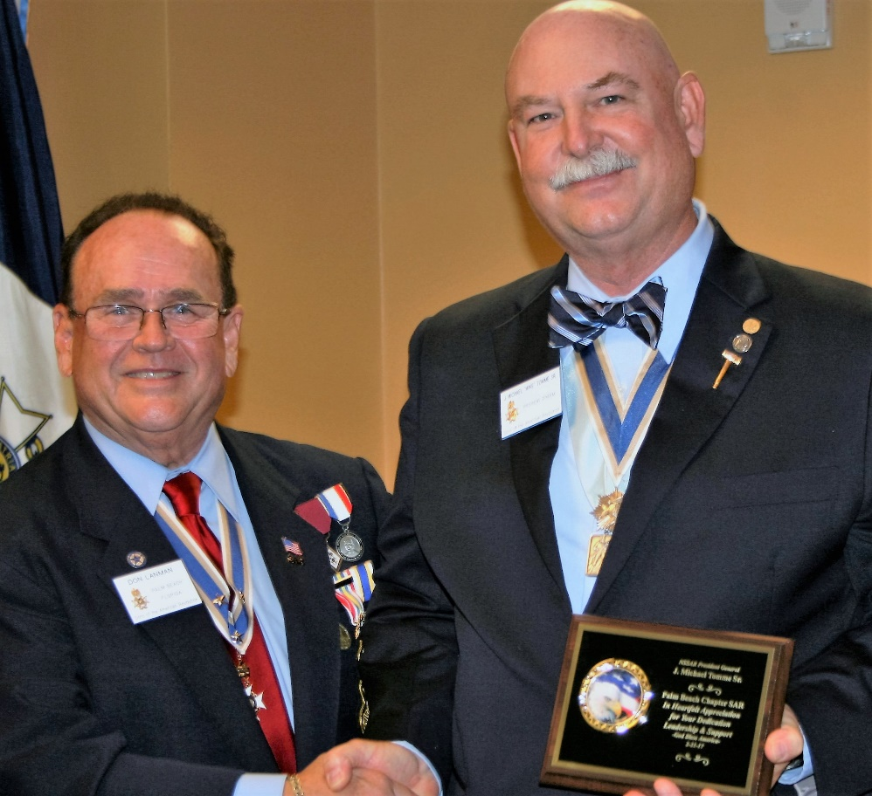

**Lanman, Dreyfoos, Stewart (T. Jefferson), State President Wess & PG Tomme**

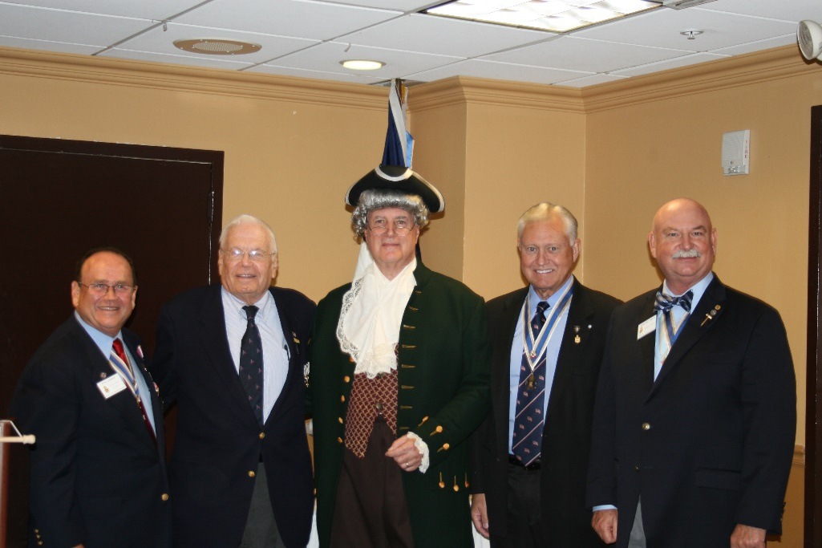

***President Lanman Honors Speaker John Sewart***

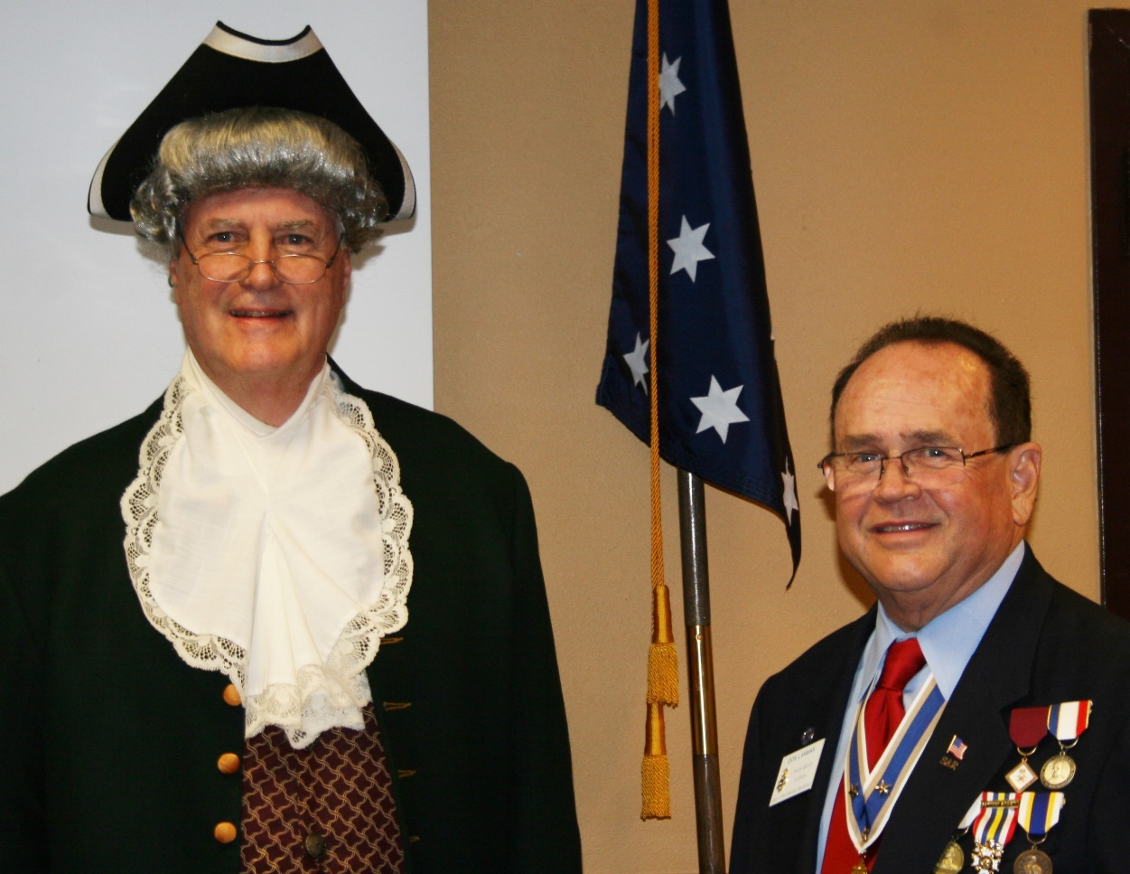

***Lanman Presents Chapter Donation for First Lady Cilla Tomme Charity***

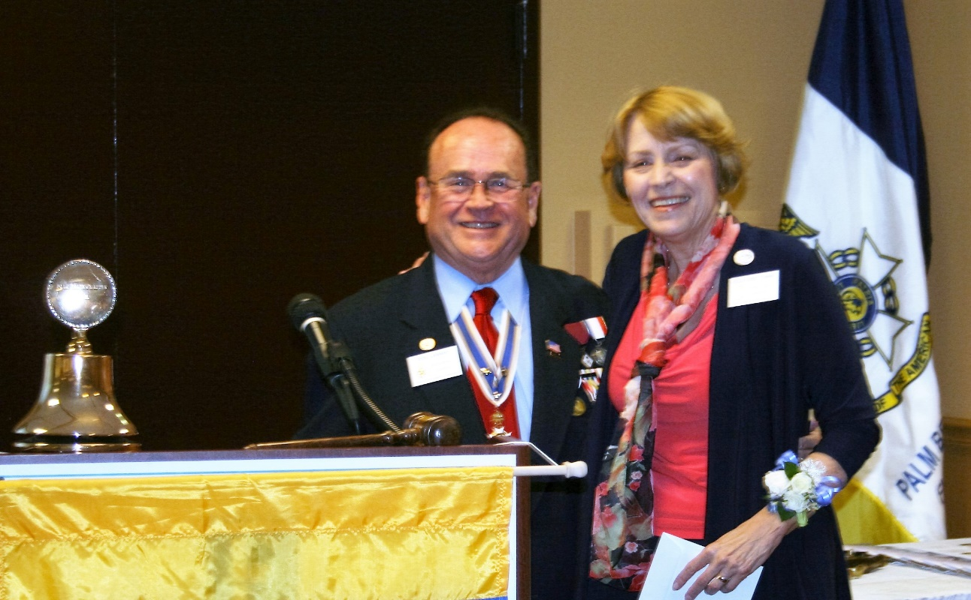

***Forest Hill Community HS JROTC Color Guard presents Colors***

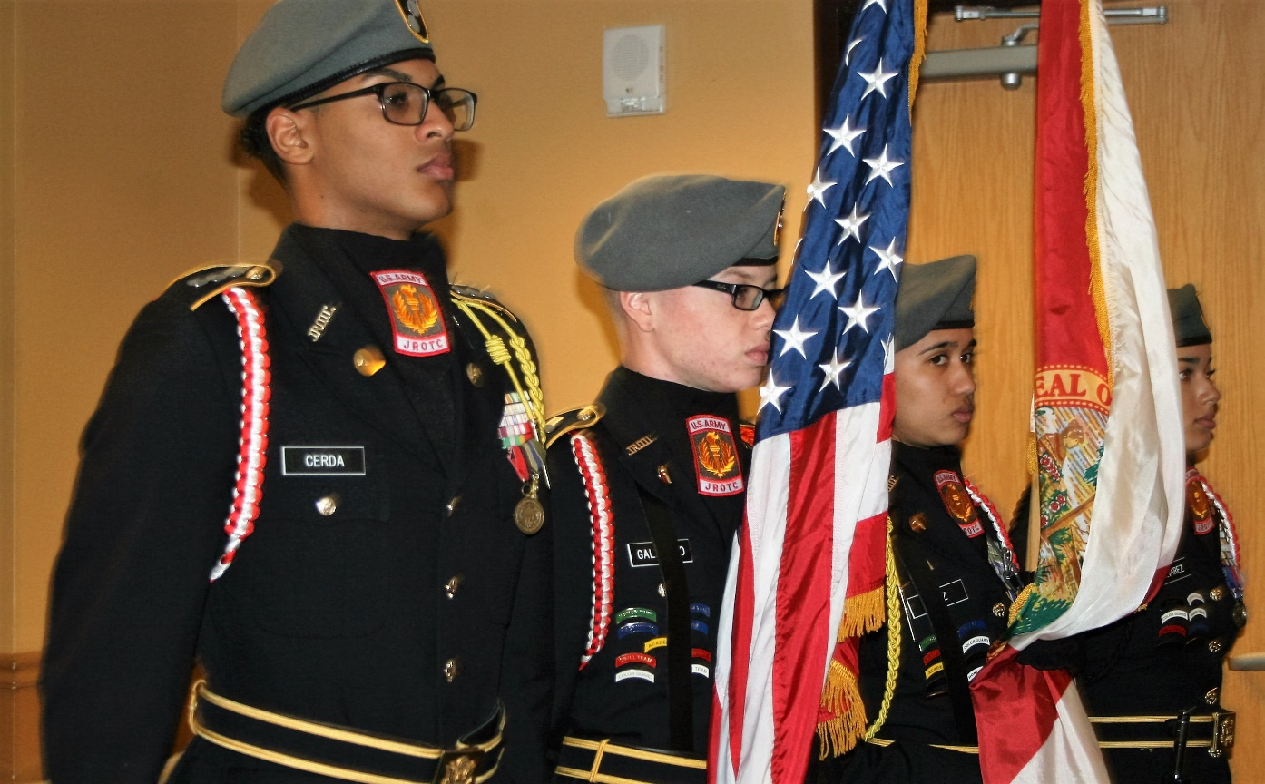

**Thomas Jefferson (Stewart) Past President Jim & Lynn Blackburn, Lanman**

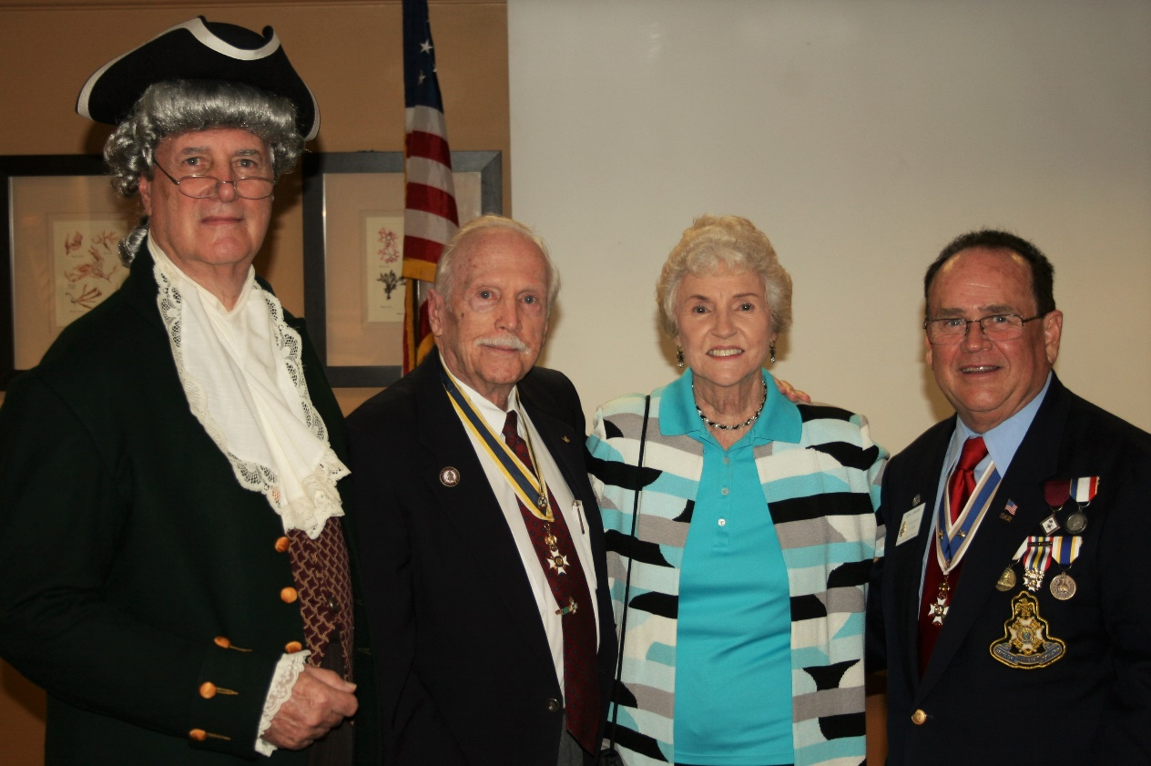

**United States Coast Guard Pipe Band Honors Chapter**

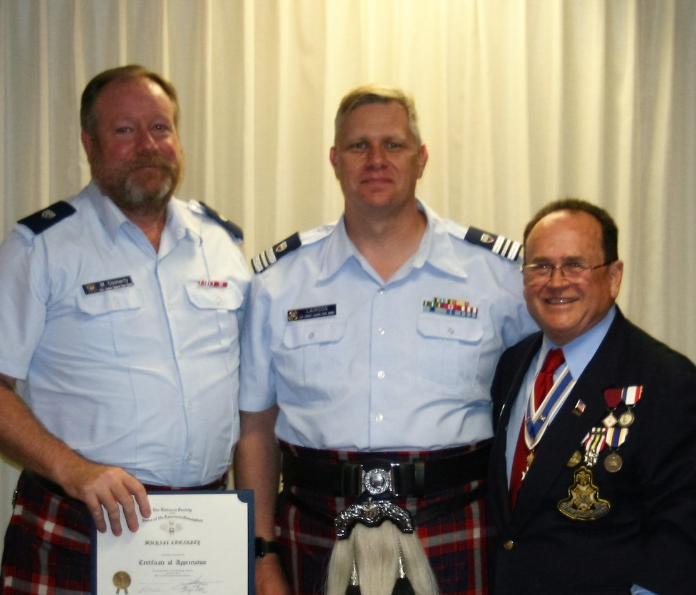

**USCG Pipe Band Honors His Excellency George Washington**

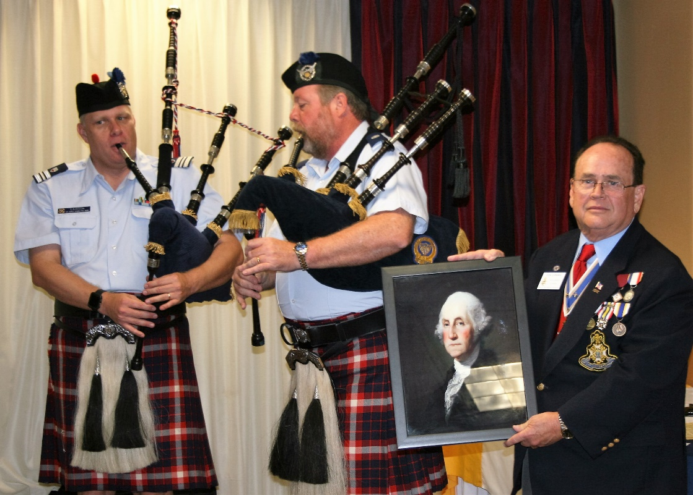

**Thank You, Daughters of the American Revolution Patriots**

**For all your Support**

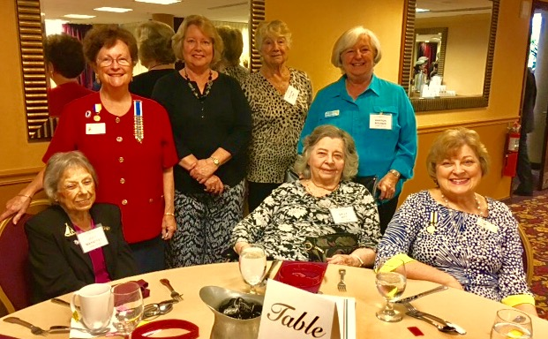

**Custom Palm Beach Chapter 80th Anniversary Challenge Coin Introduced**

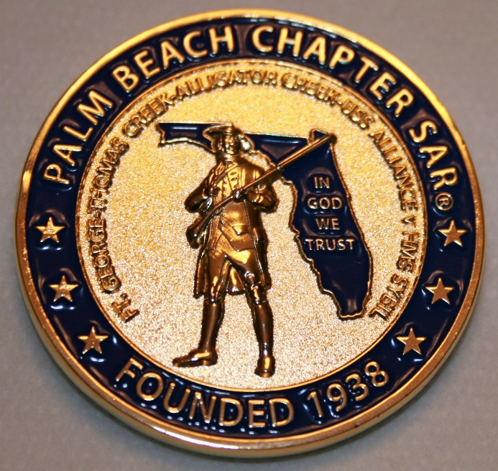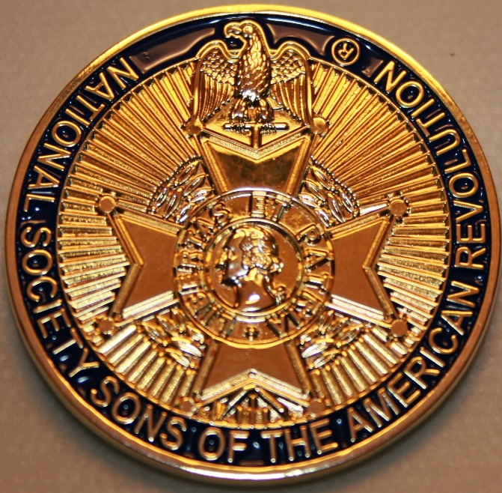

**Compatriot Sponsored Promotions:**

Compatriot sponsored Ads are important to the Chapter as they represent additional funds in support of Chapter projects including ***Boy Scout & JROTC medals, Rumbaugh & Knight Essay Youth contests, Police-Firefighter-EMT awards, Americanism & community civic programs!***

**Please** consider helping your Chapter with an Ad at the modest cost for **8** issues **@ Business Card $50, Half Page $100, Full Page $250.**

**Your AD donation will also qualify you for a listing in the *Presidents Brigade*. Call Don Lanman 561-315-5073 for information.**

***SPECIAL SPONSORED ADS ON FOLLOWING PAGES…***

***-COMPATRIOT ROBERT BRINCKERHOFF***

***-GARCILASO DE LA VEGA, CHAPTER DAUGHTERS OF THE AMERICAN REVOLUTION***

***-COMPATRIOT ALEXANDER DREYFOOS***

***-Morgan Stanley-***

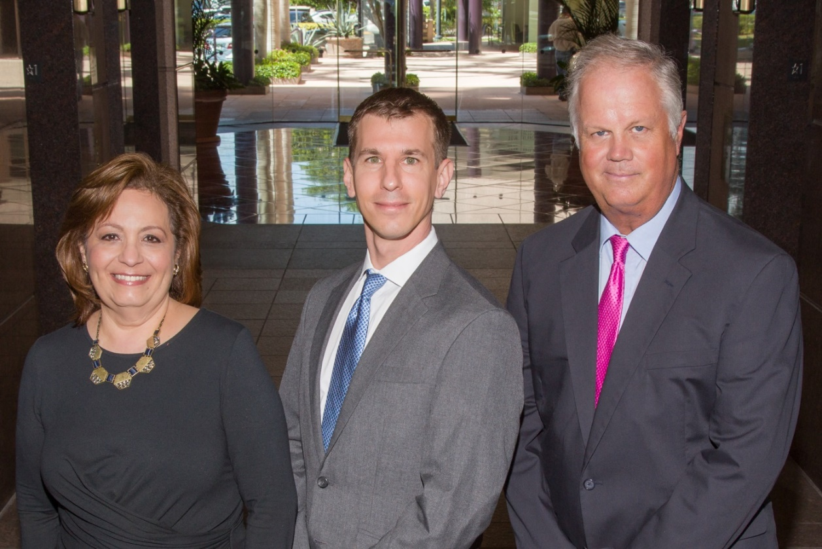  
**Amani Gaballa, Senior Registered Associate; Robert Scarborough, Financial Advisor; Robert Brinckerhoff, First Vice President, Financial Advisor**

***Robert W. Brinckerhoff  
Senior Vice President, Financial Advisor  
777 S. Flagler Dr. Suite 700, East Tower  
West Palm Beach, FL 33401  
(561) 650-7514  
Robert.Brinckerhoff@MorganStanley.com***

***Bob has been a financial advisor since March 1976. He focuses on investment strategies, retirement planning, liquidity solutions for individuals, commercial real estate, and small business owners.***

***Bob is a graduate of the University of Vermont. His clients are geographically diverse and he frequently travels from the east coast to the west to meet with clients. He is active with nonprofit organizations that support the blind and visually impaired. Bob is also an active enthusiast in Ferraris.***

*The investments listed may not be suitable for all investors. Morgan Stanley Smith Barney LLC recommends that investors independently evaluate particular investments and encourages investors to seek the advice of a financial advisor. The appropriateness of a particular investment will depend upon an investor’s individual circumstances and objectives. Morgan Stanley Smith Barney LLC is a registered Broker/Dealer, Member SIPC, and not a bank.*

*Where appropriate, Morgan Stanley Smith Barney LLC has entered into arrangements with banks and other third parties to assist in offering certain banking related products and services. Investment, insurance and annuity products offered through Morgan Stanley Smith Barney LLC are: NOT FDIC INSURED, MAY LOSE VALUE, NOT BANK GUARANTEED, NOT A BANK DEPOSIT, NOT INSURED BY ANY FEDERAL GOVERNMENT AGENCY. Copy write 2015 Morgan Stanley Smith Barney LLC, Member SIPC CRC1355648 11/15.*

*TWO GREAT BOOKS-ONE GREAT MAN*

***-Alexander W. Dreyfoos-***

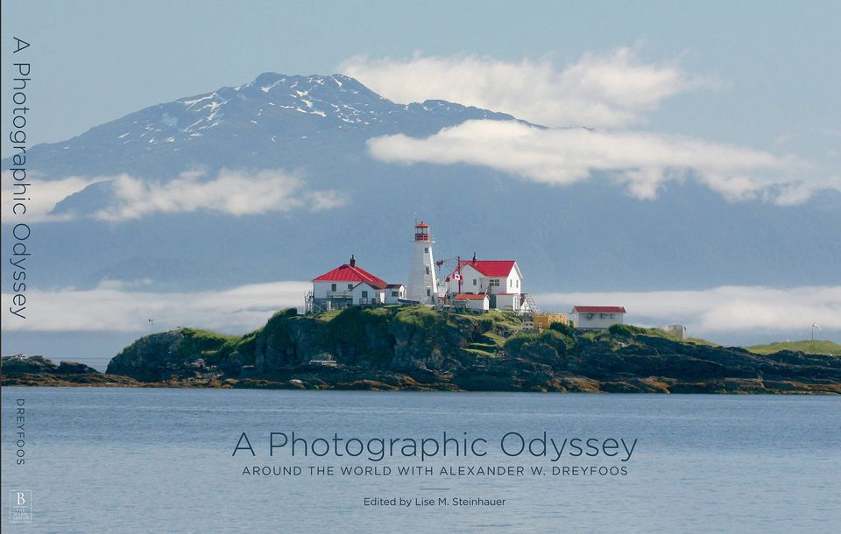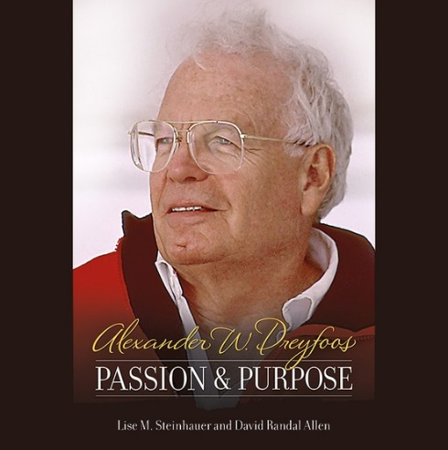

***-A PHOTOGRAPHIC ODYSSEY- -PASSION & PURPOSE-***

***Compatriot Alexander W Dreyfoos, Jr.*** an honored member of the *Palm Beach Chapter Sons of the American Revolution*, noted American entrepreneur, and philanthropist has published two remarkable books that should be on every bookshelf. **Book sales** **proceeds** **donated to local West Palm Beach charities!**

* ***Passion & Purpose*** chronicles a remarkable lifetime of passion with photography, his business, inventions and philanthropic ventures, as well as his adventures above and below the water. **$29.95.**
* ***A Photographic Odyssey*** is a remarkable collection of hundreds of stunning pictures from 100,000 photos taken by Alex around the world and bound in an elegant 15” by 10” glossy photographic book. You will travel with Alex around the world, above and below the water, to forests, jungles, glaciers, and deserts in the exotic locals of Papua New Guinea, Bhutan, Nepal, China, Japan, and Tibet. The subjects are very divergent contrasting palaces and temples with the vulnerability of people, animals, and exotic scenery. **$60.00.**
* **Support your Chapter & local charities! Get both books, *Passion & Purpose & A Photographic Odyssey,* just $71.96 @ kravis.org/books or Call 561-651-4329.**

***-Alexander W. Dreyfoos-***

*Graduating from MIT and Harvard Business School, Alex founded Photo Electronics Corporation (PCS), specializing in photography and video production. Over the decades, Alex earned 10 US patents and invented the Video Color Negative Analyzer for motion pictures earning him an Academy Award for technical achievement.Many inventions, developed by PCS, are on permanent display at the Smithsonian Institution. Locally Alex also owned television station WPEC TV-12, the CBS affiliate in West Palm Beach. Alex’s many philanthropic achievements include founding the Palm Beach County Cultural Council, the Raymond F. Kravis Center for the Performing Arts and gifting a million dollars to the Dreyfoos School of the Arts. Alex also donated a million dollars each to the Palm Beach County biomedical research campus of the Scripps Research Institute and the local Max Planck Florida Foundation for Neuroscience in Jupiter, Florida.*

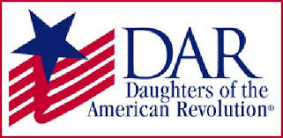

*Garcilaso de la Vega Chapter, NSDAR*

*Lake Worth, Florida*

*Sheila Zile-Pecoraro, Regent*

*Judy Mahaffey,* Registrar

Phone; 561-876-9520-Email; [Smileson@AOL.com](mailto:Smileson@AOL.com)

Chapter Email: [GarcilasodelaVegaDAR@gmail.com](mailto:GarcilasodelaVegaDAR@gmail.com)

Visit us on ***Facebook*** @ <https://www.facebook.com/LWDAR>