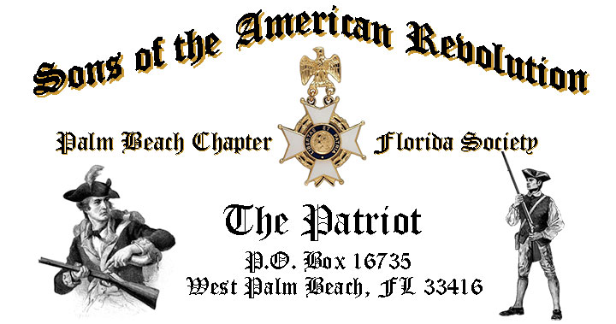

***Volume 24 March 2018 Number 03***

***What’s the Value of Linage Societies like the SAR & DAR Today?***  Review the question of why there are over 400 Linage Societies in America with special guest speaker *Former Chapter President* ***Don Lanman,*** Tuesday **March 20** @ **12 Noon** @ the *Embassy Suites Hotel* 1601 Belvedere Road, WPB! ***RSVP now for this exciting event!***

***March 20 Meeting Event Highlights…***

* ***Former Chapter President Lanman reviews the History, Value, Relevance & Importance of the SAR, DAR & 400+ Societies in America Today!***
* ***4-Course Buffet Lunch, Desserts & Beverages, $28 per person Check/Cash!***
* ***Reservations*** **Required,** **RSVP**, **Ben Tidwell** **(561)-704-9918!**
* **Family, Friends & Guests** are always ***Welcome***!

***Newsletter Content:***

* **President’s** Message
* **2018 Officers** & Board Members
* **2018** **Chapter** Meeting Dates &Topics
* ***President’s******Brigade*** Financial Supporters
* **Committees**, Chairmen & Members
* **National**/**State/Chapter**, News & Events
* **Feature Articles: *Hidden Patriot- Revolutionary War’s Deborah Sampson!***
* **Chapter** **Meetings** **& Event** Pictures
* **Compatriot** **Sponsored** Advertisements

***President’s Message:***

***Fellow Compatriots & Friends…***

As your President, I am pleased with the turn out for the February meeting. I hope that all attendees were as pleased as I was with our great guest speaker *John Stewart* and the special memorial service for *Compatriot Ned Payne*. Your attendance is very important to our existence as selfless servants to our community, our state and the nation.

There are over ***400 Linage Societies*** in America today…***Why were they created? What’s their purpose? Are they Important, Valuable or even Relevant Today?***

Join special guest speaker, *Former Chapter President, Don Lanman,* to review these provocative questions as he takes us on a revealing journey through the history and immense importance of ***Linage Societies*** like the ***SAR, DAR, Cincinnati,*** ***Illegitimate Sons/Daughters of the Kings of Britain*** *and more*.

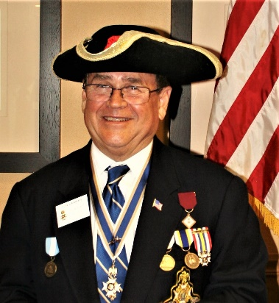

Acclaimed *Thomas Jefferson* re-enactor Compatriot and former *Chapter President John Stewart* honored our Chapter again with an encore’ portrayal of our *3rd* *President* along with insights on *Jefferson's* personal life and his leadership against the infamous *Barbary Pirates*.

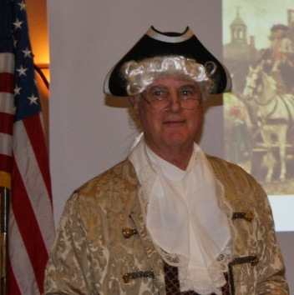

The February meeting included a special ***SAR Memorial Service*** for ***Compatriot Edward O. (Ned) Payne III***, 77 called home November 7, 2017. Ned was an active member of the ***National Society of the Sons of the American Revolution*** as a member of the *Palm Beach Chapter*, President of the *Westchester, NY Chapter* and *Vice President of the New York Empire State SAR*. Ned’s loving wife *Mary*, daughter, *Carrie*, son-in-law, *Steve Fleischmann*, and grandchildren *Connor* and *Abigail* attended the *Memorial Service*.



***Help Your Chapter***….We an immediate need for ***a Chapter Web Site Manager***. The position does not require much time but is most important to the Chapter. Please contact Ben Tidwell or Don Lanman if you can Help.

***Volunteer Today…Will You?*** Please help us on committees supporting our youth and civic programs including ***Historical Oration, Knight Essay, Historical Poster*** and ***Brochure contests, American History Teacher of the Year, Boy Scouts, JROTC, Police-Firefighter-EMS* recognition**and ***Veterans*** programs*.*

***Grow Chapter Membership***! The continued success of our Chapter depends on membership development and the mentoring of new members. All Compatriots can help grow membership by recruiting sons, relatives and friends interested in patriotism, good fellowship and honoring our patriot ancestors.

***Start today***, by enrolling your Sons and Grandsons and encouraging wives, daughters, and granddaughters to join the *Daughters of the American Revolution* and the *Palm Beach* *Chapter Women’s Auxiliary*.

We welcome all of our ***DAR Patriot Daughters*** to Chapter meetings and events, and sincerely appreciate their efforts with new member referrals and related support. ***Thank you DAR!***

All Compatriots are encouraged to actively support our local *DAR* Chapters by attending their fundraising events and meetings.

All *Compatriot Veterans* are encouraged to be recognized with the ***SAR Military Service or War Medals*** and welcomed into the***State SAR* *Veterans Battalion*** and the ***Chapter’s Own*** **“*Band of Brothers.*** Simply provide us with a copy of your *DD-214* and join the 15% of our members who have served from *WW II to Iraq*.

***Chapter Financials***, Compatriots, please help your chapter from losing money on our meeting luncheons by attending each meeting and bringing family members and guests.

**Remember** the Hotel requires a minimum number of guests to cover the food, room, and services fees, so when attendance is below 40 or if there are no shows, the Chapter must pay the difference.

*Compatriots*, I look forward to seeing you at the *March 20* meeting! Please, join me in honoring our nation’s Veterans, Patriot Ancestors, and especially our Departed Compatriots. ***God Bless You*** and ***God Bless the United States of America.***

***In Patriotism*** **– Benjamin F. Tidwell III**

*** Hear Ye-Hear Ye…..Chapter Editorial***

***Fellow Compatriots***, working in partnership with patriotic civic organizations and linage societies, like the DAR, we can leverage our collective political influence to encourage politicians and educators to support the values of our Founding Fathers, Constitution, and Bill of Rights, and to promote the teaching of in-depth and factual American history to our youth.

We can help our *Chapter* and the SAR become more relevant by structuring our societies more like the Rotary, Lions Club, Kiwanis, with interesting, informative guest speakers, fund raising for scholarships, youth programs and involvement with other civic minded groups at fundraisers, political and patriotic events.

This type of collaborative effort and involvement is important as we’re in an environment where, increasingly, the rights of small but vocal special interest groups can supersede the rights of the majority and where to disagree or express a contrary view is often negatively labeled or shouted down.

So stand up, join in and participate in *Chapter* activities, join us at *DAR* programs and attend patriotic events like *Memorial Day, Honor Flights, Flag Day, July 4th, Veterans Day* and others.

Encourage and support our Chapter leadership with their responsibilities and don’t wait to be ask….become active, volunteer and help. **God Bless You** and **God Bless the *United States of America*.**

***In Heartfelt Comradeship & Patriotism******- D. Lanman***

***2018 Chapter Meeting Dates/Topics:***

**Visit** the Palm Beach Chapter web site @ [www.sarpbchapter.org](http://www.sarpbchapter.org) for a meeting calendar, special events, articles, pictures, and general information.

* **March 20, 2018**, **Speaker- *Past Chapter President Donald Lanman***
* **April 17, 2018**, ***Law Enforcement Awards Ceremony***
* **May 15,2018, *Firefighters/EMT Awards Ceremony***
* **Oct. 16, 2018**, ***Special Guest Speaker***
* **Nov. 20, 2018**, ***Special Guest Speaker***
* **Dec. 8, 2018**, ***80th Anniversary &*** ***Christmas-Holiday Special***

***2018 Officers & Board:***

* ***President******Benjamin Franklin Tidwell III***
* ***Vice President******Robert Boggs***
* ***Secretary******Gary Green***
* ***Treasurer******Peter Johnston***
* ***Registrar******Robert Boggs***
* ***Chaplain******Father Sanford Sears***
* ***Sgt. @ Arms Peter Miller***
* ***Historian******Samuel “Buddy” Miller***
* ***Officer @ Large******Sonny Barber***
* ***Patriot Newsletter Editor******Donald Lanman***

***Join the President’s Brigade to…***

***Support Scholarship & Youth Programs:***

The Chapter has authorized ***$1,000***Scholarship to the ***Palm Beach Atlantic University*** again for ***2018***. This school educates our youth on the values of God and Country and help build character for the leaders of tomorrow

Help us increase the scholarship grant amount to ***$4,000*** *this year! W*e respectfully ask all Compatriots to consider donating a few dollars to the ***Presidents Brigade*** to grow the scholarship in support of these students of character.

The Chapter honors and expresses its sincere appreciation to the Compatriots of the ***President’s Brigade*** who support the scholarship and youth programs.

The dedicated members of the ***President’s Brigade*** donate “extra dollars” in support of the Chapter’s many youth programs, scholarships, civic activities, award certificates, police/firefighter/EMT medals, veterans’ projects, and related community civic programs.

***Honored Presidents Brigade Members*:**

* **Bronze Level: $25-$99:**

***M. Anderson, J. Blackburn, B. Boggs, J. Chataing, A. Cass, C. Coldwell, D. Coldwell, M. Curry, S. Curry, J. Damron, J. Dorsey, W. Davis, F. Devitt, J. Harper, J. Kane, L. Lassitter, P. Miller, S. Miller, J. Mayne, G. Parkinson, H. Oyer, J. Porter, S. Sears, A. Shea, W. Told, J. Wearn, L Watkins***

* **Silver Level: $100-$199:**

***J. Curry, R. Culpepper, T. Friend, G. Green, F. Green, A. Griswold, W. Johnson, D, Shepherd, S. McWhorter***

* **Gold Level: $200-$499:**

***R. Brinckerhoff, S. Barber, R. Banta , E. Buckley, J. Curry, S. Hitt, W. Meakin, J. Wynns***

* **Platinum Level: $500+**

1. ***Dreyfoos, D. Lanman, K. Christie, B. Tidwell***

***Committees, Chairs & Members:***

**Fellow Compatriots**…..The Chapter expresses its sincere appreciation to those members who volunteer to serve on our committees and projects. As you can see a few Compatriots are serving on multiple committees and could use some extra support! **Please** select a committee of interest for ***2018*** to help on any of the chapter committees listed. It does not take much time and is a major help with our many civic and youth initiatives. **Call Ben Tidwell (561-704-9918) or Bob Boggs (561-241-3128)**-**Today** to lend a hand on any of these committees.

* ***2019 Officer Nominations -All Chapter Members***
* ***80th Anniversary -Chapter Officers***
* ***JROTC & Boy Scouts -Barber, Tidwell***
* ***Law Enforcement-Fire Safety -Parkinson, Green***
* ***Veterans Affairs -Lanman, Curry***
* ***Newsletter/Publicity -Lanman***
* ***Knight Essay/Rumbaugh Oration -Boggs***
* ***American History Teacher -Boggs***
* ***Medals/Awards -Lanman, Tidwell***
* ***DAR Liaison -Lanman, Tidwell***
* ***Speakers Bureau -Lanman, Tidwell***
* ***Audit -Coldwell, Lanman***
* ***Flag Certificates -Miller, Johnston***
* ***Membership Development -Green, Boggs, Tidwell***
* ***Liberty Tree -Chapter Officers***
* ***Patriot Bios -Miller***
* ***Web Site-Facebook/Social Media -Open***

**Palm Beach Chapter 80th Year Commemorative Challenge Coin $10!**

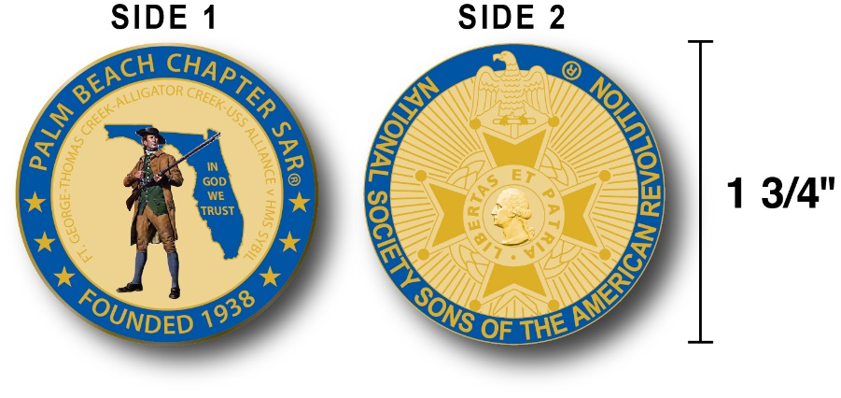

The Chapter created a custom bronze *Commemorative Anniversary Coin* honoring the founding of the ***Palm Beach Chapter* in *1938*** and celebrating its 80 years of historic, patriotic, and civic service in Palm Beach County and Florida.

The beautiful collector’s coin is highlighted in ***George Washington*** ***military blue*** on a stunning ***Gold*** background. Side-one is personalized for our Chapter with the founding date, a Minuteman standing guard over *Florida*, and the *Florida State* motto of ***"In God We Trust”.***

The collector’s coin includes an inscription listing the four major Revolutionary War battles waged in *Florida* including the battles of:

***Ft. George-Pensacola, Thomas Creek Massacre, Alligator Creek,*** and the ***Last Naval Battle* of the Revolutionary War** between the ***USS Alliance*** & ***HMS Sybil.***

Side-two displays the national ***NSSAR*** ***Cross of Malta***.  Very impressive indeed!

The custom bronze ***Commemorative Anniversary Coin*** is designed to celebrate our founding in **1938**, create a distinctive and impressive image for our Chapter and be used as a token of appreciation for honored guests, speakers, and as special awards.

***Purchase these unique Commemorative collector coins for just $10.***

***Classy SAR Lapel Pins $10:***

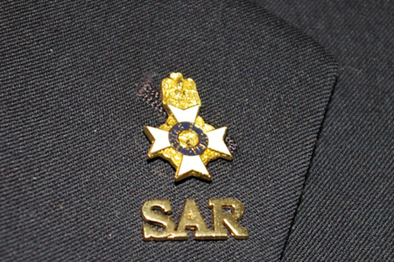

Display a ***Gold*** ***SAR*** pin on your suit lapel or shirt with the ***SAR Rosette***. The SAR Lapel Pin is part of a national branding program to help promote the S.A.R. and stimulate new membership!

The striking lapel pin is a recognizable public symbol of the SAR, provides you recognition as a member of this great society, and will spark conversations about SAR that leads to a new member.

The gold lapel pin and SAR Rosette create a professional image that will improve overall SAR name recognition. The Chapter has a supply of pins for Compatriots for just $10. ***Show Spirit….*Get your Gold SAR Pin today**!

***SAR Chapter, State & National Events:***

**-*STATE/NATIONAL*:**

***Join Chapter members presenting an Honor Wreaths at the SAR Battle of Guilford Courthouse, NC 3/17, and Thomas Creek, Jacksonville, FL, 4/7. Volunteer at the SAR Recruiting table at the 3/16 DAR State Conference Orlando, FL. See Ben Tidwell/Don Lanman for details.***

***DON’T MISS THE 2108 SAR NATIONAL CONGRESS***

***The 128th SAR Congress is scheduled for July 12-19 in Houston, Texas. Hotel registration is open now at a special SAR price of $159.00 per night King or 2-Queens.***

***Reservations can be made by calling the Westin Memorial City Hotel @ 1-800-937-8461 or online @*** [***www.starwoodmeeting.com/book/nssar2018***](http://www.starwoodmeeting.com/book/nssar2018)***. Questions contact Paul Callanan @*** [***LTCMRSC@aol.com***](mailto:LTCMRSC@aol.com) ***or 906-273-2424.***

***Feature Articles:***

***“Hidden Patriot”***

***The Colonial Army’s Herone Deborah Sampson!***

***Compiled, Edited & Written by Palm Beach Chapter SAR Past President Don Lanman***

Patriot Daughter **Deborah Sampson** joined the Continental Army in the famed **4th**

**Massachusetts Regiment** at the age of 21 disguised as a man. She is one of a number of women with a documented record of military combat service during the

Revolutionary war.

[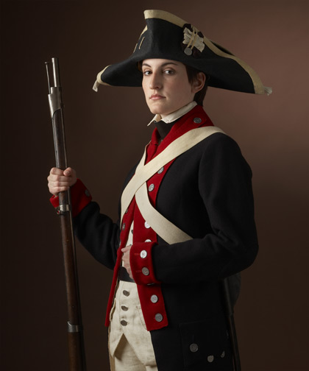](https://www.google.com/url?sa=i&rct=j&q=&esrc=s&source=images&cd=&cad=rja&uact=8&ved=2ahUKEwjMofWpzs7ZAhWGUlAKHRn4CyoQjRx6BAgAEAY&url=http://cooper11.wikis.birmingham.k12.mi.us/Tess-Deborah%2BSampson&psig=AOvVaw0zSREiv4HuBN3jLYaGSfoD&ust=1520112926591833)

Enlisting in 1782, **Patriot Daughter Deborah Sampson**, of  [*Plympton*, *Massachusetts*](https://en.wikipedia.org/wiki/Uxbridge,_Massachusetts), served 17 months in the Continental Army under the assumed name "*Robert Shirtliff*" (also spelled Shirtliffe or Shurtleff), fighting in numerous skirmishes in New York's Lower Hudson River Valley.

In July 1782 she was wounded in battle but successfully hid her secret by treating her own wounds. However, falling ill in the summer of 1783 her secret was discovered, and following her recovery, Sampson received an honorable discharge at West Point in October 1783.

Later in life, she petitioned the state of Massachusetts and US Congress and received back pay and a pension for her military service, and went on a national lecture tour giving speeches about her wartime experiences, demonstrations of the military manual of arms and traditional females’ roles in society.

Born December 17, 1760 in *Plympton*, *Massachusetts* near *Plymouth*, Sampson was one of seven children to *Jonathan Sampson Jr*. and *Deborah (Bradford) Sampson.* Both parents were direct descendants of preeminent *Mayflower Pilgrims*: *Jonathan of Myles Standish* and *Priscilla Alden*; his wife, the great granddaughter of *Massachusetts* Governor *William Bradford*.

Early in life, following the death of her mother, *Deborah* was sent to live with the *Deacon* *Jeremiah Thomas* family in [*Middleborough*](https://en.wikipedia.org/wiki/Middleborough), *MA*, where she worked as an indentured servant from 1770 to 1778.

Although treated well, she was not allowed to go to school, like the Thomas children, because *Deacon Thomas* did not believe in the education of women. Sampson was able to overcome this, however, by learning from Thomas's sons.

Her learning method was apparently successful; when her time as an indentured servant ended at age 18, *Deborah* made a living by teaching school during the summer sessions in 1779 and 1780.

In addition to her self-education, the ever industrious *Sampson* had a mechanical aptitude and woodworking skills that included *basket weaving*, and *light carpentry*. She made a variety of *wooden tools, milking stools,* *winter sleds, weather vanes, thread spools, weaving* *quills* and *pie crimpers*, which successfully she sold door to door.

*Sampson’s* biographer and personal friend of many years, *Hermann Mann*, described her in 1797 as not thin, *"her waist might displease a coquette",* and approximately 5’ 9” inches tall, compared to the average height of 5” for women and 5’ 6” for men.

*Mann* went on to write that *"the features of her face are regular; but not what a* [*physiognomist*](https://en.wikipedia.org/wiki/Physiognomy) *would term the most beautiful*". He also reported that her breasts were small, thus aiding with her male disguise as she hid them tightly wrapped with linen cloth while serving in the Army.

A 1797 portrait of *Deborah*, and contemporary descriptions of her appearance as tall, broad, strong, and not too delicately feminine likely contributed to her ruse at being a man. Biographer *Herman Mann* immortalized her life’s story in a book a 1797 book titled “The Female Review: or Memoirs of an American Young Lady”.

[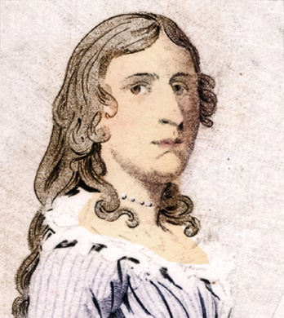](https://www.google.com/url?sa=i&rct=j&q=&esrc=s&source=images&cd=&cad=rja&uact=8&ved=2ahUKEwjJvI6izM7ZAhXHbVAKHcN3ASsQjRx6BAgAEAY&url=https://www.thinglink.com/scene/722806127510683649&psig=AOvVaw0zSREiv4HuBN3jLYaGSfoD&ust=1520112926591833) [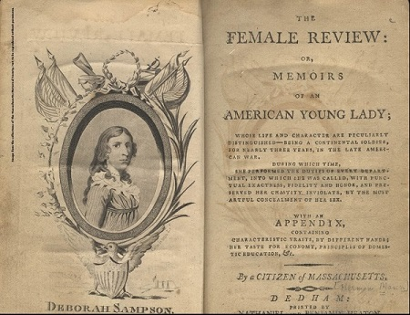](http://amzn.to/1mY30w6)

***~THE REST OF THE STORY~***

Before successfully enlisting as Robert Shurtliff, Sampson had tried to enlist earlier in 1782. Wearing men's clothes she joined a local Army unit in [*Middleborough, Massachusetts*](https://en.wikipedia.org/wiki/Middleborough,_Massachusetts), under the name *Timothy Thayer*.

Likely motivated by both patriotism and financial opportunity*, Sampson* collected the enlistment bonus. However, when she failed to muster with her [unit,](https://en.wikipedia.org/wiki/Company_(military_unit)) as scheduled, inquiries by the unit commander revealed that she had been recognized by a local resident when she signed the enlistment papers.

*Sampson’s* ruse uncovered, she was immediately mustered out of the Army and repaid the portion of the bonus that she had not already spent, but was not subjected to further punishment.

Undeterred, however, *Sampson* successfully enlisted again May 1782, this time joining an elite ***Light Infantry Company*** of the [***4th Massachusetts Regiment***](https://en.wikipedia.org/wiki/4th_Massachusetts_Regiment), under the command of *Captain* [*George Webb*](https://en.wikipedia.org/w/index.php?title=George_Webb_(soldier)&action=edit&redlink=1).

[](https://www.google.com/url?sa=i&rct=j&q=&esrc=s&source=images&cd=&cad=rja&uact=8&ved=2ahUKEwi2jIPP0M7ZAhWOblAKHYZ1DkoQjRx6BAgAEAY&url=http://www.judithkalaora.com/a-revolution-of-her-own--deborah-samson-gannett.html&psig=AOvVaw0zSREiv4HuBN3jLYaGSfoD&ust=1520112926591833)

Considered elite troops, Webb’s Light Infantry unit consisted of men specially selected because they were taller and stronger than average. Their mission was to provide rapid flank coverage for advancing regiments, [rearguard](https://en.wikipedia.org/wiki/Rearguard) action and forward [reconnaissance](https://en.wikipedia.org/wiki/Reconnaissance) duties for the main Army.

Because *Sampson* had joined an elite unit her disguise was more likely to succeed since no one was likely to look for a female in a unit made up of soldiers chosen for their above average size and superior physical ability.

In June 1782, Sampson joined two sergeants and 30 soldiers on a dangerous mission that ended with a fight with loyalist militia resulting in the capture of 15 loyalists. During the siege of *Yorktown,* *Sampson* participated in the attack on a British redoubt, dug defense trenches, and weathered hours of terrible canon fire from the British artillery.

[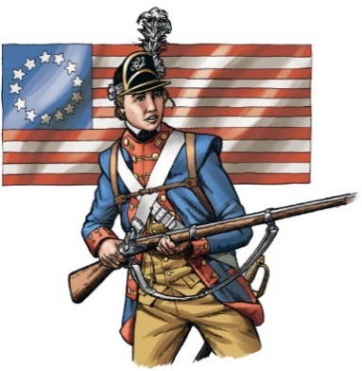](https://www.google.com/url?sa=i&rct=j&q=&esrc=s&source=images&cd=&cad=rja&uact=8&ved=2ahUKEwju5rDlz87ZAhUDUlAKHU1fBC8QjRx6BAgAEAY&url=https://www.thinglink.com/scene/636921022469111809&psig=AOvVaw0zSREiv4HuBN3jLYaGSfoD&ust=1520112926591833)

In excerpts from the *“The Female Review”,* Sampson recounts her feelings on war and battle that she found to be both exhausting and terrifying:

**“I underwent more with fatigue and heat of the day, than by fear of being killed; although my left-hand man was shot dead at the second fire, and my ears and eyes were continually tormented with the expiring agonies and horrid scenes of many others struggling in their blood. I recollect three on our side who were killed, John Bebby, James Battles and Noble Stern. I escaped with two shots through my coat, and one through my cap…No pen can describe my feelings experienced in the commencement of an engagement, the sole object of which is to open the sluices of human blood. The unfeigned tears of humanity has more than once started into my eyes in the rehearsal of such a scene as I have just described.”**

During a fierce battle in July 1782, outside [*Tarrytown, New York*](https://en.wikipedia.org/wiki/Tarrytown,_New_York), *Sampson* was severely wounded by a sword slash across the forehead and two [musket](https://en.wikipedia.org/wiki/Musket) balls lodged in her thigh.

Fearing discovery, she begged fellow soldiers to let her die on the battlefield, but over her objections a comrade placed her on his horse and rushed her to a field hospital.

Doctors treated her head wound, but fearing that her identity would be discovered she left the hospital before they could attend to her leg.

Retreating to the woods, she removed one of the balls with a small [penknife](https://en.wikipedia.org/wiki/Penknife) and closed her wounds with a [sewing needle](https://en.wikipedia.org/wiki/Sewing_needle). She could only remove one musket ball because the other ball was too deep to reach, thus causing the leg to never fully heal.

On April 1, 1783, she was reassigned to duties as an aid to *General* [*John Paterson*](https://en.wikipedia.org/wiki/John_Paterson_(New_York_politician)) for the next seven months, but during the summer of 1783, she fell ill with yellow fever, and was taken to *Doctor* [*Barnabas Binney*](https://en.wikipedia.org/w/index.php?title=Barnabas_Binney_(doctor)&action=edit&redlink=1) for treatment.

When *Dr. Binney* removed Deborah’s clothing to examine her he discovered the linin cloth used to bind her breasts. Without revealing his discovery to army authorities he moved her to his house, where his wife and daughters nursed her back to health.

In *September* 1783, following the signing of the [*Treaty of Paris*](https://en.wikipedia.org/wiki/Treaty_of_Paris_(1783)), *November* 3 was set as the date for all colonial army soldiers to muster out of the army. *Dr. Binney* then asked *Sampson* to personally deliver a letter to *General Paterson* that she correctly assumed would reveal her gender.

Realizing her secret was going to be revealed, Sampson admitted she was a woman to *General Paterson* and asked to be spared punishment for her dishonesty. *Patterson* was surprisingly supportive and instead decided that she should be rewarded for her service.

According to the “*Female Review*”: **“He told her, she might not only think herself safe, while under his protection, but that her unrivalled achievements deserved ample compensation – that he would quickly obtain her discharge, and she should be safely conducted to her friends.”**

While in other cases, women who pretended to be men to serve in the army were reprimanded, *General Paterson* gave *Sampson* an *Honorable Discharge* in recognition of her faithful service along with words of advice and money for her to travel home.

*Sampson* was officially discharged from the army at [*West Point, New York*](https://en.wikipedia.org/wiki/West_Point,_New_York), on October 25, 1783, after a year and a half of honorable service.

An Official Government Record of Deborah Sampson’s service as *"Robert Shirtliff" ,* from May 20, 1782 to October 25, 1783 is noted in the *"Massachusetts Soldiers and Sailors of the Revolutionary War"* series.

In January 1792, *Sampson*, with a letter of endorsement by friend *Paul Revere*, petitioned the *Massachusetts* State Legislature and the *US Congress* for back pay which the army had withheld from her because of her gender and a Revolutionary War pension based on her Honorable Discharge.

The *Massachusetts* legislature granted her petition and *Governor* [*John Hancock*](https://en.wikipedia.org/wiki/John_Hancock) signed it, awarding Sampson 34 pounds plus interest, and the Congress approved her pension in 1821.

Sampson was married in [*Stoughton, MA*](https://en.wikipedia.org/wiki/Stoughton,_Massachusetts), to *Benjamin Gannett*, a farmer from [*Sharon, MA*](https://en.wikipedia.org/wiki/Sharon,_Massachusetts), on April 7, 1785. They had three children: *Earl* (1786), *Mary* (1788), and *Patience* (1790), and adopted *Susanna Baker Shepard*, an orphan. In [*Sharon, Massachusetts*](https://en.wikipedia.org/wiki/Sharon,_Massachusetts)they farmed on land that had been in *Gannett's* family for generations.

In 1802, with a burning need to educate people on the contribution of women to the war effort, and to produce additional income for her family, *Sampson* went on a national lecture tour giving speeches about her wartime experiences, demonstrations of the manual of arms and females’ role in society.

Her popular lectures extolled the virtues of traditional gender roles for women, but during the second half of the presentation she would leave the stage to return, dressed in her army uniform, to discuss her military service, and to perform complicated, physically taxing military drill and ceremony drills.

[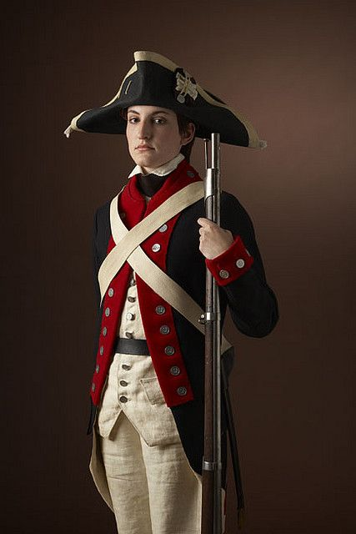](https://www.google.com/url?sa=i&rct=j&q=&esrc=s&source=images&cd=&cad=rja&uact=8&ved=2ahUKEwi9kYODzc7ZAhUPLVAKHb-ZB0MQjRx6BAgAEAY&url=https://hubpages.com/education/American-Patriot-Deborah-Sampson&psig=AOvVaw0zSREiv4HuBN3jLYaGSfoD&ust=1520112926591833) [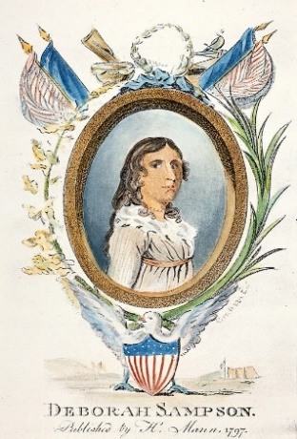](https://www.google.com/url?sa=i&rct=j&q=&esrc=s&source=images&cd=&cad=rja&uact=8&ved=2ahUKEwi2-eu2zM7ZAhVCUlAKHbY_AvQQjRx6BAgAEAY&url=https://fineartamerica.com/featured/deborah-sampson-granger.html&psig=AOvVaw0zSREiv4HuBN3jLYaGSfoD&ust=1520112926591833)

*Deborah Sampson* fell ill with [yellow fever](https://en.wikipedia.org/wiki/Yellow_fever) and died at the age of 66 on April 29, 1827, and buried at *Rock Ridge Cemetery* in [*Sharon, Massachusetts*](https://en.wikipedia.org/wiki/Sharon,_Massachusetts).

[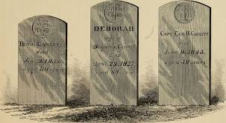](https://www.google.com/imgres?imgurl=http://uploads.neatorama.com/images/posts/855/96/96855/1497500331-1.jpg&imgrefurl=http://www.neatorama.com/2017/06/15/The-Woman-Who-Fought-in-the-Revolutionary-War/&docid=NlOGmXwcRWGItM&tbnid=DWQJSBrzqXS2qM:&vet=10ahUKEwjg2_70zNXZAhVCrVkKHavRA-MQMwhdKC0wLQ..i&w=600&h=330&bih=747&biw=1536&q=Liberty%20Ship%20S.S.%20Deborah%20Gannett%20%20images&ved=0ahUKEwjg2_70zNXZAhVCrVkKHavRA-MQMwhdKC0wLQ&iact=mrc&uact=8)

[The town of *Sharon*](https://en.wikipedia.org/wiki/Sharon,_Massachusetts), honors the memory of *Sampson’s* patriotism with a statue in front of the public library, a *Deborah Sampson Park*, and the *Deborah Sampson Gannett House*, (not open to the public).

The farmland surrounding *Sampson’s* home is also protected to ensure no development on this historic homestead.

Considered a “Daughter of Liberty”, in 1906, the town of *Plympton, MA along* with the *Deborah Sampson Chapter of National Society of the Daughters of the American Revolution*, placed a boulder on the town green, with a bronze plaque inscribed in *Sampson's* memory.

As of 2001, the official town flag of [*Plympton*](https://en.wikipedia.org/wiki/Plympton,_Massachusetts)incorporates *Sampson* as the *Official* *Heroine of the Commonwealth of Massachusetts*.

[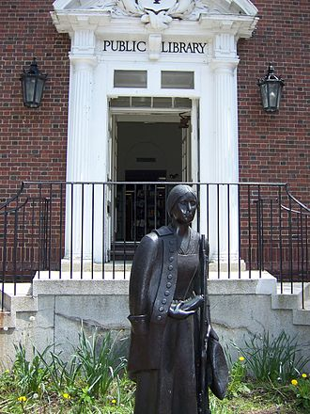](https://en.wikipedia.org/wiki/File:Sharon-public-library.jpeg) [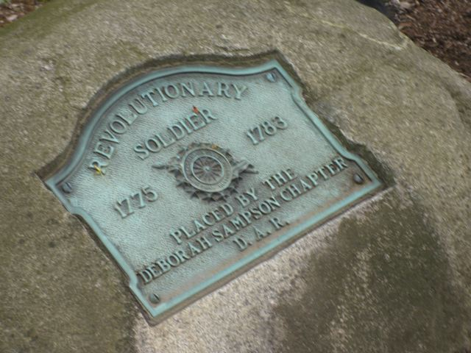](https://www.google.com/url?sa=i&rct=j&q=&esrc=s&source=images&cd=&cad=rja&uact=8&ved=2ahUKEwjQ05Gp0M7ZAhXIKVAKHSl5A08QjRx6BAgAEAY&url=https://www.findagrave.com/memorial/377/deborah-gannett&psig=AOvVaw0zSREiv4HuBN3jLYaGSfoD&ust=1520112926591833) [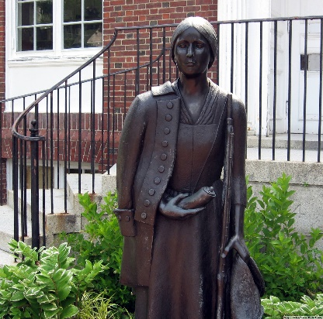](https://www.google.com/url?sa=i&rct=j&q=&esrc=s&source=images&cd=&cad=rja&uact=8&ved=2ahUKEwj07LaVz87ZAhWHL1AKHehtAkMQjRx6BAgAEAY&url=https://www.massmoments.org/moment-details/deborah-sampson-performs-in-boston.html&psig=AOvVaw0zSREiv4HuBN3jLYaGSfoD&ust=1520112926591833)

During [*World War II*](https://en.wikipedia.org/wiki/World_War_II) the [*Liberty Ship*](https://en.wikipedia.org/wiki/Liberty_Ship) *S.S.* *Deborah Gannett* was named in her honor.

The *S.S. Deborah Gannett* was launched April 10, 1944 and served honorably in war

and peace for 18 years until 1962.

[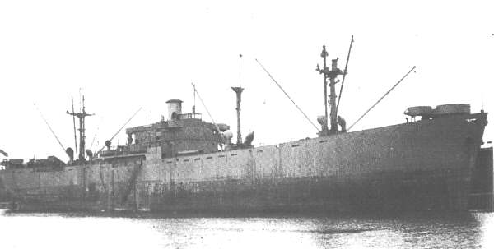](https://www.google.com/url?sa=i&rct=j&q=&esrc=s&source=images&cd=&cad=rja&uact=8&ved=2ahUKEwiwg8WNzdXZAhXtp1kKHX_qCJAQjRx6BAgAEAY&url=https://www.armed-guard.com/ag15.html&psig=AOvVaw1Yud-tFNBwKCU4dMXkUzNE&ust=1520353671111975)

In his new book ***“Revolutionary”,*** author/historian **Alex Myers** (a Sampson

descendent) presents a vivid, fictional account of Deborah/Robert's wartime and

personal experiences during the Revolutionary War.

[](https://www.google.com/url?sa=i&rct=j&q=&esrc=s&source=images&cd=&cad=rja&uact=8&ved=2ahUKEwir37-I0c7ZAhVKI1AKHXeiACAQjRx6BAgAEAY&url=http://common-place.org/book/do-clothes-make-the-man/&psig=AOvVaw0d3EplUHeH6Nu8XpYI_Pe1&ust=1520114252728373)

***Keep Your Membership Active! Pay Your 2018 Dues Today!***

**Don’t lose your SAR Membership….Reinstate your membership today by mailing** **your $75** annual membership dues today to ***SAR PB Chapter, PO Box 16735 West Palm Beach, FL 33416-6735! Include*** any changes to your personal contact information.

***Remember*….Your** **membership dues plus any additional donations fund the many Chapter’s youth and civic activities including**:

**Scholarships**, ***Boy Scout & JROTC medals, Rumbaugh & Knight Essay Youth contests, Police-Firefighter-EMT awards, Flag Certificates, Americanism, American History Teacher, Civic & Community programs.***

***~February Meeting & Event Pictures~***

***President Tidwell & Former President Lanman greet President***

***Thomas Jefferson-Compatriot/Past Chapter President John Stewart***

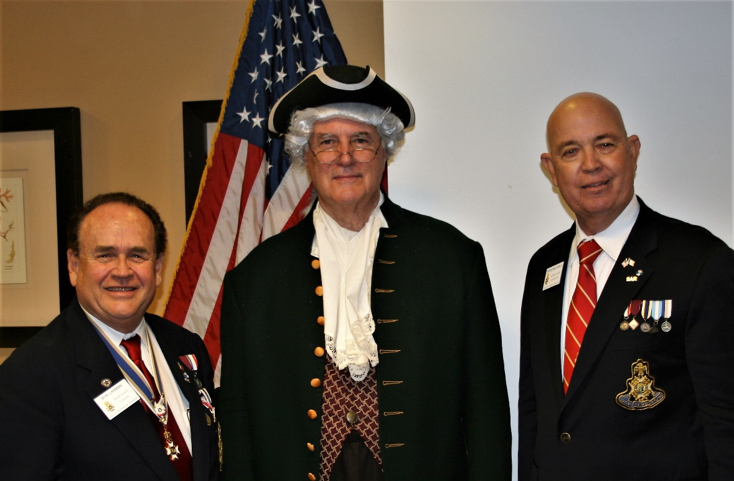

***President Tidwell & Vice President Boggs recognized***

***Compatriot John Stewart for his presentation of Thomas Jefferson***

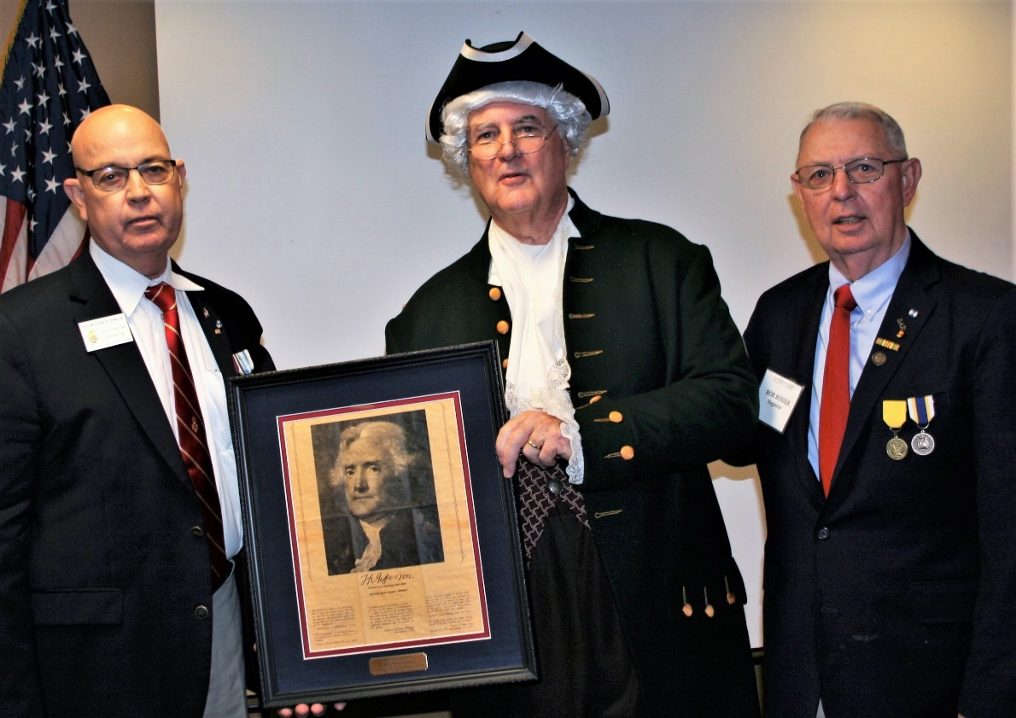

***Chapter Chaplain Father Sears delivers heartfelt Eulogy in***

***Honor of Compatriot Edward O. (Ned) Payne III.***

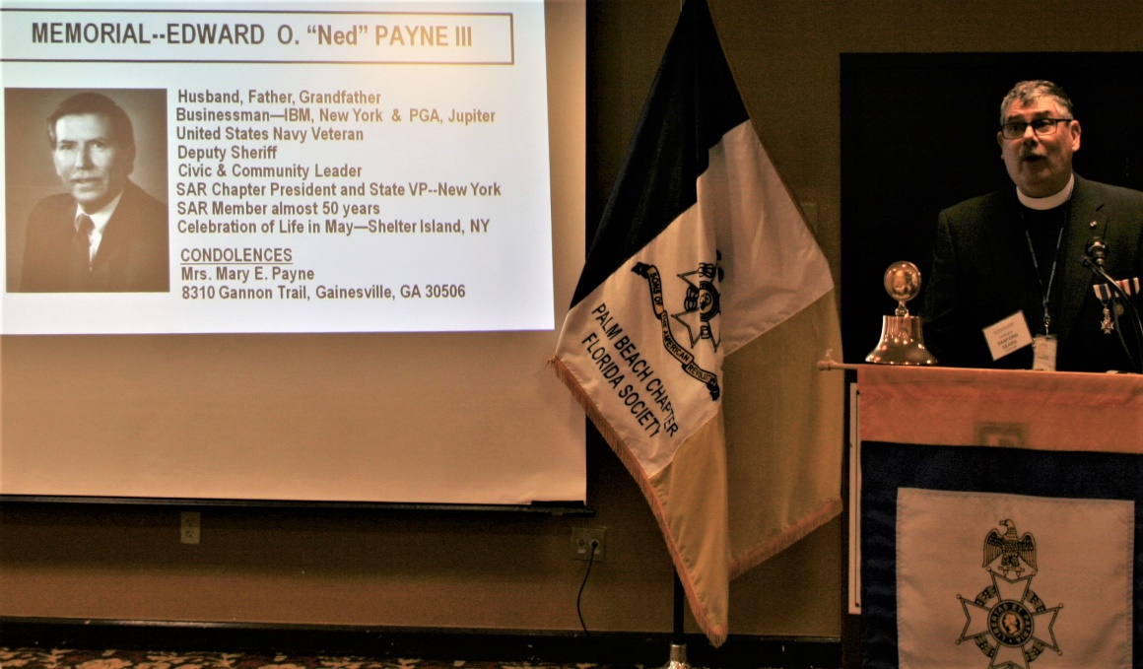

***President Tidwell & Former President Lanman & Compatriot Stewart greet Compatriot Ned Payne’s Family (L-R); Mary Payne, Grandson Connor, Daughter Carrie, Granddaughter Abigail & Son-in-Law Steve Fleischmann***

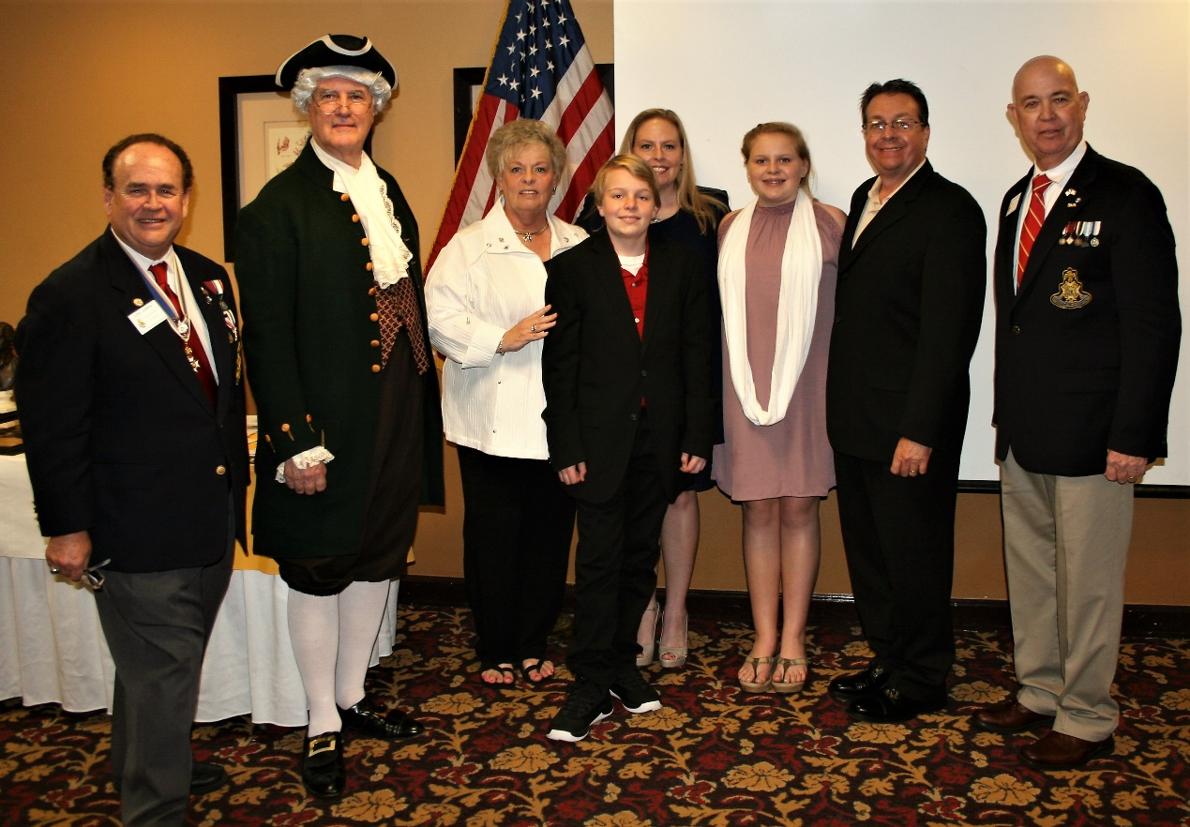

***President Jefferson greets***

***HMF-DAR Past Regent Brenda Fritz***

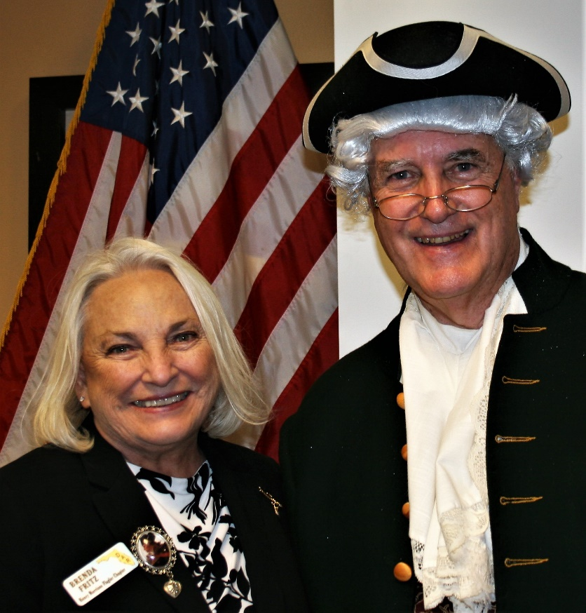

***Sgt. @ Arms Peter Miller delivers raffle basket***

***To Estahakee DAR Daughter Susie Wuest***

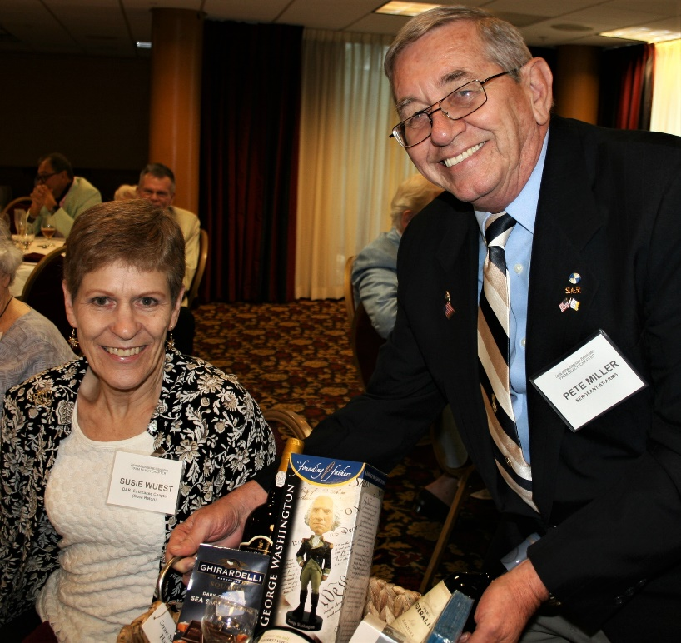

***~80th Anniversary Collectors Commemorative Collector Coin $10.00~***

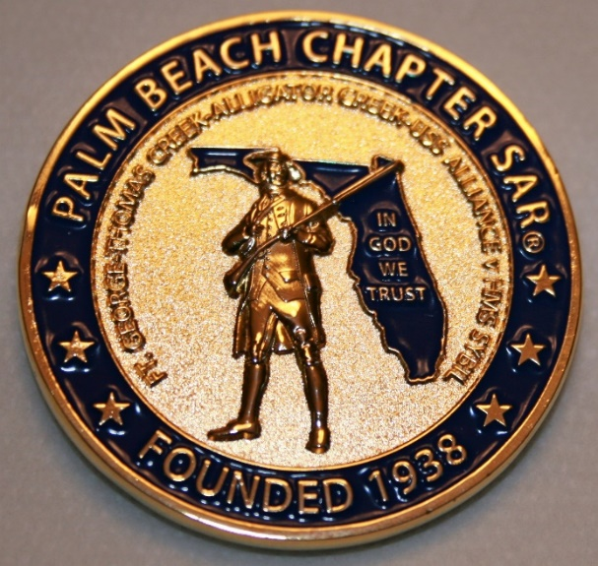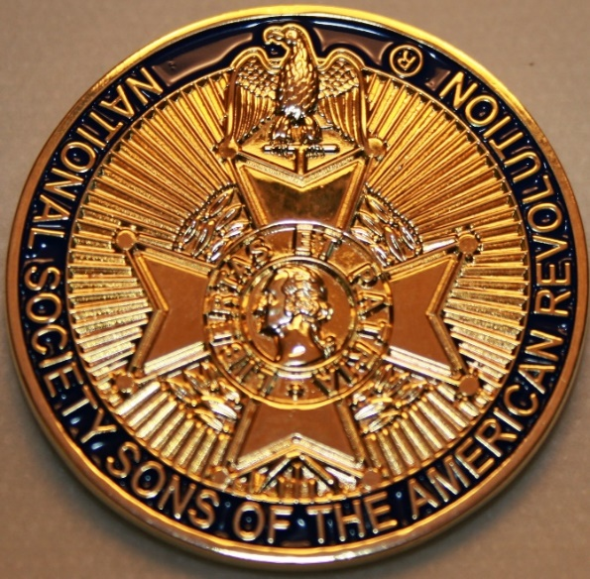

***~Compatriot Sponsored Promotions~***

**Compatriot sponsored newsletter Ads are important to the Chapter as they represent additional funds in support of Chapter projects including *Scholarships, Boy Scout & JROTC medals, Rumbaugh & Knight Essay Youth contests, Police-Firefighter-EMT medals, Americanism & community civic programs!* Help** your Chapter, sponsor an Ad for **8** issuesat a modest cost: **Business Card $50, Half Page $100, Full Page $250. Your AD donation will also qualify you for the *Presidents Brigade*. Call Don Lanman 561-315-5073 for information.**

***SPECIAL SPONSORED ADS ON FOLLOWING PAGES…***

***~COMPATRIOT ROBERT BRINCKERHOFF***

***~FINANCIAL SERVICES PROFESSIONAL***

***~COMPATRIOT ALEXANDER DREYFOOS***

***AUTHOR/PHOTOGRPHER***

***~COMPATRIOT SONNY BARBER***

***HISTORIAN/AUTHOR***

***~GARCILASO DE LA VEGA, CHAPTER***

***DAUGHTERS OF THE AMERICAN REVOLUTION***

***-Morgan Stanley-***

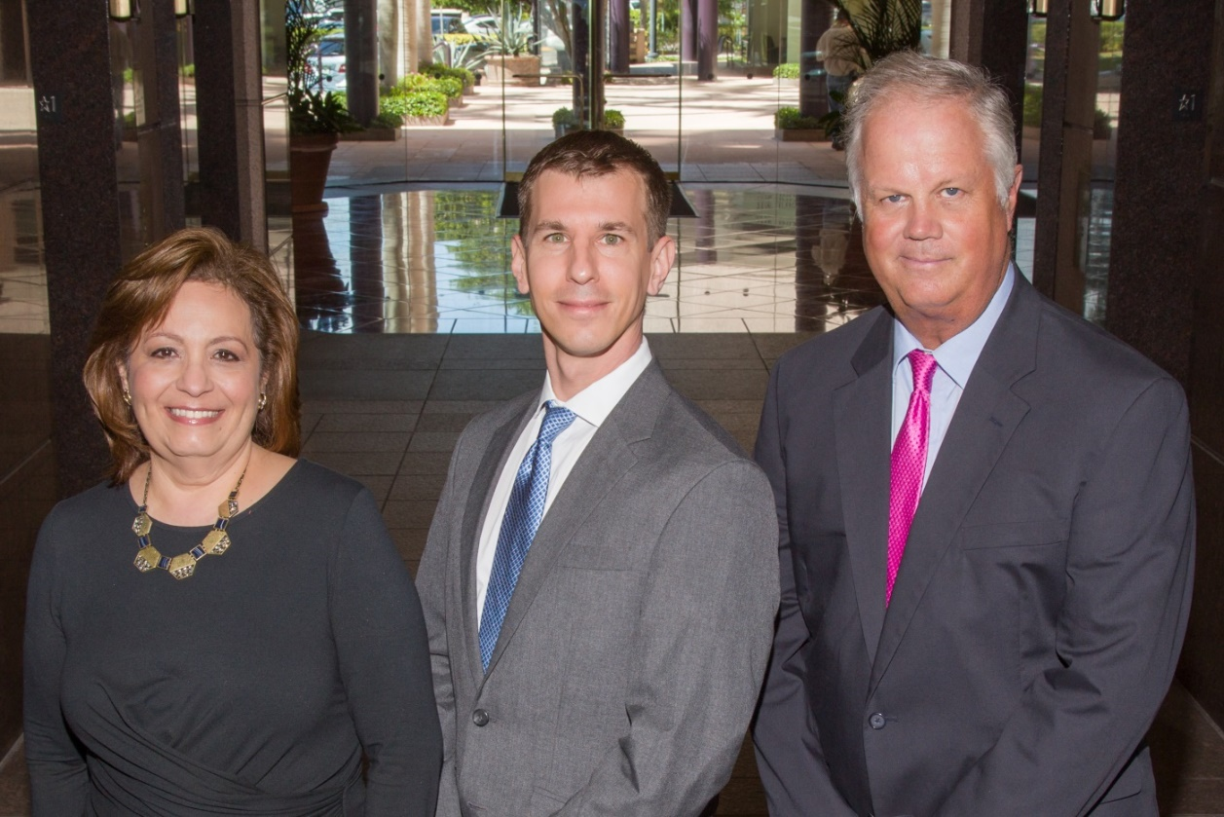  
***Amani Gaballa, Senior Registered Associate; Robert Scarborough, Financial Advisor; Robert Brinckerhoff, First Vice President, Financial Advisor***

***Robert W. Brinckerhoff  
Senior Vice President, Financial Advisor  
777 S. Flagler Dr. Suite 700, East Tower  
West Palm Beach, FL 33401  
(561) 650-7514  
Robert.Brinckerhoff@MorganStanley.com***

***Bob has been a financial advisor since March 1976. He focuses on investment strategies, retirement planning, liquidity solutions for individuals, commercial real estate, and small business owners.***

***Bob is a graduate of the University of Vermont. His clients are geographically diverse and he frequently travels from the east coast to the west to meet with clients. He is active with nonprofit organizations that support the blind and visually impaired. Bob is also an active enthusiast in Ferraris.***

*The investments listed may not be suitable for all investors. Morgan Stanley Smith Barney LLC recommends that investors independently evaluate particular investments and encourages investors to seek the advice of a financial advisor. The appropriateness of a particular investment will depend upon an investor’s individual circumstances and objectives. Morgan Stanley Smith Barney LLC is a registered Broker/Dealer, Member SIPC, and not a bank.*

*Where appropriate, Morgan Stanley Smith Barney LLC has entered into arrangements with banks and other third parties to assist in offering certain banking related products and services. Investment, insurance and annuity products offered through Morgan Stanley Smith Barney LLC are: NOT FDIC INSURED, MAY LOSE VALUE, NOT BANK GUARANTEED, NOT A BANK DEPOSIT, NOT INSURED BY ANY FEDERAL GOVERNMENT AGENCY. Copy write 2015 Morgan Stanley Smith Barney LLC, Member SIPC CRC1355648 11/15.*

*TWO GREAT BOOKS-ONE GREAT MAN*

***-Alexander W. Dreyfoos-***



***-A PHOTOGRAPHIC ODYSSEY- -PASSION & PURPOSE-***

***Compatriot Alexander W Dreyfoos, Jr.*** an honored member of the *Palm Beach Chapter Sons of the American Revolution*, noted American entrepreneur, and philanthropist has published two remarkable books that should be on every bookshelf. **Book sales** **proceeds** **donated to local West Palm Beach charities!**

* ***Passion & Purpose*** chronicles a remarkable lifetime of passion with photography, his business, inventions and philanthropic ventures, as well as his adventures above and below the water. **$29.95.**
* ***A Photographic Odyssey*** is a remarkable collection of hundreds of stunning pictures from 100,000 photos taken by Alex around the world and bound in an elegant 15” by 10” glossy photographic book. You will travel with Alex around the world, above and below the water, to forests, jungles, glaciers, and deserts in the exotic locals of Papua New Guinea, Bhutan, Nepal, China, Japan, and Tibet. The subjects are very divergent contrasting palaces and temples with the vulnerability of people, animals, and exotic scenery. **$60.00.**
* **Support your Chapter & local charities! Get both books, *Passion & Purpose & A Photographic Odyssey,* just $71.96 @ kravis.org/books or Call 561-651-4329.**

***-Alexander W. Dreyfoos-***

*Graduating from MIT and Harvard Business School, Alex founded Photo Electronics Corporation (PCS), specializing in photography and video production. Over the decades, Alex earned 10 US patents and invented the Video Color Negative Analyzer for motion pictures earning him an Academy Award for technical achievement.Many inventions, developed by PCS, are on permanent display at the Smithsonian Institution. Locally Alex also owned television station WPEC TV-12, the CBS affiliate in West Palm Beach. Alex’s many philanthropic achievements include founding the Palm Beach County Cultural Council, the Raymond F. Kravis Center for the Performing Arts and gifting a million dollars to the Dreyfoos School of the Arts. Alex also donated a million dollars each to the Palm Beach County biomedical research campus of the Scripps Research Institute and the local Max Planck Florida Foundation for Neuroscience in Jupiter, Florida.*

***HISTORICAL MYSTERY SERIES FROM THEREVOLUTIONARY WAR ACROSS TIME***



***Follow Kay Telfair across time beginning with Crossed & Found followed by Gold Hush & Stone-Walled….***

***Kay is a normal young teen—normal if that means being unusually curious and having an uncanny knack for putting herself in dangerous situations, which stresses her parents and often tests the relationship with best friend Anna.***

***The series follows Kay across two intrigue-filled summers on adventures involving events in American history. Join Kay’s journey of adventure steeped in American History through three books that excite all ages. At*** [***amazon.com***](http://amazon.com)***, Barnes & Noble or Chapter meetings. (See book summaries following page)***

***SAR Palm Beach Chapter Compatriot/Author Sonny Barber developed an interest in American history at an early age, reading and collecting newspapers, magazines and other materials on historic U.S. and world events. He’s coupled that interest with his fiction writing to create a modern-day “mystery history” Series perfect for Preteens to Adults.***

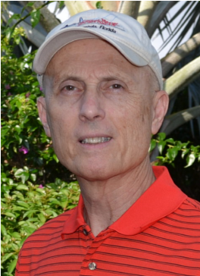

***~Crossed & Found~***



**Thirteen-year-old Kay Telfair believes her life is over when she moves with her family a thousand miles to their new home near the Delaware River in New Jersey. But her life takes an unexpected turn when she meets Anna and discovers a two-centuries-old letter--a letter that could change American history. Before she unravels the letter's mystery, Kay stumbles headlong into an adventure--confronting fears she'd never experienced, stretching the limits of her friendship with Anna, and forcing a test of Kay's physical strength that could save her own life.**

***~Gold Hush~***



**“I’m avoiding any activity that involves excitement…I’ve learned my lesson.” After an adventure-filled June, all Kay Telfair wants is a quiet vacation in Maine with her family and best friend Anna—no drama, no stress. But the thirteen-year-old’s hopes for a tranquil August stay in the village of Prospect Harbor soon fade when the girls compete for the attention of a young boy and Kay makes a startling discovery—a discovery that sends the three teens on a dangerous quest. Ignoring advice—and menacing threats from others—they continue their pursuit, drawing them deeper into a perilous mystery, deeper than Kay ever could have imagined.**

***~Stonewalled~***

[](https://www.amazon.com/Stonewalled-Mystery-History-Book-Three/dp/1519351291/ref=pd_bxgy_14_img_3?_encoding=UTF8&psc=1&refRID=75QVZ72QHQ8A2W2F3RK1)

**Kay stared at the gray line of stone walls. “They won’t be too upset to see these knocked down...” A mystery that threatens the relationship with best friend Anna, a battle with Mother Nature at her worst, and the discovery of a tragic secret—not exactly what fourteen-year-old Kay Telfair was looking for in a summer getaway. But that’s what confronts the young teen while helping the owners of Windcrest Farm find a way to stop destruction of nearby farmland and its three-hundred-year-old stone walls. Vacationing with her family and Anna at Windcrest in the quiet, coastal village of Little Compton, Rhode Island, the young teen soon discovers her goal will not be easy. Kay’s prospects for helping preserve the valuable land and stone walls look much better after a surprise visit by a boy from her past. With his help, she pours all her energy and passion into the quest, searching for answers in New England’s Native American and colonial history and learning some important lessons about perseverance and friendship.**



*Garcilaso de la Vega Chapter, NSDAR*

*Lake Worth, Florida*

*Alisha Darcy, Regent*

*Karen Christie, Registrar*

Phone; 561-236-2460-Email; [IMC4U4@AOL.com](mailto:IMC4U4@AOL.com)

Chapter Email: [GarcilasodelaVegaDAR@gmail.com](mailto:GarcilasodelaVegaDAR@gmail.com)

Visit us on ***Facebook*** @ <https://www.facebook.com/LWDAR>