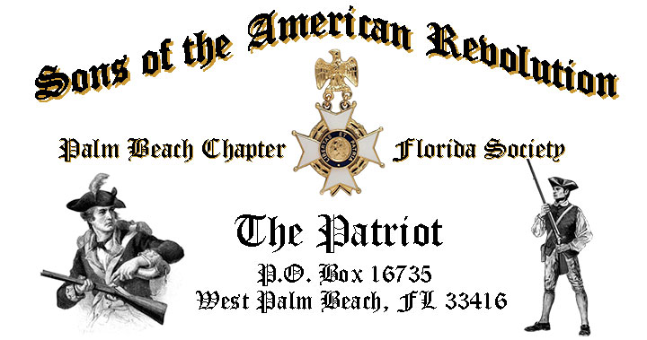

***Volume 25 March 2019 Number 03***

***Happy 81th Birthday-Palm Beach Chapter SAR!*** Join us to honor our 81st year of patriotism with special guest ***Dr. Donald Gladney,*** Tuesday **March 19** @ **12 Noon** @ the *Embassy Suites Hotel* 1601 Belvedere Road! ***RSVP Today for this popular event!***

***March 19 Meeting Event Highlights…***

* ***“Don’t Get Hacked” Cyber Risks & Security Tips - Donald Gladney, PhD***
* ***SAR State President, Colonel Patrick Niemann to bring Greetings***
* ***4-Course Buffet Lunch, Desserts & Beverages, $28 per person Check/Cash***
* ***Reservations*** **Required-Bob Boggs, 561-350-5730, bobboggs1@gmail.com**
* **Welcome Family, Friends & Guests**

***Newsletter Content:***

* **President’s** **Message**
* **2019 Officers & Board Members, Chapter Meeting Dates & Topics**
* **Feature Article: *Personal Cyber Security Risks & Protection Tips***
* **Pictures: Meetings** **& Events**
* ***President’s Brigade* Financial Supporters**
* **Committees, Chairmen & Members**
* **National/State/Chapter, News & 2019 Events**
* **Chapter Store, Coins, Badges**
* **Newsletter Supporting Advertisers**

***President’s Message:***

***Fellow Compatriots, DAR Daughters & Friends…***

As your President, I am pleased to report over 50 Compatriots, DAR Daughters and honored guests attended our February meeting.

Many guests reported that they were as pleased with our guest speaker Compatriot *John M. Stewart* and our special memorial service for *Compatriots La Voey* and *General Irzyk*. Your attendance and support is critical to our existence as selfless servants to our community, our state and the nation, and I thank you.

With the news filled with stories of ***Identity Theft, Computer Hacking*** and ***Cyber Security***, I urge you to join us March 19 for a the special presentation by *Cyber Security* expert and *Dean* of the***Cyber Security Department at Palm Beach State College****,* ***Dr. Donald Gladney, PhD.***

*Dr. Gladney* will review important new ***Personal Cyber-Security Threats & Risks, Individual Risk Assessment Ideas,* *Protection Options, Cyber Security Strategies*** and ***Tips*** to protect yourself from cyber-crime. I also urge you to read the attached article ***“Don’t Get Hacked”*** by Don Lanman in this Newsletter.

***FLSSAR* State President, *Colonel P. Niemann*** will attend our March meeting to bring greetings and recognize the ***Chapter’s 81st*** year of service. (Founded March 16, 1938)

The **February** meeting honored **His Excellency George Washington’s** Birthday with a special toast and welcomed back, by popular demand, ***President*** ***Thomas Jefferson***!

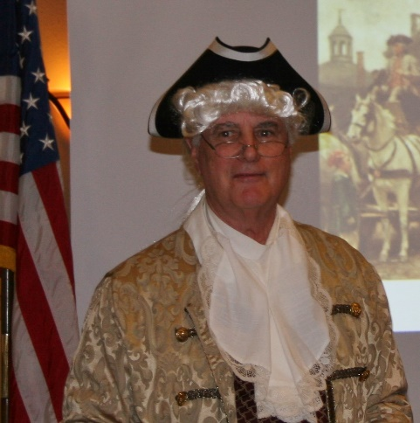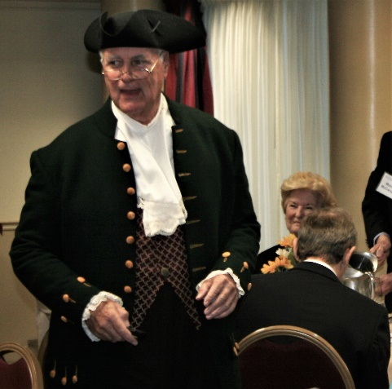

***President Jefferson*** was portrayed by Compatriot and former Chapter President John M. Stewart, in the dress, language, and speaking style of the 1700s, so we were entertained by John’s convincing portrayal of our***3rd* *President*** while benefiting from his extensive knowledge of *Jefferson's* personal life, especially his leadership in expanding our country with the famous ***Louisiana Purchase***!

The highlight of the presentation was the audience ***Q & A*** that was structured much like a modern day Presidential Press Conference with some thoughtful questions!

The Chapter conducted a special memorial service for *Compatriots La Voey* and *General Irzyk* and inducted 2 new ***Compatriots, Mason Stowell*** and ***Michael DuPont***.

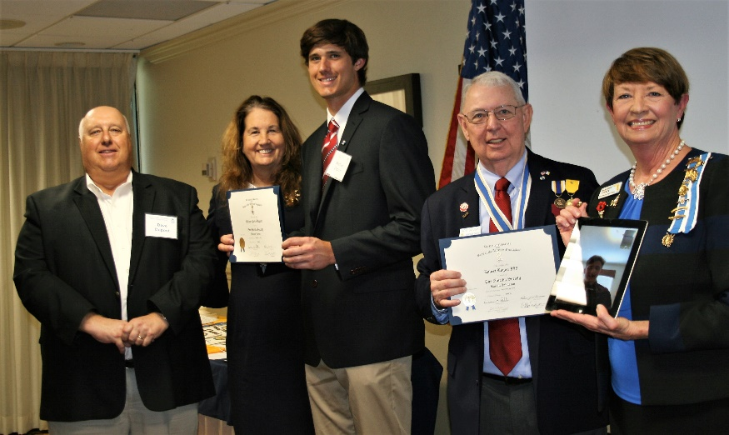

These two young men are unique indeed, ***Michael DuPont*** is in line for a major baseball scholarship and ***Mason Stowell*** is in training for the *2020 Olympics* in the mixed Marshal Arts competition. ***Compatriot Stowell*** was inducted online telephonically from his home in Colorado…high tech indeed!

Chapter Officers were most active in February attending the SAR BOM and DAR Chapter meetings at *Garcilaso de la Vega, Henry Morrison Flagler, Palm Beach,* and *Spirit of Liberty*. State Officer and *FMR Chapter President Lanman* delivered an insightful presentation on ***“Heroines of the Revolution”*** at a *Spirit of Liberty* DAR meeting, and recognized 3 female veterans for their military service.

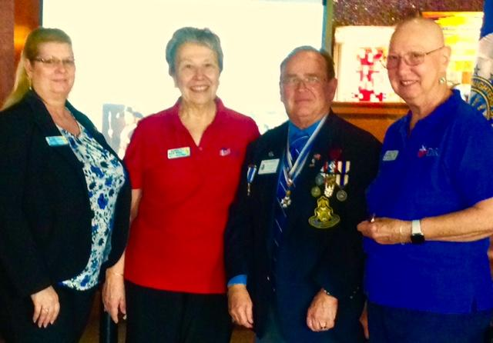

Chapter Officers *Lanman, Johnston, Parkinson*, and DAR Daughters *Christie* and *Ferrer* attended a special Veteran Funeral Services for WW-2 Naval Veteran, *Ralph A. Mercurio* at Saint Mathews Catholic Church and the South Florida National Cemetery.

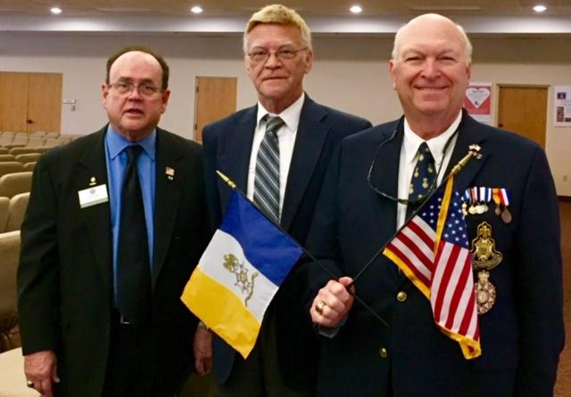



***Don’t wait to be asked***, help on a Committee today to support our youth and civic programs including ***Historical Oration, Knight Essay, Poster*** and ***Brochure*** contests***, American History Teacher of the Year, Boy Scouts, Police-Firefighter*** recognition***, Flag & Liberty Tree,*** and ***Veterans*** services*.*



***All Compatriot Veterans*** are encouraged to join the ***FLSSAR*** ***Veterans Battalion*** by providing the ***Chapter Veterans Committee Chairman Lanman*** with a copy of their ***DD-214*** and be recognized with the ***SAR Military Service*** or ***War Service Medal*** and join the 18% of *Chapter Vets* who’ve served honorably from ***WW II*** to***Iraq***.

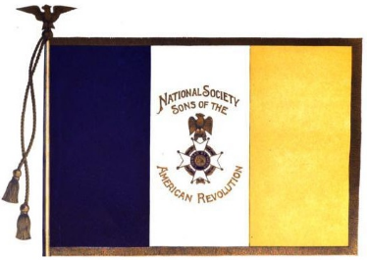

***Recruit New Members!*** The continued success of our Chapter relies on membership development and the mentoring of our new members. With the annual turnover of members, we need all Compatriots to help grow membership by recruiting Sons, Grandsons, Friends and civic-minded individuals interested in honoring our patriot ancestors and enjoying good fellowship.

***Call it a Birthday or Holiday Gift!!*** ***Compatriots*** and ***DAR Daughters*** can ***Grow Membership*** by enrolling ***Sons*** and ***Grandsons*** in the ***SAR***, along with wives, daughters, and granddaughters into the *Daughters of the American Revolution.* Remember,***“We hang together or we hang individually…Ben Franklin 1776.***

We thank our beloved ***DAR Patriot Daughters*** who continue to support our Chapter at meetings and events, and we sincerely appreciate their tireless efforts to help us grow by referring new SAR prospects. All Compatriots are encouraged to support *DAR* Chapters by attending their meetings, fundraising and patriotic events.

***Fellow Compatriots***, I look forward to seeing you at the ***March 19*** *meeting*! Please, join me in remembering our *Patriot Ancestors, Dear Departed Compatriots* and especially our nation’s Military and Veterans. ***God Bless You*** & ***God Bless the United States of America.***

***Yours in Patriotism*** **– *Robert E. Boggs, President 2019***

*** Hear Ye-Hear Ye…..Chapter Editorial***

***Don Lanman-Editor, State Officer & FMR Chapter President***

***~LIBERTAS ET PATRIA~***

***~LIBERTY & COUNTRY~***



An ***SAR Memorial Service*** is planned for ***Compatriot William Arthur Adams Jr,*** of Delray Beach at the ***March*** meeting. Compatriot Adams (90) who passed February 12 is survived by his wife of 69 years Mildred, niece Karen and great-niece Adel Adams.

Born on April 12, 1928, he was the oldest of 3 sons born to William and Gladys Adams of Kirkwood, MO. Following a semester at college, he joined the military to serve as a private in the military police occupation forces in Japan following WW II.

Following military service, he went on to *Washington University* to earn a Bachelor's Degree. Recalled during the *Korean War* he served as a Lieutenant. He went on to work for an oil company before starting a real estate development company.

Bill was a Founder and Chairman of a local real estate board and, served as the first President at a local YMCA for 6 years.  Bill also served as Lay reader at the *Episcopal Church*, both a *Chaplain* and *Compatriot* with the *Palm Beach Chapter Sons of the American Revolution*, and a life-long member with the Washington University Scholarship Fund.

A funeral mass was celebrated Friday, February 22, at St. Paul's Episcopal Church, followed by a military burial service at the South Florida National Cemetery.

***~In Heartfelt Comradeship & Patriotism******- D. Lanman, Editor***

***2019 Chapter Meeting Dates/Topics:***

**Visit** the ***SAR Palm Beach Chapter*** web site @ [www.sarpbchapter.org](http://www.sarpbchapter.org) for a meeting calendar, articles, pictures, and general information.

* **Jan. 15. 2019, Officer Installations, Recognition & Awards**
* **Feb. 19, Special Guest Speaker, *Thomas Jefferson***
* **Mar. 19, Special Guest Speaker, *Dr. Donald Gladney-Cyber Security***
* **April, 16, *Police & Law Enforcement Recognition Awards***
* **May, 21, *Firefighter & First Responder Recognition Awards***
* **Oct. 15, Special Guest Speaker**
* **Nov. 19, Special Guest Speaker**
* **Dec. 7, *Christmas-Holiday Musical***

***2019 Officers & Board Members:***

* ***President******Robert Boggs***
* ***Vice President******Thomas Hayes***
* ***Secretary,******FMR President Gary Green***
* ***Treasurer******Peter Johnston***
* ***Registrar******Robert Boggs***
* ***Chaplain******Father Sanford Sears***
* ***Registrar & Sgt. @ Arms Peter Miller***
* ***Historian,******FMR President Samuel “Buddy” Miller***
* ***Officer @ Large,******FMR President Greg Parkinson***
* ***Patriot Newsletter Editor,******FMR President Donald Lanman***

***~Feature Article~***

***Don’t Get Hacked!***

***Compiled-Edited-Written by Don Lanman, State Officer & FMR Palm Beach Chapter President***

### *Personal Cyber Security Risks, Planning & Tips…*

Everyone wants to feel safe and secure when they are at home with their doors locked and the alarm system activated. They want to know that they are protected from danger. Today, however, the Internet has added another dimension to the world of individual safety and security.

The Internet has taken us from the physical world, where fire, flood, and earthquakes are the typical causes of catastrophic damage, into the digital world, where identity theft, ransomware, and computer viruses have the potential to be just as destructive.

It is no longer sufficient to simply lock your doors and turn on the alarm system. Today, your personal information is at risk from criminals who can attack at any time. This means your information needs to be protected, locked up, and secured with an alarm—just like your home.

This article is designed to help you accomplish the following.

* ***Assess your cyber-risk level***
* ***Understand the different types of cyber risks***
* ***Learn practical strategies to improve your security while online***
* ***Software solutions & services to assist with loss prevention & post-loss responses***
* ***Understand the cyber-insurance coverages available today***

## *~What’s Your Risk Level?*

Cyber-crime is a massive problem. According industry experts $450 billion in global economic losses were recorded in 2016. The Equifax data breach of 2017 exposed over 147 million Social Security numbers, and there were over 1,500 other recorded breaches in 2017. Everyone has the potential of being a victim of cyber-crime, but there are factors that can cause your risk level to increase. Some of those factors are the following.

* ***Your level of wealth***
* ***The number of connected devices you have in your home***
* ***Your level of fame/celebrity***
* ***If you have domestic employees***
* ***The number of trades you make per year in the stock market***
* ***If you run a business out of your home***

The more risk factors you have, the higher your level of risk is and the more you should consider taking action to protect yourself. Once you have an understanding of your risk level, you can determine the actions you need to take to mitigate the risk of becoming a victim of cyber-crime. A self-assessment is a good start, but having a cyber-security professional to work with can be a viable option as well.

## *~Cyber Risk Overview:*

The average household today has 10 to 20 Internet-enabled devices in the home.Laptops, smart phones, Internet TVs, security systems, thermostats, and other connected devices are all part of the intricate web of technology that is expanding exponentially in homes across the United States.

These devices hold valuable information, such as passwords, dates of birth, and travel schedules. They may control critical functions in your home, such as temperature control. Each of these devices connects to the Internet to derive value for the user but in so doing also creates an entry point for nefarious hackers to access the devices and the information they hold.

Once criminal hackers gain access to these devices, they can easily transfer funds from bank accounts, unlock doors that use smart locks, and install harmful ransomware on computers to hold them hostage. Criminal hackers use many different strategies to cause physical, emotional, or financial harm. The following are some of those strategies.

* ***Email phishing.*** *This strategy involves email scams looking to dupe email recipients into clicking a link that can install harmful software onto the recipient's computer.*
* ***Identity theft.*** *Criminals use personally identifying information (e.g., address, name, birth date, Social Security number, etc.) to sign up for credit cards, open bank accounts, or initiate other transactions using your personal information.*
* ***Cyber extortion.*** *Hackers coerce victims to pay large sums of money when they take control of their website, servers, computers, or other digital assets and hold them hostage until their demands are met.*
* ***Cyber bullying.*** *Cyber bullying includes sending, posting, or sharing negative, harmful, false, or mean content about someone else. It can include sharing personal or private information about someone else causing embarrassment or humiliation.*
* ***Unauthorized payment or transfer.*** *This strategy involves hackers gaining access to your banking and credit card information and illicitly transferring money or making fraudulent purchases.*
* ***Social engineering.*** *Cyber criminals use deceptive tactics to trick people into giving them access to sensitive information through phishing scams, pretexting, and baiting.*

## *~Practical Cyber-Protection Strategies:*

Everyone is at risk of being affected by cyber-crime, whether it is a direct or indirect attack. There is no surefire solution that will guarantee your data is secure, but there are strategies you can implement to make it more difficult for hackers to gain access to your information.

The list below offers some of the strategies you can implement to improve your security on the Internet.

* ***Protect your Wi-Fi network at home with a strong password, one that contains more than six digits (longer passwords are more secure) and uses special characters (i.e., $%$#@), lowercase and uppercase letters, and numbers.***
* ***Change your passwords every 6 months.***
* ***Use passphrases instead of passwords. A passphrase is a string of words used to control access to a system. They are easier to remember and could be more secure than passwords (Example: JohnisSIttingon2Largechairs).***
* ***Set up a guest network at home with a separate password for guests to use rather than giving them the password to your primary network.***
* ***Use multifactor authentication whenever possible. This is a security protocol that uses a secondary device to verify you are whom you say you are. Verification codes are sent via text or email for you to enter during the sign-in process.***
* ***Store your passwords in a secure location, such as a password manager.*** [***LastPass.com***](http://lastpass.com/) ***and***[***Dashlane.com***](http://dashlane.com/) ***are websites that store your passwords to improve your security.***
* ***Use one network for connected appliances and gadgets, and a separate network for your computers, tablets, and phones. This way, if someone hacks your device network, they will not be able to access your accounts.***
* ***Download software updates as soon as they are available.***

## *~Software & Service Solutions:*

In addition to the practical steps you can take to protect yourself, there are software solutions and services to assist you with building your cyber-protection strategy. These solutions can help you detect suspicious intrusions into your network as well as monitor for fraudulent activity.

Here are examples of software solutions and service providers who specialize in working with individuals to help them with cyber security.

***~Software Solutions Options:***

* [***CyberScout.com***](http://cyberscout.com/)—CyberScout offers a full suite of services to improve your cyber security, including identity management tools, credit monitoring services, breach response services, and data privacy consulting.
* [***Norton.com***](https://us.norton.com/)—Norton provides software that identifies viruses and malware and blocks them from causing damage. It also offers other related services including a router device that monitors and protects everything within a connected home network.

***~Cyber-Risk Services Resources:***

* [***Rubica.com***](https://rubica.com/)—Rubica.com developed a technology for your tablets, smartphones, and computers that helps you avoid being the victim of a cyber-crime.
* [***K2Intelligence.com***](http://k2intelligence.com/)—K2 Intelligence is a full-service cyber-defense consultancy that brings enterprise-level cyber-security solutions to the private client and family office markets.

## *~Cyber Insurance Options:*

Even with the best security practices in place, and all of the practical risk mitigation strategies being utilized, there will always be a risk of loss, and as a result there are insurance companies offering various types of coverage.

Cyber insurance not only offers financial protection when a loss occurs, but it also may include complimentary or discounted access to software tools and services.

Today, a handful of insurance companies offer cyber-insurance policies for individuals to purchase. Some are in the midst of developing a solution, and others are in the planning stages.

Many companies offer identity theft coverage as part of their home owners’ policies, but that coverage falls short of covering most of the cyber-crimes happening today. Although the cyber-insurance products are relatively new, they are broad in the coverages offered.

**The following represents a list of coverage highlights from a few cyber-insurance products on the market:**

| **Coverage\*** | **Description** |
| --- | --- |
| **Cyber Extortion and Ransomware** | Provides reimbursement for money paid by an insured to terminate a cyber-extortion threat. Insureds have access to expert cyber consultants to assist if a criminal demands a ransom in exchange for the insured's data. |
| **Cyber Bullying** | Covers related costs as a result of an insured or family member being victimized by cyber bullying. Related expenses include professional digital forensic analysis to aid in prosecution, professional cyber-security consultant services, loss of salary due to wrongful termination, public relations service fees, and temporary relocation. |
| **Fraudulent Transfers** | Provides protection against the loss of funds stolen from an account due to a cyber-attack. |
| **Social Engineering** | Provides coverage if your authorized account user—such as a personal assistant or family office manager—is deceived into wiring money from your account. |
| **Data Restoration** | Provides coverage for the cost of a professional to reinstall damaged software, remove malicious code, reconfigure your device or system, and replace electronic data that has been lost or corrupted. |
| **Crisis Management / Reputational Injury** | Provides reimbursement and access to crisis management consultants to protect an insured from reputational harm. |
| **Cyber Disruption** | Provides support in dealing with a cyber-attack that prohibits the clients from accessing their home or interrupts their incidental business operations in their home. |

***\*Coverages above are representative of those found in cyber-insurance policies offered by AIG Private Client Group, Chubb Personal Risk Services, and PURE Insurance. Coverage limit options vary from company to company with options ranging from $50,000 to $1 million per occurrence. Prices range from $400 to $2,000 per year depending on the coverage limits selected, the coverage options included, and the company offering the coverage.***

## *~Take Control & Protect Yourself from Cyber-Crime…*

While Insurance represents a tool that can be used to help protect your wealth from cyber risk. Adequate coverage should be obtained to match the maximum potential financial loss.

However, it is also important for you to take control and use the practical strategies, software products, and services to protect themselves from cyber risks, and to develop a personal protection strategy and a plan of action in the event of a cyber security crime, hack or breach.

**###**

***~February Meeting & Event Pictures~***

***President Boggs inducts Compatriots, Mason Stowell* & *Michael DuPont***.

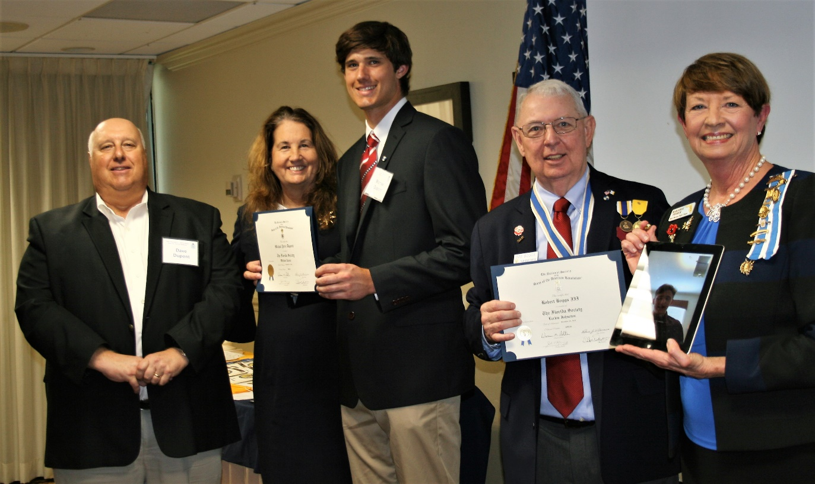

***Compatriot Stowell inducted electronically from***

***Colorado with his Aunt, HMF DAR Regent Marjorie Ferrer***

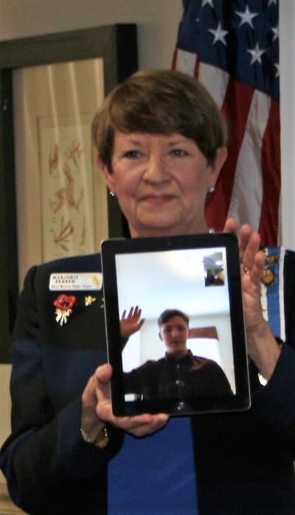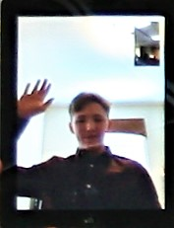

***President Thomas Jefferson (*John Stewart) discusses the Louisiana Purchase**

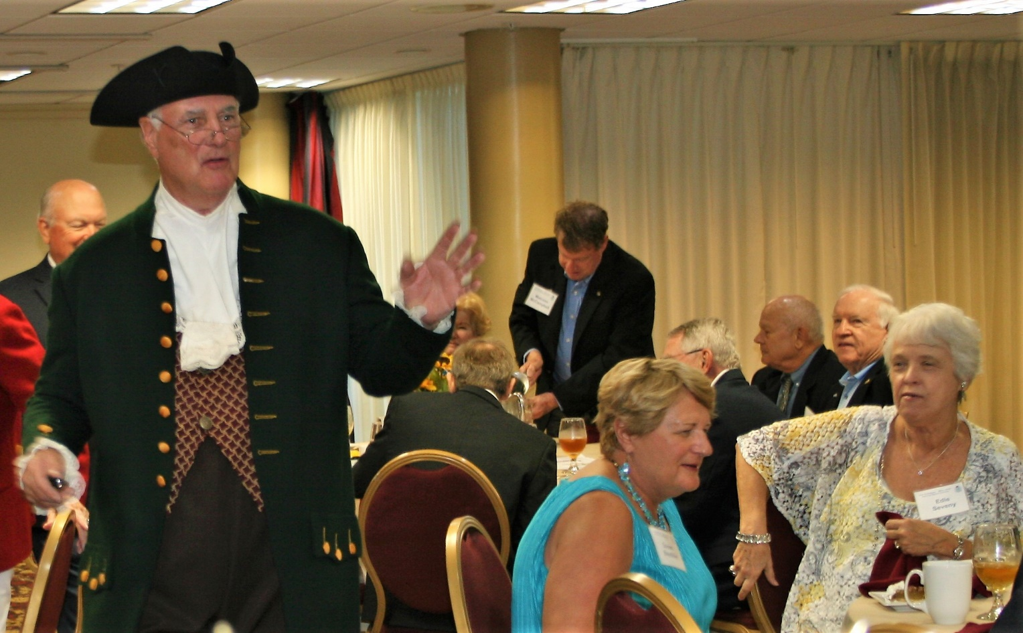

***President Boggs presents E Pluribus Unum Coin & Appreciation Certificate***

***To Compatriot & FMR Chapter President Stewart (aka Jefferson)***

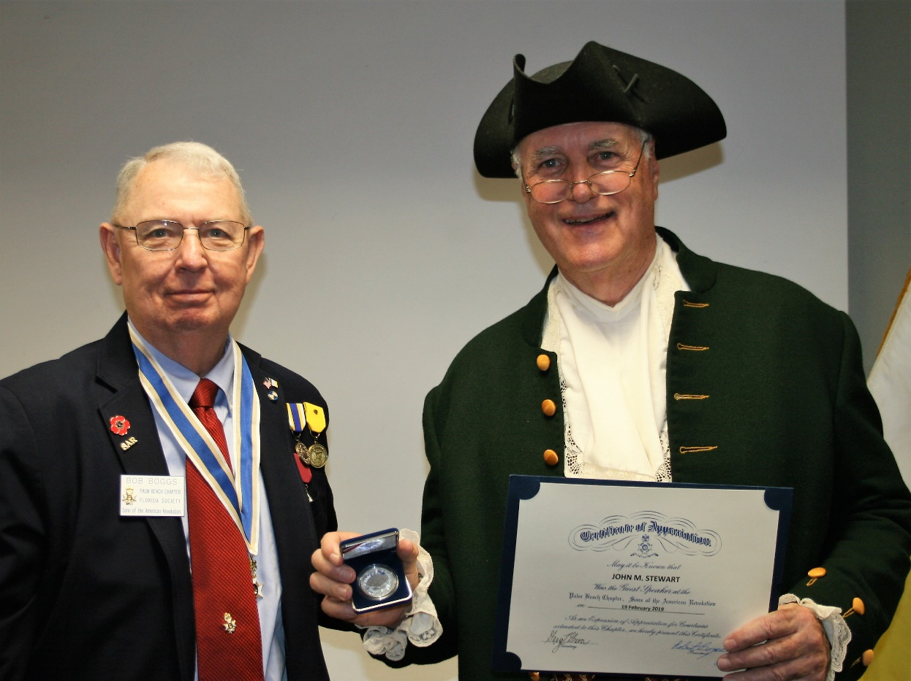

***Chaplain Father Sanford Sears delivers heartfelt Eulogy for***

***Compatriot Kenneth Ray La Voy Jr.***

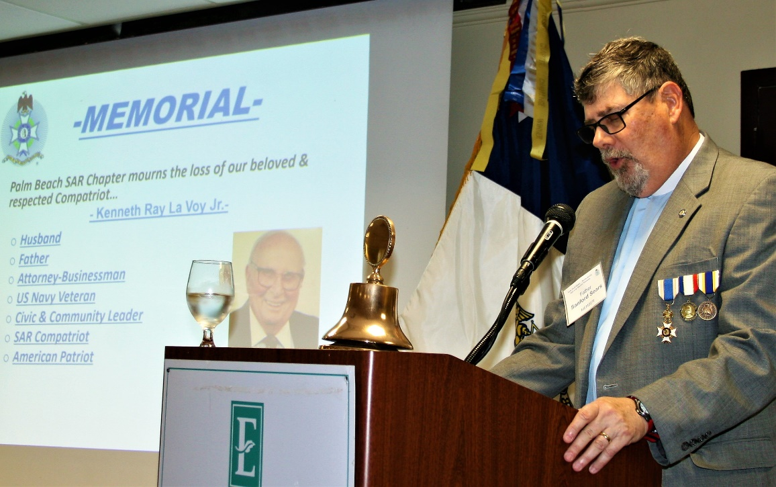

***NSSAR Deputy Inspector General & Former State & Chapter President Raymond Wess delivers Eulogy remarks for Compatriot General Irzyk*** 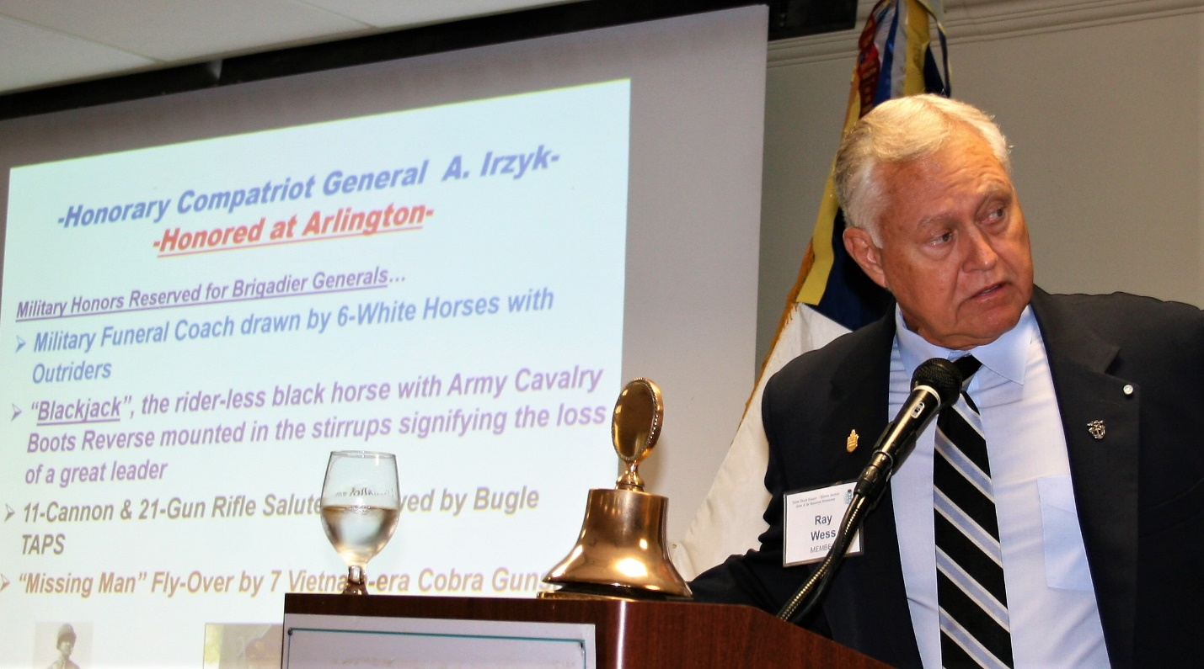

***Palm Beach SAR Chapter Officers Lanman, Johnston & Parkinson***

***Attend Services Honoring WW 2 Naval Veteran Ralph A. Mercurio***



***President Thomas Jefferson mingles with Guests***

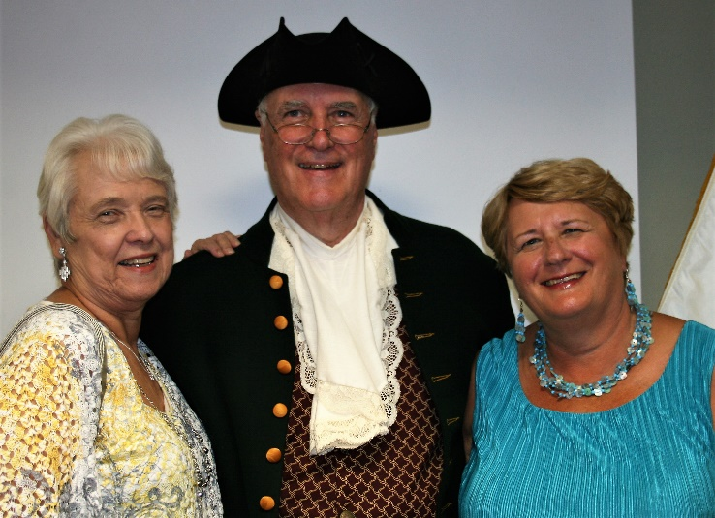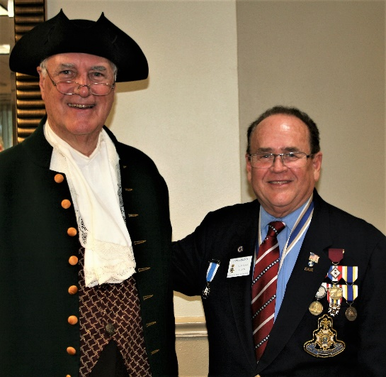

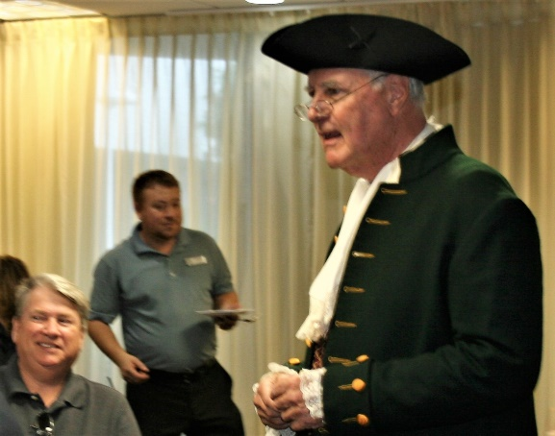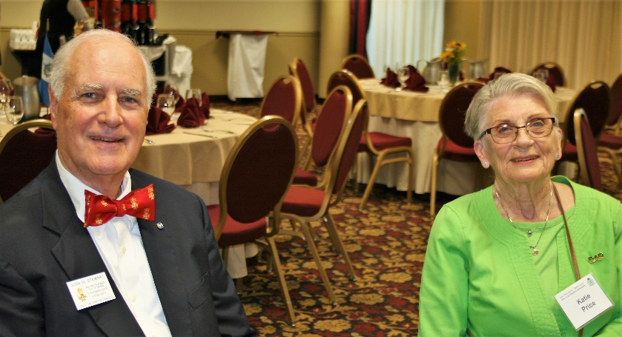

***Newly Inducted Compatriot DuPont & Proud Family***

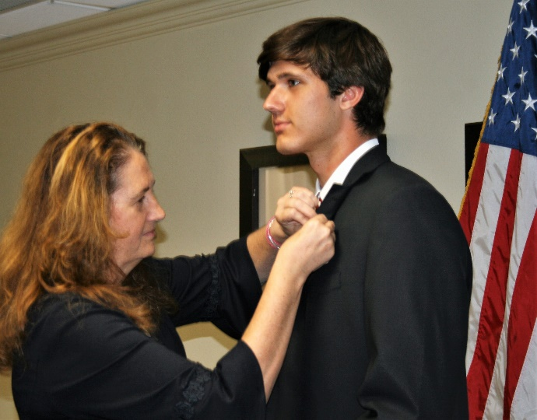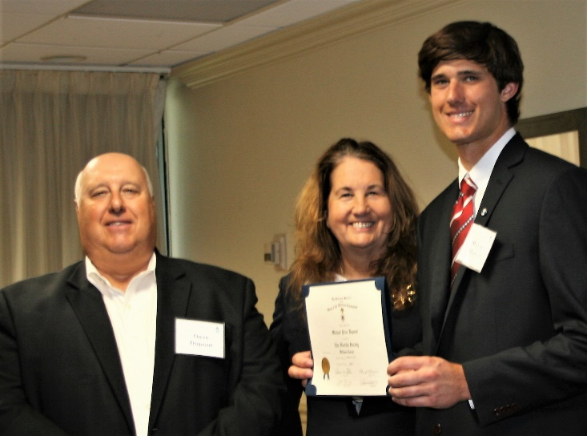

***Compatriots, DAR Daughters & Guests in Fellowship***

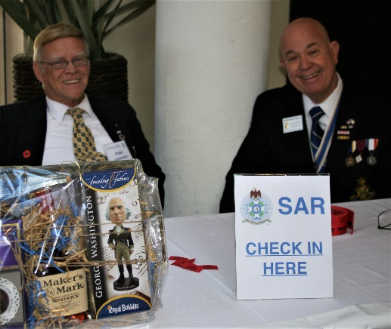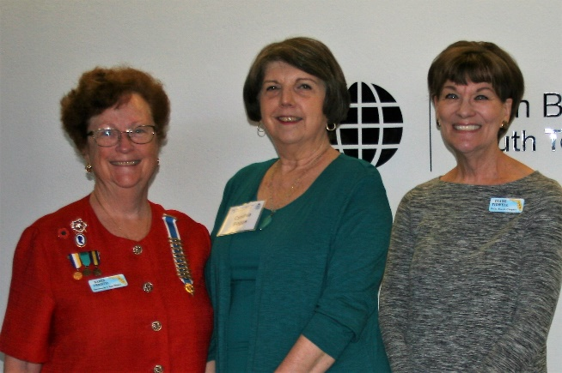

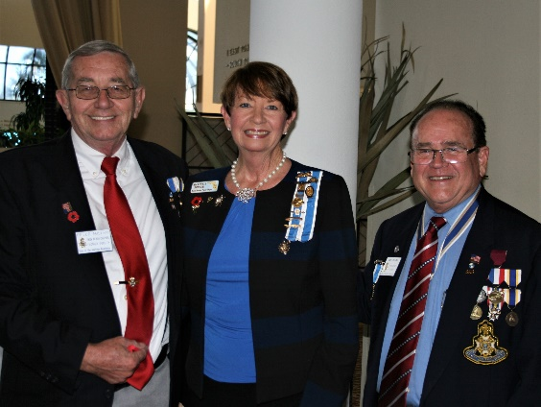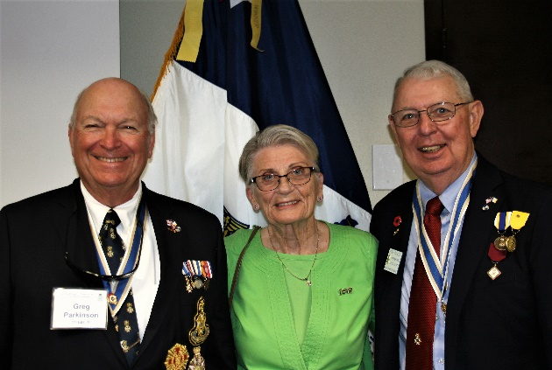

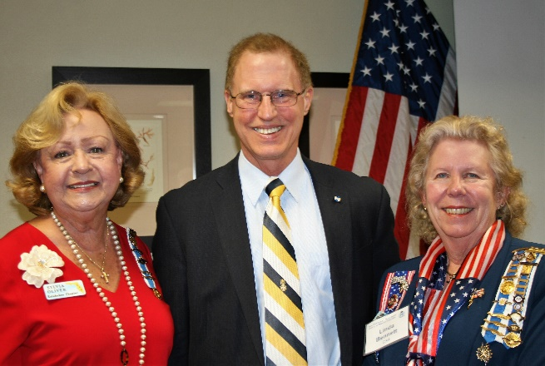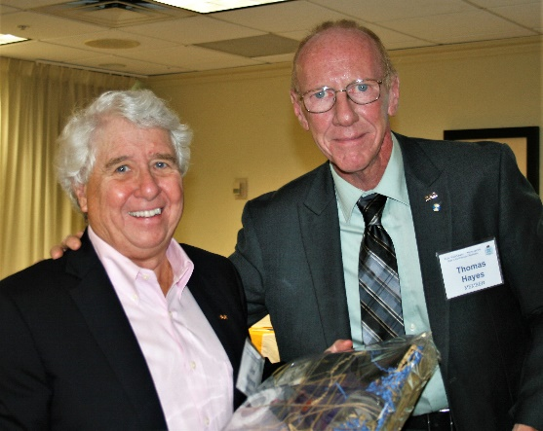

***State Officer & FMR Chapter President Lanman Presents***

***“Heroines of the Revolution” to Spirit of Liberty DAR***

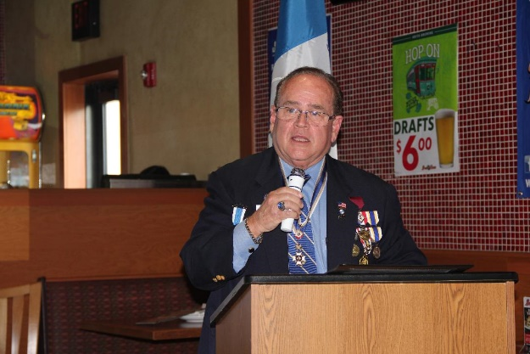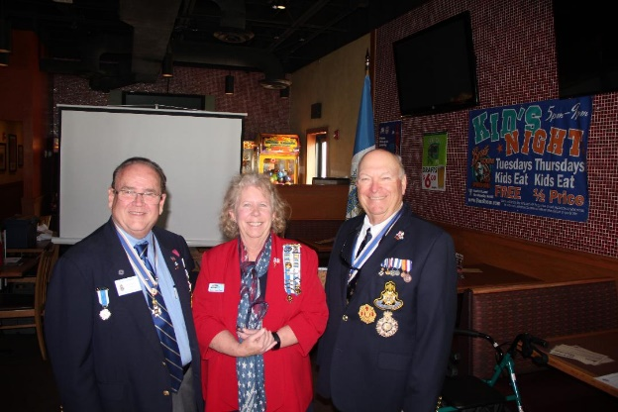

***Support Youth Programs, Join the President’s Brigade Now!***

The *Palm Beach Chapter* provides Scholarships to colleges and universities like the ***Palm Beach Atlantic University***. These colleges educate our youth on the values of *Patriotism*, *God* and *Country* and help develop students with character for the leaders of tomorrow.

The Palm Beach Chapter honors and expresses its sincere appreciation to the many *Compatriots* of the ***President’s Brigade***.

The dedicated members of the ***President’s Brigade*** donate ***“Extra Dollars”*** in support of the Chapter’s many youth programs, scholarships, civic activities, award certificates, police/firefighter/EMT medals, veterans’ projects, and related community civic programs.

***Please Help*** increase the scholarships this year *by* donating a few dollars to the ***Presidents Brigade*** in support of these ***“Students of Character”.***

***~JOIN THE 2019 CHAPTER PRESIDENTS BRIGADE ~***

***~Honored Presidents Brigade Members*~**

* **Bronze Level: $25-$99:**

***M. Anderson, J. Blackburn, B. Boggs, J. Chataing, A. Cass, C. Coldwell, M. Curry, S. Curry, J. Dorsey, W. Davis, F. Devitt, J. Harper, J. Kane, L. Lassitter, P. Miller, S. Miller, J. Mayne, G. Parkinson, H. Oyer, J. Porter, S. Sears, A. Shea, W. Told, J. Wearn, L Watkins***

* **Silver Level: $100-$199:**

***J. Curry, D. Coldwell, R. Culpepper, T. Friend, G. Green, F. Green, A. Griswold, W. Johnson, W. Meakin, S. McWhorter***

* **Gold Level: $200-$499:**

***S. Barber, R. Banta , E. Buckley, J. Curry, S. Hitt, W. Meakin, J. Wynns***

* **Platinum Level: $500+**

1. ***Dreyfoos, K. Christie, J. Damron-Fritz, D. Lanman, B. Tidwell***

***Thank You for Supporting Chapter Youth & Civic Programs***

***Chapter Committees, Chairs & Members:***

***Fellow Compatriots…..***The Chapter expresses its sincere appreciation to those members who volunteer to serve on our committees and projects. As you can see a few Compatriots are serving on multiple committees and could use some extra support! **Just** choose any committee of interest.

It doesn’t take much time and is a major help with our many civic and youth initiatives. **Support your Chapter, call Bob Boggs (561-241-3128)** **Today** to lend a hand on the following committees…

* ***2020 Officer Nominations -Chapter Members***
* ***JROTC & Boy Scouts -Barber, Tidwell***
* ***Law Enforcement-Fire Safety -Parkinson, Green***
* ***Veterans Affairs -Lanman, Curry***
* ***Newsletter/Publicity -Lanman***
* ***Knight Essay/Rumbaugh Oration -Boggs, Tidwell***
* ***American History Teacher -Boggs, Hayes***
* ***Medals/Awards -Lanman, Boggs***
* ***DAR-CAR Liaison -Tidwell, Lanman, Parkinson***
* ***Speakers Bureau -Lanman, Boggs, Hayes***
* ***Audit -Coldwell, Boggs, Johnston***
* ***Flag Certificates -Miller, Hayes, Parkinson***
* ***Membership Development/Mentor -Hayes, Boggs, Lanman, Green***
* ***Liberty Tree -Hayes, Miller, Parkinson***
* ***Patriot Bios -Miller, Hayes, Green***
* ***Web Site-Facebook/Social Media -Anderson, Lanman***

***SAR Chapter, State & National Events:***

* ***March 23: New England District Meeting***
* ***March 22-23: DAR Spring Conference, Orlando***
* ***March 30: 240th Anniversary Battle of Thomas Creek, Jacksonville***
* ***May 10-11: Spring Board of Management Annual Meeting, Orlando***
* ***July 5-10 NSSAR 129th National Congress, Costa Mesa, CA.*** [***https://www.sar.org/annual-sar-congress***](https://www.sar.org/annual-sar-congress)
* ***August 9: Atlantic Middle States Association Conference***
* ***October 4-6: Fall Board of Management Meeting-Orlando***

***Join Chapter Members at all SAR & DAR events! Visit NSSAR/FLSSAR websites for details.***

***Palm Beach Chapter SAR Store***

**Palm Beach Chapter Commemorative Coin $10!**

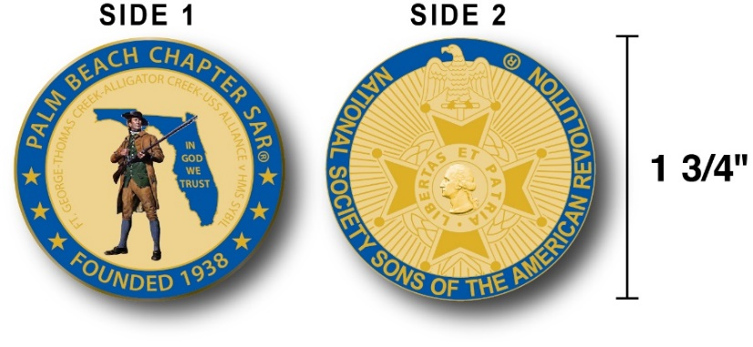

The Chapter’s ***Commemorative Coin*** celebrates the founding of the ***Palm Beach Chapter in 1938*** and honors its 80+ years of historic, patriotic, and civic service in Palm Beach County and Florida.

This beautiful collector’s coin is highlighted in ***George Washington*** ***Military Blue*** colors on a stunning ***Gold*** background personalized with the Chapter’s founding date and a ***Patriot* *Minuteman*** guarding *Florida* with the *State* motto of ***"In God We Trust”.***

This collector’s coin includes an inscription listing the four major Revolutionary War battles waged in ***Florida*** including the battles of ***Ft. George-Pensacola, Thomas Creek Massacre, Alligator Creek Battle,*** and the ***Last Naval Battle*** of the Revolutionary War between the mighty ***USS Alliance*** vs. the ***British HMS Sybil.*** The reverse side displays the national ***Sons of the American Revolution,*** ***Cross of Malta***.  The Chapter provides these collector coins for just $10.

***Classy SAR Lapel Pins $10:***



Wear the ***Gold*** ***SAR*** ***Lapel Pin*** on your clothing beside your ***SAR Rosette***. The unique *SAR Lapel Pin* is part of a national branding program to help promote the *National Society of the Sons of the American Revolution* and stimulate new memberships!

The ***SAR Gold*** lapel pin along with the ***SAR Rosette*** are recognizable public symbols of the SAR providing Compatriots recognition as an honored members of a great Patriotic society, and may spark conversations about ***SAR*** that leads to a new member. Wear your pin with pride Today for just $10.

***~Compatriot Sponsored Promotions~***

**Compatriot sponsored newsletter Ads are important to the Chapter as they represent additional funds in support of Chapter projects including; *Scholarships, Boy Scout & JROTC medals, Rumbaugh & Knight Essay Youth contests, Police-Firefighter-EMT medals, Americanism & community civic programs!***

***Support your Chapter…sponsor an Ad for 8 issues at a modest cost:***

**Business Card $50, Half Page $100, Full Page $250.**

**Your promotional Ad donation will also qualify you for membership in the Chapter’s *Presidents Brigade*.**

***Call Don Lanman 561-315-5073 for information.***

***CHAPTER SUPPORT PROMOTIONS…***

***~COMPATRIOT ALEXANDER DREYFOOS***

***~AUTHOR/PHOTOGRPHER/VETERAN/PATRIOT***

***~COMPATRIOT SONNY BARBER***

***~HISTORIAN/AUTHOR/VETERAN/PATRIOT***

***~GARCILASO DE LA VEGA, DAR CHAPTER***

***~DAUGHTERS OF THE AMERICAN REVOLUTION***

***~JAMESTOWN SOCIETY***

***~International Lineage Society***

*~TWO GREAT BOOKS-ONE GREAT MAN~*

***-Alexander W. Dreyfoos-***



***-A PHOTOGRAPHIC ODYSSEY- -PASSION & PURPOSE-***

***Compatriot Alexander W Dreyfoos, Jr.*** an honored member of the *Palm Beach Chapter Sons of the American Revolution*, noted American entrepreneur, and philanthropist has published two remarkable books that should be on every bookshelf. **Book sales** **proceeds** **donated to local West Palm Beach charities!**

* ***Passion & Purpose*** chronicles a remarkable lifetime of passion with photography, his business, inventions and philanthropic ventures, as well as his adventures above and below the water. **$29.95.**
* ***A Photographic Odyssey*** is a remarkable collection of hundreds of stunning pictures from 100,000 photos taken by Alex around the world and bound in an elegant 15” by 10” glossy photographic book. You will travel with Alex around the world, above and below the water, to forests, jungles, glaciers, and deserts in the exotic locals of Papua New Guinea, Bhutan, Nepal, China, Japan, and Tibet. The subjects are very divergent contrasting palaces and temples with the vulnerability of people, animals, and exotic scenery. **$60.00.**
* **Support your Chapter & local charities! Get both books, *Passion & Purpose & A Photographic Odyssey,* just $71.96 @ kravis.org/books or Call 561-651-4329.**

***-Alexander W. Dreyfoos-***

***Graduating from MIT and Harvard Business School, Alex founded Photo Electronics Corporation (PCS), specializing in photography and video production. Over the decades, Alex earned 10 US patents and invented the Video Color Negative Analyzer for motion pictures earning him an Academy Award for technical achievement.Many inventions, developed by PCS, are on permanent display at the Smithsonian Institution. Locally Alex also owned television station WPEC TV-12, the CBS affiliate in West Palm Beach. Alex’s many philanthropic achievements include founding the Palm Beach County Cultural Council, the Raymond F. Kravis Center for the Performing Arts and gifting a million dollars to the Dreyfoos School of the Arts. Alex also donated a million dollars each to the Palm Beach County biomedical research campus of the Scripps Research Institute and the local Max Planck Florida Foundation for Neuroscience in Jupiter, Florida.***

***HISTORICAL MYSTERY SERIES FROM THE REVOLUTIONARY WAR~ACROSS TIME***



***Follow Kay Telfair across time beginning with Crossed & Found followed by Gold Hush & Stone-Walled….***

***Kay is a normal young teen—normal if that means being unusually curious and having an uncanny knack for putting herself in dangerous situations, which stresses her parents and often tests the relationship with best friend Anna.***

***The series follows Kay across two intrigue-filled summers on adventures involving events in American history. Join Kay’s journey of adventure steeped in American History through three books that excite all ages. At*** [***amazon.com***](http://amazon.com)***, Barnes & Noble or Chapter meetings. (See book summaries following page)***

***SAR Palm Beach Chapter Compatriot/Author Sonny Barber developed an interest in American history at an early age, reading and collecting newspapers, magazines and other materials on historic U.S. and world events. He’s coupled that interest with his fiction writing to create a modern-day “mystery history” Series perfect for Preteens to Adults.***

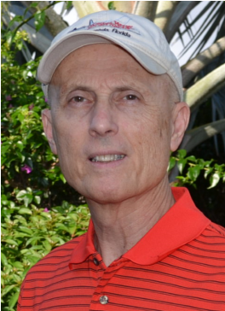

***~Crossed & Found~***

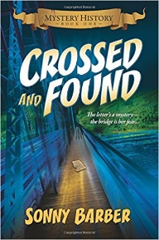

**Thirteen-year-old Kay Telfair believes her life is over when she moves with her family a thousand miles to their new home near the Delaware River in New Jersey. But her life takes an unexpected turn when she meets Anna and discovers a two-centuries-old letter--a letter that could change American history. Before she unravels the letter's mystery, Kay stumbles headlong into an adventure confronting fears she'd never experienced, stretching the limits of her friendship with Anna, and forcing a test of Kay's physical strength that could save her life.**

***~Gold Hush~***



**“I’m avoiding any activity that involves excitement…I’ve learned my lesson.” After an adventure-filled June, all Kay Telfair wants is a quiet vacation in Maine with her family and best friend Anna—no drama, no stress. But the thirteen-year-old’s hopes for a tranquil August stay in the village of Prospect Harbor soon fade when the girls compete for the attention of a young boy and Kay makes a startling discovery—a discovery that sends the three teens on a dangerous quest. Ignoring advice—and menacing threats from others—they continue their pursuit, drawing them deeper into a perilous mystery, deeper than Kay ever could have imagined.**

***~Stonewalled~***

[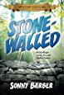](https://www.amazon.com/Stonewalled-Mystery-History-Book-Three/dp/1519351291/ref=pd_bxgy_14_img_3?_encoding=UTF8&psc=1&refRID=75QVZ72QHQ8A2W2F3RK1)

**Kay stared at the gray line of stone walls. “They won’t be too upset to see these knocked down...” A mystery that threatens the relationship with best friend Anna, a battle with Mother Nature at her worst, and the discovery of a tragic secret—not exactly what fourteen-year-old Kay Telfair was looking for in a summer getaway. But that’s what confronts the young teen while helping the owners of Windcrest Farm find a way to stop destruction of nearby farmland and its three-hundred-year-old stone walls. Vacationing with her family and Anna at Windcrest in the quiet, coastal village of Little Compton, Rhode Island, the young teen soon discovers her goal will not be easy. Kay’s prospects for helping preserve the valuable land and stone walls look much better after a surprise visit by a boy from her past. With his help, she pours all her energy and passion into the quest, searching for answers in New England’s Native American and colonial history and learning some important lessons about perseverance and friendship.**



*~Garcilaso De La Vega Chapter, NSDAR~*

***Lake Worth, Florida***

*~Michelle Robertson, Regent~*

*~Karen Christie, Registrar~*

Phone; 561-236-2460-Email; [IMC4U4@AOL.com](mailto:IMC4U4@AOL.com)

Chapter Email: [GarcilasodelaVegaDAR@gmail.com](mailto:GarcilasodelaVegaDAR@gmail.com)

Visit us on ***Facebook*** @ <https://www.facebook.com/LWDAR>

***JAMESTOWN SOCIETY***

