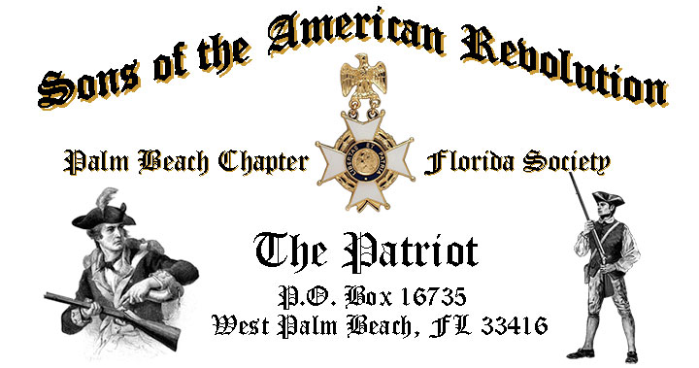

***Volume 23 May 2017 Number 05***

***Join us for the annual “Firefighters-EMS First Responder Recognition Ceremony” to honor our local first responder professionals***, *Tuesday* **May 16, 12:00 Noon** @ the Embassy Suites 1601 Belvedere Road, WPB! "***RSVP Today*** for this popular event!

***May Meeting Highlights:***

* ***Firefighters-EMS First Responder Recognition Ceremony!***
* ***New Compatriot Induction Ceremony!***
* ***Buffet******Lunch***, Desserts & Beverages, **$28** per person **Check/Cash** at the door!
* ***Reservations*** **required,** **RSVP**, Don Lanman **(561)-315-5073!**
* **Family, Friends & Guests** are always ***Welcome***!

***Newsletter Content:***

* **President’s** Message
* **2017** Chapter Meeting Dates &Topics
* **Officers** & Board Members
* ***President’s*** *Brigade* Financial Supporters
* **Committees**, Chairmen & Members
* **National**/**State** Society News & Events
* **Feature Articles:**  ***The Immortal 400! Washington’s Elite Regiment!***
* **Chapter** **April** Meeting Pictures
* **Compatriot** Sponsored Promotions

**President’s Message:**

***Fellow Compatriots & Friends…***

***Heroes running into Danger while others are running out!*** Join us for the annual ***“Firefighters-EMS Recognition Ceremony”*** honoring our local first responders. The meeting will include a new ***Compatriot Induction Ceremony*** and honored with a special ***Color Guard*** presentation by ***Boca Raton Community High School Naval JROTC Cadets*.**

[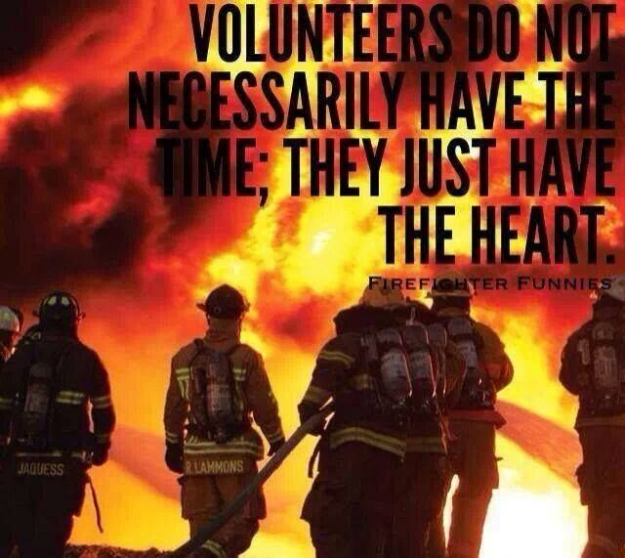](https://www.google.com/url?sa=i&rct=j&q=&esrc=s&source=images&cd=&cad=rja&uact=8&ved=0ahUKEwjpu_7QmtTTAhWISyYKHX2iBYQQjRwIBw&url=https://www.pinterest.com/smsstudios/firefighter-inspired-motivation/&psig=AFQjCNFe-QzCi1sX1hq9YXMkLZ4VRhA6zQ&ust=1493917430593864)[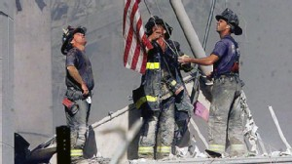](https://www.google.com/url?sa=i&rct=j&q=&esrc=s&source=images&cd=&cad=rja&uact=8&ved=0ahUKEwiB0-Cxm9TTAhUHbiYKHZZtAvQQjRwIBw&url=http://www.patriotfiles.com/forum/showthread.php?t%3D968365&psig=AFQjCNFe-QzCi1sX1hq9YXMkLZ4VRhA6zQ&ust=1493917430593864)

The April meeting was exceptional including our annual ***Thin Blue Line* *Recognition Ceremony*** honoring six local law enforcement professionals with *Commendation Medals* including *PBSO* *Deputy Chief Mike Gauger*, and featuring a demonstration by the ***Palm Beach County Sheriff’s K-9 Unit!***

We honored *Compatriot Bob Boggs* with the *SAR* *Military Service Medal* and welcomed him into the Palm Beach Chapter’s **“*Band of Brothers”***.

The Chapter recognized *Compatriots Lanman, Tidwell, Curry* and *Van Otteren* for serving as guardians for 80 WW 2 and Korea veterans on the April 8th *Veterans Honor Flight* to tour Washington DC military monuments.

Compatriots are encouraged to attend the presentation of the prestigious ***SAR Patriot Medal*** to the *“Chapter’s Own”* **Compatriot Edward S. Buckley IV** at the State BOM on May 20 in Orlando. *Compatriot Buckley*, a WW 2 Veteran, has served the SAR for over 20 years and as *Chapter President 2006-2007*.

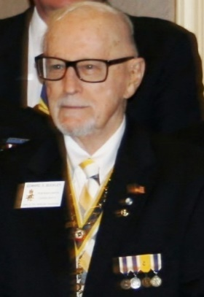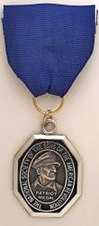

*Chapter Past President Ray Wess* will conclude his successful tenure as *President of the Florida State Society of the Sons of the American Revolution* on May 20 at the Board of Management meeting in Orlando.

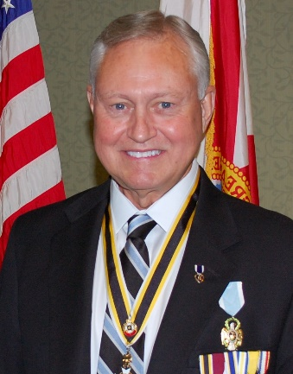

Ray’s accomplishments as State President include the ***Vietnam Veterans Welcome Home Ceremony*** and a comprehensive strategic plan for the State Society. His service reflects countless years of selfless dedication to the SAR and diligent promotion of the values of our Patriot ancestors. While Ray’s achievement represent a personal honor, it is also a reflection on his character and the quality of our Chapter members. Well Done Ray!

***May*** is ***Military Appreciation Month*** and represents a very special opportunity for all Americans’ to honor Veterans from *Bunker Hill* to *Bagdad.*

Military appreciation month events include **Loyalty Day 5/1, National Day of Prayer 5/4, Victory in Europe/Japan (VE-VJ) Day 5/8, Military Spouse Day 5/12, Children of Fallen Patriots Day 5/13, Mother’s Day 5/14, Armed Forces Day 5/20,**and **Memorial Day 5/29.**

***Memorial Day*** is an opportunity to both show our respect for and to say "*Thank You*" to Veterans, active service members and their supportive families and to the memory of those who have sacrificed for this nation at the ***Altar of Freedom***.

All are cordially invited to join other ***Palm Beach SAR Chapter Compatriots*** to present an ***SAR Honor Wreath*** at the 12th Annual ***Forgotten Soldiers Day to Remember Ceremony*** May 29 @ 11:30 AM @ the *Palm Beach Memorial Park* (3691 Seacrest BL) Lantana.

Our Chapter is a historic supporter of the Nation’s Veterans, with over 15% of our members serving from WW 2 to Iraq. We encourage all Compatriots, with military service, to provide a copy of their DD-214 to be recognized with the *SAR Military Service Medal* and join the Chapter’s *“Band of Brothers*”.

*Past President Jim Blackburn*, *SAR Patriot Medal* recipient and Korean war veteran, will join the May 20 veterans ***Southeast Florida Honor Flight*** to DC. Compatriots are invited to join fellow ***Chapter***members to greet *Compatriot Blackburn* and the 80 other veteransat the returning ***Veterans Honor Flight*** ceremony at the *West Palm Beach International Airport* level 2, concourse A/B on May 20 at 7:20 PM.

A custom ***Palm Beach Chapter Commemorative Challenge Coin*** is now available in honor of the Chapter’s 80th year. The coin notes the four major revolutionary war battles waged in *Florida* with an illustration of a Minuteman standing guard over *Florida* and the state moto of ***“In God We Trust.”***

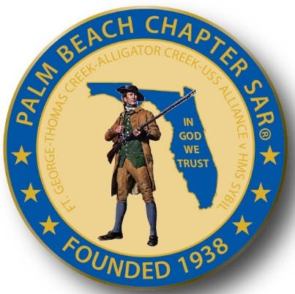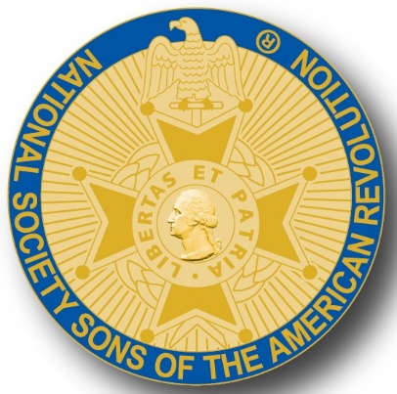

These beautiful Commemorative coins, used as mementos for chapter guests and patriotic occasions, are also available for purchase at just $10 each.

Major Chapter goal continue to be membership development and the mentoring of new members. With the natural turnover of members, we need all Compatriots to help grow membership with civic-minded individuals interested in honoring our patriot ancestors and enjoying good fellowship.

Take action to enroll Sons and Grandsons, invite friends to join and encourage wives, daughters, and granddaughters to join the *DAR* and *Chapter Women’s Auxiliary*.

Another important goal is expanding our relationships and joint events with all of the Palm Beach *DAR Chapters*. We welcome our DAR Patriot Daughters to all Chapter meetings and events, and sincerely appreciate their new member referrals and ongoing support.

***Committee Members Needed!*** The Chapter desperately needs committee members to support our diverse programs including Veterans Programs, Newsletter, Publicity, Boy Scouts, JROTC, Rumbaugh Historical Oration and Knight Essay Contests, Police-Firefighters-EMS Service Awards, social media Website Support and Fundraising/Endowment Programs.

***Raffle*** **“Gift Baskets”** are needed for our meeting for fundraising to support our many *Youth* programs. Basket donors are acknowledged at meetings, included in the newsletter, and recognized in the Chapter’s *Presidents Brigade*.

Compatriots, the hotel requires a minimum number of guests to cover the room, food, and services, so when attendance is low or there are no shows, the Chapter must pay the difference.

Please help us avoid losing money on the chapter luncheons by attending each meeting and bringing guests!

Fellow Compatriots, I look forward to seeing you at our next meeting! Please, join me in honoring our nations Veterans, Patriot Ancestors, and especially our Dear Departed Compatriots.

**God Bless You** and **God Bless the *United States of America*.**

**-D. Lanman**

**2017 Chapter Meeting Dates/Topics:**

**Visit** the Palm Beach Chapter web site @ [www.sarpbchapter.org](http://www.sarpbchapter.org) for a meeting calendar, special events, articles, pictures, and general information.

* **May 16 Firefighters/EMT** Awards & Induction Ceremony
* **Oct. 17, Special** Historian Roger Smith PhD on the 14th Colony
* **Nov. 21,** **2018** **Officer Nominations**, Special Guest Speaker
* **Dec. 9,** **Kings Academy Holiday Musical**
* **Jan. 16, 2018** **Officer Inductions**, Special Guest Speaker
* **Feb. 20, 2018**, Special Guest Speaker
* **March 20, 2018**, Special Guest Speaker
* **April 17, 2018**, Law Enforcement Awards, Special Guest Speaker
* **May 15, Firefighters/EMT** Awards

**2017 Officers & Board:**

**President** **Donald Lanman**

**Vice President** **Benjamin Tidwell III**

**Secretary** **Gary Green**

**Treasurer** **Peter Johnston**

**Registrar** **Robert Boggs**

**Chaplain** **Father Sanford Sears**

**Sgt. @ Arms Brian Davey**

**Historian** **Samuel “Buddy” Miller**

**Officer @ Large** **Bill Johnson**

**Patriot Newsletter Editor** **Donald Lanman**

**Support Scholarship & Youth Programs- Join the President’s Brigade:**

The Chapter has approved $1,000 Scholarship to the Palm Beach Atlantic University again this year.

We want to increase the scholarship to $4,000 and respectfully ask Compatriots to consider helping the Chapter grow the amount and support students of character.

The Chapter honors and expresses its sincere appreciation to the Compatriots of the ***President’s Brigade*** who support the scholarship and youth programs.

The dedicated members of the ***President’s Brigade*** donate “extra dollars” in support of the Chapter’s many youth programs, scholarships, civic activities, award certificates, police/firefighter/EMT medals, veterans’ projects, and related community civic programs.

**Honored Presidents Brigade Members:**

**-Bronze Level: $25-$99**

***M. Anderson, B. Boggs, J. Brown , R. Cass, D. Coldwell, B. Davey, J. Dorsey, W. Davis, F. Devitt J. Harper, J. Kane, J. Mayne, S. McWhorter, C. Odell, G. Parkinson, W. Told***

**-Silver Level: $100-$199**

***J. Curry, R. Culpepper, T. Friend, G. Green, F. Green, A. Griswold, B. Johnson, B. Told***

**-Gold Level: $200-$499**

***R. Brinckerhoff, R. Banta , E. Buckley, K. Christie, S. Hitt, D. Lanman, W. Meakin, B. Tidwell, R. Utley, J. Wynns***

**-Platinum Level: $500+**

**Committees, Chairs & Members:**

**Fellow Compatriots**…..The Chapter expresses its sincere appreciation to those members who volunteer to serve on our committees and projects. As you can see a few Compatriots are serving on multiple committees and could use support!

**Please** select a committee of interest and volunteer to help on any of the chapter committees listed. It does not take much time and is a major help with our many civic and youth initiatives. Thank You!

**Call** or email Don Lanman or Ben Tidwell **Today** to lend a hand with any of the following committees.

* **JROTC -Tidwell**
* **Law Enforcement-Fire Safety -Green, Tidwell**
* **Veterans Affairs -Wenman, Lanman**
* **Newsletter/Publicity -Lanman**
* **Boy Scouts -Tidwell**
* **Knight Essay/Rumbaugh Oration -Boggs**
* **American History Teacher -Boggs**
* **DAR Liaison -Lanman, Tidwell**
* **Speakers Bureau -Lanman, Tidwell**
* **Audit -Coldwell, Tidwell, Lanman**
* **2017 Officer Nomination -Lanman, Tidwell, Boggs**
* **Flag Certificates -Clouse, Miller, Tidwell**
* **Membership -Green, Boggs, Tidwell**
* **Liberty Tree -Lanman**
* **Patriot Bios -Miller**
* **Web Site-Facebook -Open**
* **80th Anniversary -All Chapter Officers**

**Chapter Commemorative Challenge Coin $10!**

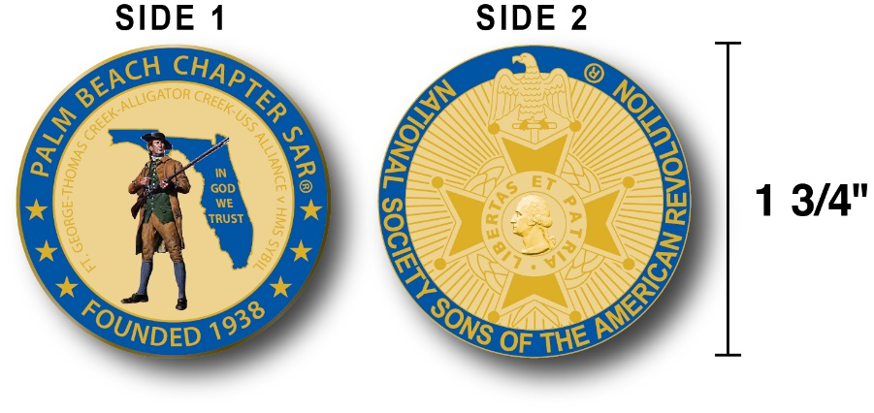

The Chapter has produced a custom bronze *Commemorative Anniversary Coin* honoring the founding of the *Palm Beach Chapter* in 1938 and celebrating its 80 years of historic, patriotic, and civic service in Palm Beach County and Florida.

The beautiful bronze coin is highlighted in ***George Washington*** military blue on a stunning gold background. Side-one is personalized to our Chapter with the founding date, a Minuteman standing guard over Florida, and the Florida State motto of ***"In God We Trust”.***

The coin also includes a notation listing the four major Revolutionary War battles waged in Florida including the battle of ***Ft. George-Pensacola, Thomas Creek Massacre, Alligator Creek battle,* and the *Last Naval Battle* of the Revolutionary War** and **Patriot victory between the *USS Alliance & HMS Sybil.*** Side-two displays the national NSSAR logo.  Very impressive indeed!

The custom bronze ***Commemorative Anniversary Coin*** is designed to celebrate our founding in **1938**, create a distinctive and impressive image for our Chapter and be used as a token of appreciation for honored guests, speakers, and as special awards.

**Compatriots may purchase these unique Chapter coins for just $10.**

**Classy SAR Lapel Pins $10:**

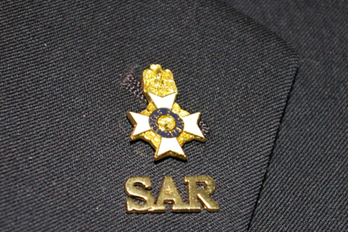

Display a gold ***SAR*** pin on your suit lapel or shirt. The SAR Lapel Pin is part of a national branding program to help promote the S.A.R. and stimulate new membership! The **classy** lapel pin is a recognizable symbol of the SAR for the public, gives you immediate recognition as a member, and may spark conversation about SAR that leads to a new member. The gold lapel pin and SAR member Rosette create a professional image that will improve overall SAR name recognition. The Chapter has a supply of pins for Compatriots for just $10. **Get yours today**!

**SAR Chapter, State & National:**

**-CHAPTER:** Veterans Flag Placement Day 5/28 S. Florida National Cemetery, Memorial Day Event 5/29 PB Memorial Park

**-STATE/NATIONAL:** *Battle of Thomas Creek* event in Jacksonville 5-13, Board of Management meeting Orlando 5-19-22, & SAR Congress 7-6.

**- HONOR FLIGHT:** The Palm Beach Chapter is supporting the *Southeast Florida* Honor Flight welcome home event on **May 20, 2017** @ 7:20 PM @ the Palm Beach level 2 concourse A/B.

**Feature Article**

***The Immortal 400!***

***Washington’s Elite Regiment!***

***By Donald Lanman, President Palm Beach Chapter\****

***-IMMORTAL 400-***

[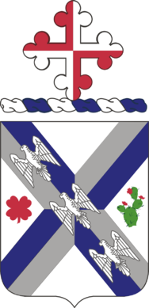](https://en.wikipedia.org/wiki/File:115InfRegCOA.PNG)[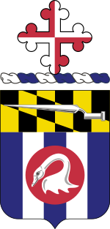](https://en.wikipedia.org/wiki/File:175th_Infantry_Regiment_COA.svg)

***115th INFANTRY REGIMENT, U.S. ARMY - 175th REGIMENT MARYLAND NATIONAL GUARD***

In August 1776, little over a month after the Continental Congress had formally declared independence from Great Britain, General George Washington’s young army faced off against over 20,000 professional and battle-hardened British and Hessian soldiers at the *Battle of Brooklyn*.

This was the largest battle of the Revolution, and with the Americans outmanned and outmaneuvered, it was almost the end of the war, as well.

However, thanks to a series of desperate bayonet charges by a single heroic regiment from Maryland, known as the “Immortal 400,” Washington was able to retreat and regroup. Evacuating his army to Manhattan allowed the Continental Army to fight another day.

The *Maryland 400* were members of the *1st Maryland Regiment* who repeatedly charged a numerically superior British force during the *Battle of Long Island* during the Revolutionary War, sustaining heavy casualties, but allowing General Washington to successfully evacuate the bulk of his troops to the safety of Manhattan.

Representing the cream of the Maryland Line, *The 400*, had a reputation of being among the best of the Continental Army because of the high quality of the regiments. According to tradition, *General Washington* referred to Maryland units as his own "*Old Line*," providing Maryland one of its nicknames as *"The Old Line State*.”

Thus, the nickname the *"Old Line State”* commemorates the action of the Maryland 400”, including a unit monument in Brooklyn plus multiple plaques across the state to honor the memory of the regiment and the fallen soldiers.

The *1st Maryland Regiment*, formed in 1775, also represents the birthdate of the United States Army. Currently the *U.S. Army’s 115th Infantry* Regiment claims lineage back to the earliest militia units formed to protect the western frontier.

Symbolic of the *Maryland 400*, the bayonet illustrated on the coat of arms of the *175th Infantry Regiment-Maryland National Guard* is symbolistic of its use at the *Battle of Long Island 1776* and its famed utility throughout the Revolutionary War.

Unlike most of Washington's Army, the Maryland units were disciplined, drilled, and so well equipped they even had bayonets. At the time both uniforms and bayonets were such a rarity for the Colonial Army that the impressive Maryland soldiers became known as “Dandies.”

The *1st Maryland Regiment* joined Washington’s army barely two weeks before the historic *Battle of Long Island*. Once the battle joined, British General Cornwallis surprised the Americans by circling his superior force around them in preparation for a deadly assault.

Aware of the enemies advance, Patriot *General William Stirling* ordered his main force to withdraw while the Marylanders were ordered into defensive positions on Brooklyn Heights to provide a rear guard delaying action as the bulk of the Colonial army withdrew to safety. Clearly, this heroic mission may have saved Washington’s army.

General Stirling remained to command the rear guard action leading *"The Maryland 400"* against Cornwallis' 2,000 battle hardened Red Coats massed around the “Old Stone House”, an impressive brick building also known as the *Vecthe-Cortelyou House* built in 1699 to withstand Indian raids, and located near present day Fifth Avenue and 3rd Street in Brooklyn.

[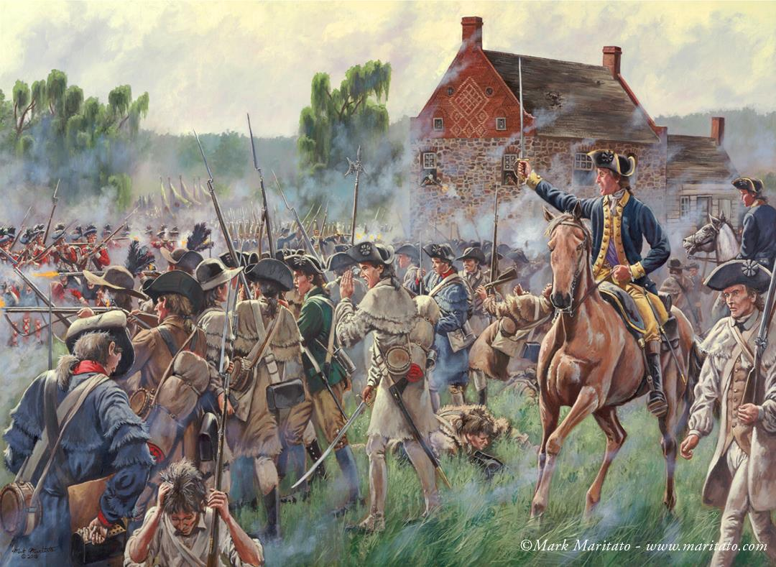](https://www.google.com/url?sa=i&rct=j&q=&esrc=s&source=images&cd=&cad=rja&uact=8&ved=0ahUKEwiI7b63h7nTAhUJ6SYKHVH7DKMQjRwIBw&url=https://yankeedoodlespies.blogspot.com/2016/05/people-samuel-smith.html&psig=AFQjCNFkyFEUlYuB0pwJV13gblURMrJ8bw&ust=1492984421507888) [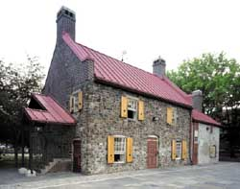](https://www.google.com/url?sa=i&rct=j&q=&esrc=s&source=images&cd=&cad=rja&uact=8&ved=0ahUKEwjxzc2LiLnTAhUBXiYKHWniC90QjRwIBw&url=https://www.nycgovparks.org/facilities/historichouses&psig=AFQjCNFkyFEUlYuB0pwJV13gblURMrJ8bw&ust=1492984421507888)

In fierce and bloody fighting, Stirling and his *“ Maryland 400”* charged the British soldiers six-times to give their comrades time to make their way to safety in Manhattan with the rest of Washington's army.

Twice the *Patriots* managed to drive the Red Coats from the stone fortress as British reinforcements continued to pour into the battle. Finally, as American casualties mounted, the *“Maryland 400”* had to cease their assaults and attempt a retreat to safety themselves.

[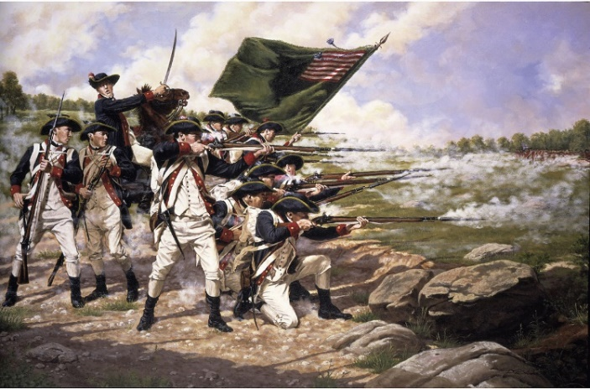](https://www.google.com/url?sa=i&rct=j&q=&esrc=s&source=images&cd=&cad=rja&uact=8&ved=0ahUKEwihsZyeh7nTAhUFQSYKHXzcAogQjRwIBw&url=https://en.wikipedia.org/wiki/Battle_of_Long_Island&psig=AFQjCNFkyFEUlYuB0pwJV13gblURMrJ8bw&ust=1492984421507888)[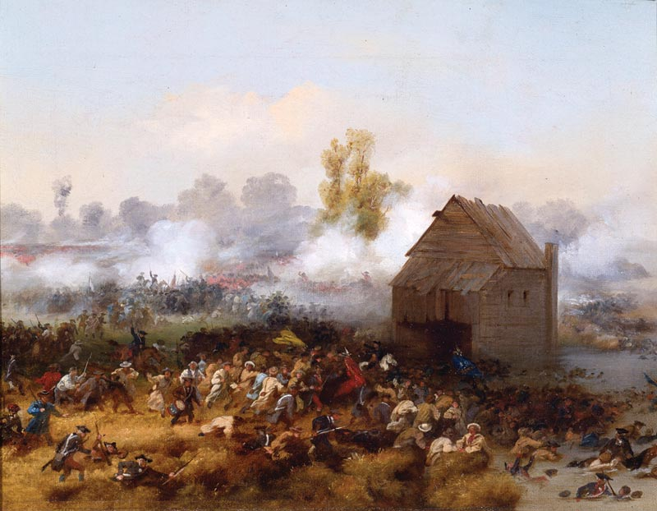](https://www.google.com/url?sa=i&rct=j&q=&esrc=s&source=images&cd=&cad=rja&uact=8&ved=0ahUKEwi13On_hrnTAhXL4yYKHV3vDLMQjRwIBw&url=https://en.wikipedia.org/wiki/Maryland_400&psig=AFQjCNFkyFEUlYuB0pwJV13gblURMrJ8bw&ust=1492984421507888)

However, the British pressed the counter attack and of the 400 Patriots, only *Major Mordecai Gist* and nine others managed to reach the safety of American lines. Of the others, over 256 lay dead in front of the *Old Stone House* and the remainder were wounded/and or captured.

The bravery of the *1st Maryland Regiment* earned them Washington’s respect and the name "*Immortals*.” The heroes were hastily buried in a mass grave consisting of six trenches in the nearby farm field. Their gravesite is located on Third Avenue between 7th and 8th Streets where it was initially marked by a simple stone tablet that read:

***"Burial place of ye 256 Maryland soldiers who fell in ye combat at ye Cortelyou House on ye 27th day of August 1776."***

The result of the brief battle was stunning for the Americans. More than a thousand men were killed, wounded, captured, or missing, and Generals Stirling and Sullivan were in the enemy's hands. Historian, Thomas Field, writing in 1869, "The Battle of Long Island," called the heroic stand of the Marylanders:

*"An hour more precious to liberty than any other in history where four companies of the 1st Maryland stood as the final anchor of the crumbled American front line, and their heroic action not only saved many of their fellows but afforded Washington critical respite to regroup and withdraw his battered troops to Manhattan and continue the struggle for independence.”*

Over time, the Patriot gravesite became the location of a paint factory, and the burial grounds became part of a factory courtyard open to the elements. As more time passed and the paint factory gave way to an auto repair shop and the courtyard gravesite roofed over.

Today these heroes, whom Washington himself lamented, lie in their unmarked graves under the floor of a building that had housed the auto repair shop, and miles from a *Stanford White Monument* erected in Prospect Park in 1895 to honor their sacrifice by the Maryland Society Sons of the American Revolution.

On one face of the monument's square base is an inscription honoring the participating Maryland 400 soldiers. The inscription reads: "In honor of the Maryland 400 who on this battlefield on August 27, 1776 saved the American army."

On the monuments marble pedestal, there is an inscription attributed to a comment by ***General Washington*** as he watched the *Marylanders* hurl themselves at the enemy, it reads simply…

***"Good God! What brave fellows I must this day lose!"***

Following the historic *Battle of Brooklyn*, the mighty and storied *1st Maryland Regiment* went on to more honor and glory fighting in key battles throughout the Revolutionary War including *Trenton, Stony Point, Camden, Cowpens, Guilford Courthouse,* and *Yorktown*. The valor, resilience, and dedication of the *Immortal 400* set an example for all, and may have changed the course of history.

* *Sources* include online research and books by historians Thomas Field*, "The Battle of Long Island,”* and “*Washington’s Immortals”* by Patrick K. O’Donnell. These authors draw on original documents, including military records, letters, diaries, and pension applications to tell the stories of these soldiers, their friendships, defeats, and triumphs.

These books chronicle the *1st Maryland Regiment*’s development into an elite fighting force amid their struggles against professional British soldiers and hostile Loyalists. Through the lens of this storied regiment, which included rich merchants, farmers and tradesmen, they tell the larger story of our war of Independence.

[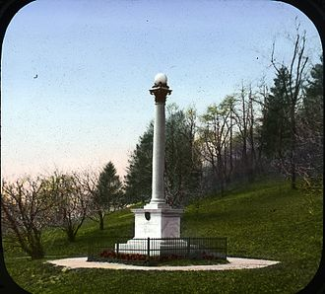](https://en.wikipedia.org/wiki/File:Prospect_Park_in_New_York.jpg)[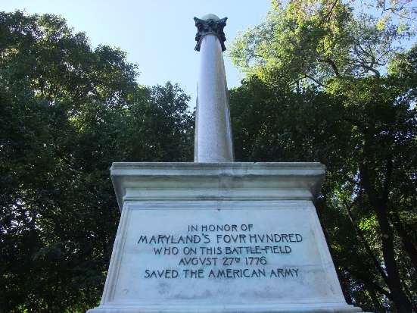](https://www.google.com/url?sa=i&rct=j&q=&esrc=s&source=images&cd=&cad=rja&uact=8&ved=0ahUKEwjlr-zMhrnTAhXC5CYKHfqqDR4QjRwIBw&url=https://msamaryland400.wordpress.com/about/&psig=AFQjCNFkyFEUlYuB0pwJV13gblURMrJ8bw&ust=1492984421507888)

**Is Your Membership Active?**

**If you forgot to send in your 2017 SAR membership dues, you may reinstate NOW…**

**But Don’t wait….Mail** your $75 annual membership fee to ***SAR PB Chapter, PO Box 16735 West Palm Beach, FL 33416-6735*** along with any changes to your personal contact information.

***Remember*….Your** membership dues and additional donations fund the many Chapter civic activities including **Scholarships**, ***Boy Scout & JROTC medals, Rumbaugh & Knight Essay Youth contests, Police-Firefighter-EMT awards, Flag Certificates, Americanism, & Community programs.***

***-April Meeting Pictures-***

**Military Service Medal for Compatriot Boggs by President Lanman**

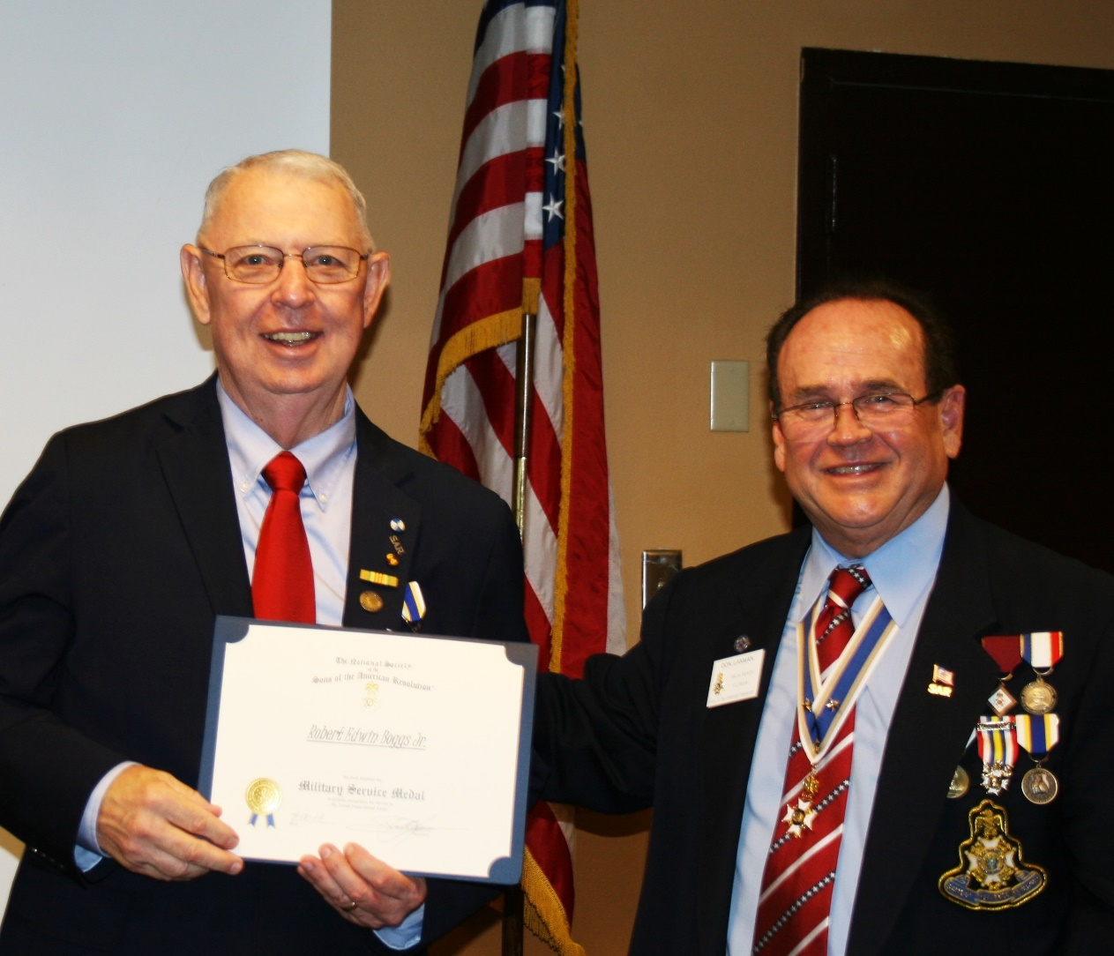

***Law Enforcement Medal recipient Deputy Sheriff Combs & K9 Partner Ciro***

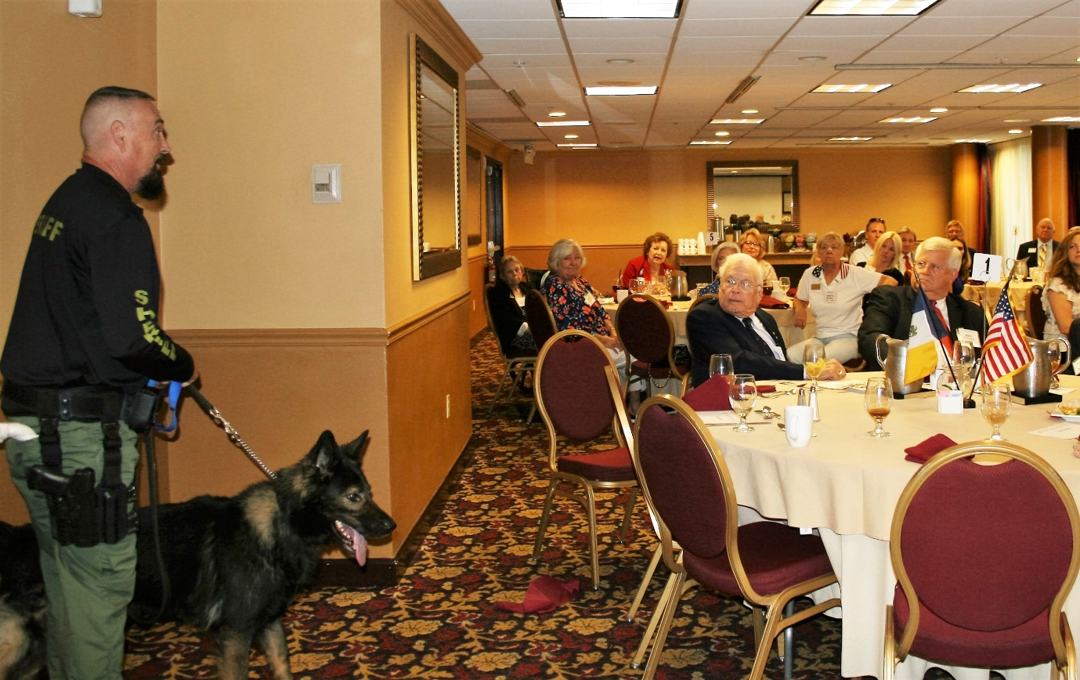

**Law Enforcement Medal to Deputy Chief Gauger by Tidwell & Lanman**

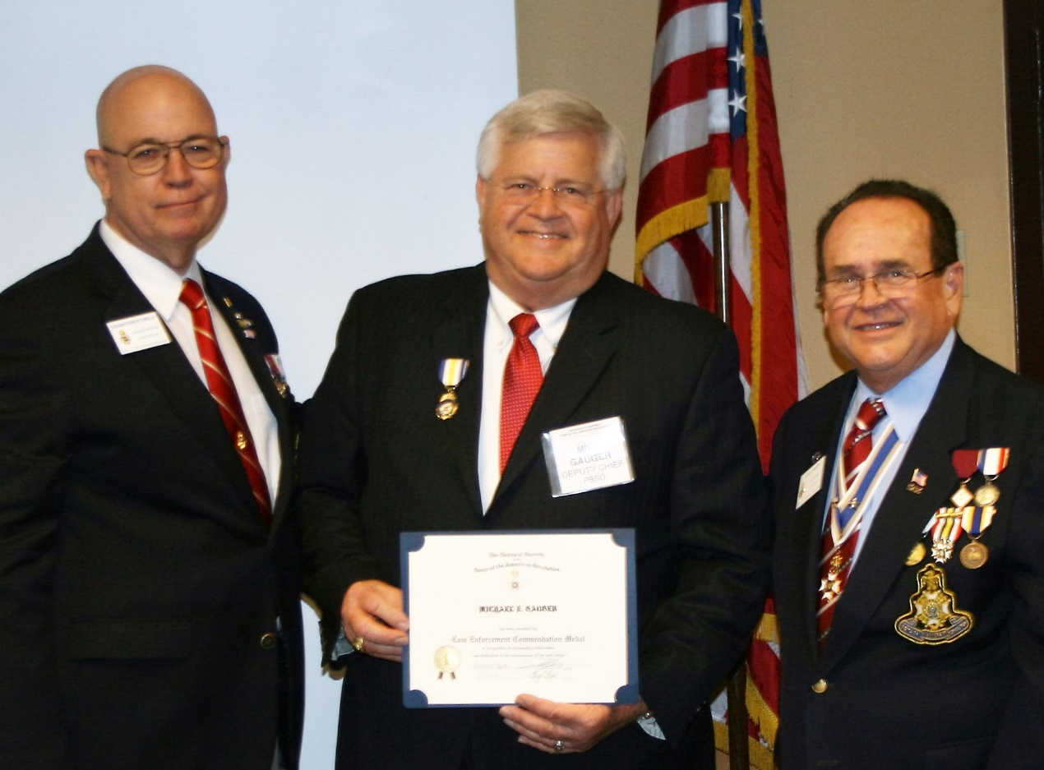

**Law Enforcement Medal to BB-PD Officer Nicole Loshelder by Lanman/Tidwell**

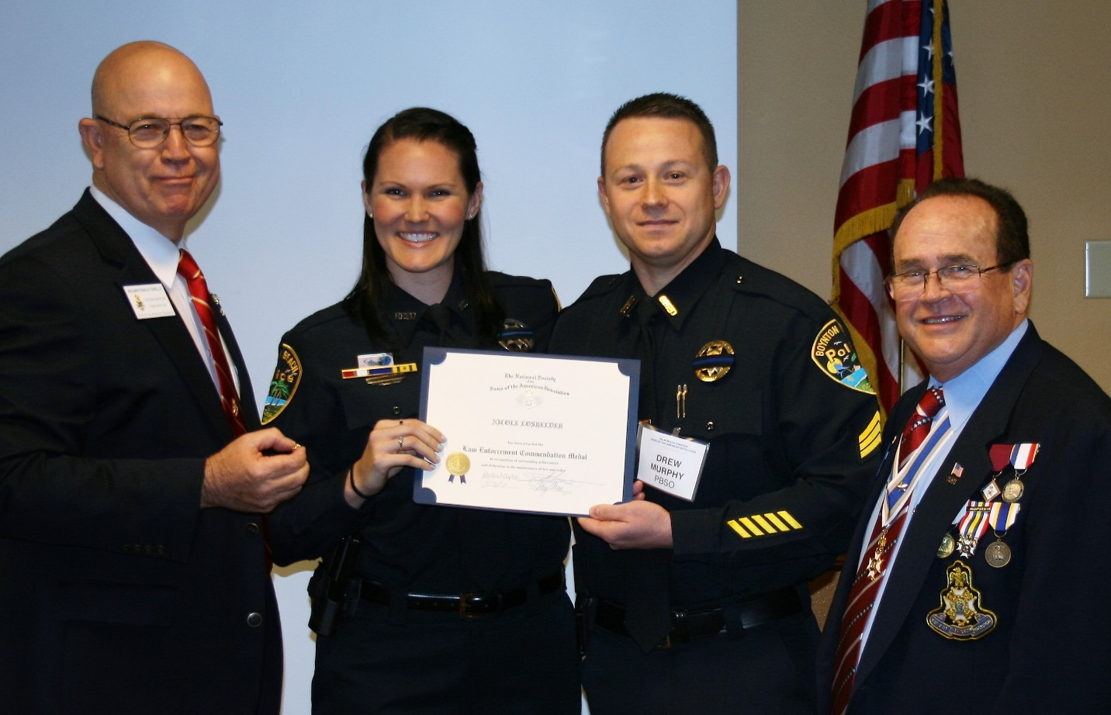

**Law Enforcement Medal for PBSO Deputy Leatherman by Lanman/Tidwell**

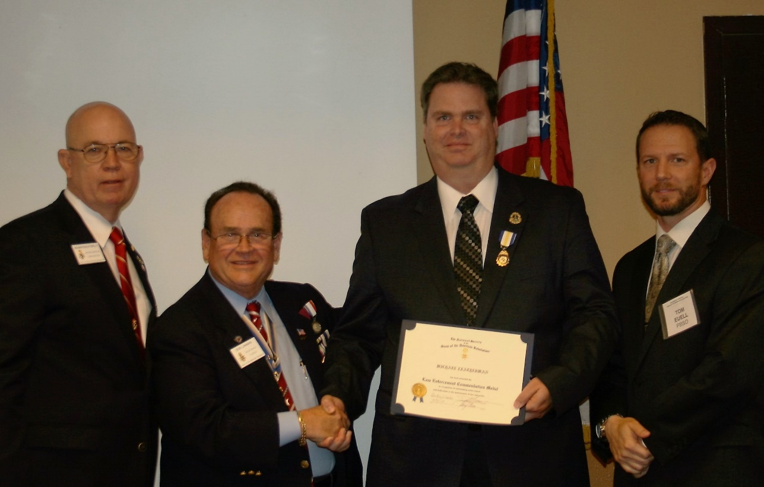

**Past President Green presents Law Enforcement Medal to Friend, Deputy Ott**

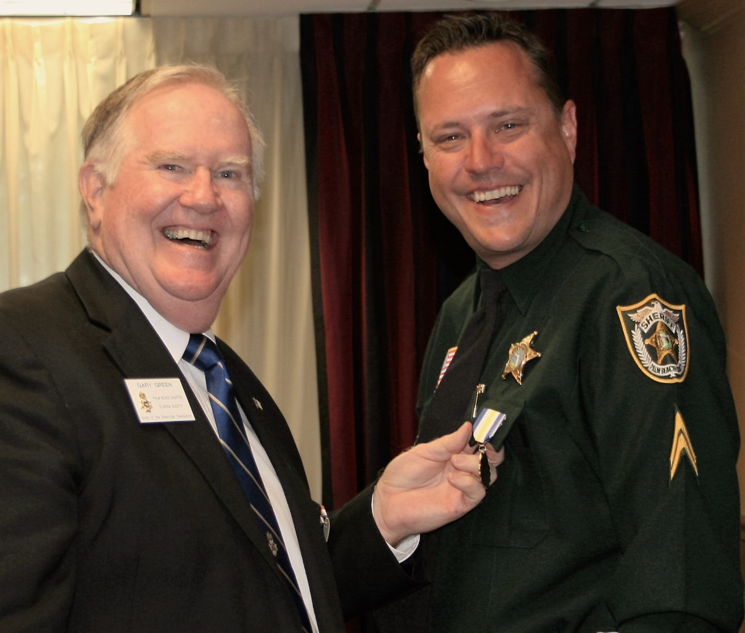

**80th Anniversary Commemorative Coin Available for $10.00**

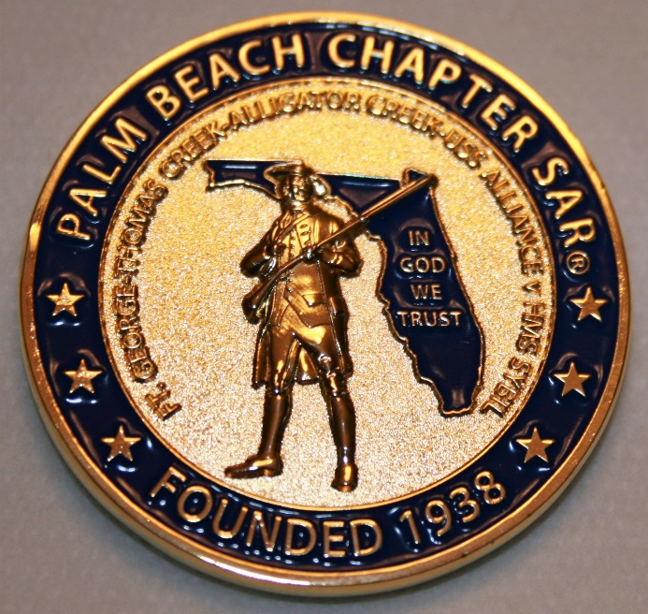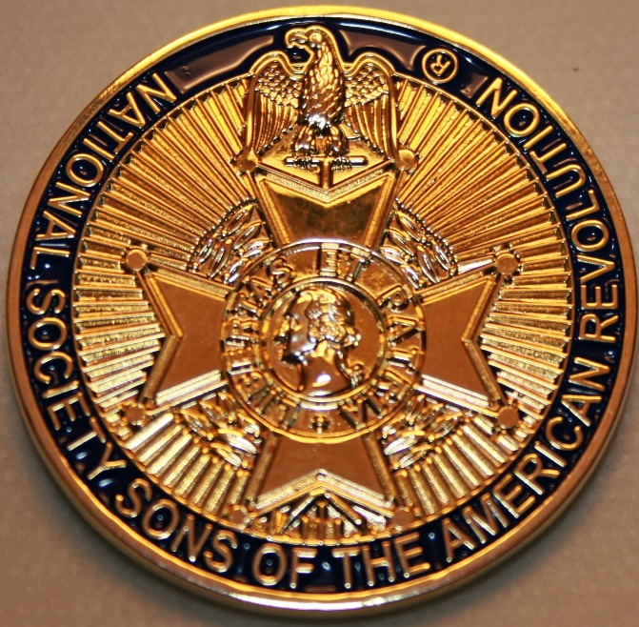

**-Compatriot Sponsored Promotions-**

**Compatriot sponsored newsletter Ads are important to the Chapter as they represent additional funds in support of Chapter projects including *Scholarships, Boy Scout & JROTC medals, Rumbaugh & Knight Essay Youth contests, Police-Firefighter-EMT medals, Americanism & community civic programs!***

**Help** your Chapter, sponsor an Ad for **8** issuesat a modest cost: **Business Card $50, Half Page $100, Full Page $250. Your AD donation will also qualify you for a listing in the *Presidents Brigade*. Call Don Lanman 561-315-5073 for information.**

***SPECIAL SPONSORED ADS ON FOLLOWING PAGES…***

***-COMPATRIOT ROBERT BRINCKERHOFF***

***-GARCILASO DE LA VEGA, CHAPTER***

***DAUGHTERS OF THE AMERICAN REVOLUTION***

***-COMPATRIOT ALEXANDER DREYFOOS***

***-Morgan Stanley-***

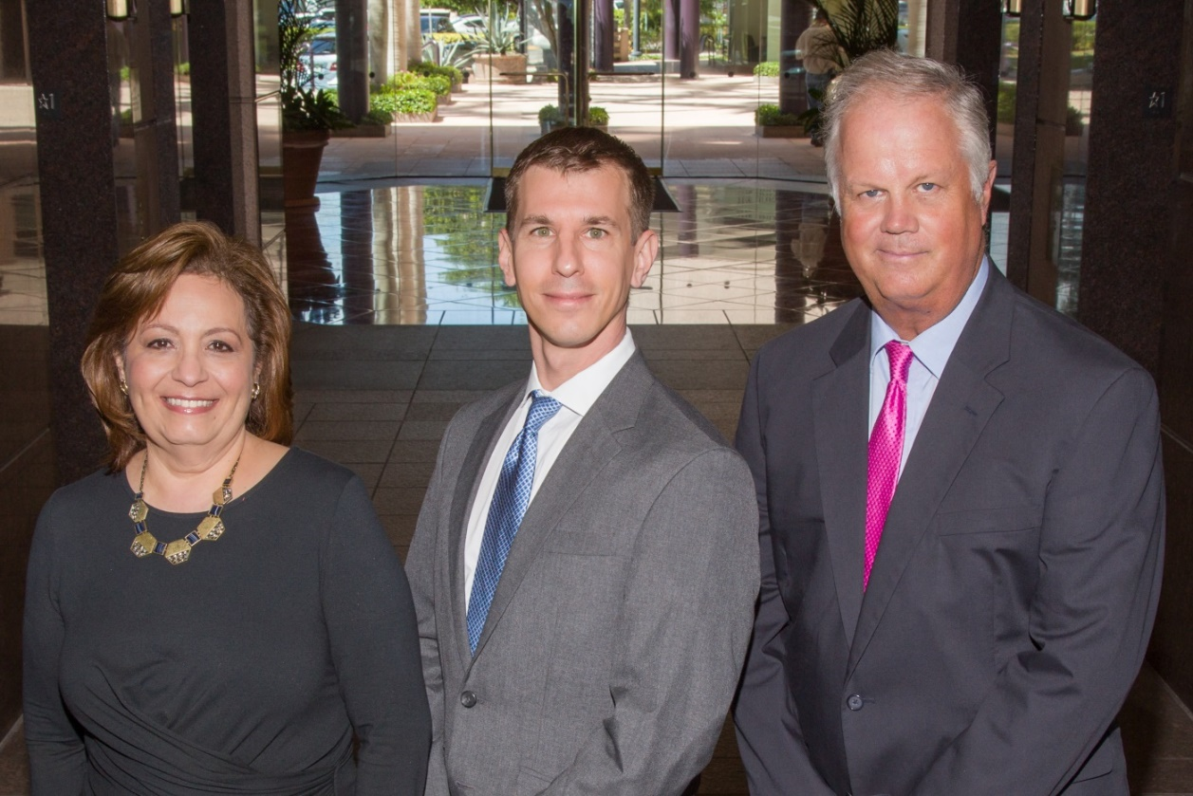  
**Amani Gaballa, Senior Registered Associate; Robert Scarborough, Financial Advisor; Robert Brinckerhoff, First Vice President, Financial Advisor**

***Robert W. Brinckerhoff  
Senior Vice President, Financial Advisor  
777 S. Flagler Dr. Suite 700, East Tower  
West Palm Beach, FL 33401  
(561) 650-7514  
Robert.Brinckerhoff@MorganStanley.com***

***Bob has been a financial advisor since March 1976. He focuses on investment strategies, retirement planning, liquidity solutions for individuals, commercial real estate, and small business owners.***

***Bob is a graduate of the University of Vermont. His clients are geographically diverse and he frequently travels from the east coast to the west to meet with clients. He is active with nonprofit organizations that support the blind and visually impaired. Bob is also an active enthusiast in Ferraris.***

*The investments listed may not be suitable for all investors. Morgan Stanley Smith Barney LLC recommends that investors independently evaluate particular investments and encourages investors to seek the advice of a financial advisor. The appropriateness of a particular investment will depend upon an investor’s individual circumstances and objectives. Morgan Stanley Smith Barney LLC is a registered Broker/Dealer, Member SIPC, and not a bank.*

*Where appropriate, Morgan Stanley Smith Barney LLC has entered into arrangements with banks and other third parties to assist in offering certain banking related products and services. Investment, insurance and annuity products offered through Morgan Stanley Smith Barney LLC are: NOT FDIC INSURED, MAY LOSE VALUE, NOT BANK GUARANTEED, NOT A BANK DEPOSIT, NOT INSURED BY ANY FEDERAL GOVERNMENT AGENCY. Copy write 2015 Morgan Stanley Smith Barney LLC, Member SIPC CRC1355648 11/15.*

*TWO GREAT BOOKS-ONE GREAT MAN*

***-Alexander W. Dreyfoos-***



***-A PHOTOGRAPHIC ODYSSEY- -PASSION & PURPOSE-***

***Compatriot Alexander W Dreyfoos, Jr.*** an honored member of the *Palm Beach Chapter Sons of the American Revolution*, noted American entrepreneur, and philanthropist has published two remarkable books that should be on every bookshelf. **Book sales** **proceeds** **donated to local West Palm Beach charities!**

* ***Passion & Purpose*** chronicles a remarkable lifetime of passion with photography, his business, inventions and philanthropic ventures, as well as his adventures above and below the water. **$29.95.**
* ***A Photographic Odyssey*** is a remarkable collection of hundreds of stunning pictures from 100,000 photos taken by Alex around the world and bound in an elegant 15” by 10” glossy photographic book. You will travel with Alex around the world, above and below the water, to forests, jungles, glaciers, and deserts in the exotic locals of Papua New Guinea, Bhutan, Nepal, China, Japan, and Tibet. The subjects are very divergent contrasting palaces and temples with the vulnerability of people, animals, and exotic scenery. **$60.00.**
* **Support your Chapter & local charities! Get both books, *Passion & Purpose & A Photographic Odyssey,* just $71.96 @ kravis.org/books or Call 561-651-4329.**

***-Alexander W. Dreyfoos-***

*Graduating from MIT and Harvard Business School, Alex founded Photo Electronics Corporation (PCS), specializing in photography and video production. Over the decades, Alex earned 10 US patents and invented the Video Color Negative Analyzer for motion pictures earning him an Academy Award for technical achievement.Many inventions, developed by PCS, are on permanent display at the Smithsonian Institution. Locally Alex also owned television station WPEC TV-12, the CBS affiliate in West Palm Beach. Alex’s many philanthropic achievements include founding the Palm Beach County Cultural Council, the Raymond F. Kravis Center for the Performing Arts and gifting a million dollars to the Dreyfoos School of the Arts. Alex also donated a million dollars each to the Palm Beach County biomedical research campus of the Scripps Research Institute and the local Max Planck Florida Foundation for Neuroscience in Jupiter, Florida.*

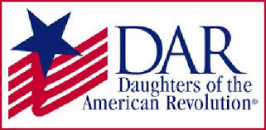

*Garcilaso de la Vega Chapter, NSDAR*

*Lake Worth, Florida*

*Alisha Darcy, Regent*

*Karen Christie, Registrar*

Phone; 561-236-2460-Email; [IMC4U4@AOL.com](mailto:IMC4U4@AOL.com)

Chapter Email: [GarcilasodelaVegaDAR@gmail.com](mailto:GarcilasodelaVegaDAR@gmail.com)

Visit us on ***Facebook*** @ <https://www.facebook.com/LWDAR>