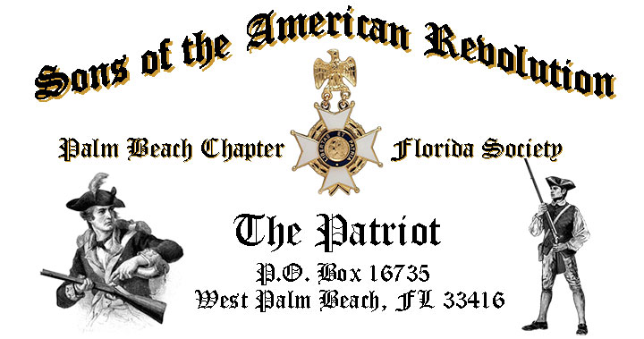

***Volume 24 May 2018 Number 05***

***Join us for the annual “Firefighter-EMS First Responder Recognition Ceremony” to honor our local first responder professionals***, *Tuesday* **May 15, 12:00 Noon** @ the Embassy Suites 1601 Belvedere Road, WPB! "***RSVP TODAY*** ***for this popular event!***

***May 15 Meeting Event Highlights…***

* ***“Firefighter-EMS First Responder Recognition Ceremony”***
* ***4-Course Buffet Lunch, 2-Special Desserts & Beverages***
* ***$28 per person Check/Cash at the Door***
* ***Reservations*** **Required,** **RSVP**, **Ben Tidwell** **(561)-704-9918!**
* **Family, Friends & Guests** **are always** ***Welcome***!

***Newsletter Content:***

* **President’s** **Message**
* **2018 Officers & Board Members**
* **2018 Chapter Meeting Dates &Topics**
* ***President’s Brigade* Financial Supporters**
* **Committees, Chairmen & Members**
* **National/State/Chapter, News & Events**
* **Feature Articles: *Birth of a State-Cradle of Patriotism-Vermont***
* **Pictures-Meetings** **& Even**ts
* **Compatriot Sponsored Promotions**

***President’s Message: Fellow Compatriots, DAR Daughters & Friends…***

As your President, it’s been a great first four months in office. I look forward to the *May* meeting as we honor our ***Firefighters-EMS*** professionals for their dedication and service. I am pleased with our growing attendance and with our Officers and Compatriots who work tirelessly to support me and our chapter.

As we take our summer break your Officers and Committees will be working on new memberships, patriotic events and our special ***80th Anniversary Celebration***, scheduled for ***December the 8th 2018***. Mark your calendars today for this special occasion that will be held at the very Palm Beach location where our Chapter was founded in *1938*!

Special thanks go to *Compatriots Michael Anderson* and *Don Lanman* who are working tirelessly to update our web site, increase its functionality and add additional content. A special thanks go to all SAR and DAR patriots who take the time to support the Chapter by attending meetings and referring new members.

***Local Heroes running into Danger while others are running out!*** Join us for our annual ***“Firefighter-EMS First Responder Recognition Ceremony”*** in *Honor* of our *Local First Responder Professionals*.

We’ll share stories of their *dedication, heroism* and *community* service, and recognize *First Responders* from several local cities in *Palm Beach County* with the prestigious ***SAR Fire Safety- EMS Commendation Medals***.

[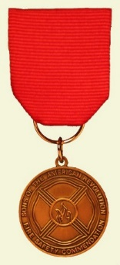](https://www.google.com/url?sa=i&rct=j&q=&esrc=s&source=images&cd=&cad=rja&uact=8&ved=2ahUKEwj00ce74OfaAhWjwFkKHQByBaIQjRx6BAgBEAU&url=http://www.fairfaxresolvessar.org/ffx_community_firesafetymedal.html&psig=AOvVaw1g3ZJGlbgawyHrKqw_pGdJ&ust=1525375388827063)[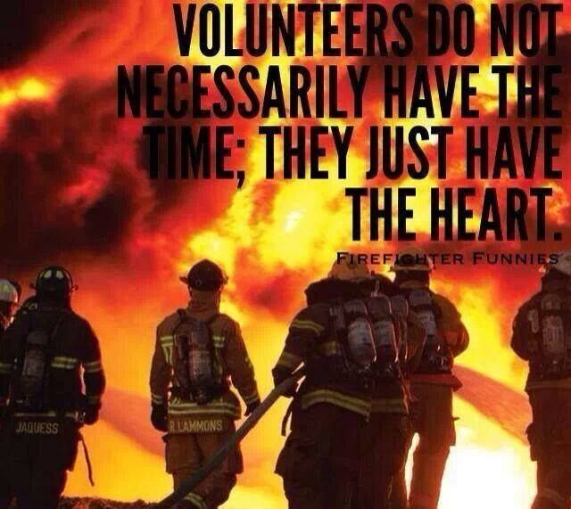](https://www.google.com/url?sa=i&rct=j&q=&esrc=s&source=images&cd=&cad=rja&uact=8&ved=0ahUKEwjpu_7QmtTTAhWISyYKHX2iBYQQjRwIBw&url=https://www.pinterest.com/smsstudios/firefighter-inspired-motivation/&psig=AFQjCNFe-QzCi1sX1hq9YXMkLZ4VRhA6zQ&ust=1493917430593864)[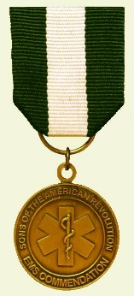](https://www.google.com/url?sa=i&rct=j&q=&esrc=s&source=images&cd=&cad=rja&uact=8&ved=2ahUKEwid0omn4OfaAhVjtlkKHY-yBqEQjRx6BAgBEAU&url=http://www.fairfaxresolvessar.org/ffx_community_emsmedal.html&psig=AOvVaw1g3ZJGlbgawyHrKqw_pGdJ&ust=1525375388827063)

*April* was an exceptional meeting including a remarkable presentation of the ***Colors*** by the ***Lake Worth High School AFJROTC Color Guard*** to begin our annual ***Thin Blue Line* Law Enforcement *Recognition Ceremony!***

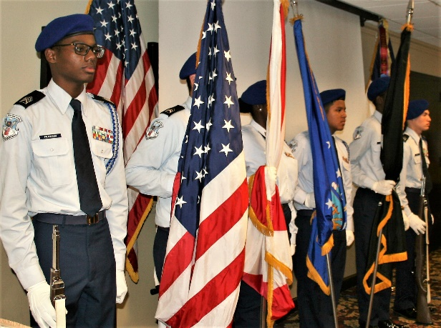

Our Chapter Honored four local law enforcement professionals with *SAR* *Law Enforcement* *Commendation Medals* to ***Officers T. Coleman, C. Malta, W. Reasoner, W. Smith***, and featuring a greetings from the ***Palm Beach County Sheriff Office, Deputy Chief, Mike Gauger*.**

We welcome and Congratulate ***Compatriot Swain*** who was formally inducted into the SAR and our Chapter by President Tidwell.

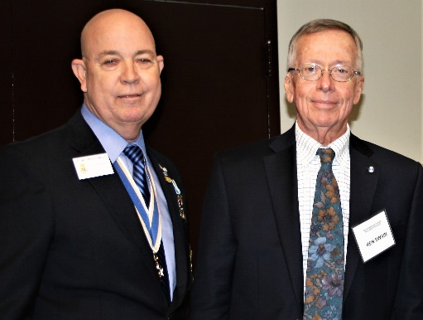

Chapter Compatriots *Barber* and *Tidwell* presented ***JROTC Bronze Service Medals*** to local High School JROTC ***Cadets;******Ashley Cabera, James Doucett, Kendal Sermons and Dovan Freeman***. These young citizens represent the type of youth whose character deserve our recognition and support.

*Compatriots* *Tidwell, Lanman, Barber, Miller* and *Parkinson* represented our Chapter at several patriotic eventsincluding: *Missing in America Veterans Ceremony, Battle of Thomas Creek* dedication*, Jamestown Society* event, *JROTC Medal* ceremonies, and visits to local ***DAR Chapters: Garcilaso de la Vega, Palm Beach, Spirit of Liberty*** and ***Seminole.***

All Compatriots are asked to attend patriotic events to support the Chapter, promote patriotism and recruit SAR candidates. Please review the events schedule and join us at the *Spring State SAR Board of Management* meeting 5/18-19 and annual ***Forgotten Soldiers Memorial Day*** ceremony on 5/28.

*Compatriot Veterans* are encouraged to provide us a copy of their ***DD-214*** to be recognized with the ***SAR Military Service or War Service Medals*** and join the 15% of our members who have served our Nation honorably from *WW II to Iraq*.



***Don’t wait to be asked***, we need help on committees supporting our youth and civic programs including ***Historical Oration, Knight Essay, Historical Poster*** and ***Brochure*** contests***, American History Teacher of the Year, Boy Scouts, Police-Firefighter-EMS* recognition**and ***Veterans*** supportprograms*.* ***Volunteer Today…Will You?***

***Grow Chapter Membership*** by enrolling your *Sons* and *Grandsons* and encourage wives, daughters, and granddaughters to join the *Daughters of the American Revolution, Children of the Revolution* and the *Chapter Women’s Auxiliary*.

***Thank you DAR!*** Our beloved ***DAR Patriot Daughters*** are always welcome at all Chapter meetings and events, and we sincerely appreciate their tireless efforts to support us and refer new SAR members. Support the *DAR* Chapters by attending their fundraising and patriotic events and meetings.

***Chapter Financials***, Compatriots, please help your chapter from losing money on our meeting luncheons by **attending** each meeting and **bringing** family members and guests. **Remember** the Hotel requires a **minimum number** of guests to cover the food, room, and services fees, so when attendance is below **40** or if there are **no shows**, your **Chapter must pay the difference**.

*Compatriots*, I look forward to seeing you at the ***May 15***meeting! Please, join me remembering our Patriot Ancestors, departed Compatriots and especially our nation’s Veterans. ***God Bless you and the United States of America.***

***Yours In Patriotism*** **– *Benjamin F. Tidwell III***

*** Hear Ye-Hear Ye…..Chapter Editorial***

***~LIBERTAS ET PATRIA~***

***~LIBERTY & COUNTRY~***

***Fellow Compatriots, Friends & Veteran Supporters,***

|  |
| --- |
|  |

You are cordially invited to join your fellow Chapter Patriots to celebrate ***Memorial Day*** at the annual***Forgotten Soldiers Outreach “A Day to Remember”*** May 28 at the *Palm Beach Memorial Park* (3691 Seacrest BL, Lantana, FL) starting at 11:30 am.

The Palm Beach SAR Chapter will present an ***SAR Honor Wreath*** at the ceremony that includes; Emcee TV personality ***Jim Sackett, Military Guest Speakers, US Navy Officer Lt. Kate Arrizza, POW/MIA Tribute, Wreath Ceremony, Vietnam military vehicles display, Patriotic Music*** and ***a ceremonial ‘Release of the Doves’, plus complimentary hot dogs.***

***Bring the whole family***, especially the children, to learn more about Patriotism while honoring our nations Veterans. ***No RSVP needed***.

Compatriots…join us and participate at all *Chapter* activities including SAR and *DAR* programs and patriotic events like *SAR ceremonies*, *MIA*, *BOM*, *Memorial Day, Honor Flights, Flag Day, July 4th, Veterans Day* and others.

Please encourage and support our Chapter leadership with their responsibilities, but don’t wait to be asked…rather ask what -You can do to help. ***God Bless You*** and ***God Bless the United States of America.***

***~In Heartfelt Comradeship & Patriotism******- D. Lanman, Editor***

***2018 Chapter Meeting Dates/Topics:***

**Visit** the Palm Beach Chapter web site @ [www.sarpbchapter.org](http://www.sarpbchapter.org) for a meeting calendar, special events, articles, pictures, and general information.

* **May 15,2018, *Firefighters/EMT Awards Ceremony***
* **Oct. 16, 2018**, ***Special Guest Speaker***
* **Nov. 20, 2018**, ***Special Guest Speaker***
* **Dec. 8, 2018**, ***80th Anniversary &*** ***Christmas-Holiday Event***

***2018 Officers & Board:***

* ***President******Benjamin Franklin Tidwell III***
* ***Vice President******Robert Boggs***
* ***Secretary******Gary Green***
* ***Treasurer******Peter Johnston***
* ***Registrar******Robert Boggs***
* ***Chaplain******Father Sanford Sears***
* ***Sgt. @ Arms Peter Miller***
* ***Historian******Samuel “Buddy” Miller***
* ***Officer @ Large******Sonny Barber***
* ***Patriot Newsletter Editor******Donald Lanman***

***Join the President’s Brigade…***

***Support Scholarship & Youth Programs:***

The Chapter has authorized ***$1,000***Scholarship to the ***Palm Beach Atlantic University*** again for ***2018***. This university educates our youth on the values of God and Country and help develop character for the leaders of tomorrow.

The Chapter honors and expresses its sincere appreciation to the *Compatriots* of the ***President’s Brigade*** who support our scholarship and youth programs. The dedicated members of the ***President’s Brigade*** donate ***“Extra Dollars”*** in support of the Chapter’s many youth programs, scholarships, civic activities, award certificates, police/firefighter/EMT medals, veterans’ projects, and related community civic programs.

***Please Help*** increase the scholarship amount this year to ***$4,000*** *by* donating a few dollars to the ***Presidents Brigade*** in support of these students of character.

***Honored Presidents Brigade Members*:**

* **Bronze Level: $25-$99:**

***M. Anderson, J. Blackburn, B. Boggs, J. Chataing, A. Cass, C. Coldwell, D. Coldwell, M. Curry, S. Curry, J. Damron, J. Dorsey, W. Davis, F. Devitt, J. Harper, J. Kane, L. Lassitter, P. Miller, S. Miller, J. Mayne, G. Parkinson, H. Oyer, J. Porter, S. Sears, A. Shea, W. Told, J. Wearn, L Watkins***

* **Silver Level: $100-$199:**

***J. Curry, R. Culpepper, T. Friend, G. Green, F. Green, A. Griswold, W. Johnson, D. Shepherd, S. McWhorter***

* **Gold Level: $200-$499:**

***R. Brinckerhoff, S. Barber, R. Banta , E. Buckley, J. Curry, S. Hitt, W. Meakin, J. Wynns***

* **Platinum Level: $500+**

1. ***Dreyfoos, B. Tidwell, D. Lanman, K. Christie***

***Committees, Chairs & Members:***

***Fellow Compatriots…..***The Chapter expresses its sincere appreciation to those members who volunteer to serve on our committees and projects. As you can see a few Compatriots are serving on multiple committees and could use some extra support! **Just** choose a committee of interest for ***2018***. It doesn’t take much time and is a major help with our many civic and youth initiatives. **Call Ben Tidwell (561-704-9918) or Bob Boggs (561-241-3128)** **Today** to lend a hand on any of the following committees…

* ***2019 Officer Nominations -All Chapter Members***
* ***80th Anniversary -Lanman, Tidwell, Officers***
* ***JROTC & Boy Scouts -Barber, Tidwell***
* ***Law Enforcement-Fire Safety -Parkinson, Green***
* ***Veterans Affairs -Lanman, Curry***
* ***Newsletter/Publicity -Lanman***
* ***Knight Essay/Rumbaugh Oration -Boggs***
* ***American History Teacher -Boggs***
* ***Medals/Awards -Lanman, Tidwell***
* ***DAR Liaison -Lanman, Tidwell***
* ***Speakers Bureau -Lanman, Tidwell***
* ***Audit -Coldwell, Lanman***
* ***Flag Certificates -Miller, Johnston***
* ***Membership Development -Green, Boggs, Tidwell***
* ***Liberty Tree -Chapter Officers***
* ***Patriot Bios -Miller***
* ***Web Site-Facebook/Social Media -Anderson, Lanman***

**Palm Beach Chapter 80th Year Commemorative Coin $10!**

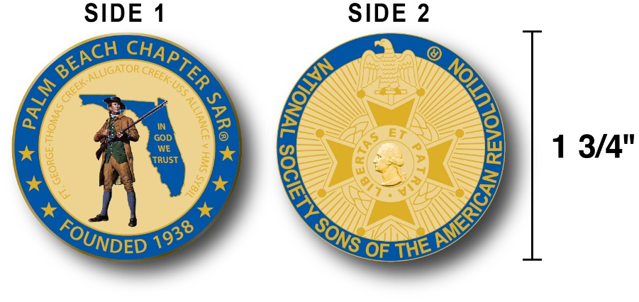

The Chapter created a custom bronze *Commemorative Anniversary Coin* honoring the founding of the ***Palm Beach Chapter* in *1938*** and celebrating its 80 years of historic, patriotic, and civic service in Palm Beach County and Florida.

The beautiful collector’s coin is highlighted in ***George Washington*** ***military blue*** on a stunning ***Gold*** background. *Side-one* is personalized for our Chapter with our founding date, *Patriot* *Minuteman* guarding *Florida* over the *State* motto ***"In God We Trust”.***

The collector’s coin includes an inscription listing the four major Revolutionary War battles waged in *Florida* including the battles of ***Ft. George-Pensacola, Thomas Creek Massacre, Alligator Creek Battle,*** and the ***Last Naval Battle* of the Revolutionary War** between the ***USS Alliance*** & ***HMS Sybil.*** Side-two displays the national ***SAR*** ***Cross of Malta***.  Very impressive indeed!

The custom bronze ***Commemorative Anniversary Coin*** is designed to celebrate our founding in **1938**, create a distinctive and impressive image for our Chapter and be used as a token of appreciation for honored guests, speakers, and as special awards.

***Classy SAR Lapel Pins $10:***



Display a ***Gold*** ***SAR*** pin on your suit lapel or shirt with the ***SAR Rosette***. The SAR Lapel Pin is part of a national branding program to help promote the S.A.R. and stimulate new membership!

The striking lapel pin is a recognizable public symbol of the SAR, provides you recognition as a member of this great society, and will spark conversations about SAR that leads to a new member.

The gold lapel pin and SAR Rosette create a professional image that will improve overall SAR name recognition. The Chapter has a supply of pins for Compatriots for just $10.

***Show Chapter Spirit….*Get your 80th Anniversary Coin & Gold SAR Pin today**!

***SAR Chapter, State & National Events:***

**-*CHAPTER/STATE*:**

***Join Chapter members @ Flags for Fallen Vets 5/10 @ So. FL National Cemetery, Honor Wreath at the Memorial Day Ceremony 5/28, State Board of Management conference 5/18-19. See Ben Tidwell/Don Lanman for event adetails.***

***-2018 SAR NATIONAL CONGRESS:***

***The 128th SAR Congress is scheduled for July 12-19 in Houston, Texas. Hotel registration is open now at a special SAR price of $159.00 per night King or 2-Queens.***

***Reservations can be made by calling the Westin Memorial City Hotel @ 1-800-937-8461 or online @*** [***www.starwoodmeeting.com/book/nssar2018***](http://www.starwoodmeeting.com/book/nssar2018)***. Questions contact Paul Callanan @*** [***LTCMRSC@aol.com***](mailto:LTCMRSC@aol.com) ***or 906-273-2424.***

***~Feature Article~***

***Republic of Vermont…***

***Birth of a State-Cradle of Patriotism!***

**Compiled, Edited & Written By Don Lanman, Former President, SAR Palm Beach Chapter**

[](https://www.google.com/url?sa=i&rct=j&q=&esrc=s&source=images&cd=&cad=rja&uact=8&ved=2ahUKEwjKwf7PyNjaAhWKyVMKHZIcC8sQjRx6BAgAEAU&url=http://www.nesc.wvu.edu/septic_idb/vermont.htm&psig=AOvVaw2_A0ZJ6xLk8XnzJyTQJGXt&ust=1524853484606845)

Through a series of treaties, native tribes had surrendered title to large areas of land. Subsequently, the Provincial Governor of [New Hampshire](https://en.wikipedia.org/wiki/Province_of_New_Hampshire) had provided land grants west of the [Connecticut River](https://en.wikipedia.org/wiki/Connecticut_River) in land that was also claimed by the [Province of New York](https://en.wikipedia.org/wiki/Province_of_New_York).

Strife was created by New York attempting to enforce its legitimate claim to government on settlers who had in good faith purchased land titles from New Hampshire. The King upon the advice of the Privy Council decreed a settlement that was not followed by the Governor and Legislature of New York.

Sandwiched between New York and New Hampshire, the area was constantly in dispute and claimed by both.

New York claimed it was included in its 1664 grant from [*Charles II*](https://en.wikipedia.org/wiki/Charles_II_of_England), but had made no effort to settle it. New Hampshire, desiring to expand its frontier to the west, simply expropriated the land and proceeded to grant 131 charters in the territory, which then became known as the [New Hampshire Grants](https://en.wikipedia.org/wiki/New_Hampshire_Grants).

New York retaliated by declaring the Grants null and void and telling the settlers they would have to repurchase the land from New York (at a much higher price) if they wished to stay.

The New Hampshire Grantees countered by organizing the *"*[*Green Mountain Boys*](https://en.wikipedia.org/wiki/Green_Mountain_Boys)*",* an informal alliance of civilian soldiers who successfully prevented the settlers from being evicted.

[](https://en.wikipedia.org/wiki/File:Flag_of_the_Vermont_Republic.svg)

To protect their investments in the land and improvements, and the health and security of their families, farm representatives from 28 towns called the New Hampshire Grants formed *Committees of Safety* to coordinate protection of their society.

Formed to protect themselves from the Crown, these Safety Committees predated the 13 colonies anti-Crown activity by eight years with precedents developed by similar organizations during the [French and Indian War](https://en.wikipedia.org/wiki/French_and_Indian_War).

[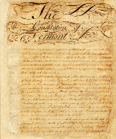](https://en.wikipedia.org/wiki/File:VtConstitution.png)

By 1775, the land control controversy had reached the point that the Grantees decided to take official action, and they held a general convention in Cephas Kent's tavern. Matters discussed at that meeting were not limited to their internal affairs but also included the general cause of American independence.

The [*Continental Congress*](https://en.wikipedia.org/wiki/Continental_Congress) had voted to pay the *Green Mountain Boys* for their services and had asked that a regiment be formed in the New Hampshire Grants.

The Grantees wanted to join in the general rebellion but not as a part of New Hampshire and certainly not as a part of New York. So they petitioned the Continental Congress to intervene in their behalf against New York and permit the Grantees to serve independently in the war of rebellion.

The Grantees met three more times during the course of the next year, always in *Cephas Kent's* tavern, and on 25 June 1776 voted *"that application be made to the inhabitants of said Grants to form the same into a separate district."*

Later that day the convention bound itself *"to defend by arms the United American States against the hostile attempts of the British fleet and armies until the present unhappy controversy between the two countries shall be settled."* This was the first official step toward Vermont's independence.

Thus, the future state of *Vermont* was underway. On 2 July 1777 the town of [*Windsor*](https://en.wikipedia.org/wiki/Windsor,_Vermont) became the birthplace of *Vermont*, since it was there that the state constitution was adopted and its name chosen.

However, it was in the town of *Dorset*, at *Cephas Kent's* tavern*,* that the *Dorset Accords* were drafted and signed leading to the independent *Vermont Republic* and the idea of Vermont was born.

The delegates from 28 towns declared independence from the jurisdictions and land claims both of the British colony of [Quebec](https://en.wikipedia.org/wiki/Province_of_Quebec_(1763%E2%80%931791)) and of the American states of New Hampshire and New York, and also [abolished adult slavery](https://en.wikipedia.org/wiki/History_of_slavery_in_Vermont) within their boundaries.

Because of vehement objections from New York, with its conflicting property claims, the Continental Congress declined to recognize Vermont until 1791 when Vermont officially joined the [United States](https://en.wikipedia.org/wiki/United_States) as the 14th [state](https://en.wikipedia.org/wiki/U.S._state) and New York vacated its claims.

The only *Revolutionary War* battle fought in ***Vermont*** occurred near the current day town of ***Hubbardton*** where ***American*** and ***British*** forces clashed at the seminal battle of *Saratoga*.

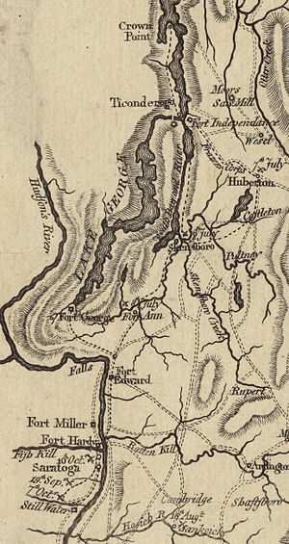

On July 1, 1777, ***British General John Burgoyne*** launched his campaign to divide the colonies and control of the Hudson River valley by moving his professional army of 8,000 south from *Lake Champlain* to capture *Fort Ticonderoga* and destroy *the Northern Colonial Army*.

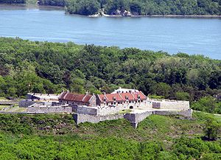

However, on July 5, ***General Arthur St. Clair’s Colonial*** forces defending Fort Ticonderoga discovered that Burgoyne's army had deployed cannons on the high ground overlooking the Fort.

Launching a strategic withdrawal to save the Northern army, ***General*** ***St. Clair*** ordered his forces to evacuate the Fort, under cover of darkness, toward *Hubbardton*.

The *Colonials* forced marched over 30 miles down a rough road (now referred to as the “*1776 Hubbardton Military Road*”) before making camp on the evening of July 6 at *Monument Hill* near *Hubbardton*.

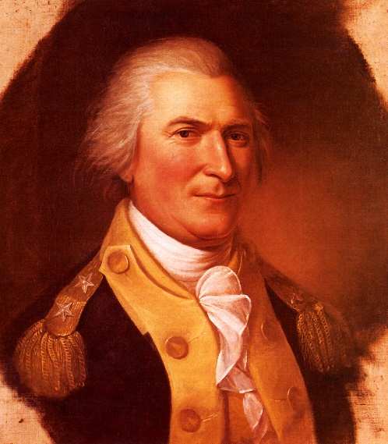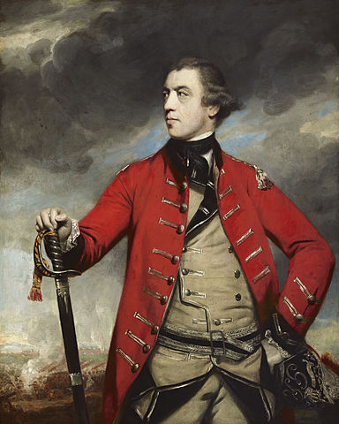 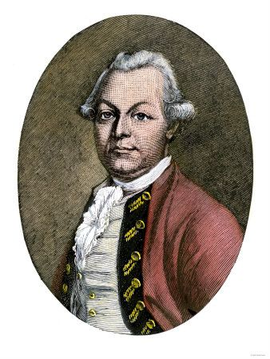

***General St. Clair General Burgoyne General Fraser***

***British Brigadier General Simon Fraser*** discovered early on July 6 that the Americans abandoned *Fort Ticonderoga*, and pursued the *Colonials* with an impressive army of *Grenadiers, Light Infantry, Loyalists Militia,* and *Indian* allies.

To reinforce *General Fraser’s* army, *General Burgoyne* ordered several companies of Hessian mercenaries including the famed *Brunswick Regiment* and grenadiers, commanded by famed *German General* ***Friedrich Riedesel***, into the *Hubbardton* battle.

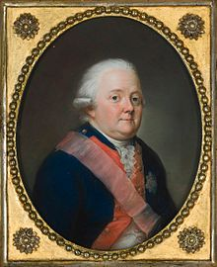

***General Riedesel***

***Colonial General St. Clair*** ordered ***Colonel Seth Warner’s Green Mountain Boys***, ***Colonel Ebenezer Francis’ 11th Massachusetts Regiment***, and ***Colonel Nathan Hale’s 2nd New Hampshire Regiment*** to serve a rear guard delaying action to allow the main force of his army to withdraw to the southeast.

***Colonel Warner***, who had experience in rear-guard actions while serving in the invasion of Quebec, deployed his soldiers in defensive positions on *Monument Hill*, and set patrols to defend the British axis of advance from *Fort Ticonderoga*.

Early on July 7 in 1777, *Hessians* and *British* surprised American forces and launched a surprise attack on the Patriot’s rear guard defenders. Rapidly reforming into a line behind embattlements, the brave ***11th Massachusetts*** soldiers unleashed a withering volley of musket fire at the advancing *Redcoats*.

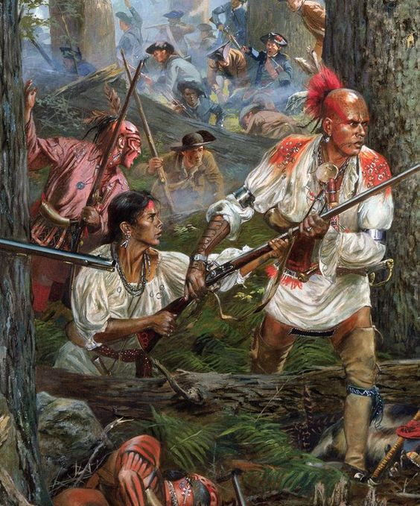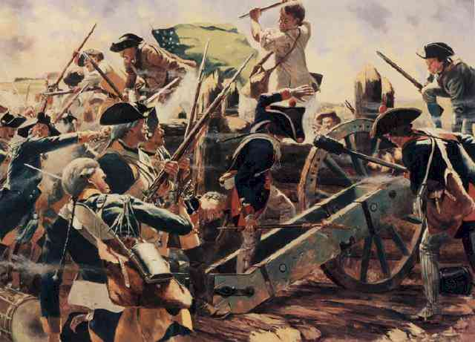

Hoping to hold the field until the ***Hessian*** reinforcements arrived, ***General Fraser*** ordered his soldiers to flank the Americans at the risk of exposing his own left flank.

***General Fraser’s*** soldiers fought bravely but the Patriots repelled the attacks and held *Monument Hill* for over an hour until ***General Riedesel*** attacked with his hymn-singing *Brunswick Grenadiers*.

Observing that the *Americans* were pressing on *Fraser's* left flank, *General Riedesel* sent his grenadiers to reinforce *Fraser’s* flank and directed his storied “*Jägers*” to attack the *American’s* center defense.

The disciplined and battle hardened *German* mercenaries gained the field mauling the ***11th Massachusetts Regiment*** and killing its commander, ***Colonel Ebenezer Francis***.

The *Americans* were defeated, and had to make a desperate race across an open field to avoid capture. The scattered remnants of the *American* rear guard laboriously made their way toward *Rutland City, VT* to rejoin the main army.

Despite heavy losses of 41 killed, 96 wounded, and 234 captured, the valiant ***Colonial*** rear guard action succeeded in its goal of covering ***General St. Clair’s*** strategic withdrawal to *Castleton, Vermont*.

Fresh from his success at the *Hubbardton* battle, ***British General Simon Fraser*** was killed three months later at the decisive *Battle of Bemis Heights* on October 7, 1777!

***General Burgoyne’s*** attack at *Bemis Heights* met with a fierce *American* resistance, spearheaded by ***Major General*** and ***Traitor, Benedict Arnold***, in the wooded area south of *Saratoga* that ended in defeat for the ***British***.

The American victory at the ***Battle of Bemis Heights***, or the ***Second Battle of Saratoga***, proved a major turning point in the *Revolutionary War*.

***British General John Burgoyne’s*** formal surrender at Saratoga on October 17, 1777, included the capture both *Riedesel* and his wife, *Luise Charlotte Riedesel*. Mrs. Riedesel’s memoirs of her experiences during the War for Independence published in German and English provided remarkable insight into the northern battles and the aftermath.

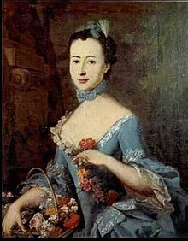 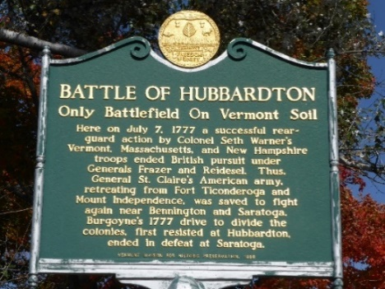

***Luise Riedesel Hubbardton Monument***

The state of *Vermont* commissioned a monument on the *Hubbardton* battlefield site in 1859, and in the 1930’s began acquiring surrounding battlefield lands as a state historic site.

Today the *Hubbardton* battlefield is on the *National Register of Historic Places* and the site of annual Revolutionary War reenactments. The original Constitution House is located in Windsor VT & Vermont Republic tribute at Kents Tavern in Dorset VT.

***Keep Your SAR Membership Active!***

**Don’t lose your SAR Membership….Reinstate your membership today by mailing** **your $75** annual membership dues today to ***SAR PB Chapter, PO Box 16735 West Palm Beach, FL 33416-6735! Include*** any changes to your personal contact information.

***Remember*….Your** **membership dues plus any additional donations fund the many Chapter’s youth and civic activities including**:

**Scholarships**, ***Boy Scout & JROTC medals, Rumbaugh & Knight Essay Youth contests, Police-Firefighter-EMT awards, Flag Certificates, Americanism, American History Teacher, Civic & Community programs.***

***~April Meeting & Event Pictures~***

***President Tidwell Welcomes***

***Lake Worth Hill High School AFJROTC Color Guard***

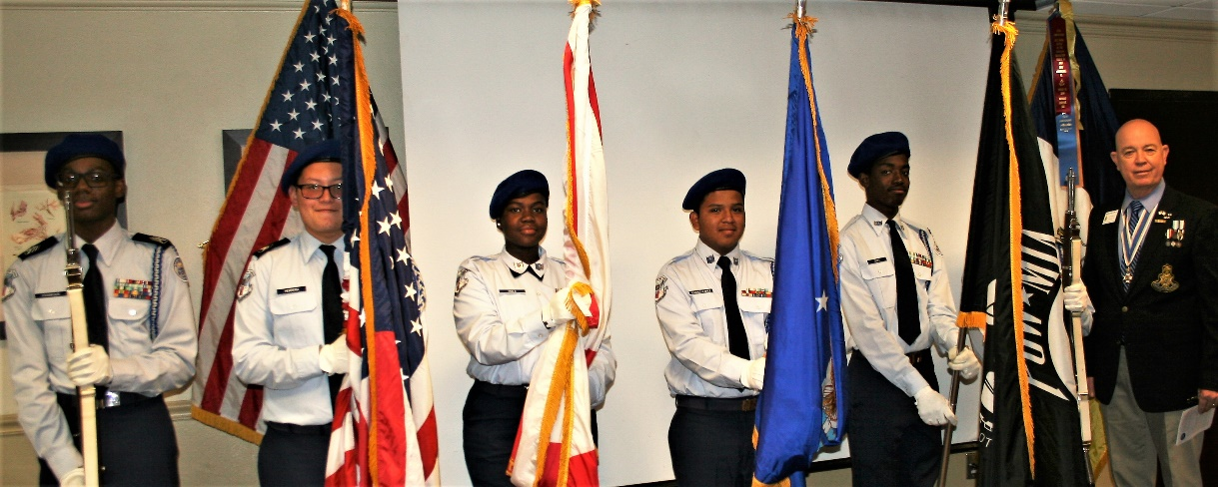

***President Tidwell welcomes Compatriot Ken Swain into the Chapter***

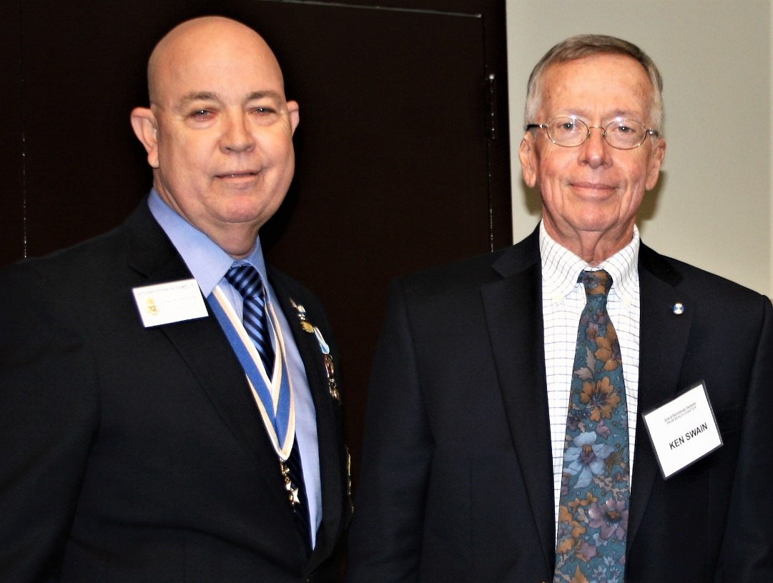

***President Tidwell & FMR President Parkinson present***

***SAR Law Enforcement Medal to PBSO Officer Coleman***

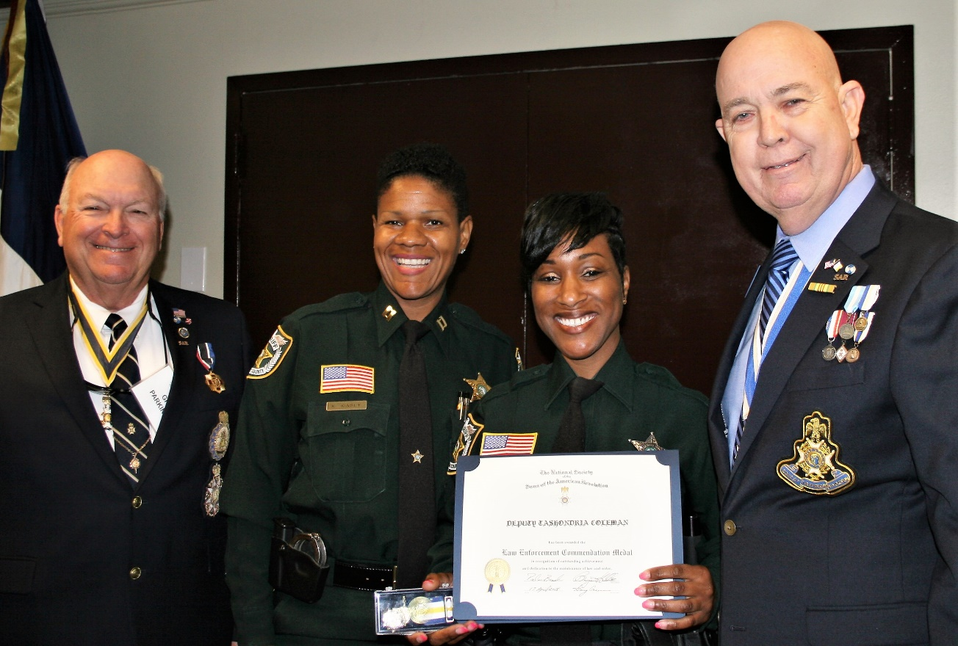

***President Tidwell & FMR President Parkinson present***

***SAR Law Enforcement Medal to Officer Malta***

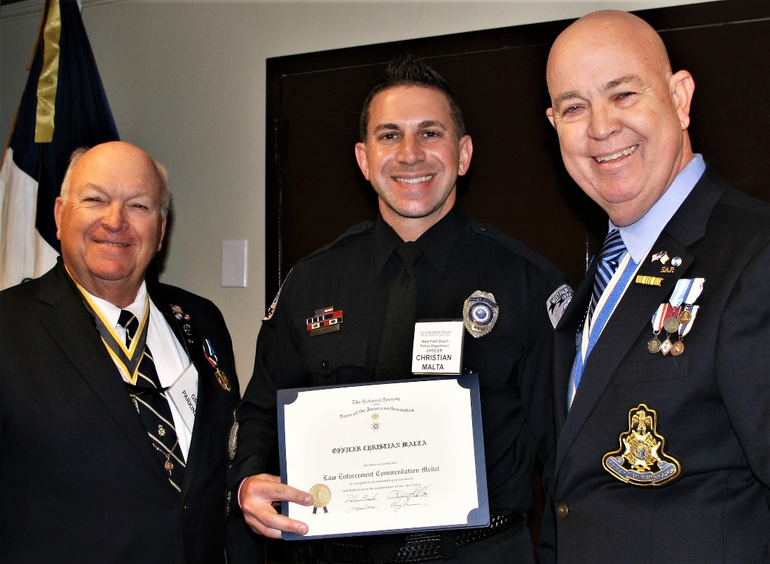

***President Tidwell & FMR President Parkinson present***

***SAR Law Enforcement Medal to Officer Reasoner***

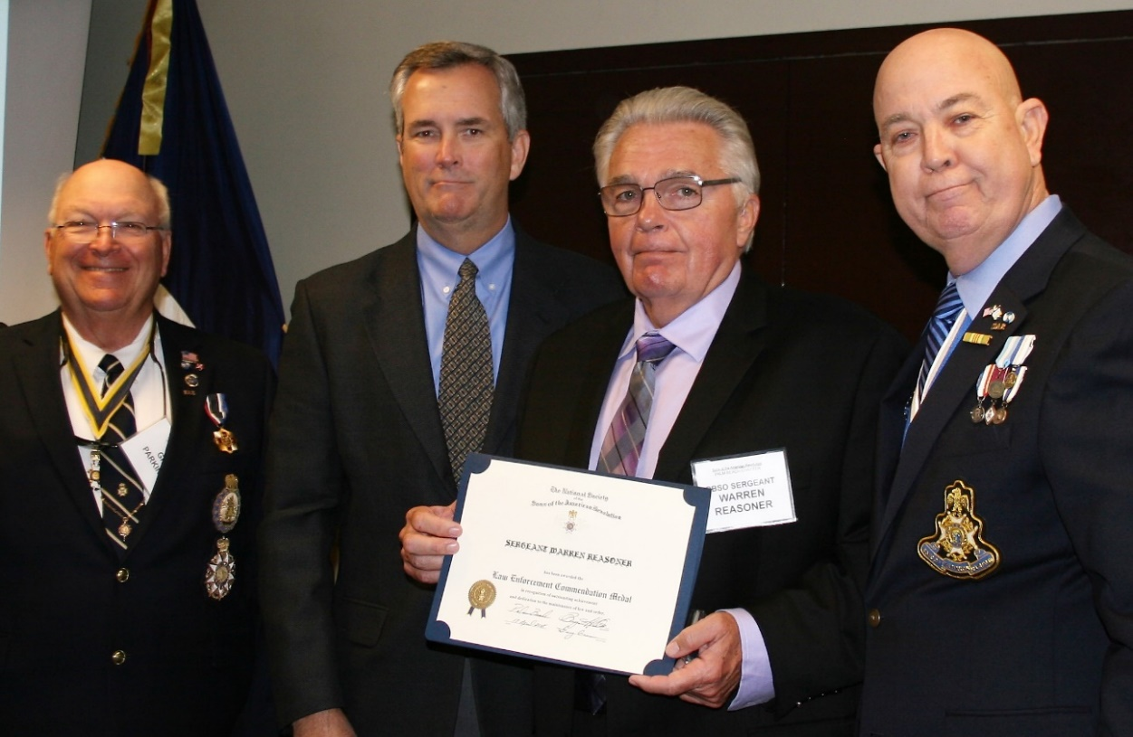

***President Tidwell & FMR President Parkinson present***

***SAR Law Enforcement Medal to Chief Smith***

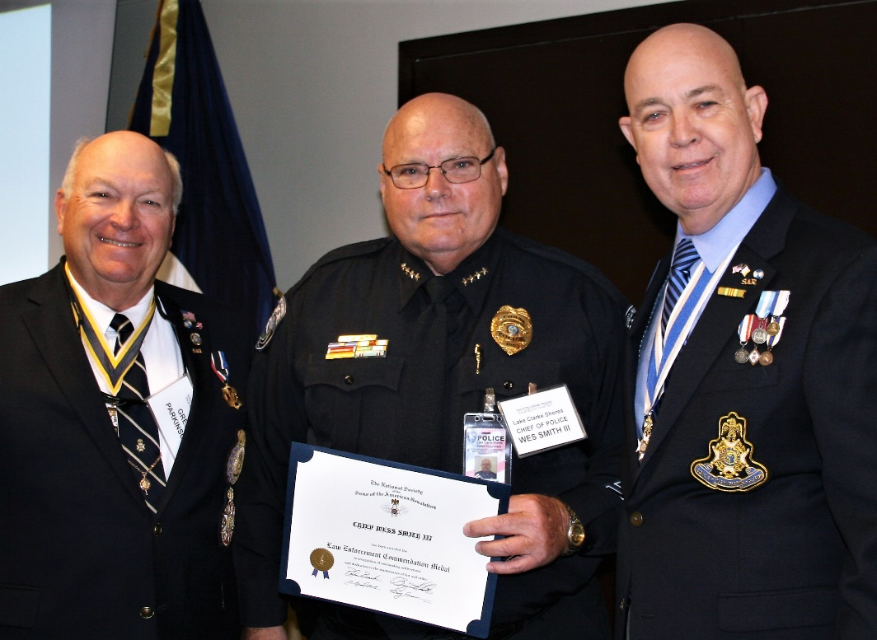

***President Tidwell presents SAR***

***Appreciation Certificate to PBSO Deputy Chief Gauger***

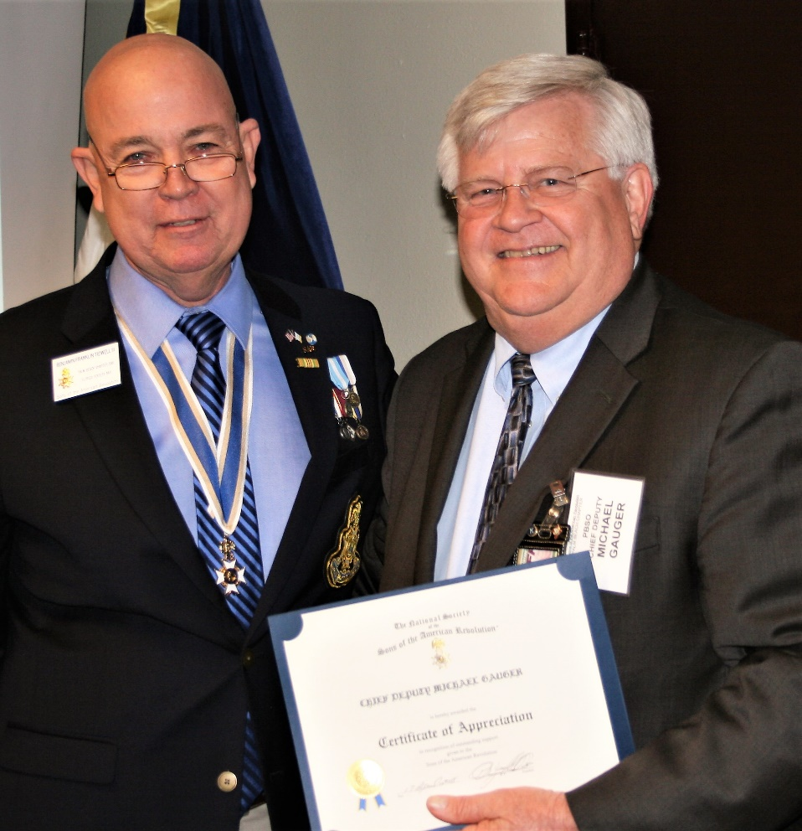

***Officer @ Large Barber presents JROTC Bronze Medal to***

***High School Cadets Cabera, Doucett, Sermons & Freeman***

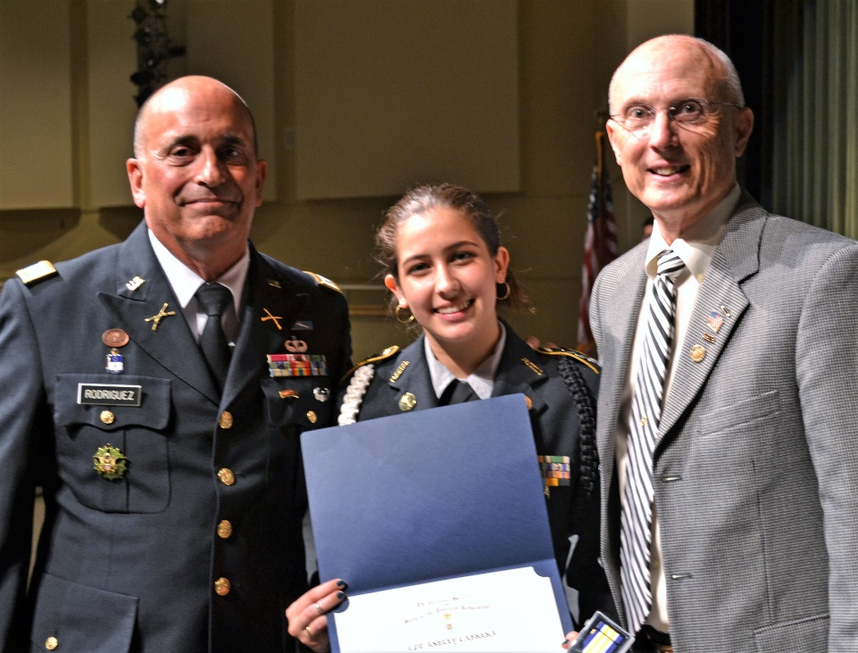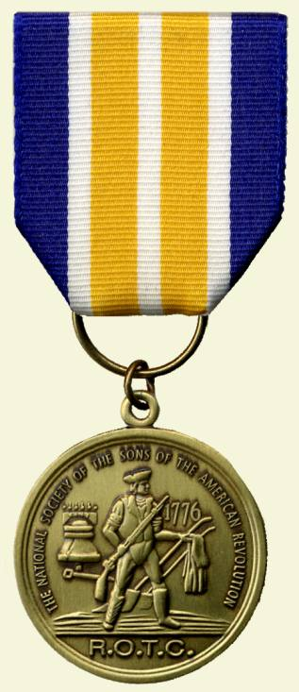

***President Tidwell places Palm Beach Chapter Honor Wreath @***

***Thomas Creek Battle Ceremony in Jacksonville***

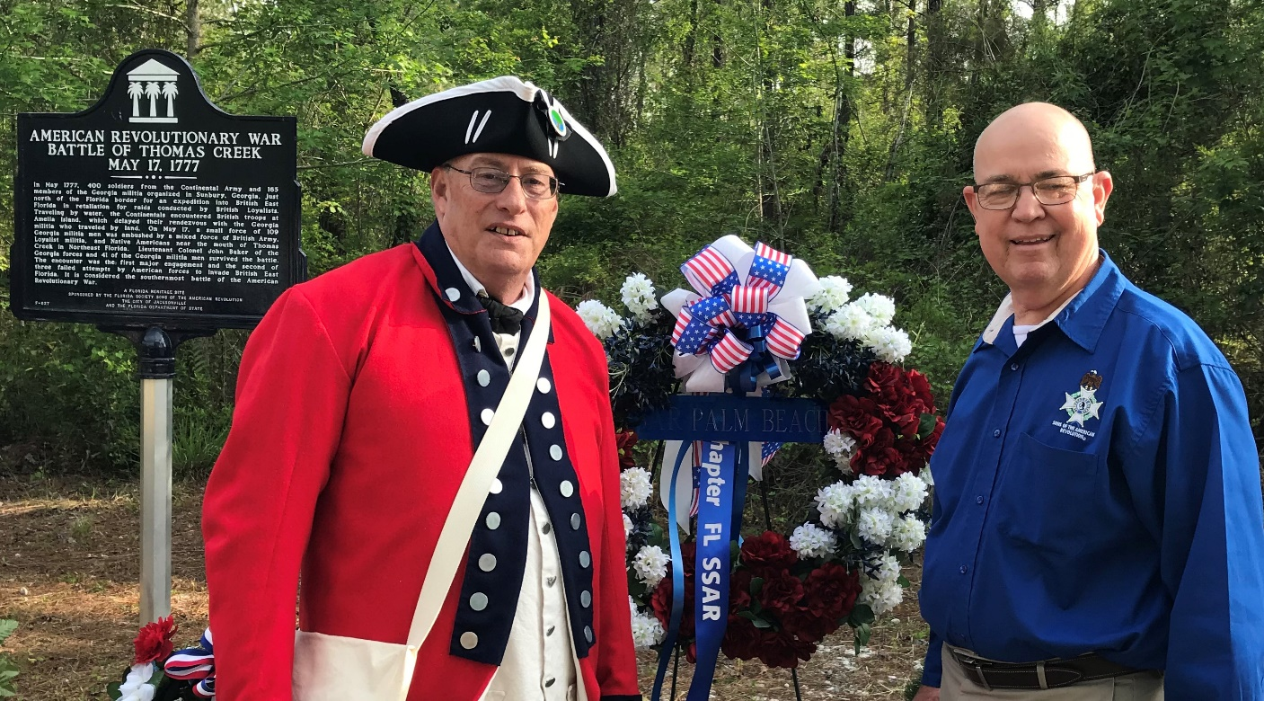

***President Tidwell brings greetings to***

***Spirit of Liberty DAR Regent Bennett & Vice Regent Stroke***

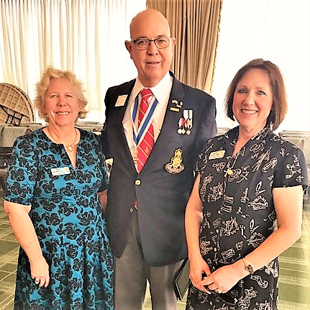

***Former Chapter Presidents Don Lanman & Gary Green***

***Bring greetings to DAR Garcilaso de la Vega Regent Darcy***

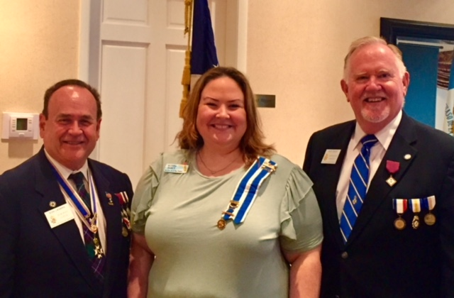

***Former Presidents Lanman & Parkinson & Compatriot Miller***

***Represents Chapter at Veterans Missing in America Ceremony***

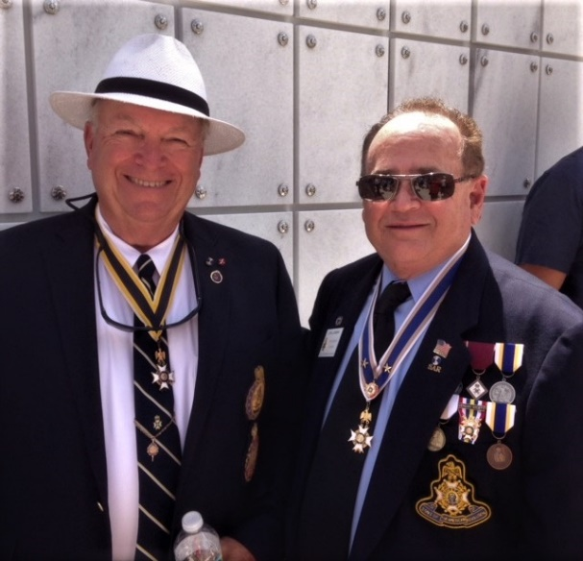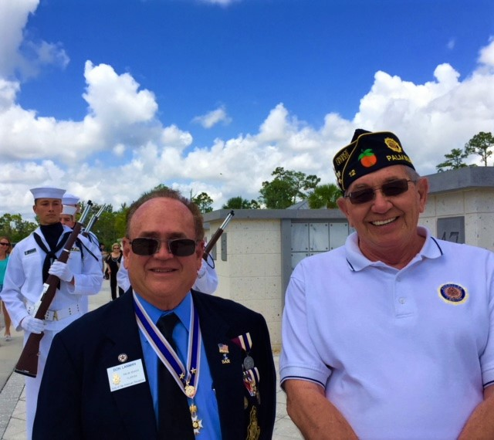

***Former Chapter President Lanman & Treasurer Johnston***

***Join DAR Daughters to bring greetings to Jamestown Society***

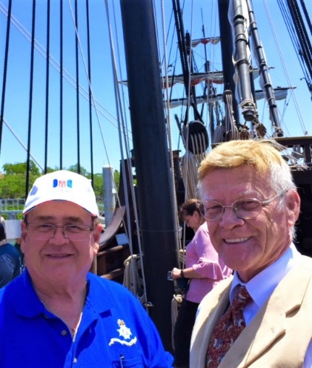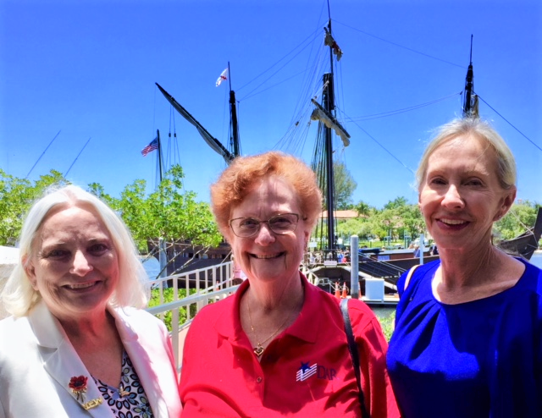

***Sgt. @ Arms Peter Miller delivers raffle basket***

***Law Enforcement Officer***

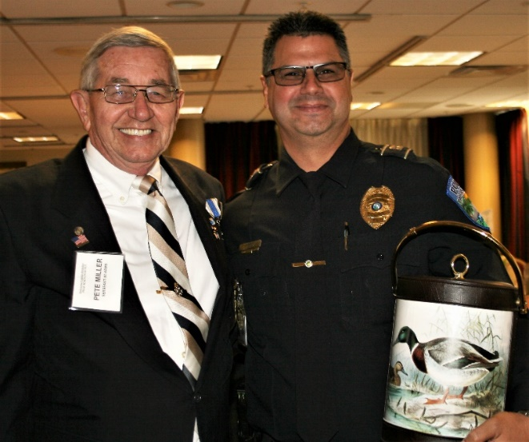

***~80th Anniversary Collectors Commemorative Coin $10.00~***

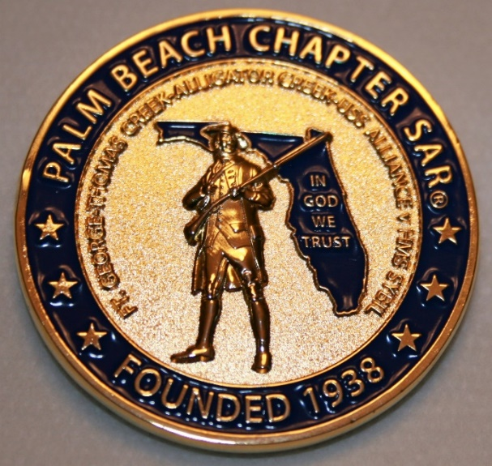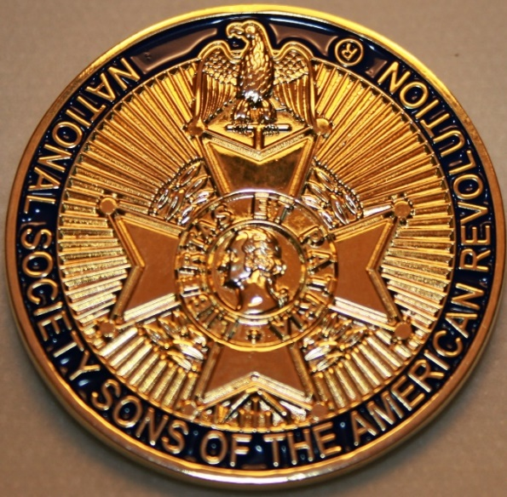

***~Compatriot Sponsored Promotions~***

**Compatriot sponsored newsletter Ads are important to the Chapter as they represent additional funds in support of Chapter projects including;**

***Scholarships, Boy Scout & JROTC medals, Rumbaugh & Knight Essay Youth contests, Police-Firefighter-EMT medals, Americanism & community civic programs!*** Support your Chapter…sponsor an Ad for **8** issuesat a modest cost:

**Business Card $50, Half Page $100, Full Page $250.**

**Your AD donation will also qualify you for the *Presidents Brigade*. Call Don Lanman 561-315-5073 for information.**

***SPECIAL SUPPORT ADS ON FOLLOWING PAGES…***

***~COMPATRIOT ROBERT BRINCKERHOFF***

***~FINANCIAL SERVICES PROFESSIONAL***

***~COMPATRIOT ALEXANDER DREYFOOS***

***~AUTHOR/PHOTOGRPHER/PATRIOT***

***~COMPATRIOT SONNY BARBER***

***~HISTORIAN/AUTHOR/PATRIOT***

***~GARCILASO DE LA VEGA, DAR CHAPTER***

***~DAUGHTERS OF THE AMERICAN REVOLUTION***

***-Morgan Stanley-***

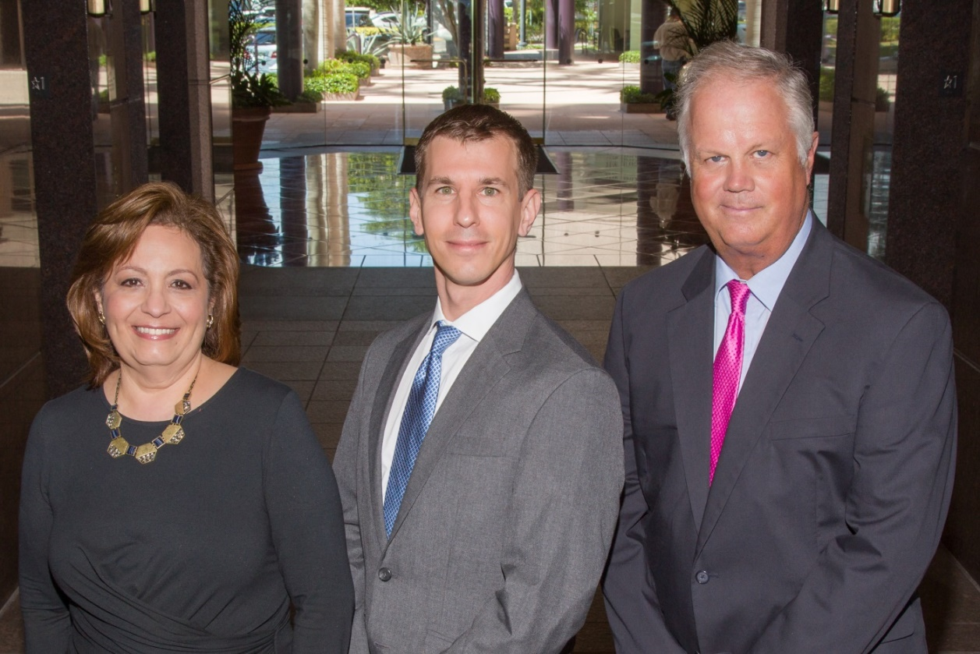  
***Amani Gaballa, Senior Registered Associate; Robert Scarborough, Financial Advisor; Robert Brinckerhoff, First Vice President, Financial Advisor***

***Robert W. Brinckerhoff  
Senior Vice President, Financial Advisor  
777 S. Flagler Dr. Suite 700, East Tower  
West Palm Beach, FL 33401  
(561) 650-7514  
Robert.Brinckerhoff@MorganStanley.com***

***Bob has been a financial advisor since March 1976. He focuses on investment strategies, retirement planning, liquidity solutions for individuals, commercial real estate, and small business owners.***

***Bob is a graduate of the University of Vermont. His clients are geographically diverse and he frequently travels from the east coast to the west to meet with clients. He is active with nonprofit organizations that support the blind and visually impaired. Bob is also an active enthusiast in Ferraris.***

*The investments listed may not be suitable for all investors. Morgan Stanley Smith Barney LLC recommends that investors independently evaluate particular investments and encourages investors to seek the advice of a financial advisor. The appropriateness of a particular investment will depend upon an investor’s individual circumstances and objectives. Morgan Stanley Smith Barney LLC is a registered Broker/Dealer, Member SIPC, and not a bank.*

*Where appropriate, Morgan Stanley Smith Barney LLC has entered into arrangements with banks and other third parties to assist in offering certain banking related products and services. Investment, insurance and annuity products offered through Morgan Stanley Smith Barney LLC are: NOT FDIC INSURED, MAY LOSE VALUE, NOT BANK GUARANTEED, NOT A BANK DEPOSIT, NOT INSURED BY ANY FEDERAL GOVERNMENT AGENCY. Copy write 2015 Morgan Stanley Smith Barney LLC, Member SIPC CRC1355648 11/15.*

*TWO GREAT BOOKS-ONE GREAT MAN*

***-Alexander W. Dreyfoos-***



***-A PHOTOGRAPHIC ODYSSEY- -PASSION & PURPOSE-***

***Compatriot Alexander W Dreyfoos, Jr.*** an honored member of the *Palm Beach Chapter Sons of the American Revolution*, noted American entrepreneur, and philanthropist has published two remarkable books that should be on every bookshelf. **Book sales** **proceeds** **donated to local West Palm Beach charities!**

* ***Passion & Purpose*** chronicles a remarkable lifetime of passion with photography, his business, inventions and philanthropic ventures, as well as his adventures above and below the water. **$29.95.**
* ***A Photographic Odyssey*** is a remarkable collection of hundreds of stunning pictures from 100,000 photos taken by Alex around the world and bound in an elegant 15” by 10” glossy photographic book. You will travel with Alex around the world, above and below the water, to forests, jungles, glaciers, and deserts in the exotic locals of Papua New Guinea, Bhutan, Nepal, China, Japan, and Tibet. The subjects are very divergent contrasting palaces and temples with the vulnerability of people, animals, and exotic scenery. **$60.00.**
* **Support your Chapter & local charities! Get both books, *Passion & Purpose & A Photographic Odyssey,* just $71.96 @ kravis.org/books or Call 561-651-4329.**

***-Alexander W. Dreyfoos-***

*Graduating from MIT and Harvard Business School, Alex founded Photo Electronics Corporation (PCS), specializing in photography and video production. Over the decades, Alex earned 10 US patents and invented the Video Color Negative Analyzer for motion pictures earning him an Academy Award for technical achievement.Many inventions, developed by PCS, are on permanent display at the Smithsonian Institution. Locally Alex also owned television station WPEC TV-12, the CBS affiliate in West Palm Beach. Alex’s many philanthropic achievements include founding the Palm Beach County Cultural Council, the Raymond F. Kravis Center for the Performing Arts and gifting a million dollars to the Dreyfoos School of the Arts. Alex also donated a million dollars each to the Palm Beach County biomedical research campus of the Scripps Research Institute and the local Max Planck Florida Foundation for Neuroscience in Jupiter, Florida.*

***HISTORICAL MYSTERY SERIES FROM THEREVOLUTIONARY WAR ACROSS TIME***



***Follow Kay Telfair across time beginning with Crossed & Found followed by Gold Hush & Stone-Walled….***

***Kay is a normal young teen—normal if that means being unusually curious and having an uncanny knack for putting herself in dangerous situations, which stresses her parents and often tests the relationship with best friend Anna.***

***The series follows Kay across two intrigue-filled summers on adventures involving events in American history. Join Kay’s journey of adventure steeped in American History through three books that excite all ages. At*** [***amazon.com***](http://amazon.com)***, Barnes & Noble or Chapter meetings. (See book summaries following page)***

***SAR Palm Beach Chapter Compatriot/Author Sonny Barber developed an interest in American history at an early age, reading and collecting newspapers, magazines and other materials on historic U.S. and world events. He’s coupled that interest with his fiction writing to create a modern-day “mystery history” Series perfect for Preteens to Adults.***

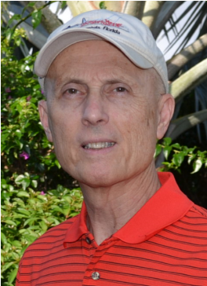

***~Crossed & Found~***

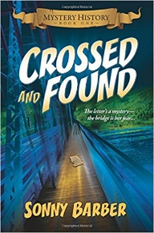

**Thirteen-year-old Kay Telfair believes her life is over when she moves with her family a thousand miles to their new home near the Delaware River in New Jersey. But her life takes an unexpected turn when she meets Anna and discovers a two-centuries-old letter--a letter that could change American history. Before she unravels the letter's mystery, Kay stumbles headlong into an adventure--confronting fears she'd never experienced, stretching the limits of her friendship with Anna, and forcing a test of Kay's physical strength that could save her own life.**

***~Gold Hush~***

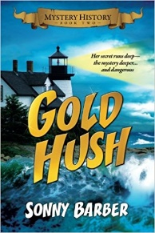

**“I’m avoiding any activity that involves excitement…I’ve learned my lesson.” After an adventure-filled June, all Kay Telfair wants is a quiet vacation in Maine with her family and best friend Anna—no drama, no stress. But the thirteen-year-old’s hopes for a tranquil August stay in the village of Prospect Harbor soon fade when the girls compete for the attention of a young boy and Kay makes a startling discovery—a discovery that sends the three teens on a dangerous quest. Ignoring advice—and menacing threats from others—they continue their pursuit, drawing them deeper into a perilous mystery, deeper than Kay ever could have imagined.**

***~Stonewalled~***

[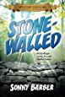](https://www.amazon.com/Stonewalled-Mystery-History-Book-Three/dp/1519351291/ref=pd_bxgy_14_img_3?_encoding=UTF8&psc=1&refRID=75QVZ72QHQ8A2W2F3RK1)

**Kay stared at the gray line of stone walls. “They won’t be too upset to see these knocked down...” A mystery that threatens the relationship with best friend Anna, a battle with Mother Nature at her worst, and the discovery of a tragic secret—not exactly what fourteen-year-old Kay Telfair was looking for in a summer getaway. But that’s what confronts the young teen while helping the owners of Windcrest Farm find a way to stop destruction of nearby farmland and its three-hundred-year-old stone walls. Vacationing with her family and Anna at Windcrest in the quiet, coastal village of Little Compton, Rhode Island, the young teen soon discovers her goal will not be easy. Kay’s prospects for helping preserve the valuable land and stone walls look much better after a surprise visit by a boy from her past. With his help, she pours all her energy and passion into the quest, searching for answers in New England’s Native American and colonial history and learning some important lessons about perseverance and friendship.**

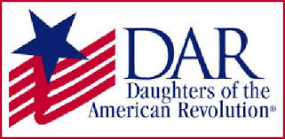

*Garcilaso de la Vega Chapter, NSDAR*

*Lake Worth, Florida*

*Alisha Darcy, Regent*

*Karen Christie, Registrar*

Phone; 561-236-2460-Email; [IMC4U4@AOL.com](mailto:IMC4U4@AOL.com)

Chapter Email: [GarcilasodelaVegaDAR@gmail.com](mailto:GarcilasodelaVegaDAR@gmail.com)

Visit us on ***Facebook*** @ <https://www.facebook.com/LWDAR>