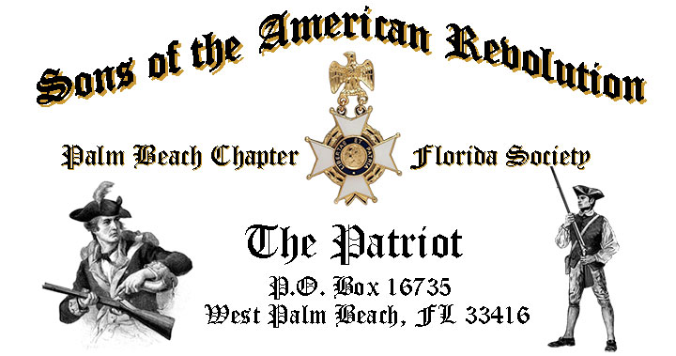

**Volume 22 November 2016 Number 07**

***Welcome to a special meeting to honor all Veterans…***Tuesday, **November 15** @ 12:00 Noon Sharp @ the Embassy Suites Hotel 1601 Belvedere Road, West Palm Beach!

***November Meeting Highlights:***

* ***JROTC Honor Guard-“Presentation of the Colors”!***
* ***Special Guest Speaker Army 1st Sgt. Antonio Correa***
* ***World War 2 Battle of the Bulge Veteran, Sgt. Carl Arfa***
* **Buffet** Lunch, Desserts & Beverages @ **$28** per person **check/cash** at the door.
* **Reservations** required **RSVP** Don Lanman (561)-315-5073
* **Friends & Guests** are always welcome!

**Newsletter Content:**

* President’s Message
* 2016/17 Chapter Meeting Dates &Topics
* Officers & Board Members
* *President’s Brigade* Financial Supporters
* Committees, Chairmen & Members
* National/State Society News & Events
* Feature Article: ***Battle of Guilford Courthouse North Carolina*** 
  + ***“Another Such victory would ruin the British Army!”***
* ***2017 SAR*** Membership Fees are Due
* Chapter Activities Pictures
* Compatriot Sponsored Promotions

**President’s Message:**

Fellow Compatriots,

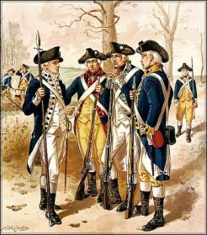

We kicked off the fall season with a remarkable speaker in October with *James Vick*, genealogist and expert in the exciting new science of DNA Ancestral Testing!

Larry took us on a journey of discovery understanding the power of DNA sequencing to uncover amazing information about our origins in general and tracing the male Patriots line using the tools provided by the popular testing services like*Family Tree DNA, 23 & Me, and AncesteryDNA*.

November is Veterans Month and our Chapter will welcome Army First Sergeant *Antonio Correa* and Staff Sergeant *Carl Arfa*, WW2 Battle of the Bulge Veteran and Liberator of the Dachau concentration camp.

Since the birth of our Nation, *American Patriots* of every race, color, creed, gender and national origin have volunteered to serve our country and defend the vision of our founding fathers for a Nation Of, By and For the People.

With honor, distinction and sacrifice, these generations of Patriots risked both lives and fortunes to win our independence, preserve our Union, and secure our freedom.

Beginning with the *Minutemen* at Concord, American heroes have served unselfishly so that our children might live in a world that is safer, freer, and more just than any other nation in history, and to them we owe a profound debt of gratitude.

This *Veterans month*, fellow Compatriots from across the nation salute the long line of Soldiers, Sailors, Airmen, Marines, Coast Guard, and Merchant Marine veterans who rendered the highest service any American can offer.

As grateful Americans, I ask everyone to honor their service through private prayers of thanks, appropriate public ceremonies, and participation in patriotic activities including civic, social, and fraternal organizations, places of worship, schools, and community centers.

We’re blessed to live in a Land of the Free because of the Brave, so this Veterans Month, please display the flag of the United States of America in recognition of the valor and sacrifice of all Veterans!

I hope that you will also join me and your fellow Americans with a warm welcome home, and *“Thank You for Your Service”* to all our Veterans, and especially remember those heroes who made the ultimate sacrifice at the “Alter of Freedom” and have yet to return home.

State and Chapter Veterans who attended the Fall BOM meeting in Orlandowere honored in a special Veterans *Vietnam War Commemoration* Ceremony including a special Memorial Pin, Ribbon, and Proclamations from the President of the United States and Florida Governor Rick Scott.

As a reminder, the SAR “Veterans Battalion” recognizes and honors all Chapter Veterans for their military service. Presently, there are 24 Palm Beach Chapter Compatriots recognized and honored in the *FLSSAR Veterans Battalion*.

To assure that other Chapter veterans receive this recognition, I invite all Vets to simply provide me with a copy of their DD-214 to be recognized and receive the SAR “Service Medal” and Veterans Battalion certificate in honor of their service.

In recognition of Veterans month, I encourage Chapter Veterans to wear the *Florida State Governors Military Service Medal* to the November 15 meeting.

As the Chapter continues to expand its relationships and joint event activity with the local DAR Chapters we are always pleased to welcome our Patriot sisters from DAR Chapters to attend all of our meetings.

I can report that DAR representatives from the Palm Beach chapters including *Palm Beach, Garcilaso de la Vega, Henry Morrison Flagler, Lighthouse Point, Seminole* and *Spirit of Liberty,* have all referred SAR prospects to our Chapter.

We greatly value and sincerely appreciate these new member referrals and the ongoing DAR support of our member development initiatives. Please take time to thank our Patriot Sisters whenever you see them.

The Chapter continues to offer “gift basket raffles” at chapter meetings to raise funds to supplement the Youth Programs budget. Please support this fundraiser by donating interesting raffle items or gift baskets, with a suggested retail value of $30.

All raffle donations are acknowledged at the meeting, included in the newsletter, and donors recognized as a cash donation in support of the *Chapter’s Presidents Brigade*.

**Your Chapter Needs You!!!** **Officer nominations** for 2017 are scheduled for November. The Chapter requests that all members consider officer positions. Please be contact Don Lanman with your nominations or candidacy for President, Vice President, Secretary, Treasurer, Historian, Sergeant at Arms, Officer at Large.

Committee members are needed to support its many youth and civic programs including: Flag Certificates, Liberty Tree Program, Medals/Awards, Veterans Programs, Newsletter, Publicity, High School/Youth Programs; Boy Scouts, JROTC, Rumbaugh Historical Oration and Knight Essay Contests, Police-Firefighters-EMS Service Awards, Chapter Events, Americanism-Patriot Bios, Audit, Membership Development , Officer Nomination, Speakers Bureau, Website Support, Fundraising/Endowment Programs.

Please volunteer for the Officer and committee opportunities of most interest to you and Help make your Chapter both interesting and successful!

Compatriots, I am pleased to report that our membership has grown to 170 with another 20+ applications in process! However, we need your help to continue growing our membership with like-minded individuals interested in good fellowship, honoring our patriot ancestors.

Help us grow our membership by enrolling your Sons and Grandsons in SAR, invite friends and neighbors to join and encourage wives, daughters, and granddaughters to join the *DAR* and *SAR Women’s Auxiliary*.

* **Spread the word about SAR**
* **Serve as Officers & on Committees!**
* **Attend Chapter lunches with guests!**
* **Recruit new members!**

Compatriots, our monthly meetings are important and the Chapter needs your help to avoid losing money on the meeting luncheons. The hotel requires a minimum number of members to cover the room, food, and service, so if the meeting attendance falls below the minimum, the Chapter must pay the difference.

**So, please**, support your Chapter by coming to the meetings, inviting friends and if you cannot make a meeting be sure to cancel your reservation or pay the $28 fee so the chapter does not lose money. Many Thanks

**IMPORTANT—Please send in your 2017 Membership Dues!!** Compatriots are reminded that their 2017 SAR membership fees are due. **Please** mail your $75 annual membership fee to ***SAR PB Chapter, PO Box 16735 West Palm Beach, FL 33416-6735* ASAP** along with any changes to your personal contact information.

Fellow Compatriots, I look forward to seeing you at the November 15 meeting! In closing please, join me in honoring our Veterans, patriot ancestors and remembering our departed Compatriots. **God Bless the *United States of America*.**

-D. Lanman

**2016/2017 Chapter Meeting Dates/Topics:**

**Visit** the Palm Beach Chapter web site @ [www.sarpbchapter.org](http://www.sarpbchapter.org) for a meeting calendar, special events, articles, pictures, and general information.

* **Nov. 15 2017 Officer Nominations**, **Special Veteran Guest Speakers**
* **Dec. 10** Officers Vote,Holiday Event: **Kings Academy Holiday Musical**
* **Jan. 17** 2017 Officer Inductions, **Special Service Awards**
* **Feb. 21** Washington’s Birthday, **Thomas Jefferson to Speak**
* **Mar. 21** Boy Scout/JROTC Awards & a Special Guest Speaker
* **Apr. 18** Law Enforcement Awards & a Special Guest Speaker
* **May 16** Firefighters/EMT Awards & a Special Guest Speaker

**2016 Officers & Board:**

**President**; Donald Lanman

**Vice President;** Benjamin Tidwell III

**Secretary**; Gary Green

**Treasurer**; Peter Johnston

**Registrar**; Robert Boggs

**Chaplain**; Father Sanford Sears

**Sgt. @ Arms**: Byrd Wenman

**Historian**; Samuel “Buddy” Miller

**Patriot Newsletter Editor**; Donald Lanman

**Support Youth Programs-Donate to the President’s Brigade:**

The Chapter honors and expresses its sincere appreciation to the Compatriots of the ***President’s Brigade***! The dedicated members of the ***Presidents Brigade*** donate “extra dollars” in support of the Chapter’s many youth programs, scholarships, civic activities, award certificates, police/firefighter medals, veterans’ projects, and related community outreach programs.

**Presidents Brigade Members:**

**-Bronze Level: $50-$99**

**-Silver Level: $100-$199**

G. Green

J. Harper

J. Curry

A. Griswold

T. Friend

H. Wynns

R. Culpepper

D. Coldwell

D. Shepherd

**-Gold Level: $200-$499**

R. Brinckerhoff

R. Banta

W. Meakin

R. Beck

E. Buckley

D. Lanman

B. Tidwell

S. Hitt

**-Platinum Level: $500+**

1. Dreyfoos

**Committees, Chairs & Members:**

Fellow Compatriots…..The Chapter expresses its sincere appreciation to those members who have volunteered to help with the many committees and projects. **Please** volunteer to help with any of the chapter committees. It does not take much time and is a major help with our many civic initiatives. **Call** or email Don Lanman or Ben Tidwell **Today** to lend a hand on any of the following committees.

* **JROTC** -Tidwell, Chasteen
* **Law Enforcement-Fire Safety** -Davis, Tidwell, Green
* **Veterans Affairs** -Wenman, Lanman
* **Newsletter/Publicity** -Lanman
* **Boy Scouts** -Tidwell
* **Knight Essay/Rumbaugh** **Oration** -Boggs
* **American History Scholarship** -Boggs
* **DAR Liaison** -Lanman, Tidwell
* **Speakers Bureau** -Lanman, Tidwell
* **Audit** -Coldwell, Tidwell, Lanman
* **2017 Officer Nomination** -Lanman, Tidwell, Boggs
* **Flag Certificates** -Clouse, Lanman, Tidwell
* **Membership** -Green, Boggs
* **Liberty Tree** -Open
* **Patriot Bios** -Open

**New SAR Lapel Pin:**

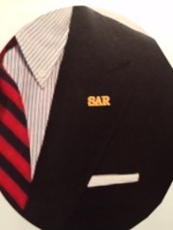

Make a fashion statement with a new ***SAR*** pin for your lapel or shirt. The new society Lapel Pin is part of an S.A.R. Branding program to help promote the S.A.R. and stimulate new membership!

The **classy** new lapel pin is a recognizable symbol of the SAR for the public, gives you immediate recognition as a member, and may spark conversation about SAR that leads to a new member. The new pin worn with the SAR rosette creates a very professional image that will improve overall SAR name recognition. The Chapter has a supply of pins for Compatriots at the monthly meetings for just $10. **Get yours today**!

**National & State Society News:**

**-Chapter Events:** Chapter Compatriots participated in the Missing in America Veteran internment ceremony in October to honor 16 veterans with full military honors. Compatriots also participated in an October Genealogical Society new member recruiting event.

**-State Society:** Board of Management meeting held in October, compatriots honored with a ***“Welcome Home, Vietnam Veterans Ceremony”*** including special ribbons, pins and proclamations from the President of the United States and Florida State Governor.

**- “HONOR FLIGHT” Guardian Program:** The Palm Beach Chapter is supporting the *Florida State Society of the Daughters of the American Revolution* and *Honor Flights Southeast Florida* with an Honor Flight event on **April 8, 2017** from Palm Beach Airport to Washington DC.Interested Chapter Compatriots must complete an application and submit $400 for travel expenses to join Florida DAR members and WW 2 & Korean War Vets on their visit to war memorials in DC!  For **information** and an application contact Gladys Van Otteren, FSSDAR State Chairman Honor Flight program (561)-324-2937 or [HMFchapterDAR@gmail.com](mailto:HMFchapterDAR@gmail.com).

**Feature Article:**

***“Another such victory would Ruin the British Army.”***

***The Battle of Guilford Courthouse North Carolina!***

**By Don Lanman, President Palm Beach Chapter**

The *“Ides of March”* were particularly fateful 235 years ago in the closing days of the war when a signature battle of the *American Revolutionary War* took place in the Southern colonies at the remote county seat of *Gilford Courthouse* in North Carolina.

It was a bright, cool winter day in north central North Carolina when the two major armies clashed at Guilford Courthouse on March 15, 1781. This rural county seat had less than 100 full time residents but its population grew that day to 4,400 as Continental regulars and Colonial militia under the command of *General Nathanael Greene* gathered to meet the Redcoats.

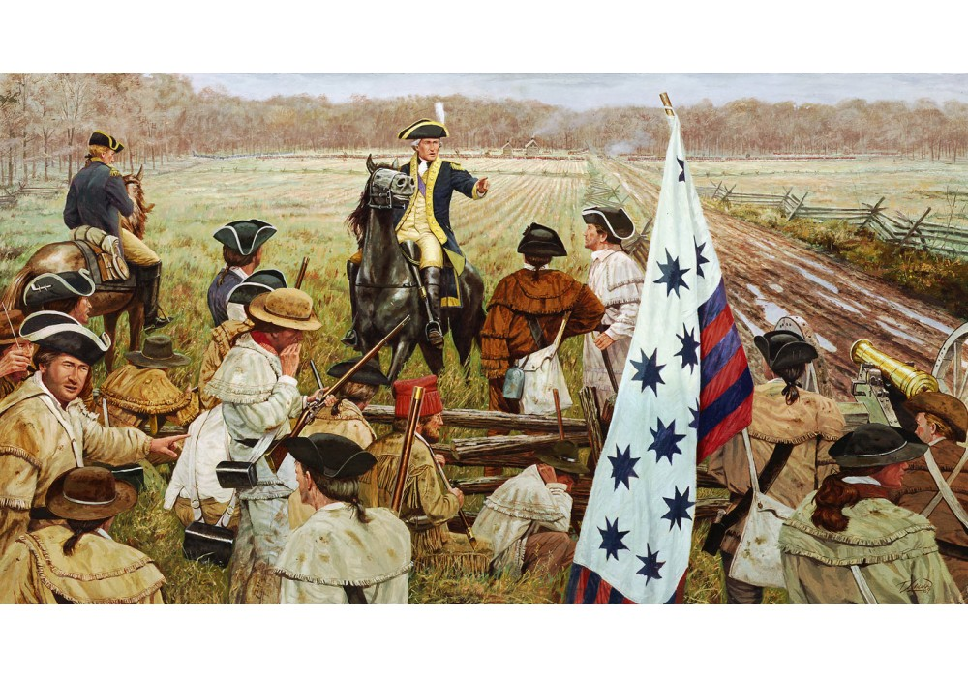

General Greene’s Colonial army of 4,400* was comprised of 1,700 regulars and 2,700 militia, mostly of farmers, called for temporary military service as needed.

The British army comprised of 2,000 professional and battle-hardened troops commanded by aristocrat and professional soldier *General Charles Cornwallis*, had recently overrun Virginia, Georgia, and South Carolina, and were now poised to beat the Americans of North Carolina into submission.

While grossly outnumbered, General Cornwallis was confident that his professional soldiers could sweep aside this mixture of regulars and inexperienced militia.

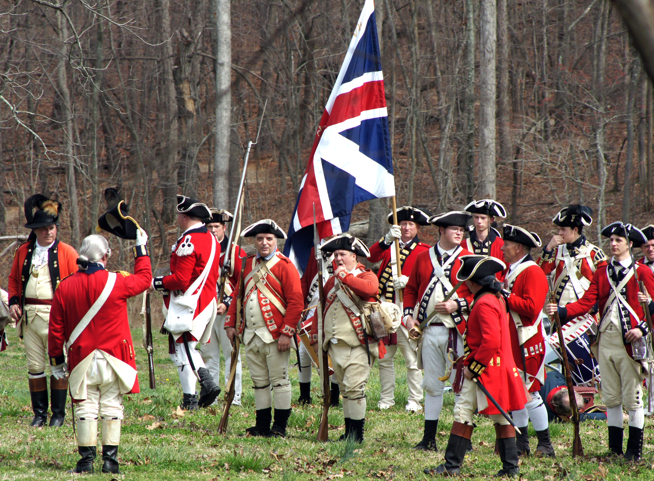

General Greene chose his ground carefully by deploying his men into three lines of battle across the *Great Salisbury Wagon Road* that led to the southwest facing the British army, locating his Continental regulars as the finial line to deliver the most destructive resistance to the enemy.

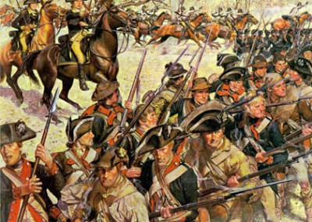

Greene had deployed first line of North Carolina militia with instructions to fire at least two shots into the enemy ranks before withdrawing behind the second then third line of regulars. His troops strategically positioned, the battle began just after noon when Greene’s artillery unleashed deadly cannon fire on the Redcoats.

Drums snapping, bagpipes skirling, and bayonets glinting in the winter sun, the Redcoats marched at a measured pace through the artillery barrage toward the rail fence where a thousand American militia long rifles opened fire with devastating results.

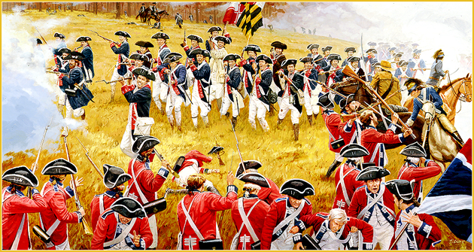

The British line, with great holes torn in its ranks and indifferent to causalities, staggered but then re-formed, and stepping over their dead and wounded rushed head on into the North Carolinians with musket fire and leveled bayonets.

Before retreating, Greene’s first line of militia inflicted heavy casualties on the Redcoats. One British officer later recalled that when men of *His* *Majesty’s* *Own*, *71st Highland Regiment of Foot* were hit by the first volley, "*one half of the Highlanders dropped on that spot."*

The second Colonial line proved another powerful fighting force to blunt the British advance. Greene had located them in heavy forest, with good cover, clear targets, and Officers ordered to shoot any soldiers who broke ranks to run from the battle.

Greene’s Virginia militia fought valiantly against the Redcoats for about an hour in a fierce battle that a British writer later described as *"a number of irregular, but hard fought and bloody skirmishes."*

The heaviest fighting took place on the third line where General Greene had stationed his battle seasoned Continentals. After fighting savagely and enduring more heavy losses, the Redcoats continued their assault finally breaking through the third line to scatter the American ranks onto a cleared field just beyond the skirmish line.

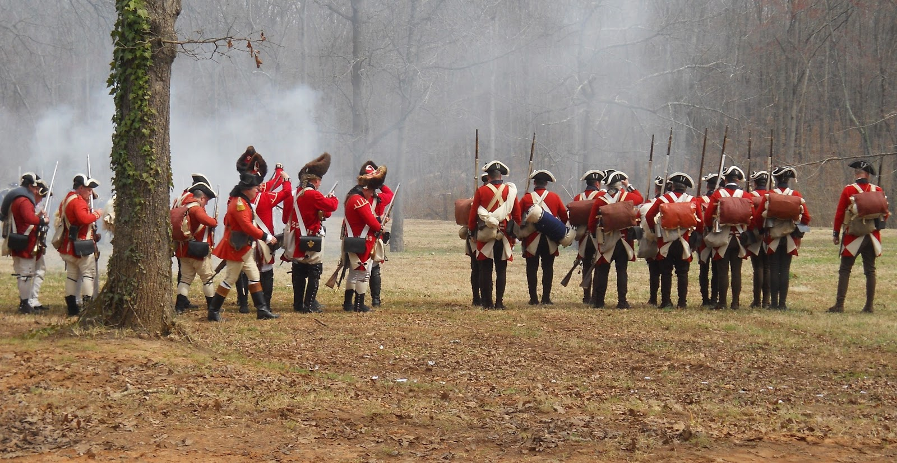

In that cleared field, the fighting swayed back and forth, and there, for the first time in the battle, Greene’s cavalry rode slashing into the Redcoats ranks. Cornwallis suddenly saw that he was in real danger of attack from both the front and flanks by Greene’s infantry and cavalry.

Fearing defeat, Cornwallis ordered his artillery to fire deadly *grapeshot* rounds directly into the battle area killing and wounding both American and British soldiers alike.

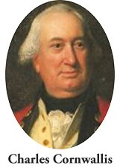

The Cornwallis artillery gambit worked and despite killing many of his own soldiers, when the smoke cleared the battle was over and Greene ordered his army into a strategic withdrawal leaving the British in possession of the battlefield.

Final battle casualty reports noted 93* British soldiers killed, 413 wounded, and 26 missing while on the American side 79 soldiers were reported killed, 185 wounded and 1,046 missing. The missing soldiers were likely the Colonial militia returning to their farms since the battle was over.

While the British won the *Guildford Courthouse* battle, Cornwallis failure to destroy Greene’s army and allowing them to escape unopposed into South Carolina, unwittingly sealed the fate of the British-held South.

Over the following month’s Greene’s troops continued to fight engaging in four pitched battles in the South and while losing these engagements, reminiscent of Guilford Courthouse, they refused to give up the offensive against the British. As Greene commented, “*We fight, get beat, rise, and fight again.”*

General Greene’s “hit and run” strategy kept the British forces fully engaged in the South, exhausting their supplies and keeping them from diverting much needed forces to the northern campaign.

While the Gilford Courthouse battle was a British victory, failing to defeat either the spirit or will of the Americans led the British Parliament to the conclusion that the Colonial war was just too expensive for the government to support.

*Receiving the news of the battle of *Guilford Courthouse*, Member of Parliament Charles J. Fox addressing the *House of Commons* commented,…

***“Another such victory would ruin the British army.”***

**Footnote: As an interesting footnote to the *Battle of Guilford Courthouse* is that my Patriot Ancestor, ***James Lanman*** is a veteran of that famous battle.

The son of America’s pioneer founders, James Lanman took up the Patriot’s cause in July 1776 enlisting in Charleston, SC as an Orderly Sargent with the *1st Regiment of Rife of the South Carolina* Colonial Army.

Serving under General Williams, his service included battles against members of the loyalist Cherokee Nation including the fierce battle of *Valley Town* on the Tennessee River.

Following his service with the Regiment of Rifle, James reenlisted in March 1781 in Hillsborough, NC with the *1st Regiment of Horse* (cavalry) of the Southern Army in time to see action in two major battles of the Southern campaign, *Guilford Courthouse* and *Eutaw Springs*.

Following the Guilford Courthouse battle, James fought in the last major battle of the Southern campaign at Eutaw Springs, SC on September 8 1781.

Under the command of Revolutionary War greats including General Greene*, “Swamp Fox”* Francis Marion, and *“Light Horse”* Harry Lee, the two armies were equally matched at about 2,000 troops each.

The fighting was fierce and the causalities were high on both sides, but while the battle was technically a draw, it was actually a loss for the British since they failed to stop General Greene’s Southern campaign.

Wounded during the battle along with his commander Colonel John Henderson, both men were transported to the farm of a Quaker widow named Nelson for first aid. Following recuperation, James, honorably discharged from the Colonial Army, moved back to his home in Caswell County, NC then on to Illinois to claim is war bounty land grant.

His personal flintlock from that battle has been in the Lanman family for generations….

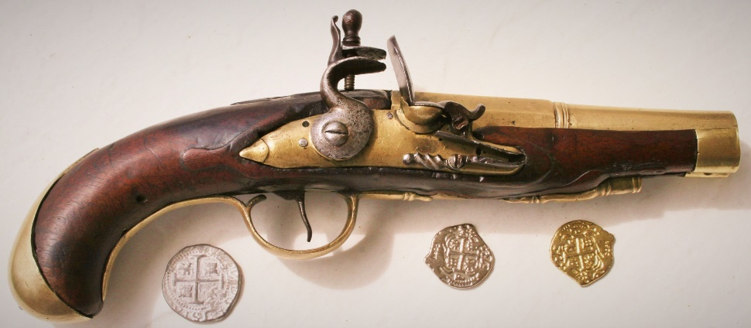

***Patriot James Lanman’s Personal Flintlock***

*\*Source: Thomas E. Baker book-Another Such Victory*

**2017 Membership Fees are Due Now!**

**Keep your SAR membership active…**Compatriots the 2017 SAR membership dues are payable now. **Please** mail your $75 annual membership fee to ***SAR PB Chapter, PO Box 16735 West Palm Beach, FL 33416-6735*** ASAP along with any changes to your personal contact information.

**Remember….Your** membership dues and additional donations fund the many Chapter civic activities including **Scholarships**, ***Boy Scout & JROTC medals, Rumbaugh & Knight Essay Youth contests, Police-Firefighter-EMT awards, Flag Certificates, Americanism, & Community programs.***

**Chapter Activities Pictures:**

**Chapter Veterans Honored @ October BOM**

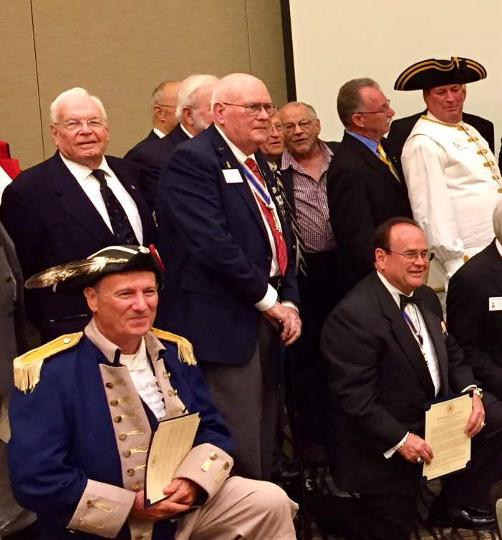

**President Lanman Presents Florida**

**Veterans Foundation Certificate of**

**Appreciation to State Society @**

**October BOM for Veterans Support**

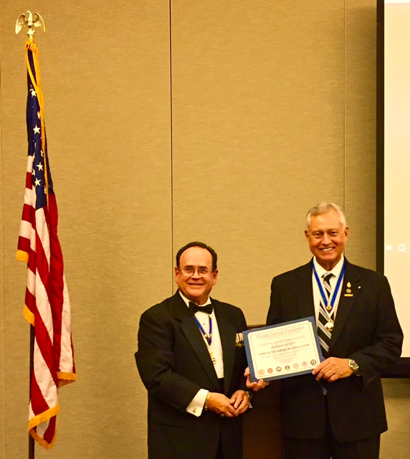

**Army 1st Sergeant Correa to Speak @ November Meeting**

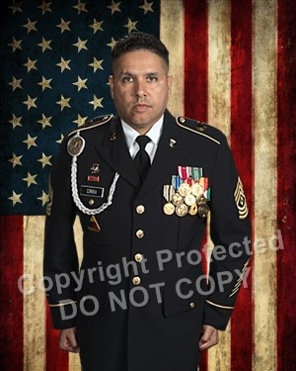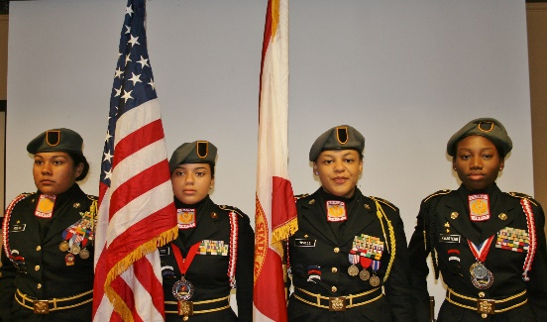

**President Lanman VP Tidwell @ Veterans Missing in America Ceremony**

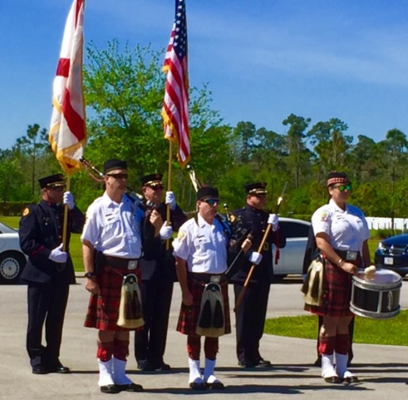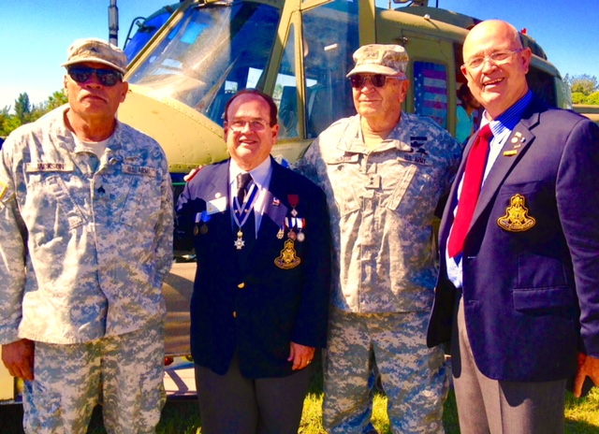

**President Lanman, VP Tidwell, Treasurer Johnston,**

**Past President Green Recruiting @ Genealogical Event**

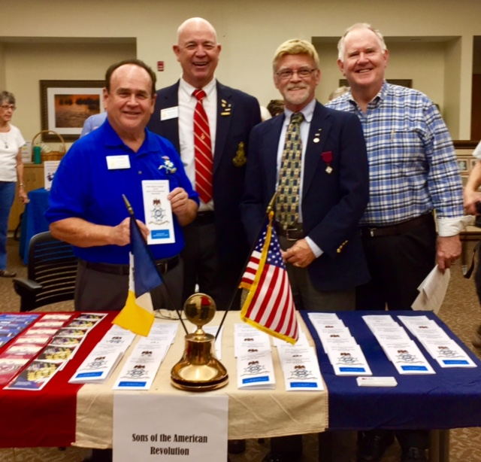

**Compatriot Sponsored Promotions:**

The Compatriot sponsored Ads are important to the Chapter as they represent additional funds to support all Chapter projects including: ***Boy Scout & JROTC medals, Rumbaugh & Knight Essay Youth contests, Police-Firefighter-EMT awards, Americanism & community programs!***

**Please** consider helping your Chapter with an Ad at the modest cost for **8** issues **@ Business Card $50, Half Page $100, Full Page $200.**

**Your AD donation will also qualify you for the *Presidents Brigade* listing. Call Don Lanman 561-315-5073 for information.**

***SPECIAL SPONSORED ADS ON FOLLOWING PAGES…***

***-COMPATRIOT ALEXANDER DREYFOOS***

***-COMPATRIOT ROBERT BRINCKERHOFF***

***-DAR GARCILASO DE LA VEGA, CHAPTER DAUGHTERS OF THE AMERICAN REVOLUTION***

*TWO GREAT BOOKS-ONE GREAT MAN*

***-Alexander W. Dreyfoos-***



***-A PHOTOGRAPHIC ODYSSEY- -PASSION & PURPOSE-***

***Compatriot Alexander W Dreyfoos, Jr.*** an honored member of the *Palm Beach Chapter Sons of the American Revolution*, noted American entrepreneur, and philanthropist has published two remarkable books that should be on every bookshelf. **Book sales** **proceeds** **donated to local West Palm Beach charities!**

* ***Passion & Purpose*** chronicles a remarkable lifetime of passion with photography, his business, inventions and philanthropic ventures, as well as his adventures above and below the water. **$29.95.**
* ***A Photographic Odyssey*** is a remarkable collection of hundreds of stunning pictures from 100,000 photos taken by Alex around the world and bound in an elegant 15” by 10” glossy photographic book. You will travel with Alex around the world, above and below the water, to forests, jungles, glaciers, and deserts in the exotic locals of Papua New Guinea, Bhutan, Nepal, China, Japan, and Tibet. The subjects are very divergent contrasting palaces and temples with the vulnerability of people, animals, and exotic scenery. **$60.00.**
* **Support your Chapter & local charities! Get both books, *Passion & Purpose & A Photographic Odyssey,* just $71.96 @ kravis.org/books or Call 561-651-4329.**

***-Alexander W. Dreyfoos-***

*Graduating from MIT and Harvard Business School, Alex founded Photo Electronics Corporation (PCS), specializing in photography and video production. Over the decades, Alex earned 10 US patents and invented the Video Color Negative Analyzer for motion pictures earning him an Academy Award for technical achievement.Many inventions, developed by PCS, are on permanent display at the Smithsonian Institution. Locally Alex also owned television station WPEC TV-12, the CBS affiliate in West Palm Beach. Alex’s many philanthropic achievements include founding the Palm Beach County Cultural Council, the Raymond F. Kravis Center for the Performing Arts and gifting a million dollars to the Dreyfoos School of the Arts. Alex also donated a million dollars each to the Palm Beach County biomedical research campus of the Scripps Research Institute and the local Max Planck Florida Foundation for Neuroscience in Jupiter, Florida.*

-Morgan Stanley-

  
***Robert Scarborough, Financial Advisor; Amani Gaballa, Senior Registered Associate;***

***Logan Gordon, Financial Advisor; Robert Brinckerhoff, Senior Vice President, Financial Advisor***

***Robert W. Brinckerhoff, Senior Vice President, Financial Advisor  
777 S. Flagler Dr. Suite 700, East Tower  
West Palm Beach, FL 33401, (561) 650-7514***[***Robert.Brinckerhoff@MorganStanley.com***](mailto:Robert.Brinckerhoff@MorganStanley.com)

***Bob has been a financial advisor since March 1976. He focuses on investment strategies, retirement planning, liquidity solutions for individuals, commercial real estate, and small business owners.***

***Bob is a graduate of the University of Vermont. His clients are geographically diverse and he frequently travels from the east coast to the west to meet with clients. He is active with nonprofit organizations that support the blind and visually impaired. Bob is also an active enthusiast in Ferraris.***

*The investments listed may not be suitable for all investors. Morgan Stanley Smith Barney LLC recommends that investors independently evaluate particular investments and encourages investors to seek the advice of a financial advisor. The appropriateness of a particular investment will depend upon an investor’s individual circumstances and objectives. Morgan Stanley Smith Barney LLC is a registered Broker/Dealer, Member SIPC, and not a bank.*

*Where appropriate, Morgan Stanley Smith Barney LLC has entered into arrangements with banks and other third parties to assist in offering certain banking related products and services. Investment, insurance and annuity products offered through Morgan Stanley Smith Barney LLC are: NOT FDIC INSURED, MAY LOSE VALUE, NOT BANK GUARANTEED, NOT A BANK DEPOSIT, NOT INSURED BY ANY FEDERAL GOVERNMENT AGENCY. Copy write 2015 Morgan Stanley Smith Barney LLC, Member SIPC CRC1355648 11/15.*



*Garcilaso de la Vega Chapter, NSDAR*

*Lake Worth, Florida*

*Sheila Zile-Pecoraro, Regent*

*Judy Mahaffey,* Registrar

Phone; 561-876-9520-Email; [Smileson@AOL.com](mailto:Smileson@AOL.com)

Chapter Email: [GarcilasodelaVegaDAR@gmail.com](mailto:GarcilasodelaVegaDAR@gmail.com)

Visit us on ***Facebook*** @ <https://www.facebook.com/LWDAR>