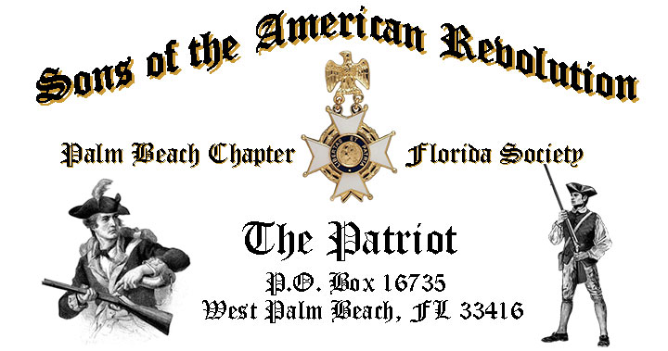

***Volume 23 November 2017 Number 08***

***RSVP early for the November meeting featuring Florida Historian/Author Steve Carr*** presents, ***“Ride with the Ashley Gang”*** *Tuesday* **November 21, 12:00 Noon** @ the Embassy Suites 1601 Belvedere Road, WPB! ***RSVP*** today for this popular event.

***November 21, Meeting Highlights:***

* ***Florida Historian/Author Steve Carr, “Ride with the Ashley Gang”***
* ***Special Vocalist CAR Member-Page: Ms. Emma Robbins***
* ***Buffet******Lunch***, Desserts & Beverages, **$28** per person **Check/Cash** @ the door!
* ***Reservations*** **required,** **RSVP**, Don Lanman **(561)-315-5073!**
* **Family, Friends & Guests** are always ***Welcome***!

***Newsletter Content:***

* **President’s** Message
* **2017/18** Chapter Meeting Dates &Topics
* **Officers** & Board Members
* ***President’s*** *Brigade* Financial Supporters
* **Committees**, Chairmen & Members
* **National**/**State** Society News & Events
* **Feature Articles: *Burning His Majesty’s Ship “Gaspee”***
  + ***Land of the Free-Because of the Brave-Veterans Tribute***
* **Chapter** Meeting & Event Pictures
* **Compatriot** Sponsored Promotions

***President’s Message:***

***Fellow Compatriots & Friends…***

The ***November*** meeting will be exceptional as Florida historian/author *Steve Carr* takes us back to *Prohibition-Era Palm Beach* to follow the exploits of *John Ashley* and *Laura Upthegrove,* the ***“King & Queen of the Everglades”!***

Carr’s book, ***"Ride with the Ashley Gang",*** sheds new light on Florida’s most notorious gang of outlaws! We’ll follow the Ashley gang as they unleash murder, mayhem, bank/train robberies, bootlegging, moonshining, prostitution, and a "to the death blood feud" with the Palm Beach County Sheriff *Bob Baker* in this incredible tale of Florida's frontier history.

[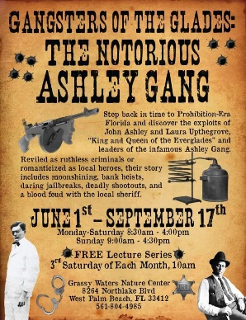](https://www.google.com/url?sa=i&rct=j&q=&esrc=s&source=images&cd=&cad=rja&uact=8&ved=0ahUKEwirp9_Z-LHXAhVMJiYKHQr8DrAQjRwIBw&url=https://twitter.com/westpalmbch/status/870338401311928321&psig=AOvVaw1ihDzyu4PWaXQX2V4ESpeO&ust=1510332288018940)[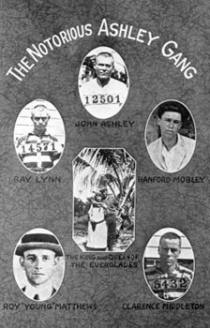](https://www.google.com/url?sa=i&rct=j&q=&esrc=s&source=images&cd=&cad=rja&uact=8&ved=0ahUKEwjY54fM-7HXAhUPxCYKHU_eDK0QjRwIBw&url=http://www.wpb.org/Meetings-Events/Event-Listings/Ride-withthe-Ashley-Gang-Free-Lecture&psig=AOvVaw1ihDzyu4PWaXQX2V4ESpeO&ust=1510332288018940)[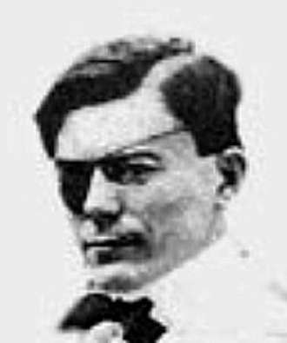](https://www.google.com/url?sa=i&rct=j&q=&esrc=s&source=images&cd=&cad=rja&uact=8&ved=0ahUKEwiu0POF_LHXAhVG7iYKHceiCCcQjRwIBw&url=http://www.mypalmbeachpost.com/news/local/south-florida-most-wily-gangster-john-ashley/wQWBHTo2DVro7LKv4DpjCK/&psig=AOvVaw1ihDzyu4PWaXQX2V4ESpeO&ust=1510332288018940)[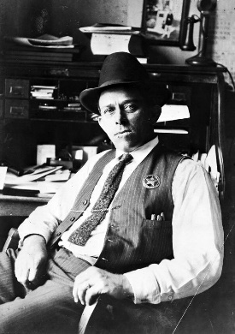](https://www.google.com/url?sa=i&rct=j&q=&esrc=s&source=images&cd=&cad=rja&uact=8&ved=0ahUKEwjQ95y1-7HXAhXLQiYKHeUOBfgQjRwIBw&url=https://www.pinterest.com/pin/503418064569443902/&psig=AOvVaw1ihDzyu4PWaXQX2V4ESpeO&ust=1510332288018940)

The meeting also features aspiring vocalist, pianist, and *Children of the American Revolution* Page, *Ms. Emma Robbins* to sing our National Anthem and God Bless America, plus a *“Patriot Bio”* delivered by *Compatriot Thom Irwin*.

In recognition and honor of Veterans Month, each meeting attendees will receive a special ***“American Veteran Flag”*** lapel pin donated by *Compatriot Thom Irwin.*

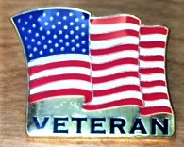

The Palm Beach Chapter is a historic supporter of our Nation’s Veterans, with over 15% of its members serving, from *WW II to Iraq*. Veteran Compatriots are encouraged to provide their *DD-214* to be recognized with the ***SAR Military Service Medal*** and welcomed into the***FLSSAR* *Veterans Battalion*** and the *Chapter’s* own **“*Band of Brothers.”***

Chapter Compatriots joined DAR Daughters at the military funeral of WW II US Army soldier ***Sergeant Richard G. "Tiny" Sowell*** at the Woodlawn Cemetery in West Palm Beach on 11/10.

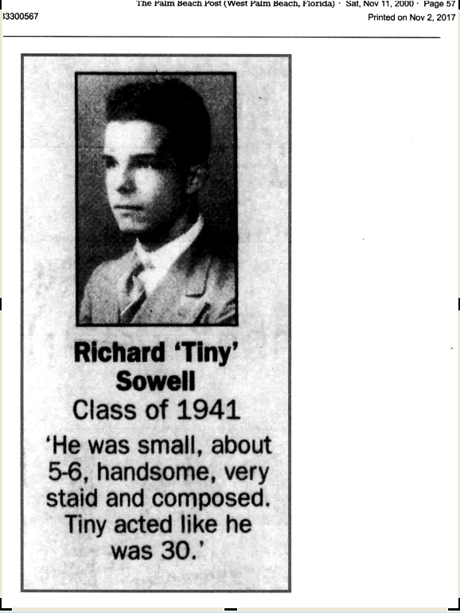

A Veteran of many terrible battles in the South Pacific, Sergeant Sowell was killed in Saipan in 1944. His remains were not identified until 2017 however and returned to West Palm Beach on 11/8 for a full Military Funeral. Sgt. Sowell was a native of West Palm Beach, graduate of Palm Beach High School Class of 1941 and sophomore at the University of Florida before entering the Army in 1943.

During the October meeting, the Chapter delivered a special ***Memorial Service*** to honor departed ***Compatriot, Combat Veteran, Past Chapter/State President*** *and* ***Patriot Medal***recipient ***Gerry******Meeks***.

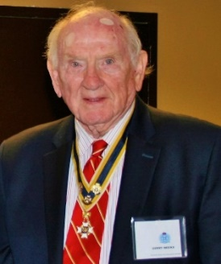

***Veterans Month*** is always a special opportunity to show our respect and to say **"*Thank You*"** to Veterans, Active Service Members and their supportive Families, and to honor the memory of those who sacrificed all at the ***Altar of Freedom***.

The “***Chapter’s Own”***, *Lauren Goepfert* was honored at the November Board of Management meeting for winning both the Chapter, State and National “*History Teacher of the Year Award*” contests.

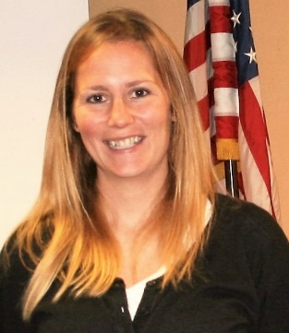

The Chapter presented a scholarship check for $1,000 to Palm Beach Atlantic University for an as aspiring History student. We will also induct several new members at the November meeting.

*Compatriots Lanman, Tidwell* and *Pete Miller* manned an SAR recruiting display at the annual *Palm Beach County Genealogical Club* event in West Palm Beach identifying 3 SAR prospects.

The custom ***Palm Beach Chapter Commemorative Coin*** is available in honor of the ***Chapter’s 80th Year***. The coin notes the four major revolutionary war battles waged in *Florida* with an illustration of a Minuteman standing guard over *Florida* with the State moto of ***“In God We Trust.”***

These beautiful Collector coins, used as mementos for special chapter guests and patriotic occasions, are available for purchase at just $10 each.

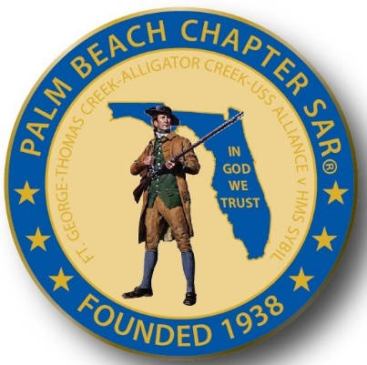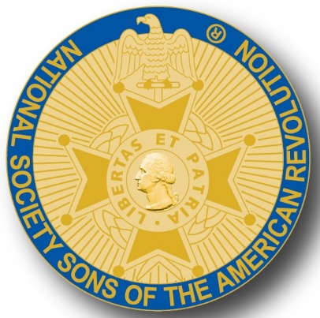

A primary Chapter goal for our continued success is membership development and the mentoring of new members. We are currently at 185 members with 41 prospects in the pipeline.

However, with the natural turnover of members, we need all Compatriots to help grow membership by recruiting civic-minded individuals interested in honoring our patriot ancestors and enjoying good fellowship.

Take action today to enroll Sons and Grandsons, invite friends to join and encourage wives, daughters, and granddaughters to join the *DAR* and *Chapter Women’s Auxiliary*.

Another important mission is expanding our relationships with all of the Palm Beach *DAR Chapters*. We welcome our ***DAR Patriot Daughters*** to all Chapter meetings and events, and sincerely appreciate their new member referrals and ongoing support. ***Thank you DAR!***



***Nominate Officers for 2018!*** Contact Don Lanman to nominate Officers for all positions from President to Officer-@-Large positions. The Chapter will vote on 2018 Officers in December and induct the officers in January 2108.

Our Chapter **desperately** needs Compatriots for the 2018 committees to support our many civic programs including Rumbaugh Historical Oration/Knight Essay Contests, Teacher of the Year, social media, website support Veterans programs, Publicity, Boy Scouts, JROTC, Police-Firefighters-EMS Service Awards, and Fundraising/Endowment Programs. ***Volunteer Today!***

***2018 Membership Dues!*** Compatriots need to send in their **2018 Membership Dues Notices** as soon as possible with the annual membership dues of $75 plus any additional donation to the general fund. It’s also a good time to update your contact information.

***Compatriots***, please remember that our hotel requires a minimum number of guests to cover the room, food, and services fees, so when attendance is low or there are no shows, the Chapter must pay the difference. Please help us avoid losing money on the chapter luncheons by attending each meeting and bringing guests!

Fellow Compatriots, I look forward to seeing you at our October meeting! Please, join me in honoring our nation’s Veterans, Patriot Ancestors, and especially our Dear Departed Compatriots. **God Bless You** and **God Bless the *United States of America*.** **-D. Lanman**

**2017/18 Chapter Meeting Dates/Topics:**

**Visit** the Palm Beach Chapter web site @ [www.sarpbchapter.org](http://www.sarpbchapter.org) for a meeting calendar, special events, articles, pictures, and general information.

* **Nov. 21,** **Officer Nominations 2018**, **SAR State President Folk Visit**
* **Dec. 9,** ***Kings Academy Christmas & Holiday Musical***
* **Jan. 16, 2018** **Officer Inductions**, Special Guest Speaker
* **Feb. 20, 2018**, ***Special Guest Speaker Thomas Jefferson***
* **March 20, 2018**, Special Guest Speaker
* **April 17, 2018**, ***Law Enforcement Awards Ceremony***
* **May 15,2018, *Firefighters/EMT Awards Ceremony***

***2017 Officers & Board:***

**President** **Donald Lanman**

**Vice President** **Benjamin Tidwell III**

**Secretary** **Gary Green**

**Treasurer** **Peter Johnston**

**Registrar** **Robert Boggs**

**Chaplain** **Father Sanford Sears**

**Sgt. @ Arms Brian Davey**

**Historian** **Samuel “Buddy” Miller**

**Officer @ Large** **Bill Johnson**

**Patriot Newsletter Editor** **Donald Lanman**

***Nominations Open for 2018 Officer & Board. Nominated to date:***

**President** **Benjamin Tidwell III**

**Vice President** **Robert Boggs**

**Secretary** **Gary Green**

**Treasurer** **Peter Johnston**

**Registrar** **Robert Boggs**

**Chaplain** **Father Sanford Sears**

**Sgt. @ Arms Peter Miller**

**Historian** **Samuel “Buddy” Miller**

**Officer @ Large** **Sonny Barber**

**Patriot Newsletter Editor** **Donald Lanman**

**Support Scholarship & Youth Programs- Join the President’s Brigade:**

The Chapter has awarded ***$1,000***Scholarship to the *Palm Beach Atlantic University* again this year.

We want to increase the scholarship to ***$4,000*** and respectfully ask Compatriots to consider helping the Chapter grow the amount and support these students of character.

The Chapter honors and expresses its sincere appreciation to the Compatriots of the ***President’s Brigade*** who support the scholarship and youth programs.

The dedicated members of the ***President’s Brigade*** donate “extra dollars” in support of the Chapter’s many youth programs, scholarships, civic activities, award certificates, police/firefighter/EMT medals, veterans’ projects, and related community civic programs.

***Join the Honored Presidents Brigade Today….***

***Honored Presidents Brigade Members*:**

**-Bronze Level: $25-$99**

***M. Anderson, B. Boggs, J. Brown , R. Cass, D. Coldwell, B. Davey, J. Dorsey, W. Davis, F. Devitt J. Harper, J. Kane, J. Mayne, S. McWhorter, C. Odell, G. Parkinson, W. Told***

**-Silver Level: $100-$199**

***J. Curry, R. Culpepper, T. Friend, G. Green, F. Green, A. Griswold, B. Johnson, B. Told***

**-Gold Level: $200-$499**

***R. Brinckerhoff, R. Banta , E. Buckley, K. Christie, S. Hitt, D. Lanman, W. Meakin, B. Tidwell, R. Utley, J. Wynns***

**-Platinum Level: $500+**

***A. Dreyfoos***

***Committees, Chairs & Members:***

**Fellow Compatriots**…..The Chapter expresses its sincere appreciation to those members who volunteer to serve on our committees and projects. As you can see a few Compatriots are serving on multiple committees and could use support!

**Please apply for an officer position for 2018** and select a committee of interest to help on any of the chapter committees listed. It does not take much time and is a major help with our many civic and youth initiatives. Thank You! **Call** or email Don Lanman or Ben Tidwell **Today** to lend a hand with any of the following committees.

* **2018 Officer Nominations -All Chapter Members**
* **80th Anniversary -All Chapter Officers**
* **JROTC & Boy Scouts -Tidwell**
* **Law Enforcement-Fire Safety -Green, Tidwell**
* **Veterans Affairs -Lanman, Curry**
* **Newsletter/Publicity -Lanman**
* **Knight Essay/Rumbaugh Oration -Boggs**
* **American History Teacher -Boggs**
* **DAR Liaison -Lanman, Tidwell**
* **Speakers Bureau -Lanman, Tidwell**
* **Audit -Coldwell, Tidwell, Lanman**
* **Flag Certificates -Clouse, Miller, Johnston**
* **Membership -Green, Boggs, Tidwell**
* **Liberty Tree -Chapter Officers**
* **Patriot Bios -Miller**
* **Web Site-Facebook/Social Media -Open**

**Palm Beach Chapter 80th Year Commemorative Challenge Coin $10!**

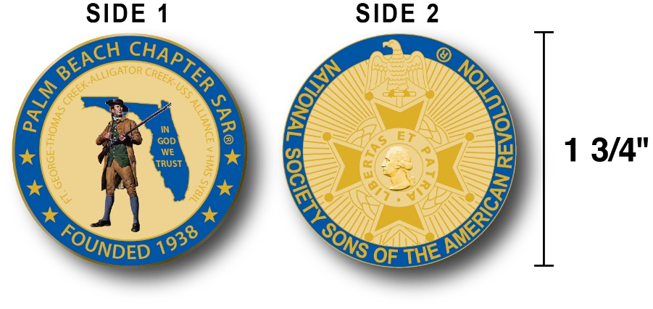

The Chapter has produced a custom bronze *Commemorative Anniversary Coin* honoring the founding of the *Palm Beach Chapter* in 1938 and celebrating its 80 years of historic, patriotic, and civic service in Palm Beach County and Florida.

The beautiful bronze coin is highlighted in ***George Washington*** military blue on a stunning gold background. Side-one is personalized to our Chapter with the founding date, a Minuteman standing guard over Florida, and the Florida State motto of ***"In God We Trust”.***

The coin also includes a notation listing the four major Revolutionary War battles waged in Florida including the battles of:

***Ft. George-Pensacola, Thomas Creek Massacre, Alligator Creek,*** and the ***Last Naval Battle* of the Revolutionary War** between the ***USS Alliance*** & ***HMS Sybil.***

Side-two displays the national *NSSAR* logo.  Very impressive indeed!

The custom bronze ***Commemorative Anniversary Coin*** is designed to celebrate our founding in **1938**, create a distinctive and impressive image for our Chapter and be used as a token of appreciation for honored guests, speakers, and as special awards.

***Compatriots may purchase these unique collector coins for just $10 each.***

***Classy SAR Lapel Pins $10:***

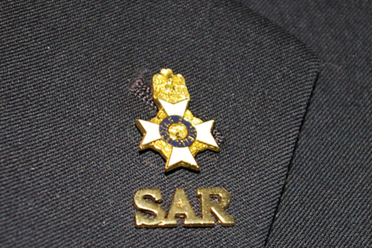

Display a ***Gold*** ***SAR*** pin on your suit lapel or shirt with the ***SAR Rosette***. The SAR Lapel Pin is part of a national branding program to help promote the S.A.R. and stimulate new membership!

The striking lapel pin is a recognizable public symbol of the SAR, provides you recognition as a member of this great society, and will spark conversations about SAR that leads to a new member.

The gold lapel pin and SAR Rosette create a professional image that will improve overall SAR name recognition. The Chapter has a supply of pins for Compatriots for just $10. **Get yours today**!

***SAR Chapter, State & National Events:***

**-*STATE/NATIONAL*:**

***DON’T MISS THE 2108 SAR NATIONAL CONGRESS***

***The 128th SAR Congress is scheduled for July 12-19 in Houston Texas. Hotel registration is open now at a special SAR price of $159.00 per night King or 2-Queens.***

***Reservations can be made by calling the Westin Memorial City Hotel @ 1-800-937-8461 or online @*** [***www.starwoodmeeting.com/book/nssar2018***](http://www.starwoodmeeting.com/book/nssar2018)***.***

***Questions contact Paul Callanan @*** [***LTCMRSC@aol.com***](mailto:LTCMRSC@aol.com) ***or 906-273-2424.***

***Feature Articles:***

***Burning His Majesty’s Schooner “Gaspee”….***

***Americas first attack on the Crown!***

**Compiled & Edited By Don Lanman, President Palm Beach Chapter SAR**

Over one year before the **Boston Tea Party**, a group of colonial protestors captured and burned the British naval schooner Gaspee stationed in Rhode Island waters. The attack on *HMS Schooner Gaspee* well before the American Revolution helped accelerate tensions between Great Britain and its American colonies.

In early 1772, British Lieutenant William Dudingston arrived in Rhode Island's Narragansett Bay abroad the mighty HMS Gaspee and aggressively enforced customs collections and cargo inspections of all vessels.

Lieutenant Dudingston cracked down on American smugglers to be sure, but he also incited anger among colonists by harassing lawful ships too, and leading up to the colonial retaliation against the Gaspee.

The fateful events of June 10, 1772, when the Gaspee was attacked are chronicled in this excerpt from Steven Parks’s new book **“The Burning of His Majesties Schooner Gaspee”**.

Parks book frames the Gaspee episode as a pivotal spark that served to further ignite colonial resistance to British authority in the early-1770s....

“Thirty-six-year-old John Brown called for eight longboats, each carrying five pairs of oars requiring ten rowers, to assemble at Fenner's Wharf. Brown put his employee Abraham Whipple in charge of the operation. At age 39, Whipple was an accomplished seaman and the brother-in-law of Chief Justice Stephen Hopkins.

Daniel Pearce beat a drum along Main Street to call the raiders to Sabin's Tavern. Some men cast bullets in the kitchen of the tavern, and the raiders departed from Providence around 10:00 PM.

Relatively fit men would have had no trouble rowing against the tidal current to get to *Namquid Point* in two hours' time. If another longboat had joined them from Bristol, it had a greater distance to travel, but the advantage of rowing with the tide. One anonymous source reported that the men blackened their faces and hands.

Brown put a sea captain in charge of the tiller of each boat. Obviously, they could not hope to do anything until nightfall, and the month of June gave them the longest days of the year.

Coming out of Providence, they would have to row against a flooding tide and muffle their oars and oarlocks in order to approach the *Gaspee* undetected. The raiders would want to arrive after the moon had set, which indeed they did. ”

“In the darkness on June 10, 1772, Bartholomew Cheevers, the *Gaspee's* deck sentinel on watch at the time, spotted what he thought was just a pile of rocks, so he reported nothing.

At 12:45 AM, he hailed the approaching longboats asking them to identify themselves. Dudingston came on deck, clad in his nightshirt, and repeated the call.

Cheevers claimed that he tried to fire his musket but it misfired repeatedly. The commander called for light on the deck but had no success. He called for more small arms, but the arms chest was locked and the keys were down in his cabin. ”

“Surely Dudingston must have had some concern about the readiness of his crew. He did not have the added protection of the Beaver. He had only nineteen men on board at the time.

Indeed, he was on his way to *Providence* to pick up more men coming down from Boston. The men he had were below decks in their nightclothes, and tired from scraping the hull. The schooner's small arms chest was locked and the lanterns were not lit on deck.”

“Abraham Whipple raised his voice, identified himself as the sheriff of Kent County, and declared he was in possession of a warrant for Dudingston's arrest.

Dudingston hollered back that the sheriff should return at a more appropriate hour. When men tried to board near the starboard forward shrouds, Dudingston struck someone with his sword and cut him.

Then he called for all men on deck. *Gaspee* midshipman William Dickinson claimed that the men in the boats gave " three cheers" and that the *Gaspee* deck lookouts then fired upon the boats with muskets.

The men in the boats-Dickinson estimated half a dozen-returned musket fire, and the *Gaspee* lookouts responded with pistols. Already the raiding party was too close for the *Gaspee* to use its larger cannon; besides, the attackers approached directly at the bow.

Ephraim Bowen claimed that he gave his gun to Joseph Bucklin, who proceeded to fire only one shot, which hit Dudingston in the left arm and groin.

A minute later they boarded without further opposition over the starboard bow and quarter, not the more accessible stern. This indicates that the *Gaspee* was still listing significantly to starboard.

*Gaspee* midshipman Dickinson estimated that thirty or forty men (out of 150-200 total) boarded and overwhelmed the British schooner's crew. With their commander down, the crew was forced to surrender. The Rhode Islanders calling themselves the "captain" and the "head sheriff" gave their word that the *Gaspee* crew would not be harmed.”

“The raiding party seemed specifically interested in Dudingston and the pilot, Mr. Sylvanus Daggett. Local pilots who helped Royal Navy and customs vessels navigate the shallow waters that were utilized by smugglers were not popular among merchants and seafarers.

While the raiders had brought doctors with them, they did not immediately tend Dudingston's wounds. Perhaps they expected to treat members of the raiding party only.

Whipple and Brown allowed Dudingston to bleed on the deck, and later claimed that they thought he had been shot by his own men. Still not certain whether to let the lieutenant live or not, they made him beg for his life.

They had Dickinson tied up in one of the boats for a half hour before he was summoned back onto the *Gaspee* to carry the lieutenant below. Apparently Whipple and Brown later rethought their actions and asked the commander if he had a surgeon on board. When he said that he had none, the raiders brought Dr. John Mawney up from the stern of one of the boats.

Dudingston apparently wanted Dickinson to help them find material and make bandages. Dickinson went below and showed the "ringleaders of the mob" the officers' commissions, orders, and instructions, which the raiders took. This, of course, also gave the officers the much-needed artificial light to see the faces of their adversaries for later identification.

Some of the papers went into the raiders' pockets; others went over the side and may or may not have made it into the boats. Regardless, the "ringleaders" saw Dudingston's commissions and deputations, and therefore could not claim that they thought Dudingston was acting without orders.

Dickinson also claimed that he saw a "negro" (his word) holding Dudingston's sword. Peter May, a *Gaspee* mariner, testified that the raiders wanted remuneration for Jacob Greene's seized rum. They would take Dudingston's personal effects in exchange and return him to the schooner. ”

“The wounded Dudingston and his crew were herded aboard the raiders' boats. While the *Gaspee* officers and crew were still angry, or afraid, or both, something unexpected happened.

The dark, now moonless night sky of *Narragansett Bay* suddenly filled with a bright light as the schooner, which had been their home and fortress, burst into flames. Was it set aflame intentionally? Was it an accident?

They watched from the boats as they were rowed quietly away; when the flames finally reached the powder magazine buried deep in the hull for protection, a dramatic explosion occurred that must have been heard for miles around.

Light and sound filled the normally quiet coast, and Rhode Islanders were awakened from their slumber. There was very little of the *Gaspee* left to salvage.

The *Gaspee* crew could see other longboats returning to Cranston and Providence. Ephraim Bowen, in his later recollection of events that night, claimed that it was the leaders of the raid who returned to burn the vessel, not some rogue element.”

Read all of exciting story in Steven Parks’s new book…..

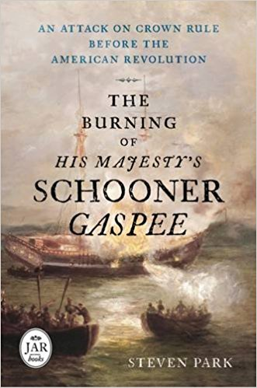

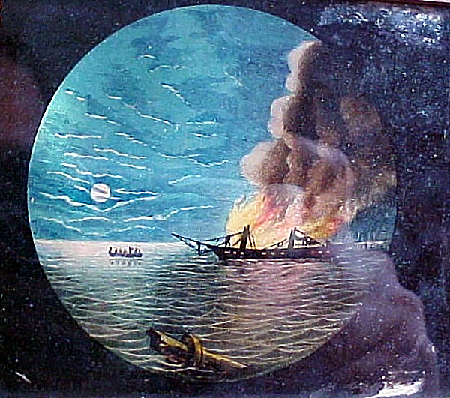

***Land of the Free - Because of the Brave***

***Veterans Day Tribute***

***By Don Lanman, US Army, President Palm Beach Chapter SAR***

Since the birth of our Nation, *American Patriots* of every race, color, creed, gender and national origin have come forward to serve our country and defend the founding fathers vision for a Nation of the people, by the people and for the people.

With honor, distinction and sacrifice, these generations of men and women risked their lives and fortunes to win our independence, preserve our Union, and secure our freedom.

Beginning with the *Minutemen* at Concord, American heroes have served unselfishly so that our children might live in a world that is safer, freer, and more just than any other nation in history, and to them we owe a profound debt of gratitude.

This *Veterans Day*, we salute the long grey line of Soldiers, Sailors, Airmen, Marines, Coast Guard, and Merchant Marine veterans who have rendered the highest service any American can offer.

For each day that we live under the banner of freedom, they secured, we have a solemn obligation to serve these veterans as well as they have served us and to help them return to civilian life by assuring that they have the resources and benefits they have rightly earned.

Working together, we must help heal the wounds of conflict, *PTSD*, to end the tragedy of homelessness among our veterans by remaining committed to providing all veterans with quality health care, access to education, employment, and the resources they need to transition to civilian life.

The Millions of veterans who fought to protect our democracy around the globe are now strengthening that very democracy here at home. They have the experience, skills, loyalty and dedication necessary to achieve success as productive members of our civilian workforce, and we must strengthen our society with their talent.

Trained and tested in the Armed Forces, our Veterans are the new pioneers of industry, entrepreneurs, small business owners, and leaders within their communities.

Their faith, service, and character reflects both the unique and enduring American spirit, and serves as an example of motivation, inspiration, and strength for all Americans.  
   
This *Veterans Day*, and every day, we should pay tribute to America's sons and daughters who have answered our country's call.  Recognize the sacrifice of those who have been part of the finest military the world has ever known and the loved ones who stand beside them.

Especially Honor those fallen heroes who made the ultimate sacrifice at the “Alter of Freedom” and never forget those who have yet to return home.

As grateful Americans, we must honor their service through private prayers of thanks, appropriate public ceremonies, and participation in patriotic activities including civic, social, and fraternal organizations, places of worship, schools, and community centers.

We live in a Land of the Free because of the Brave, so this Veterans Day display the flag of the United States of America in recognition of the valor and sacrifice of all service members and Veterans!

Join fellow Americans with a warm welcome home, and *“Thank You for Your Service”*!

**###**

**2018 Dues Now Due….Keep Your Membership Active:**

**Please Don’t delay….Mail** **your $75 annual** membership fee as soon as you receive your notices to ***SAR PB Chapter, PO Box 16735 West Palm Beach, FL 33416-6735! Include*** any changes to your personal contact information.

***Remember*….Your** membership dues plus any additional donations fund the many Chapter civic activities including **Scholarships**, ***Boy Scout & JROTC medals, Rumbaugh & Knight Essay Youth contests, Police-Firefighter-EMT awards, Flag Certificates, Americanism, & Community programs.***

***-Meeting & Event Pictures-***

***President Lanman with DAR State Regent Lemongello & DAR Daughters***

***at the Military Funeral for WW 2 Army Veteran St. Richard ‘Tiny’ Sowell***

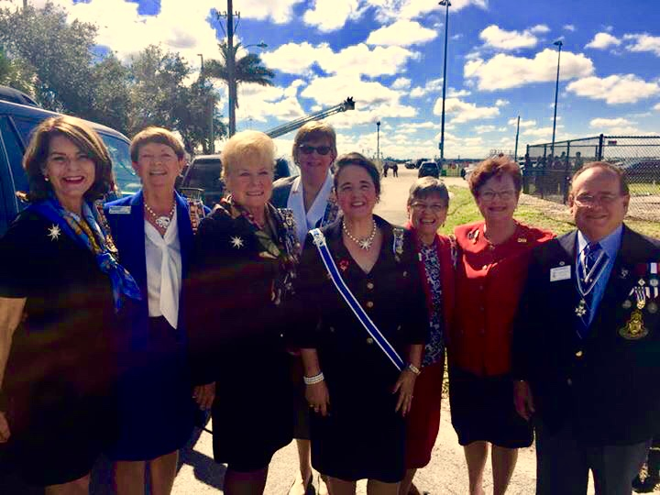

***Chapter/State/National Teacher of the Year Winner***

***Lauren Goepfert Past PB Tomme & Past State President Wess,***

***& President Lanman @ BOM Awards Dinner***

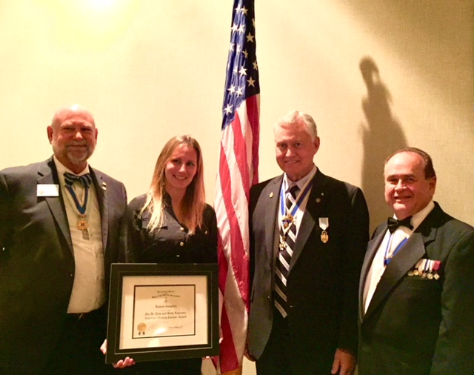

***Chapter/State/National Teacher of the Year Winner***

***Lauren Goepfert, President Lanman & VP Tidwell***

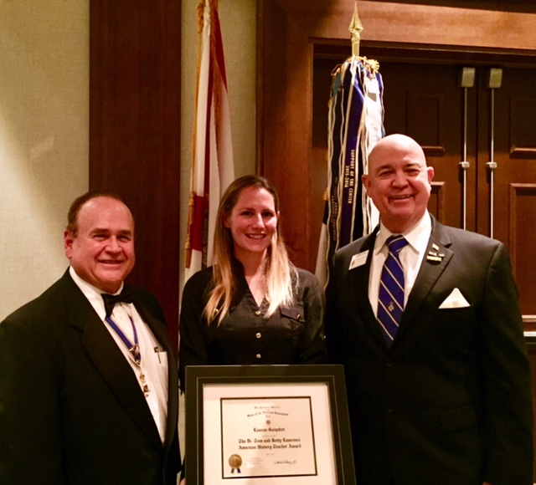

***PBAU Student Jack Davies Receive History Scholarship***

***From SAR Palm Beach Chapter Officers Tidwell & Lanman***

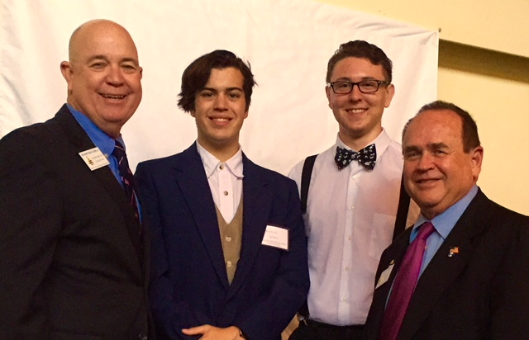

***Compatriots Tidwell, Lanman & Miller @ Palm Beach***

***Genealogical Club Recruiting Event***

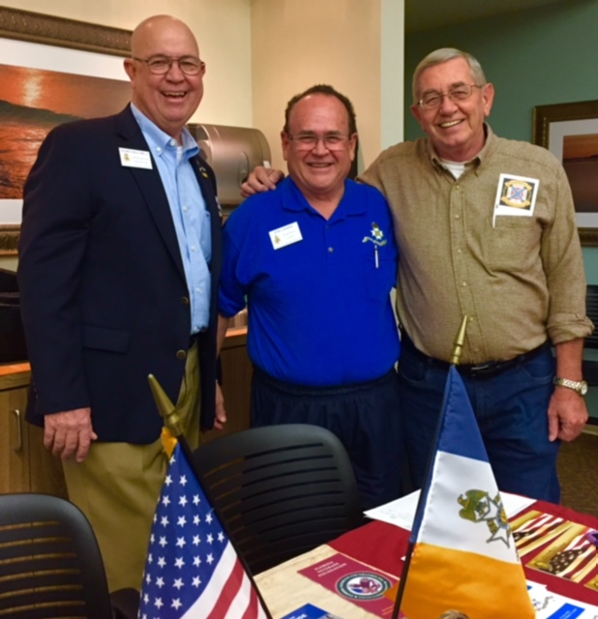

***~80th Anniversary Bronze Commemorative Collector Coin $10.00~***

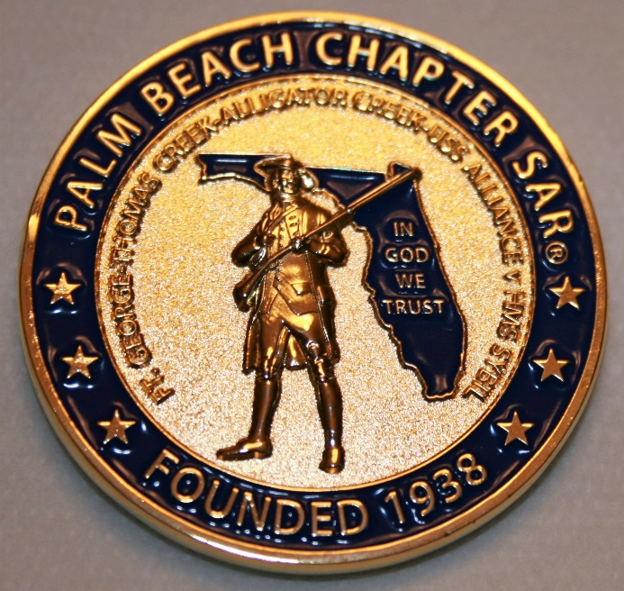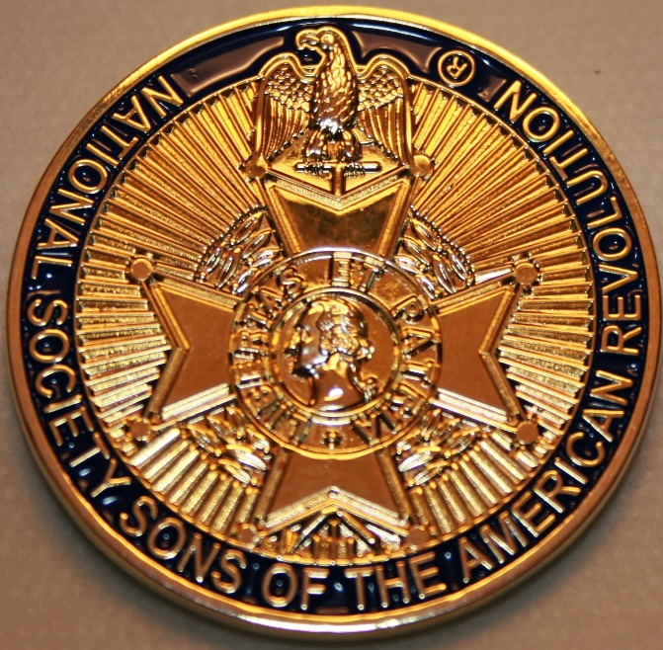

***~Compatriot Sponsored Promotions~***

**Compatriot sponsored newsletter Ads are important to the Chapter as they represent additional funds in support of Chapter projects including *Scholarships, Boy Scout & JROTC medals, Rumbaugh & Knight Essay Youth contests, Police-Firefighter-EMT medals, Americanism & community civic programs!***

**Help** your Chapter, sponsor an Ad for **8** issuesat a modest cost: **Business Card $50, Half Page $100, Full Page $250. Your AD donation will also qualify you for a listing in the *Presidents Brigade*. Call Don Lanman 561-315-5073 for information.**

***SPECIAL SPONSORED ADS ON FOLLOWING PAGES…***

***~COMPATRIOT ROBERT BRINCKERHOFF***

***~GARCILASO DE LA VEGA, CHAPTER***

***DAUGHTERS OF THE AMERICAN REVOLUTION***

***~COMPATRIOT ALEXANDER DREYFOOS***

***~COMPATRIOT ROGER SMITH PhD,***

***HISTORIAN/AUTHOR***

***-Morgan Stanley-***

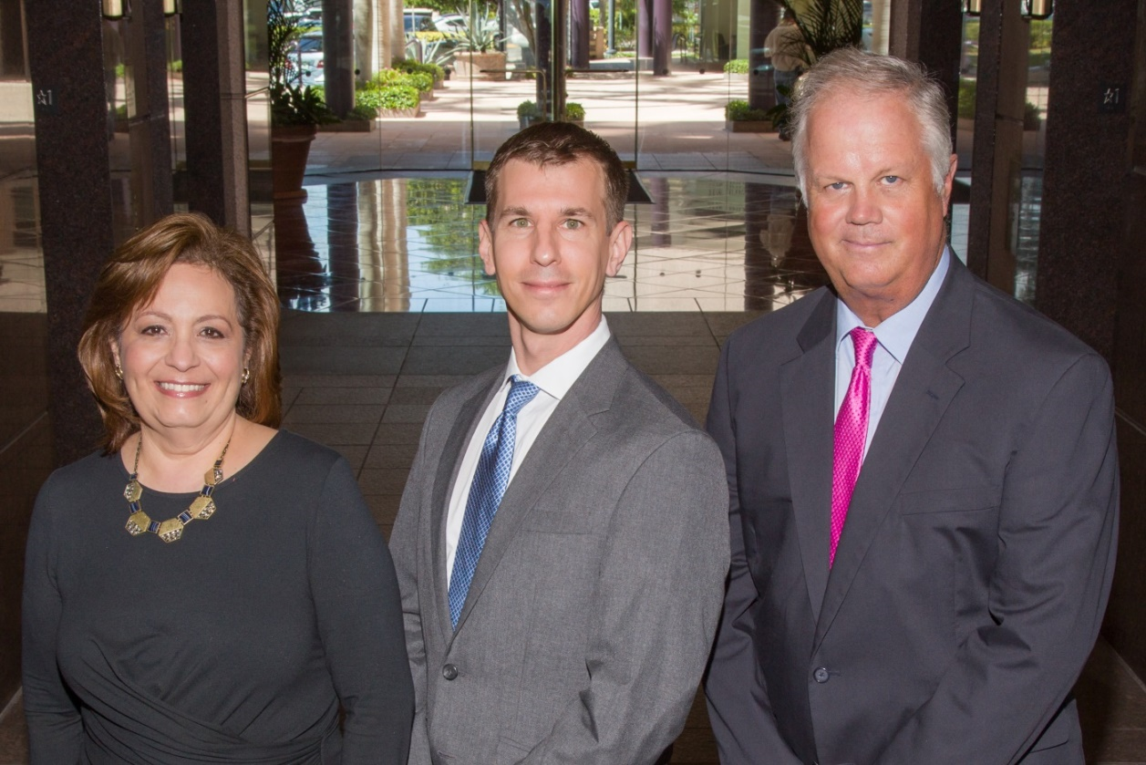  
***Amani Gaballa, Senior Registered Associate; Robert Scarborough, Financial Advisor; Robert Brinckerhoff, First Vice President, Financial Advisor***

***Robert W. Brinckerhoff  
Senior Vice President, Financial Advisor  
777 S. Flagler Dr. Suite 700, East Tower  
West Palm Beach, FL 33401  
(561) 650-7514  
Robert.Brinckerhoff@MorganStanley.com***

***Bob has been a financial advisor since March 1976. He focuses on investment strategies, retirement planning, liquidity solutions for individuals, commercial real estate, and small business owners.***

***Bob is a graduate of the University of Vermont. His clients are geographically diverse and he frequently travels from the east coast to the west to meet with clients. He is active with nonprofit organizations that support the blind and visually impaired. Bob is also an active enthusiast in Ferraris.***

*The investments listed may not be suitable for all investors. Morgan Stanley Smith Barney LLC recommends that investors independently evaluate particular investments and encourages investors to seek the advice of a financial advisor. The appropriateness of a particular investment will depend upon an investor’s individual circumstances and objectives. Morgan Stanley Smith Barney LLC is a registered Broker/Dealer, Member SIPC, and not a bank.*

*Where appropriate, Morgan Stanley Smith Barney LLC has entered into arrangements with banks and other third parties to assist in offering certain banking related products and services. Investment, insurance and annuity products offered through Morgan Stanley Smith Barney LLC are: NOT FDIC INSURED, MAY LOSE VALUE, NOT BANK GUARANTEED, NOT A BANK DEPOSIT, NOT INSURED BY ANY FEDERAL GOVERNMENT AGENCY. Copy write 2015 Morgan Stanley Smith Barney LLC, Member SIPC CRC1355648 11/15.*

*TWO GREAT BOOKS-ONE GREAT MAN*

***-Alexander W. Dreyfoos-***



***-A PHOTOGRAPHIC ODYSSEY- -PASSION & PURPOSE-***

***Compatriot Alexander W Dreyfoos, Jr.*** an honored member of the *Palm Beach Chapter Sons of the American Revolution*, noted American entrepreneur, and philanthropist has published two remarkable books that should be on every bookshelf. **Book sales** **proceeds** **donated to local West Palm Beach charities!**

* ***Passion & Purpose*** chronicles a remarkable lifetime of passion with photography, his business, inventions and philanthropic ventures, as well as his adventures above and below the water. **$29.95.**
* ***A Photographic Odyssey*** is a remarkable collection of hundreds of stunning pictures from 100,000 photos taken by Alex around the world and bound in an elegant 15” by 10” glossy photographic book. You will travel with Alex around the world, above and below the water, to forests, jungles, glaciers, and deserts in the exotic locals of Papua New Guinea, Bhutan, Nepal, China, Japan, and Tibet. The subjects are very divergent contrasting palaces and temples with the vulnerability of people, animals, and exotic scenery. **$60.00.**
* **Support your Chapter & local charities! Get both books, *Passion & Purpose & A Photographic Odyssey,* just $71.96 @ kravis.org/books or Call 561-651-4329.**

***-Alexander W. Dreyfoos-***

*Graduating from MIT and Harvard Business School, Alex founded Photo Electronics Corporation (PCS), specializing in photography and video production. Over the decades, Alex earned 10 US patents and invented the Video Color Negative Analyzer for motion pictures earning him an Academy Award for technical achievement.Many inventions, developed by PCS, are on permanent display at the Smithsonian Institution. Locally Alex also owned television station WPEC TV-12, the CBS affiliate in West Palm Beach. Alex’s many philanthropic achievements include founding the Palm Beach County Cultural Council, the Raymond F. Kravis Center for the Performing Arts and gifting a million dollars to the Dreyfoos School of the Arts. Alex also donated a million dollars each to the Palm Beach County biomedical research campus of the Scripps Research Institute and the local Max Planck Florida Foundation for Neuroscience in Jupiter, Florida.*

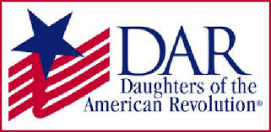

*Garcilaso de la Vega Chapter, NSDAR*

*Lake Worth, Florida*

*Alisha Darcy, Regent*

*Karen Christie, Registrar*

Phone; 561-236-2460-Email; [IMC4U4@AOL.com](mailto:IMC4U4@AOL.com)

Chapter Email: [GarcilasodelaVegaDAR@gmail.com](mailto:GarcilasodelaVegaDAR@gmail.com)

Visit us on ***Facebook*** @ <https://www.facebook.com/LWDAR>

