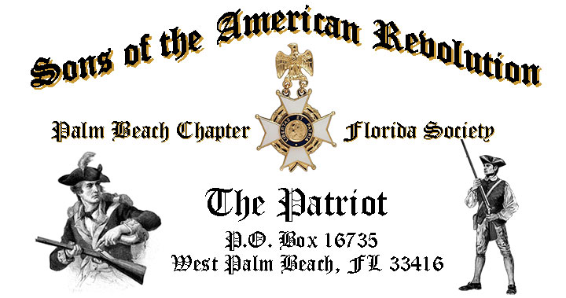

***Volume 24 November 2018 Number 08***

***“Poppies of Flanders Field”***-***Honor Veterans Month*** with ***US Navy Veteran, Author, Historian & Compatriot Sonny Barber*** as he delivers a heartfelt window into the tragedy of *World War One,* ***Tuesday,*** **November 20** @ **12 Noon** @ the *Embassy Suites Hotel* 1601 Belvedere Road, WPB!

***RSVP Now for this exciting event!***

***November 20 Meeting Highlights…***

* ***“Poppies of Flanders Field”, Veteran, Historian/Author Sonny Barber***
* ***4-Course Buffet Lunch, 2-Special Desserts & Beverages***
* ***$28 per person Check/Cash at the Door***
* **Family, Friends & Guests Always** ***Welcome***
* ***Reservations*** **Required,** **RSVP**, **Ben Tidwell** **(561)-704-9918**

***Newsletter Content:***

* **President’s** **Message**
* **2018 Officers & Board Members**
* **2018 Chapter Meeting Dates &Topics**
* ***President’s Brigade* Financial Supporters**
* **Committees, Chairmen & Members**
* **National/State/Chapter, News & Events**
* **Feature Articles: *In Flanders Field & Land of the Free Because of the Brave!***
* **Pictures-Meetings** **& Events**

***President’s Message:***

***Fellow Compatriots, DAR Daughters & Friends…***

As an Army Veteran, I look forward to *Veteran’s Month*, and especially *Veterans Day* as a time honored opportunity to say *“Thank You”* to our nation’s veterans and serving members of our beloved military world-wide.

Don’t miss Compatriot and fellow *Navy* *Veteran*, *Sonny Barber* as he gives us a window to the tragedy and meaning of the WW One 100th Anniversary. You’ll also want to read *Compatriot* and *Army Veteran Lanman’s* ***“Home of the Free-Because of the Brave”*** article in honor of *Veterans Month*.

While I look forward to the *November* meeting with great anticipation, I am most excited about our***80th Anniversary***celebration ***December 8*** at the historic and iconic *Everglades Club on Palm Beach Island*. The anniversary program includes a special 3-Course Plated Lunch following the ***Chapter’s Annual Christmas Holiday Musical*** featuring the award winning, world class ***Dimension 20 Choir***. Space is limited so don’t wait to RSVP.

During the October meeting, the Chapter inducted 10 new Compatriots including; ***Thomas Haynes, Scott, Barak & Andrew Craig, Vincent & Christopher Burkhardt, Jeffrey Joyner, Jahn & Christopher Lennon, James & Berry Alex.***

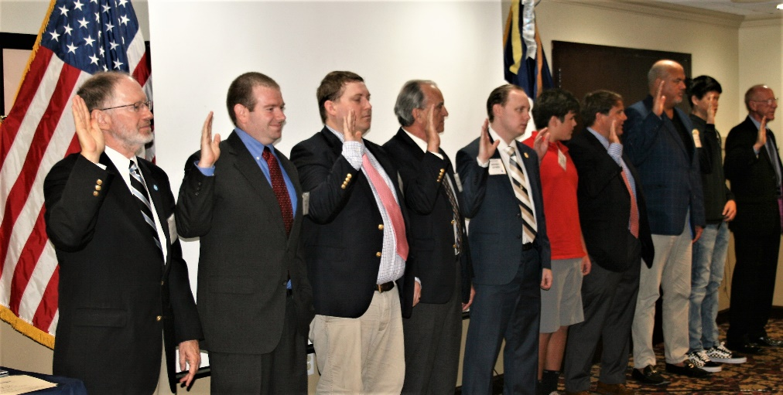

Congratulations & Welcome fellow Compatriots, we look forward to your active involvement in the Chapter, its committees and events.

The ***October 16th*** meeting featured award winning 4th generation Palm Beach Native and Author/Historian/Compatriot ***Harvey Oyer III*** as he took us on a remarkable journey of Palm Beach County beginning in 1872 with his famous relative “***Captain Hannibal******Pierce”*** to the ***Barefoot Mailman”***.

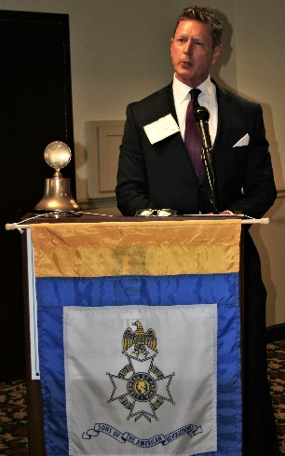

***Compatriot Oyer***

President Tidwell awarded the prestigious ***SAR Chapter Bronze*** and ***State Silver Good Citizenship Medals*** to ***Compatriots Harvey Oyer III*** and ***Richard Linn*** in recognition of their countless years of selfless community, civic and board service.

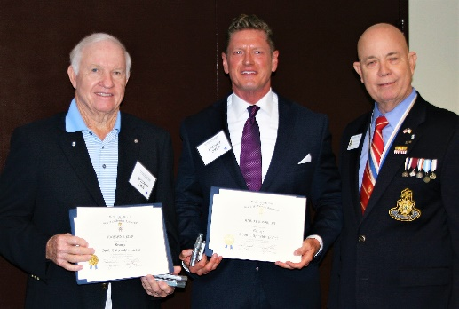

***Compatriot Lanman*** represented the Chapter at several patriotic events in October including: the Grand Opening of the *Veterans Resource-Success Center* on the***Palm Beach State College*** campus in Lake Worth.

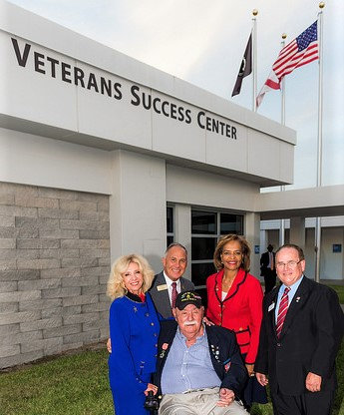

**Senator Sachs, VP Rutherford, College President Parker**

**WW II Hero Sgt. Carl Arfa, Compatriot Donald Lanman**

In recognition of his years of outstanding service as the Registrar for the Chapter, ***Compatriot Bob Boggs*** received the **“Oak Leaf”** bar for his ***Liberty Medal*** in recognition of the remarkable number of new members registered to the Chapter.The Chapter is the largest in the State with 185 members.

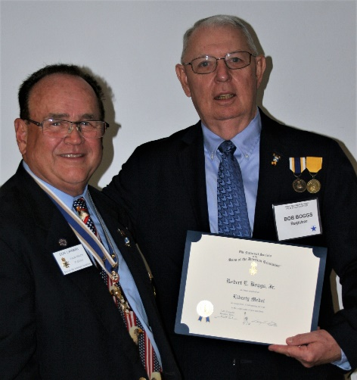

***Compatriots Tidwell*** presented ***Compatriot Lanman*** with the *National SAR Veterans Corp* certificate. Lanman is the State Chairman for the Florida Veterans Battalion.

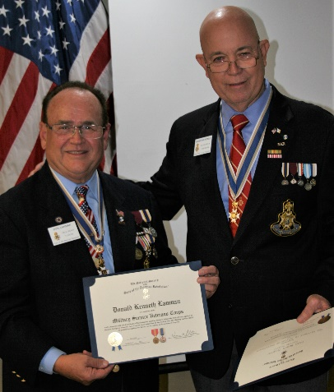

***Compatriots Tidwell****,* ***Lanman*** and ***Parkinson*** represented the Chapter at the annua*l Palm Beach Atlantic University Scholarship Day* presenting *a Chapter Scholarship for $1,000* to support students of this great university.

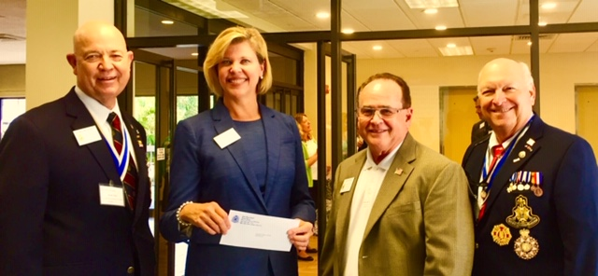

***Compatriots Tidwell****,* and***Lanman*** represented the Chapter at the *FLSSAR* State Board of Management fall meeting where the Chapter was awarded a *FLSSAR* ***“Chapter Honor Flight Recognition”*** for its participation in the *Veterans Honor Flight* program. ***Lanman*** and ***Tidwell*** also serve on multiple state committees including *Veterans Recognition Committee Chair* for Lanman and *JROTC* committee for Tidwell.

Special thanks to ***Compatriot Michael Anderson,*** who works tirelessly to update the Chapter web site, increase its functionality and add content including a Chapter member’s page listing all Compatriots. Check out the enhancements at [www.sarpbchapter.org](http://www.sarpbchapter.org).

*Compatriot Veterans* are encouraged to provide the Chapter with a copy of their ***DD-214*** to be recognized with the ***SAR Military Service*** or ***War Service Medal*** and join the 15% of Chapter Vets who’ve served honorably from ***WW II*** to***Iraq***.



***Don’t wait to be asked***, we need help on committees supporting our youth and civic programs including ***Historical Oration, Knight Essay, Poster*** and ***Brochure*** contests***, American History Teacher of the Year, Boy Scouts, Police-Firefighter* recognition*, Flag & Liberty Tree,*** and ***Veterans*** services*.*

***Help Grow Chapter Membership*** by enrolling your ***Sons*** and ***Grandsons*** and encourage wives, daughters, and granddaughters to join the *Daughters of the American Revolution, Children of the Revolution* and the *Chapter Women’s Auxiliary*.

Our beloved ***DAR Patriot Daughters*** support our Chapter meetings and events, and we sincerely appreciate their tireless efforts to help us by referring new SAR prospects. All Compatriots are encouraged to support local *DAR* Chapters by attending their meetings, fundraising and patriotic events.

***Compatriots***, I look forward to seeing you at the ***November 20th***meeting! Please, join me in remembering our Patriot Ancestors, Departed Compatriots and especially our nation’s Veterans. ***God Bless You*** and ***the United States of America.***

***Yours In Patriotism*** **– *Benjamin Franklin Tidwell III***

*** Hear Ye-Hear Ye…..Chapter Editorial***

***~LIBERTAS ET PATRIA~***

***~LIBERTY & COUNTRY~***

***Compatriots SAVE THE DATE! December 8 2018!***

|  |
| --- |
|  |

*The Palm Beach Chapter* was founded and chartered by then ***President General Messmore Kendall*** on ***March 16, 1938*** in the iconic ***Writing Room*** of the historic ***Palm Beach Everglades Club***.

The *Charter’s 19* founding members included many of America’s leading political, civic and business leaders of the time including *Compatriots* *Messmore Kendall, Charles F. Coe, Clifford V. Brokaw, Phil H. Sawyer, Blane Webb, J. Field Wardlaw, David B. Crandall, Harold A. Braman, Roscoe T. Anthony, Loring W. White, Ellingsworth Warner, W. Marvin Clifton, Homer E. Sawyer, F. Reeves Rutledge, James A. Dew, Ira L. Nesmith, W. Murry Hammer* and *Richard P. Robbins.*

In honor of our ***80th Anniversary****,* the Chapter designed a custom gold ***Chapter Commemorative* *Coin*** honoring the *Palm Beach Chapter* and its 80 years of patriotic, philanthropic, and civic service in Palm Beach County, Florida. These coins may be purchased for just $10 each.

***Save the Date!*** A year-long celebration that began in January will conclude with a very special ***80th Anniversary*** 3-course plated luncheon at the iconic/historic ***Palm Beach Everglades Club*** on *Palm Beach Island*, **Saturday** ***December 8, 2018*** from 11:30 to 2PM.

The anniversary program includes a special ***Toast to Washington*** and 3-course plated lunch following the ***Chapter’s Annual Holiday Musical*** featuring the world class ***Dimension 20 Choir***.

***Invitations*** were mailed with all the details. Advance ***RSVP*** and lunch prepayment is required and Space is limited so **Don’t Wait**, make advance reservations with ***Don Lanman @ DLanman259@aol or 561-315-5073*** including the number and names of guests joining you.

**\*Special Note….2019 Membership Dues of $75 are Due**. Compatriots please mail your dues check of $75 to Palm Beach SAR, PO Box 16735 West Palm Beach FL, 33416-6735. ***God Bless You*** and ***God Bless the United States of America.***

***~In Heartfelt Comradeship & Patriotism******- D. Lanman, Editor***

***2018-19 Chapter Meeting Dates/Topics:***

**Visit** the Palm Beach Chapter web site @ [www.sarpbchapter.org](http://www.sarpbchapter.org) for a meeting calendar, special events, articles, pictures, and general information.

* **Nov. 20, 2018**, ***Compatriot S. Barber-Veterans Day “Poppies”***
* **Dec. 8, 2018**, ***80th Anniversary-Christmas-Holiday Musical***
* **Jan. 15. 2019, Officer Installations, Guest Speaker**
* **Feb. 19, Special Guest Speaker, *Thomas Jefferson***
* **Mar. 19, Special Guest Speaker**
* **April, 16, Police & Law Enforcement Recognition**
* **May, 21, Firefighter & First Responder Recognition**
* **Oct. 15, Special Guest Speaker**
* **Nov. 19, Special Guest Speaker**
* **Dec. 7, 2019, *Christmas-Holiday Musical***

***2018 Officers & Board:***

* ***President******Benjamin Franklin Tidwell III***
* ***Vice President******Robert Boggs***
* ***Secretary******Gary Green***
* ***Treasurer******Peter Johnston***
* ***Registrar******Robert Boggs***
* ***Chaplain******Father Sanford Sears***
* ***Sgt. @ Arms Peter Miller***
* ***Historian******Samuel “Buddy” Miller***
* ***Officer @ Large******Sonny Barber***
* ***Patriot Newsletter Editor******Donald Lanman***

***Join the President’s Brigade to Support Youth Programs!***

The Chapter authorized ***$1,000***Scholarship to the ***Palm Beach Atlantic University*** again for ***2018***. This university educates our youth on the values of God and Country and helps develop character for the leaders of tomorrow.

The Chapter honors and expresses its sincere appreciation to the *Compatriots* of the ***President’s Brigade*** who support our scholarship and youth programs.

The dedicated members of the ***President’s Brigade*** donate ***“Extra Dollars”*** in support of the Chapter’s many youth programs, scholarships, civic activities, award certificates, police/firefighter/EMT medals, veterans’ projects, and related community civic programs.

***Please Help*** increase the scholarship amount this year to ***$4,000*** *by* donating a few dollars to the ***Presidents Brigade*** in support of these students of character.

***Honored Presidents Brigade Members*:**

* **Bronze Level: $25-$99:**

***M. Anderson, J. Blackburn, B. Boggs, J. Chataing, A. Cass, C. Coldwell, D. Coldwell, M. Curry, S. Curry, J. Damron, J. Dorsey, W. Davis, F. Devitt, J. Harper, J. Kane, L. Lassitter, P. Miller, S. Miller, J. Mayne, G. Parkinson, H. Oyer, J. Porter, S. Sears, A. Shea, W. Told, J. Wearn, L Watkins***

* **Silver Level: $100-$199:**

***J. Curry, R. Culpepper, T. Friend, G. Green, F. Green, A. Griswold, W. Johnson, D. Shepherd, S. McWhorter***

* **Gold Level: $200-$499:**

***R. Brinckerhoff, S. Barber, R. Banta , E. Buckley, J. Curry, S. Hitt, W. Meakin, J. Wynns***

* **Platinum Level: $500+**

1. ***Dreyfoos, B. Tidwell, D. Lanman, K. Christie***

***Committees, Chairs & Members:***

***Fellow Compatriots…..***The Chapter expresses its sincere appreciation to those members who volunteer to serve on our committees and projects. As you can see a few Compatriots are serving on multiple committees and could use some extra support! **Just** choose a committee of interest for ***2018***.

It doesn’t take much time and is a major help with our many civic and youth initiatives. **Call Ben Tidwell (561-704-9918) or Bob Boggs (561-241-3128)** **Today** to lend a hand on any of the following committees…

* ***2019 Officer Nominations -All Chapter Members***
* ***80th Anniversary -Lanman, Tidwell, Officers***
* ***JROTC & Boy Scouts -Barber, Tidwell***
* ***Law Enforcement-Fire Safety -Parkinson, Green***
* ***Veterans Affairs -Lanman, Curry***
* ***Newsletter/Publicity -Lanman***
* ***Knight Essay/Rumbaugh Oration -Boggs***
* ***American History Teacher -Boggs***
* ***Medals/Awards -Lanman, Tidwell***
* ***DAR-CAR Liaison -Tidwell, Lanman***
* ***Speakers Bureau -Lanman, Tidwell***
* ***Audit -Coldwell, Tidwell***
* ***Flag Certificates -Miller, Johnston***
* ***Membership Development -Green, Boggs, Tidwell***
* ***Liberty Tree -Chapter Officers***
* ***Patriot Bios -Miller***
* ***Web Site-Facebook/Social Media -Anderson, Lanman***

**Palm Beach Chapter 80th Year Commemorative Coin $10!**

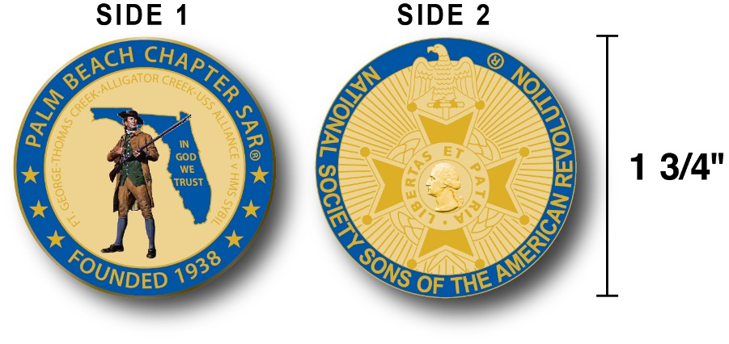

The Chapter created a custom bronze *Commemorative Anniversary Coin* honoring the founding of the ***Palm Beach Chapter* in *1938*** and celebrating its 80 years of historic, patriotic, and civic service in Palm Beach County and Florida.

The beautiful collector’s coin is highlighted in ***George Washington*** ***military blue*** on a stunning ***Gold*** background. *Side-one* is personalized for our Chapter with our founding date and a *Patriot* *Minuteman* guarding *Florida* over the *State* motto ***"In God We Trust”.***

The collector’s coin includes an inscription listing the four major Revolutionary War battles waged in *Florida* including the battles of ***Ft. George-Pensacola, Thomas Creek Massacre, Alligator Creek Battle,*** and the ***Last Naval Battle* of the Revolutionary War** between the ***USS Alliance*** & ***HMS Sybil.***

Side-two displays the national ***SAR*** ***Cross of Malta***.  Very impressive indeed!

The custom bronze ***Commemorative Anniversary Coin*** is designed to celebrate our founding in **1938**, create a distinctive and impressive image for our Chapter and be used as a token of appreciation for honored guests, speakers, and as special awards.

***Classy SAR Lapel Pins $10:***



Display a ***Gold*** ***SAR*** pin on your suit lapel or shirt with the ***SAR Rosette***. The SAR Lapel Pin is part of a national branding program to help promote the S.A.R. and stimulate new membership!



The striking lapel pin is a recognizable public symbol of the SAR, provides you recognition as a member of this great society, and will spark conversations about SAR that leads to a new member.

The ***SAR Gold*** lapel pin along with the ***SAR Rosette*** create a professional image that will improve overall SAR name recognition. The Chapter has a supply of pins for Compatriots for just $10.

***Show Chapter Spirit….***

**Get your 80th Anniversary Coin & Gold SAR Pin today**!

***SAR Chapter, State & National Events:***

**-*CHAPTER/STATE*:**

***Join Chapter Members at SAR events. See Ben Tidwell/Don Lanman for details.***

***~Feature Articles~***



In Flanders Field …

**By Major John McCrae, May 1915**

***In Flanders fields the poppies blow  
Between the crosses, row on row,  
That mark our place; and in the sky  
The larks, still bravely singing, fly  
Scarce heard amid the guns below.***

***We are the Dead. Short days ago  
We lived, felt dawn, saw sunset glow,  
Loved and were loved, and now we lie  
In Flanders fields.***

***Take up our quarrel with the foe:  
To you from failing hands we throw  
The torch; be yours to hold it high.  
If ye break faith with us who die  
We shall not sleep, though poppies grow  
In Flanders fields.***

**During the early days of the Second Battle of *Ypres* in WW I a young Canadian artillery officer, *Lieutenant Alexis Helmer*, was killed on 2 May, 1915 in the gun positions near *Ypres*. An exploding German artillery shell landed near him.**

**He was serving in the same Canadian artillery unit as a friend of his, the Canadian military doctor and artillery commander *Major John McCrae*.**

**As the brigade commander, *Major McCrae* was asked to conduct the burial service for *Lieutenant Helmer* because the unit Chaplain was called away for services elsewhere.**

**It is believed that later that evening, following the burial, John began the draft for the heart touching and internationally famous poem…*“In Flanders Fields”***

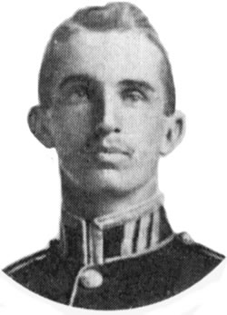

***~Lieutenant Alexis Helmer~***

***1st Brigade Canadian Field Artillery***

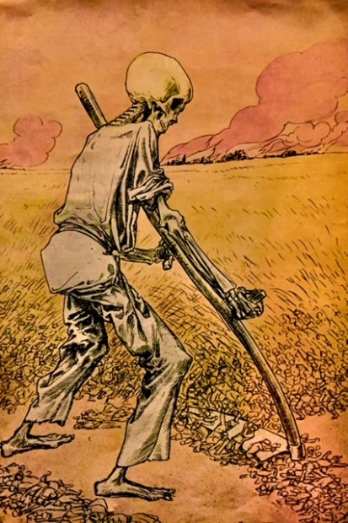**[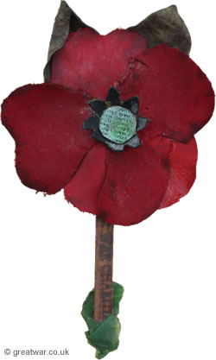](http://www.greatwar.co.uk/article/remembrance-poppy.htm)**



***Land of the Free - Because of the Brave!***

***11th Month, 11th Day, 11th Hour…Veterans Day!***

***By Don Lanman, USA (RET)***

**Since the birth of our Nation, *American Patriots* of every race, color, creed, gender and national origin have come forward to serve our country with honor and to defend the founding father’s vision for a Nation of the people, by the people and for the people.**

**With honor, distinction and sacrifice, these generations of men and women risked their lives and fortunes to win our independence, preserve our Union, and secure our freedom.**

**Beginning with the *Minutemen* at *Concord*, American patriots have served unselfishly so that our children might live in a world that is safer, freer, and more just than any other nation in history, and to them we owe a profound debt of gratitude.**

**This *Veterans Day*, we salute the long grey line of Soldiers, Sailors, Airmen, Marines, Coast Guard, and Merchant Marine veterans who have rendered the highest service any American can offer.**

**For each day that we live under the banner of freedom that they secured, we have a solemn obligation to serve these veterans as they have served us, and to help them return to civilian life by assuring that they have the resources and receive the benefits they earned.**

**Working together, we must help heal the wounds of conflict, *PTSD*, and to end the tragedy of homelessness among our veterans by remaining committed to providing all veterans with quality health care, access to education, employment, and the resources they need to transition to civilian life.**

**The millions of veterans who fought to protect our democracy around the globe are now strengthening that very democracy here at home.**

**They have the experience, skills, loyalty and dedication necessary to achieve success as productive members of our civilian workforce, and we must strengthen our society with their talent.**

**Trained and tested in the Armed Forces, our Veterans are the new pioneers of industry, entrepreneurs, small business owners, and leaders within their communities.**

**Their faith, service, and character reflects both the unique and enduring American spirit, and serves as an example of motivation, inspiration, and strength for all Americans.  
   
This *Veterans Day*, and every day, we should pay tribute to America's sons and daughters who have answered our country's call.  Recognize the sacrifice of those who have been part of the finest military the world has ever known and the loved ones who stand beside them.**

**Remember and Honor those heroes who made the ultimate sacrifice at the *“Altar of Freedom”* and never forget those who have yet to return home.**

[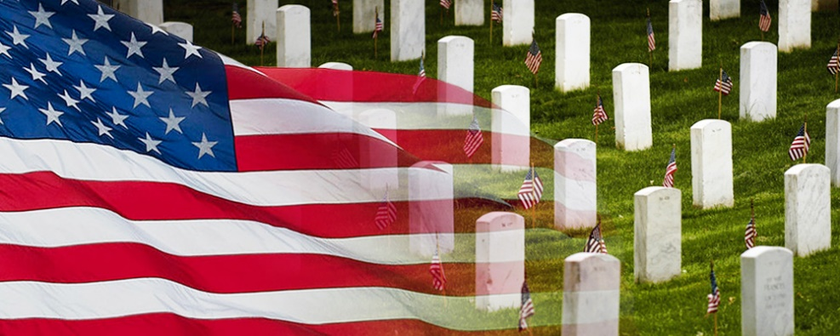](https://www.google.com/url?sa=i&rct=j&q=&esrc=s&source=images&cd=&cad=rja&uact=8&ved=2ahUKEwjapbPawsLeAhWJt1kKHUbUBaAQjRx6BAgBEAU&url=http://www.riveroflifeworship.com/a-sacrifice-on-the-altar-of-freedom/&psig=AOvVaw1BbVwMK8GZNqcB4gbys9n1&ust=1541688303121576)

**As grateful Americans, we can honor their service through private prayers of thanks, appropriate public ceremonies, and participation in patriotic activities including civic, social, and fraternal organizations, places of worship, schools, and community centers.**

**We live in a *Land of the Free because of the Brave*, so this Veterans Day display the flag of the *United States of America* in recognition of the valor and sacrifice of all Veterans!**

**Join fellow Americans with a warm welcome home to all Veterans with a genuine *“Thank You, For Your Service”,* especially remembering those who never returned.**

[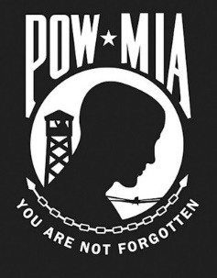](https://www.google.com/url?sa=i&rct=j&q=&esrc=s&source=images&cd=&cad=rja&uact=8&ved=2ahUKEwiEw4-4wcLeAhXFuFkKHYR9AO0QjRx6BAgBEAU&url=http://geneabloggerstribe.com/event/former-prisoner-of-war-recognition-day/&psig=AOvVaw24Jnod5nfE2PphTnG-Iu_M&ust=1541687979750167)

***2019 Dues now Due! Keep Your SAR Membership Active!***

**Don’t lose your SAR Membership….Don’t forget to pay your membership 2019 dues by mailing** **your $75** annual membership dues today to ***SAR PB Chapter, PO Box 16735 West Palm Beach, FL 33416-6735! Include*** any changes to your personal contact information today.

***Remember*….Your** **membership dues plus any additional donations fund the many Chapter youth and civic activities including**:

**Scholarships**, ***Boy Scout & JROTC medals, Rumbaugh & Knight Essay Youth contests, Police-Firefighter-EMT awards, Flag Certificates, Americanism, American History Teacher, Civic & Community programs.***

***~October Meeting & Event Pictures~***

***VP/Registrar Boggs, President Tidwell & FMR President Lanman***

***Welcome 10 New Compatriots into the Palm Beach SAR Chapter***

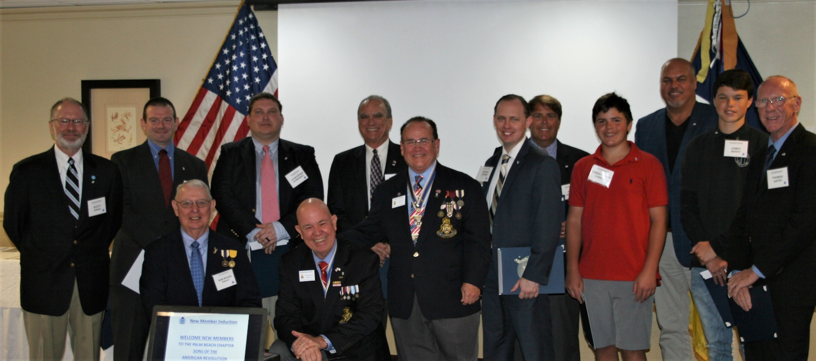

***President Tidwell Presents Chapter Bronze & Florida State***

***SAR Good Citizenship Medal to Richard Linn & Harvey Oyer***

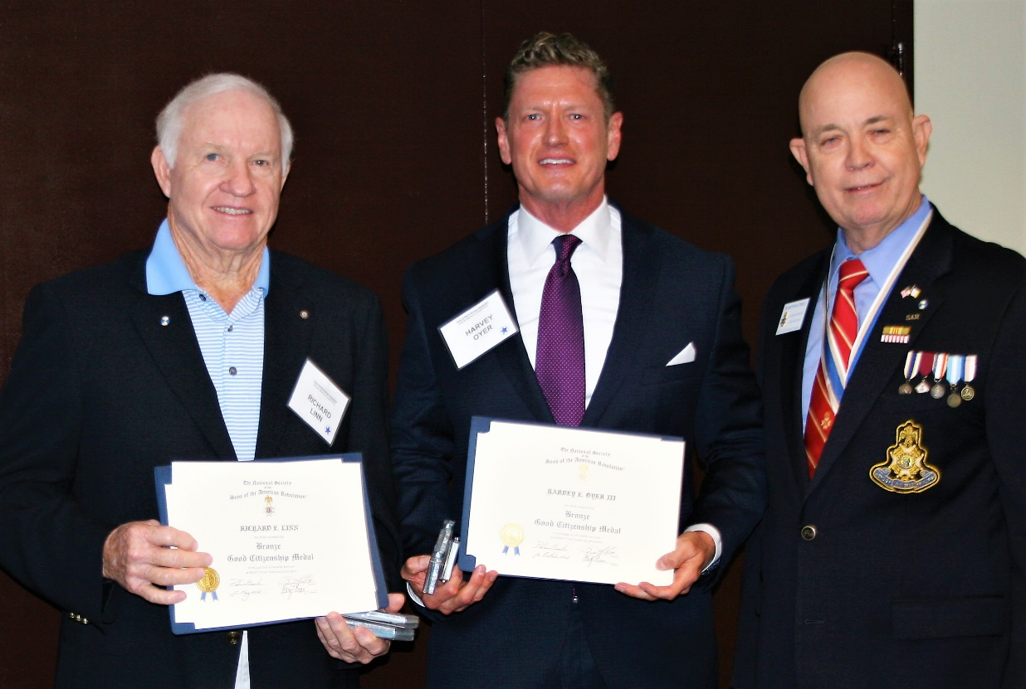

***State Officer & FMR President Lanman Presents National***

***SAR Liberty Medal ‘Oak Leaf’ Pin to VP/Registrar Boggs***

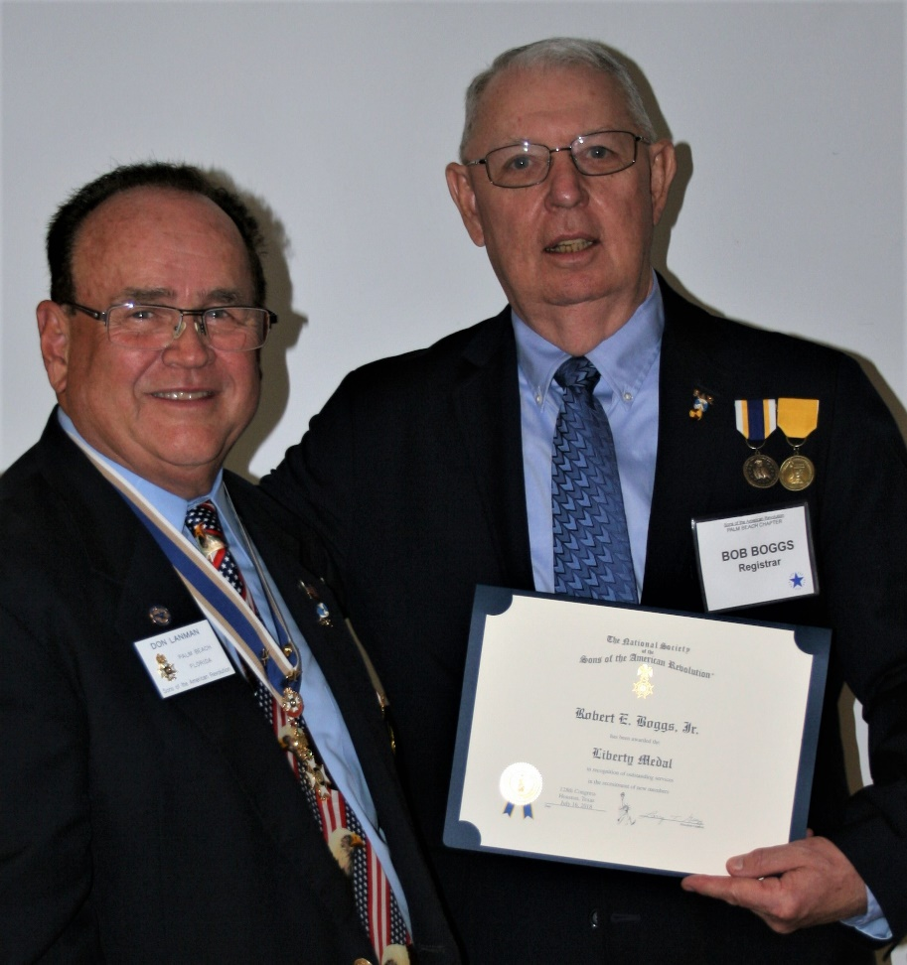

***Compatriot Harvey Oyer III Delivers Powerful***

***Lesson In Palm Beach History***

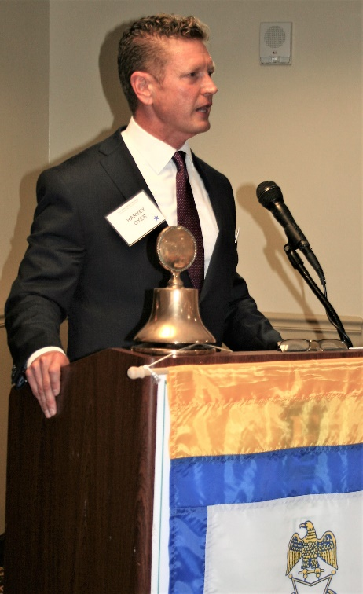

***President Tidwell, & FMR Presidents Lanman & Parkinson***

***Present Scholarship Donation to PBAU Vice President Vicki Pugh***



***Compatriot Harvey Oyer III & FMR President/Patriot Medalist Jim Blackburn***

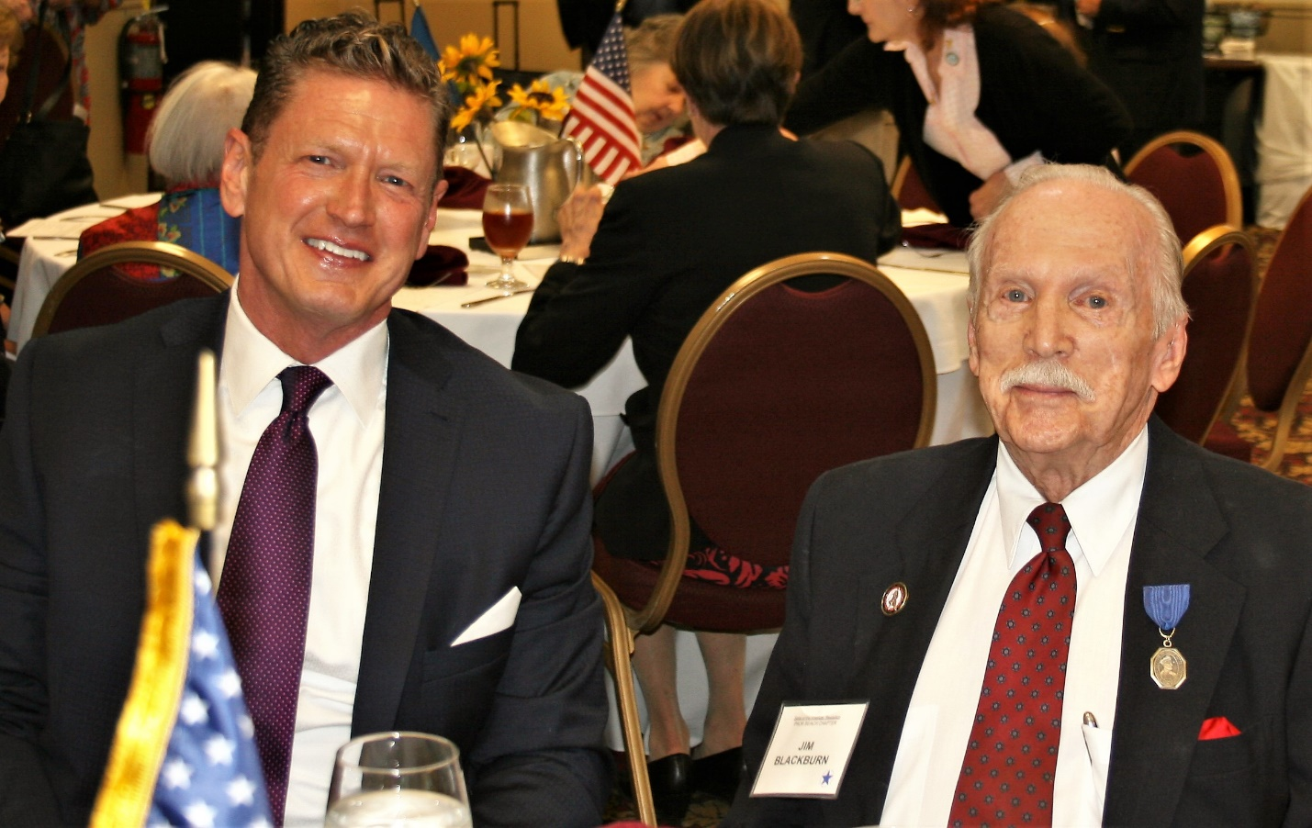

***Former Chapter Presidents Parkinson, Green, Moore, Blackburn, Tidwell, Lanman***

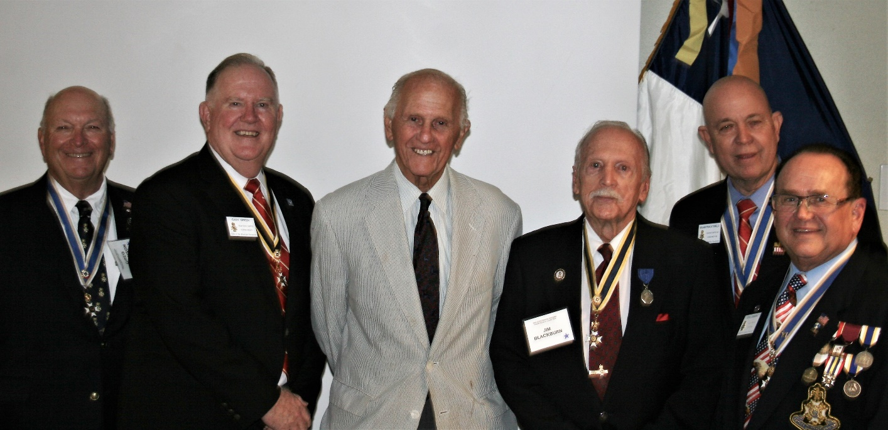

***President Tidwell Presents NASSAR Veterans Corp***

***Military Service Certificate to Compatriot Lanman***

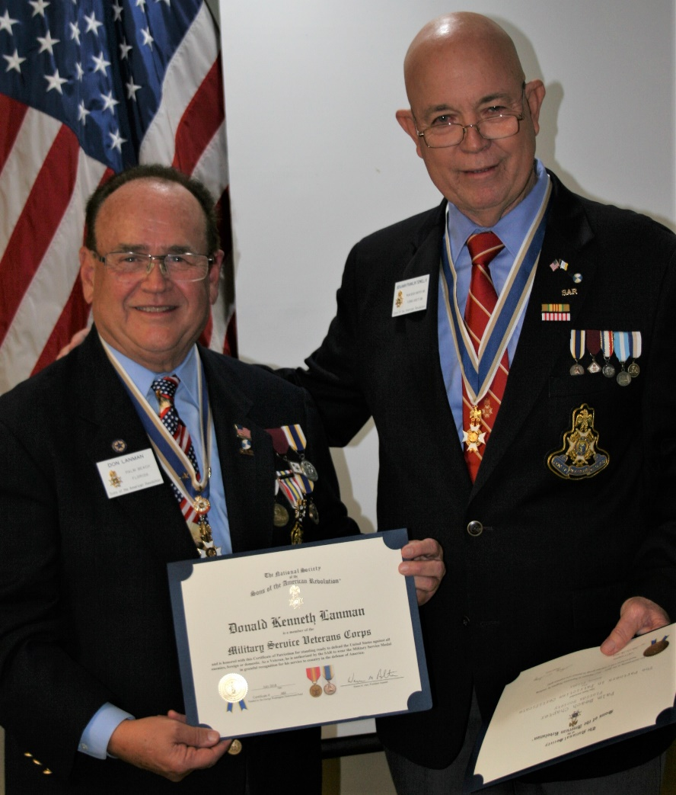

***Honored DAR Daughters Marjorie Ferrer, Zoe Stout, Sally Hitt, Sharon Bounds***

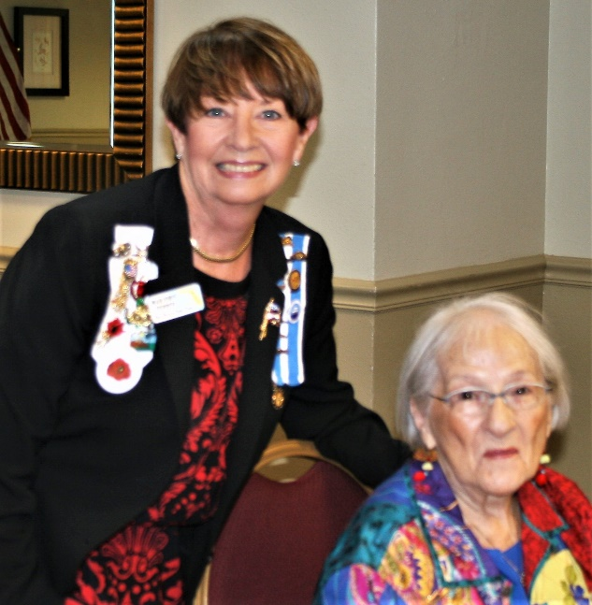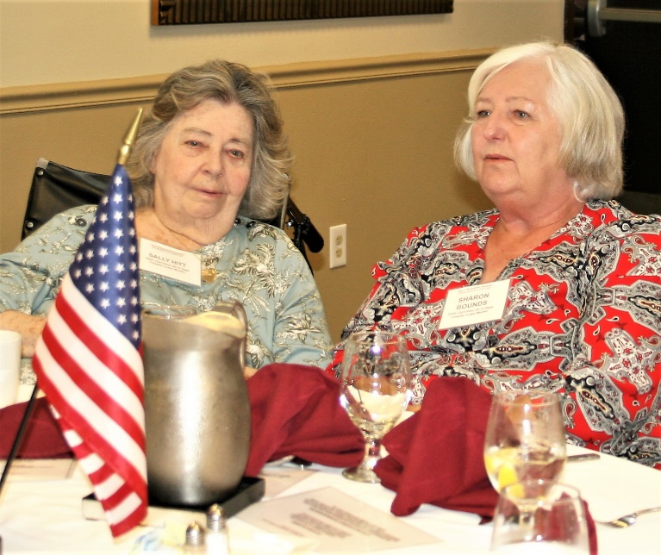

***Welcome New Palm Beach SAR Chapter Compatriots***

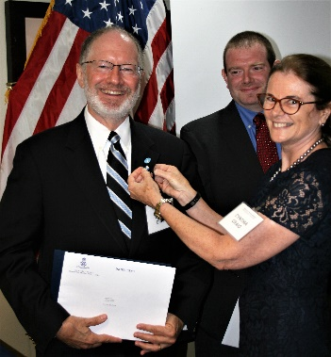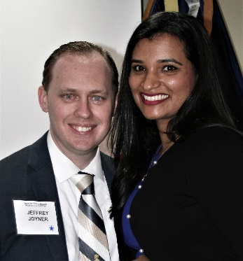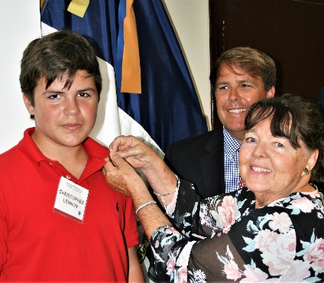

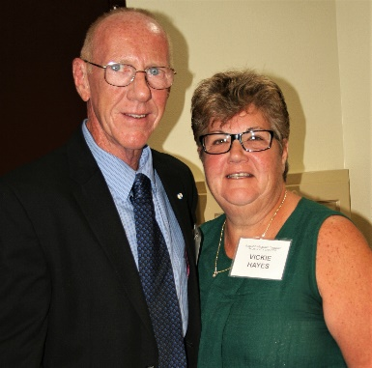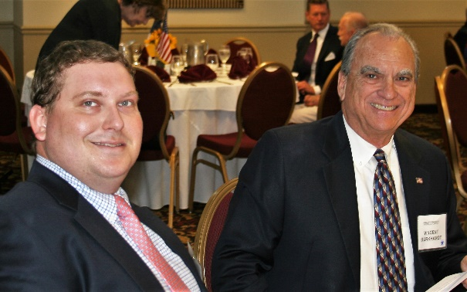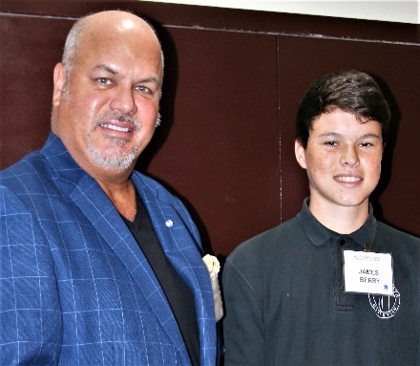

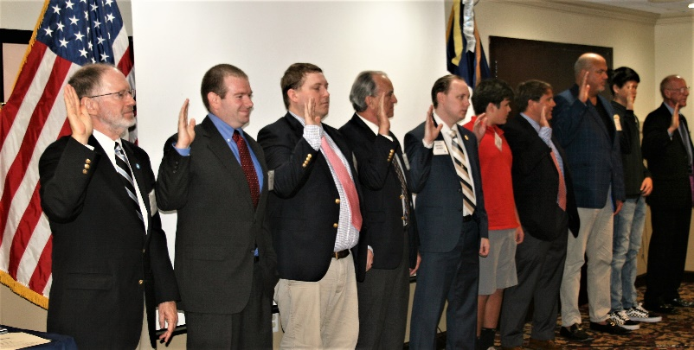

***~80th Anniversary Collectors Commemorative Coin $10.00~***

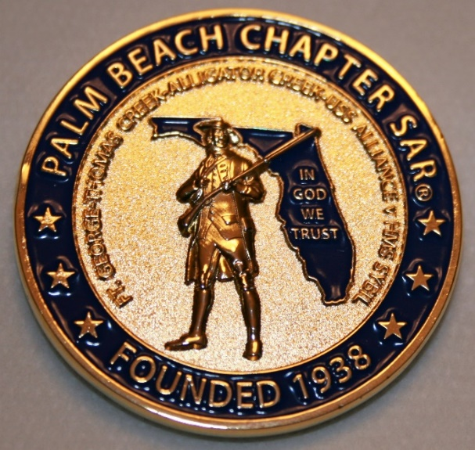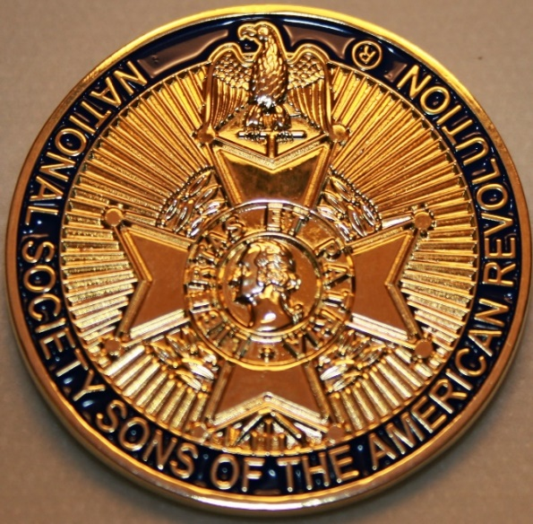

***~Compatriot Sponsored Promotions~***

**Compatriot sponsored newsletter Ads are important to the Chapter as they represent additional funds in support of Chapter projects including; *Scholarships, Boy Scout & JROTC medals, Rumbaugh & Knight Essay Youth contests, Police-Firefighter-EMT medals, Americanism & community civic programs!*** Support your Chapter…sponsor an Ad for **8** issuesat a modest cost:

**Business Card $50, Half Page $100, Full Page $250.**

**Your AD donation will also qualify you for the *Presidents Brigade*. Call Don Lanman 561-315-5073 for information.**

***CHAPTER SUPPORT ADS…***

***~COMPATRIOT ALEXANDER DREYFOOS***

***~AUTHOR/PHOTOGRPHER/PATRIOT***

***~COMPATRIOT SONNY BARBER***

***~HISTORIAN/AUTHOR/PATRIOT***

***~GARCILASO DE LA VEGA, DAR CHAPTER***

***~DAUGHTERS OF THE AMERICAN REVOLUTION***

*~TWO GREAT BOOKS-ONE GREAT MAN~*

***-Alexander W. Dreyfoos-***



***-A PHOTOGRAPHIC ODYSSEY- -PASSION & PURPOSE-***

***Compatriot Alexander W Dreyfoos, Jr.*** an honored member of the *Palm Beach Chapter Sons of the American Revolution*, noted American entrepreneur, and philanthropist has published two remarkable books that should be on every bookshelf. **Book sales** **proceeds** **donated to local West Palm Beach charities!**

* ***Passion & Purpose*** chronicles a remarkable lifetime of passion with photography, his business, inventions and philanthropic ventures, as well as his adventures above and below the water. **$29.95.**
* ***A Photographic Odyssey*** is a remarkable collection of hundreds of stunning pictures from 100,000 photos taken by Alex around the world and bound in an elegant 15” by 10” glossy photographic book. You will travel with Alex around the world, above and below the water, to forests, jungles, glaciers, and deserts in the exotic locals of Papua New Guinea, Bhutan, Nepal, China, Japan, and Tibet. The subjects are very divergent contrasting palaces and temples with the vulnerability of people, animals, and exotic scenery. **$60.00.**
* **Support your Chapter & local charities! Get both books, *Passion & Purpose & A Photographic Odyssey,* just $71.96 @ kravis.org/books or Call 561-651-4329.**

***-Alexander W. Dreyfoos-***

***Graduating from MIT and Harvard Business School, Alex founded Photo Electronics Corporation (PCS), specializing in photography and video production. Over the decades, Alex earned 10 US patents and invented the Video Color Negative Analyzer for motion pictures earning him an Academy Award for technical achievement.Many inventions, developed by PCS, are on permanent display at the Smithsonian Institution. Locally Alex also owned television station WPEC TV-12, the CBS affiliate in West Palm Beach. Alex’s many philanthropic achievements include founding the Palm Beach County Cultural Council, the Raymond F. Kravis Center for the Performing Arts and gifting a million dollars to the Dreyfoos School of the Arts. Alex also donated a million dollars each to the Palm Beach County biomedical research campus of the Scripps Research Institute and the local Max Planck Florida Foundation for Neuroscience in Jupiter, Florida.***

***HISTORICAL MYSTERY SERIES FROM THE REVOLUTIONARY WAR~ACROSS TIME***

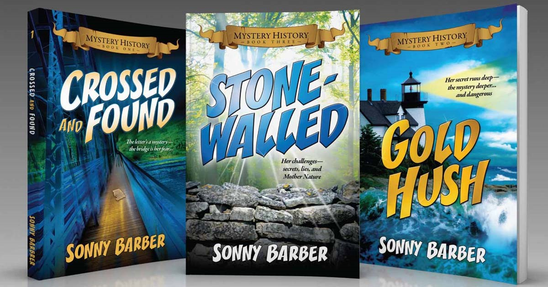

***Follow Kay Telfair across time beginning with Crossed & Found followed by Gold Hush & Stone-Walled….***

***Kay is a normal young teen—normal if that means being unusually curious and having an uncanny knack for putting herself in dangerous situations, which stresses her parents and often tests the relationship with best friend Anna.***

***The series follows Kay across two intrigue-filled summers on adventures involving events in American history. Join Kay’s journey of adventure steeped in American History through three books that excite all ages. At*** [***amazon.com***](http://amazon.com)***, Barnes & Noble or Chapter meetings. (See book summaries following page)***

***SAR Palm Beach Chapter Compatriot/Author Sonny Barber developed an interest in American history at an early age, reading and collecting newspapers, magazines and other materials on historic U.S. and world events. He’s coupled that interest with his fiction writing to create a modern-day “mystery history” Series perfect for Preteens to Adults.***

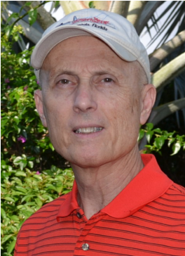

***~Crossed & Found~***

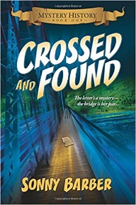

**Thirteen-year-old Kay Telfair believes her life is over when she moves with her family a thousand miles to their new home near the Delaware River in New Jersey. But her life takes an unexpected turn when she meets Anna and discovers a two-centuries-old letter--a letter that could change American history. Before she unravels the letter's mystery, Kay stumbles headlong into an adventure confronting fears she'd never experienced, stretching the limits of her friendship with Anna, and forcing a test of Kay's physical strength that could save her life.**

***~Gold Hush~***

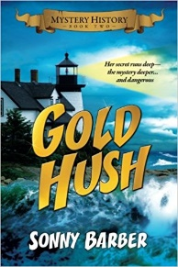

**“I’m avoiding any activity that involves excitement…I’ve learned my lesson.” After an adventure-filled June, all Kay Telfair wants is a quiet vacation in Maine with her family and best friend Anna—no drama, no stress. But the thirteen-year-old’s hopes for a tranquil August stay in the village of Prospect Harbor soon fade when the girls compete for the attention of a young boy and Kay makes a startling discovery—a discovery that sends the three teens on a dangerous quest. Ignoring advice—and menacing threats from others—they continue their pursuit, drawing them deeper into a perilous mystery, deeper than Kay ever could have imagined.**

***~Stonewalled~***

[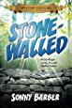](https://www.amazon.com/Stonewalled-Mystery-History-Book-Three/dp/1519351291/ref=pd_bxgy_14_img_3?_encoding=UTF8&psc=1&refRID=75QVZ72QHQ8A2W2F3RK1)

**Kay stared at the gray line of stone walls. “They won’t be too upset to see these knocked down...” A mystery that threatens the relationship with best friend Anna, a battle with Mother Nature at her worst, and the discovery of a tragic secret—not exactly what fourteen-year-old Kay Telfair was looking for in a summer getaway. But that’s what confronts the young teen while helping the owners of Windcrest Farm find a way to stop destruction of nearby farmland and its three-hundred-year-old stone walls. Vacationing with her family and Anna at Windcrest in the quiet, coastal village of Little Compton, Rhode Island, the young teen soon discovers her goal will not be easy. Kay’s prospects for helping preserve the valuable land and stone walls look much better after a surprise visit by a boy from her past. With his help, she pours all her energy and passion into the quest, searching for answers in New England’s Native American and colonial history and learning some important lessons about perseverance and friendship.**

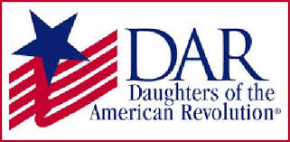

*~Garcilaso De La Vega Chapter, NSDAR~*

*Lake Worth, Florida*

*~Michelle Robertson, Regent~*

*~Karen Christie, Registrar~*

Phone; 561-236-2460-Email; [IMC4U4@AOL.com](mailto:IMC4U4@AOL.com)

Chapter Email: [GarcilasodelaVegaDAR@gmail.com](mailto:GarcilasodelaVegaDAR@gmail.com)

Visit us on ***Facebook*** @ <https://www.facebook.com/LWDAR>