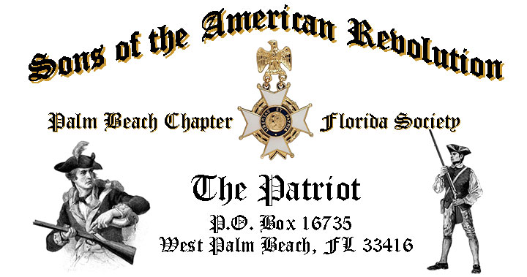

***Volume 23 October 2017 Number 07***

***The first meeting of the season features Historian/Author Dr. Roger Smith’s*** remarkable presentation, ***“Florida, America’s 14th Colony”*** *Tuesday* **October 17, 12:00 Noon** @ the Embassy Suites 1601 Belvedere Road, WPB! RSVP early for this popular event.

***October 17 Meeting Highlights:***

* ***Historian/Author Dr. Roger Smith***, ***“Florida, America’s 14th Colony”***
* ***Special Memorial Service for Compatriot-Past President Gerry Meeks***
* ***Buffet******Lunch***, Desserts & Beverages, **$28** per person **Check/Cash** at the door!
* ***Reservations*** **required,** **RSVP**, Don Lanman **(561)-315-5073!**
* **Family, Friends & Guests** are always ***Welcome***!

***Newsletter Content:***

* **President’s** Message
* **2017/18** Chapter Meeting Dates &Topics
* **Officers** & Board Members
* ***President’s*** *Brigade* Financial Supporters
* **Committees**, Chairmen & Members
* **National**/**State** Society News & Events
* **Feature Article: *No Vet Left Behind! Missing in America Project***
* **Chapter** Meeting & Event Pictures
* **Compatriot** Sponsored Promotions

***President’s Message:***

***Fellow Compatriots & Friends…***

The ***October*** meeting promises to be exceptional as we welcome revolutionary war historian, author and SAR Compatriot, Dr. Roger Smith. Dr. Smith will present a remarkable review of *“Florida, America’s 14th Colony”* including new research on the importance of Florida during the revolution.

[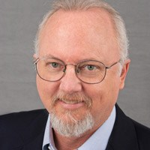](http://www.colonialra.com/talks)[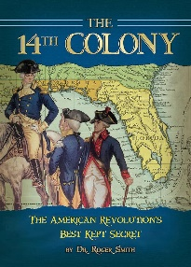](http://www.colonialra.com/books/14th-colony/)[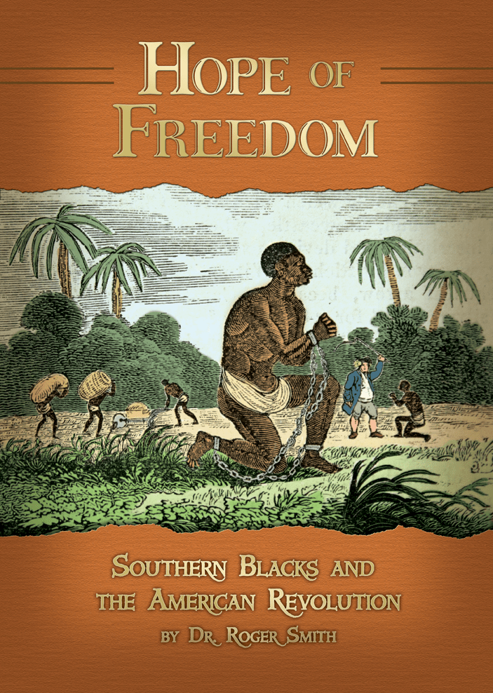](http://www.colonialra.com/books/hope-of-freedom)[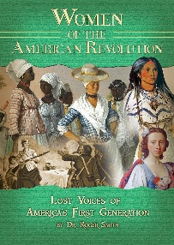](http://www.colonialra.com/books/women-of-the-american-revolution/)

Dr. Smith will be available to sign any of his groundbreaking books: ***“The 14th Colony”,* “*Hope & Freedom”,***and *“****Women of the American Revolution”.***

The Chapter welcomed three new Compatriots during a special ***Compatriot Induction Ceremony*** in May including ***Jacque Chataing, Tipton Lichtenstein*** and 2-year-old ***Carter Grant Coldwell***…our youngest Compatriot yet!

The Chapter was also honored with a special ***Color Guard*** presentation by the ***Boca Raton Community High School Naval JROTC Cadets*.** The Cadets presented the colors in perfect military precision exhibiting the high quality of students that the ***JROTC*** program produces.

Compatriots***Bill Johnson, Sonny Barber,***and***Jack Curry***were presentedwith the *SAR* *Military Service Medal*, *Vietnam 50th Anniversary* pins, and welcomed into the *FLSSAR* *Veterans Battalion* and the *Chapter’s* own **“*Band of Brothers.”***

Our Chapter is a historic supporter of the Nation’s Veterans, with over 15% of our members serving from *WW II to Iraq*. Veteran Compatriots are encouraged to provide their *DD-214* to be recognized with the ***SAR Military Service Medal*.**

Chapter Compatriots and family members attended a special award presentation of the prestigious ***SAR Patriot Medal*** to the *“Chapter’s Own”* ***Compatriot Edward S. Buckley IV*** during the State Board of Management meeting.

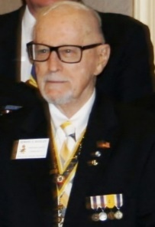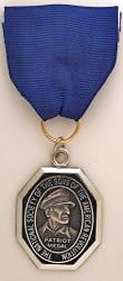

***Compatriot Buckley***, a *WW 2 Veteran*, has served the *SAR* for 20+ years, serving as *Chapter President 2006-2007* and then as *South East Regional Vice President*. Congratulations *Compatriot Buckley*.

***Chapter Past President Ray Wess*** concluded his successful tenure as *President of the Florida State Society of the Sons of the American Revolution* at the May Board of Management meeting in Orlando.

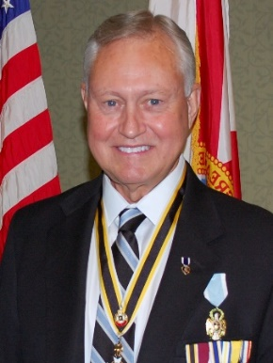

Ray’s many accomplishments as State President include the ***Vietnam Veterans Welcome Home Ceremony*** and a comprehensive strategic plan for the State Society. His service reflects countless years of selfless dedication to the SAR and diligent promotion of the values of our Patriot ancestors. Congratulations Ray, Well Done!

The “***Chapter’s Own”***, *Lauren Goepfert* was honored at the May BOM meeting for winning both the Chapter and State “*History Teacher of the Year Award*” contests. *Ms. Goepfert* went on to win the “*National History Teacher of the Year Award”* at the SAR National Congress in Knoxville, TN. Congratulations Lauren.

It is my sad duty to report the passing of beloved ***Compatriot, Past Chapter/State President*** and ***Patriot Medal*** recipient ***Gerry Meeks***.

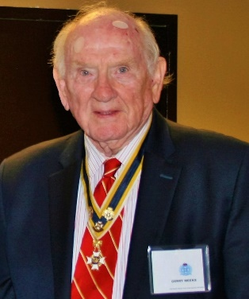

The ***Palm Beach Chapter, National Society of the Sons of the American Revolution*** will deliver a special ***SAR Memorial Service*** in honor of ***Veteran, Past President*** *and* ***Patriot Medal***recipient ***Gerry******Meeks*** at October 17 meeting.

***Memorial Day*** is always a special opportunity to show our respect and to say **"*Thank You*"** to Veterans, Active Service Members and their supportive Families, and to honor the memory of those who sacrificed all at the ***Altar of Freedom***.

***Palm Beach Chapter Compatriots*** participated in the ***Veterans Flag Placement Day*** at the *South Florida National Cemetery* by placing over 160 American Flags at the tombstones of our Honored Veterans.

Compatriots also presented an ***SAR Honor Wreath*** at the ***12th Annual Forgotten Soldiers Day to Remember Ceremony*** on ***Memorial Day*** at the *Palm Beach Memorial Park*.

***SAR Past President, Patriot Medal*** recipient and *Korean* War veteran *Compatriot* *Jim Blackburn* joined 80+ WW-2 and Korean war vets on the ***Southeast Florida Honor Flight*** to visit war memorials in Washington, DC.

Chapter Compatriots were at the airport to welcome *Compatriot Blackburn* and the other Veterans home*.* ***Welcome Home*** and ***thanks for your service Jim*!**

The custom ***Palm Beach Chapter Commemorative Challenge Coin*** is now available in honor of the ***Chapter’s 80th Year***. The coin notes the four major revolutionary war battles waged in *Florida* with an illustration of a Minuteman standing guard over *Florida* with the State moto of ***“In God We Trust.”***

These beautiful Commemorative Collector coins, used as mementos for special chapter guests and patriotic occasions, are available for purchase at just $10 each.

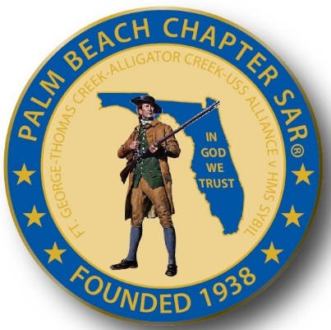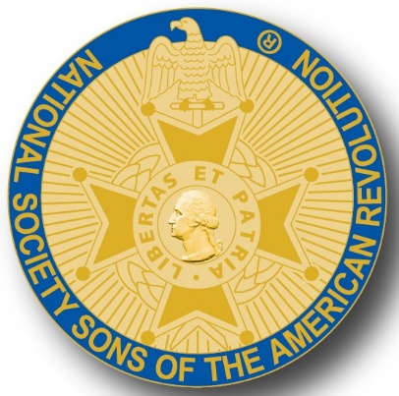

A primary Chapter goal for our continued success is membership development and the mentoring of new members. We are currently at 185 members with 41 prospects in the pipeline.

However, with the natural turnover of members, we need all Compatriots to help grow membership by recruiting civic-minded individuals interested in honoring our patriot ancestors and enjoying good fellowship. Take action today to enroll Sons and Grandsons, invite friends to join and encourage wives, daughters, and granddaughters to join the *DAR* and *Chapter Women’s Auxiliary*.

Another important goal is expanding our relationships and joint events with all of the Palm Beach *DAR Chapters*. We welcome our ***DAR Patriot Daughters*** to all Chapter meetings and events, and sincerely appreciate their new member referrals and ongoing support. ***Thank you DAR!***

***Officers for 2018*** and ***Committee Members Needed!*** The Chapter **desperately** needs members to volunteer for 2018 Officer positions and for committee to support our many diverse civic programs including Rumbaugh Historical Oration and Knight Essay Contests, Teacher of the Year, social media, website support Veterans programs, Publicity, Boy Scouts, JROTC, Police-Firefighters-EMS Service Awards, and Fundraising/Endowment Programs.

***2018 Membership Dues!*** Compatriots will begin receiving their **2018 Membership Dues Notices** beginning the week of 10/22. Please respond immediately with the annual membership dues of $75 plus any additional donation to the general fund. It’s also a good time to update your contact information.

***Compatriots***, the hotel requires a minimum number of guests to cover the room, food, and services fees, so when attendance is low or there are no shows, the Chapter must pay the difference. Please help us avoid losing money on the chapter luncheons by attending each meeting and bringing guests!

Fellow Compatriots, I look forward to seeing you at our October meeting! Please, join me in honoring our nation’s Veterans, Patriot Ancestors, and especially our Dear Departed Compatriots. **God Bless You** and **God Bless the *United States of America*.** **-D. Lanman**

**2017/18 Chapter Meeting Dates/Topics:**

**Visit** the Palm Beach Chapter web site @ [www.sarpbchapter.org](http://www.sarpbchapter.org) for a meeting calendar, special events, articles, pictures, and general information.

* **Oct. 17, Historian Roger Smith PhD**, **Florida, America’s 14th Colony**
* **Nov. 21,** **Officer Nominations 2018**, **SAR State President Folk Visit**
* **Dec. 9,** ***Kings Academy Christmas & Holiday Musical***
* **Jan. 16, 2018** **Officer Inductions**, Special Guest Speaker
* **Feb. 20, 2018**, ***Special Guest Speaker Thomas Jefferson***
* **March 20, 2018**, Special Guest Speaker
* **April 17, 2018**, ***Law Enforcement Awards Ceremony***
* **May 15,2018, *Firefighters/EMT Awards Ceremony***

**2017 Officers & Board:**

**President** **Donald Lanman**

**Vice President** **Benjamin Tidwell III**

**Secretary** **Gary Green**

**Treasurer** **Peter Johnston**

**Registrar** **Robert Boggs**

**Chaplain** **Father Sanford Sears**

**Sgt. @ Arms Brian Davey**

**Historian** **Samuel “Buddy” Miller**

**Officer @ Large** **Bill Johnson**

**Patriot Newsletter Editor** **Donald Lanman**

**Support Scholarship & Youth Programs- Join the President’s Brigade:**

The Chapter has approved ***$1,000***Scholarship to the *Palm Beach Atlantic University* again this year. We want to increase the scholarship to ***$4,000*** and respectfully ask Compatriots to consider helping the Chapter grow the amount and support students of character.

The Chapter honors and expresses its sincere appreciation to the Compatriots of the ***President’s Brigade*** who support the scholarship and youth programs.

The dedicated members of the ***President’s Brigade*** donate “extra dollars” in support of the Chapter’s many youth programs, scholarships, civic activities, award certificates, police/firefighter/EMT medals, veterans’ projects, and related community civic programs.

**Honored Presidents Brigade Members:**

**-Bronze Level: $25-$99**

***M. Anderson, B. Boggs, J. Brown , R. Cass, D. Coldwell, B. Davey, J. Dorsey, W. Davis, F. Devitt J. Harper, J. Kane, J. Mayne, S. McWhorter, C. Odell, G. Parkinson, W. Told***

**-Silver Level: $100-$199**

***J. Curry, R. Culpepper, T. Friend, G. Green, F. Green, A. Griswold, B. Johnson, B. Told***

**-Gold Level: $200-$499**

***R. Brinckerhoff, R. Banta , E. Buckley, K. Christie, S. Hitt, D. Lanman, W. Meakin, B. Tidwell, R. Utley, J. Wynns***

**-Platinum Level: $500+**

***A. Dreyfoos***

**Officers, Committees, Chairs & Members:**

**Fellow Compatriots**…..The Chapter expresses its sincere appreciation to those members who volunteer to serve on our committees and projects. As you can see a few Compatriots are serving on multiple committees and could use support!

**Please apply for an officer position for 2018** and select a committee of interest to help on any of the chapter committees listed. It does not take much time and is a major help with our many civic and youth initiatives. Thank You!

**Call** or email Don Lanman or Ben Tidwell **Today** to lend a hand with any of the following committees.

* **2018 Officer Nominations -All Chapter Members**
* **80th Anniversary -All Chapter Officers**
* **JROTC & Boy Scouts -Tidwell**
* **Law Enforcement-Fire Safety -Green, Tidwell**
* **Veterans Affairs -Lanman, Curry**
* **Newsletter/Publicity -Lanman**
* **Knight Essay/Rumbaugh Oration -Boggs**
* **American History Teacher -Boggs**
* **DAR Liaison -Lanman, Tidwell**
* **Speakers Bureau -Lanman, Tidwell**
* **Audit -Coldwell, Tidwell, Lanman**
* **Flag Certificates -Clouse, Miller, Johnston**
* **Membership -Green, Boggs, Tidwell**
* **Liberty Tree -Chapter Officers**
* **Patriot Bios -Miller**
* **Web Site-Facebook/Social Media -Open**

**Palm Beach Chapter 80th Year Commemorative Challenge Coin $10!**

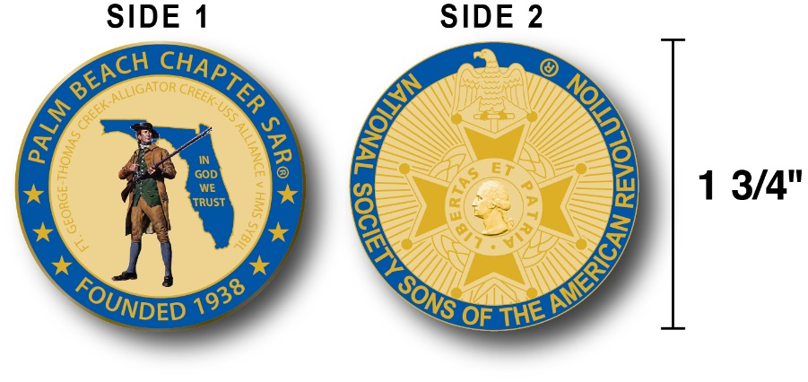

The Chapter has produced a custom bronze *Commemorative Anniversary Coin* honoring the founding of the *Palm Beach Chapter* in 1938 and celebrating its 80 years of historic, patriotic, and civic service in Palm Beach County and Florida.

The beautiful bronze coin is highlighted in ***George Washington*** military blue on a stunning gold background. Side-one is personalized to our Chapter with the founding date, a Minuteman standing guard over Florida, and the Florida State motto of ***"In God We Trust”.***

The coin also includes a notation listing the four major Revolutionary War battles waged in Florida including the battles of ***Ft. George-Pensacola, Thomas Creek Massacre, Alligator Creek,*** and the ***Last Naval Battle* of the Revolutionary War** between the ***USS Alliance*** & ***HMS Sybil.*** Side-two displays the national *NSSAR* logo.  Very impressive indeed!

The custom bronze ***Commemorative Anniversary Coin*** is designed to celebrate our founding in **1938**, create a distinctive and impressive image for our Chapter and be used as a token of appreciation for honored guests, speakers, and as special awards.

***Compatriots may purchase these unique collector coins for just $10 each.***

***Classy SAR Lapel Pins $10:***

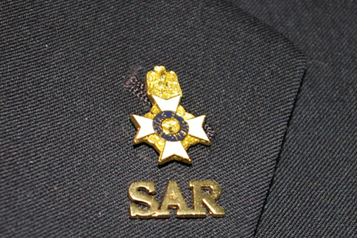

Display a ***Gold*** ***SAR*** pin on your suit lapel or shirt with the ***SAR Rosette***. The SAR Lapel Pin is part of a national branding program to help promote the S.A.R. and stimulate new membership!

The striking lapel pin is a recognizable public symbol of the SAR, provides you recognition as a member of this great society, and will spark conversations about SAR that leads to a new member.

The gold lapel pin and SAR Rosette create a professional image that will improve overall SAR name recognition. The Chapter has a supply of pins for Compatriots for just $10. **Get yours today**!

**SAR Chapter, State & National Events:**

**-*STATE/NATIONAL*:**State Board of Management meeting is November 3-4 with meetings on Friday and Saturday.  The registration form is accessed (**download** before filling it out) at the BOM menu tab on the ***FLSSAR.org*** website.

**~*In Memorial*~**

The ***Palm Beach Chapter, National Society of the Sons of the American Revolution*** mourns the loss of its own Compatriot Meeks. A special ***SAR Memorial Service*** in honor of *Veteran, Past President and Patriot Medal winner Meeks* will be delivered during the October 17 meeting.

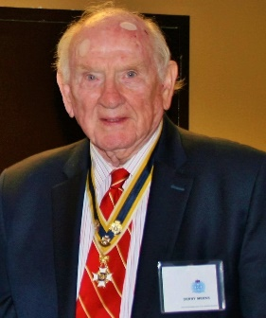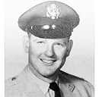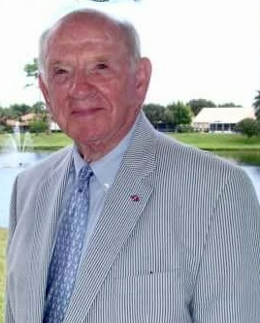

***Gerald E. Meeks***, 86, of Delray Beach, passed away on September 21, 2017. He is survived by his wife, Ann L. Alexander, stepson, Dr. Stephen (Kelly) Alexander; stepdaughters, Tracee Ferrell and Christi (David) Halcomb. Gerald Meeks is also survived by two sons, John L. (Lisa) Meeks and their three beautiful daughters and Timothy Meeks.

Gerald retired after 32 years in the Unites States Air Force as a Lieutenant Colonel. He is a highly decorated veteran with many military awards that include the [Purple Heart](http://www.legacy.com/memorial-sites/purple-heart/?personid=186789534&affiliateID=1017) and [Bronze Star](http://www.legacy.com/memorial-sites/bronze-star/?personid=186789534&affiliateID=1017). At that point in his life he moved to Austin, Texas where he became a successful Realtor.

In 1987 he moved to Delray Beach, Florida where he had reconnected with his high school and college sweetheart, Ann Alexander, who he had not seen in 33 years. They were married in 1990. Mr. Meeks was a member of the Society of Colonial Wars where he served as governor from 2007-2008.

He was also a member and gave service to the National Society of the Sons of the American Revolution.

These services include but not limited to: president of the Palm Beach Chapter 2001-2003; president of the Florida State Society 2010-2011; numerous committees and was the recipient of various SAR medals including the highly regarded Patriot Medal in 2016 for outstanding contributions to his country and to the SAR.

***In Respect & Heartfelt Patriotism*, *Compatriots of the Palm Beach Chapter SAR***

***Feature Article:***

***No Vet Left Behind…***

***Missing in America Project!***

**By Don Lanman, Veteran & President Palm Beach Chapter SAR**

*“I can't promise you that I will bring you all home alive. But this I swear, before you and before Almighty God, that when we go into battle, I will be the first to set foot on the field, and I will be the last to step off, and I will leave no one behind. Dead or Alive, we will all come Home together. So help me, God."* ~ Lt Gen Hal Moore, (Ret) 'We Were Soldiers Once . . . and Young: before the battle of the Ia Drang Valley Vietnam-The Battle That Changed the War in Vietnam”.

***No Vet left Behind***…is an eternal promise and profound commitment to all American Veterans from blood soaked Bunker Hill to the killing fields of Afghanistan.

Founded in 2006, the national *Missing in America Project* (MIA) is a Veteran remains recovery program with the noble mission to locate, identify and inter, with honors, the unclaimed cremated remains of American Veterans through the joint efforts of volunteers, private, state and federal organizations.

While difficult to comprehend, one state hospital reported over 3,500 unclaimed cremains were sitting on their shelves yet to be identified and representing a time span from the 1890s to 1971. It is estimated that over 1,000 of these cremains are veterans. This is happening in every state.

Now a nation-wide effort, the MIA project continues its mission to locate, identify and inter the unclaimed remains of forgotten veterans. This task is being executed through the combined, cooperative efforts of members of the American Legion, other veteran organizations, service organizations, local Funeral Homes, State Funeral Commissions, State and National Veterans Administration Agencies, and the State and National Veterans Cemetery Administrations.

Working together, these organizations assure that all local, state and national laws are followed in the identification, claiming process and proper interment of the unclaimed veterans’ remains, and assure that these forgotten veterans who served our country are buried with the honor, dignity and respect they earned.

Since 2006 the MIA project has contacted over 2,100 funeral homes, located 15,259 unclaimed cremains, identified and interred, with full military honors, over 3,200 Veterans, but the work continues.

Members of the *Palm Beach SAR Chapter* and local *DAR Chapters* have been working for several years with the MIA Florida project providing escorts at each of the military ceremonies for these forgotten heroes.

To honor and respect to those veterans who have served this country by securing a final resting place for these forgotten heroes, Compatriots of the *Palm Beach Chapter National Society of the Sons of the American Revolution* are encouraged to attend each event at the South Florida *Missing In America Veteran Internment Ceremony.*

Open to all, the June ceremony interred the remains of 14 veterans and 6 spouses with full military honors.

These veterans served in the US Army, Marines, Airforce and Navy, during the Cold War, Vietnam, and World Wars I, II and Korea.  The *Palm Beach County Sheriff’s Office* will lead an Honor Escort and welcome any motorcycle organizations, riders, and or vehicles are welcome to participate. All MIA Ceremonies will be published in advance to Chapter Compatriots. For more information visit [www.miaps.us](http://www.miaps.us).

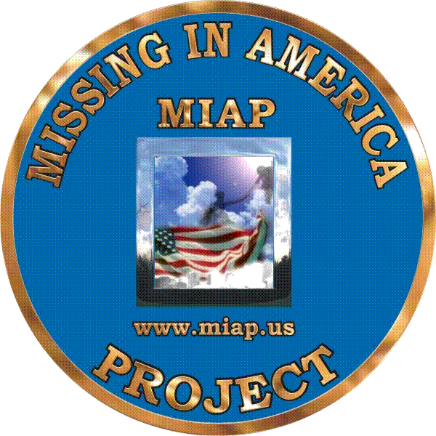

***Pictures from the June 2017 MIA Ceremony***

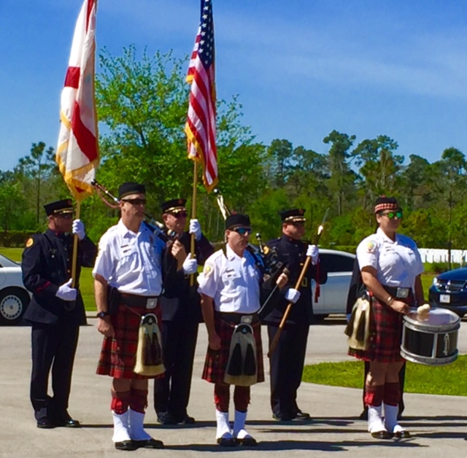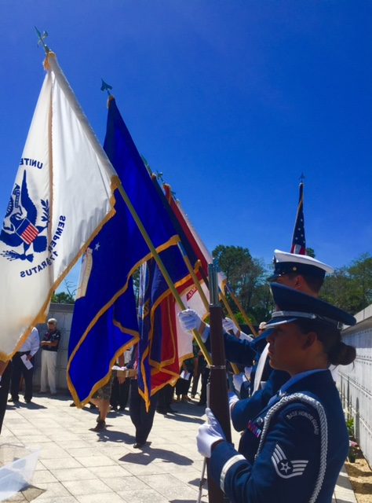

**2018 Dues Notices Mailed….Keep Your Membership Active:**

**Your 2018 SAR membership dues notices have been mailed.** Compatriots should receive their notices along with a return envelope beginning the week of 10/22.

**Please Don’t delay….Mail** **your $75 annual** membership fee as soon as you receive your notices to ***SAR PB Chapter, PO Box 16735 West Palm Beach, FL 33416-6735! Include*** any changes to your personal contact information.

***Remember*….Your** membership dues plus any additional donations fund the many Chapter civic activities including **Scholarships**, ***Boy Scout & JROTC medals, Rumbaugh & Knight Essay Youth contests, Police-Firefighter-EMT awards, Flag Certificates, Americanism, & Community programs.***

***-Meetings & Event Pictures-***

***Military Service Medals for Compatriots J. Curry, S. Barber, W. Johnson***

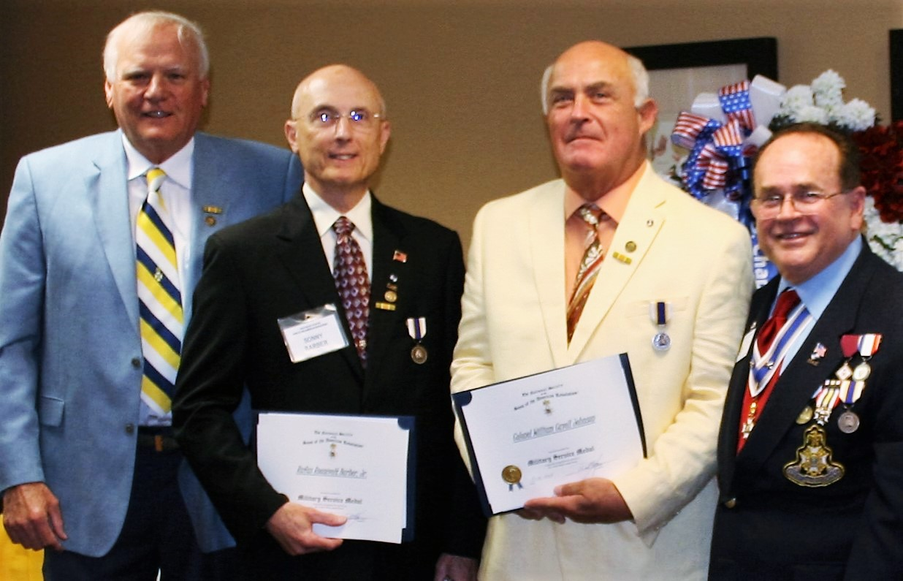

***New Compatriot Induction, C. Coldwell, T. Lichtenstein, J. Chataing***

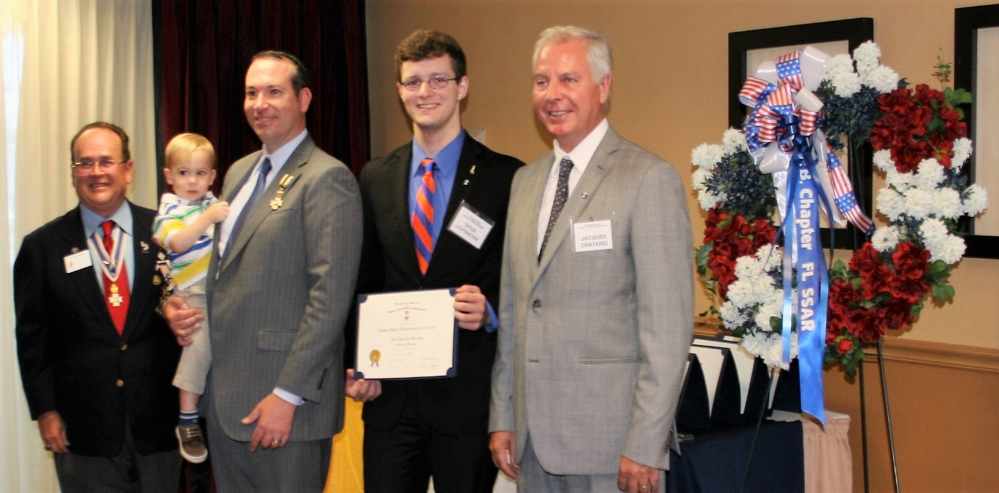

***Boca Raton Community High School Naval JROTC Color Guard***

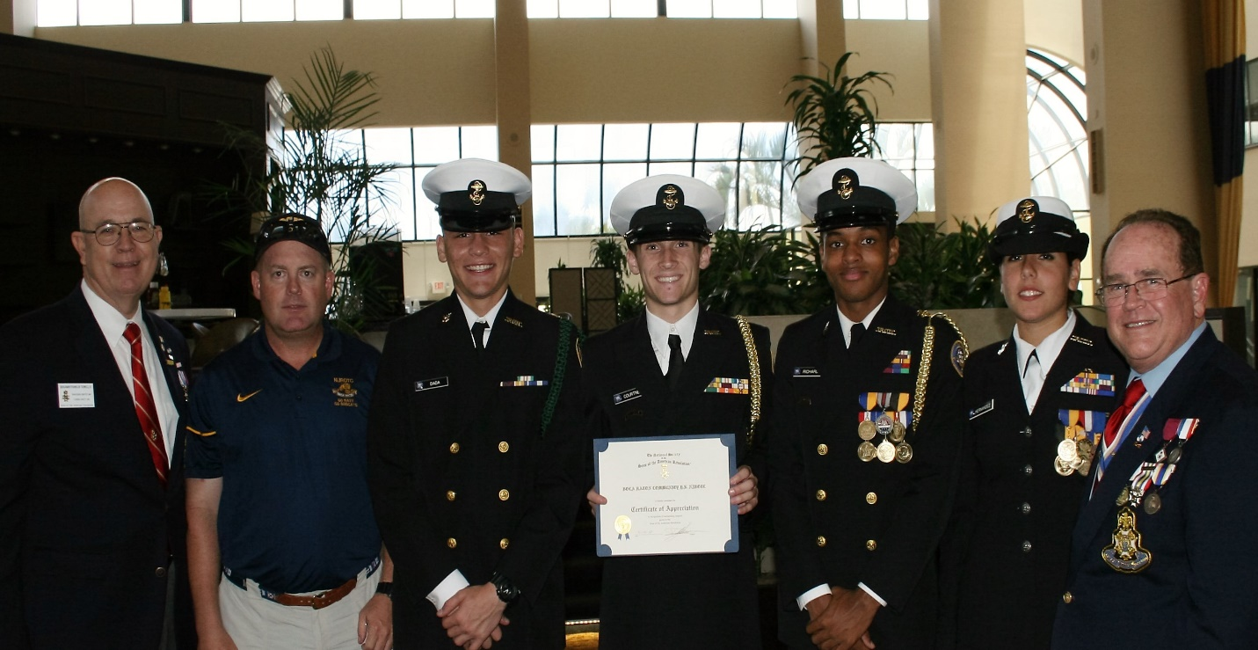

***2-Years-Old Compatriot Carter G. Coldwell***

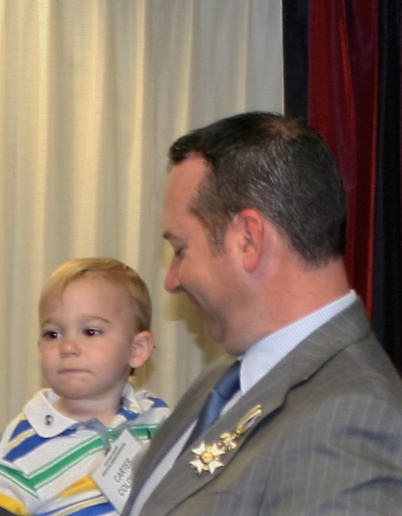

***SAR Patriot Medal for Compatriot Ed Buckley, w/Family & State President Wess***

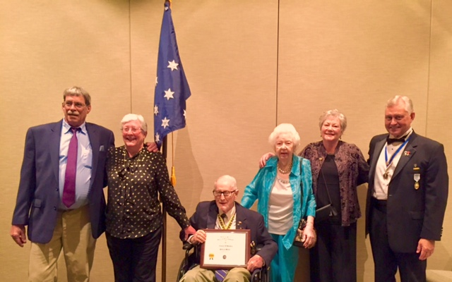

***Chapter/State/National Teacher of the Year Winner Lauren Goepfert***

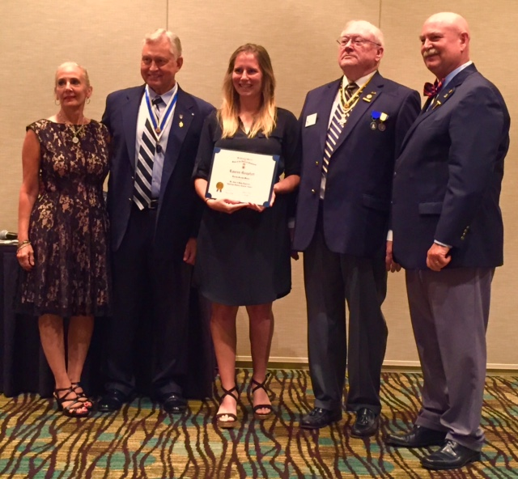

***Compatriots Johnston, Sears, Lanman Honor Memorial Day***

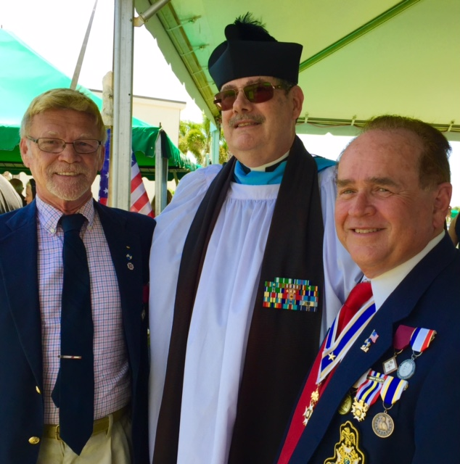

***~80th Anniversary Bronze Commemorative Collector Coin $10.00~***

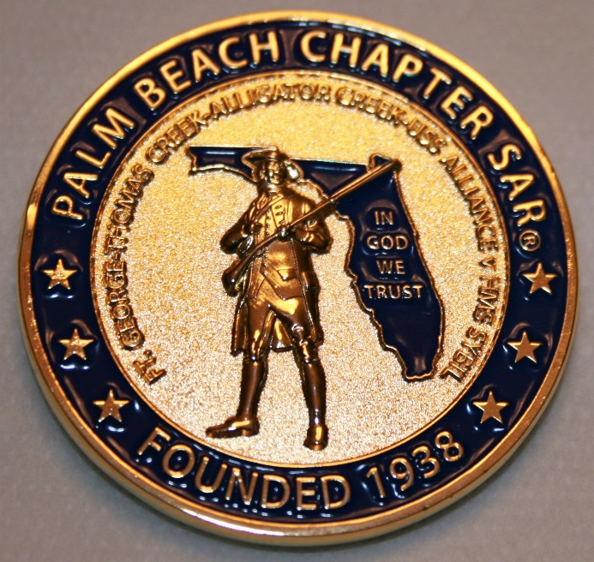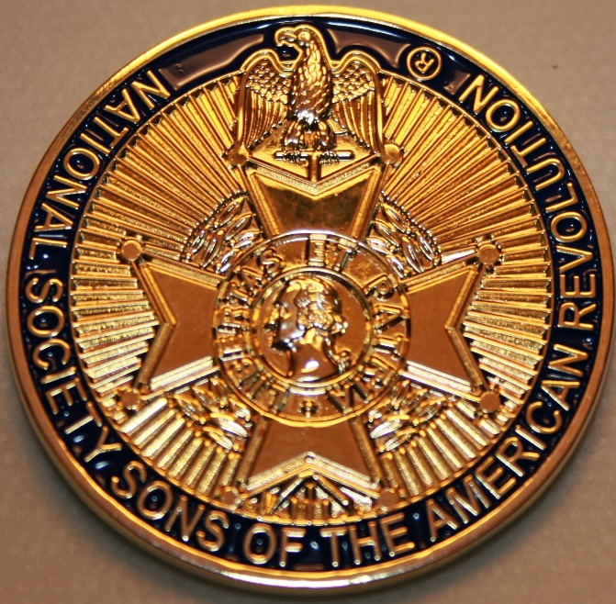

***~Compatriot Sponsored Promotions~***

**Compatriot sponsored newsletter Ads are important to the Chapter as they represent additional funds in support of Chapter projects including *Scholarships, Boy Scout & JROTC medals, Rumbaugh & Knight Essay Youth contests, Police-Firefighter-EMT medals, Americanism & community civic programs!***

**Help** your Chapter, sponsor an Ad for **8** issuesat a modest cost: **Business Card $50, Half Page $100, Full Page $250. Your AD donation will also qualify you for a listing in the *Presidents Brigade*. Call Don Lanman 561-315-5073 for information.**

***SPECIAL SPONSORED ADS ON FOLLOWING PAGES…***

***~COMPATRIOT ROBERT BRINCKERHOFF***

***~GARCILASO DE LA VEGA, CHAPTER***

***DAUGHTERS OF THE AMERICAN REVOLUTION***

***~COMPATRIOT ALEXANDER DREYFOOS***

***~COMPATRIOT ROGER SMITH PhD,***

***HISTORIAN/AUTHOR***

***-Morgan Stanley-***

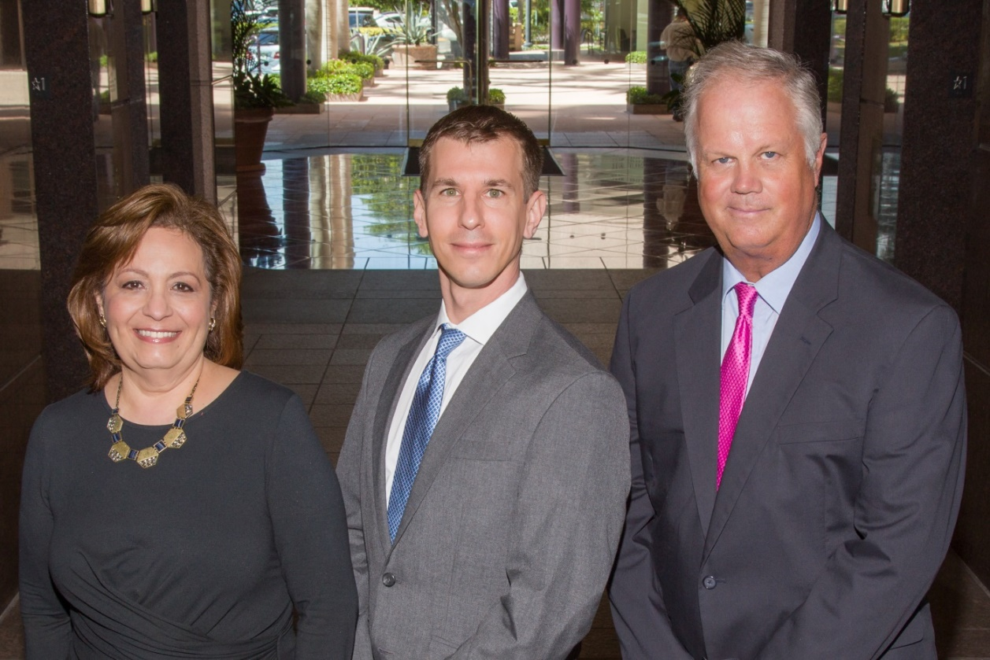  
***Amani Gaballa, Senior Registered Associate; Robert Scarborough, Financial Advisor; Robert Brinckerhoff, First Vice President, Financial Advisor***

***Robert W. Brinckerhoff  
Senior Vice President, Financial Advisor  
777 S. Flagler Dr. Suite 700, East Tower  
West Palm Beach, FL 33401  
(561) 650-7514  
Robert.Brinckerhoff@MorganStanley.com***

***Bob has been a financial advisor since March 1976. He focuses on investment strategies, retirement planning, liquidity solutions for individuals, commercial real estate, and small business owners.***

***Bob is a graduate of the University of Vermont. His clients are geographically diverse and he frequently travels from the east coast to the west to meet with clients. He is active with nonprofit organizations that support the blind and visually impaired. Bob is also an active enthusiast in Ferraris.***

*The investments listed may not be suitable for all investors. Morgan Stanley Smith Barney LLC recommends that investors independently evaluate particular investments and encourages investors to seek the advice of a financial advisor. The appropriateness of a particular investment will depend upon an investor’s individual circumstances and objectives. Morgan Stanley Smith Barney LLC is a registered Broker/Dealer, Member SIPC, and not a bank.*

*Where appropriate, Morgan Stanley Smith Barney LLC has entered into arrangements with banks and other third parties to assist in offering certain banking related products and services. Investment, insurance and annuity products offered through Morgan Stanley Smith Barney LLC are: NOT FDIC INSURED, MAY LOSE VALUE, NOT BANK GUARANTEED, NOT A BANK DEPOSIT, NOT INSURED BY ANY FEDERAL GOVERNMENT AGENCY. Copy write 2015 Morgan Stanley Smith Barney LLC, Member SIPC CRC1355648 11/15.*

*TWO GREAT BOOKS-ONE GREAT MAN*

***-Alexander W. Dreyfoos-***

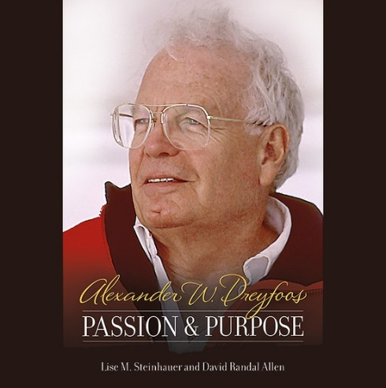

***-A PHOTOGRAPHIC ODYSSEY- -PASSION & PURPOSE-***

***Compatriot Alexander W Dreyfoos, Jr.*** an honored member of the *Palm Beach Chapter Sons of the American Revolution*, noted American entrepreneur, and philanthropist has published two remarkable books that should be on every bookshelf. **Book sales** **proceeds** **donated to local West Palm Beach charities!**

* ***Passion & Purpose*** chronicles a remarkable lifetime of passion with photography, his business, inventions and philanthropic ventures, as well as his adventures above and below the water. **$29.95.**
* ***A Photographic Odyssey*** is a remarkable collection of hundreds of stunning pictures from 100,000 photos taken by Alex around the world and bound in an elegant 15” by 10” glossy photographic book. You will travel with Alex around the world, above and below the water, to forests, jungles, glaciers, and deserts in the exotic locals of Papua New Guinea, Bhutan, Nepal, China, Japan, and Tibet. The subjects are very divergent contrasting palaces and temples with the vulnerability of people, animals, and exotic scenery. **$60.00.**
* **Support your Chapter & local charities! Get both books, *Passion & Purpose & A Photographic Odyssey,* just $71.96 @ kravis.org/books or Call 561-651-4329.**

***-Alexander W. Dreyfoos-***

*Graduating from MIT and Harvard Business School, Alex founded Photo Electronics Corporation (PCS), specializing in photography and video production. Over the decades, Alex earned 10 US patents and invented the Video Color Negative Analyzer for motion pictures earning him an Academy Award for technical achievement.Many inventions, developed by PCS, are on permanent display at the Smithsonian Institution. Locally Alex also owned television station WPEC TV-12, the CBS affiliate in West Palm Beach. Alex’s many philanthropic achievements include founding the Palm Beach County Cultural Council, the Raymond F. Kravis Center for the Performing Arts and gifting a million dollars to the Dreyfoos School of the Arts. Alex also donated a million dollars each to the Palm Beach County biomedical research campus of the Scripps Research Institute and the local Max Planck Florida Foundation for Neuroscience in Jupiter, Florida.*

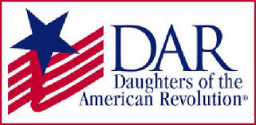

*Garcilaso de la Vega Chapter, NSDAR*

*Lake Worth, Florida*

*Alisha Darcy, Regent*

*Karen Christie, Registrar*

Phone; 561-236-2460-Email; [IMC4U4@AOL.com](mailto:IMC4U4@AOL.com)

Chapter Email: [GarcilasodelaVegaDAR@gmail.com](mailto:GarcilasodelaVegaDAR@gmail.com)

Visit us on ***Facebook*** @ <https://www.facebook.com/LWDAR>

