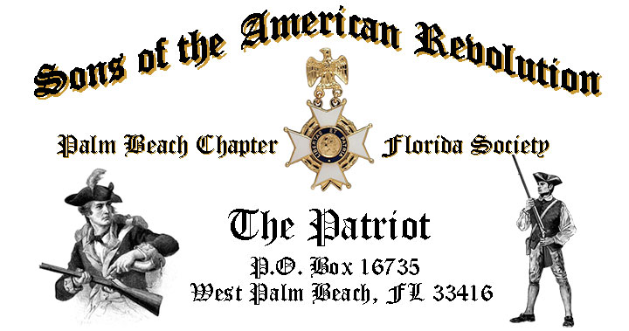

***Volume 24 Special Summer Edition June 2018 Number 06***

***~SAVE THE DATE- DECEMBER 8-2018~***

***Join*** us for the ***Chapter’s 80th Anniversary & Holiday Celebration Saturday*** ***December 8, 11:00 AM*** @ the *historic* and *iconic* ***Everglades Club*** on***Palm Beach Island***where our Chapter was founded in 1938! ***Don’t Miss this Special event!***

***December 8 Anniversary & Holiday Musical Event Highlights…***

* ***“Toast to Washington” Sparkling Wine Social; Orange Room- Foyer***
* ***Color Guard & Bag Pipes; Historic Everglades Club Orange Room***
* ***Special Holiday Musical - Award Winning “Dimension 20 Choir”***
* ***Club Catered 3-Course “Plated Lunch”, Special Desserts & beverages***
* ***Special Invitations will be mailed to Compatriots in October***
* ***RSVP & Event Payment***, **Don Lanman 561-315-5973 DLanman258@AOL**

***Newsletter Content:***

* **President’s** **Message**
* **2018 Officers & Board Members**
* **2018 Chapter Meeting Dates &Topics**
* ***President’s Brigade* Financial Supporters**
* **Committees, Chairmen & Members**
* **National/State/Chapter, News & Events**
* **Feature Articles: *Yankee Doodle Dandy--America’s Unofficial Anthem!***
* **Pictures-Meetings** **& Events**

***President’s Message:***

***Fellow Compatriots, DAR Daughters & Friends…***

As your President, I want to thank everyone who has made the first five months of my presidency a most enjoyable event. I could not hope for a more industrious and selfless group of compatriots and guests, who have made each month better than the one before.

I look forward to the fall with great anticipation and especially our *80th Anniversary* celebration. As a summary of your achievements the following activities were achieved in May.

The Chapter honored 4 Local Heroes at our annual ***“Firefighter-EMS First Responder Recognition Ceremony”*** at the *May* meeting. We shared stories of the *dedication, heroism* and *community* service, and recognized first responderprofessionals *Chief Reginald Duren, Jon Ferguson, Joseph Duffy* and *Andrew DeFilippis* with the prestigious ***SAR Fire Safety/EMS Commendation Medal***.

[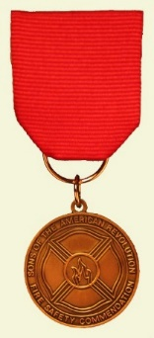](https://www.google.com/url?sa=i&rct=j&q=&esrc=s&source=images&cd=&cad=rja&uact=8&ved=2ahUKEwj00ce74OfaAhWjwFkKHQByBaIQjRx6BAgBEAU&url=http://www.fairfaxresolvessar.org/ffx_community_firesafetymedal.html&psig=AOvVaw1g3ZJGlbgawyHrKqw_pGdJ&ust=1525375388827063)[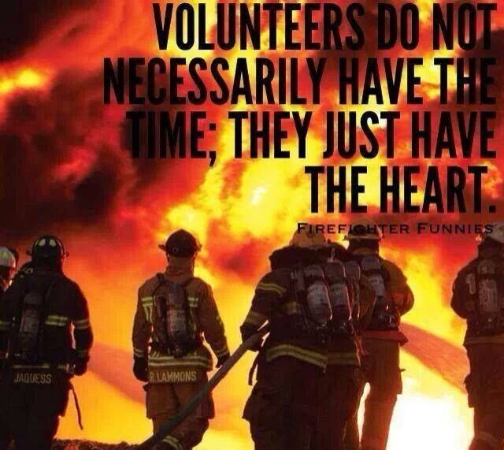](https://www.google.com/url?sa=i&rct=j&q=&esrc=s&source=images&cd=&cad=rja&uact=8&ved=0ahUKEwjpu_7QmtTTAhWISyYKHX2iBYQQjRwIBw&url=https://www.pinterest.com/smsstudios/firefighter-inspired-motivation/&psig=AFQjCNFe-QzCi1sX1hq9YXMkLZ4VRhA6zQ&ust=1493917430593864)[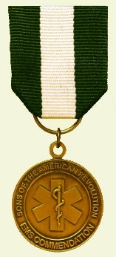](https://www.google.com/url?sa=i&rct=j&q=&esrc=s&source=images&cd=&cad=rja&uact=8&ved=2ahUKEwid0omn4OfaAhVjtlkKHY-yBqEQjRx6BAgBEAU&url=http://www.fairfaxresolvessar.org/ffx_community_emsmedal.html&psig=AOvVaw1g3ZJGlbgawyHrKqw_pGdJ&ust=1525375388827063)

*May* was an exceptional meeting including a presentation of the ***Colors*** by the ***Forest Hill Community High School JROTC Color Guard*** to begin our annual ***“Firefighter-EMS First Responder Recognition Ceremony”***

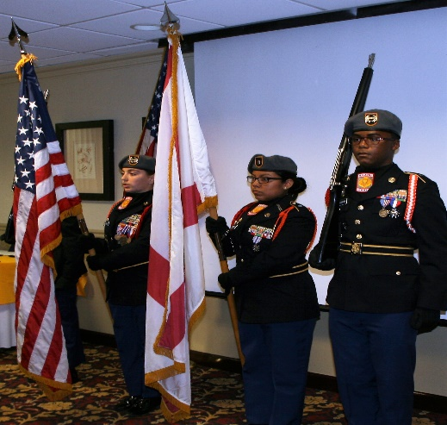

President Tidwell awarded the prestigious ***SAR Chapter Bronze*** and ***State Silver Good Citizenship Medals*** to ***Compatriot Richard Linn*** in recognition of his countless years of selfless community, civic and board service to our community including serving as *WPB City Commissioner* and *West Palm Beach Mayor*.

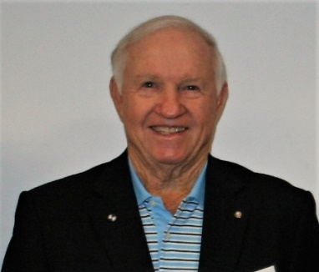

***Compatriots Tidwell, Lanman, Green, Boggs, Johnston, Barber, Miller, Sears, Parkinson, Swain, Giddens*** and ***Wratislaw***represented our Chapter at several patriotic events in Mayincluding: *Memorial Day Flag Placement at the South Florida National Cemetery* and *Chapter Honor Wreath* dedication at the *Forgotten Soldiers “A Day to Remember” Memorial Day Ceremony*.

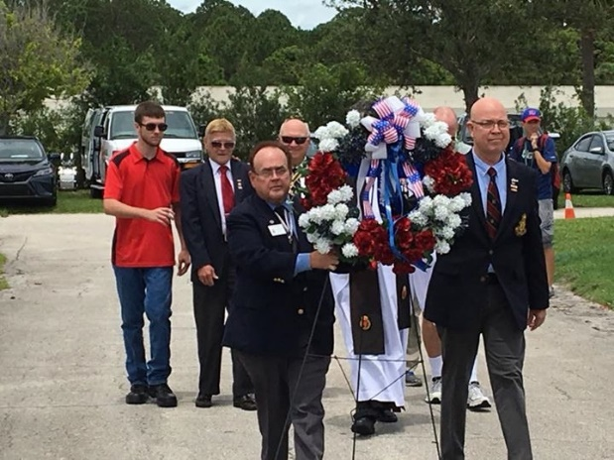

***Palm Beach Chapter's “Own”, Ray Wess***, Former Chapter and State President, was awarded the prestigious ***State Society Sons of the American******Revolution*** ***Patriot Medal*** and ***Distinguished Service Medal*** at the State Board of Management meeting May 20th.

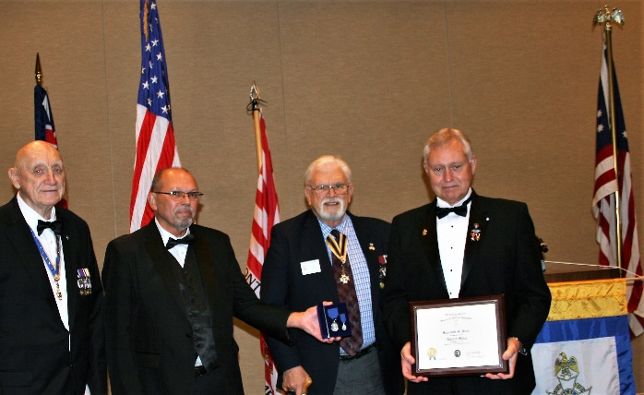

The ***SAR Patriot Medal*** is the highest award that can be presented to a Compatriot by the State Society in recognition of *long, faithful, outstanding,* and *distinguished* service.  The ***Patriot Medal*** is suspended from a ribbon of royal blue with a silver finish that bears the portrait of ***Compatriot, General of the Army, Douglas MacArthur*** and personally inscribed ***“Awarded to Raymond Wess"***for *Patriotic Service*.

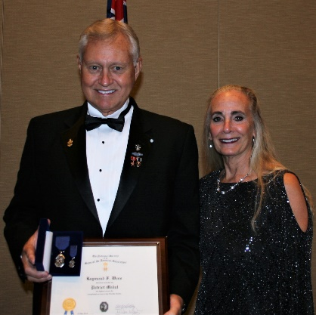

Congratulations ***Compatriot Wess*** on this well-earned tribute to your years of faithful and selfless service that continues to this day.  ***Thank You Ray...Well Done!***

***Compatriots Tidwell*** and ***Barber*** presented SAR Service Medals to local high school *JROTC* *Cadets Moreno, Finch, Cabrea, Doucett, Reyes* and *Matlach*, and an *SAR* *Good Citizenship Award* to the Boca Raton *Sea Cadet Bruno Barber*.

The Chapter paid its respects to ***Compatriot & Veteran Joseph K.*** ***Leinbach*** in a special memorial service conducted by *President Tidwell* concluding with the ceremonial ringing of the ***Chapter’s Bell of Remembrance***.

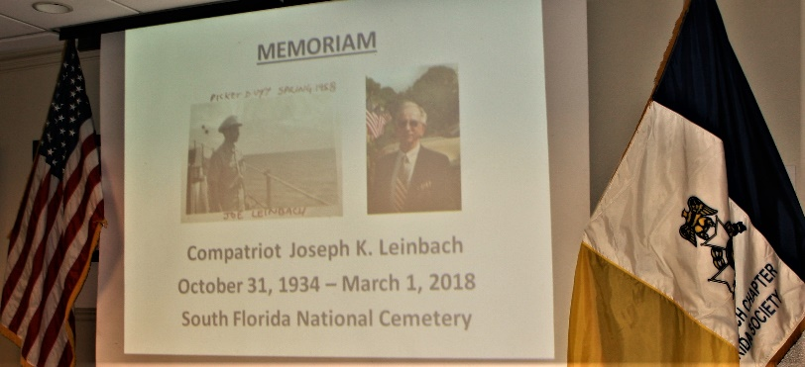

***Compatriots Tidwell***and***Lanman*** represented our Chapter at the *FLSSAR* State Board of Management meeting May 19 where the Chapter was presented a *FLSSAR* *“Chapter Challenge Award”* for 2017.

***Compatriot Lanman*** was elected to a FLSSAR officer position as “Member @ Large” to the Executive Committee representing Chapter Presidents and SAR members. *Lanman* also received a state *Certificate of Appreciation* for state committee chairmanship and a *Presidents* *Service Certificate* for his leadership as the Chapter’s 2016 & 2017 President.

***Lanman*** and ***Tidwell*** were also appointed to multiple state committees including *Veterans Recognition Committee Chair* for Lanman and *JROTC* for Tidwell. *Col. Patrick Niemann* was elected *FLSSAR* state president, *Lee Popham* SVP and *Bernard Wolf* as Southeast Regional VP.

Special thanks to ***Compatriots Anderson,* *Lanman*** and FLSSARWebmaster***Bushnell*** who worked tirelessly to update the Chapter web site, increase its functionality and add content including a Chapter member’s page listing all Compatriots. Check out the enhancements at [www.sarpbchapter.org](http://www.sarpbchapter.org).

*Compatriot Veterans* are encouraged to provide the Chapter with a copy of their ***DD-214*** to be recognized with the ***SAR Military Service*** or ***War Service Medal*** and join the 15% of Chapter Vets who’ve served honorably from ***WW II*** to***Iraq***.



***Don’t wait to be asked***, we need help on committees supporting our youth and civic programs including ***Historical Oration, Knight Essay, Poster*** and ***Brochure*** contests***, American History Teacher of the Year, Boy Scouts, Police-Firefighter* recognition*, Flag & Liberty Tree,*** and ***Veterans*** services*.*

***Grow Chapter Membership*** by enrolling your *Sons* and *Grandsons* and encourage wives, daughters, and granddaughters to join the *Daughters of the American Revolution, Children of the Revolution* and the *Chapter Women’s Auxiliary*.

Our beloved ***DAR Patriot Daughters*** are always welcome at all Chapter meetings and events, and we sincerely appreciate their tireless efforts to support us and refer new SAR members. Support the *DAR* Chapters by attending their fundraising and patriotic events and meetings.

***Chapter Financials***, Compatriots, please help your chapter from losing money on our meeting luncheons by **attending** each meeting and **bringing** family members and guests. **Remember** the Hotel requires a **minimum number** of guests to cover the food, room, and services fees, so when attendance is below **40** or if there are **no shows**, your **Chapter must pay the difference**.

*Compatriots*, I look forward to seeing you at the ***Oct 16th***meeting! Please, join me remembering our Patriot Ancestors, departed Compatriots and especially our nation’s Veterans. ***God Bless you*** and ***the United States of America.***

***Yours In Patriotism*** **– *Benjamin F. Tidwell III***

*** Hear Ye-Hear Ye…..Chapter Editorial***

***~LIBERTAS ET PATRIA~***

***~LIBERTY & COUNTRY~***

***Compatriots SAVE THE DATE!***

***December 8 2018***

|  |
| --- |
|  |

*The Palm Beach Chapter* was founded and chartered by then ***President General Messmore Kendall*** on March 16 1938 in the iconic ***Writing Room*** of the historic ***Palm Beach Everglades Club***.

The Charter’s 19 founding members included many of America’s leading political, civic and business leaders of the time including *Compatriots* *Messmore Kendall, Charles F. Coe, Clifford V. Brokaw, Phil H. Sawyer, Blane Webb, J. Field Wardlaw, David B. Crandall, Harold A. Braman, Roscoe T. Anthony, Loring W. White, Ellingsworth Warner, W. Marvin Clifton, Homer E. Sawyer, F. Reeves Rutledge, James A. Dew, Ira L. Nesmith, W. Murry Hammer* and *Richard P. Robbins.*

In honor of our ***80th Anniversary****,* the Chapter designed a custom gold ***Chapter Commemorative* *Coin*** honoring the *Palm Beach Chapter* and its 80 years of patriotic, philanthropic, and civic service in *Palm Beach County, Florida*. These coins may be purchased for just $10 each.

***Save the Date!*** A yearlong celebration began in January and will conclude with a very special ***80th Anniversary*** 3-course plated luncheon at the iconic/historic ***Palm Beach Everglades Club*** on *Palm Beach Island*, Saturday ***December 8, 2018***.

***RSVP*** and lunch prepayment is required. Contact ***Don Lanman 561-315-5073. DLanman259@aol*** for information and advance reservations.

Compatriots…please join us and participate at all *Chapter* activities including SAR and *DAR* programs and patriotic events like *SAR ceremonies*, *MIA*, *BOM*, *Memorial Day, Honor Flights, Flag Day, July 4th, Veterans Day* and others.

Please encourage and support our Chapter leadership with their responsibilities, but don’t wait to be asked…rather ask what -You can do to help.

***God Bless You*** and ***God Bless the United States of America.***

***~In Heartfelt Comradeship & Patriotism******- D. Lanman, Editor***

***2018 Chapter Meeting Dates/Topics:***

**Visit** the Palm Beach Chapter web site @ [www.sarpbchapter.org](http://www.sarpbchapter.org) for a meeting calendar, special events, articles, pictures, and general information.

* **Oct. 16, 2018**, ***Compatriot H. Oyer, Palm Beach Bare-Foot Postman***
* **Nov. 20, 2018**, ***Compatriot S. Barber-Veterans Day “Poppies”***
* **Dec. 8, 2018**, ***80th Anniversary-Christmas-Holiday Musical***

***2018 Officers & Board:***

* ***President******Benjamin Franklin Tidwell III***
* ***Vice President******Robert Boggs***
* ***Secretary******Gary Green***
* ***Treasurer******Peter Johnston***
* ***Registrar******Robert Boggs***
* ***Chaplain******Father Sanford Sears***
* ***Sgt. @ Arms Peter Miller***
* ***Historian******Samuel “Buddy” Miller***
* ***Officer @ Large******Sonny Barber***
* ***Patriot Newsletter Editor******Donald Lanman***

***Join the President’s Brigade to Support Youth Programs!***

The Chapter has authorized ***$1,000***Scholarship to the ***Palm Beach Atlantic University*** again for ***2018***. This university educates our youth on the values of God and Country and helps develop character for the leaders of tomorrow.

The Chapter honors and expresses its sincere appreciation to the *Compatriots* of the ***President’s Brigade*** who support our scholarship and youth programs. The dedicated members of the ***President’s Brigade*** donate ***“Extra Dollars”*** in support of the Chapter’s many youth programs, scholarships, civic activities, award certificates, police/firefighter/EMT medals, veterans’ projects, and related community civic programs.

***Please Help*** increase the scholarship amount this year to ***$4,000*** *by* donating a few dollars to the ***Presidents Brigade*** in support of these students of character.

***Honored Presidents Brigade Members*:**

* **Bronze Level: $25-$99:**

***M. Anderson, J. Blackburn, B. Boggs, J. Chataing, A. Cass, C. Coldwell, D. Coldwell, M. Curry, S. Curry, J. Damron, J. Dorsey, W. Davis, F. Devitt, J. Harper, J. Kane, L. Lassitter, P. Miller, S. Miller, J. Mayne, G. Parkinson, H. Oyer, J. Porter, S. Sears, A. Shea, W. Told, J. Wearn, L Watkins***

* **Silver Level: $100-$199:**

***J. Curry, R. Culpepper, T. Friend, G. Green, F. Green, A. Griswold, W. Johnson, D. Shepherd, S. McWhorter***

* **Gold Level: $200-$499:**

***R. Brinckerhoff, S. Barber, R. Banta , E. Buckley, J. Curry, S. Hitt, W. Meakin, J. Wynns***

* **Platinum Level: $500+**

1. ***Dreyfoos, B. Tidwell, D. Lanman, K. Christie***

***Committees, Chairs & Members:***

***Fellow Compatriots…..***The Chapter expresses its sincere appreciation to those members who volunteer to serve on our committees and projects. As you can see a few Compatriots are serving on multiple committees and could use some extra support! **Just** choose a committee of interest for ***2018***.

It doesn’t take much time and is a major help with our many civic and youth initiatives.

**Call Ben Tidwell (561-704-9918) or Bob Boggs (561-241-3128)** **Today** to lend a hand on any of the following committees…

* ***2019 Officer Nominations -All Chapter Members***
* ***80th Anniversary -Lanman, Tidwell, Officers***
* ***JROTC & Boy Scouts -Barber, Tidwell***
* ***Law Enforcement-Fire Safety -Parkinson, Green***
* ***Veterans Affairs -Lanman, Curry***
* ***Newsletter/Publicity -Lanman***
* ***Knight Essay/Rumbaugh Oration -Boggs***
* ***American History Teacher -Boggs***
* ***Medals/Awards -Lanman, Tidwell***
* ***DAR-CAR Liaison -Tidwell, Lanman***
* ***Speakers Bureau -Lanman, Tidwell***
* ***Audit -Coldwell, Tidwell***
* ***Flag Certificates -Miller, Johnston***
* ***Membership Development -Green, Boggs, Tidwell***
* ***Liberty Tree -Chapter Officers***
* ***Patriot Bios -Miller***
* ***Web Site-Facebook/Social Media -Anderson, Lanman***

**Palm Beach Chapter 80th Year Commemorative Coin $10!**

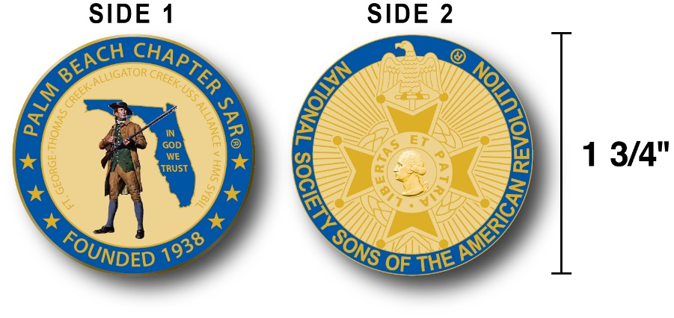

The Chapter created a custom bronze *Commemorative Anniversary Coin* honoring the founding of the ***Palm Beach Chapter* in *1938*** and celebrating its 80 years of historic, patriotic, and civic service in Palm Beach County and Florida.

The beautiful collector’s coin is highlighted in ***George Washington*** ***military blue*** on a stunning ***Gold*** background. *Side-one* is personalized for our Chapter with our founding date, *Patriot* *Minuteman* guarding *Florida* over the *State* motto ***"In God We Trust”.***

The collector’s coin includes an inscription listing the four major Revolutionary War battles waged in *Florida* including the battles of ***Ft. George-Pensacola, Thomas Creek Massacre, Alligator Creek Battle,*** and the ***Last Naval Battle* of the Revolutionary War** between the ***USS Alliance*** & ***HMS Sybil.*** Side-two displays the national ***SAR*** ***Cross of Malta***.  Very impressive indeed! The custom bronze ***Commemorative Anniversary Coin*** is designed to celebrate our founding in **1938**, create a distinctive and impressive image for our Chapter and be used as a token of appreciation for honored guests, speakers, and as special awards.

***Classy SAR Lapel Pins $10:***

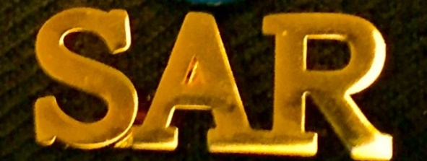

Display a ***Gold*** ***SAR*** pin on your suit lapel or shirt with the ***SAR Rosette***. The SAR Lapel Pin is part of a national branding program to help promote the S.A.R. and stimulate new membership!

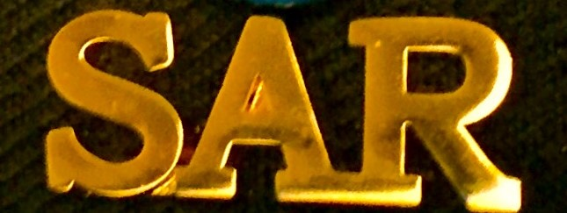

The striking lapel pin is a recognizable public symbol of the SAR, provides you recognition as a member of this great society, and will spark conversations about SAR that leads to a new member.

The ***SAR Gold*** lapel pin along with the ***SAR Rosette*** create a professional image that will improve overall SAR name recognition. The Chapter has a supply of pins for Compatriots for just $10.

***Show Chapter Spirit….***

**Get your 80th Anniversary Coin & Gold SAR Pin today**!

***SAR Chapter, State & National Events:***

**-*CHAPTER/STATE*:**

***Join Chapter members at events. See Ben Tidwell/Don Lanman for details.***

***-2018 SAR NATIONAL CONGRESS:***

***The 128th SAR Congress is scheduled for July 12-19 in Houston, Texas. Hotel registration is open now at a special SAR price of $159.00 per night King or 2-Queens.***

***Reservations can be made by calling the Westin Memorial City Hotel @ 1-800-937-8461 or online @*** [***www.starwoodmeeting.com/book/nssar2018***](http://www.starwoodmeeting.com/book/nssar2018)***.***

***Questions contact Paul Callanan @*** [***LTCMRSC@aol.com***](mailto:LTCMRSC@aol.com) ***or 906-273-2424.***

***~Feature Article~***

***Yankee Doodle Dandy…***

***America’s Unofficial National Anthem***

***Compiled-Edited-Written by Don Lanman FMR Palm Beach Chapter President***

[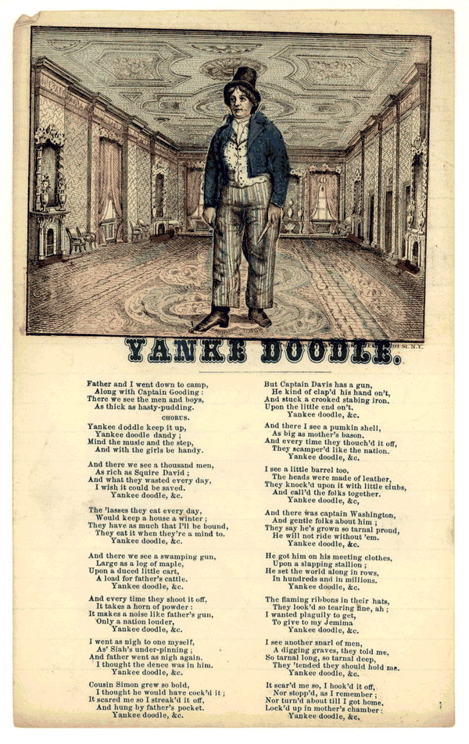](http://memory.loc.gov/diglib/ihas/loc.rbc.hc.00037b/enlarge.html?page=1&from=pageturner)

***"Yankee Doodle"*** is an old melody of murky origins with many versions of humorous verses. It’s a well-known [American](https://en.wikipedia.org/wiki/Music_of_the_United_States) song, the early versions of which date to before the [*Seven Years' War*](https://en.wikipedia.org/wiki/Seven_Years%27_War) and the[*American Revolution*](https://en.wikipedia.org/wiki/American_Revolution).

However, the melody itself is thought to be much older than both the lyrics and the subject matter, going back to folk songs of [Medieval Europe](https://en.wikipedia.org/wiki/Middle_Ages). It is often sung patriotically in the [***United States***](https://en.wikipedia.org/wiki/United_States) today and is the [state anthem](https://en.wikipedia.org/wiki/List_of_U.S._state_songs) of [***Connecticut***](https://en.wikipedia.org/wiki/Connecticut), and is listed in the [***Roud Folk Song*** *Index*](https://en.wikipedia.org/wiki/Roud_Folk_Song_Index) song #4501.

Traditions place the current song’s origin to about 1755, apparently written by ***British Army Surgeon Dr. Richard Shuckburgh*** while campaigning in upper New York during the[*French and Indian War*](https://en.wikipedia.org/wiki/French_and_Indian_War).

The song was originally sung by [***British***](https://en.wikipedia.org/wiki/Great_Britain) officers to mock the disheveled, disorganized colonial ***"***[***Yankees***](https://en.wikipedia.org/wiki/Yankee)***"*** to make fun of the ***American*** soldier stereotype as a simpleton who thought that he was stylish by simply sticking a feather in his cap.

While the ***British*** sang the song to mock the colonials, the ***Americans*** subsequently took ownership and turned it into a song of patriotic pride, especially during the *Revolutionary War*. The most popular version of the first stanza of ***Yankee Doodle Dandy***…

***Yankee Doodle came to town  
Riding on a pony;   
He stuck a feather in his cap  
And called it macaroni.  
Yankee Doodle, keep it up  
Yankee Doodle dandy;   
Mind the music and the step,   
And with the girls be handy.***

So how was this song disparaging? In 1750s England, ***Yankee*** was a general term of contempt. “**Doodle”** refers to a lowly provincial person, while a ***Dandy*** is a meticulously well-dressed man. In the 1700s, a “**Macaroni”** was an ***English*** dandy who affected foreign fashions and mannerisms.

[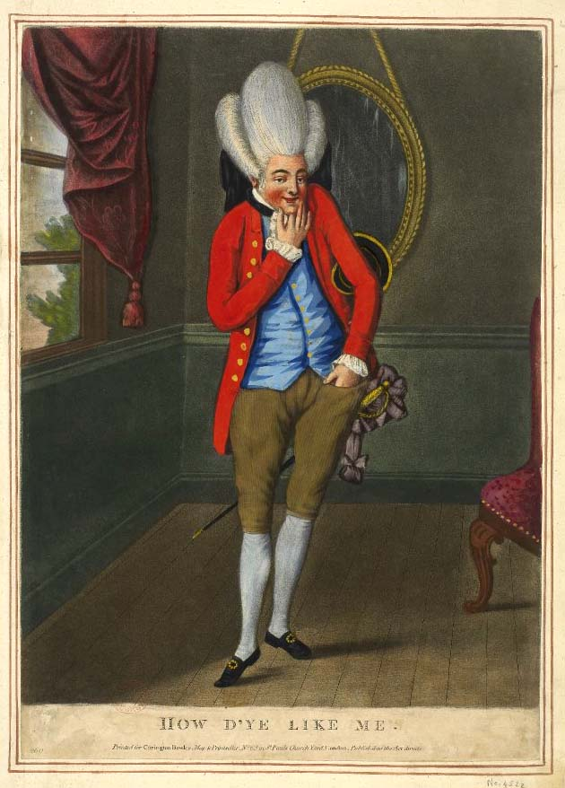](https://www.google.com/url?sa=i&source=images&cd=&ved=2ahUKEwjNnfmFsvnaAhVntlkKHUpnD8oQjRx6BAgBEAU&url=http://www.datuopinion.com/macaroni-moda&psig=AOvVaw3BWmn2-FCroLN7lhd4jTgS&ust=1525980427476130)

So, roughly interpreted, the song means, ***"This country bumpkin came along on a pony — not a horse — and thought that merely sticking a feather in his hat would turn him into a suave sophisticate like a European Gentlemen. What a rube!"***

The ***British*** used to sing the song following battles including ***Bunker-Breeds Hill***. However, despite losing their strategic positions, the battle was a significant morale-builder for the inexperienced ***Americans***, convincing them that *“fury & patriotic dedication”* could overcome superior ***British*** military might.

Additionally, the high price of victory at the ***Battle of Bunker Hill*** made the ***British*** realize that the war with the colonies would be long, tough and costly.

Following *Bunker Hill*, the ***Americans*** started singing ***Yankee Doodle Dandy***, ironically, and annoying the ***British*** who did not appreciate the ***American’s*** ironic and very finely tuned sense of humor.

The ***Patriots*** had turned the song intended to be insulting into their rallying theme song throughout the *Revolutionary War*. They sang it proudly during many of the battles against the ***British***...but with extra exuberance when ***Lord Cornwallis*** surrendered to ***His Excellency George Washington*** at *Yorktown* in 1781.

[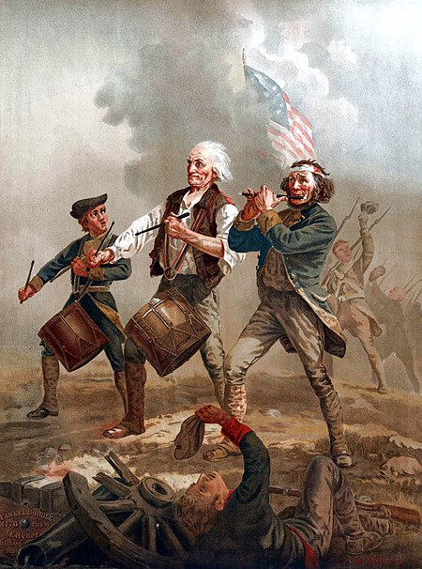](https://en.wikipedia.org/wiki/File:Sprit_of_'76.2.jpeg)

Following the ***British*** surrender at *Yorktown*, being called a **"Yankee Doodle"** had been transformed from being an insult to a symbol of national patriotic pride! ***Yankee Doodle Dandy*** had become the new republic’s ***Unofficial National Anthem***.

[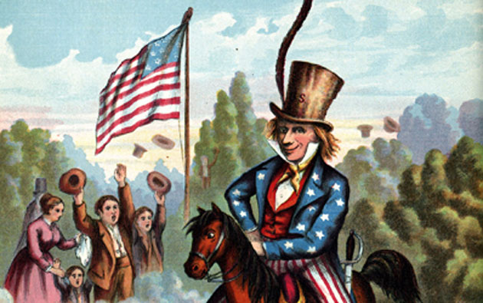](https://www.google.com/url?sa=i&source=images&cd=&cad=rja&uact=8&ved=2ahUKEwi11bn5rvnaAhWnrFkKHVmuAIQQjRx6BAgBEAU&url=https://www.emaze.com/@AQTRLIQC/-copy1&psig=AOvVaw3BWmn2-FCroLN7lhd4jTgS&ust=1525980427476130)[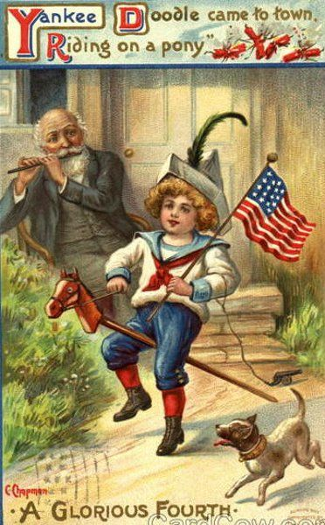](https://www.google.com/url?sa=i&source=images&cd=&cad=rja&uact=8&ved=2ahUKEwiX0pyXsPnaAhUyrlkKHZzuBcEQjRx6BAgBEAU&url=https://www.pinterest.com/seashoregarden/vintage-fourth-of-july-images/&psig=AOvVaw3BWmn2-FCroLN7lhd4jTgS&ust=1525980427476130)

***Keep Your SAR Membership Active!***

**Don’t lose your SAR Membership….Don’t forget to pay your membership 2019 dues by mailing** **your $75** annual membership dues today to ***SAR PB Chapter, PO Box 16735 West Palm Beach, FL 33416-6735! Include*** any changes to your personal contact information.

***Remember*….Your** **membership dues plus any additional donations fund the many Chapter’s youth and civic activities including**:

**Scholarships**, ***Boy Scout & JROTC medals, Rumbaugh & Knight Essay Youth contests, Police-Firefighter-EMT awards, Flag Certificates, Americanism, American History Teacher, Civic & Community programs.***

***~May Meeting & Event Pictures~***

***President Tidwell Welcomes***

***Forest Hill Community High School JROTC Color Guard***

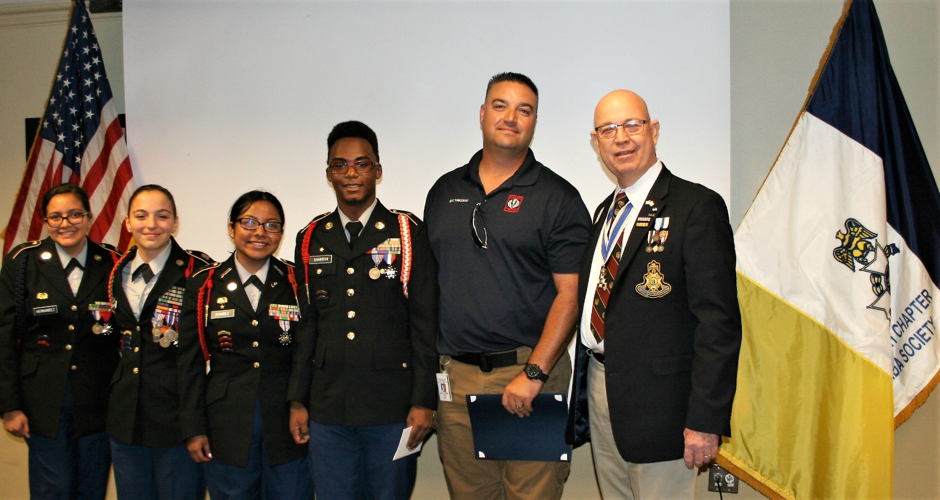

***President Tidwell presents Firefighter Medal***

***to First Responder Professional Andrew Deflippis***

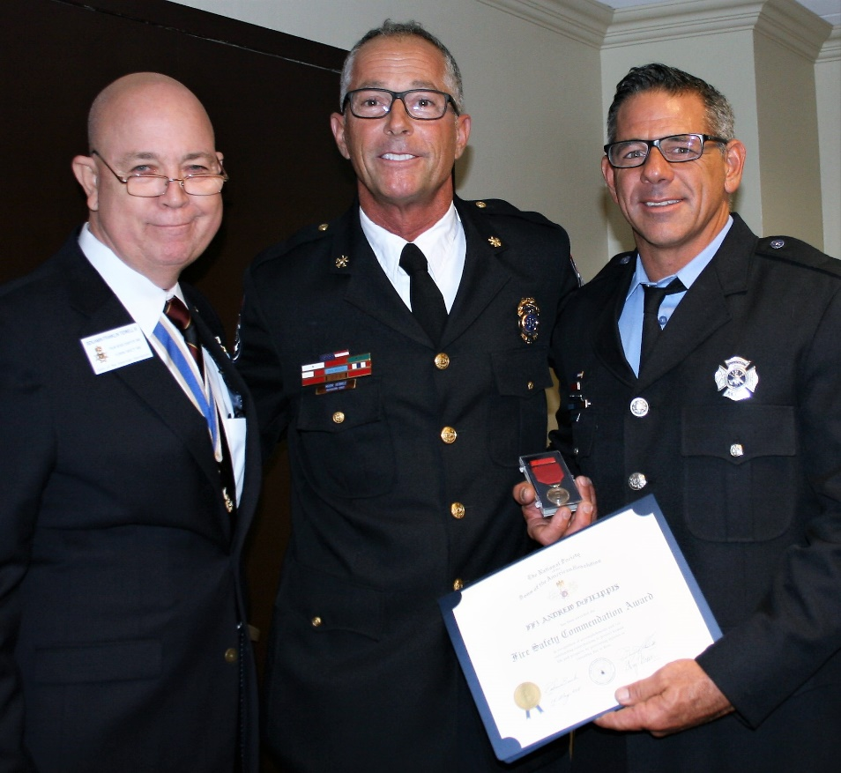

***President Tidwell presents Firefighter Medal***

***to First Responder Professional Joe Duffy***

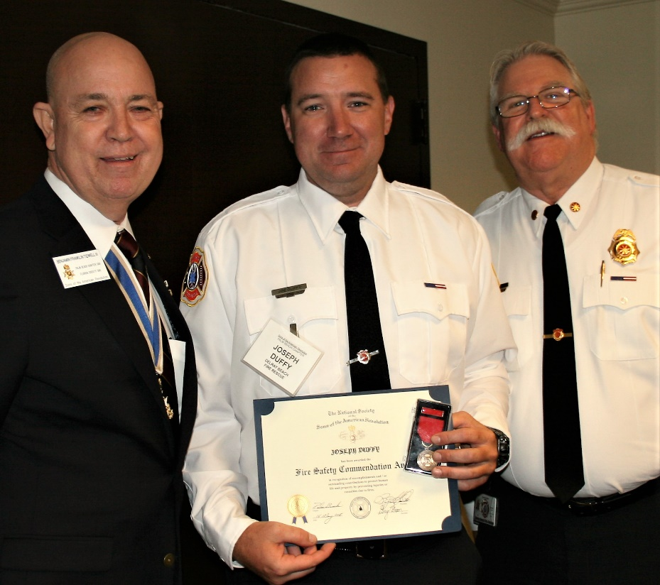

***President Tidwell, FMR President Parkinson***

***present Firefighter Medal to Chief Reg Duren***

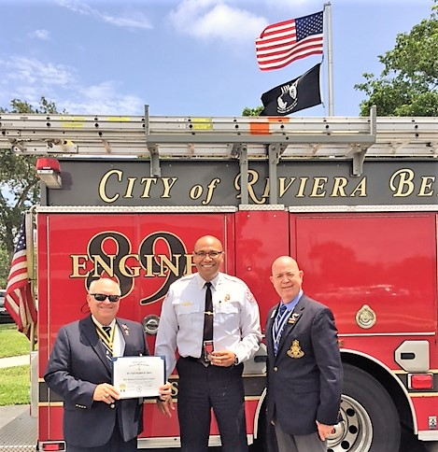

***President Tidwell, FMR President Parkinson***

***present Firefighter Medal to Jon Ferguson***

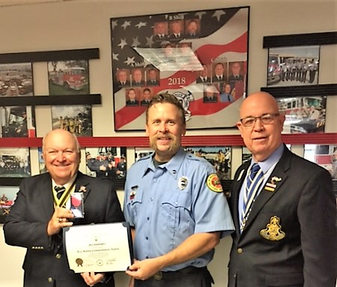

***Former Chapter & State President Ray Wess***

***Honored with SAR Patriot Medal from FLSSAR***

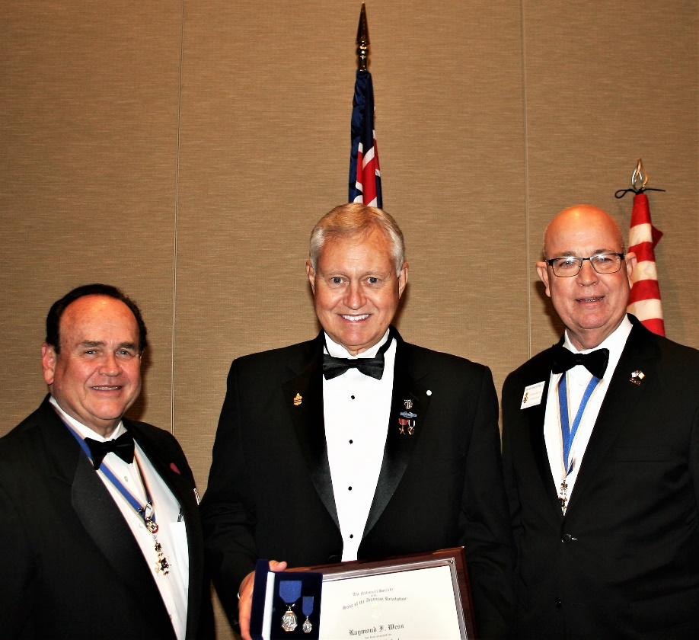

***Former Chapter President Lanman installed as***

***FLSSAR State Officer Executive Committee Member @ Large***

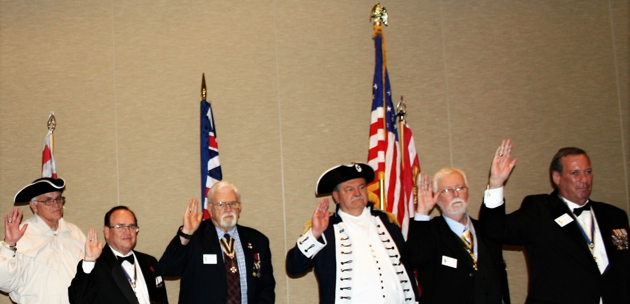

***President Tidwell presents FLSSAR JROTC Medal***

***At the Board of Management Meeting***

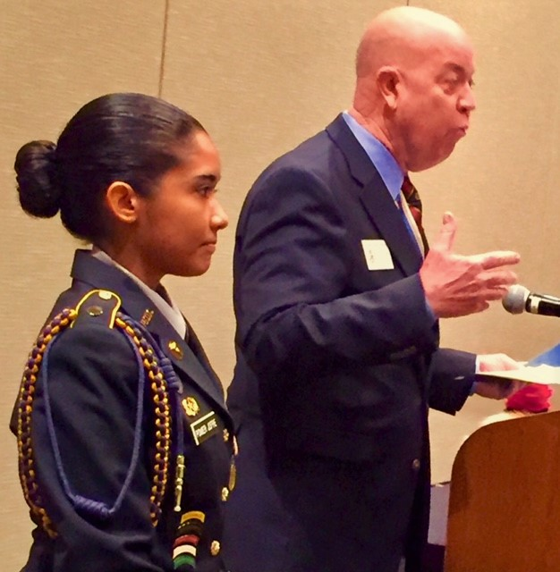

***President Tidwell & Former President Lanman &***

***Chapter Compatriots present Chapter Honor Wreath***

***@ Forgotten Soldiers Memorial Day Ceremony***

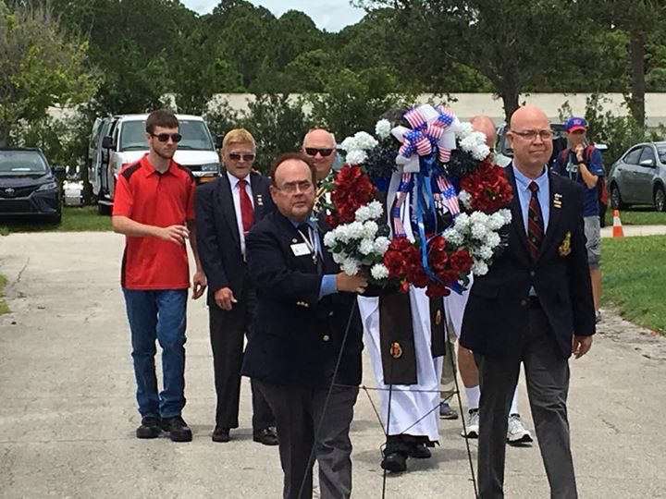

***Chapter Presidents Tidwell, Lanman, Green & Treasurer Johnston***

***deliver Greetings @ Forgotten Soldiers Memorial Day Ceremony***

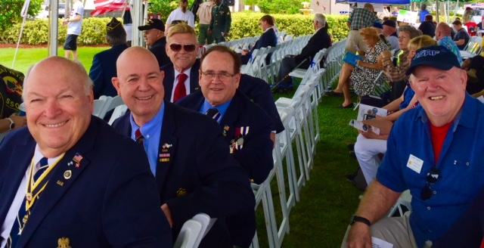

***Presidents Tidwell, Former President Lanman present***

***SAR Appreciation Certificate to Forgotten Soldiers Outreach***

***Executive Director Lynelle Zelner @ Memorial Day Ceremony***

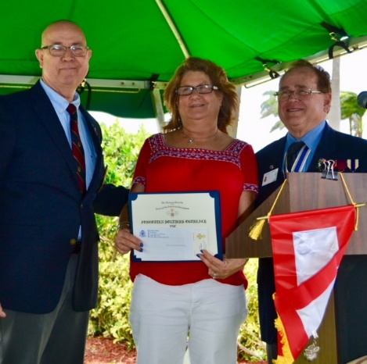

***Chapter Compatriots & GdlV DAR Daughters place American***

***Flags @ the South Florida National Cemetery Memorial Day Ceremony***

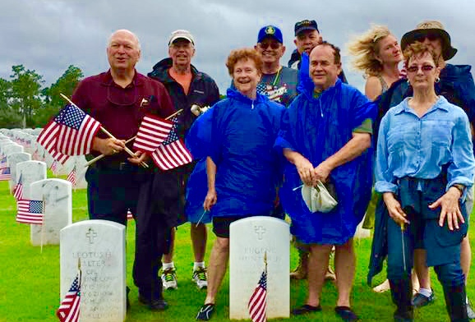

***Chapter Officer @ Large Sonny Barber presents***

***SAR Bronze Good Citizenship Medal***

***to Boca Raton Sea Cadet Bruno Barber***

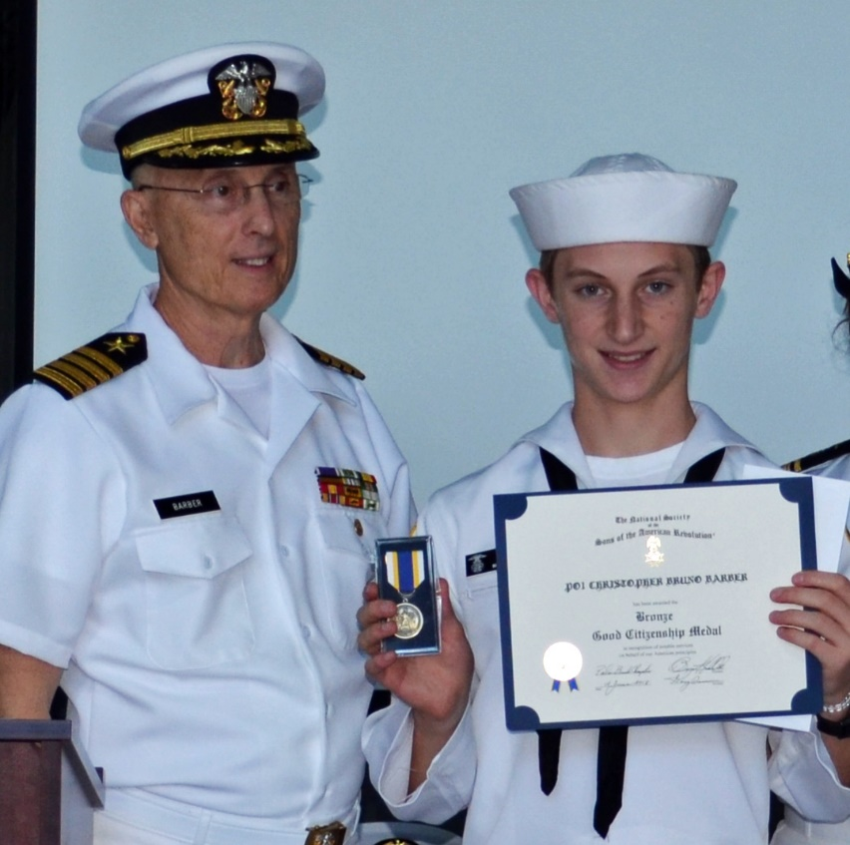

***~80th Anniversary Collectors Commemorative Coin $10.00~***

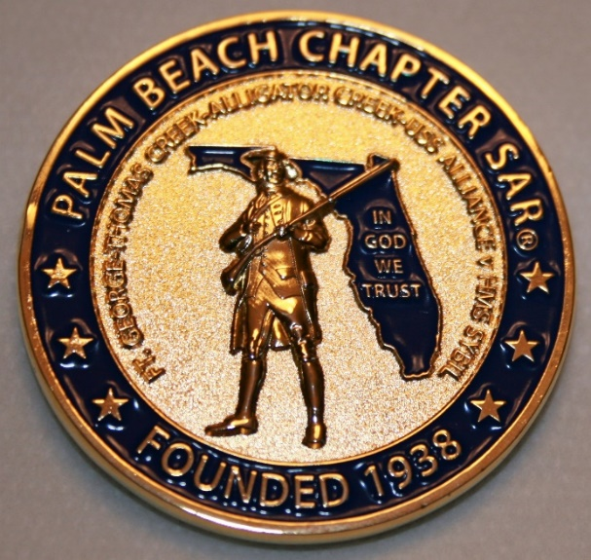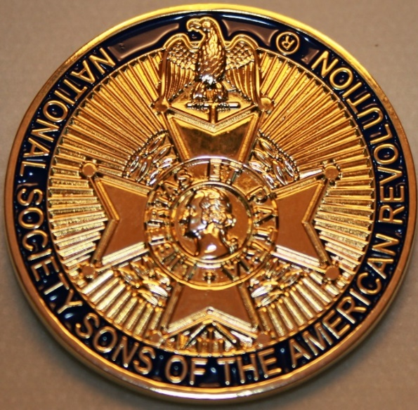

***~Compatriot Sponsored Promotions~***

**Compatriot sponsored newsletter Ads are important to the Chapter as they represent additional funds in support of Chapter projects including;**

***Scholarships, Boy Scout & JROTC medals, Rumbaugh & Knight Essay Youth contests, Police-Firefighter-EMT medals, Americanism & community civic programs!*** Support your Chapter…sponsor an Ad for **8** issuesat a modest cost:

**Business Card $50, Half Page $100, Full Page $250.**

**Your AD donation will also qualify you for the *Presidents Brigade*. Call Don Lanman 561-315-5073 for information.**

***CHAPTER SUPPORT ADS…***

***~COMPATRIOT ALEXANDER DREYFOOS***

***~AUTHOR/PHOTOGRPHER/PATRIOT***

***~COMPATRIOT SONNY BARBER***

***~HISTORIAN/AUTHOR/PATRIOT***

***~GARCILASO DE LA VEGA, DAR CHAPTER***

***~DAUGHTERS OF THE AMERICAN REVOLUTION***

*~TWO GREAT BOOKS-ONE GREAT MAN~*

***-Alexander W. Dreyfoos-***



***-A PHOTOGRAPHIC ODYSSEY- -PASSION & PURPOSE-***

***Compatriot Alexander W Dreyfoos, Jr.*** an honored member of the *Palm Beach Chapter Sons of the American Revolution*, noted American entrepreneur, and philanthropist has published two remarkable books that should be on every bookshelf. **Book sales** **proceeds** **donated to local West Palm Beach charities!**

* ***Passion & Purpose*** chronicles a remarkable lifetime of passion with photography, his business, inventions and philanthropic ventures, as well as his adventures above and below the water. **$29.95.**
* ***A Photographic Odyssey*** is a remarkable collection of hundreds of stunning pictures from 100,000 photos taken by Alex around the world and bound in an elegant 15” by 10” glossy photographic book. You will travel with Alex around the world, above and below the water, to forests, jungles, glaciers, and deserts in the exotic locals of Papua New Guinea, Bhutan, Nepal, China, Japan, and Tibet. The subjects are very divergent contrasting palaces and temples with the vulnerability of people, animals, and exotic scenery. **$60.00.**
* **Support your Chapter & local charities! Get both books, *Passion & Purpose & A Photographic Odyssey,* just $71.96 @ kravis.org/books or Call 561-651-4329.**

***-Alexander W. Dreyfoos-***

***Graduating from MIT and Harvard Business School, Alex founded Photo Electronics Corporation (PCS), specializing in photography and video production. Over the decades, Alex earned 10 US patents and invented the Video Color Negative Analyzer for motion pictures earning him an Academy Award for technical achievement.Many inventions, developed by PCS, are on permanent display at the Smithsonian Institution. Locally Alex also owned television station WPEC TV-12, the CBS affiliate in West Palm Beach. Alex’s many philanthropic achievements include founding the Palm Beach County Cultural Council, the Raymond F. Kravis Center for the Performing Arts and gifting a million dollars to the Dreyfoos School of the Arts. Alex also donated a million dollars each to the Palm Beach County biomedical research campus of the Scripps Research Institute and the local Max Planck Florida Foundation for Neuroscience in Jupiter, Florida.***

***HISTORICAL MYSTERY SERIES FROM THE REVOLUTIONARY WAR~ACROSS TIME***

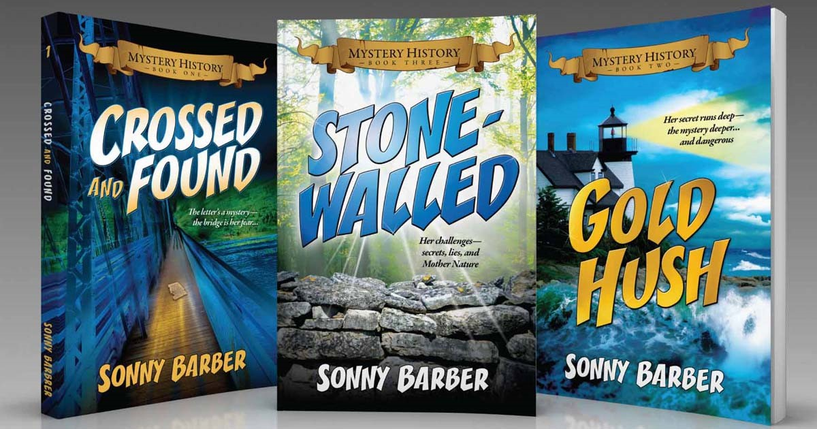

***Follow Kay Telfair across time beginning with Crossed & Found followed by Gold Hush & Stone-Walled….***

***Kay is a normal young teen—normal if that means being unusually curious and having an uncanny knack for putting herself in dangerous situations, which stresses her parents and often tests the relationship with best friend Anna.***

***The series follows Kay across two intrigue-filled summers on adventures involving events in American history. Join Kay’s journey of adventure steeped in American History through three books that excite all ages. At*** [***amazon.com***](http://amazon.com)***, Barnes & Noble or Chapter meetings. (See book summaries following page)***

***SAR Palm Beach Chapter Compatriot/Author Sonny Barber developed an interest in American history at an early age, reading and collecting newspapers, magazines and other materials on historic U.S. and world events. He’s coupled that interest with his fiction writing to create a modern-day “mystery history” Series perfect for Preteens to Adults.***

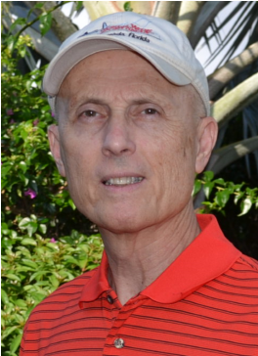

***~Crossed & Found~***

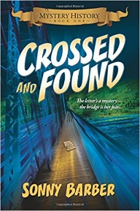

**Thirteen-year-old Kay Telfair believes her life is over when she moves with her family a thousand miles to their new home near the Delaware River in New Jersey. But her life takes an unexpected turn when she meets Anna and discovers a two-centuries-old letter--a letter that could change American history. Before she unravels the letter's mystery, Kay stumbles headlong into an adventure confronting fears she'd never experienced, stretching the limits of her friendship with Anna, and forcing a test of Kay's physical strength that could save her life.**

***~Gold Hush~***

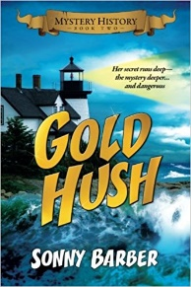

**“I’m avoiding any activity that involves excitement…I’ve learned my lesson.” After an adventure-filled June, all Kay Telfair wants is a quiet vacation in Maine with her family and best friend Anna—no drama, no stress. But the thirteen-year-old’s hopes for a tranquil August stay in the village of Prospect Harbor soon fade when the girls compete for the attention of a young boy and Kay makes a startling discovery—a discovery that sends the three teens on a dangerous quest. Ignoring advice—and menacing threats from others—they continue their pursuit, drawing them deeper into a perilous mystery, deeper than Kay ever could have imagined.**

***~Stonewalled~***

[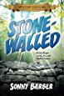](https://www.amazon.com/Stonewalled-Mystery-History-Book-Three/dp/1519351291/ref=pd_bxgy_14_img_3?_encoding=UTF8&psc=1&refRID=75QVZ72QHQ8A2W2F3RK1)

**Kay stared at the gray line of stone walls. “They won’t be too upset to see these knocked down...” A mystery that threatens the relationship with best friend Anna, a battle with Mother Nature at her worst, and the discovery of a tragic secret—not exactly what fourteen-year-old Kay Telfair was looking for in a summer getaway. But that’s what confronts the young teen while helping the owners of Windcrest Farm find a way to stop destruction of nearby farmland and its three-hundred-year-old stone walls. Vacationing with her family and Anna at Windcrest in the quiet, coastal village of Little Compton, Rhode Island, the young teen soon discovers her goal will not be easy. Kay’s prospects for helping preserve the valuable land and stone walls look much better after a surprise visit by a boy from her past. With his help, she pours all her energy and passion into the quest, searching for answers in New England’s Native American and colonial history and learning some important lessons about perseverance and friendship.**

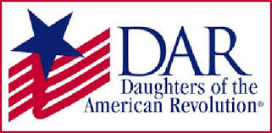

*~Garcilaso De La Vega Chapter, NSDAR~*

*Lake Worth, Florida*

*~Michelle Robertson, Regent~*

*~Karen Christie, Registrar~*

Phone; 561-236-2460-Email; [IMC4U4@AOL.com](mailto:IMC4U4@AOL.com)

Chapter Email: [GarcilasodelaVegaDAR@gmail.com](mailto:GarcilasodelaVegaDAR@gmail.com)

Visit us on ***Facebook*** @ <https://www.facebook.com/LWDAR>